Revision History
Date | Rev. | Description | Author(s)
2020-08-04 | 1.0 | Initial draft | Team 26

1. Actor-Goal List
Actor | Goal
Home-Residents | - Ensure house security against intrusion.  - Open/Close points of entry and exit to the house.  - 24 x 7 Video based Surveillance.  - Reduce energy and utility bill  - Manage alternate energy sources.  - Monitor Air quality  - Use different modes to access and authorize the system  - Provide system access to only authorized personal  - Experience more personalized and uninterrupted entertainment  - Automate daily household tasks
Notification Manager | - Sends notification to users.  - Initiating calls to 911.
Window controller | - Open Windows  - Close Windows
Window Blinds controller | - Open Window Blinds  - Close Window Blinds
Smart Air Conditioning system | - Turn on/off heating  - Turn on/off cooling
Smart Lighting system | - Switch on light  - Switch off light
Alarms System | - Trigger Alarms
Air quality monitor | - Record air quality parameters  - Calculate air quality score
Weather Reporter | - Record current weather  - Predict weather for next 24 hours
Usage Pattern Analyzer | - Generate automated schedule based on usage data
Third party device vendors | - Provides API support.  - Support the working of the device.
2. 2. Use Case Model
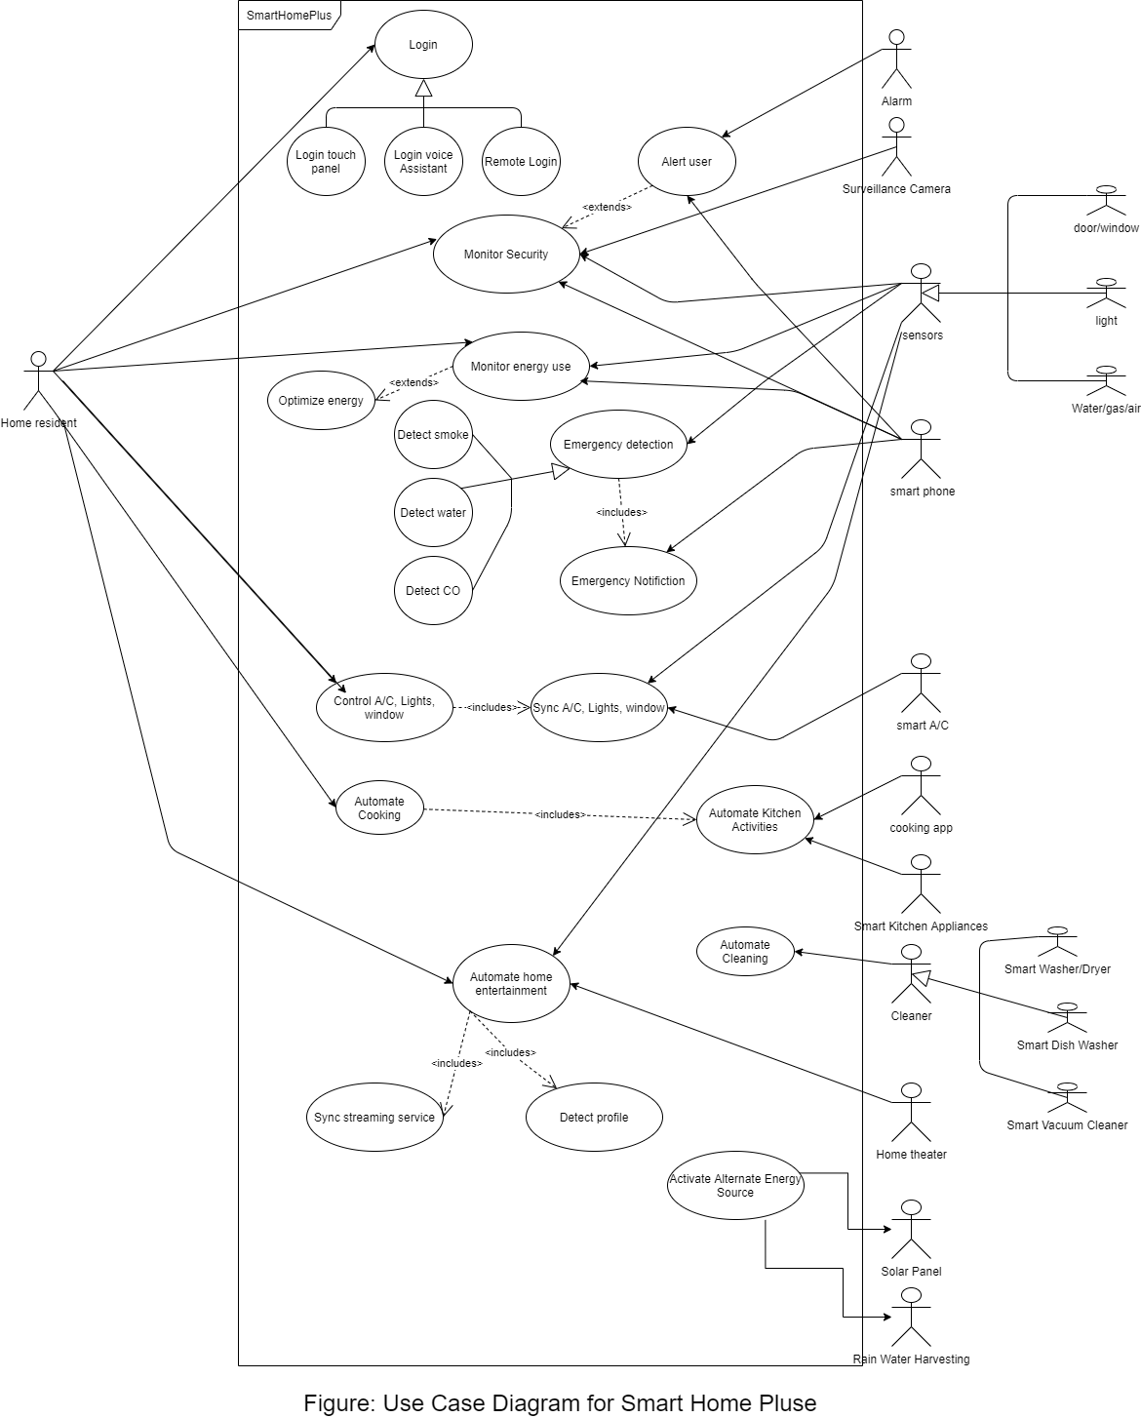
3. Package: Home security and safety

Id: UC-1.1

Use Case: Provide Home Security against home intrusion. – Refer Section 4.3 of Vision Document – Need -> Security Measures, Feature -> Intrusion Detection

Description
The system will provide (24x7) home surveillance and detect any events of unauthorized intrusion into the house.

Level: User Goal

Primary Actor
- Home-Residents
Supporting Actors
- Unauthorized Intruder
- Notification manager sub-component
- Centralized Alarming System
- Surveillance Cameras
- Cloud Storage

Stakeholders and Interests
- Home-Residents – Get a sense of security within their homes
- Unauthorized Intruder – Trying to Intrude the house
- Internet and Wi-Fi Service Providers – Provide connectivity services to send commands and receive notifications.
- Cloud Service Providers – Provide online storage for surveillance videos.
- Security Authorities (911) – Receive calls on event of an intrusion in the house.

Pre-Conditions
- Smart Home+ solution is installed and configured.
- Smart Home+ Home security management sub-component can access and control the following:
- Surveillance cameras
- Central Home Alarming facility
- Notification Manager Subcomponent

Post Conditions
- After customers are informed of an intrusion, they receive an immediate confirmation to check if they also want to send an automated voice note to 911 Security Services.

Success end conditions
- System successfully detects any intrusion activity being carried out to gain unauthorized entry into the house.
- System initiates the sequence of actions to counter and report this intrusion to the home residents.

Failure end conditions
- System fails to detect an intrusion leading to some unwanted events like robbery.
- System fails to automatically lock any point of entry into the house.
- System fails or delays sending notifications to home residents.
- Both the local and the cloud storage has space has been consumed and there is no space to store any further surveillance recordings.

Minimal Guarantee
- In case of intrusion detection system would not allow unlocking any points of entry unless users explicitly give a command to unlock them.

Main Success Scenario
- This use case begins when Smart Home+ is actively capturing surveillance videos and detects an intrusion being carried out to gain unauthorized access into house.
- The system immediately triggers the centralized home alarms.
- The system would then automatically locks all points of entries which can only be unlocked if users explicitly do so.
- System also sends an emergency notification to users on their smartphone to report this intrusion and also confirms with the users if they want to send an automated voice note to 911 security services.
- Users can then check surveillance recordings to see if it is not a false alarm and they should actually be calling 911.
- If users select YES, Notification Manager Subcomponent initiates a call to 911 security services, with a pre-recorded distress signal message along with the address details.

Extensions

Step 5 - False Positive Alarm
System detects an intrusion and raises an alarm for the end users however looking at the surveillance recordings users identify it to be a false positive alarm.
- Users can initiate a command to stop the alarm and bring the system back to a normal state.

Step 1 - Surveillance video capture storage limit threshold exceeds
Storage space for saving surveillance videos is exceeding the 70% threshold.
- System automatically cleans up storage space (removing the oldest footage first) and sends user notification regarding the same.
- System continues with action sequence from Step 2.

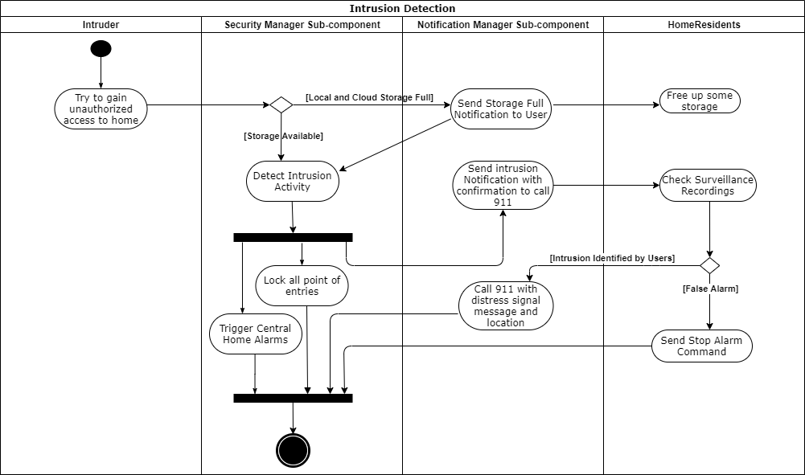
Fig 1 Intrusion Detection Activity Diagram

Special Requirements
- Security Requirements - Section 6.1 in Supplementary Specifications

********************************************************************
Id: UC-1.2

Use Case: Provide controls for points of entry and exit (doors, windows, main gate) into the house - Refer Section 4.3 of Vision Document –
Need -> Security Measures
Feature -> Doors, Windows and Main Gate Access Control

Description
The system will allow users to control opening and closing of all points of entry and exit both locally from within the house and sending commands remotely over the internet.

Level: User Goal

Primary Actor
- Home-Residents
Supporting Actors
- Actuators to physically move doors, windows, and main gate.
- Sensors to detect any obstructing objects
- Notification manager sub-component

Stakeholders and Interests
- Home-Residents – Able to control points of entry and exit both locally and remotely
- Internet and Wi-Fi Service Providers – Provide connectivity services to send commands and receive notifications.

Pre-Conditions
- Smart Home+ solution is installed and configured.
- Smart Home+ Home security management sub-component can access and control the following:
- Actuators and sensors linked to Doors, windows and Main Gate
- Notification Manager Subcomponent

Post Conditions
- System captures and analyses data about how often and at what time users move out and move into the house. This data would then be used in other subcomponents responsible for energy management and temperature regulation.

Success end conditions
- Users can send commands from a remote location (both within and outside home) to successfully open or close doors, main gate, and windows.
- System notifies the users if the corresponding command to open or close a point of entry was not executed for some reason (say an obstruction in the movement path).

Failure end conditions
- With clear movement path, system fails to open or close any point of entry after receiving the corresponding command from users.
- System continues to open or close a point of entry even after it detects some obstacle or resistance in the movement path.

Minimal Guarantee
- Under any circumstances if the system is not able to execute commands to open or close a point of entry, it would notify the users of the same.

Main Success Scenario
- This use case begins when SmartHome+ initiates a command to open/close any point of entry (door, main gate) or windows within the house.
- The system first checks if there is any state of emergency and the respective open or close command might create a potential threat to security.
- If there is no state of emergency system interprets the command and sends a signal to actuator to physically open or close the door.
- Once the command is successfully executed the users receives a confirmation notification for the same.

Extensions
Step 1 - Missing or delayed command request
Due to connectivity or network issues sometimes, commands initiated by the user might get lost or delayed before they make it up to central controller.
- So, whenever the central controller receives a request a request, it checks the creation timestamp for the request to verify if it was initiated more than 20secs before the current time.
- If the command is found to be older it is discarded, and user is notified for the same and can re-initiate a new request.
- Otherwise the system would execute the command and notifies user accordingly.

Step 3 - Obstruction while executing any open or close commands
System identifies an obstruction in the movement path.
- Actuators reverse the direction of movement.
- System notifies the user about request not getting executes due to obstruction.

Step 2 - Emergency
System identifies an already active emergency in the home and the open/close request a user has made might create a potential threat to security.
- System cancels the user request.
- System notifies the user about request not getting executes due to an already existing emergency.

Special Requirements
- Security Requirements. Refer section 6.1 of supplementary specification.

********************************************************************
Id: UC-1.3

Use Case: Provide Home Residents safety against emergency situations - Refer Section 4.3 of Vision Document –
Need -> Emergency Detection
Feature -> Fire/Smoke, Water Leakage/Accumulation and CO Level detection.

Description
System would automatically detect any emergency like smoke/fire, increase in Carbon Monoxide (CO) levels and water leakage/accumulation within the house. It then takes appropriate actions to subdue it and notify the users at the same time.

Level: User Goal

Primary Actor
- Home-Residents

Supporting Actors
- Home security management sub-component as it controls opening and closing of point of entry and exit.
- Roof based water sprinklers
- Sensors - to detect smoke, increase in temperature, CO levels, and water leakage/accumulation
- Notification manager sub-component
- Centralized Alarming System

Stakeholders and Interests
- Home-Residents – Get a sense of safety from emergency like situations within their homes.
- Internet and Wi-Fi Service Providers – Provide connectivity services to send commands and receive notifications.
- Emergency control Authorities (911) – Receive calls on event of any unforeseen emergency like situation within the house.

Pre-Conditions
- Smart Home+ solution is installed successfully with the main control device placed inside a fireproof casing.
- Smart Home+ emergency management subcomponent can access and control the following:
- Roof based water sprinklers.
- Sensors
- Actuators linked to Doors, Windows and Main Gate.
- Central Home Alarming facility.
- Notification Manager Subcomponent.

Post Conditions
- After customers are informed of an emergency, they receive an immediate confirmation to check if they also want to send an automated voice note to 911 Emergency handling Services.

Success end conditions
- System successfully detects smoke/fire, increased CO levels or any water leakage inside house and initiates the sequence of actions to bring it under control.
- System successfully notifies the users on time about any fire breaking out, increased CO levels or water leakage inside the house, giving them enough time to escape or to address the situation.

Failure end conditions
- System fails to notify users on time.
- System fails to automatically unlock any point of entry.
- System fails to trigger the roof-based water sprinklers in case of a fire.
- System fails to shut down any potentially dangerous electrical equipment under the state of emergency.

Minimal Guarantee
- In case of emergency system would unlock and open all points of entry and try to guide the users towards the nearest safe exit.

Main Success Scenario
- This use case begins when Smart Home+ detects either:
- Fire like situation due to an unusually high temperature and smoke.
- Increase in CO levels beyond the specified threshold
- Water leakage or accumulation inside home.
- On event of a fire system immediately triggers roof based water sprinklers to subdue the fire.
- In any type of emergency system would unlock and open all points of exits and windows to open escape routes for residents and allow for better ventilation.
- System would automatically shut down electrical appliances like room heaters, water heater, microwave ovens, refrigerator, laundry machine etc.
- System would also trigger centralized home alarms.
- System then sends an emergency notification to user’s smartphone and also check with them if they want to send an automated voice note to 911.
- If users select YES, Notification Manager Subcomponent initiates a call to fire control department (911), with a pre-recorded distress signal message along with the address details.
- Smartphone app further guides the users towards the nearest point of exit that has been successfully unlocked.

Extensions
Step 3 Damage to connectivity
Fire damages the Wi-Fi router and disrupts the connectivity which was being used to send notifications to the users.

- System immediately uses the SIM card installed on central controller to initiate an emergency call to notify users on their cell phones.
- Smartphone app can then be used on cellular data instead of Wi-Fi to guide users towards the nearest point of exit.

Special Requirements
Sensors and equipment are certified under Safety standards – NFPA Standards - Section 14.5 in Supplementary Requirements

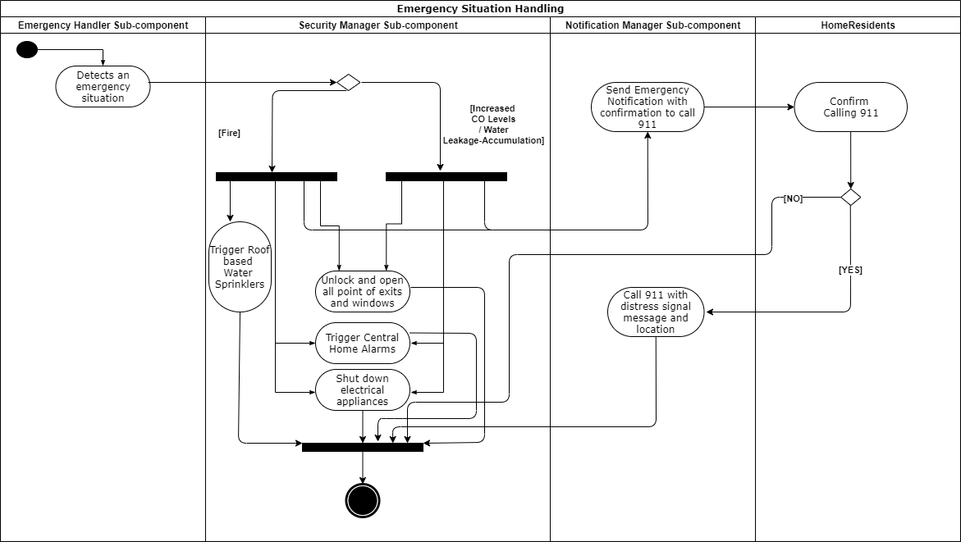
Fig 2 Emergency Handling – Activity Diagram
********************************************************************
4. Package: Energy Management

Id: UC-2.1

Use Case: Regulate Energy Usage - Refer Section 4.3 of Vision Document –
Need -> Energy Management
Feature -> Energy usage stats and analytics during different time periods in a day

Description
The system will monitor and control the energy used by various smart home products by regulating their usage as per the customer’s daily/weekly schedule.

Level: User level

Primary Actor
- Home-Resident
Supporting Actors
- Air Conditioning system
- Window Blinds controller
- Automated Lightning system
- Storage
- Usage Pattern Analyzer
- Notification manager

Stakeholders and Interests
- Home-Resident – Reduce energy waste and utility bill
- Utility providers – Reduce usage of energy
- Vendors of the various smart product – Provides support and shares the usage data with the controller

Pre-Conditions
- Smart home+ solution is installed successfully.
- Smart home+ controller can access and control the following systems:
  - Air Conditioning system
  - Window Blinds controller
  - Automated lightning system
- Space is available for the Smart home+ controller to store the data.
- All systems are up and running i.e. no power outage

Post Conditions
Success end condition
- The identified systems function as per the customer’s schedule without user intervention.
- Temperature of the house is maintained as per the customer’s preference and schedule.
- Window blinds and lights in the house are controlled as per the customer’s preference and schedule.
- Customers receive notification regarding the energy usage statistics.
- Customers can generate and view periodic reports to compare present usage with usage in past.

Failure end condition:
- Incorrect automated schedule
  - Poor accuracy of the system in predicting daily user schedule
  - Change in customer habits or preference.
  - Change in daylight savings.

Minimal Guarantee
- Customer can access and control the air conditioner, window blinds and lights as per his/her schedule and preference.

Main Success Scenario
- Once the system is up and running it will monitor customer’s daily schedule (like sleeping and wake up time, house move in and move out timings) and collect energy usage data from the Smart air conditioning system, Smart lighting system, and window blind controller.
- The collected data is put in some persistent storage.
- The data is collected for 10 days.
- The system generates an automated schedule for the customers based on the stored data.
- The new automated schedule goes into effect at 12 Noon.
- Based on the automated schedule, the system adjusts the temperate of air conditioning system depending on the time of the day.
- Based on the automated schedule the system controls the lights and window blinds depending on the time of the day.
- System sends notification to customer regarding the adjustments made.
- System sends recommendations to customer on how to reduce energy usage depending on the collected data.

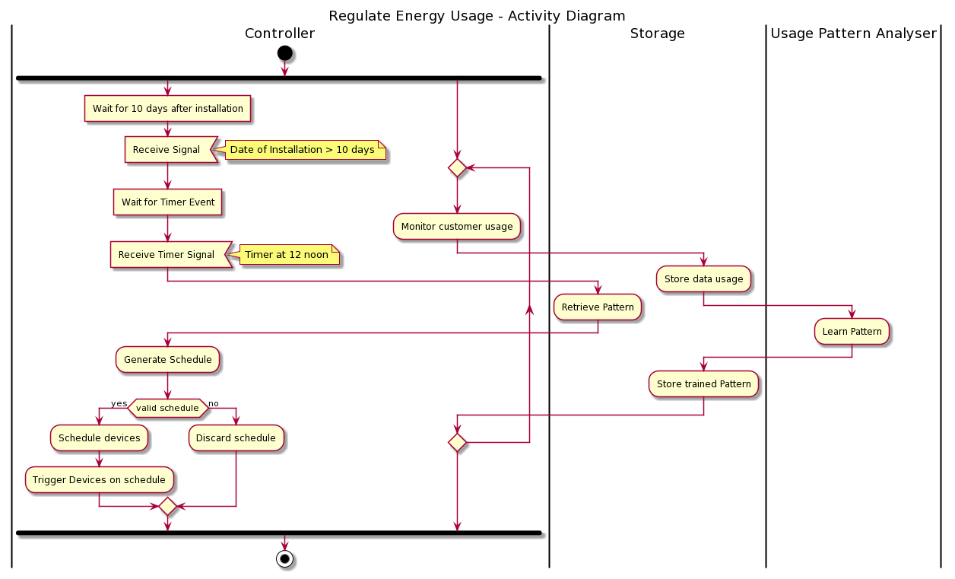
Fig 3 – Regulate Energy Usage Activity Diagram

Extensions
Step 4 Insufficient/Erratic data to derive a pattern and generate an automated schedule
- If the generated schedule has low accuracy or precision, the system suspends that schedule.
- Continue to collect, store, and analyze data for another 3 days.
- After 3 days go to step 4a and verify the accuracy and precision of the schedule.

Change in customer habits or preference:
- Keep collecting data linked to current energy usage.
- Monitor when the customer deviates from the automated schedule and record his/her preferences.
- A new schedule will be generated based on the newly collected data every day.
- This schedule goes into effect every day at 12 noon.

Change in daylight savings:
- The system will get the current time from the Network Time Protocol servers every hour.
- In case of change in time during daylight savings the system will detect and adjust the schedule accordingly.

Step 2 Insufficient storage space:
- The system will monitor the available storage space.
- If the available spaces cross a predefined threshold the system will clean up the storage in first in first out manner.
- Repeat step 2 until the available space is under a predefined threshold.
- Notify the user about this cleanup.

Special Requirements
Reliability Requirement – Section 4.1 of Supplementary Specification

********************************************************************
Id: UC- 2.2

Use Case: Manage Alternative Energy harness systems Refer Section 4.3 of Vision Document –
Need -> Energy Management
Feature -> Managing Alternative Energy harness systems like solar and rain-water harvesting.

Description
The system will control the alternative energy systems like solar power panel based systems and rainwater harvesting system depending on the weather data.

Level: User level

Primary Actor
- Resident/Homeowner
Supporting Actors
- Solar power panel based system
- Rainwater harvesting system
- Weather Reporter
- Notification manager

Stakeholders and Interests
- Home-Resident– Reduce energy waste and utility bill
- Utility providers – Energy from alternative sources.

Pre-Conditions
- Smart home+ solution is installed successfully.
- Smart home+ controller can access and control the following systems:
  - Solar power panel based system
  - Rainwater harvesting system
- Smart home+ controller can get weather data based on location.
- All systems are up and running i.e. no power outage

Post Conditions

Success end condition
- Solar power panel based system is activated.
- Rainwater harvesting system is activated.
- Customers receive notification when the solar power panel based system or rainwater harvesting system is activated.

Failure end condition:
- Solar power plant is activated during un-preferable weather conditions like cloudy and rainy days.
- Rainwater harvesting system is activated during un-preferable weather conditions like peak summer periods without any possibilities of rain.

Minimal Guarantee
- Solar power panel and Rainwater harvesting systems can be accessed and controlled by the user irrespective of the automated schedule.

Main Success Scenario
- Every day at 4 AM the system will obtain weather forecast data from the weather reporter.
- Depending on the data, the system will generate a schedule for the solar power plant and the rainwater harvesting system.
- Before activating the systems as per the schedule, system verifies if the current weather data and the prediction matches.
- The system will activate the solar power panel based system if it is on schedule.
- The system will activate the rainwater harvesting system if it is on schedule.
- The system will deactivate the solar power plant if it is on schedule and the schedule ends.
- The system will deactivate the rainwater harvesting system if it is on schedule and the schedule ends
- System sends notification to customer once the systems are activated and deactivated.

Extensions
Step 3 Incorrect weather predictions
- During the scheduled time, if the current weather data and the prediction do not match system will not activate the systems.
- No notifications would then be sent to customers.

********************************************************************
5. Package: Monitor Environment

Id: UC-3.1

Use Case: Monitor Air Quality - Refer Section 4.3 of Vision Document –
Need -> Energy Management
Feature -> Air flow monitoring.

Description
The system will monitor the air quality of the environment using parameters like temperature, humidity, CO₂, CO, pollutants, chemicals, and dust.

Level: User level

Primary Actor
- Home-Resident

Supporting Actors
- Smart Air conditioning system
- Air quality monitor
- Window controller
- Notification manager
- Alarm system

Stakeholders and Interests
- Resident/Homeowner – Maintain good air quality
- Vendors of Air quality monitor and Air conditioning system
- HVAC Technicians – Installs Air quality monitor and Air conditioning systems

Pre-Conditions
- Smart home+ solution is installed successfully.
- Smart home+ controller can access and control the following systems:
  - Smart Air Conditioning system
  - Window controller
  - Air quality monitor
- All system subcomponents are up and running.
- Accepted and dangerous limits have been set for the air quality parameters.

Post Conditions
Success end condition
- Air quality of the home is maintained in a good condition.
- Customers receive notifications and periodic reports regarding the air quality.

Failure end condition:
- Air quality is not being maintained at desired levels of purity.
- Customers are not receiving any notification regarding the air quality.

Minimal Guarantee
- Customers will be notified when air quality degrades.

Main Success Scenario
- System will calculate air quality score every 15 minutes, using parameters like temperature, humidity, CO₂, CO, pollutants, chemicals, and dust which are obtained from the air quality monitor.
- If the score starts to move up from acceptable limit towards dangerous limit, system will automatically open windows and turn on the fans to for better ventilation.
- If the score further goes beyond dangerous limit system will immediately send notifications to customer.
- If high CO levels are detected, system will trigger alarm, open the windows using the windows controller turn on fan using air conditioning system to recirculate air from outside and send notifications to customers.
- In case of steps 2, 3 and 4, state of the system will change to air quality event detected.
- System will move out of the air quality event detected state only when the air quality score falls below the accepted limit.

Extensions
Step 3 - An automated schedule overlaps during preventive actions
- If the system is air quality event detected state, any automated schedule related to air conditioning system and window controller will be suspended.
- The automated schedule will resume only when the system moves out of the event detected state.

Special Requirements
Standards – Section 14.7 of Supplementary Specification

********************************************************************

6. Package: Accessibility and Authorization

Id: UC- 4.1

Use Case: Accessing Smart Home+ - Refer Section 4.3 of Vision Document –
Need -> Modes of user access control
Feature -> Controller Linked Touch Panel/Keypad, Voice Based, Mobile App based system access.

Description
The system offers different means of access to end-users depending on if they want to access the system locally from within the house or from some remote location.

Level: User Level

Primary Actor
- Home-Resident

Supporting Actors
- Smart Home+ Central Control Unit.
- Intelligent Voice Assistant (Amazon Alexa, Google Home).
- Smartphone.
- Smart Home+ Mobile App.
- Controller Linked Touch Panel/Keypad

Stakeholders and Interests
- Home-Resident – Want to access and control the system.
- Voice Assistant Manufacturers – Providing Voice Assistants to receive, interpret and forward any voice commands sent by users to the central controller.
- Cellular and Internet Service Provider – To provide internet connectivity for sending commands locally and remotely

Pre-Conditions
- Smart Home+ solution is installed successfully with the main control device linked to Touch-Panel, Mobile Apps on user Smartphones and other voice based assistants using Wi-Fi, Bluetooth or Cellular 4G/LTE connectivity.
- Users know the correct passcodes using which they have logged into the system.
- Voice based assistants have been configured to accept Home Residents voice instructions.

Post Conditions

Success end condition
- Users are successfully able to log into the system and send commands to it locally from within the home, using touch panel, mobile app or voice assistants.
- Users are successfully able to log into the system and send commands to it remotely over the internet using mobile app.
- Desired command gets executed and the user is notified of the status of execution.

Failure end condition:
- Smart Home+ Control Unit did not receive any commands initiated by the user.
- An undesirable action gets executed on some command, corresponding to which users were expecting a different action to happen.

Minimal Guarantee
- User with proper credentials should always be able to gain access and send commands to the system, using local controller linked touch panels.

Main Success Scenario
- The use case begins when users try to send commands to Smart Home+ controller either using their mobile apps or device linked touch panels or by sending commands as voice instructions to a voice based assistant.
- System checks if the command is received using thorough some voice assistant. If yes system does an extra translation step to convert the instructions sent from voice assistant into the instruction set supported by the Smart Home+ solution.
- System then forwards the command to the appropriate subcomponent for execution.
- Once the subcomponent executes the command, the users are given an appropriate notification on their smartphones to provide the status of execution.

Extensions
Step 2 – Voice command translation to Smart Home+ instruction set failed.
- System suspends the command and notifies user on the smartphone about it.

Special Requirements
Performance-Response Time – Section 5.1 of Supplementary Specification
********************************************************************
Id: UC- 4.2

Use Case: Authorize valid users - Refer Section 4.3 of Vision Document –
Need -> Mode of authorization
Feature -> Passcode, Fingerprint, Facial Recognition.

Description
The system has different modes of authorization of user as well as different user management modes to manage the system.

Level: User Level

Primary Actor
- Home-Resident

Supporting Actors
- Door Access Controller.
- Window access Controller.
- Main gate access Controller.
- Smart Home Controller.

Stakeholders and Interests
- Home-Resident – Gets control of access to the home.
- Smart Home Inc. – Responsible for installation and maintenance of the devices

Pre-Conditions
- The SamrtHome+ solution must be installed in the home.
- Access Security Systems must be installed properly.
- All the Security Systems are connected to WIFI.
- User has been setup with the credentials

Post Conditions

Success end condition
- Access to the Home is only given to authorized people.

Failure end condition:
- SmartHome+ System won’t authorize a valid user.
- SmartHome+ System might give access to an unauthorized person.

Minimal Guarantee
- Only user with proper credentials will be allowed to access the home.

Main Success Scenario
- The use case begins when SmartHome+ is successfully installed and all the access control devices are in place.
- The user wishes to enter the house by giving his credentials like a passcode or fingerprint or facial recognition
- The device sends the credentials to the Home Security Management subcomponent.
- Once the subcomponent responds, the user is given access if he is authorized.
- If the user is not authorized and makes multiple incorrect attempts to gain access, system locks the particular mode of access and notifies the user about it.
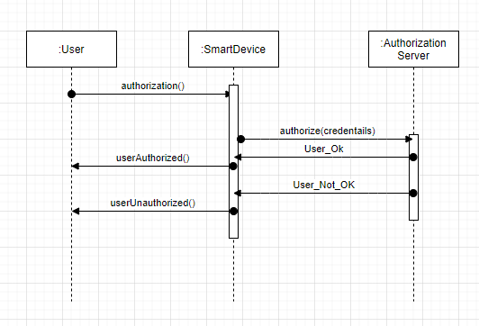
Fig 4: User authorization sequence diagram

Extensions
Step 1 Controller might not work properly or be tampered
- The user will be given an option to hard reset the authorization device to make it work as new.
- SmartHome+ team would replace the device if it doesn’t work even after the reset.

Step 2 User Passcode can get leaked
- User will get a notification after every attempt of authorization.
- User will have access to website to change the passcode which needs admin password which only the main user will have.

Special Requirements
Reliability Requirement. Refer section 4.5 of Supplementary specification.

********************************************************************
7. Package: Home Automation

Id: UC- 5.1

Use Case: Manage and Automate essential elements like Lighting and Air Conditioning. Refer Section 4.3 of Vision Document –
Need -> Household Automation

Feature -> Automation of the Lighting and Air Conditioning.

Description
The system will help Home-Residents manage and synchronize features from various devices and automate some essential tasks like Lighting and Air Conditioning within the home.

Level: User Level

Primary Actor
Home-Residents
Supporting Actors
- Smart Air Conditioning System (A/C)
- Window sensor
- Smart lighting system
- Usage Pattern Analyzer

Stakeholders and Interests
- Home-Residents - want to automate some daily essential activities.
- Smart light, Smart A/C, Sensor vendors - provide interfaces that integrate to the Smart Home Plus platform.

Pre-Conditions
- Smart A/C, Lights and sensors integrate with the Central Smart Home Control Unit
- Home residents have agreed to share their usage pattern to improve Self-evolving Mode
- Home resident is able to control the smart home appliances using a valid mode of access like mobile, voice control etc.

Post Conditions
Success end condition
- A/C turned on/off
- Smart lights turned on/off
- Windows sensor responds to user actions
- Usage data was record and sent to pattern analyzer

Failure end condition:
- A/C did not function as expected
- Smart light did not turn on/off
- Windows sensor did not respond to current light and room temperature

Minimal Guarantee
- A/C and lights responds to user provided commands

Main Success Scenario
- Home residents turns on/off the smart A/C from Central control unit (APP, voice assistant or local controller)
- Window sensors shuts the window off/on
- Time and room temperature, A/C input during the action recorded and sent to pattern analyzer
- Home Resident turns on/off smart lights
- Window sensor turns off/on window blinder
- Time, Window sensor log recorded sent to pattern analyzer
- Pattern analyzer analyzes usage pattern and sends user temperature and light preset to Central control unit
- Central Control unit updates the preset if changed
- Central unit auto adjust smart light, AC, window sensor according to Home resident’s preference

Extensions
Step 1 User opens the window manually when the A/C is turned on
- Central control unit sends a notification to user and turns off the A/C

Step 4 User turns on the light when window blind is set to open
- Central control unit sends a notification to user and turns off the blind

Step 3 and 7 User sets a device setting contradicting to usage pattern
- Central control notes the input and environment condition and sends to pattern analyzer
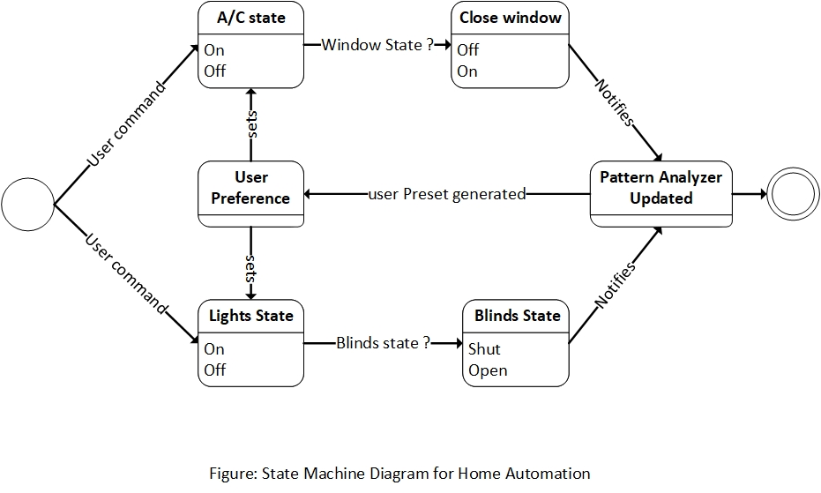

Special Requirements
- Functionality Requirements. Refer section 2.4 of Supplementary Specification.

********************************************************************
Id: UC- 5.2

Use Case: Automate kitchen inventory management and guide cooking. Refer Section 4.3 of Vision Document –
Need -> Household Automation.
Feature -> Automation in cooking.

Description
The System will help Home residents manage kitchen supplies and guide user’s cooking activity using the smartphone app.

Level: User Level

Primary Actor
- Home-Residents
Supporting Actors
- Smart Fridge
- Smart Microwave Oven
- Smart stove
- Smart dishwasher
- Smartphone App
- Usage Pattern Analyzer

Stakeholders and Interests
- Home-Residents – want to ensure availability of their kitchen stocks and get some automation assistance during cooking.
- Smart Microwave, Smart Refrigerator, Smart Dishwasher vendors - provide interfaces that integrate to the Smart Home Plus platform.

Pre-Conditions
- Smart devices integrate with the Central Smart Home Control Unit
- Home residents have agreed to share their usage pattern to improve Self-evolving Mode.

Post Conditions
Success end condition
- User is notified by the central control unit when the food is cooked.
- User gets timely notification if the food stock is getting over in the refrigerator
- Microwave and stoves are turned off.
- Usage data was record and sent to pattern analyzer.

Failure end condition:
- Food gets burnt or overcooked and system fails to notify the users.
- Microwave couldn’t recognize the label in package.
- System fails to notify user on time about food stock getting over.

Minimal Guarantee
- User is notified when food is ready to serve.

Main Success Scenario
- Home residents select a recipe from the smartphone app’s cooking section.
- Controller fetches smart fridge data and confirms the availability of the ingredients.
- Controller communicates with the pattern analyzer and sends suggestion of probable grocery list to the app.
- Upon home resident’s instruction controller schedules a cooking period.
- Controller preheats the oven, as necessary.
- Controller fetches data from the smart dish washer and updates users via the app about the necessary utensils already placed in dish washer and probable equipment need for the recipe.
- User gets notified about the cooking schedule in advance.
- When user starts cooking the controller adjusts the heating level of stove according to the recipe.
- If microwave detects any labeled item, it automatically adjusts the heating level according to instruction in the package.
- Controller detects user absence in the room and shut the stove heating if more time has passed than the time mention in the recipe to prevent burning.
- After the cooking ends Controller turns off all the kitchen devices to save electricity.

Extensions
Step 4 User did not appear in the kitchen during cooking schedule
- The Controller notifies user.
- Control unit turns off preheating in smart microwave oven/ smart oven.

Step 8 User not following heating level instructed in recipe
- The Controller notifies user.
- If user leaves the kitchen reduce the heat after a wait time.

Step 2 Missing ingredients for the recipe.
- The Controller notifies the user

Special Requirements
- Functionality Requirements. Refer section 2.5 of supplementary specification.

********************************************************************
8. Package: Entertainment
Id: UC-6.1

Use Case: Provide seamless personalized entertainment experience.

Description
The SmartHome+ system will provide a more enhanced and automated home theatre experience personalized to different user within the house each having their own likes and dislikes.

Level: User Level

Primary Actor
Home-Residents
Supporting Actors
- Smart home theatre devices
- Room based sensors
- Usage Pattern Analyzer

Stakeholders and Interests
- Household residents – Wants to enhance home entertainment experience.
- Home theatre device vendors - Provides APIs that integrate to the Smart Home Plus platform.

Pre-Conditions
- The room is registered as media and entertainment room with the central control unit
- User has agreed to share watch profile and preferences with the system.
- The home theatre system has provided control option for smart home plus platform

Post Conditions
Success end condition
- Home user is detected correctly, and the watch profile is loaded accordingly.
- Devices are turned off after home user leaves for a certain period otherwise the video is paused.

Failure end condition:
- Wrong user profile is loaded.
- Wrong room setting is applied.
- Devices do not turn off when user leaves.

Minimal Guarantee
- Right user profile is selected, and watch history is loaded.

Main Success Scenario
- Home residents enters the media and entertainment room, the room sensor alerts central control unit
- Central control unit detects the home users and sets room lighting and temperature based on user preference learned from their usage data.
- Central Control unit automatically make a few recommendations and given an option to connect to the last media streaming service logged in.
- Central control unit takes voice command from user and plays desired content.
- If home resident leaves the room the content is paused.
- When the movie ends and users leave the room, the central control unit turns of all the devices.

Extensions
Step 5 - If a single home resident leaves the room while watching personalized content and a different user enters
- Central control turns the screen off to ensure privacy of previous user
- Central control unit sends last user’s info to pattern analyzer to resume later
- Central control unit takes command from new users

Special Requirements
- Functionality Requirements. Refer section 2.6 of supplementary specification.

********************************************************************

