Database System Engineering and Distributed Backend Development
Course Code: 25CS1302E
03 agreegate functions with having group order by examples

Name: S.Poojitha
Roll no: 2520030110
Query 1:
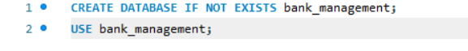
Output:
Query 2:
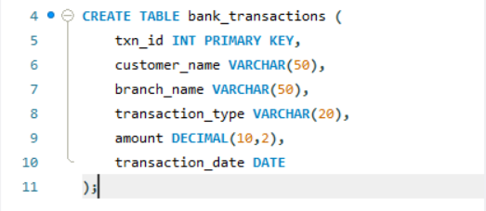
Output:
Query 3:
Output:
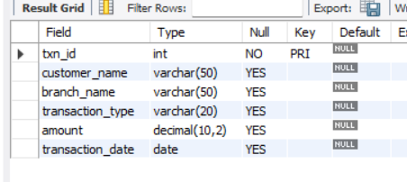
Query 4:
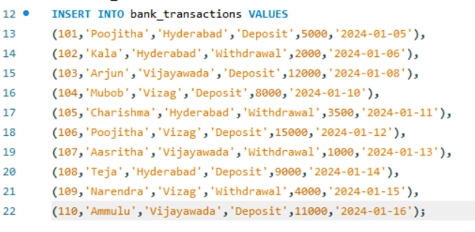
Output:
Query 5:
Output:
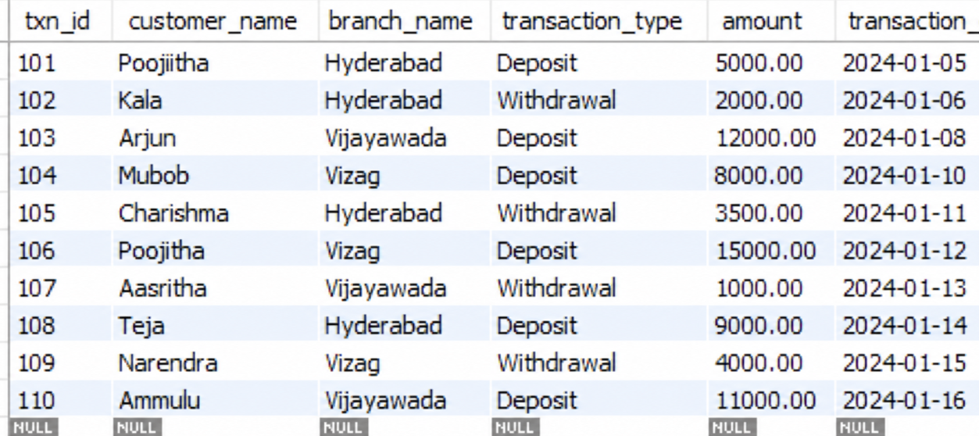
Query 6:
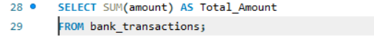
Output:
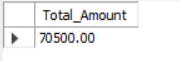
Query 7:
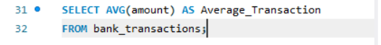
Output:
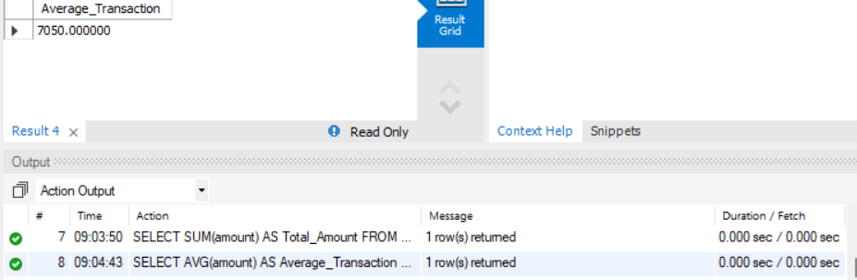
Query 8:
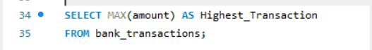
Output:
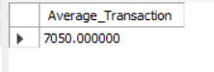
Query 9:
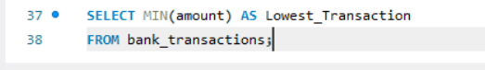
Output:
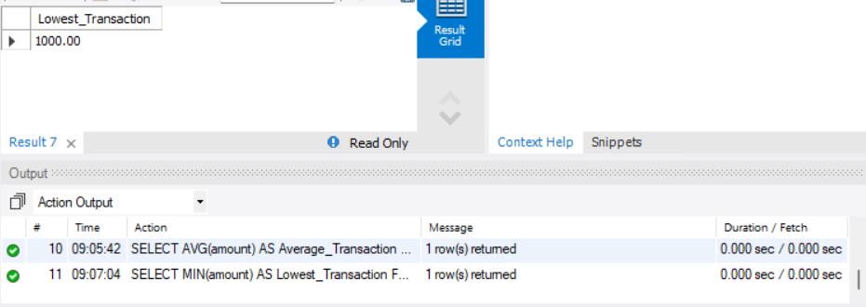
Query 10:
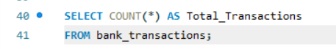
Output:
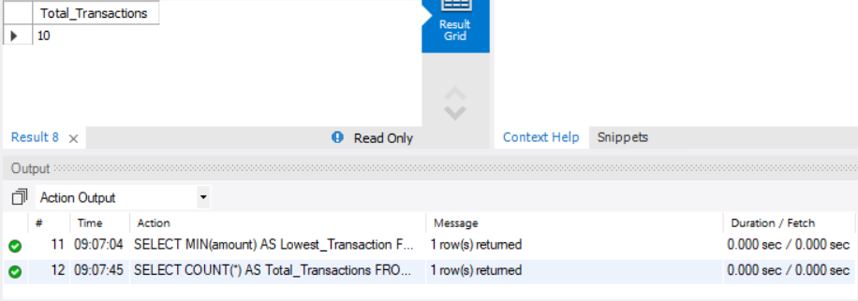
Query 11:
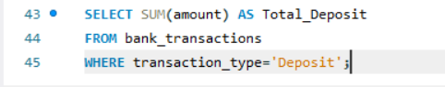
Output:
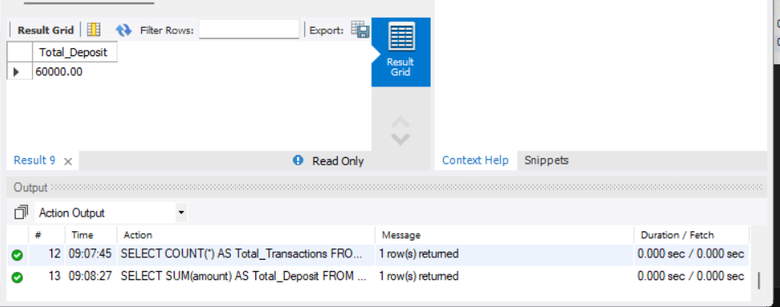
Query 12:
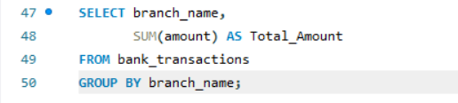
Output:
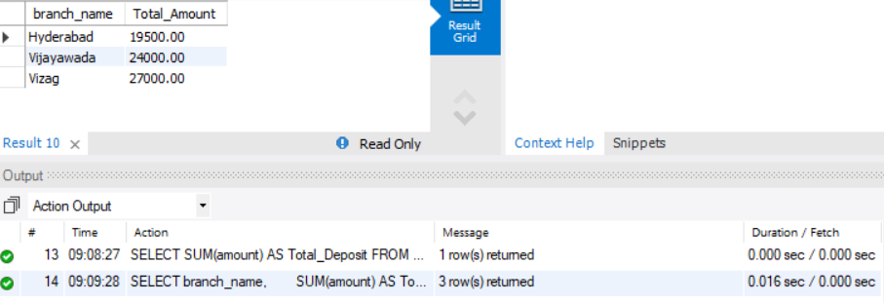
Query 13:
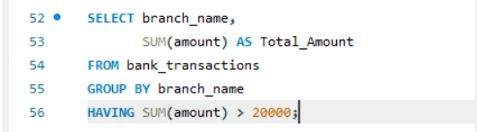
Output:
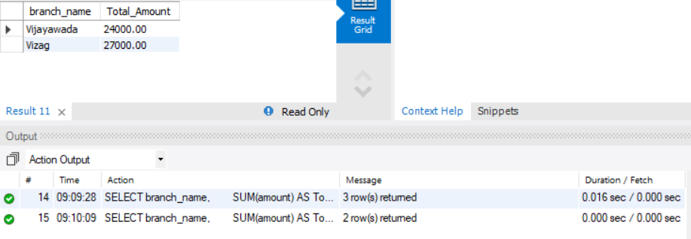
Query 14:
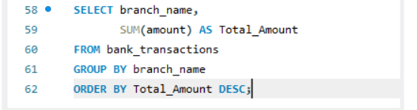
Output:
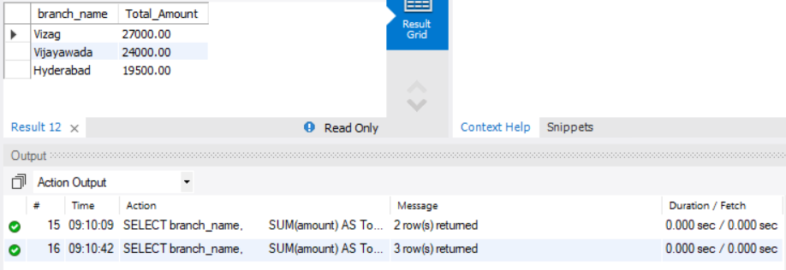
Query 15:
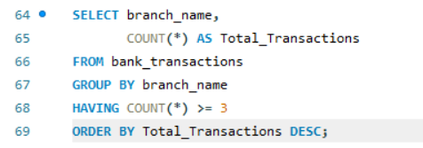
Output:
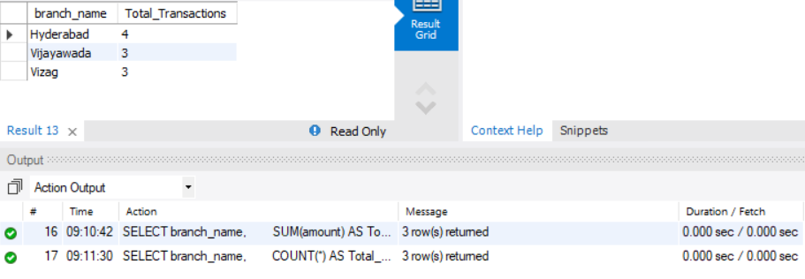
Query 16:
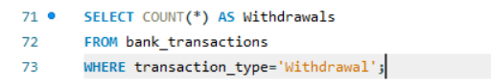
Output:
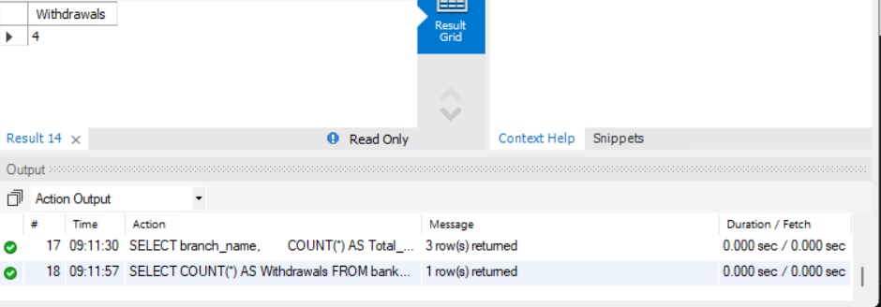
Query 17:
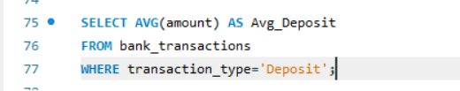
Output:
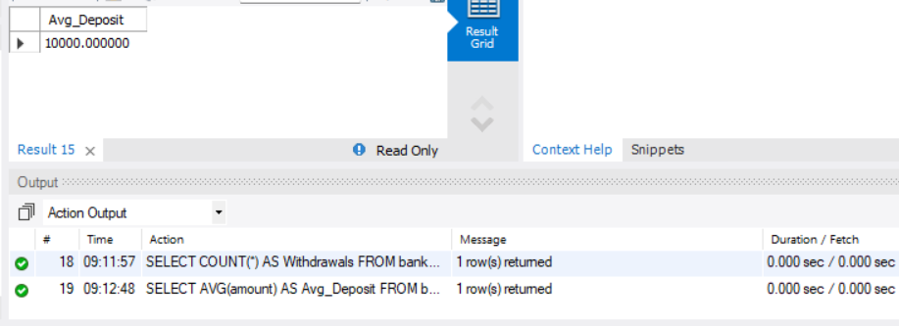
Query 18:
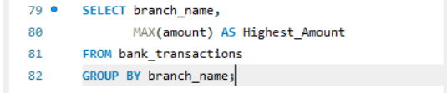
Output:
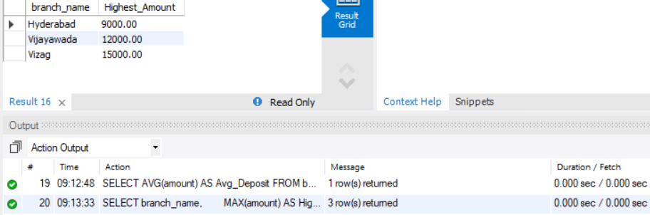
Query 19:
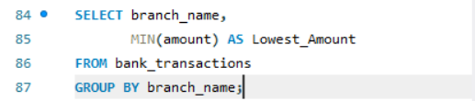
Output:
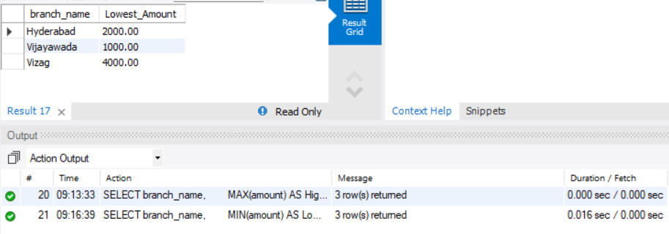
Query 20:
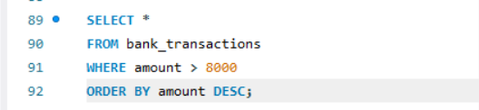
Output:
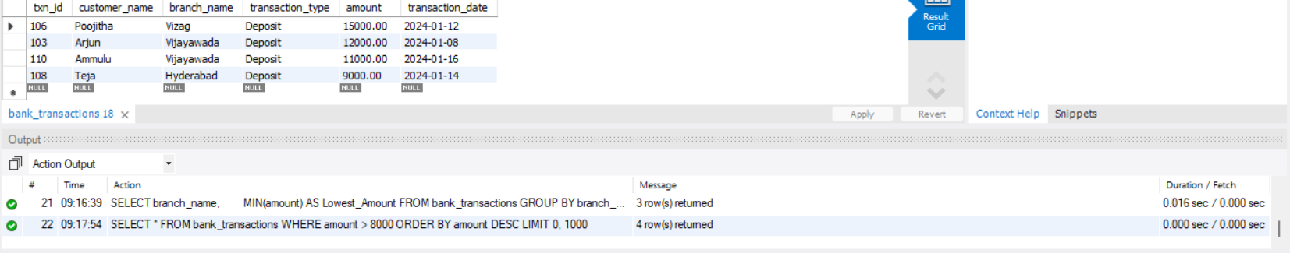
Query 21:
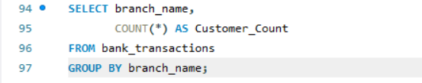
Output:
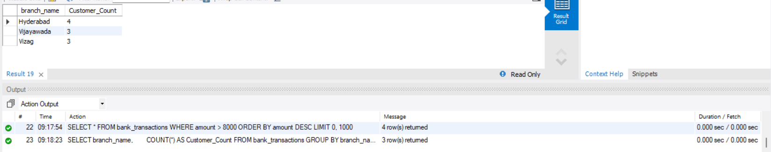
Query 22:
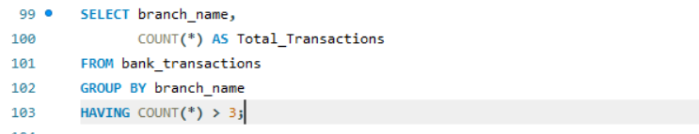
Output:
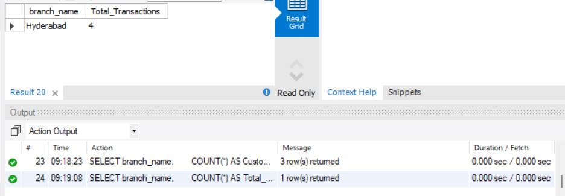
Query 23:
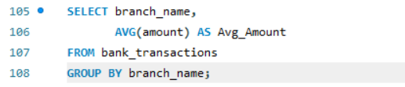
Output:
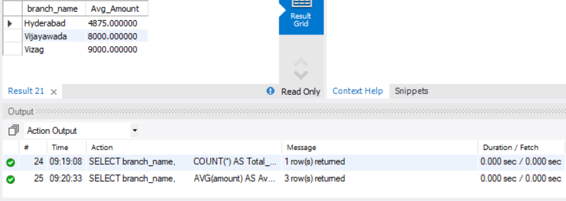
Query 24:
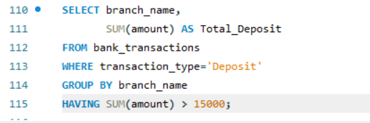
Output:
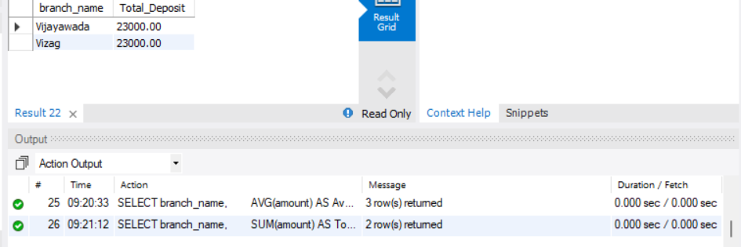
Query 25:
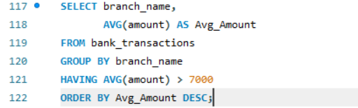
Output:
