“Event Management System”

Project Report submitted for the partial fulfilment of grade for the course

Data Structures and Algorithms -3 (25CS2103E)

in

DEPARTMENT OF COMPUTER SCIENCE ENGINEERING

by

S. POOJITHA REDDY :2520030110

K. AASRITHA :2520030178

G. NIKHITHA :2520030033

Team Number: 14
Section: 8

Under the Guidance of

Dr. V. Sireesha
Professor
Department of Computer Science and Engineering





2026-27

DEPARTMENT OF COMPUTER SCIENCE ENGINEERING

Declaration

The Project Report entitled “Event Management System” is a record of Bonafide work of S. Poojitha Reddy – 2520030110, K. Aasritha – 2520030178, G. Nikhitha – 2520030033 submitted in partial fulfillment for the award of B. Tech in Computer Science and Engineering. The results embodied in this report have not been copied from any other departments/University/Institute.

S. Poojitha Reddy – 2520030110
K. Aasritha – 2520030178
G. Nikhitha – 2520030033

DEPARTMENT OF COMPUTER SCIENCE ENGINEERING

CERTIFICATE

This is certify that the mini project based report entitled “Event Management System” is a bonafide work done and submitted by S. POOJITHA REDDY – 2520030110, K. AASRITHA – 2520030178, G. NIKHITHA – 2520030033 in partial fulfillment of the requirements for the award of the degree of BACHELOR OF TECHNOLOGY in Department of Computer Science Engineering, during the academic year 2026-27.

Signature of the Guide Signature of the HOD
(Dr. V. Sireesha)

Signature of the External Examiner
ACKNOWLEDGEMENT

We express our sincere gratitude to our project guide, Dr. V. Sireesha, Professor, Department of Computer Science and Engineering, for her valuable guidance, constant encouragement and timely suggestions throughout this project. Her support helped us to understand how data structures and algorithms can be applied to solve a real-world problem.
We are thankful to Dr. P. Venkateshwara Rao, Associate Professor and Head of the Department of Computer Science and Engineering, for providing the facilities and the motivating academic environment needed to complete this work. We also thank all the faculty members of the department for their support.
Finally, we thank our parents and friends for their encouragement, and Koneru Lakshmaiah Education Foundation for giving us the opportunity to carry out this project as part of the course Data Structures and Algorithms-3.

S. Poojitha Reddy – 2520030110
K. Aasritha – 2520030178
G. Nikhitha – 2520030033

Abstract

The Event Management System is a web-based application designed to simplify the process of organizing and managing events conducted by colleges and organizations. It provides a centralized platform where users can view event details, schedules, venues, and registration information in one place. The system allows organizers to create, update, and manage events efficiently, while participants can easily search for events, register online, and receive important updates. By reducing manual work and improving access to event information, the system helps increase participation and ensures smooth event coordination. It also minimizes scheduling conflicts by maintaining an organized event calendar. Overall, the Event Management System enhances communication between organizers and participants, saves time, and provides a user-friendly solution for effective event planning and management.

Table of Contents

 |  |  | Page No.
 | Acknowledgement
 | Abstract
 | Table of Contents
 | List of Figures
1 | Introduction | 1.1 Overview  1.2 Problem statement  1.3 Scope of the project  1.4 Objectives | 1–3
2 | System Requirements | 2.1 Functional Requirements  2.2 Non-Functional Requirements  2.3 Hardware and Software Requirements | 4–5
3 | System Design | 3.1 High-level Architecture Diagram  3.2 Description of each layer  3.3 Selection of Data Structures  3.4 Workflow Design  3.5 Data Model | 6–10
4 | Implementation | 4.1 Module-wise implementation  4.2 Front-end logic (UI rendering, state management)  4.3 API integration  4.4 Complexity summary | 11–15
5 | Results | 5.1 Experimental setup  5.2 Functional testing  5.3 Performance evaluation  5.4 Discussion | 16–19
6 | Challenges & Limitations | 6.1 Issues faced during development  6.2 Solutions applied  6.3 Limitations of the System | 20–21
7 | Conclusion & Future Work | 7.1 Conclusion  7.2 Future Work  7.3 Skills learned during development | 22–23
 | References | - Books, tutorials, APIs, documentation sites used | 24

List of Figures

1.1 Overview of the Event Management System 1
3.1 High-level Architecture of the Event Management System 6
3.2 Flowchart for Event Creation with Venue Clash Detection 8
3.3 Flowchart for Participant Registration with Waitlist 9
3.4 Flowchart for Cancellation and Waitlist Promotion 9
5.1 Venue Clash Detection Time versus Number of Events 17
5.2 Event Search Time versus Number of Events 18
5.3 Time to Fetch the 10 Upcoming Events 18
5.4 Event Lookup Time versus Number of Events 19

- INTRODUCTION

1.1 Overview
Events such as technical fests, cultural programmes, workshops, seminars, guest lectures and sports meets form an important part of college and organizational life. They create opportunities for learning, networking and teamwork. However, as the number of events grows, organizing them becomes a complex task. The organizer must fix a venue and a time slot, publish the details, collect registrations, control the number of seats and keep every participant informed about changes. When these activities are carried out through notice boards, spreadsheets and messaging groups, information gets scattered and errors such as double-booked halls and overbooked events become common.
The Event Management System is a web-based application that brings these activities onto a single platform. Organizers can create, update and cancel events, while participants can search for events, register online and receive updates. As shown in Fig. 1.1, the system serves three types of users (organizers, participants and administrators) and is divided into four functional modules: event management, venue and schedule management, registration and waitlist management, and search and notification. All modules work on a common data store.
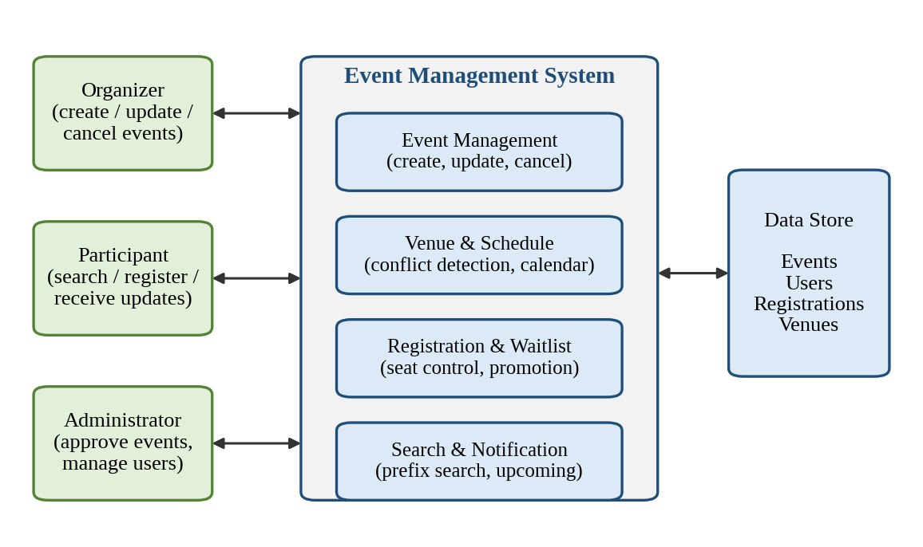
Fig. 1.1 Overview of the Event Management System
This project is carried out as part of the course Data Structures and Algorithms-3, so special importance is given to the choice of data structures that make each operation efficient. A hash table gives constant-time access to events and users, a sorted venue calendar with binary search detects scheduling conflicts in logarithmic time, a min-heap supplies the next upcoming events, a trie supports instant search by event name, and a queue manages the waitlist in first-come-first-served order [1], [2].

1.2 Problem Statement
In many colleges and organizations, event information is spread over posters, e-mails, social-media groups and spreadsheets. Participants do not know where to find a complete and up-to-date list of events, and organizers have no reliable way to check whether a venue is free before announcing an event. Registrations are collected manually, seat limits are not enforced automatically, and cancelled seats are not re-allotted to waiting students. This results in scheduling conflicts, duplicate or lost registrations, overcrowded events, wasted organizer time and low participation.
The problem addressed by this project is therefore to design and develop a centralized web-based Event Management System that (i) stores and displays all event details in one place, (ii) prevents scheduling conflicts automatically, (iii) allows online registration with automatic seat and waitlist handling, and (iv) responds quickly even when the number of events and users becomes large.

1.3 Scope of the Project
The scope of the project covers the complete life cycle of an event inside an institution or organization: creation, scheduling, publicity, registration, waitlist management and cancellation. The system is intended for three groups of users: organizers (faculty coordinators and student club members), participants (students and staff) and administrators. The following are included in the scope:
- Creating, updating and cancelling events with venue, date, time and capacity.
- Venue-wise event calendar with automatic detection of overlapping time slots.
- Online registration, seat limits, waitlist and automatic promotion of waiting participants.
- Searching events by name and viewing upcoming events in chronological order.
Online payment, ticket scanning hardware, live streaming of events and native mobile applications are outside the scope of the present work and are listed as future enhancements in Chapter 7.
Several challenges were considered while designing the system: detecting overlapping time slots quickly when thousands of events exist, keeping all internal data structures consistent after every create, register or cancel operation, handling boundary cases such as back-to-back events and duplicate registrations, and keeping search results instantaneous as the data grows.
The rest of this report is organized as follows. Chapter 2 lists the functional, non-functional, hardware and software requirements after reviewing existing systems. Chapter 3 presents the architecture and design decisions. Chapter 4 explains the implementation using pseudocode. Chapter 5 presents the test results and performance analysis. Chapter 6 discusses the challenges, solutions and limitations, and Chapter 7 concludes the report and suggests future work.

1.4 Objectives
- To build a centralized web platform where users can view event details, schedules, venues and registration information in one place.
- To allow organizers to create, update and manage events efficiently.
- To allow participants to search for events, register online and receive important updates.
- To minimize scheduling conflicts by maintaining an organized event calendar for every venue.
- To enforce seat limits automatically and manage a fair first-come-first-served waitlist.
- To select suitable data structures and algorithms and to verify their efficiency through testing and benchmarking.
- To improve communication between organizers and participants and to reduce manual work.
- SYSTEM REQUIREMENTS
Event handling has traditionally been done manually using notice boards, printed circulars, e-mails and spreadsheets. These methods are simple but cannot detect clashes, cannot enforce seat limits and do not give participants a single place to look for events. Online platforms such as Eventbrite [3] and Meetup [4] provide event publishing and registration, but they are general-purpose commercial services designed mainly for public events. They do not model campus-specific needs such as venue-wise time-slot clashes between departments and clubs, or first-come-first-served waitlists with automatic promotion, and an institution cannot freely customize them.
Textbooks on algorithms describe the data structures needed for such scheduling and search problems: hash tables, sorted and tree-based structures, heaps, tries and queues [1], [2], [5]. They are, however, usually studied in isolation. The gap addressed by this project is the integration of these data structures into one working event-management workflow, together with measured evidence of their benefit over naive list-based approaches.

2.1 Functional Requirements
The functional requirements describe what the system must do. They are summarized in Table 2.1.
Table 2.1 Functional requirements
ID | Requirement
FR1 | User registration and login with role-based access (organizer, participant, administrator).
FR2 | Organizer can create an event with name, description, venue, date, start time, end time and capacity.
FR3 | System checks venue availability and rejects an event that overlaps an existing booking at the same venue.
FR4 | Organizer can update or cancel an event; registered participants are informed of the change.
FR5 | Participants can view the event list, event details, schedule and venue.
FR6 | Participants can search events by name using a prefix search.
FR7 | System shows upcoming events in chronological order.
FR8 | Participants can register for an event online; duplicate registrations are blocked.
FR9 | If an event is full, the participant is added to a waitlist and shown the waitlist position.
FR10 | When a confirmed participant cancels, the first waitlisted participant is confirmed automatically.
FR11 | Participants receive notifications about confirmation, promotion, change or cancellation.
FR12 | Administrator can manage users and venues and can remove or approve events.

2.2 Non-Functional Requirements
- Performance: common operations (search, registration, clash check) should respond in well under one second, even with a very large number of events.
- Usability: a simple, consistent interface that a first-time user can operate without training.
- Scalability: the data structures must keep their efficiency as events and users grow; the engine was tested with up to 100,000 events (Chapter 5).
- Reliability and consistency: a failed operation must not leave the hash table, calendar, heap, trie and queues in an inconsistent state.
- Security: role-based access, validation of all inputs and protection of user data.
- Maintainability and portability: modular code and a browser-based interface that works on any modern device.

2.3 Hardware and Software Requirements
Table 2.2 Hardware and software specifications
Item | Specification
Processor | Intel Core i3 (or equivalent) or higher
Memory (RAM) | 4 GB minimum, 8 GB recommended
Storage | 500 MB of free disk space
Operating system | Windows 10/11, Linux or macOS
Programming languages | Python 3.10 or above; HTML5, CSS3 and JavaScript
Framework and database | Flask (REST API) [6]; SQLite for persistent storage
Browser | Latest version of Google Chrome, Microsoft Edge or Mozilla Firefox [7]
Tools | Visual Studio Code, Git

- SYSTEM DESIGN
The design follows a layered approach so that the user interface, the business logic and the data structures can be developed, tested and changed independently. The design decisions are explained in this chapter.

3.1 High-level Architecture Diagram
Fig. 3.1 shows the high-level architecture. A request from the browser passes through the presentation layer to the service layer, which uses the in-memory data-structure layer for fast processing and the storage layer for permanent records.
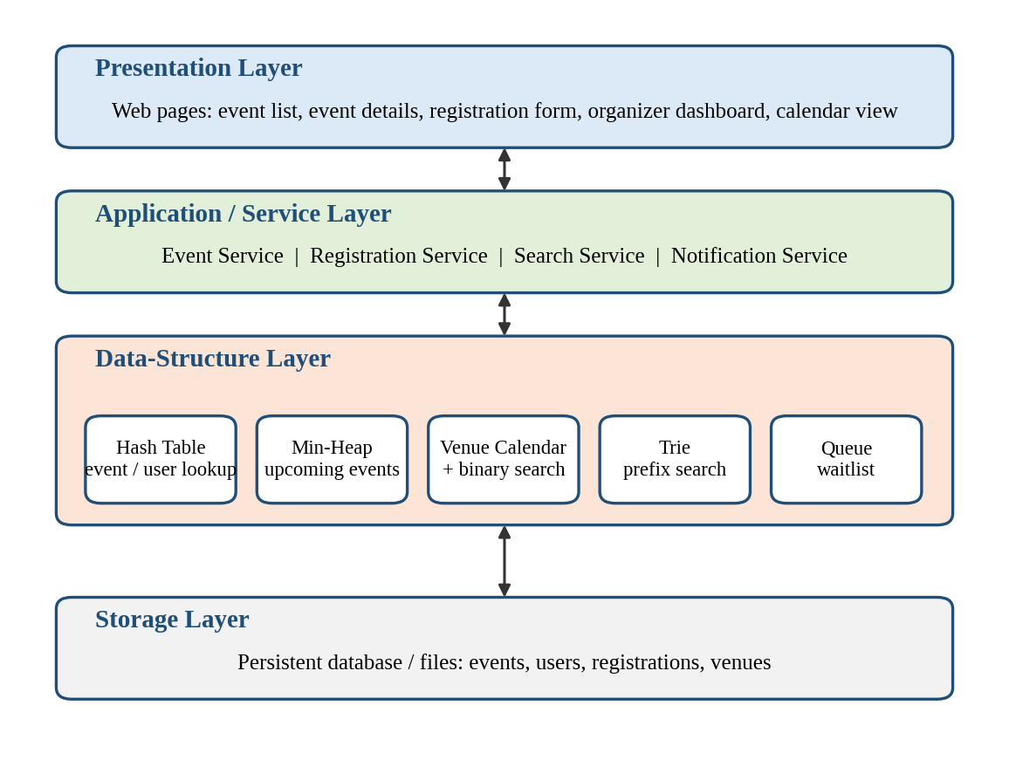
Fig. 3.1 High-level Architecture of the Event Management System

3.2 Description of each layer
Presentation layer. The web pages through which users interact with the system: event list, event details, registration form, organizer dashboard and calendar view. It sends requests to the service layer and displays the responses without containing any business rules.
Application / service layer. Contains the event service, registration service, search service and notification service. It validates every request, applies the rules (clash check, seat limit, waitlist) and decides which data structure to use.
Data-structure layer. Keeps the working data in memory in structures chosen for each operation: a hash table, a sorted calendar per venue, a min-heap, a trie and queues. This layer is the core of the project and is described in Section 3.3.
Storage layer. A database that stores events, users, venues and registrations permanently. When the server starts, the data-structure layer is rebuilt from these records.

3.3 Selection of Data Structures
Each operation of the system has a different access pattern, so a single structure is not suitable for all of them. Table 3.1 lists the structure selected for each operation and the reason for the choice. The trie [8] provides search whose cost depends on the prefix length, the binary heap [9] always keeps the earliest event at its root, and binary search on a sorted sequence [10] finds a position in logarithmic time.
Table 3.1 Data structures selected for the system
Operation | Data structure | Time | Reason for selection
Event / user lookup by ID | Hash table | O(1) average | Direct access by key; ordering is not needed.
Venue clash detection | Sorted calendar per venue + binary search | O(log n) | Only the two neighbours of the new slot must be checked.
Upcoming events | Min-heap keyed by start time | O(log n) insert; O(k log n) for k events | Earliest event is always at the root; no full sort is needed.
Search by event name | Trie | O(L), L = prefix length | Cost depends on the prefix, not on the number of events.
Waitlist | Queue (FIFO) | O(1) enqueue and dequeue | First waiting participant is promoted first (fairness).
Registered participants | Hash set | O(1) average | Fast duplicate-registration check.

3.4 Workflow Design
The three most important workflows are shown as flowcharts. In event creation (Fig. 3.2), the input is validated, the calendar of the requested venue is searched, and the event is stored only if no overlap is found.
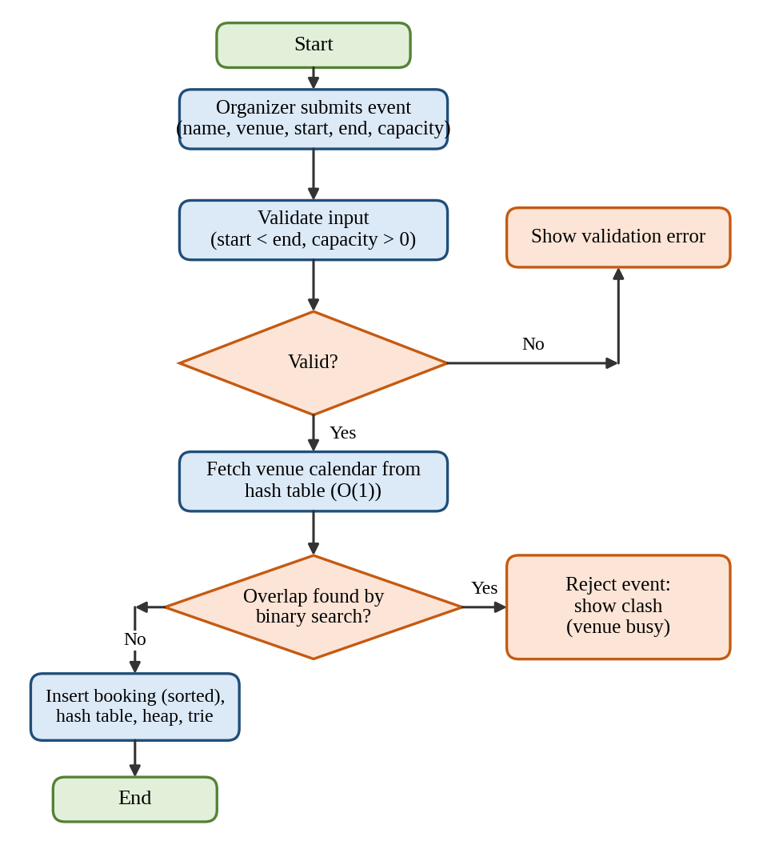
Fig. 3.2 Flowchart for Event Creation with Venue Clash Detection
In registration (Fig. 3.3), the system first checks that the event exists and that the participant is not already registered. A seat is confirmed if the capacity allows; otherwise the participant joins the waitlist queue.
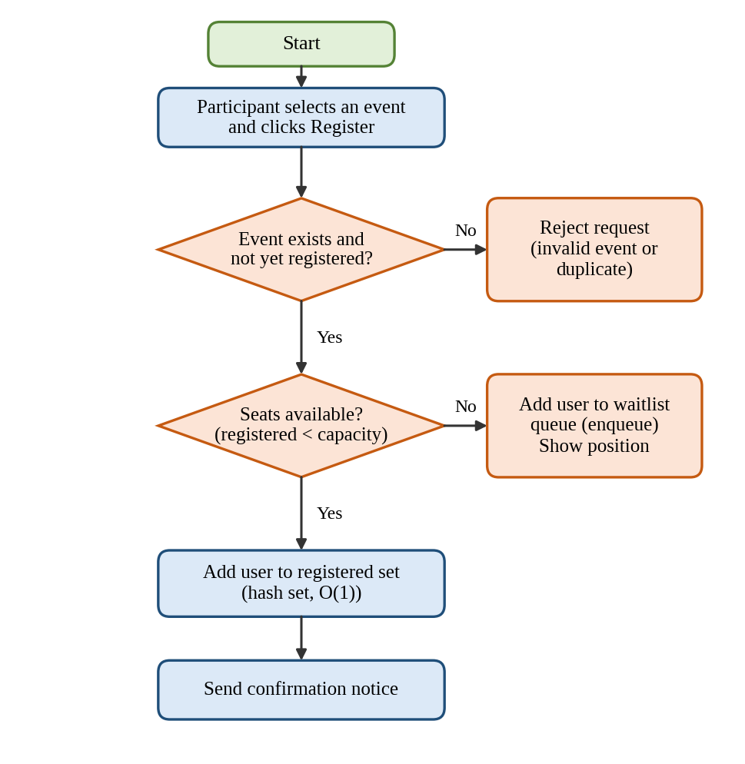
Fig. 3.3 Flowchart for Participant Registration with Waitlist
In cancellation (Fig. 3.4), the seat is released and, if the waitlist is not empty, the participant at the front of the queue is confirmed and notified automatically.
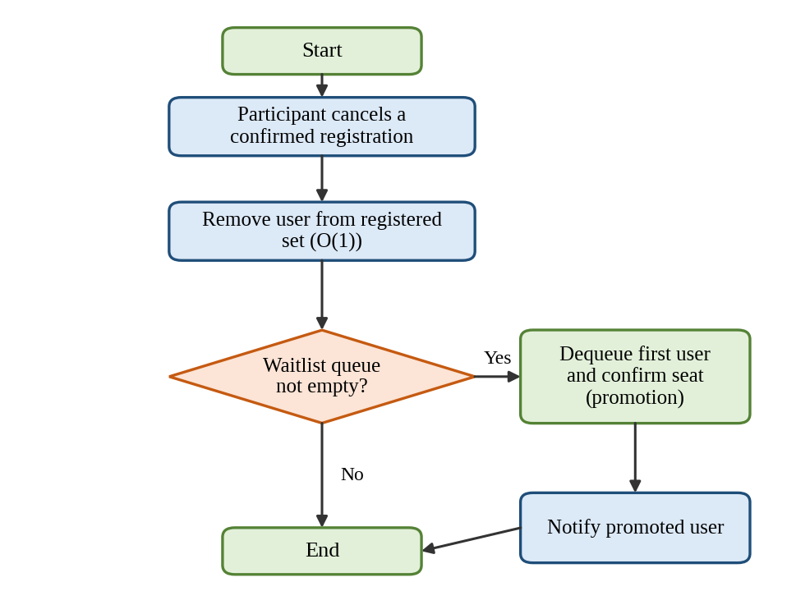
Fig. 3.4 Flowchart for Cancellation and Waitlist Promotion

3.5 Data Model
Table 3.2 shows the main entities stored in the database and their attributes.
Table 3.2 Main entities and attributes
Entity | Attributes
Event | event_id (PK), name, description, venue_id (FK), start_time, end_time, capacity, organizer_id (FK), status
User | user_id (PK), name, email, password_hash, role
Venue | venue_id (PK), name, seating_capacity
Registration | reg_id (PK), event_id (FK), user_id (FK), status (CONFIRMED / WAITLISTED / CANCELLED), waitlist_position, timestamp

- IMPLEMENTATION
This chapter explains the implementation of the system using pseudocode. Keywords are shown in bold. Time intervals are treated as half-open, [start, end), so an event ending at 12:00 does not clash with an event starting at 12:00. The core engine was written using only the Python standard library modules bisect [11] and heapq [12].

4.1 Module-wise implementation

4.1.1 Event Management Module
Every venue has a calendar: a list of bookings kept sorted by start time. To test a new slot, binary search finds the position where it would be inserted, and only the booking before it and the booking after it need to be examined (Algorithm 4.1). Algorithm 4.2 validates the input, performs this check and, only when it succeeds, updates all data structures together.
Algorithm 4.1 Clash detection in a venue calendar
FUNCTION hasConflict(calendar, start, end)
// binary search for the insertion position, O(log n)
i ← index of first booking with booking.start ≥ start
// the previous booking must end before the new slot starts
IF i > 0 AND calendar[i-1].end > start THEN RETURN TRUE
// the next booking must start after the new slot ends
IF i < size(calendar) AND calendar[i].start < end THEN RETURN TRUE
RETURN FALSE
END FUNCTION

Algorithm 4.2 Creating an event
FUNCTION createEvent(id, name, venue, start, end, capacity)
IF id EXISTS IN events THEN RETURN "duplicate id"
IF start ≥ end OR capacity ≤ 0 THEN RETURN "invalid input"
calendar ← venueCalendars[venue] // empty list for a new venue
IF hasConflict(calendar, start, end) THEN RETURN "venue clash"
insert (start, end, id) into calendar at its sorted position
events[id] ← new Event(name, venue, start, end, capacity)
insert (start, id) into upcomingHeap
trie.insert(name, id)
registered[id] ← empty set; waitlist[id] ← empty queue
RETURN "created"
END FUNCTION

4.1.2 Registration Module
Registration compares the number of confirmed participants with the event capacity. A participant who arrives after the event is full is placed at the end of a FIFO queue (Algorithm 4.3). When a confirmed participant cancels, the person at the front of the queue is promoted (Algorithm 4.4).
Algorithm 4.3 Registering a participant
FUNCTION register(eventId, user)
IF eventId NOT IN events THEN RETURN "no such event"
IF user IN registered[eventId] OR user IN waitlist[eventId] THEN
RETURN "already registered"
END IF
IF size(registered[eventId]) < events[eventId].capacity THEN
add user to registered[eventId]; RETURN "confirmed"
ELSE
enqueue(waitlist[eventId], user)
RETURN "waitlisted at position " + size(waitlist[eventId])
END IF
END FUNCTION

Algorithm 4.4 Cancelling a registration with waitlist promotion
FUNCTION cancel(eventId, user)
IF user NOT IN registered[eventId] THEN RETURN "not registered"
remove user from registered[eventId]
IF waitlist[eventId] is not empty THEN
next ← dequeue(waitlist[eventId])
add next to registered[eventId]; notify(next)
RETURN "cancelled, waitlisted user promoted"
END IF
RETURN "cancelled"
END FUNCTION

4.1.3 Search Module
Event names are stored in a trie. Every node keeps the identifiers of the events whose names pass through it, so the search simply walks down the trie along the typed prefix and returns the list stored at the last node (Algorithm 4.5). The search is case-insensitive.
Algorithm 4.5 Trie insertion and prefix search
PROCEDURE insert(trie, name, id)
node ← trie.root
FOR EACH character ch IN lowercase(name) DO
IF ch NOT IN node.children THEN
node.children[ch] ← new TrieNode
END IF
node ← node.children[ch]; append id to node.ids
END FOR
END PROCEDURE
FUNCTION search(trie, prefix)
node ← trie.root
FOR EACH character ch IN lowercase(prefix) DO
IF ch NOT IN node.children THEN
RETURN empty list
END IF
node ← node.children[ch]
END FOR
RETURN node.ids
END FUNCTION

4.1.4 Upcoming Events Module
A min-heap ordered by start time keeps the earliest event at the root. To list the next k events, events that have already started are discarded, k events are extracted and then pushed back so that the heap is unchanged (Algorithm 4.6). This costs O(k log n) instead of the O(n log n) needed to sort all events.
Algorithm 4.6 Listing the next k upcoming events
FUNCTION nextEvents(k, now)
WHILE heap is not empty AND minimum(heap).start < now DO
extractMin(heap)
END WHILE
result ← empty list
REPEAT min(k, size(heap)) TIMES
append extractMin(heap) TO result
END REPEAT
FOR EACH item IN result DO
insert item INTO heap
END FOR
RETURN event ids of result
END FUNCTION

4.2 Front-end logic (UI rendering, state management)
The front end keeps one state object holding the list of events, the current search text, a loading flag and an error message. Whenever the state changes, the page is drawn again from the state (Algorithm 4.7). This keeps the screen consistent with the data and avoids manual updates of individual elements.
Algorithm 4.7 Page rendering and state handling
PROCEDURE loadEventsPage()
state ← { events: [], query: "", loading: TRUE, error: NULL }
render(state)
response ← GET /api/events/upcoming?k=20
IF response.ok THEN
state.events ← response.data
ELSE
state.error ← response.message
END IF
state.loading ← FALSE; render(state)
END PROCEDURE
PROCEDURE onSearchInput(text)
state.query ← text
IF length(text) ≥ 1 THEN
state.events ← GET /api/events/search?prefix=text
ELSE
state.events ← GET /api/events/upcoming?k=20
END IF
render(state)
END PROCEDURE
PROCEDURE onRegisterClick(eventId)
result ← POST /api/events/{eventId}/register
// status is confirmed, waitlisted or an error
show message(result.status)
update the event card with result
END PROCEDURE
PROCEDURE render(state)
IF state.loading THEN
show spinner
ELSE IF state.error NOT NULL THEN
show error banner
ELSE
FOR EACH event IN state.events DO
draw card(name, venue, date, seats left, Register button)
END FOR
END IF
END PROCEDURE

4.3 API integration
The front end and the back end communicate through a REST API that exchanges JSON over HTTP. Table 4.1 lists the main endpoints. Standard status codes are used: 200 and 201 for success, 400 for invalid input, 404 when an event is not found and 409 for a venue clash or duplicate registration.
Table 4.1 REST API endpoints
Method | Endpoint | Purpose | Structure used
POST | /api/events | Create an event (clash check) | Venue calendar, hash table
PUT | /api/events/{id} | Update an event | Hash table, calendar
DELETE | /api/events/{id} | Cancel an event | Hash table, calendar
GET | /api/events/{id} | View event details | Hash table
GET | /api/events/upcoming?k= | List next k events | Min-heap
GET | /api/events/search?prefix= | Search events by name | Trie
POST | /api/events/{id}/register | Register or join waitlist | Hash set, queue
POST | /api/events/{id}/cancel | Cancel seat, promote waitlist | Hash set, queue

4.4 Complexity summary
Table 4.2 summarizes the running time and extra space of the main operations. Here n is the number of events, m the number of venues, L the length of the name or prefix, k the number of events requested and w the length of a waitlist.
Table 4.2 Complexity of the main operations
Operation | Time | Remark
Event lookup by ID | O(1) average | Hash table
Clash check for a new event | O(log n) | Binary search; insertion into the list shifts elements, O(n) in the worst case
Create event | O(L + log n) | Includes clash check, heap push and trie insertion
Register / cancel | O(1) + O(w) | The O(w) part is the membership test in the waitlist
Prefix search | O(L) | Result list is stored at the trie node
Next k upcoming events | O(k log n) | Extract k and push back

- RESULTS

5.1 Experimental setup
The core engine described in Chapter 4 was implemented in Python 3.12 using only the standard library and executed on a single CPU core under Linux. Two kinds of experiments were carried out. First, a set of functional test cases checked the correctness of the rules. Second, performance tests compared each selected data structure with the naive alternative (a plain list scan or a full sort) for n = 1,000; 5,000; 10,000; 50,000 and 100,000 events spread over 20 venues. Event names were generated from a vocabulary of 25 words followed by a random number. Every timing is the mean of repeated runs measured with time.perf_counter(). Absolute times depend on the machine, so the growth trend is the important result.

5.2 Functional testing
Table 5.1 lists the test cases, the expected result and the actual result obtained from the program. All 11 test cases passed, including the boundary cases of back-to-back events and invalid time slots.
Table 5.1 Functional test cases and results
ID | Test case | Expected result | Actual result | Status
T1 | Create 'Tech Fest' at Seminar Hall, 09:00-12:00 | CREATED | CREATED | Pass
T2 | Create overlapping event at same venue, 11:00-13:00 | REJECTED: venue clash | REJECTED: venue clash | Pass
T3 | Create back-to-back event at same venue, 12:00-14:00 | CREATED | CREATED | Pass
T4 | Create event at same time in a different venue | CREATED | CREATED | Pass
T5 | Create event whose end time is before its start time | REJECTED: invalid input | REJECTED: invalid input | Pass
T6 | Register first participant (capacity = 2) | CONFIRMED | CONFIRMED | Pass
T7 | Register third participant when event is full | WAITLISTED #1 | WAITLISTED #1 | Pass
T8 | Register the same participant twice | REJECTED: already registered | REJECTED: already registered | Pass
T9 | Cancel a confirmed seat; first waitlisted user is promoted | CANCELLED; promoted u3 | CANCELLED; promoted u3 | Pass
T10 | Search events with prefix 'tech' | E1, E3 | E1, E3 | Pass
T11 | Next 3 upcoming events in chronological order | E1, E4, E3 | E1, E4, E3 | Pass

5.3 Performance evaluation

5.3.1 Venue clash detection
Fig. 5.1 compares a linear scan of all bookings of a venue with the sorted calendar and binary search. The linear scan grows in proportion to the number of events, from 0.87 to 76.1 microseconds per check, whereas the binary search stays almost flat, from 0.19 to 0.28 microseconds.
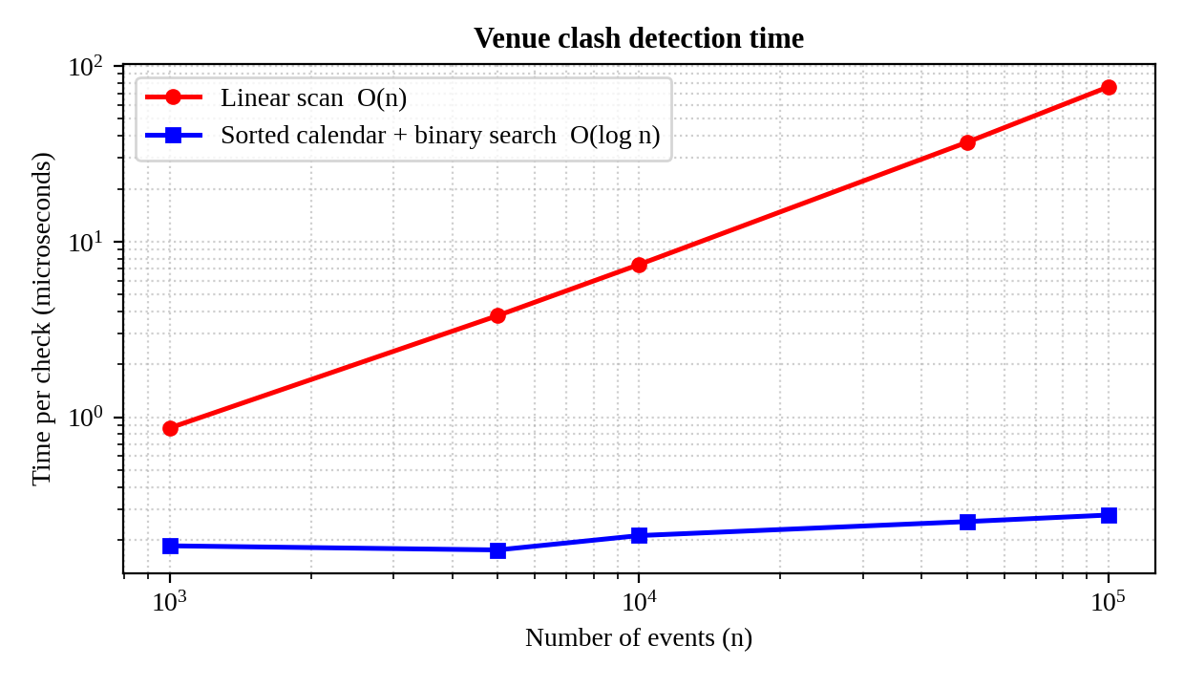
Fig. 5.1 Venue Clash Detection Time versus Number of Events

5.3.2 Search by event name
Fig. 5.2 shows the time for a prefix search. Scanning all names takes 6,002 microseconds at 100,000 events, while the trie answers in 0.47 microseconds because it only walks along the characters of the prefix. The trie returns a list that was prepared during insertion, which is the price paid in extra memory.
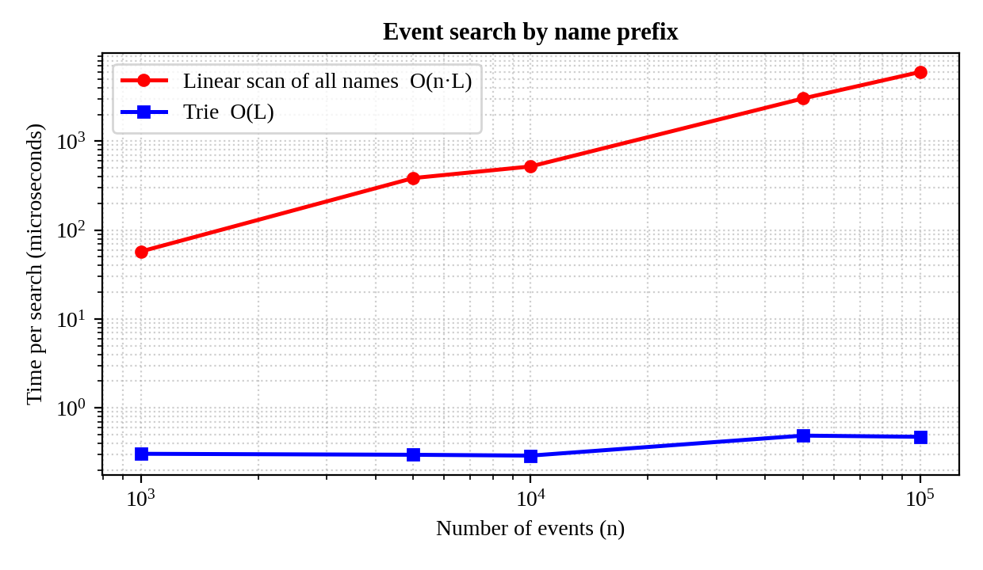
Fig. 5.2 Event Search Time versus Number of Events

5.3.3 Upcoming events
Fig. 5.3 compares sorting all events to find the first ten with extracting ten events from the min-heap and restoring them. At 100,000 events the heap needs 8.02 microseconds against 37,719 microseconds for the sort.
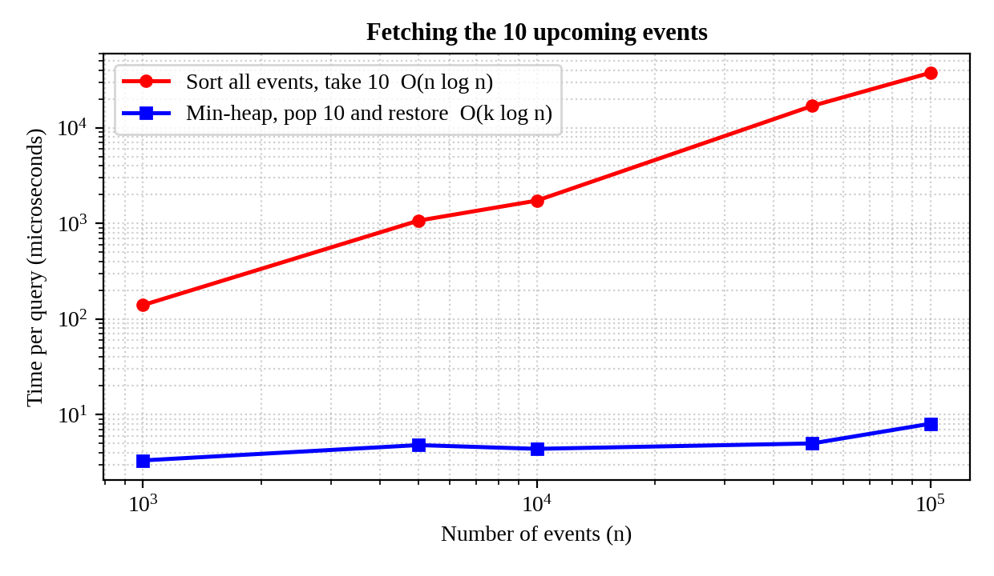
Fig. 5.3 Time to Fetch the 10 Upcoming Events

5.3.4 Event lookup by ID
Fig. 5.4 shows that looking up an event by its identifier in the hash table takes about 0.04 microseconds regardless of the number of events, while scanning a list grows to 721 microseconds at 100,000 events.
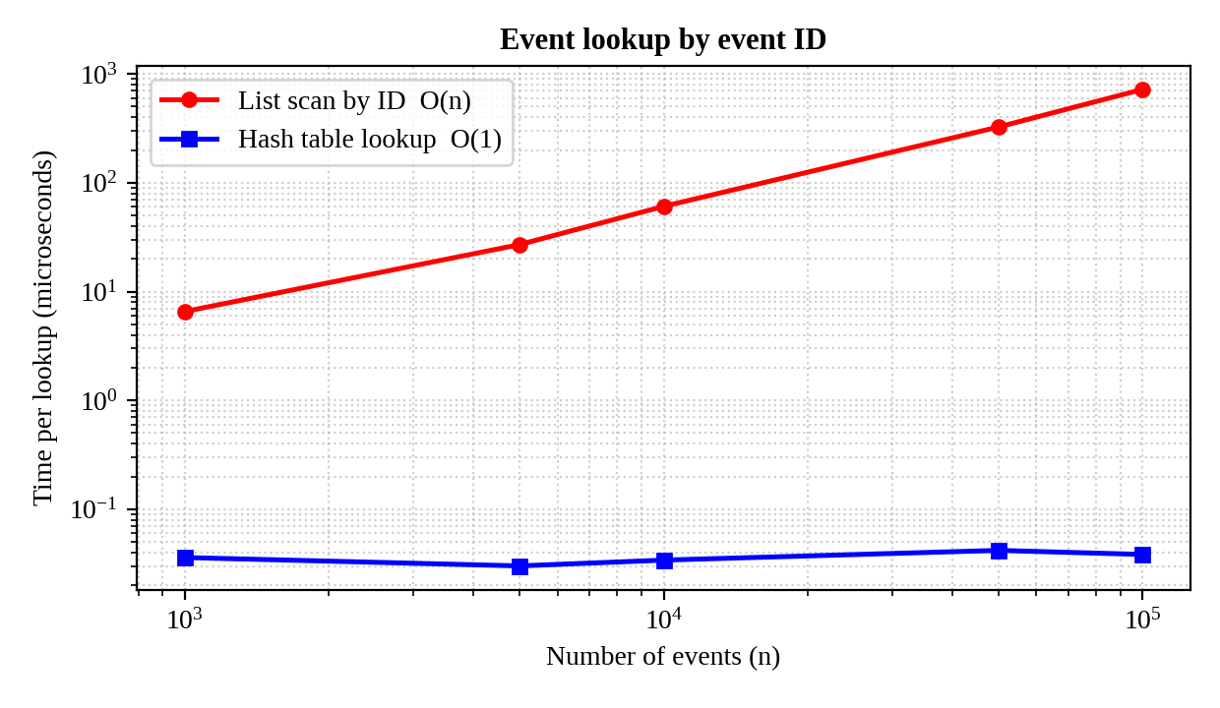
Fig. 5.4 Event Lookup Time versus Number of Events
Table 5.2 summarizes the results for n = 100,000 events.
Table 5.2 Performance summary for n = 100,000 events (time in microseconds)
Operation | Naive approach | Selected structure | Improvement
Clash detection | 76.1 | 0.28 | 274 times faster
Prefix search | 6,002 | 0.47 | 12,667 times faster
Next 10 events | 37,719 | 8.02 | 4,705 times faster
Lookup by ID | 721 | 0.04 | 18,798 times faster

5.4 Discussion
The experiments confirm the theoretical analysis of Chapter 4. Every selected data structure keeps its response time nearly constant while the naive approach slows down in proportion to n (or n log n for sorting). For an institution with a few thousand events all approaches would feel fast, but the chosen structures leave a large safety margin when many colleges or a whole organization use the same system. Two trade-offs were observed: the trie needs additional memory because identifiers are stored at every node, and inserting into the sorted calendar list shifts elements, which a balanced search tree would avoid.
- CHALLENGES & LIMITATIONS

6.1 Issues faced during development
- Boundary cases in clash detection: an event that ends exactly when the next one starts must be allowed, while even a one-minute overlap must be rejected.
- Consistency of several structures: a new event must be added to the calendar, hash table, heap, trie and the registration structures. A failure in the middle could leave them inconsistent.
- Duplicate and waitlist handling: a participant must not be able to register again while already waiting, and a promoted participant must be removed from the queue exactly once.
- Memory use of the trie: storing event identifiers at every node increases memory compared with storing them only at the end of a name.
- Fair benchmarking: very small operations are affected by timing noise, which can hide the real difference between two approaches.

6.2 Solutions applied
- Half-open intervals [start, end) were adopted, so that the end of one event and the start of the next do not overlap.
- Validation is completed first and the structures are updated together only after every check has passed.
- Registration checks both the confirmed set and the waitlist before accepting a request, and promotion removes the first element of the queue in a single step.
- The additional memory of the trie was accepted as a time-space trade-off because it makes searching independent of the number of events.
- Each timing was repeated and averaged, and both the naive and the selected approach used exactly the same data.

6.3 Limitations of the System
- The in-memory structures must be rebuilt from the database whenever the server restarts.
- Insertion into the sorted calendar list takes O(n) time in the worst case; a balanced search tree or interval tree would give O(log n).
- The engine does not yet lock data against simultaneous requests, so two users trying to take the last seat at the same instant need additional concurrency control.
- Checking whether a user is already on a waitlist takes O(w) time.
- The performance results were measured on the core engine, not on the complete web application with network and database delays.
- Online payments, mobile applications and e-mail or SMS gateways are not included.
- CONCLUSION & FUTURE WORK

7.1 Conclusion
The Event Management System provides a single place where organizers can create and manage events and participants can search for events, register online and receive updates. By maintaining an organized calendar for every venue, the system prevents scheduling conflicts automatically, and by enforcing seat limits with a waitlist it handles popular events fairly. This reduces manual work, saves time and improves communication between organizers and participants.
From the data-structures point of view, the project shows that choosing the right structure for each operation matters. The hash table, sorted calendar with binary search, min-heap, trie and queue passed all 11 functional tests and were 274 to 18,798 times faster than the naive alternatives for 100,000 events. The main limitations are the O(n) insertion into the sorted list, the lack of concurrency control and the absence of payment and mobile features.

7.2 Future Work
- Replace the sorted list by a balanced binary search tree (AVL) or an interval tree for O(log n) insertion and deletion.
- Add concurrency control and a cache such as Redis for multi-server deployment.
- Send e-mail, SMS and push notifications and synchronize events with Google Calendar.
- Add QR-code check-in, attendance tracking and certificates.
- Integrate online payment for paid events.
- Recommend events to participants according to their interests and past registrations.
- Develop Android and iOS applications and an analytics dashboard for organizers.

7.3 Skills learned during development
- Selecting data structures according to the access pattern of each operation and analyzing their time and space complexity.
- Writing clear pseudocode and converting it into a working program.
- Designing a layered architecture and a REST API.
- Writing test cases, including boundary cases, and benchmarking algorithms.
- Teamwork, documentation and technical report writing.

REFERENCES
- T. H. Cormen, C. E. Leiserson, R. L. Rivest and C. Stein, Introduction to Algorithms, 3rd ed. Cambridge, MA, USA: MIT Press, 2009.
- M. T. Goodrich, R. Tamassia and M. H. Goldwasser, Data Structures and Algorithms in Python. Hoboken, NJ, USA: Wiley, 2013.
- Eventbrite, “Event management and ticketing platform.” [Online]. Available: https://www.eventbrite.com
- Meetup, “Online platform for local groups and events.” [Online]. Available: https://www.meetup.com
- R. Sedgewick and K. Wayne, Algorithms, 4th ed. Boston, MA, USA: Addison-Wesley, 2011.
- Pallets Projects, “Flask documentation.” [Online]. Available: https://flask.palletsprojects.com
- Mozilla, “MDN Web Docs: HTML, CSS and JavaScript.” [Online]. Available: https://developer.mozilla.org
- E. Fredkin, “Trie memory,” Communications of the ACM, vol. 3, no. 9, pp. 490–499, 1960.
- J. W. J. Williams, “Algorithm 232: Heapsort,” Communications of the ACM, vol. 7, no. 6, pp. 347–348, 1964.
- D. E. Knuth, The Art of Computer Programming, Vol. 3: Sorting and Searching, 2nd ed. Reading, MA, USA: Addison-Wesley, 1998.
- Python Software Foundation, “bisect: Array bisection algorithm,” Python 3 Documentation. [Online]. Available: https://docs.python.org/3/library/bisect.html
- Python Software Foundation, “heapq: Heap queue algorithm,” Python 3 Documentation. [Online]. Available: https://docs.python.org/3/library/heapq.html

