OSSP PRACTICAL PROGRAMS
WEEK-4
ROLLNO:2520030110
NAME: POOJITHA REDDY
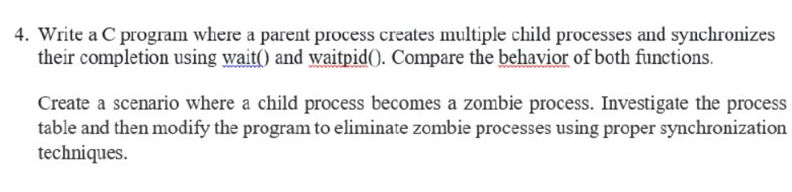
4a: Multiple child process using wait() & waitpid()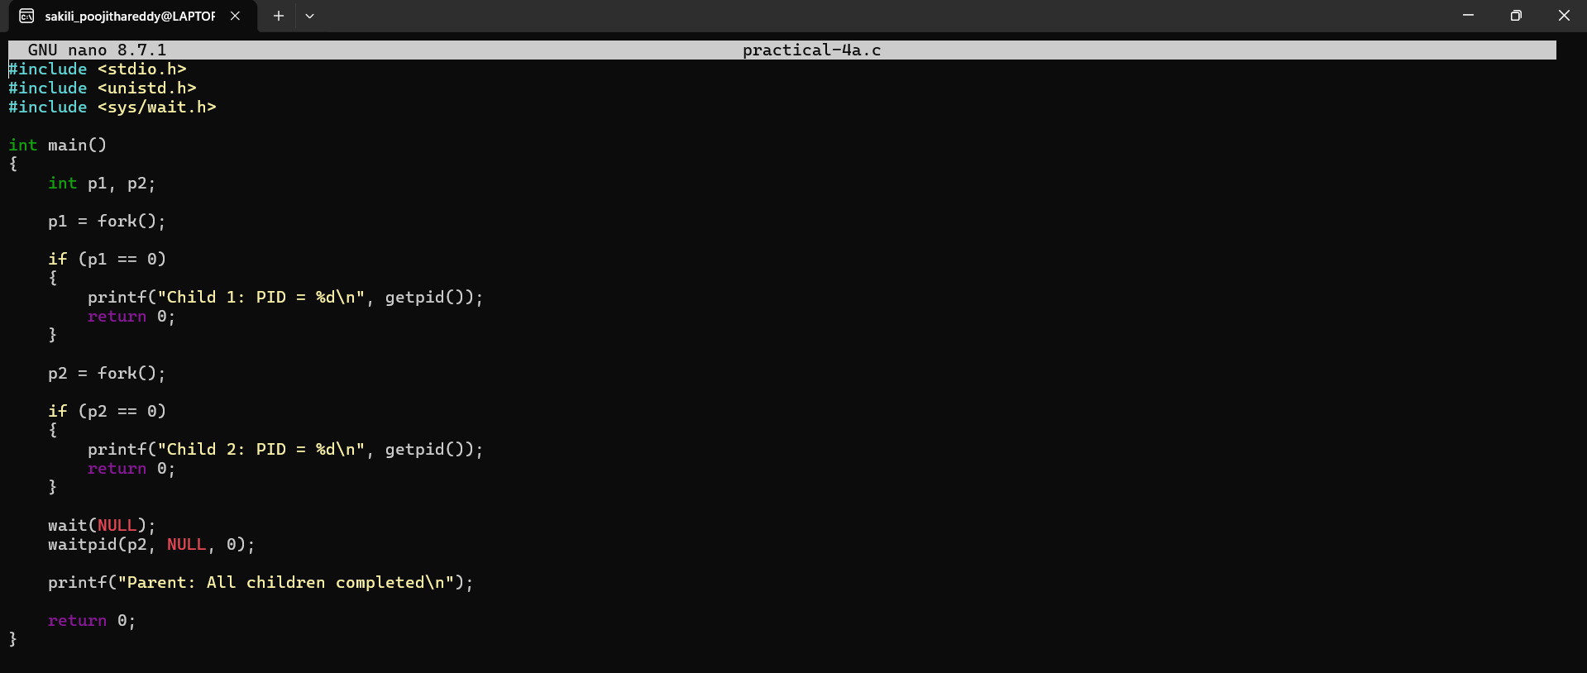
4b:Zombie Process
