OSSP PRACTICAL PROGRAMS
WEEK-5
ROLLNO: 2520030110
NAME: POOJITHA REDDY
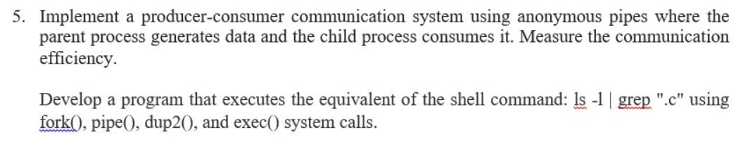
5A: Producer consumer using anonymous pipe
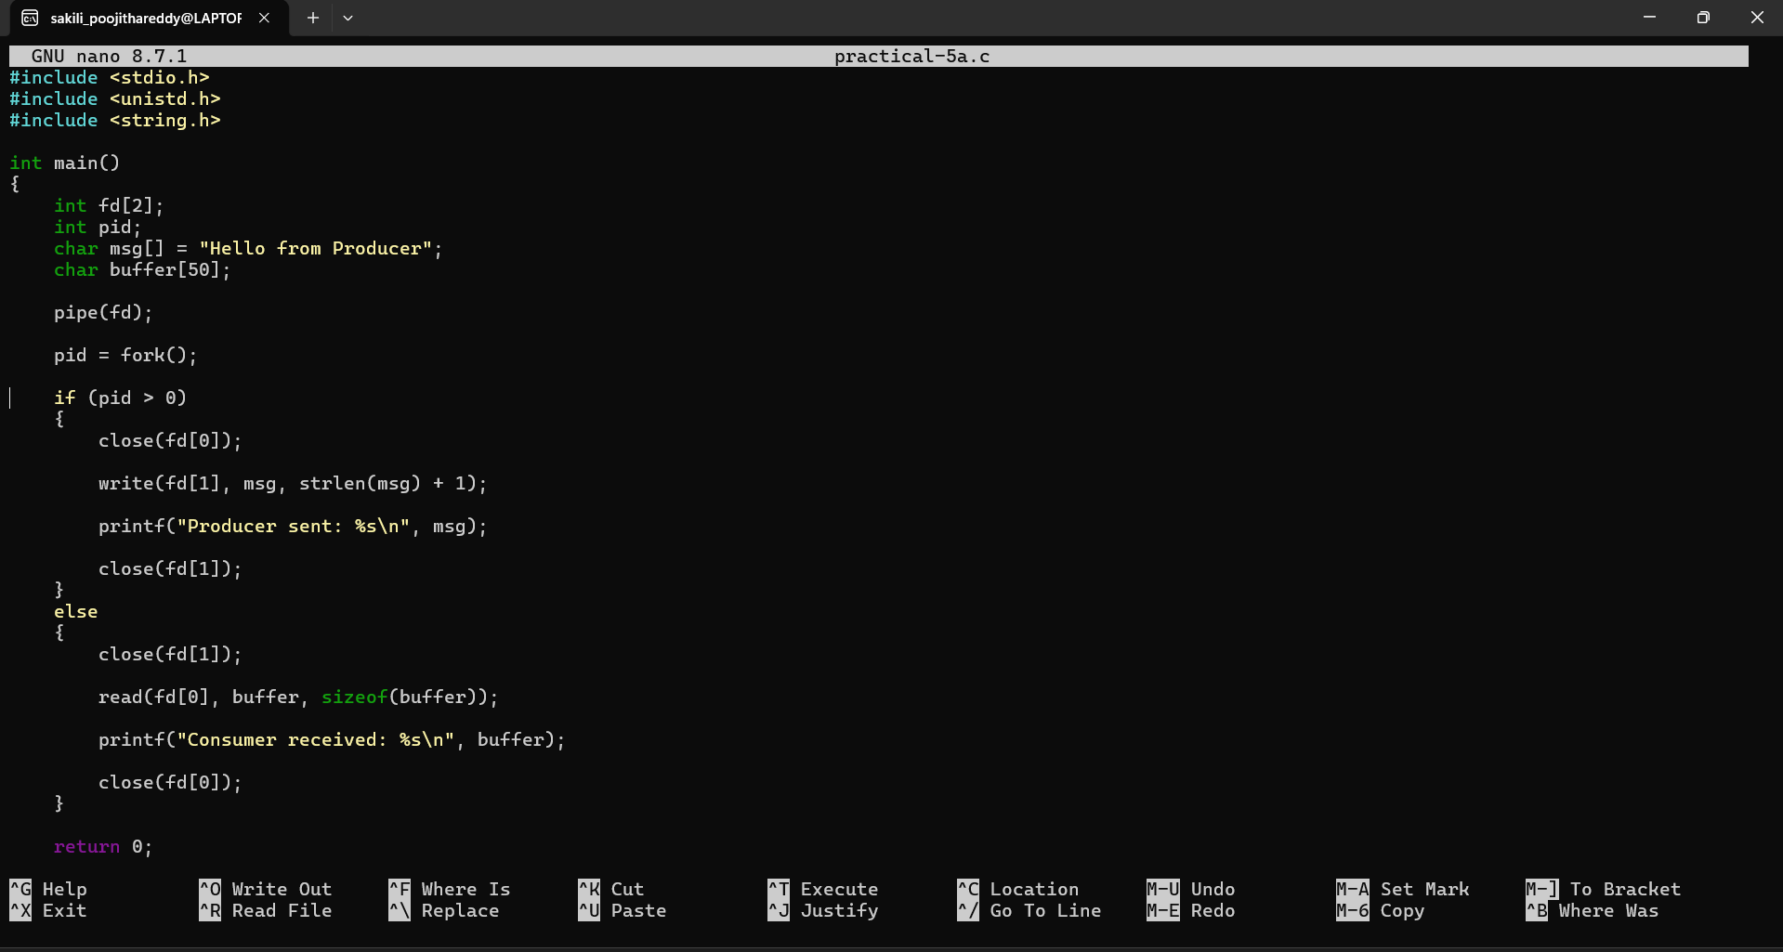
5B: ls-1|grep”.c”
