OSSP PRACTICAL PROGRAMS
WEEK-6
ROLLNO: 2520030110
NAME: POOJITHA REDDY
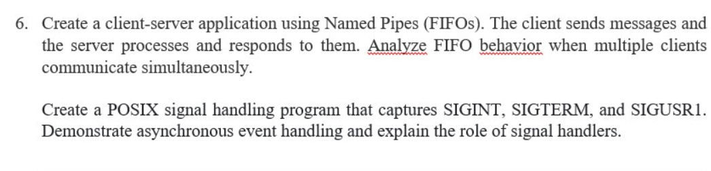
6A:FIFO Server
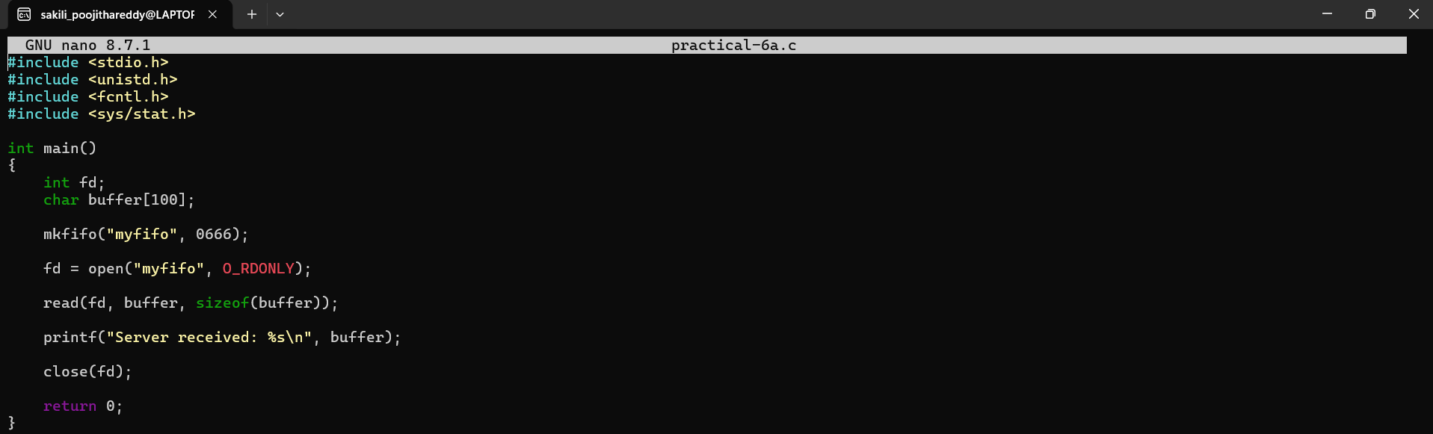
6B: FIFO Client
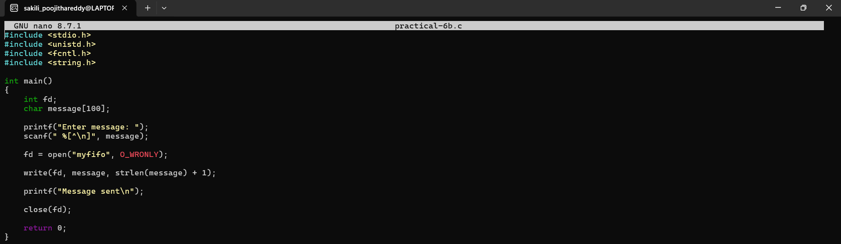
6C: Signal Handling
