SHARED MEMORY BASED DATA EXCHANGE SYSTEM
Operating Systems Project Report
Submitted in partial fulfilment of the requirements for the course
OPERATING SYSTEMS
In
DEPARTMENT OF COMPUTER SCIENCE ENGINEERING
By

Nikhitha 2520030033
Poojitha 2520030110

Team Number: 17
Section: 9

Under the Guidance of
Dr. Y. Harika Devi
Department of Computer Science and Engineering



DEPARTMENT OF COMPUTER SCIENCE ENGINEERING
DECLARATION
We hereby declare that the project entitled "Shared Memory Based Data Exchange System" is an academic project carried out as part of the requirements for the Operating Systems course.
The project demonstrates inter-process communication using POSIX shared memory in C. It uses shm_open(), ftruncate() and mmap() to create a shared memory region, fork() to create a child process, and a POSIX named semaphore to coordinate access. In the working demonstration, the child process writes a message into shared memory and the parent process reads it. The demo is also connected to an Express.js backend and a React/Vite frontend so that it can be run from a webpage.
This documentation describes the design, implementation approach, testing procedure, limitations, and possible future improvements. Any sample terminal output or values included in this report are illustrative unless they are explicitly recorded from an actual test run.

Nikhitha – 2520030033
Poojitha – 2520030110
CERTIFICATE
This is to certify that the project entitled "Shared Memory Based Data Exchange System" is a project work carried out by the student(s) named on the cover page, under the guidance of the undersigned, as part of the academic requirements for the Operating Systems course.
The project focuses on inter-process communication using POSIX shared memory and a named semaphore, implemented in C, with a web-based demonstration built using Express.js and React/Vite.

Signature of the Guide Signature of the HOD
(Dr. Y. Harika Devi)
Signature of the External Examiner

ACKNOWLEDGEMENT
We express our sincere gratitude to our course instructor and project guide for their guidance and encouragement during the development of this Operating Systems project. We also thank the Department of Computer Science and Engineering for providing the opportunity to explore inter-process communication and process management through practical implementation.
We acknowledge the Linux manual pages and POSIX documentation for shared memory, semaphores and process creation interfaces, which provide the technical foundation for understanding how processes can safely exchange data.

ABSTRACT
Processes in an operating system run in separate memory spaces, so exchanging data between them requires a deliberate mechanism. Shared memory is one of the fastest forms of inter-process communication, but when several processes use the same memory they must coordinate their access to keep the data consistent. The Shared Memory Based Data Exchange System is a small educational application that demonstrates this idea.
The system is written in C using POSIX shared memory. It uses shm_open(), ftruncate() and mmap() to create and map a shared memory region, fork() to create a child process, and a POSIX named semaphore to coordinate access. In the working demonstration, the child process writes a message into shared memory and the parent process reads it. The C demo is connected to an Express.js backend and a React/Vite frontend, so a user can click a button on a webpage to run the demo and view its output.
The project is a learning prototype. Its current scope is a single parent–child pair exchanging a message, and it does not claim additional features beyond this. It nevertheless provides hands-on experience with shared memory, process creation, synchronization, and the integration of a systems-level program with a web interface.
Keywords: Operating Systems, Shared Memory, POSIX, Inter-Process Communication, Semaphore, fork(), mmap(), C Programming, Express.js, React.

TABLE OF CONTENTS
Section | Contents
Preliminary pages | Declaration, Certificate, Acknowledgement, Abstract
Chapter 1 | Introduction
Chapter 2 | System Requirements and Background
Chapter 3 | System Design
Chapter 4 | Implementation
Chapter 5 | Testing and Results
Chapter 6 | Challenges and Limitations
Chapter 7 | Conclusion and Future Work
References | Technical documentation and manuals
LIST OF FIGURES
- Figure 3.1 — High-level architecture of the Shared Memory Based Data Exchange System
- Figure 3.2 — Process and data exchange workflow
- Figure 4.1 — Project folder structure (example, to be updated)
- Figure 5.1 — Example terminal output (illustrative)
- Figure 5.2 — Webpage screenshot (placeholder)

CHAPTER 1: INTRODUCTION

1.1 Overview
An operating system gives every process its own private address space so that one program cannot accidentally read or damage the memory of another. This protection is essential, but many real programs consist of several cooperating processes that need to share information. The operating system therefore provides inter-process communication (IPC) mechanisms such as pipes, message queues, sockets and shared memory.
Shared memory allows two or more processes to map the same region of memory into their address spaces. Once mapped, the processes can read and write the region like ordinary memory, without copying data through the kernel for every message. Because several processes can touch the same data, a synchronization mechanism such as a semaphore is needed to keep the data consistent. This project implements a small demonstration of both ideas in C.

1.2 Problem Statement
Processes run in isolated memory spaces, yet cooperating processes still need to exchange data. If two processes access the same data at the same time without coordination, the result can be mixed-up or corrupted data, known as a race condition. The problem addressed by this project is to build an application in which multiple processes exchange data through shared memory while maintaining data consistency.

1.3 Objectives
- Let processes exchange data through POSIX shared memory.
- Keep the shared data consistent by coordinating access with a POSIX named semaphore.
- Use fork() to create a child process that cooperates with the parent.
- Demonstrate the child writing a message and the parent reading it.
- Connect the C demo to an Express.js backend and a React/Vite frontend so it can be run from a webpage.

1.4 Scope of the Project
The project is scoped to a single demonstration in which one parent process and one child process share a memory region and exchange a message. The web layer (React/Vite frontend and Express.js backend) is used to run the demo and display its output. The project does not attempt to provide a general-purpose IPC library, and it does not claim features beyond those described in this report.

1.5 Significance
The project connects theoretical Operating Systems topics with observable behaviour. It illustrates process creation, memory mapping, shared memory, synchronization with semaphores, and the idea of data consistency. It also shows how a systems-level C program can be launched and observed through a simple web interface.

1.6 Organization of the Report
Chapter 1 introduces the project. Chapter 2 describes requirements and technical background. Chapter 3 explains the architecture and workflow. Chapter 4 documents the implementation and setup. Chapter 5 describes test cases and result interpretation. Chapter 6 discusses challenges and limitations. Chapter 7 concludes the report and lists proposed future improvements.

CHAPTER 2: SYSTEM REQUIREMENTS AND BACKGROUND

2.1 Functional Requirements
- The program creates a shared memory region that can be accessed by more than one process.
- The program creates a child process using fork().
- A POSIX named semaphore coordinates access to the shared memory.
- The child process writes a message into shared memory.
- The parent process reads the message from shared memory.
- A user can click a button on the webpage to run the demo and view its output.

2.2 Non-Functional Requirements
Requirement | Description
Portability | Uses POSIX interfaces (shm_open, mmap, sem_open, fork), so it targets POSIX-compliant systems such as Linux.
Usability | The demo can be started with one button click on a webpage, and the output is shown on the same page.
Reliability | A semaphore is used so that processes take turns using the shared memory, helping keep the data consistent.
Simplicity | A small C program and a thin web layer make the project easy to read, explain and extend.
Maintainability | The C demo, backend and frontend are separate parts, so each can be changed independently.

2.3 Hardware Requirements
A standard computer capable of running a POSIX-compliant operating system such as Linux is sufficient. No special hardware is required.

2.4 Software Requirements
Software | Purpose
POSIX-compliant OS (e.g., Linux) | Provides shared memory, semaphore and process-creation interfaces
GCC | Compile the C source code
Node.js and npm | Run the Express.js backend and the Vite development tools
Express.js | Backend that runs the C demo and returns its output
React with Vite | Frontend webpage with a button to run the demo
Web browser | View the frontend and the demo output
Text editor / terminal | Edit source files, compile and run the program

2.5 Technical Background

2.5.1 Inter-Process Communication and Shared Memory
Inter-process communication refers to the ways in which processes exchange data. In shared memory, the operating system maps the same physical memory into the address spaces of several processes. After the mapping is set up, data can be exchanged by ordinary reads and writes, which makes shared memory a fast IPC method. The operating system does not coordinate the accesses itself, so the programmer must provide synchronization.

2.5.2 POSIX Shared Memory Interfaces
shm_open() creates or opens a named shared memory object that different processes can find by name. ftruncate() sets the size of that object. mmap() maps the object into the calling process's address space so that it can be used like normal memory; when it is mapped as shared, changes made by one process are visible to the others. When the object is no longer needed it can be removed with shm_unlink().

2.5.3 Process Creation with fork()
fork() creates a new child process that is a copy of the calling parent process. The child inherits the parent's open resources, including the memory mappings, so the parent and child can both use a shared mapping. The return value of fork() tells each process whether it is the parent or the child.

2.5.4 Semaphores and Data Consistency
A semaphore is a synchronization tool that controls access to a shared resource. A process waits on the semaphore before using the resource and signals it when finished (for example with sem_wait() and sem_post()). A POSIX named semaphore, opened with sem_open(), has a name and can therefore be used by different processes. By making processes take their turn, a semaphore prevents a reader from seeing half-written data and so helps maintain data consistency.

CHAPTER 3: SYSTEM DESIGN

3.1 High-Level Architecture
The application has two main parts: a web layer and a C program. The user clicks a button on the React/Vite frontend. The Express.js backend runs the C demo. Inside the C program, a parent process creates a child process with fork(), and the two processes exchange a message through a shared memory region while a named semaphore coordinates their access. The output of the program is then shown on the webpage.
Layer | Responsibility
React + Vite Frontend | Shows a webpage with a button that starts the demo and displays the output.
Express.js Backend | Receives the request from the webpage, runs the C demo, and returns its output.
C Program | Sets up shared memory and the semaphore and creates the child process.
Parent Process | Reads the message from shared memory.
Child Process | Writes a message into shared memory.
Shared Memory | Memory region (shm_open, ftruncate, mmap) used by both processes.
Named Semaphore | Ensures that only one process uses the shared memory at a time.

3.2 Architecture Diagram
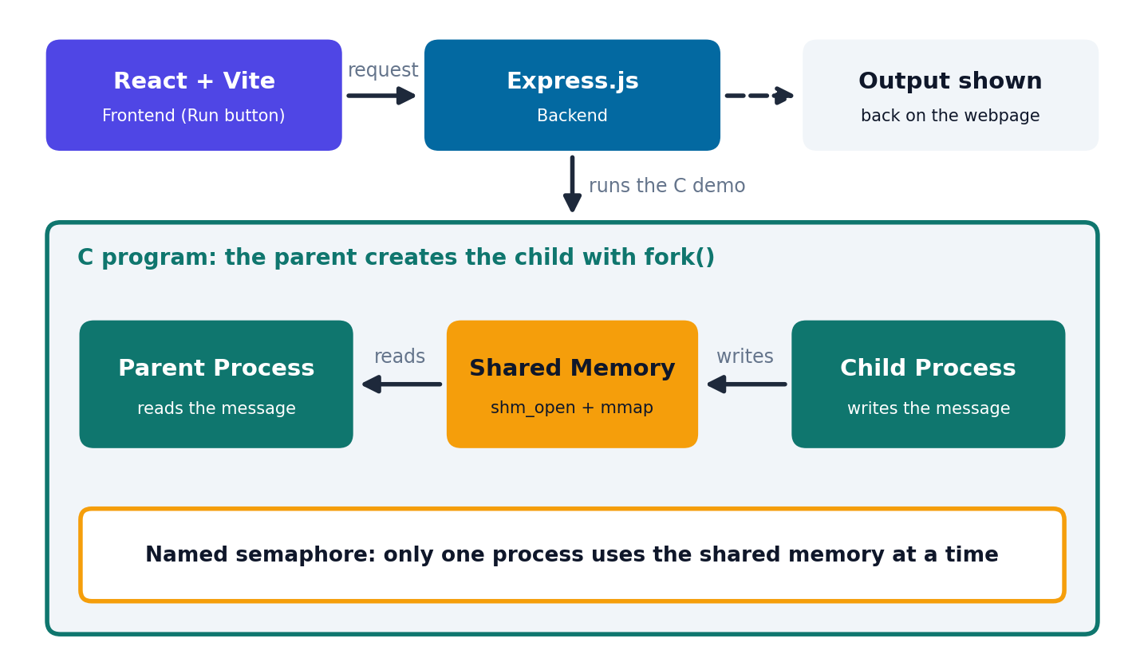
Figure 3.1: High-level architecture of the Shared Memory Based Data Exchange System

3.3 Process Workflow
- The user clicks the Run button on the React webpage.
- The Express.js backend starts the C demo program.
- The C program creates or opens the shared memory region and the named semaphore.
- The parent process calls fork() to create the child process.
- The child process writes a message into shared memory.
- The parent process waits for its turn (using the semaphore) and reads the message.
- The output is returned through the backend and shown on the webpage.
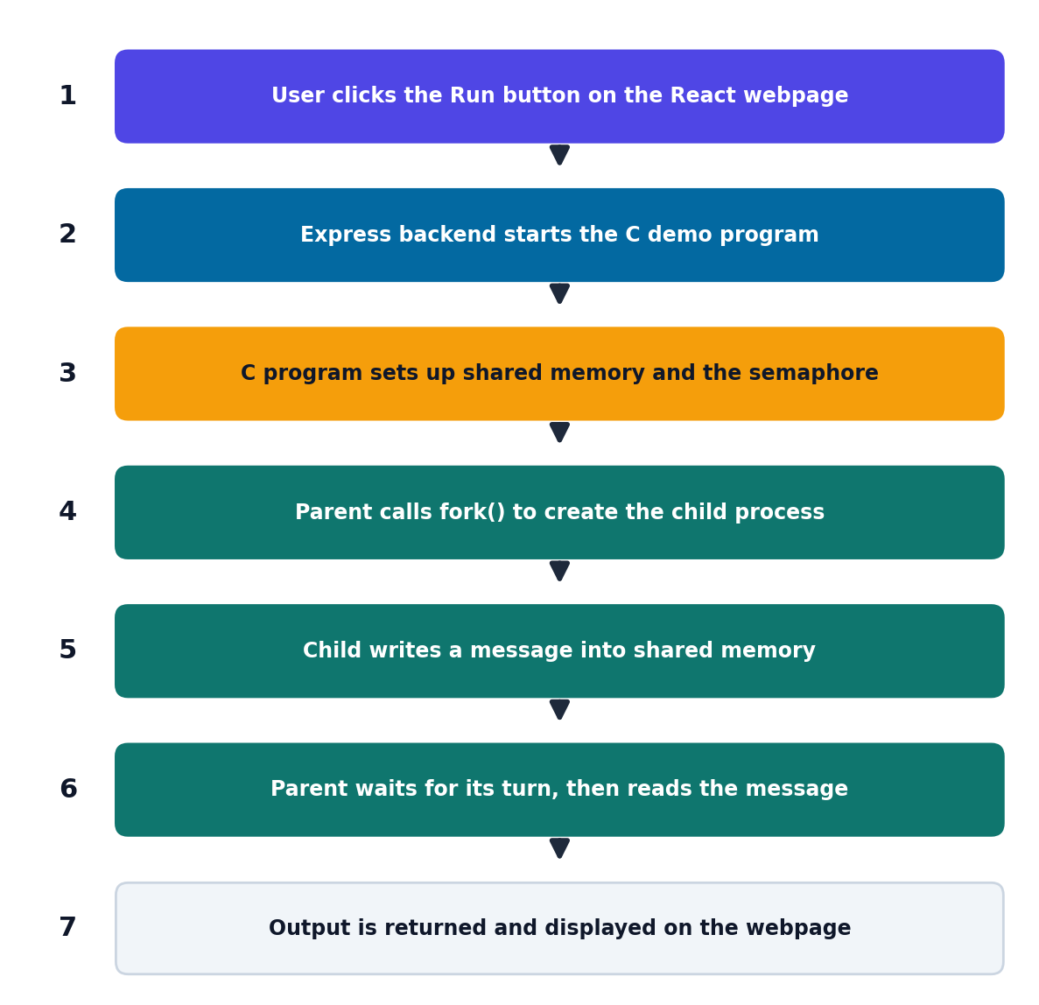
Figure 3.2: Process and data exchange workflow

3.4 Design Considerations
Shared memory gives direct access to the same data from several processes, so access must be coordinated. A named semaphore is used for this purpose: it lets the processes take turns so that the parent does not read the message while it is being written. The design uses POSIX interfaces, which are available on Linux and other POSIX-compliant systems. The web layer is kept thin: it is used to start the demo and display its output, while the inter-process communication itself is done entirely inside the C program.

CHAPTER 4: IMPLEMENTATION

4.1 Development Environment
The core of the project is a C program compiled with GCC. It uses POSIX interfaces for shared memory, semaphores and process creation. The backend is written with Express.js on Node.js, and the frontend is built with React and Vite. Source files can be edited in any text editor, and the C program is compiled and run from the terminal.

4.2 Project Folder Structure
The folder structure below is an example layout. Please replace the folder and file names with those used in your actual project.
shared-memory-demo/
├── c-demo/
│ └── <your_demo>.c (C program: shared memory + fork + semaphore)
├── backend/ (Express.js server that runs the C demo)
└── frontend/ (React + Vite webpage with the Run button)
Figure 4.1: Project folder structure (example, to be updated)

4.3 Installation and Setup
Install the compiler and Node.js tools if they are not already available (example commands for Ubuntu):
sudo apt update
sudo apt install build-essential nodejs npm
Install the dependencies of the backend and the frontend from their project folders:
cd backend && npm install
cd ../frontend && npm install

4.4 Compilation
Compile the C program with GCC. On many Linux systems, the real-time and thread libraries must be linked for shared memory and semaphores. Replace the file name with the actual source file name.
gcc -Wall -Wextra -O2 <your_demo>.c -o <your_demo> -lrt -pthread
The compiler checks the source and creates the executable. Compiler errors must be corrected before running the program, and warnings should be reviewed because they may indicate correctness issues.

4.5 Execution
The C demo can be run directly from the terminal to check that it works. The full system is then started by running the backend and the frontend (example commands):
./<your_demo>

cd backend && node <your_server>.js
cd frontend && npm run dev
Open the address printed by Vite in a web browser and click the button to run the demo.

4.6 Module-Wise Implementation

4.6.1 Creating the Shared Memory Region
The program calls shm_open() to create or open a named shared memory object, ftruncate() to set its size, and mmap() to map it into the process's address space. Because the region is mapped as shared, the data written by one process can be seen by the other.

4.6.2 Child Process Creation
The program calls fork() to create a child process. The return value of fork() is used to decide which code runs in the parent and which in the child. The child inherits the shared memory mapping from the parent.

4.6.3 Semaphore Coordination
A POSIX named semaphore coordinates access to the shared memory. A process waits on the semaphore before using the memory and signals it when finished, so the processes take turns and the data stays consistent.

4.6.4 Writing and Reading the Message
In the working demonstration, the child process writes a message into the shared memory region. The parent process then reads that message from the same region and prints it.

4.6.5 Backend and Frontend Integration
The React/Vite frontend provides a button on a webpage. When the button is clicked, a request is sent to the Express.js backend, which runs the C demo and returns its output. The frontend then displays that output to the user.

4.7 Logging
The terminal output of the C program can be redirected to a file for inspection and for inclusion in the project demonstration:
./<your_demo> > logs/output.txt 2>&1
cat logs/output.txt
The log should be described as a record of the specific run, because the output depends on the environment in which the program was executed.

CHAPTER 5: TESTING AND RESULTS

5.1 Testing Strategy
Testing begins with compiling the C program and running it from the terminal. The web interface is then tested by running the backend and frontend and clicking the button on the webpage. The objective is to verify that the child process writes a message into shared memory, that the parent process reads it, and that the output is visible on the webpage.

5.2 Test Cases
Test | Action | Expected observation
Compilation | Compile the C source with GCC | The executable is created without errors.
C demo run | Run the compiled program in the terminal | The child writes a message and the parent reads and prints it.
Backend run | Start the Express.js backend | The server starts and is ready to accept requests.
Frontend run | Start the React/Vite frontend and open it in a browser | The webpage with the Run button is displayed.
End-to-end demo | Click the Run button on the webpage | The demo runs and its output is shown on the webpage.

5.3 Illustrative Output
The following is a format example only. The actual message text and values must be copied from a real run before being presented as measured results.
========================================
SHARED MEMORY DATA EXCHANGE DEMO
========================================
Child process : writing message to shared memory
Parent process: reading message from shared memory
Message received: <actual message from your run>
========================================
Figure 5.1: Example terminal output (illustrative)

5.4 Webpage Screenshot
[ Insert screenshot of the webpage and demo output here ]

Figure 5.2: Webpage screenshot (placeholder)

5.5 Interpreting Results
A successful demonstration shows that the child process wrote a message into shared memory and that the parent process was able to read the same message. This confirms that the two processes share the memory region and that the semaphore allowed them to take turns. The results describe the behaviour of the demonstration only; no performance measurements were taken for this report.

5.6 Result Recording
For final submission, record the operating system and version, the exact commands used, and the actual outputs. Screenshots of the webpage and terminal may be added after testing. Do not report sample values from this template as experimental results.

CHAPTER 6: CHALLENGES AND LIMITATIONS

6.1 Challenges Faced

6.1.1 Coordinating Access to Shared Memory
Shared memory has no built-in protection against simultaneous access. The processes must be coordinated so that one does not read while the other is writing. A named semaphore is used for this, and its correct use is important for consistent data.

6.1.2 Understanding the Process and Memory Interfaces
Using shm_open(), ftruncate(), mmap(), fork() and semaphores together requires understanding how each interface works and the order in which they are used. Correct sizing and mapping of the shared region are essential for the processes to see the same data.

6.1.3 Connecting a C Program to a Web Application
The C demo is a command-line program, while the frontend runs in a browser. The Express.js backend acts as a bridge: it runs the C program and returns its output so that it can be displayed on the webpage.

6.2 Limitations
- The demonstration involves one parent process and one child process exchanging a message.
- The web interface is used only to run the demo and view its output.
- The program relies on POSIX interfaces and is intended for POSIX-compliant systems such as Linux.
- No performance measurements have been made, so no performance claims are made in this report.
- Advanced features such as multiple writers, large structured data, or detailed error recovery are not claimed as part of this project.

6.3 Safety and Reliability Notes
Shared memory objects and named semaphores can remain in the system after a program ends unless they are removed (for example with shm_unlink() and sem_unlink()). Programs should be tested carefully, including error paths such as failure to create or map the shared memory, and should only be run in environments where you are authorized to do so.

CHAPTER 7: CONCLUSION AND FUTURE WORK

7.1 Conclusion
The Shared Memory Based Data Exchange System demonstrates how processes can exchange data through POSIX shared memory while a named semaphore coordinates access. Using shm_open(), ftruncate(), mmap() and fork(), the C program lets a child process write a message into shared memory and a parent process read it. The demo is connected to an Express.js backend and a React/Vite frontend, so it can be run with a button click and its output viewed on a webpage.
The current implementation is intentionally small and should be treated as an educational prototype. Its value lies in showing the idea of shared memory and data consistency clearly.

7.2 Future Work
The following improvements are proposals only. They are not implemented in the current project.
- Support more than one child process.
- Exchange larger or structured messages.
- Add more error handling and checks.
- Show more detailed status on the webpage.

7.3 Skills Learned
- Inter-process communication using POSIX shared memory.
- Creating and managing processes with fork().
- Synchronization using POSIX named semaphores.
- C programming, compiling with GCC, and testing.
- Connecting a C program to a web application using Express.js and React/Vite.

REFERENCES
- Linux man-pages project. shm_open(3) — create/open POSIX shared memory objects. https://man7.org/linux/man-pages/man3/shm_open.3.html
- Linux man-pages project. mmap(2) — map files or devices into memory. https://man7.org/linux/man-pages/man2/mmap.2.html
- Linux man-pages project. ftruncate(2) — truncate a file to a specified length. https://man7.org/linux/man-pages/man2/ftruncate.2.html
- Linux man-pages project. fork(2) — create a child process. https://man7.org/linux/man-pages/man2/fork.2.html
- Linux man-pages project. sem_overview(7) — overview of POSIX semaphores. https://man7.org/linux/man-pages/man7/sem_overview.7.html
- GNU Compiler Collection. GCC documentation. https://gcc.gnu.org/onlinedocs/
- Express.js. Express documentation. https://expressjs.com/
- React. React documentation. https://react.dev/
- Vite. Vite documentation. https://vite.dev/

