ព្រះរាជាណាចក្រកម្ពុជា
ជាតិ សាសនា ព្រះមហាក្សត្រ
3
វិទ្យាស្ថានបច្ចេកវិទ្យាកម្ពុជា
ដេប៉ាតឺម៉ង់ថ្នាក់ឆ្នាំសិក្សាមូលដ្ឋាន

កិច្ចការស្រាវជ្រាវក្រុម(៥)
មុខវិជា្ជ៖...........................................................
និស្សិតឈ្មោះ ID ពិន្ទុ
១. សុងសៀង ពិសី e20220225 .....................
២. ទៀង សុបញ្ញា e20220547 .....................
៣. សួរ អាលីយា e20220969 .....................
បង្រៀនដោយ៖ លោកគ្រូ/អ្នកគ្រូ ចាន់ បូណា
លោកគ្រូ លីវ ប៊ុនថន

ឆ្នាំសិក្សា ២០២៣~២០២៤

Table of Contents
Table of Contents I
List of Figure II
I. Introduction 1
1.1 Project purpose 1
1.2 Problem Statement 1
1.3 Objective 1
1.4 Scope 1
1.5 Overview of the report 1
II. Implementation 2
2.1 Development Environment 2
2.2 Key Concepts and Algorithms 2
2.3 Code Explanation 2
III. Results 6
3.1 Test Cases 7
IV. Conclusion 9
4.1 Summary of Achievements 9
4.2 Learning Outcomes 9
4.3 Future Work 9

List of Figure
Figure 1: Menu of the system 7
Figure 2:Adding employee information into system 7
Figure 3:Displaying employee information from system 8
Figure 4:Updating new employee information to system 8
Figure 5:Searching employee information from system 8
Figure 6:Deleting employee information from system 9

Introduction

1.1 Project purpose
The purpose of this project is to develop an EMPLOYEE MANAGEMENT SYSTEM that allows users to ADD in new employees , SHOW the list of the employees , UPDATE new employees , and DELETE from the employees list using an excel file for data storage. This system aims to streamline the process of managing employee information in the company , providing a more efficient and organised way for companies to track and manage their employees.

1.2 Problem Statement

Companies often face significant challenges in managing their employees' information, including keeping track of new employees or old employees that are still working in the companyy , updating employees’ information , and maintaining an organised database. Traditional methods such as paper records or basic spreadsheets can be inefficient and prone to errors, leading to issues like lost or misfiled employees’ information and inaccurate inventory counts.

1.3 Objective
The objectives of this project are:
- To develop a console-based application for managing employees’ record
- To implement CRUD operations for employees’ records.
- To store and manage employee data using an excel file.
- To provide a user-friendly interface for the company.

1.4 Scope
The project focuses on the following functionalities:
- Adding new employees’ records.
- Viewing existing employees’ records.
- Updating employees’ information.
- Deleting employees’ information.
- Reading from and Writing to Excel file.

1.5 Overview of the report
This report covers the implementation details of the Employees Management System, the results of testing the application, and conclusions of the project. The report is divided into four main sections: Introduction, Implementation, Results, and Conclusion.

Implementation

2.1 Development Environment
In this section, I present the development tools and Integrated Development Environment (IDE) used in this project. The project was developed using Visual Studio Code as the IDE, which provided a comprehensive environment for writing, debugging, and testing the code. The GCC compiler was used to compile the C++ code. The libraries “iostream” and “fstream” were used for file handling operations, particularly for reading and writing data to an Excel file.

2.2 Key Concepts and Algorithms

This section details the primary programming concepts and techniques used in the project. The implementation heavily relied on:

Loops: utilised for iterating over employee records and menu options, ensuring efficient handling of repeated tasks.

Enum : utilised for colouring the text in order to make the output looks more interesting

Functions: Used to enhancing readability and maintainability by encapsulating specific tasks.

Double Link List: Used to manage the dynamic list of employee information, allowing efficient insertion, deletion, and traversal operations.

File Handling: Used “fstream” to read from and write to Excel files, ensuring that the employee information is persistently stored and easily accessible.

2.3 Code Explanation
In this section, I describe the implementation of the primary features of the Employee Management System, focusing on how each functionality was developed and integrated into the system.
- Adding Employee information
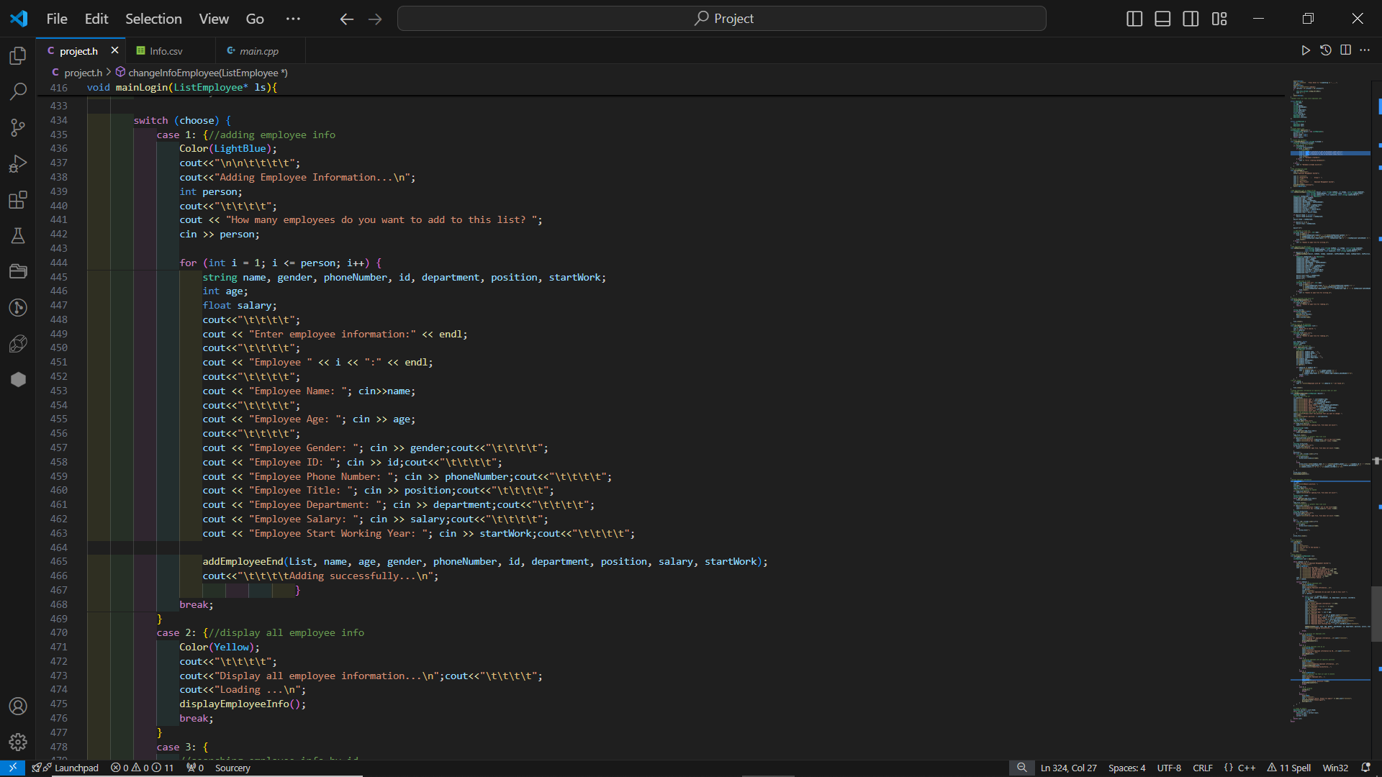
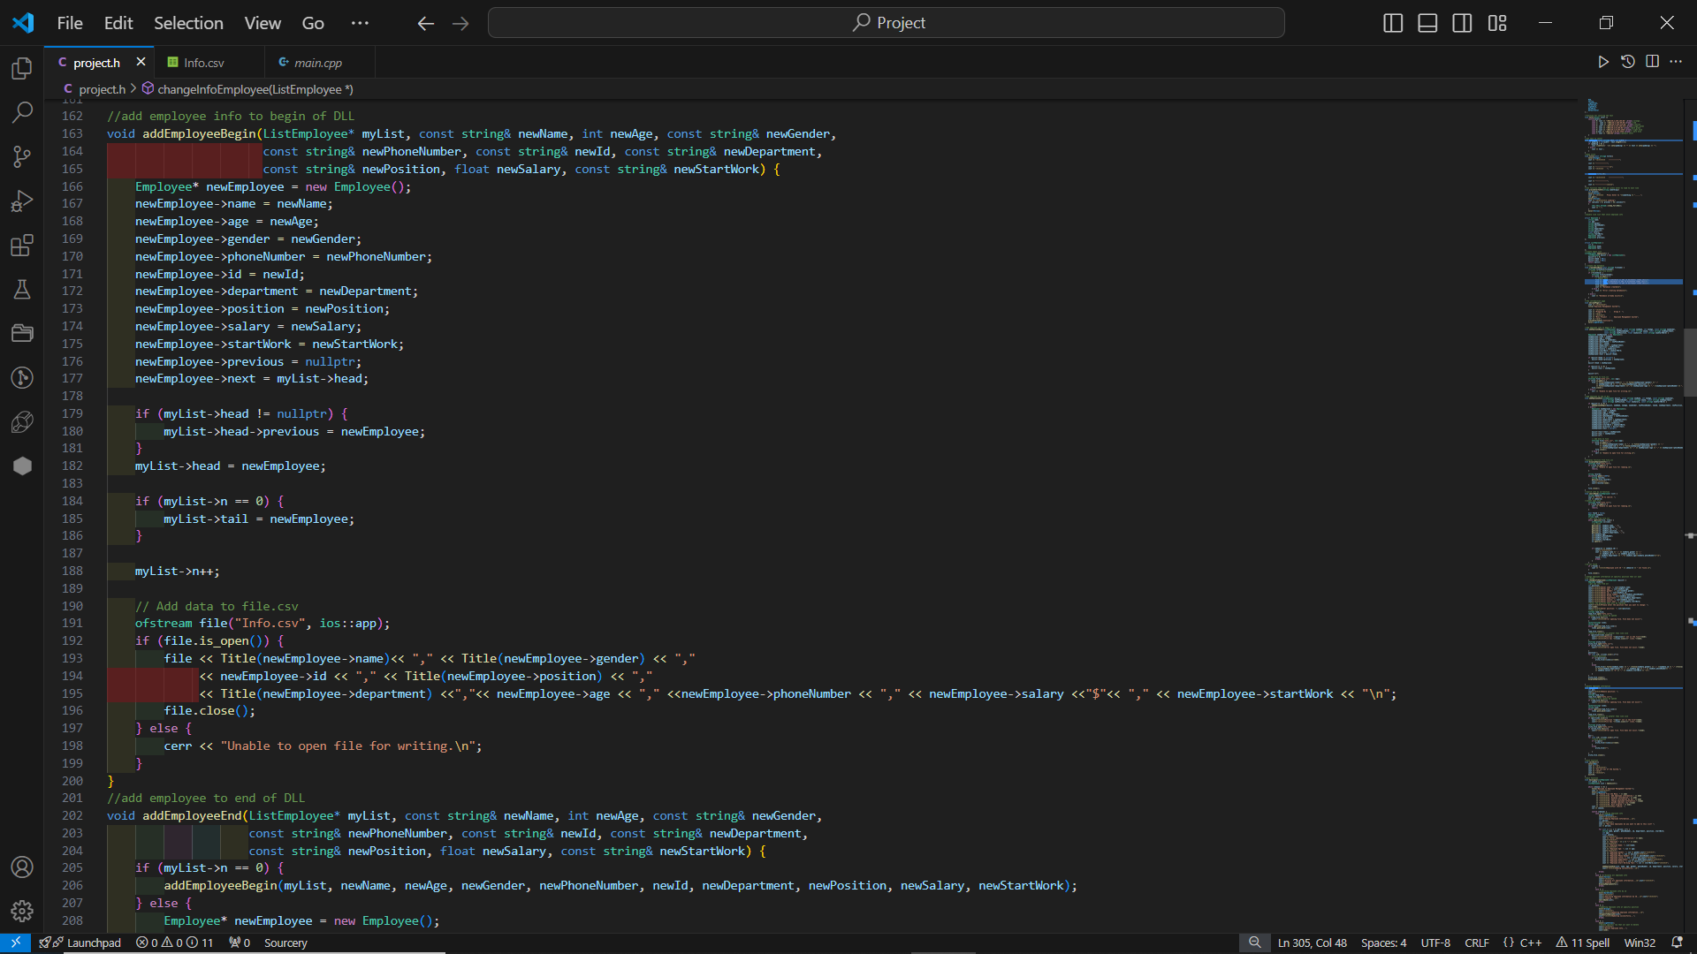
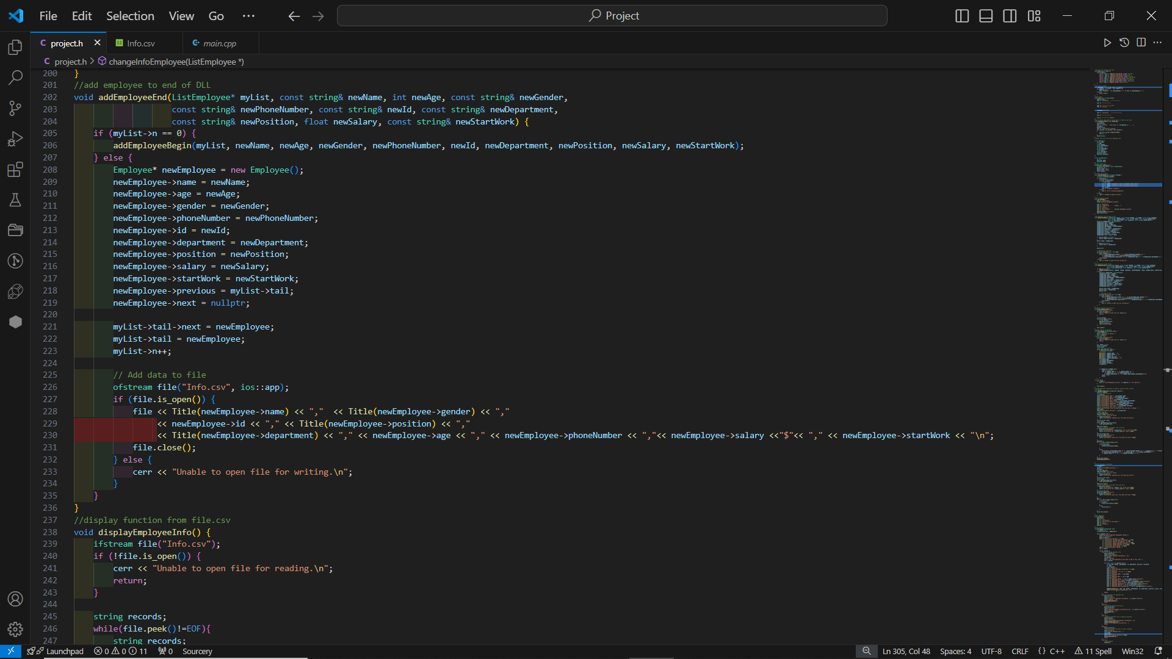
The application allows users to add new employee records by entering details such as book ID, name, age, phone number, start working year, gender, title, department and salary. The new employee data is appended to the existing records and saved to the Excel file. The double linked list is used to dynamically manage the list of employee records, allowing efficient insertion of new records.

- Displaying employee information
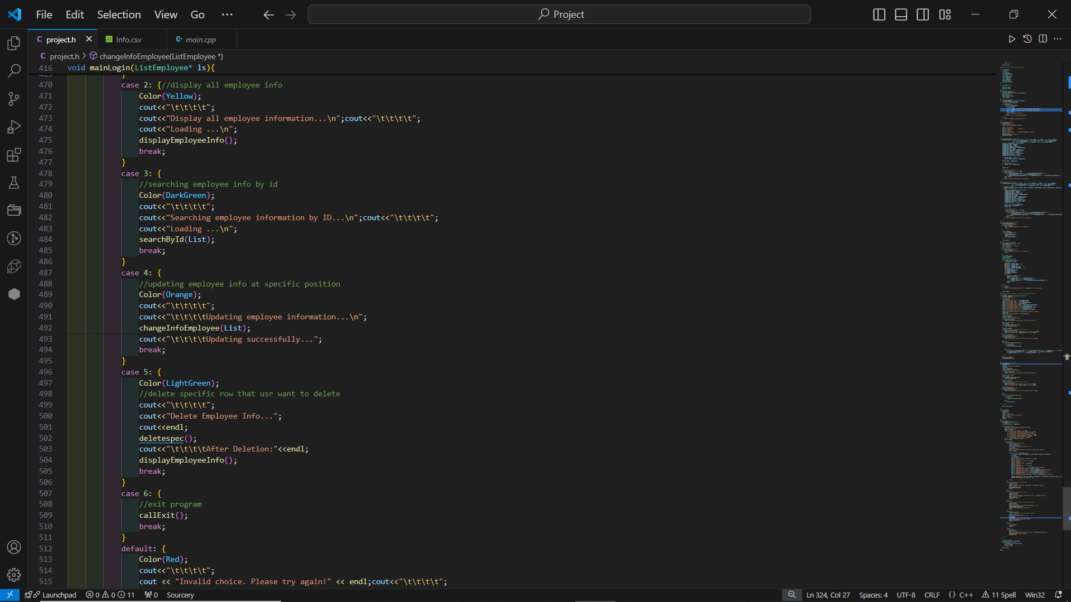
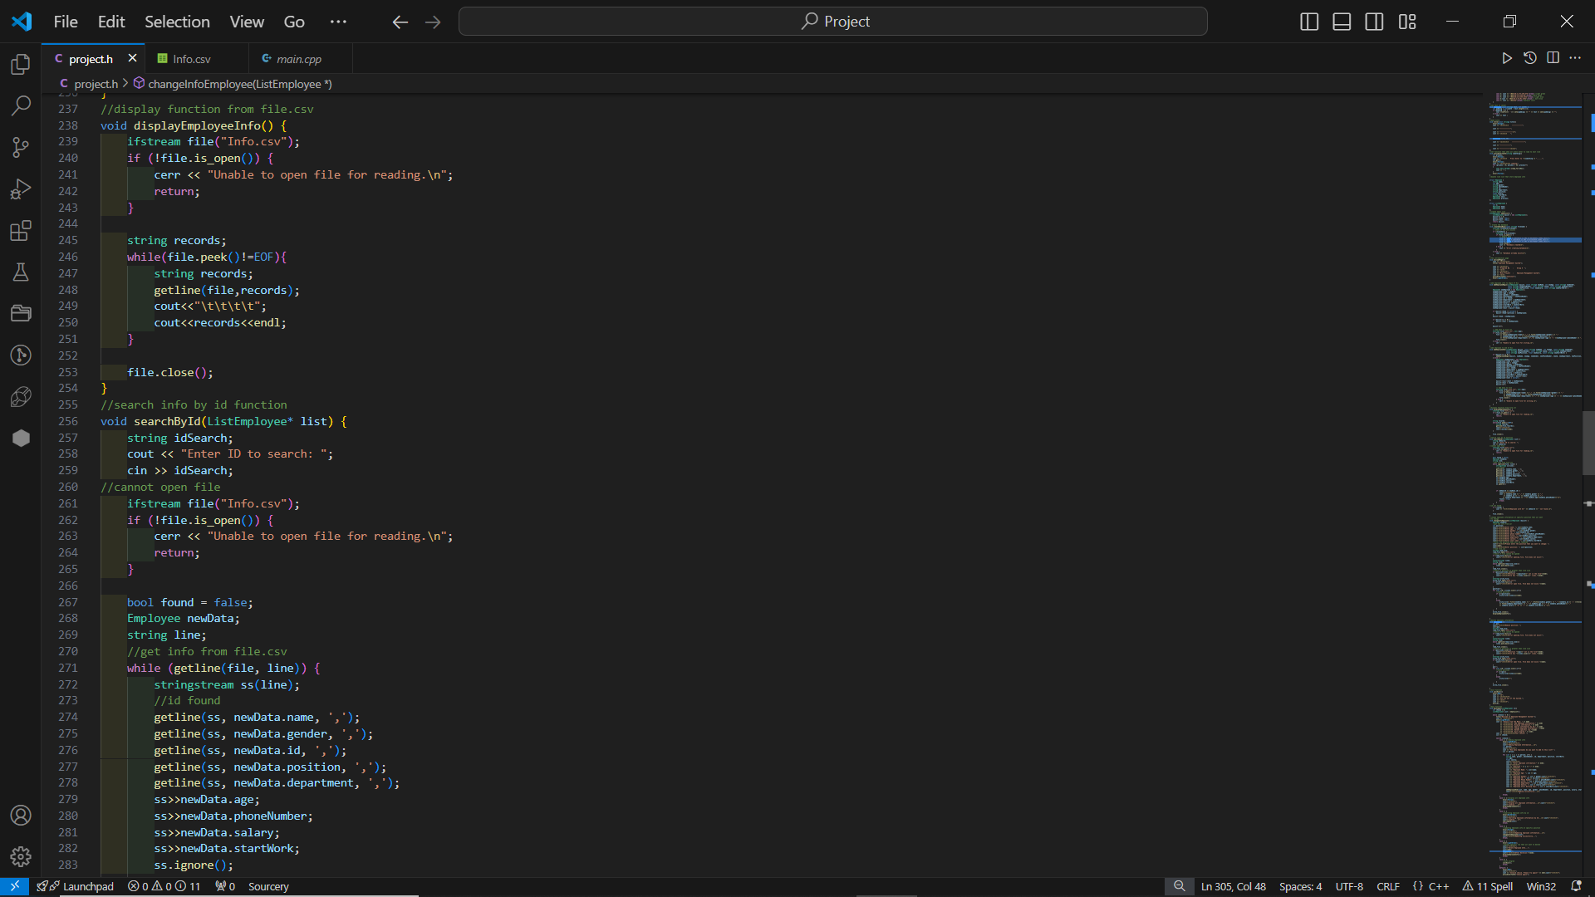
Users can view all employee records stored in the system. The application reads the data from the Excel file and displays it in a user-friendly format on the console. Loops are used to iterate through the records and print them, providing a clear and organised presentation of the employee data.

- Updating employee information
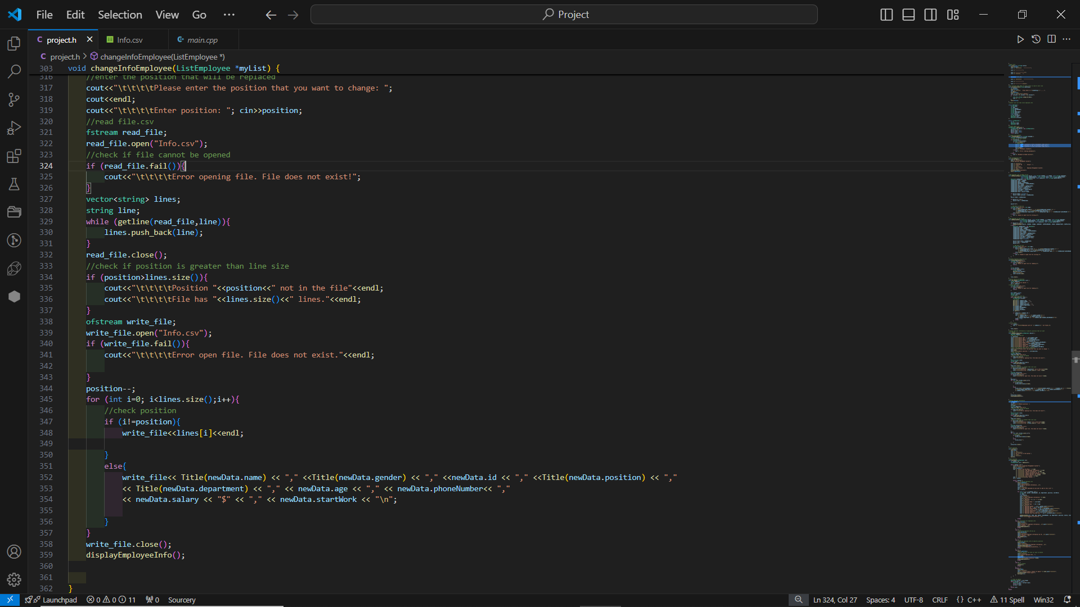
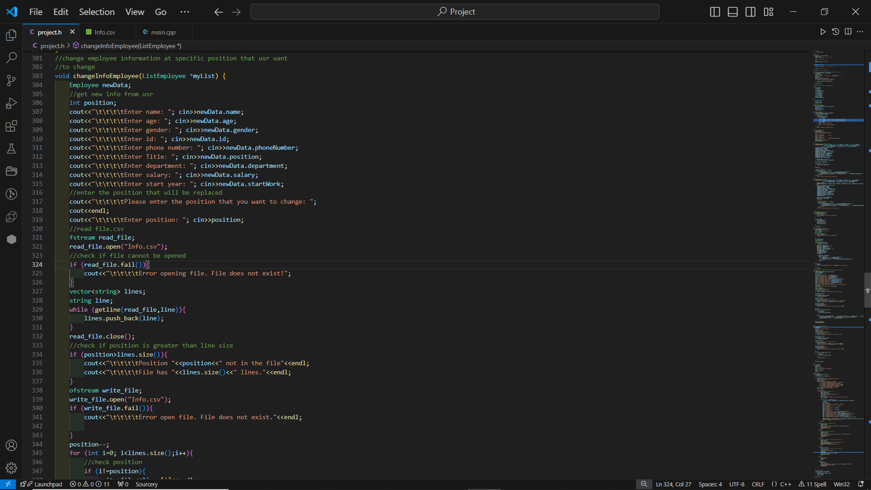
Users can change or update employee information in any position they’d love to. First, the users will be asked by the system to input new information then input a specific position. Then, the system will update new data into the excel file.
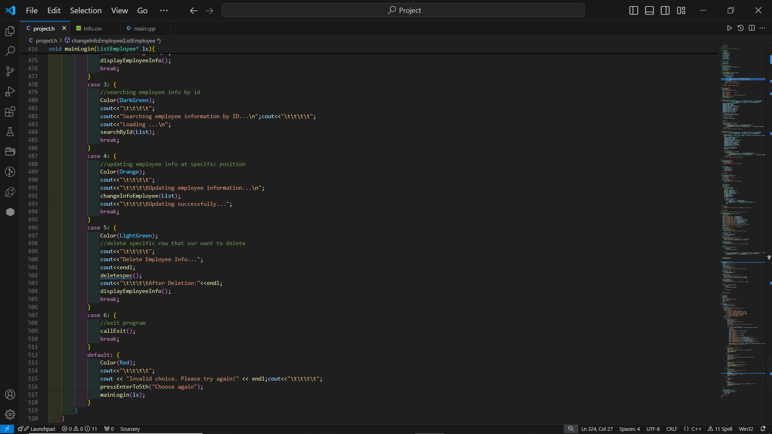

- Searching employee information through id

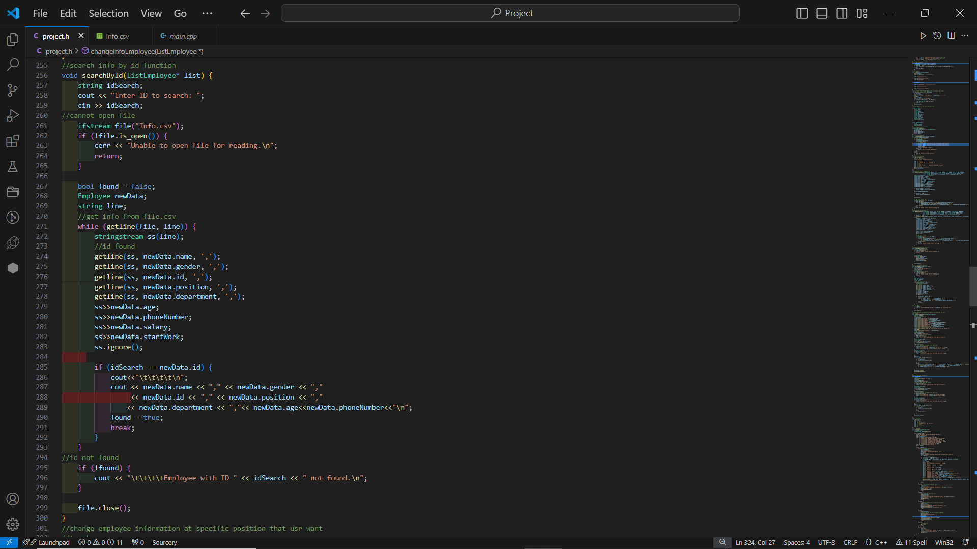
Users can search specific employee data through inputting the id of that employee. Initially, the system has to ask for the id first then it will read from excel file and check through the conditions. Finally, if it meets the true condition (the id that users have inputted), it will display the employee data according to their id.

- Deleting specific employee
Users can delete any employee records from the system. For deleting employee information from excel files, users just need to input the specific position that they want to delete. The system will read from the file and check the position. If the position is found, the employee information will delete directly from the excel file.

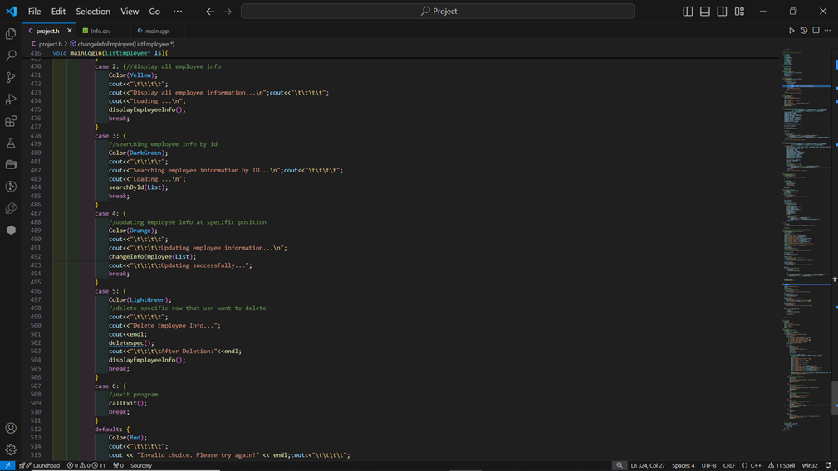
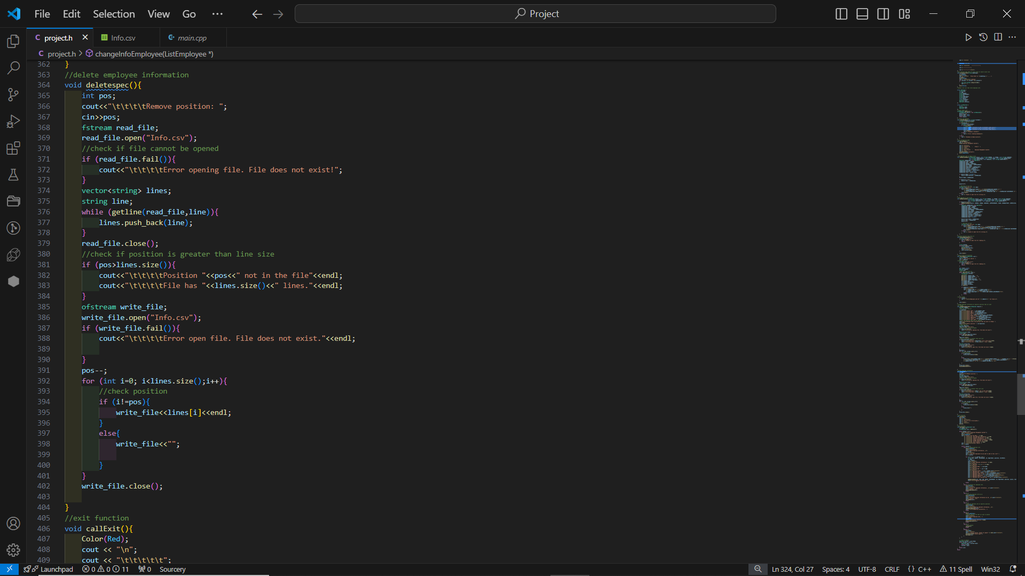
- Exit program

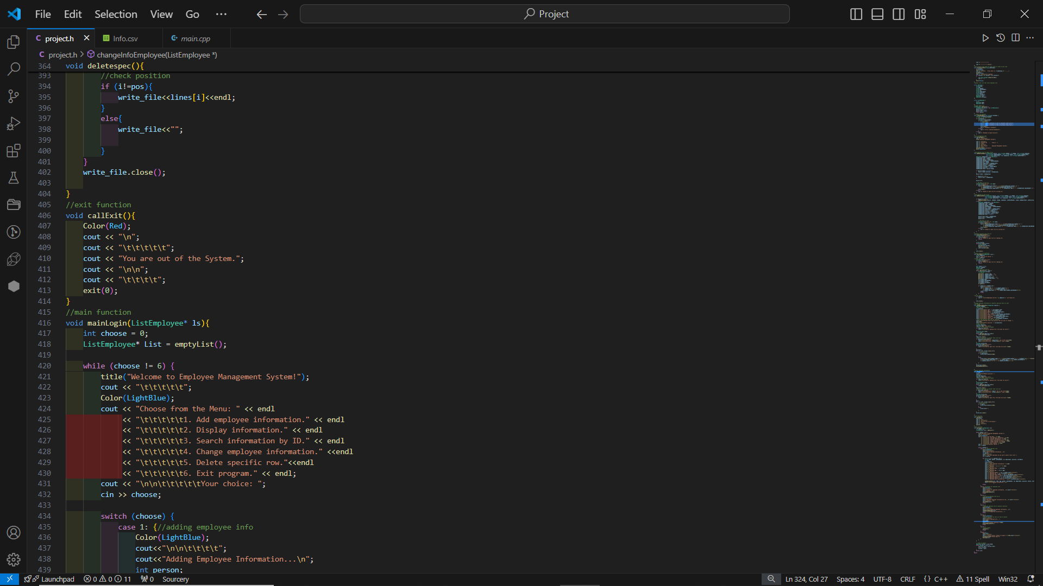
Our program will run until users input number 6 which is the exit program option. In the case that users want to exit the program, they just press number 6 and our program will tell them that “you are out of the system” which means the loop breaks.

Results
In this section, I present the results of testing and validation efforts to ensure the application functions as expected.

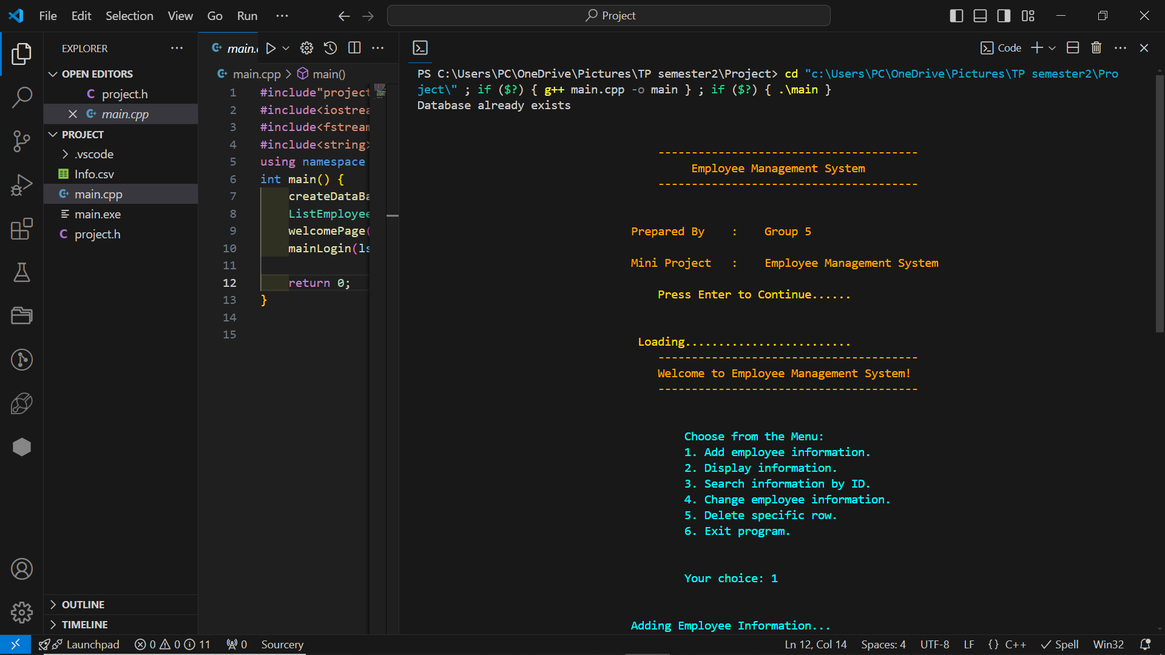
Figure 1: Menu of the system

3.1 Test Cases
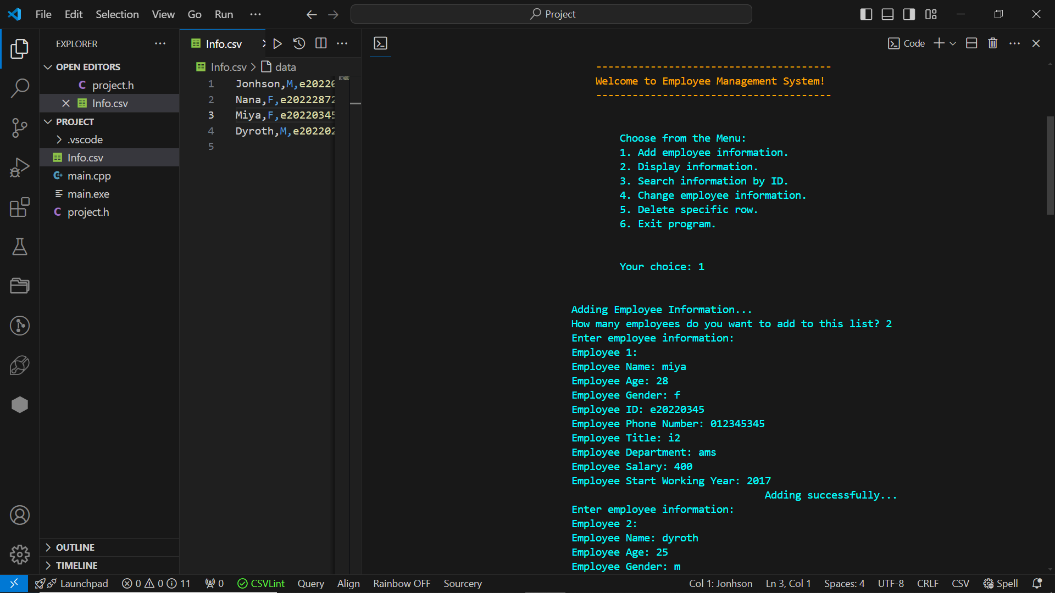
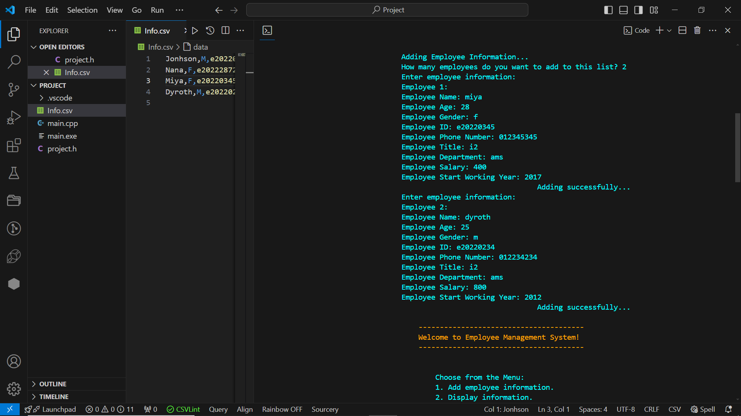
  - Adding Employee information: Verified by adding multiple employee data and
checking if they appear correctly in the Excel file.

Figure 2:Adding employee information into system

  - Viewing Employee data: Ensured that all employees’ information were displayed correctly on the console.
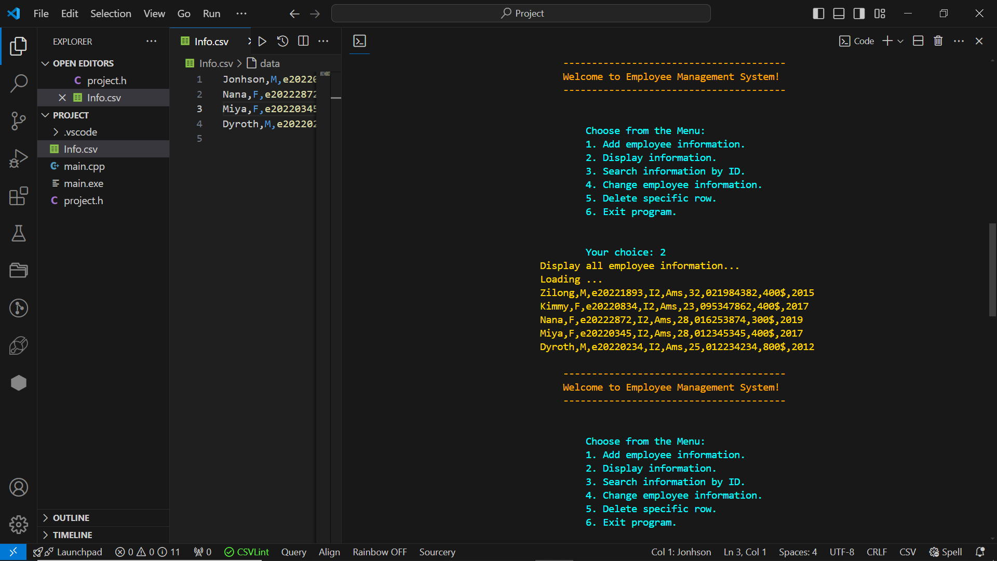

Figure 3:Displaying employee information from system

  - Updating Employee information: Verified by updating Employee details and checking the Excel file for accuracy.
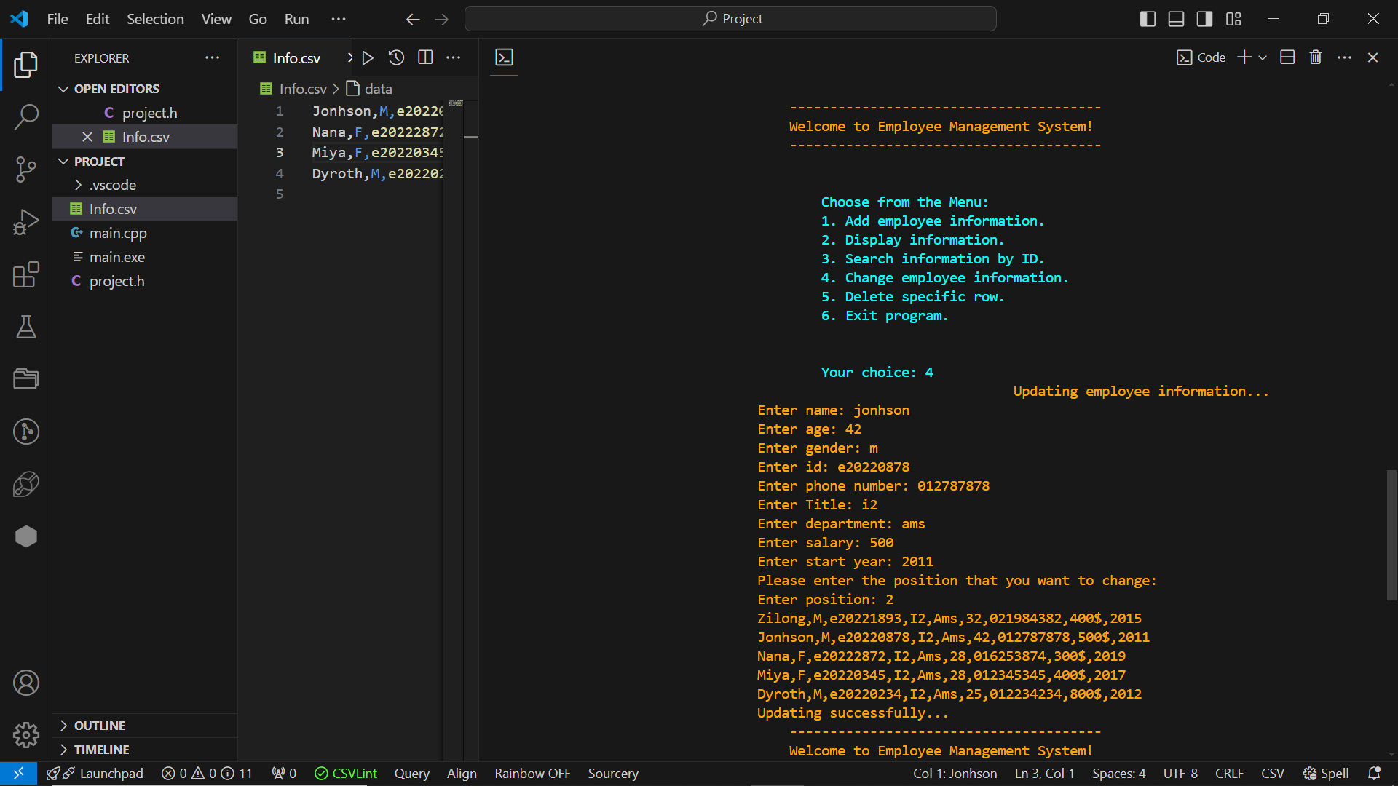
Figure 4:Updating new employee information to system

  - Search Employee by their ID:
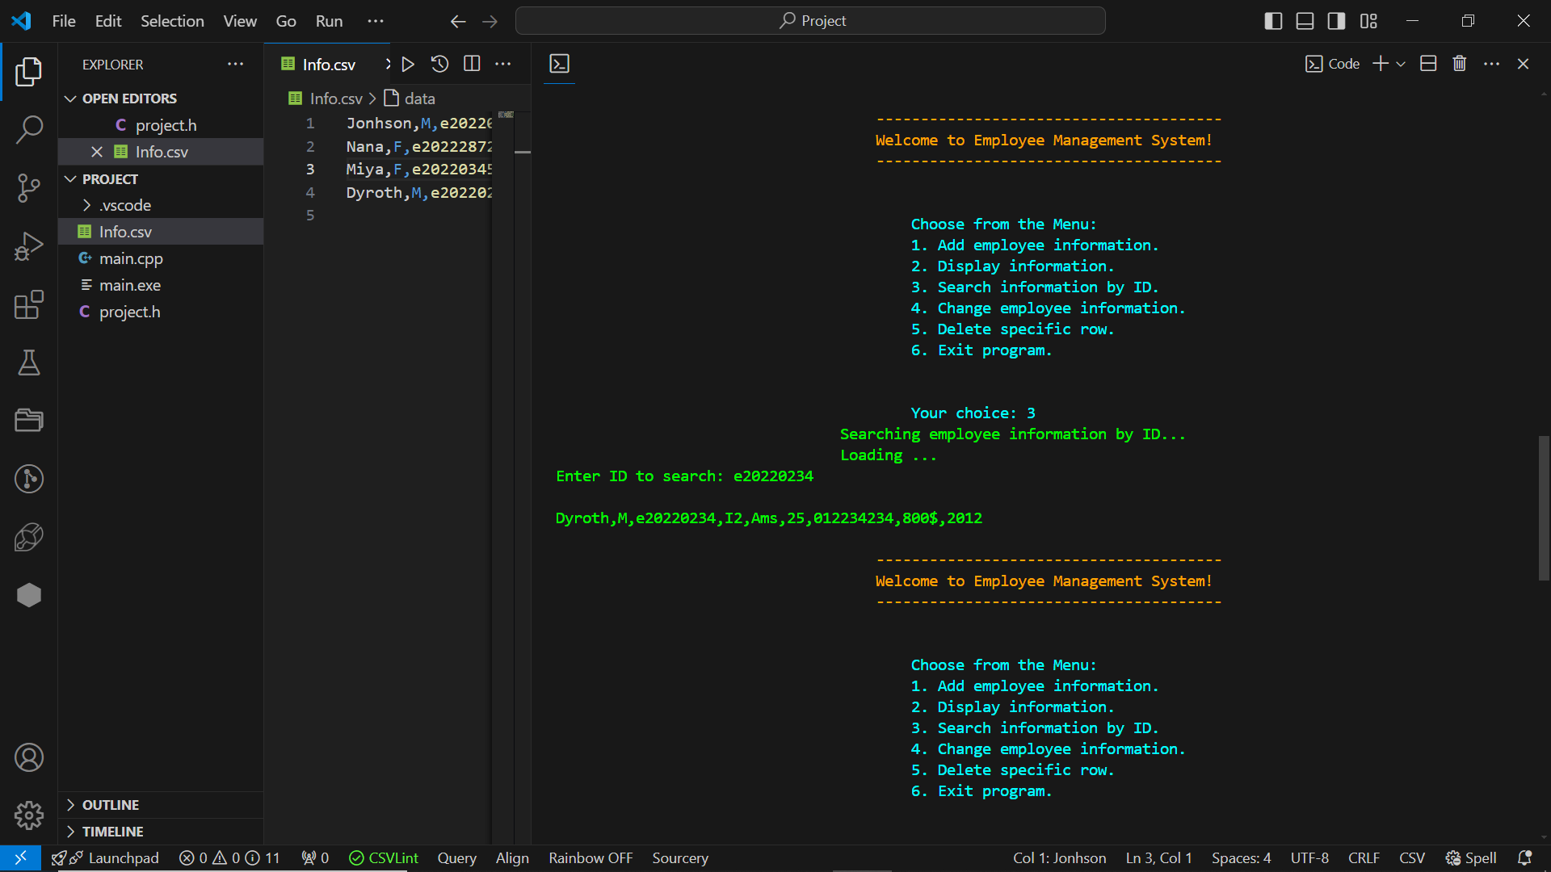

Figure 5:Searching employee information from system

  - Deleting Employee information: Confirmed by deleting employee data position and ensuring they were removed from the Excel file.
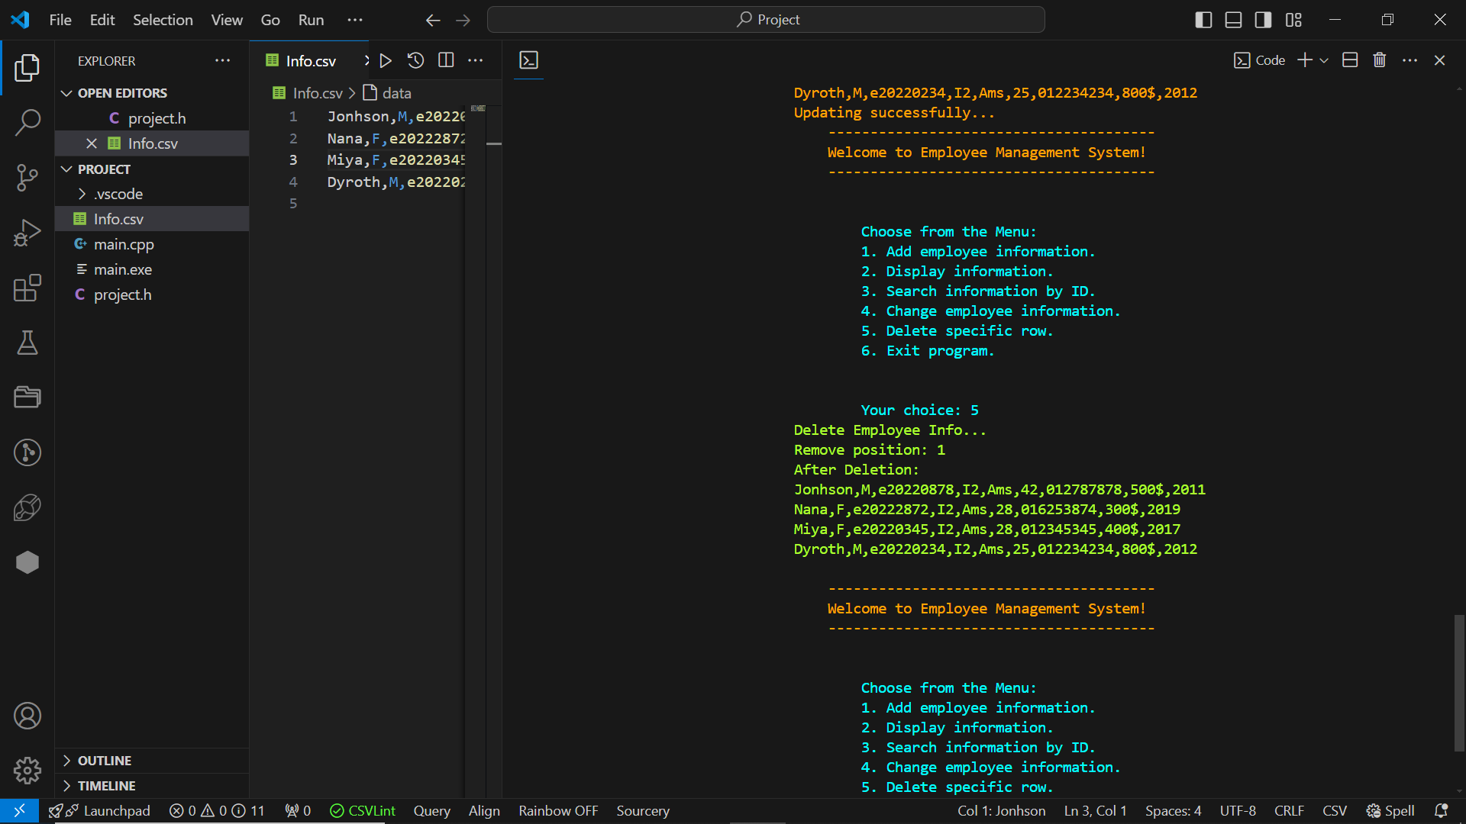

Figure 6:Deleting employee information from system

Conclusion

4.1 Summary of Achievements
In this section, I summarise the key achievements of the project. The Employees Management System successfully implemented CRUD operations for managing employees’ information using an Excel file for data storage. The application met all outlined objectives and provided a functional and efficient solution for employees’ information management.
4.2 Learning Outcomes
This project provided valuable insights into:
- Using the “fstream” library for Excel file manipulation in C++.
- Implementing CRUD operations in a console-based application.
- Handling file operations and ensuring data consistency.

Utilising data structures such as Loops, Double Linked Lists, Enum, Functions and File Handling to manage employees’ records effectively.

4.3 Future Work
In this section, I suggest potential future improvements and extensions to the project.
- GUI Implementation: Developing a graphical user interface to enhance user experience.
- Advanced Search: Adding functionalities to filter and search employee based on different ID.
- Updated employees’ information functions to help organize and change information that update from time to time.

