Reproducible Research -- Peer Assessment 1

By: Sakinah

November 14, 2015

## Reproducible Research -- Peer Assessment 1

### Loading and preprocessing the data

Reading data from excel

mydata <- read.csv("activity.csv")

### The summary of the data

summary(mydata)

## steps date interval   
## Min. : 0.00 2012-10-01: 288 Min. : 0.0   
## 1st Qu.: 0.00 2012-10-02: 288 1st Qu.: 588.8   
## Median : 0.00 2012-10-03: 288 Median :1177.5   
## Mean : 37.38 2012-10-04: 288 Mean :1177.5   
## 3rd Qu.: 12.00 2012-10-05: 288 3rd Qu.:1766.2   
## Max. :806.00 2012-10-06: 288 Max. :2355.0   
## NA's :2304 (Other) :15840

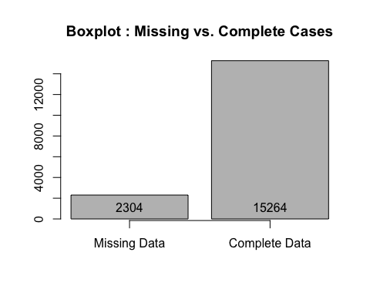

### What is mean total number of steps taken per day?

The **mean** and **median** total number of steps taken per day:

## [1] 10766.19

## [1] 10765

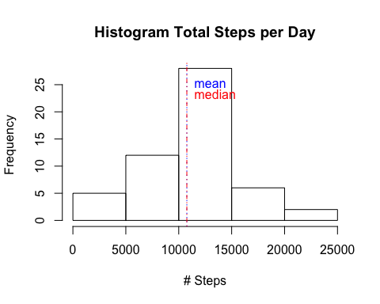

## Min. 1st Qu. Median Mean 3rd Qu. Max.   
## 41 8841 10760 10770 13290 21190

### What is the average daily activity pattern?

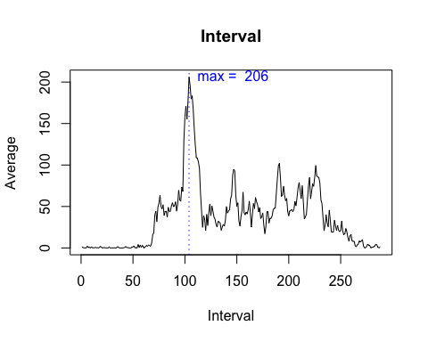

## [1] "835"

## [1] 206

## 835   
## 104

### Imputing missing values

mydata$steps[is.na(mydata$steps)] = mean(mydata$steps, na.rm=TRUE)  
ImpuData = mydata

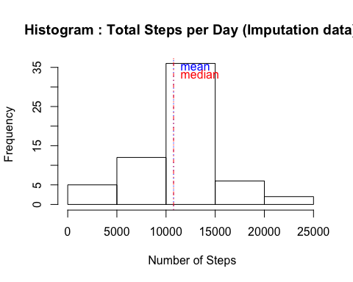

## Min. 1st Qu. Median Mean 3rd Qu. Max.   
## 41 9819 10770 10770 12810 21190

Make a histogram of the total number of steps taken each day and Calculate and report the mean and median total number of steps taken per day. Do these values differ from the estimates from the first part of the assignment? What is the impact of imputing missing data on the estimates of the total daily number of steps?

**By using the average value for imputation, the only difference is in the frequency or the number of observations for the center bar of the new histogram** 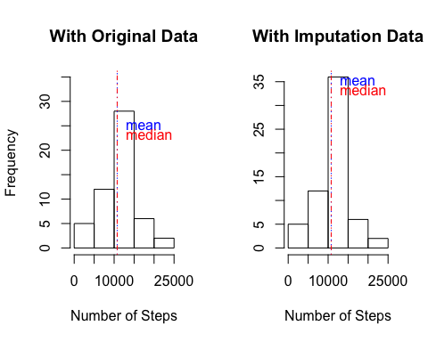

### Are there differences in activity patterns between weekdays and weekends?

This person does most of his or her walking on the weekends! 