UniBus

A one stop solution for universitites to track live location of their buses. It helps the students and teachers to locate their prefered buses when needed. Also the administration gets the insights and tracking information of their buses live and realtime.

The system is a subscription based model where a university can take service from us. Once they contact us, we will install trackers into their buses and give them access to create/update users under their own university domain. There would be a one time installation fee and a monthly charge for the service they receive.

Here are the entities and their features:

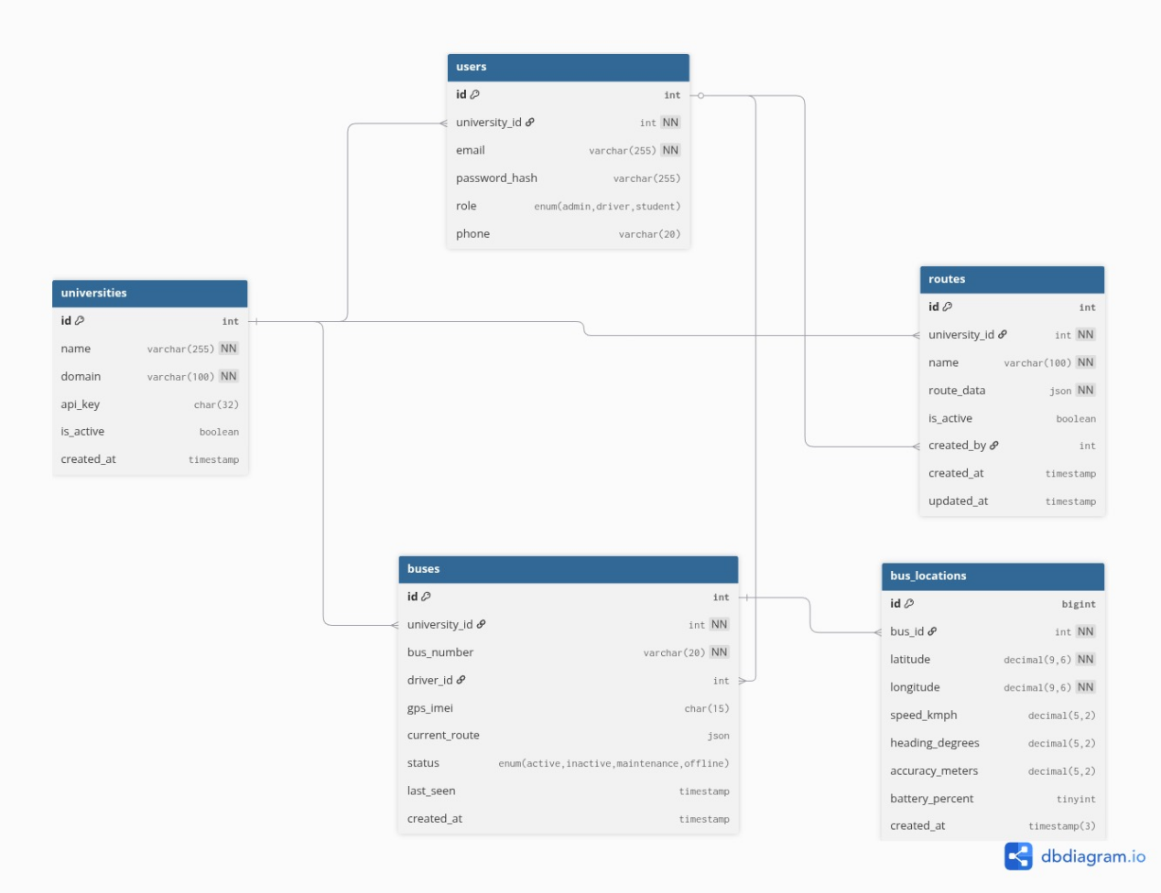

- Users:
  - Role Based User creations
  - Super Admin is the vendor(us) who creates Universities(including a single admin for that university) and assign buses.
  - Admin can Create/Read/Delete/Update users for their own university only.
  - Users can only view the live locations of their university buses only.
- Universities:
  - A university will have a single admin and many users
  - A university will have one or more buses
- Buses:
  - A bus can be registered under a single university.
  - It also registers the last location of the bus.

- Routes:
  - A single bus can have a single predefined route which will be shown to the users.
  - Routes can be configures by the admin of the university.
- Bus_location:
  - Logs the bus locations on every few seconds
  - The logs are kept for 7days or 1month only for administrations use.

Technologies:

- Frontend:
  - Two type of views:
    - Admin
    - User
  - Admin View(Web App):
    - NextJS
    - TypeScript
  - User View(Mobile App):
    - React Native
    - JavaScript
- Backend:
  - NodeJS
  - ExpressJS
  - WebSocket
  - MySQL
  - TypeORM
- Hardware
  - GSM Module
  - GPRS Module
  - Battery
  - Sim
  - ESP32

