**Task 1:**

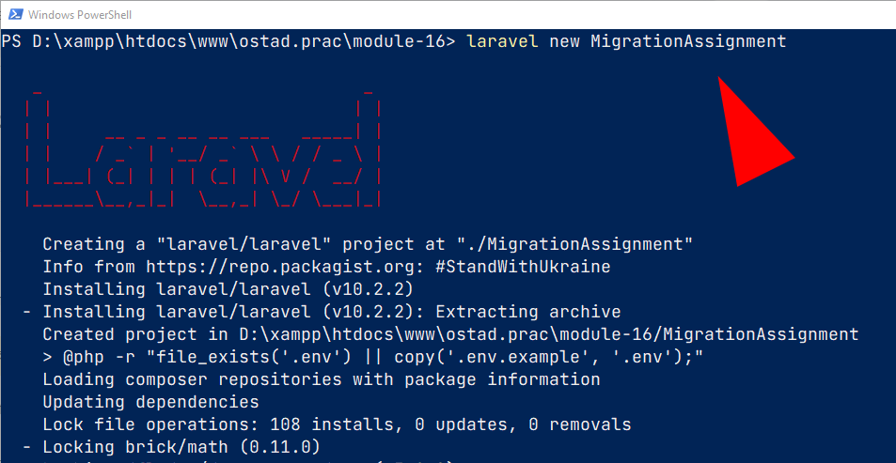

**Task 2:**

php artisan make:migration create_products_table --create=products

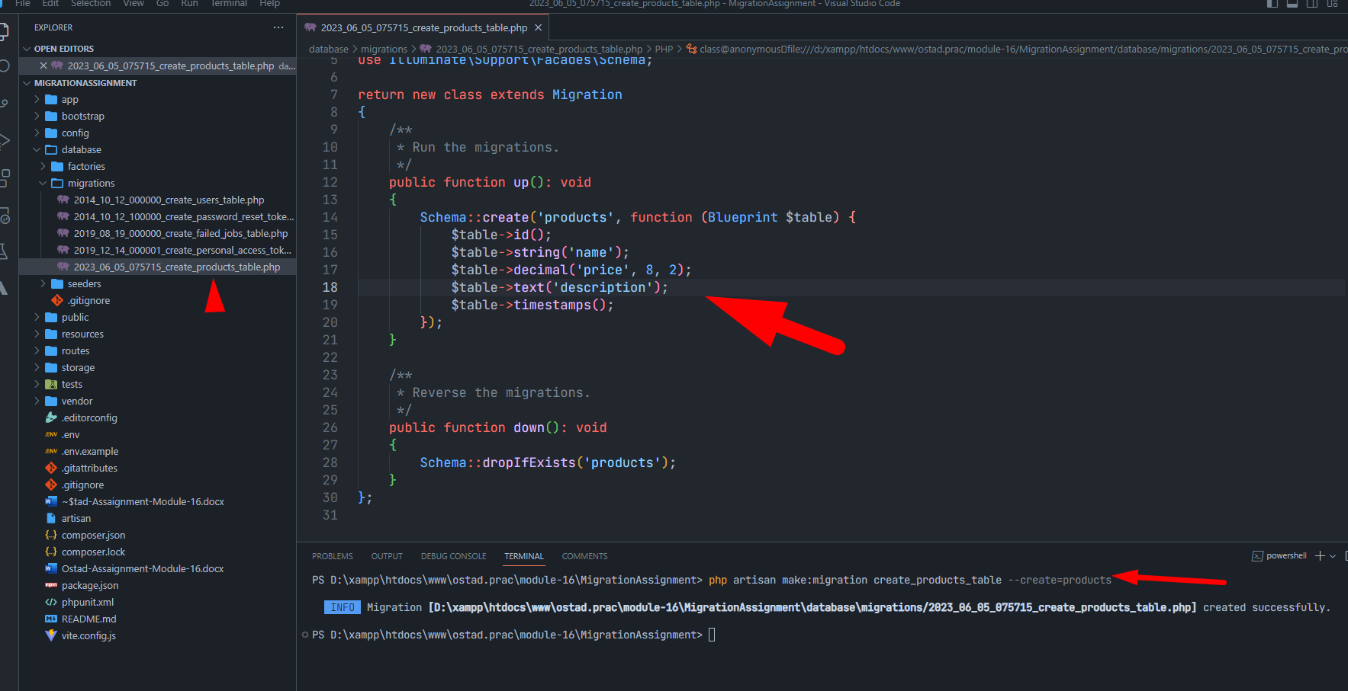

**Task: 3:**

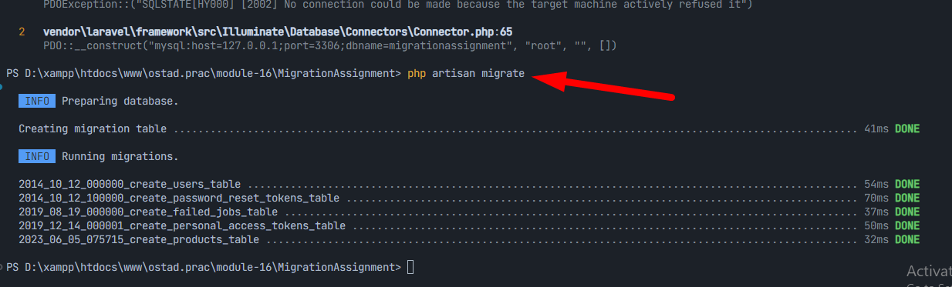

**Task: 4:**

php artisan make:migration add_quantity_to_products_table --table=products

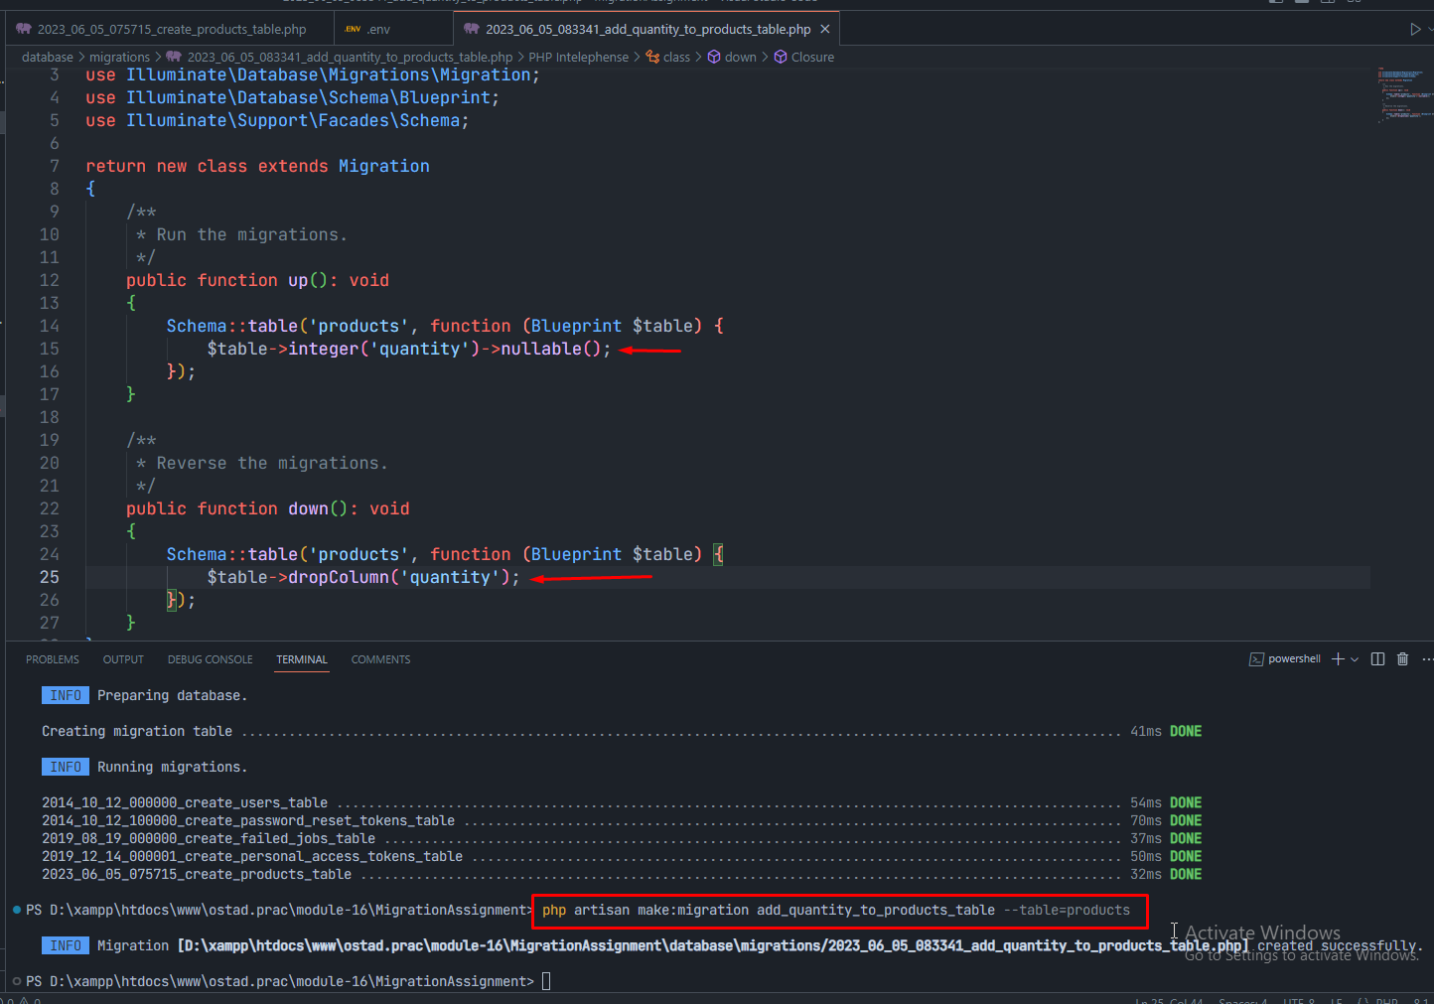

**Task: 5:**

php artisan make:migration add_category_to_products_table --table=products

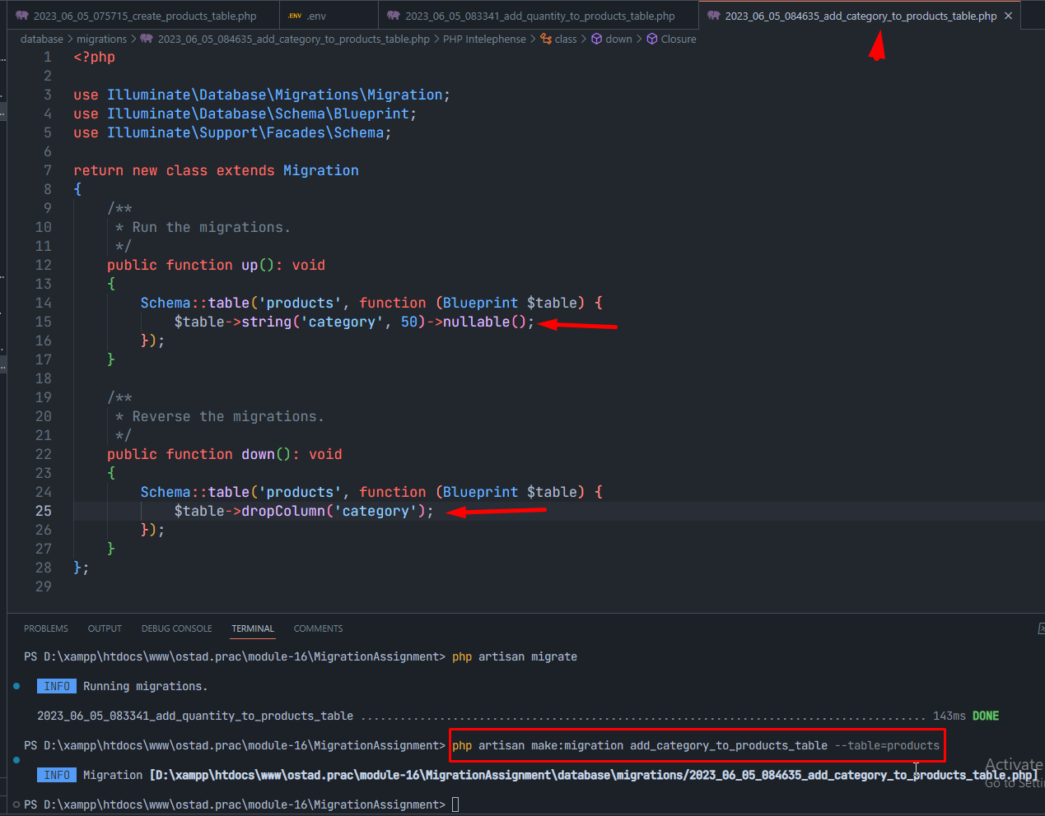

**Task: 6:**

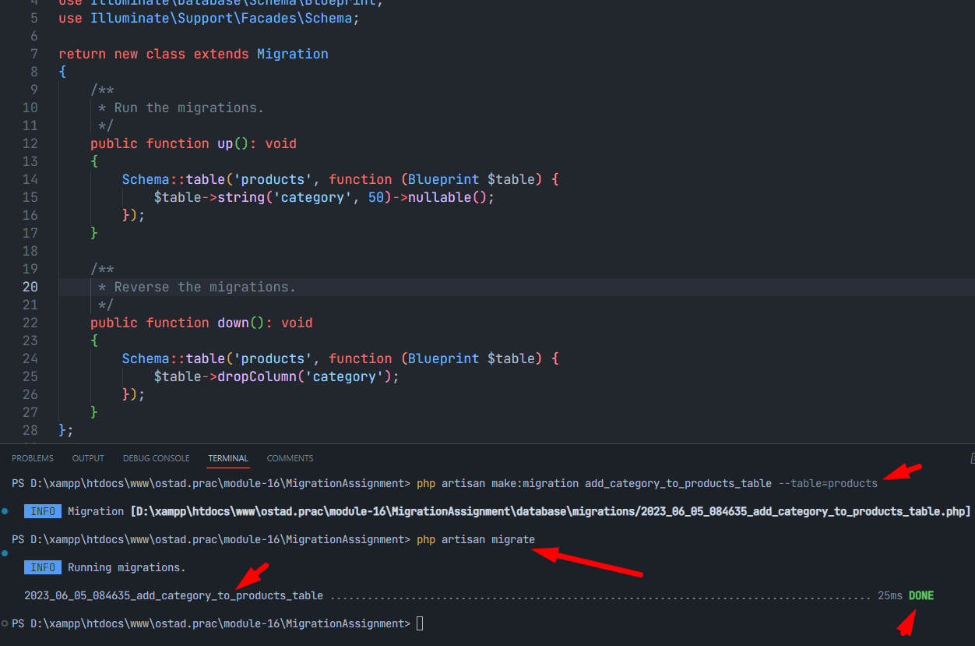

**Task: 7:**

php artisan make:migration create_orders_table

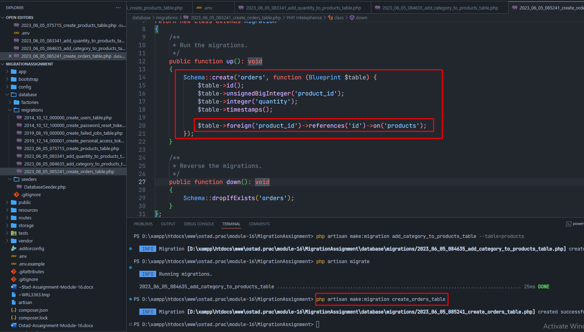

**Task: 8:**

