Comment on the web of <https://www.berkshirehathaway.com/>

For the web berkshirehathaway I think

1. For the Design I think the Design for this Website its look too much minimal and its too old,Should change the category for user to navigate more easy way to other part of the website The user cant find easy way to navigate to other parts of the website so should fix the navbar first for user make it more modern and first page should just for information of the website or any welcome that more user – friendly for user

2.Layout for this website is just too much simple not that modern at the bottom of the website should just change it and put button for user to navigate or re-design the bottom of the page to be more modern website

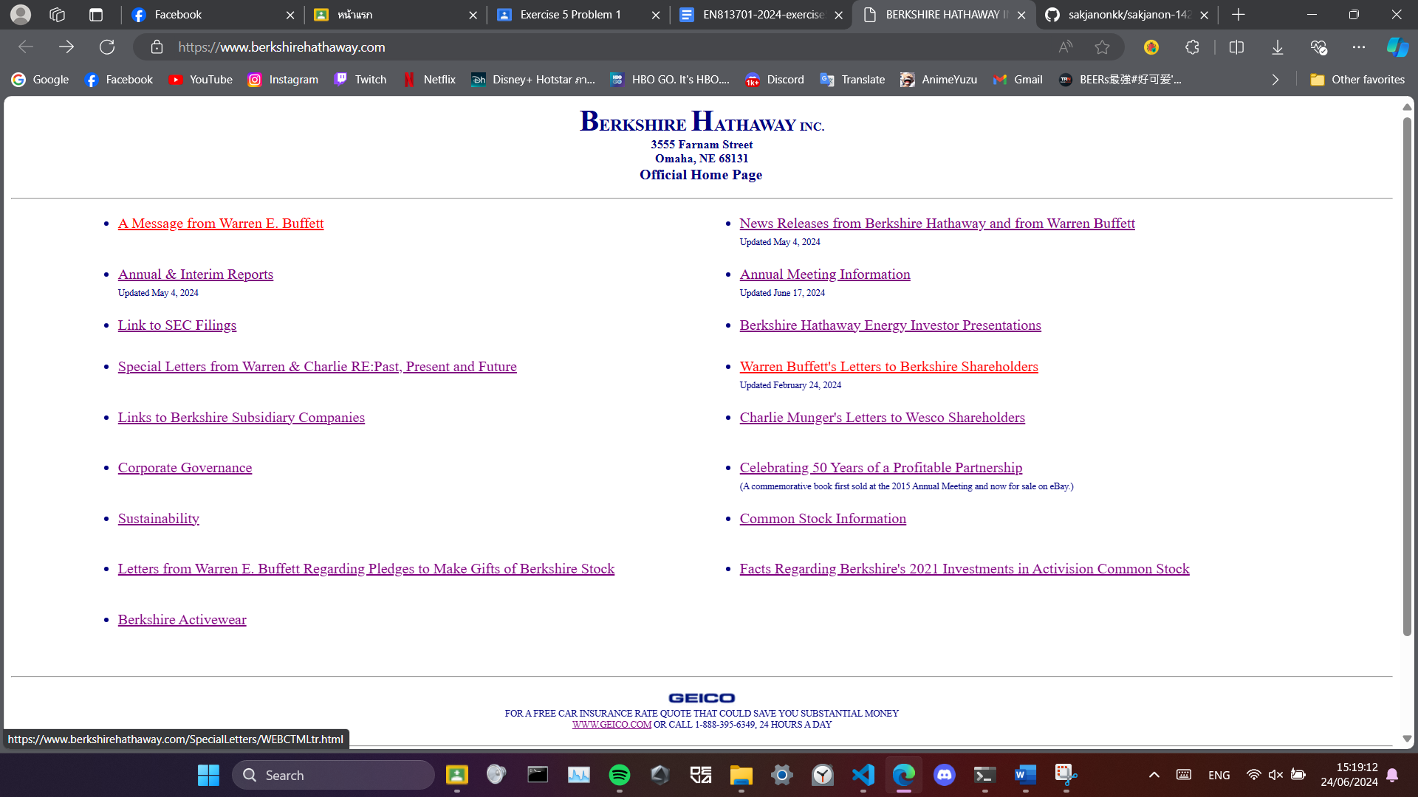

3. Tool for user isnt that much should’ve add more something that can support user something like : theme , language changing for many languages etc,actually should add more features for the user interface and more user friendly

1. The Colour of this website design also look very minimalistic but look cool actually can use Blue , White , Black as a base colour for website
2. The Font too small and shouldn’t have underline the text or just add colour that can mean link to other site and should just change the font to more modern also should change the size,All the page are the same size should just have Bold , Semi-Bold

