* For the students who have ID that ends with 3, 7
  + Comment on the web <https://spotify.com>

I think for this website spotify

For the UI

1. The Design was great design everything have think about the interface to be easily for user like its have feature to search for the song that user want and the design for each part of web is great left side for navigate the album and library , favorite thing that user’ve added on it , right side page for navigate the artist song and new song or new album for user friendly everypart of this page design very cool and very user friendly
2. The colour for this I think its just easy too look with the black background colour very simple to look at the song and album as user can see colour name of song and name of artist has the way easy too look at
3. The Layout Just great at every side of page left and right for Pc u can see left part and right part of user interface just really great design

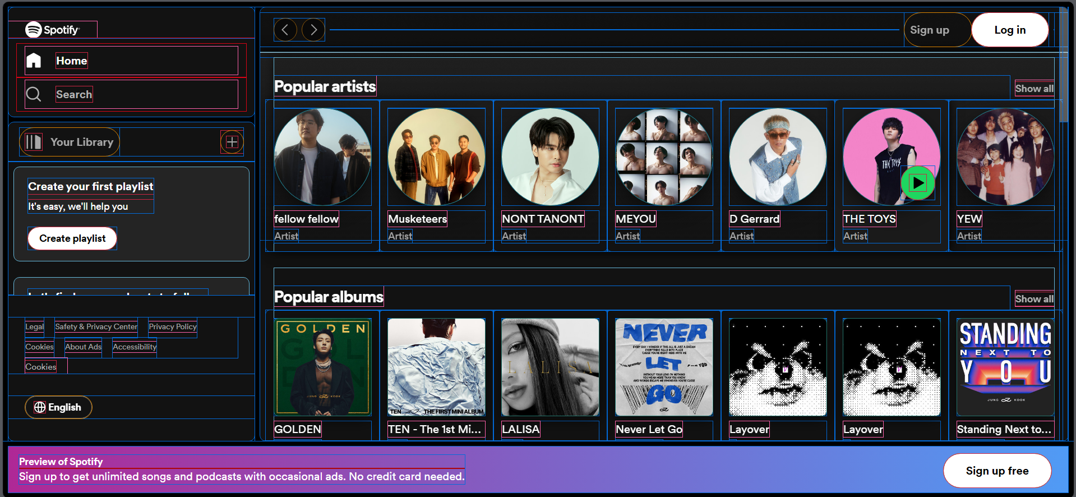

For the UX

1. Search Bar very good u can search it right away just only by type some character and it very fast to search
2. The User setting just look easy to set everything up u can just do easy log-in and log-out and change the user setting easy for both mobile app and web app
3. For the langauge change for this site I think its do great very functional and easy against user to change the language

