Writing task 1
You should spend about 20 minutes on this task.
The illustrations below show how coffee is sometimes produced.
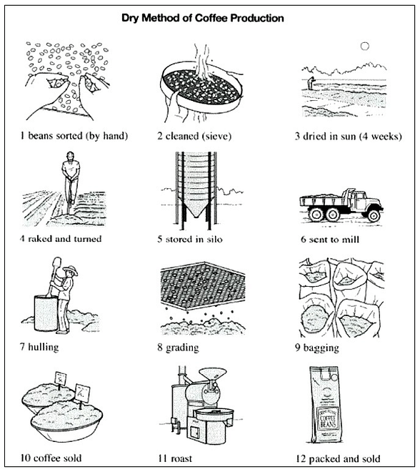
Summarise the information by selecting and reporting the main features.
Writing task-2
You should spend about 40 minutes on this task. Write about the following topic.
Some people believe that adults always do exercise and sports because of the major sports events that shown on T.V like the Olympic Games and Football World Cup. While others say that there are many other ways to encourage them to practice exercises other than T.V shows. Discuss both views and give your opinion.
Write at least 250 words.
Writing task-1
You should spend about 20 minutes on this task.
A friend has agreed to look after your house and pet while you are on holiday. Write a letter to your friend.
In your letter:
- give contact details for when you are away
- give instructions on how to care for your pet
- describe other household duty
You do NOT need to write any addresses.
Begin your letter as follows:
Dear ..................,

Writing task-2
You should spend about 40 minutes on this task
Write about the following topic.
Nowadays many students live with their families while others go to another city to study at a university. Discuss the advantages and disadvantages of both scenarios. Include relevant examples in your answer.
Give reasons for your answers and include any relevant examples from your knowledge or experience.
Write at least 250 words.

