Writing task 1
You should spend about 20 minutes on this task.
The graph below shows the number of complaints made about noise to Environmental Health authorities in the city of Newtown between 1980 and 1996.
Summarise the information by selecting and reporting the main features, and make comparisons where relevant.
» Write at least 150 words.
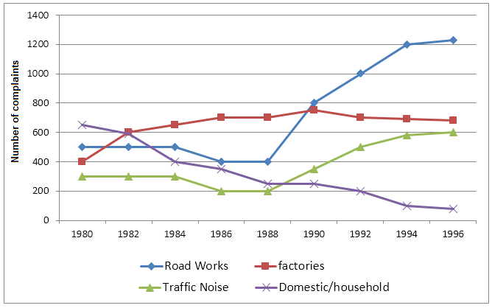
Task-02
You should spend about 40 minutes on this task.
Nowadays many students live with their families while others go to another city to study at a university. Discuss advantages and disadvantages of both scenarios.
Give reasons for your answer and include any relevant examples from your own knowledge or experience.
Write at least 250 words.
Task-01
You should spend about 20 minutes on this task.
You want to organize a party in your office to celebrate something. Write a letter to your manager about the party at the office.

In your letter,
- say what the party is about
- mention why it is necessary
- explain what you expect from him/her to do
Write at least 150 words.
You do NOT need to write any addresses.
Begin your letter as follows:
Dear Sir or Madam,

Task-02
You should spend about 40 minutes on this task.
Nowadays many students live with their families while others go to another city to study at a university. Discuss advantages and disadvantages of both scenarios.
Give reasons for your answer and include any relevant examples from your own knowledge or experience.
Write at least 250 words.

