LISTENING

PART 1 Questions 1-10

Questions 1-10
Complete the form below.
Write NO MORE THAN TWO WORDS AND/OR A NUMBER for each answer.

Tourism Survey
Example | Answer
Name: | Robert Goddard
Destination: | Melbourne
Total number of visits? | 1…………..
Best thing about the city: | 2…………..
Favourite attraction: | 3…………..
Best thing about
the destination’s dining  options: | 4………….. of food
Method of transport
to destination: | by 5…………..
Age group: | 6…………..
Income level: | 7…………..
Purpose of visit: | • on business  • 8…………..
Occupation: | • 9…………..  • writer for a travel magazine
Opinion about accommodation: | 10…………..

PART 2 Questions 11-20

Questions 11-15
Label the map below.
Write the correct letter, A-E, next to questions 11-15.
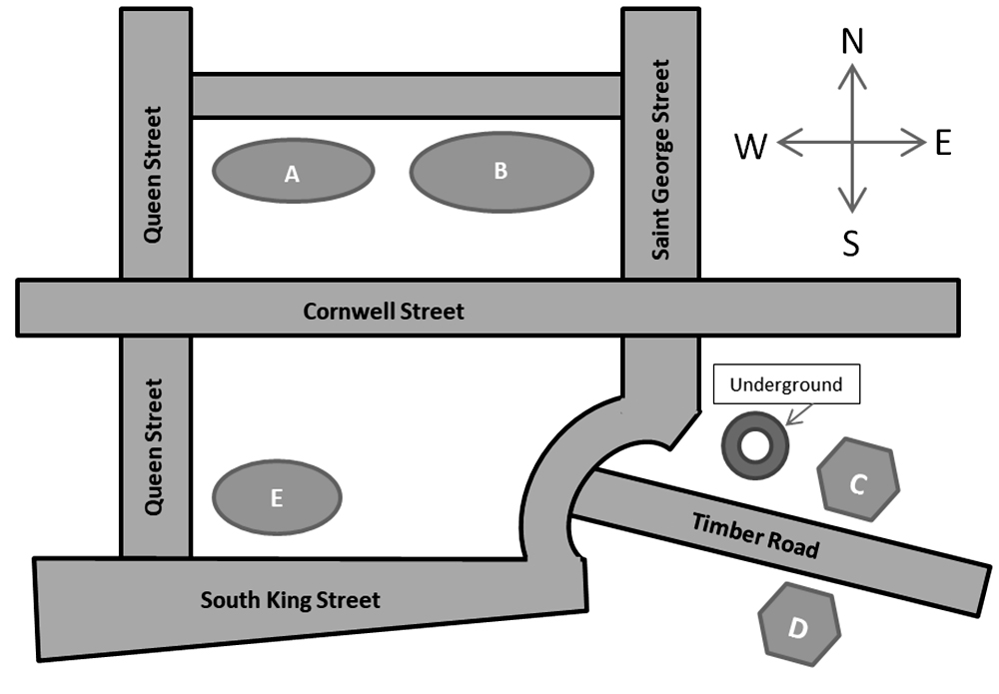
11 Science Museum
12 National History Museum
13 Car Park
14 Shopping Mall
15 Primary School

Questions 16-20
What is the improvement of each main point of interest in the area?
Choose FIVE answers from the box and write the correct letter, A-G, next to questions 16-20.
A New entrance
B Free lunch provided
C Free information provided
D Increase in size
E Additional signs
F New exhibitions
G New structure
16 CarPark
17 Primary School
18 Science Museum
19 National History Museum
20 Shopping Mall

PART 3 Question 21-30
Questions 21-23
Choose the correct letter, A, B or C.
21 The proposal will
A be reviewed by two examiners.
B be added to the final grade.
C be returned with feedback.
22 The proposal will consist mostly of
A topics
B methods
C results
23 For the practice paper, the tutor has directed the students to make sure to
A pay attention to time limits.
B write at least 6,000 words.
C keep on topic.
Questions 24-30 Complete the sentences below. Write ONE WORD AND/OR A NUMBER for each answer
24. There is no need to ………….. lots of people.
25. Pay attention to the ………….. of the final report.
26. Prepare two ………….., one for the teacher, another for the students themselves.
27. The deadline of the final paper is …………..
28. The students can ………….. their topics before the beginning of April.
29. Students deciding to change topics must deliver a ………….. to the teacher in advance.
30. At the beginning of the report, the hypothesis and an outline of the ………….. are needed.

PART 4 Questions 31-40
Questions 31-40 Complete the notes below. Write NO MORE THAN TWO WORDS for each answer.
Advertising Effect
The important factor to consider
• The 31………….. that customers must travel affects the probability that they will buy the product.
Methods of communication
• Advertising slogans are easier to remember if there is a 32………….. played with them.
• Mandy’s Candy Store appeals to people’s sense of 33………….. to draw in customers.
• To an ad campaign for digital products, it is 34………….. that is extremely important.
Effect on your product sales
• The customer’s 35………….. after he or she experiences the ad is most important.
Marketing strategies
• On international flights, it is wise for advertisements to be displayed in the common 36………….. of most passengers.
• Very few young people buy 37…………..
• The UNESCO website would be a good place to advertise for companies aiming to improve the 38…………..
• One good location to place ads for suntan lotion is the 39…………..
• A good scene for a water purification commercial would be wonderful sights of a 40…………..

