LISTENING
PART 1 Questions 1-10
Questions 1-4
Complete the table below
Write NO MORE THAN THREE WORDS AND/OR A NUMBER for each answer
University clubs | Monday | Tuesday | Wednesday
Name of club | film | climbing | chess
Extra Activities | discussions | 1………….. | 2………………..
Current number of  members | 3…………….. | 40 | 55
Contact | Events organizer | 4…………………… | Maths tutor

Questions 5-10 Complete the notes below Write NO MORE THAN THREE WORDS for each answer
Details of climbing club:
5. meets ………………………………………………….. 6. excursion to France in the ……………………… 7. subscriptions paid …………………………………
Benefits:
8 discounts on ………………… 9. annual ……………………….. 10 free entrance to climbing ………………….. in Cardiff

PART 2 Questions 11-20.
Questions 11-15
Which features are available at the following halls of residence?
Choose FIVE answers from the box and write the correct letter A-G next to Questions 11-15.
LIST OF FEATURES
A cleaning included
B all meals included
C private showers
D modern building
E parking spaces
F single sex
G sports facilities
HALLS OF RESIDENCE
11 Brown Hall ……………..
12 Blake residence ………………
13 Queens Building ……………..
14 Parkway Flats ………………
15. Temple Rise ………………..

Questions 16-20
Label the map below.
Write the correct letter A-G next to questions 16-20.
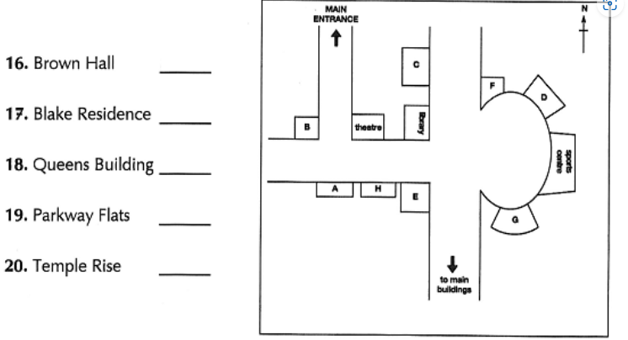

PART 3 Questions 21-30
Questions 21-24
Complete the sentences below.
Write NO MORE THAN THREE WORDS OR A NUMBER for each answer.
21. Jenna and Marco must complete their project by …………………………. .
22. The project will be a study of the increase in ……………………………..
23. The project will be assessed by …………………………..
24. Jenna and Marco agree they need a ……………………for the project.
Questions 25-27
Choose THREE letters , A-G.
what THREE things do Macro and Jenna have to do now for the project?
A……. interviews some people
B……..hand out Questionnaires
C……..choose their subjects
D……..take photographs
E………Use statistical software
F……….do some work in the library
G……….contact some local companies

Questions 28-30
Choose the correct letter , A , B or C.
28 Why did Jenna and Macro agree to work together?
A because they both wanted to work with some else
B because they each have different skills
C because they have worked together before
29 Why does Macro suggest that he writes the analysis?
A He needs more practice with this kind of writing.
B He is better at English than Jenna.
C He has more experience of this than Jenna.
30 Why does Jenna offer to do the presentation?
A Her tutor wants her to do the presentation.
B macro is very nervous about giving presentations
C She wants to divide the work on the project fairly.

PART 4 Questions 31-40
Questions 31-35
Of which US news source is each of the following statements true?
Write the correct letter, A, B or c next to Questions 31-35.
NEWS SOURCES
A television
B internet
C the press
31 It is more popular at the weekend than during the week ……………
32 it has affected the popularity of local radio. ……………..
33 It has recently been able to expand internationally……………..
34 It is offering more varied reporting than previously ……………..
35 It has suffered from government intervention……………….
Questions 36-40
Complete the summary below
Write NO MORE THAN TWO WORDS for each answer.
ADVERTISING AND NEWSPAPERS
In the USA, newspapers are being increasingly inventive about the way they attract advertisers and their 36………………… Now exceeds that of other industries. Advertising has increased because of a good relationship with the industries. Advertising has increased because of a good relationship with the .37…………………… sector. in addition, newspapers now run more adverts which include 38………………………. These have been found to raise readership of the papers and create more sales for the 39……………………. There are also an increasing number of more expensive 40…………………….. adverts.

