Writing
Task 1
You should spend about 40 minutes on this task.
The pie chart gives information on the proportion of carbohydrates, protein and fat in three different diets.
Write a report for a university lecturer describing the information shown below. Make comparisons where relevant.
You should write at least 150 words.
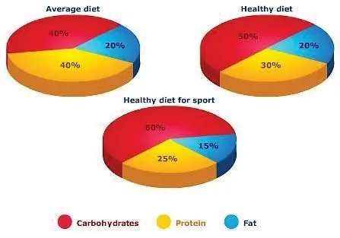
Task 2
You should spend about 40 minutes on this task.

Governments and big companies should work together to reverse environmental damage, rather than expecting individuals to take responsibility. To what extent do you agree or disagree with this statement? Give your opinion and relevant examples.

Give reasons for your answer and include any relevant examples from your knowledge or experience.

You should write at least 250 words.

Writing
Task 1
You should spend about 20 minutes on this task.

You currently live in a rental apartment, and the noise from your neighbours disturbs you. Write a letter to your landlord. In your letter
describe how this situation affects you;

- describe how this situation affects you
- Explain what steps you have taken to address the problem;
- Ask the landlord to take action to resolve the issue.
You should write at least 150 words.

Task 2
You should spend about 40 minutes on this task.
In Britain, when someone gets old they often go to live in a home with other old people where there are nurses to look after them. Sometimes the government has to pay for this care.
Who do you think should pay for this care, the government or the family?
Give reasons for your answer and include any relevant examples from your own knowledge or experience.
You should write at least 250 words.

