TASK-1
You should spend about 20 minutes on this task.

The graph below shows the proportion of the population aged 65 and over between 1940 and 2040 in three different countries.
Write at least 150 words.
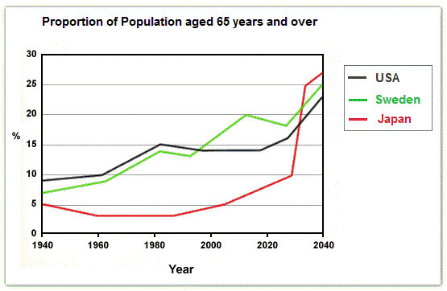

TASK-2

Some people think that the most important thing about being rich is it gives a person the opportunity to help other people.

Do you agree or disagree?
Give reasons for your answer and include any relevant examples from your own knowledge or experience.
Write at least 250 words.
Writing 1 hour
Task-1:
You should spend about 20 minutes on this task.

Your child is going on a trip to another country for a week. The school authority is looking for some parents who can join the trip. You are interested in going with the children.
Write a letter to the head of the school. In your letter,
- say why you want to join the team
- mention what you can do to assist
- also ask questions related to the trip
Write at least 150 words.
You do NOT need to write any addresses.
Begin your letter as follows:
Dear Sir or Madam,

Task-2
You should spend about 40 minutes on this task.
The use of plastic has revolutionized many industries, but it also has negative effects on the environment, such as polluting the oceans and harming wildlife.
Discuss the benefits and drawbacks and give your own opinion.
Write at least 250 words.

