WRITING TASK 1
You should spend about 20 minutes on this task.
The line graph below shows the average daily maximum temperatures for Auckland and Christchurch, two cities in New Zealand, and London and Edinburgh, two cities in the United Kingdom.
Summarise the information by selecting and reporting the main features, and make comparisons where relevant.
Write at least 150 words.
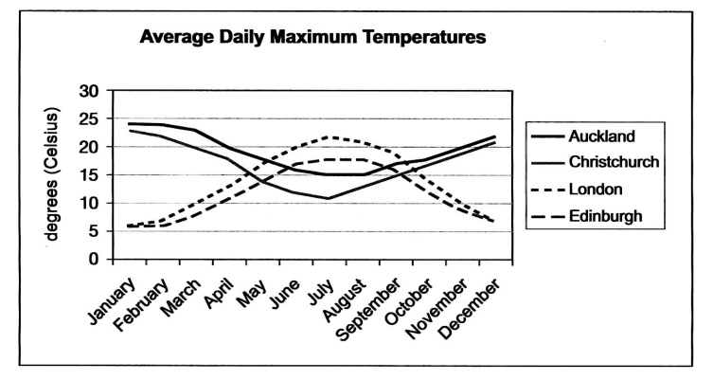
Task-2
You should spend 40 minutes on the task, Write about the following topic:
Doctors in many countries say that people do not do enough physical exercise. What are the causes of this trend? How can the situation be improved?
Give your opinion for your answer and include any relevant examples from your own knowledge or experience.

GT Writing Task 1:
You should spend about 20 minutes on this task.

You recently started commuting to work by bicycle and discovered that there is a problem with bicycle parking near the building where you work.
Write a letter to the building manager. In your letter,
- explain the reason for using a bicycle to commute
- mention what problems you have encountered with parking
- what you recommend to solve the problems
Write at least 150 words.
You do NOT need to write any addresses.
Begin your letter as follows:
Dear Sir or Madam,

Writing Task 2:
You should spend about 40 minutes on this task.
Write about the following topic:

Some people think that the internet has brought people closer together while others think that people and communities have become more isolated due to the internet.

Discuss both these views and give your own opinion.
Give reasons for your answer and include any relevant examples from your own knowledge or experience.
Write at least 250 words.

