WRITING 1 hour
Task 1
You should spend about 20 minutes on this task.
The graph below shows the percentage of people going to cinemas in one European country on different days. Summarize the information by selecting and reporting the main features and make comparisons where relevant.
You should write at least 150 words.
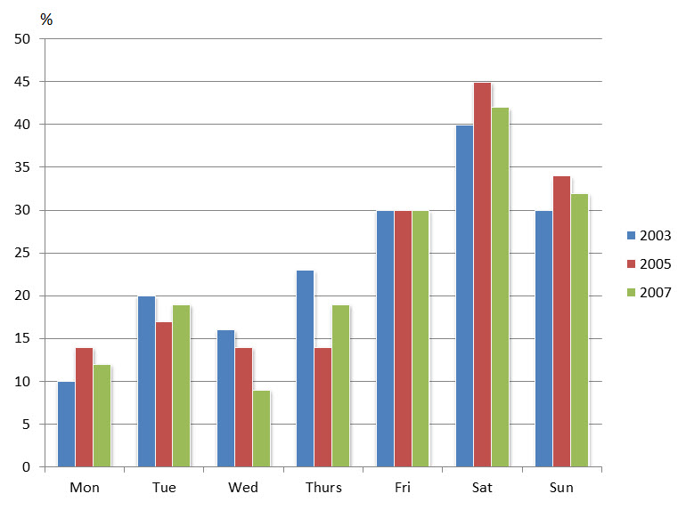
Task 2:
You should spend about 40 minutes on this task.
More people decided to have children in their later age than in the past. Why?
Do advantages of this outweigh disadvantages?
Give reasons for your answer and include any relevant examples from your own knowledge or experience.
You should write at least 250 words

WRITING 1 hour
Task 1
You should spend about 20 minutes on this task.
Your workplace requires an interpreter to translate from one language to another during meetings. Write a letter to your manager.
In your letter
- recommend someone to act as an interpreter;
- explain why the person is qualified for that role;
- say how the person can be contacted.
Write at least 150 words.
You do NOT need to write any addresses
Begin your letter as follows:
Dear Sir or Madam,

Task 2:
You should spend about 40 minutes on this task.
More people decided to have children in their later age than in the past. Why?
Do advantages of this outweigh disadvantages? Give reasons for your answer and include any relevant examples from your own knowledge or experience.
You should write at least 250 words

