LISTENING
PART 1 Questions 1-10
Questions 1-6
Complete the form below.
Write NO MORE THAN THREE WORDS AND/OR A NUMBER for each answer.
PATIENT RECORD
Time of appointment: 10:00 am
Given names: Simon 1…………….
Family name: Lee
Date of birth: 2……………. 1989
Address: 3……………. Adams Terrace, Wellington
Phone number: 0211558809
Name of insurance company: 4…………….
Date of last eye test: 5…………….
Patient’s observations: Problems seeing 6…………….

Questions 7-10
Answer the questions below.
Write NO MORE THAN THREE WORDS for each answer.
7 When must Simon wear his glasses?
8 What type of glasses are the least expensive?
9 What is good about the glasses Simon chooses?
10 How does Simon decide to pay?

PART 2 Questions 11-20
Questions 11-12
Choose the correct letter, A, B or C.
11 Who is buried in the tomb of the Taj Mahal?
A the emperor Shahjahan
B the wife of Shahjahan
C the emperor and his wife
12 Where did the white marble come from?
A India
B China
C Persia
Questions 13-16
Label the plan below.
Write NO MORE THAN THREE WORDS for each answer.
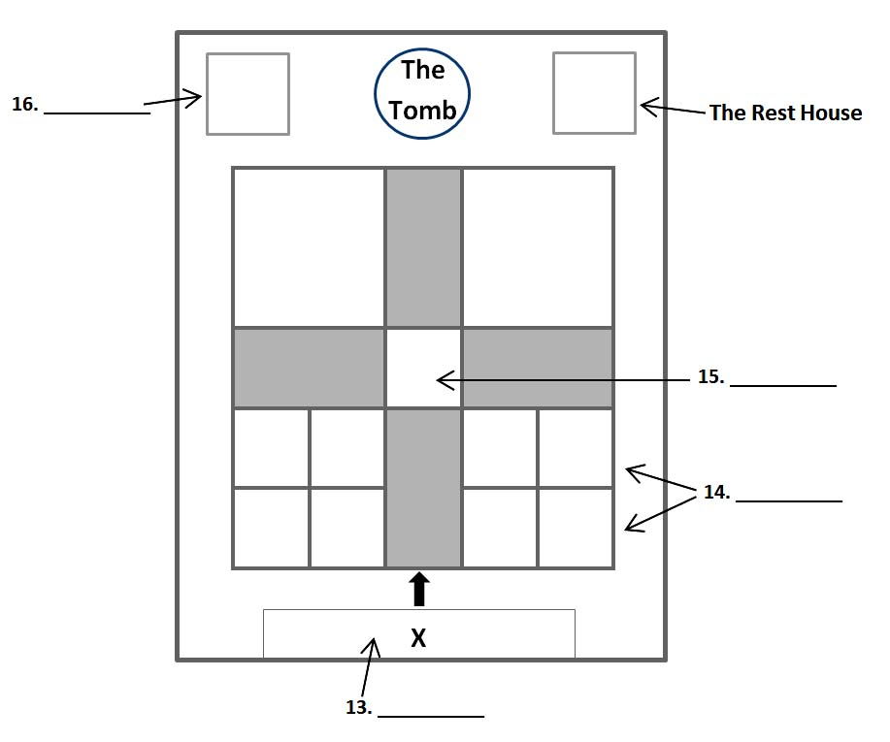
13 …………….
14 …………….
15 …………….
16 …………….

Question 17
Choose the correct letter, A, B or C.
17 What is the purpose of the Rest House?
A a place for the poor to stay
B a meeting place for pilgrims
C an architectural feature
Questions 18-20
Complete the flow chart below.
Write NO MORE THAN TWO WORDS for each answer.
How running water is provided
Water taken from the 18……………. by bullocks.
↓
Water channelled into the 19…………….
↓
Water piped to the 20…………….

PART 3 Questions 21-30
Questions 21-24
Choose the correct letter, A, B or C.
21 What background information does Daisy give about rice?
A Wild rice is grown throughout Asia
B Some types of rice need less water than others.
C All rice varieties have a lovely aroma
22 Erik says that a priority for rice farmers is to be able to
A grow rice without fertilizers.
B predict the weather patterns.
C manage water resources.
23 Where is the International Rice Research Institute?
A The Philippines
B China
C Japan
24 Scientists in Bangladesh want to find a
A more effective type of fertilizer.
B strain of rice resistant to flooding.
C way to reduce the effects of global warming.
Questions 25-30
Which country do the following statements apply to?
Choose the correct letter, A, B or C.
A Japan
B China
C Thailand

25 They grow the most rice in the world.
26 They export the most rice in the world.
27 They aim to increase the nutritional value of rice.
28 Less rice is eaten than in the past.
29 An annual rice festival takes place.
30 A new type of rice is now popular locally.

SECTION 4
Questions 31-33
Complete the sentences below.
Write NO MORE THAN ONE WORD for each answer,
RADIO WRITING
You may have to ignore some of the ordinary 31……………. of writing.
Written words do not indicate things like emphasis, the 32……………. Of reading or where to pause.
A script needs to sound like a 33…………….

Questions 34-40
Complete the notes below.
Write NO MORE THAN THREE WORDS for each answer.
Know who you are talking to
Imagine a typical listener:
e.g. imagine telling your 34……………. about a film.
Create an informal tone:
e.g. use words like 35…………….
Work out what you are going to say
Remember:
listeners cannot ask questions
you cannot 36……………. ideas
Make your script logical:
37……………. the information.
Use concrete images e.g. compare the size of a field to a 38…………….
Use the 39……………. to get attention.
Check the script by 40…………….

