Writing 1 HOUR
TASK-01
You should spend about 20 minutes on this task.
The tables below provide information about the consumption and production of potatoes in five parts of the world in 2006. Summarise the information by selecting and reporting the main features, and make comparisons where relevant.
You should write at least 150 words.
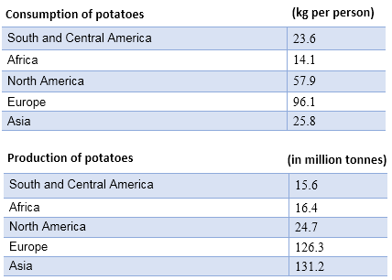

TASK-02
You should spend about 40 minutes on this task.
The demand for coaching services has grown significantly in the digital age, with online coaching platforms becoming prevalent. Some now feel online coaching is a superior option to in-person coach.
To what extent do you agree or disagree?
You should write at least 250 words.

Writing 1 HOUR
TASK-01
You should spend about 20 minutes on this task.
You found a piece of lost luggage with someone's belongings labeled with their name and address. Write a letter to the owner.
In your letter
- describe the luggage you found;
- explain where you found it;
- suggest how the owner could get it back.
Write at least 150 words.
You do NOT need to write any addresses
Begin your letter as follows:
Dear Sir or Madam,

TASK-02
You should spend about 40 minutes on this task.
The demand for coaching services has grown significantly in the digital age, with online coaching platforms becoming prevalent. Some now feel online coaching is a superior option to in-person coach.
To what extent do you agree or disagree?
You should write at least 250 words.

