Writing 1 HOUR
TASK-01
You should spend about 20 minutes on this task.
The maps below show the town of Langley in 1910 and 1950. Summarise the information by selecting and reporting the main features, and make comparisons where relevant.
You should write at least 150 words.
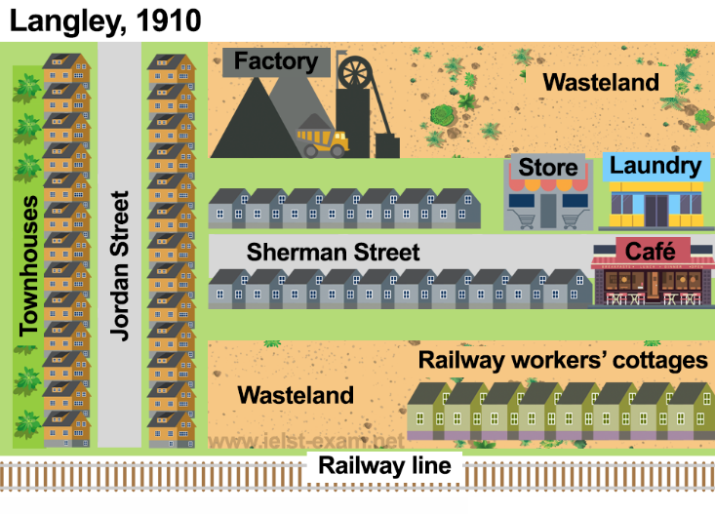
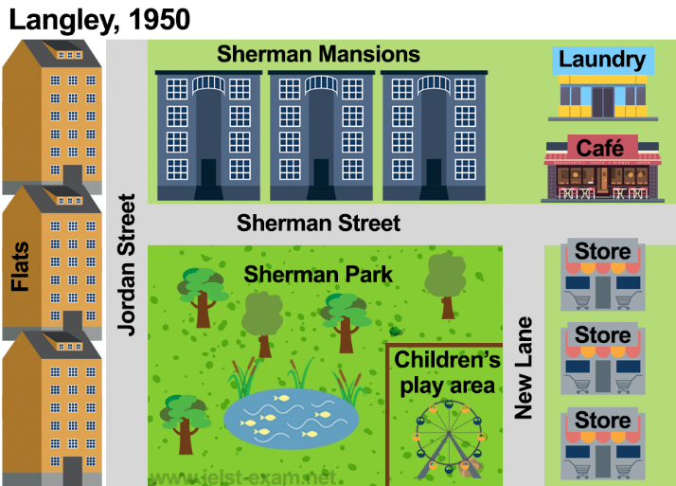

TASK-02
You should spend about 40 minutes on this task.
Today, the high sales of popular consumer goods reflect the power of advertising and not the real needs of the society in which they are sold.
To what extent do you agree or disagree?
You should write at least 250 words.

Writing 1 HOUR
TASK-01
You should spend about 20 minutes on this task.
Your friend invited you to go with him/her to a concert next week, however, you are unable to come. Write a letter to your friend.
In your letter
- let your friend know why you can't go to the concert;
- suggest another activity you can do together;
- explain why you think your friend would enjoy this activity.
Write at least 150 words.
You do NOT need to write any addresses.
Begin your letter as follows:
Dear ……………,

TASK-02
You should spend about 40 minutes on this task.
Today, the high sales of popular consumer goods reflect the power of advertising and not the real needs of the society in which they are sold.
To what extent do you agree or disagree?
You should write at least 250 words.

