LISTENING
Part 1: Questions 1-10
Questions 1-4
Complete the form below.
Write NO MORE THAN TWO WORDS AND/OR A NUMBER for each answer.
Product Incident Report
Example | Answer
Product: | rice cooker
Model Number: | 1 ………………………
Price of the Product: | £2 …………………..
Name of the Branch: | 3 …………………….
Problem: | 4 ………………………

Questions 5-10
Complete the form below.
Write NO MORE THAN THREE WORDS AND/OR A NUMBER for each answer.
CUSTOMER’S INFORMATION DETAILS
Name: | Herbert Hewitt
Address: | 5 ………………
Postcode: | 6…………………
Method of payment: | 7 ………………..
Card’s Expiry Date: | 8 ……………..
Method of Compensation: | 9 ……………
Shopping Frequency: | 10 ……………….

Part 2: Questions 11-20
Questions 11-15
Listen to the directions and match the places in questions 11-15 to the appropriate place among A-E on the map.
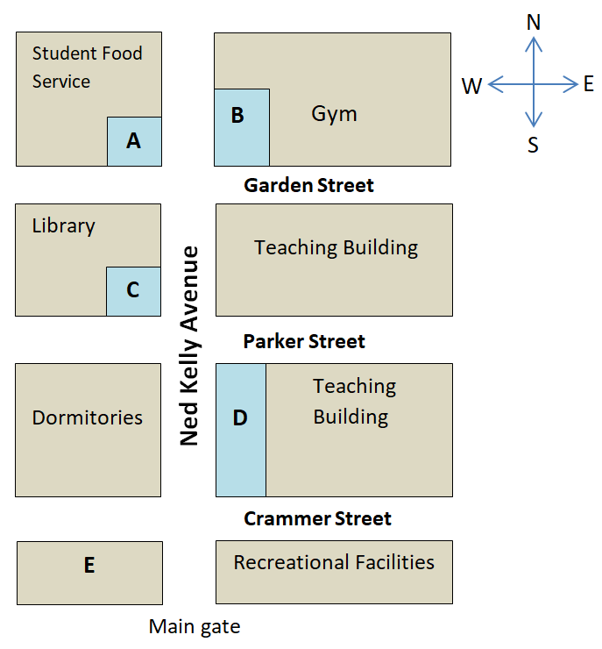

11 Student Centre
12 Health Centre
13 Internet Unit1
14 Complaint Office
15 Café

Questions 16-20
Complete the sentences below.
Write NO MORE THAN TWO WORDS AND/OR A NUMBER for each answer.
Students in a room don’t need to share a 16 ………….with ones in other rooms.
Everyone has to write down his name on the 17 …………..
All the students use a 18 ………….to enter the dorm's front door.
If you want to wash your clothes, go to the laundry room which is located in the 19 ………..
The dormitory closes at 20 ………..every night.

Part 3: Questions 21-30
Questions 21-22
Choose the correct letters, A-C, and write each next to questions 21 and 22.
According to Betty, which lines describe the sales of both cheese and oil in New Zealand and Colombia?
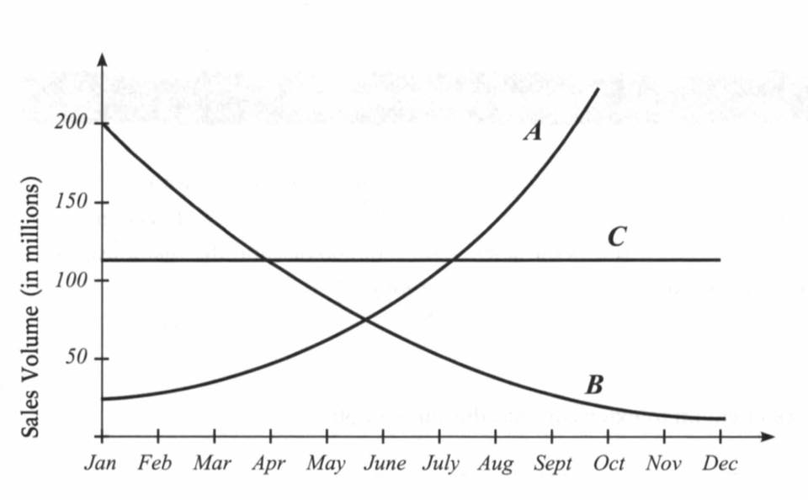
21 ………………….
22 …………………

Questions 23-24
Write the correct letters, A-E, next to questions 23-24.
Which TWO of the following are sales strategies for chocolate in Italy and Germany?
A. Locate near a children’s school
B. Change the location of the product on shelves
C. Give a free gift
D. Make it the cheapest brand
E. Make Schmutzig the second cheapest brand

Questions 25-30
Complete the table below. Write NO MORE THAN TWO WORDS for each answer.
Research plan
Betty is interested in how 25…………….affects the sales of cosmetics and 26……………….
Bruce is going to be concerned with how 27…………may impact on sales of cookies and the relationships among 28……………….., 29…………………, and sales.
The professor advised the students to bear in mind the extensions of 30………………………

Part 4: Questions 31-40
Questions 31-37
Complete the table below.
Write NO MORE THAN TWO WORDS AND/OR A NUMBER for each answer.
Talking about the history of bikes
Years/Time | Feature | Advantage | Disadvantage
1830s | wooden wheels  covered with metal | need 31……….than  walking | quite 32…………….
33 ……….. | Chain and sprocket are 34 ………. | easier and 35………..ride | harder to balance
1880s | use 36……………… | more comfortable | The faster you go, the more you feel every bump.
1890s | equal-sized wheels | 37 ………………… | dangerous before brakes appeared

Questions 38-40
Choose THREE letters, A-F, and write them next to questions 38-40.
The invention of different gears on a bicycle affected which THREE of the following?

A. Wheel size
B. Balance
C. Rate of speed
D. The back wheel
E. Safety
F. Downhill travel

