Writing 1 HOUR
TASK 01:
You should spend about 20 minutes on this task.
Summarise the information by selecting and reporting the main features, and make comparisons where relevant.
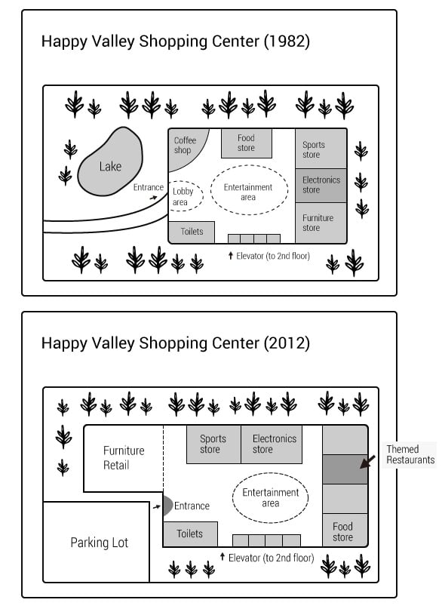

Write at least 150 words.

TASK 02:
You should spend about 40 minutes on this task.
Online shopping has made it easier than ever to buy goods from around the world, but it also has its downsides, such as the impact on local businesses and the environmental costs of shopping. Discuss the advantages of online shopping.
Write at least 250 words.

Writing 1 HOUR
TASK 01:
You should spend about 20 minutes on this task.

Your English-speaking friend who lives in your town has asked for your advice about learning a new sport.
Write a letter to your friend. In your letter,
- recommend a new sport that would be suitable for your friend to learn
- explain how your friend could learn this sport
- suggest that you both learn this sport together

Write at least 150 words.
You do NOT need to write any addresses.
Begin your letter as follows:
Dear Sir or Madam,

TASK 02:
You should spend about 40 minutes on this task.

Online shopping has made it easier than ever to buy goods from around the world, but it also has its downsides, such as the impact on local business and the environmental costs of shopping.
Discuss the advantages and disadvantages of online shopping.
Write at least 250 words.

