**NAME- Saksham Bhambota**

**UID-19BCS3820**

**SUBJECT-BEEE LAB**

**AIM:**

**Design an automatic night lighting system such the system is only activated when the master control switch is pressed. a) Below 300 lux led glows with full brightness. b) Above 300 lux led glows with 50% brightness.**

**CIRCUIT DIAGRAM:**

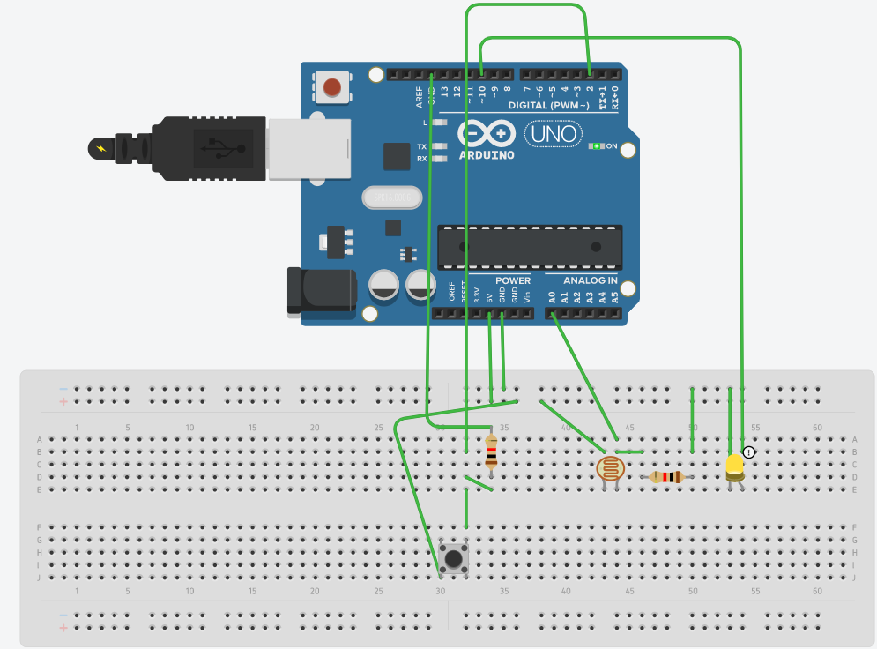

**THEORY:**

Arduino is an open-source electronics platform based on easy-to-use hardware and software. Arduino boards are able to read inputs - light on a sensor, a finger on a button.

**LEARNING AND OBSERVATIONS:**

1. How led glow with using code.
2. How we can change the delay that is time of glowing.
3. Whenever switch is on led start glowing.

**PROBLEM AND TROUBLESHOOTING:**

1) Setting up a connection.

2) Errors in code.

3) Port was not selected.

4) Internet network poor.

**PRECAUTIONS:**

1. Don’t plug in a LED without a current limiting resistor.
2. Circuit should be properly set into breadboard.
3. Don’t supply high voltage.

**LEARNING OUTCOMES:**

1. Came to know about Arduino.
2. Came to know about how to design a circuit and Glow LED without using battery.