IE 563: Experimental Design
Homework #4
Samuel Nwosu
Adapted from Montgomery, Design and Analysis of Experiments, 6th Edition, 2005
Problem 1
The yield of a chemical process is being studied. The two most important variables thought to effect % yield are pressure and temperature. The data from the experiment (in the order collected) are shown in the following table.
Temperature | Pressure (psi) | Yield (%)
high | 200 | 58.59
high | 215 | 70.99
high | 230 | 49.43
high | 200 | 77.58
high | 215 | 73.42
high | 230 | 61.70
high | 200 | 63.81
high | 215 | 71.93
high | 230 | 66.96
high | 200 | 73.37
high | 215 | 70.95
high | 230 | 53.36
low | 200 | 65.03
low | 215 | 76.46
low | 230 | 84.88
low | 200 | 71.23
low | 215 | 70.07
low | 230 | 82.93
low | 200 | 63.61
low | 215 | 75.33
low | 230 | 72.51
low | 200 | 68.88
low | 215 | 83.74
low | 230 | 80.24

- What is the response? What are the factors? How many levels of each factor are used? How many replicates were used? The response is Yield, the factors are temperature and pressure, there are three factor levels for pressure and two levels for temperature. There are 4 replicates.
- Perform an analysis of variance to determine if temperature and/or pressure effects the mean % yield at =0.05.
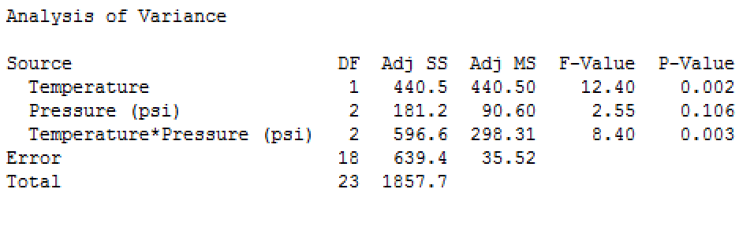

By analyzing the results of the ANOVA we see that temperature does affect the mean % yield. It has a p-value of .002 which is less than our alpha of .05. Pressure does not affect the mean % yield as it has a p-value of .106 which is greater than our alpha. The interaction between temperature and pressure did effect the % yield having a p-value of .003 which is less than our alpha.
- Prepare appropriate residual plots and comment on the model’s adequacy.
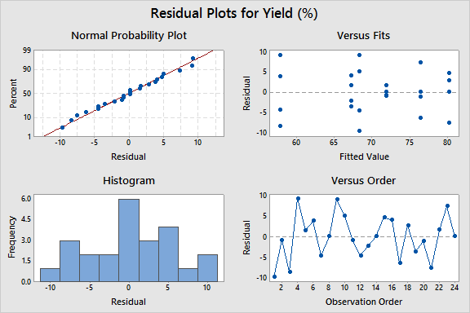
By looking at the normal probability plot we and see that the residuals are normally distributed and are centered on 0. The Versus fits plot shows that Residuals have constant variance.
- Under what conditions (i.e. what level of temp. and pressure) would you operate this process to maximize the mean % yield? use =0.05.
Temperature*Pressure
(psi) N Mean Grouping
low 230 4 80.1400 A
low 215 4 76.4000 A
high 215 4 71.8225 A
high 200 4 68.3375 A B
low 200 4 67.1875 A B
high 230 4 57.8625 B

(Low 200), (High 200),(Low 215),(High 215),(low 230)
Problem 2
A consumer interest group conducts an experiment to determine if there are significant differences in gasoline prices ($/gallon) between gasoline stations in the Louisville Metro area. The price of regular unleaded gasoline (87 octane) is recorded at 6 gas stations on 8 different days. The data obtained follow.

Day | gas station | price |  | day | gas station | price
1 | 1 | 2.75 |  | 1 | 4 | 2.64
2 | 1 | 3.30 |  | 2 | 4 | 3.49
3 | 1 | 3.34 |  | 3 | 4 | 3.18
4 | 1 | 3.44 |  | 4 | 4 | 3.23
5 | 1 | 3.66 |  | 5 | 4 | 3.57
6 | 1 | 3.83 |  | 6 | 4 | 3.31
7 | 1 | 3.50 |  | 7 | 4 | 3.18
8 | 1 | 3.57 |  | 8 | 4 | 2.82
1 | 2 | 2.93 |  | 1 | 5 | 2.90
2 | 2 | 3.39 |  | 2 | 5 | 2.90
3 | 2 | 3.07 |  | 3 | 5 | 3.13
4 | 2 | 4.46 |  | 4 | 5 | 3.94
5 | 2 | 3.97 |  | 5 | 5 | 3.57
6 | 2 | 3.69 |  | 6 | 5 | 3.12
7 | 2 | 3.10 |  | 7 | 5 | 3.21
8 | 2 | 3.02 |  | 8 | 5 | 3.15
1 | 3 | 3.67 |  | 1 | 6 | 3.03
2 | 3 | 2.89 |  | 2 | 6 | 2.97
3 | 3 | 3.33 |  | 3 | 6 | 3.19
4 | 3 | 3.02 |  | 4 | 6 | 3.49
5 | 3 | 3.17 |  | 5 | 6 | 4.00
6 | 3 | 3.51 |  | 6 | 6 | 3.64
7 | 3 | 2.91 |  | 7 | 6 | 3.07
8 | 3 | 3.29 |  | 8 | 6 | 3.17

- What is the response? What are the factors? How many levels of each factor are used? How many replicates were used? The response is the prices, the factors are day and gas stations, days has 8 levels and gas stations has 6 levels. There were only one replicate .
- Perform an analysis of variance to determine if gas station effects the mean price ($/gallon) at =0.05.

Analysis of Variance

Source DF Adj SS Adj MS F-Value P-Value
day 7 2.5518 0.36454 3.92 0.003
gas station 5 0.5082 0.10164 1.09 0.381
Error 35 3.2541 0.09297
Total 47 6.3141

Analyzing the ANOVA table we find that gas stations do not affect the mean price. It has a p-value of .381 which is less than the alpha value of .05.
- Prepare appropriate residual plots and comment on the model’s adequacy.
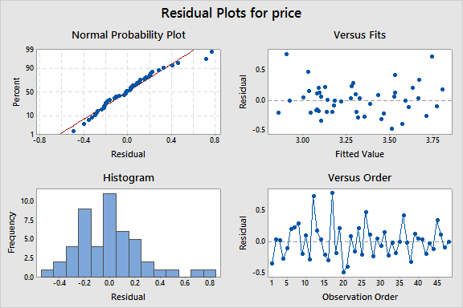
All anova assumptions appear to be met:
• Residuals are Normally distributed with mean 0 (see normal probability plot).
• Residuals have constant variance (see residuals vs fitted values plot).
- Which gas station(s) should you visit to minimize the price of gasoline? use =0.05.
gas
station N Mean Grouping
2 8 3.45375 A
1 8 3.42375 A
6 8 3.32000 A
5 8 3.24000 A
3 8 3.22375 A
4 8 3.17750 A

Gas station 1,2,3,4,5 and 6

Problem 3
The percentage of hardwood concentration in raw pulp (2%, 4%, 8%), the vat pressure (400, 500, 600 psi), and the cooking time of the pulp (3.0, 4.0 hours) are being investigated for their effects on the mean tensile strength (kN/m) of paper. Three levels of hardwood concentration, three levels of pressure, and two cooking times are selected. The data from the experiment (in the order collected) are shown in the following table.
Hardwood (%) | Pressure (psi) | Cook Time (hours) | Strength |  | Hardwood (%) | Pressure (psi) | Cook Time (hours) | Strength
8 | 400 | 4 | 2.74 |  | 2 | 600 | 4 | 2.38
2 | 500 | 4 | 2.31 |  | 2 | 600 | 3 | 2.07
4 | 500 | 3 | 2.48 |  | 2 | 600 | 4 | 2.56
4 | 600 | 3 | 2.72 |  | 2 | 500 | 3 | 2.27
4 | 400 | 3 | 2.35 |  | 2 | 400 | 3 | 2.41
4 | 500 | 3 | 2.61 |  | 8 | 600 | 3 | 3.33
8 | 500 | 4 | 2.76 |  | 2 | 400 | 3 | 2.15
4 | 600 | 4 | 2.90 |  | 4 | 400 | 4 | 2.09
8 | 500 | 3 | 2.73 |  | 8 | 600 | 4 | 3.24
2 | 500 | 4 | 2.24 |  | 8 | 500 | 4 | 2.75
8 | 600 | 3 | 3.23 |  | 8 | 400 | 4 | 3.12
4 | 400 | 3 | 2.20 |  | 4 | 500 | 4 | 2.70
8 | 600 | 4 | 3.38 |  | 2 | 500 | 3 | 1.91
8 | 400 | 3 | 2.80 |  | 4 | 400 | 4 | 2.46
8 | 500 | 3 | 2.63 |  | 2 | 400 | 4 | 2.28
8 | 400 | 3 | 2.60 |  | 2 | 600 | 3 | 2.54
4 | 500 | 4 | 2.24 |  | 4 | 600 | 4 | 2.53
4 | 600 | 3 | 2.69 |  | 2 | 400 | 4 | 1.97

- Perform an ANOVA to determine if hardwood concentration, pressure, and/or cooking time effect the mean tensile strength of paper. Use α=0.05.
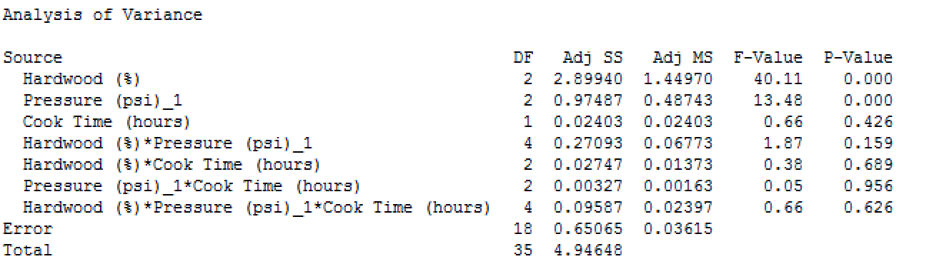
Based of the ANOVA table hardwood affects the mean tensile strength of paper having a p-value of 0, which is less than our alpha of .05. Pressure also affects the mean tensile strength of paper having a p-value of 0, which is less than our alpha of .05.Cook time does not affect the mean tensile strength having a p-value of .426 which is greater that our alpha of .05. hardwood and pressure, hardwood and cook time, pressure and cook time, and Hardwood and pressure and cook time all do not affect the mean tensile strength with all of them having p-values greater than our alpha.
- Prepare appropriate residual plots for your ANOVA analysis and comment on the model’s adequacy.
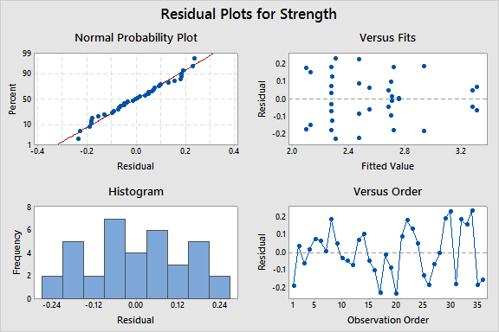
All anova assumptions appear to be met:
• Residuals are Normally distributed with mean 0 (see normal probability plot).
• Residuals have constant variance (see residuals vs fitted values plot).

- Which levels of hardwood concentration, pressure, and cooking time should you use to maximize mean tensile strength.

Hardwood
(%)*Pressure
(psi)_1*Cook
Time (hours) N Mean Grouping
8 600 4 2 3.310 A
8 600 3 2 3.280 A B
8 400 4 2 2.930 A B C
8 500 4 2 2.755 A B C D
4 600 4 2 2.715 A B C D
4 600 3 2 2.705 A B C D
8 400 3 2 2.700 A B C D
8 500 3 2 2.680 A B C D
4 500 3 2 2.545 B C D
2 600 4 2 2.470 C D
4 500 4 2 2.470 C D
2 600 3 2 2.305 C D
2 400 3 2 2.280 C D
2 500 4 2 2.275 C D
4 400 3 2 2.275 C D
4 400 4 2 2.275 C D
2 400 4 2 2.125 D
2 500 3 2 2.090 D

(8 600 4), (8 600 3),(8 400 4), (8 500 4),( 4 600 4),( 4 600 3),( 8 400 3), and (8 500 3)

- Find an appropriate regression model for this data.
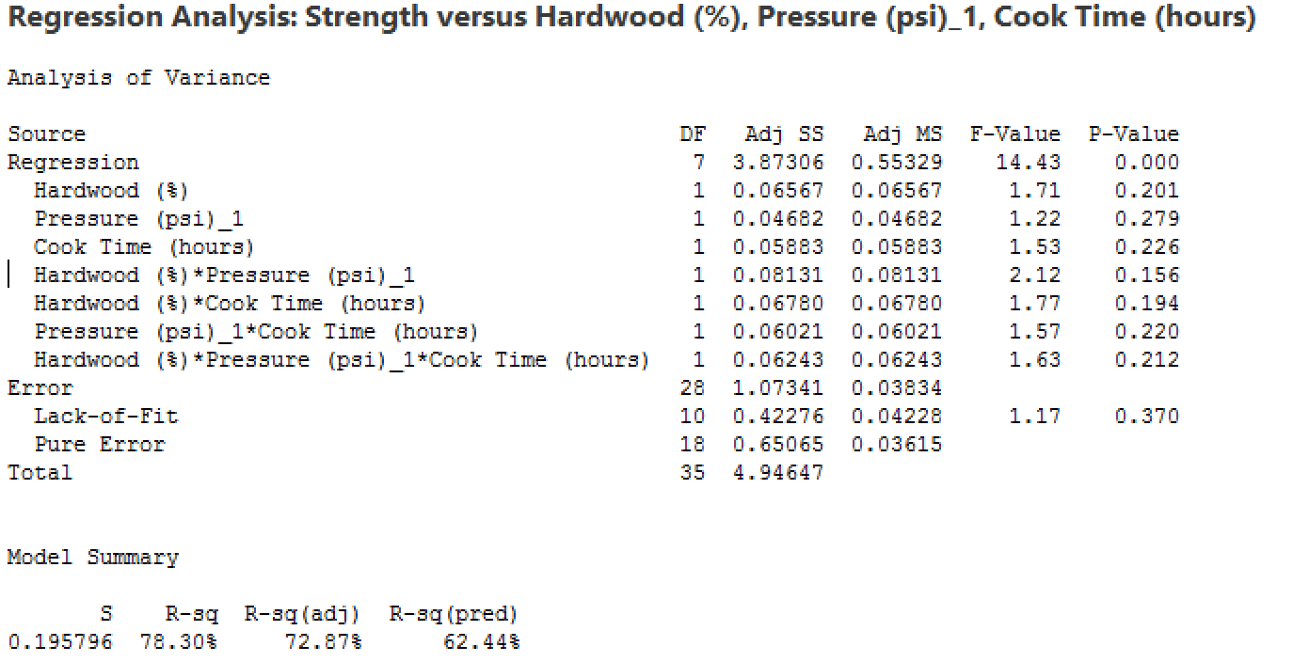
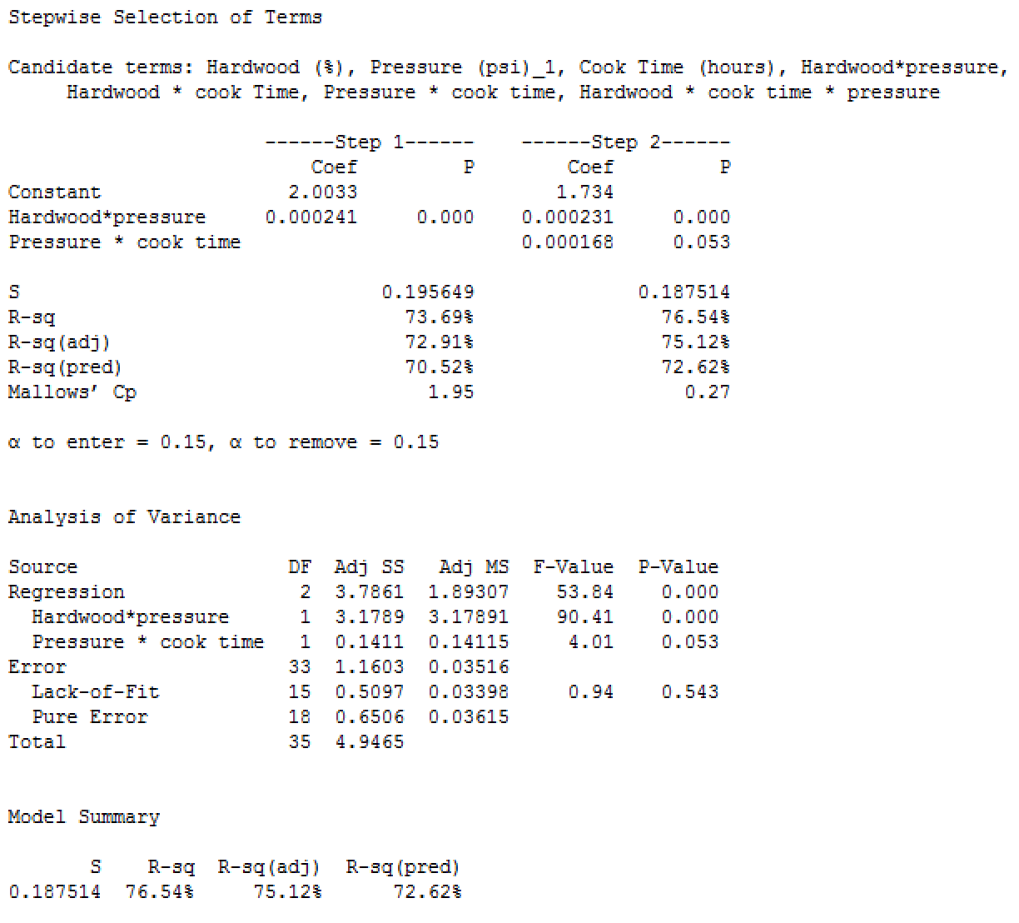

Use the stepwise model since it has a higher r-sq
- Prepare appropriate residual plots for your regression analysis and comment on the model’s adequacy.
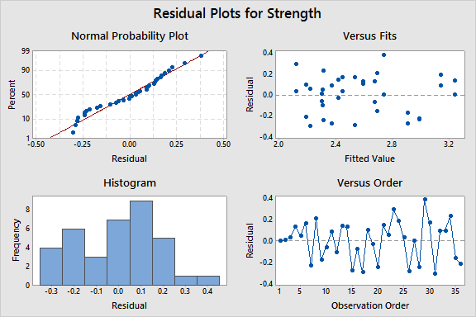
All regression assumptions appear to be met:
• Residuals are Normally distributed with mean 0 (see normal probability plot).
• Residuals have constant variance (see residuals vs fitted values plot).
- Using the regression equation you found in part c, predict the tensile strength for a hardwood concentration of 6%, a pressure of 425 psi, and a cooking time of 3.5 hours. Strength = 1.734 + 0.000231 Hardwood*pressure + 0.000168 Pressure * cook time.
Strength = 1.734 + .000231*6*425 + .000168*425*3.5 = 2.57095

- Find a 95% prediction interval for the tensile strength for a hardwood concentration of 5%, a pressure of 450 psi, and a cooking time of 3.75 hours.
