**ASSIGNMENT ONE – Advance Web**

**Kayla Wiest Portfolio Style Guide**

Style Guide for Assignment One – Express Portfolio Site. This guide contains the following criteria: Color Palette, Typography, Wireframes, and Images.

**COLOUR PALETTE**

**Alizarin Crimson**

**#E82320**

**Mine Shaft**

**#E82320**

**TYPOGRAPHY**

**Header 1**

Font: Tahoma / Color: #000 / Size: 2 em / Weight: Bold

**Header 2**

Font: Tahoma / Color: #000 / Size 1.5 em / Weight: Bold

**Header 3**

Font: Tahoma / Color: #000 / Size 1.17 em / Weight: Bold

This is the Body copy. Lorem ipsum dolor sit amet, consectetur adipisicing elit. Praesent eu semper ligula, nee fermentum odio. Aenean non blandit neque, ac accumsan nibh. Morbi elementum neque id sodales blandit. Morbi eget turpis in urna sodales pharetra. Aenean quis pulvinar lacus, sed lacinia serm.

Font: Tahoma / Color: #000 / Size 1 em / Weight: Normal

**WIREFRAMES**

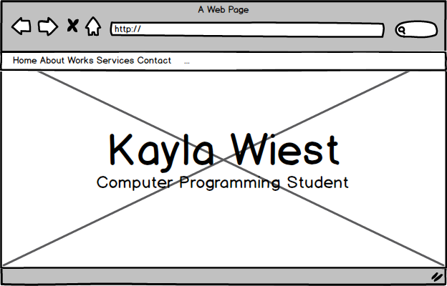**Home Page**

* Full cover background image
* Overlay text name and title

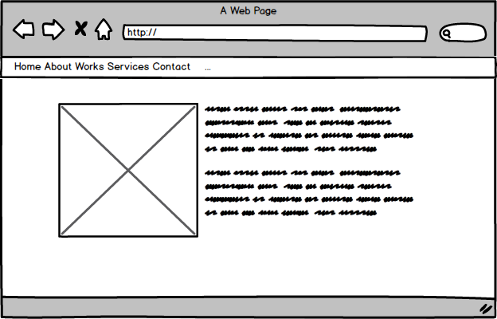**About Page**

* Large square profile image
* Large text block description

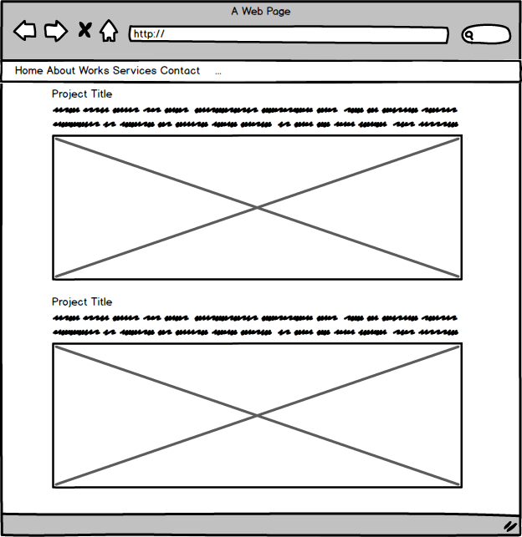**Works**

* Project Title Header
* Small text block description
* Large project image

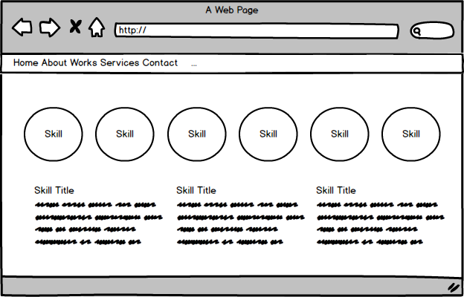**Services**

* Small circle skillset images
* Skill title header
* Small text box description

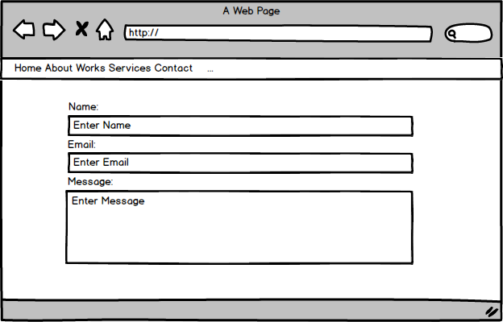**Contact**

* Large form input

**Images**

**Home**

Stock image from Pexel.com, free for personal and commerical use.

<https://www.pexels.com/photo/black-android-smartphone-on-black-surface-168765/>

Image to be cover display, ratio to browser resolution.

**About**

400px by 400px ratio

**Skill Sets**

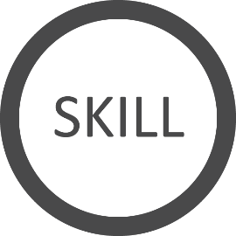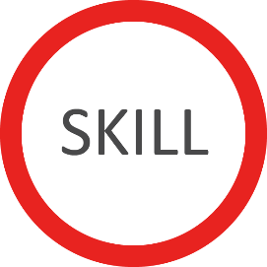

Unexperienced Skill Experienced Skill

Font: Calibri / Color: E82320 Font: Calibri / Color: E82320

**Works**

Fixed 1425px width, height to width ratio