Update Master Forms Data Utility:
The forms recognition process uses data from the Master Forms such as the OCR Data, field's location and field's type. These data are stored inside Bin & XML files by our DLLS.
When we update our DLLs, the data files might not be compatible with the new DLLs. This compatibility problem might trigger accuracy problems in the recognition process. In order to overcome this problem, the Master Forms Data files should be updated using the "Update Master Forms Data Utility".
How To Use The Utility:
1- Run Utility.
You can run this utility from the Master Forms Editor Demo by selecting "Update master Forms Data" from File menu.
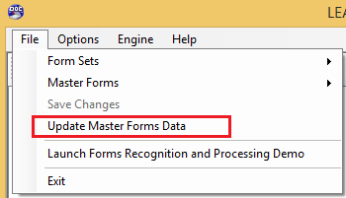

2- Setting Old Master Forms Data Path.
When you run the utility, a Dialog will show. In this dialog, you can select the path of the Master Forms Folder that contains the Master Forms Data files (BIN & XML).
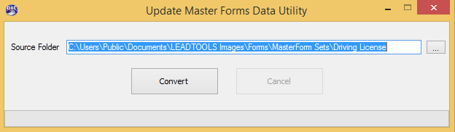

3- Converting Master Forms Data.
After setting the folder's path, press Convert, and the utility will start converting the files. After the convert finishes, you can use them without facing any of the compatibility problems. Note that the utility will replace the data files.

Notes:
- This utility can be used to update the data files whether these files are created using LEAD or OmniPage OCR engines.
- If the old data files were created using LEAD OCR engine (for example), and you selected the OmniPage engine when the demo started, the new data files will be updated based on the OmniPage engine recognition results.
- This utility can be used if we update our DLLs, for example from v18 to v19 or from early version of v19 to newer version of v19.

