Arab Open University
Faculty of Computer Studies
T316: Advanced Networking
Tutor-Marked Assignment (TMA) – KSA – Fall 26/27
Technical Report
Network Design, Addressing, Security and Documentation
Chosen Scenario: Scenario Option 1 – Multi-Site Community Pharmacy Chain with OSPF Routing
Name of Student: ……………………………………………
University ID: ……………………………………………
Date: ……………………………………………

Plagiarism Warning and Declaration
Plagiarism Warning: As per AOU rules and regulations, all students are required to submit their own TMA work and avoid plagiarism. The AOU has implemented sophisticated techniques for plagiarism detection. You must provide all references in case you use and quote another person's work in your TMA. You will be penalized for any act of plagiarism as per the AOU's rules and regulations.
Declaration of No Plagiarism by Student (to be signed and submitted by student with TMA work):
I hereby declare that this submitted TMA work is a result of my own efforts and I have not plagiarized any other person's work. I have provided all references for information that I have used and quoted in my TMA work.
Name of Student: ……………………………………………
Signature: ……………………………………………
Date: ……………………………………………

1. Introduction and Chosen Scenario
A community pharmacy chain operates its headquarters and central dispensary in Riyadh (HQ) and two branch pharmacies, Branch-A in Dammam and Branch-B in Abha. This report documents the network that was designed, configured and verified for the company in Cisco Packet Tracer. Chosen scenario: Scenario Option 1 – Multi-Site Community Pharmacy Chain with OSPF Routing.
The company holds a single private IPv4 block [2], 172.20.0.0/25, which must serve six LANs and three point-to-point WAN links, so the addressing follows a VLSM plan [3]. The sites are joined by serial links in a triangle, so each branch keeps connectivity if one link fails, and OSPFv2 [1] distributes the routes. HQ also provides inter-VLAN routing, DHCP for its own VLANs and NAT/PAT towards the ISP.
This report covers Part A (design and implementation) and Part C (documentation and analysis); each step is supported by a labelled screenshot.

2. Network Design

2.1 Topology
Figure 1 shows the topology built in Packet Tracer and Figure 2 shows the logical view. HQ uses an ISR4331 router, which performs router-on-a-stick inter-VLAN routing, and one 2960-24TT switch. Each branch has an ISR4321 router and a 2960-24TT switch. Three serial links form the WAN triangle, and a 1941 router named ISP represents the service provider. The end systems are nine PCs and laptops (five at HQ, two in each branch), two servers in VLAN 30 and one network printer at HQ.
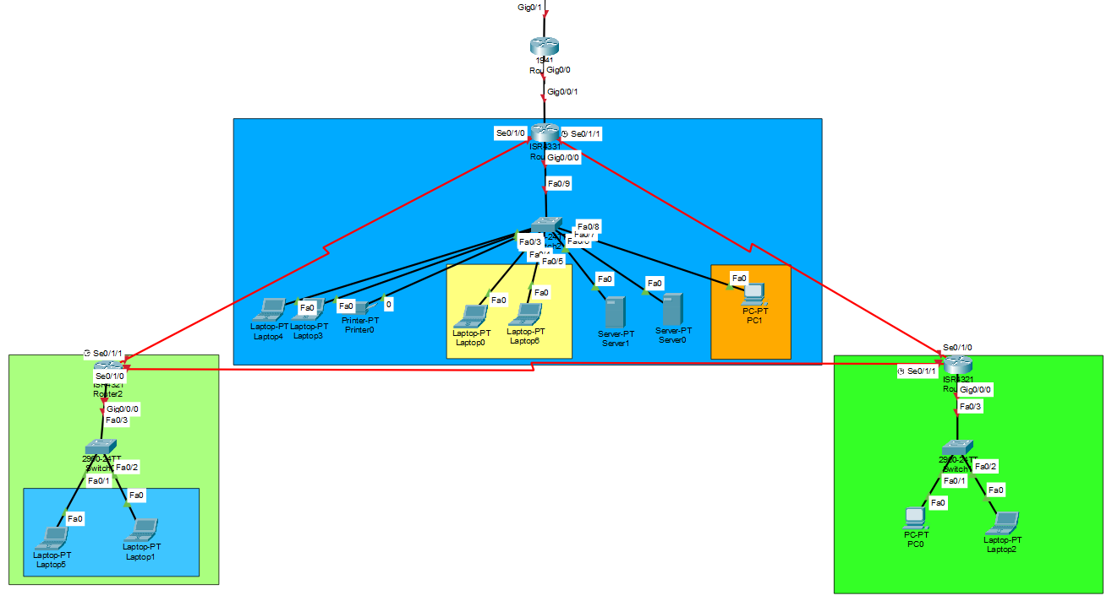
Figure 1: Packet Tracer topology with devices, links and port labels
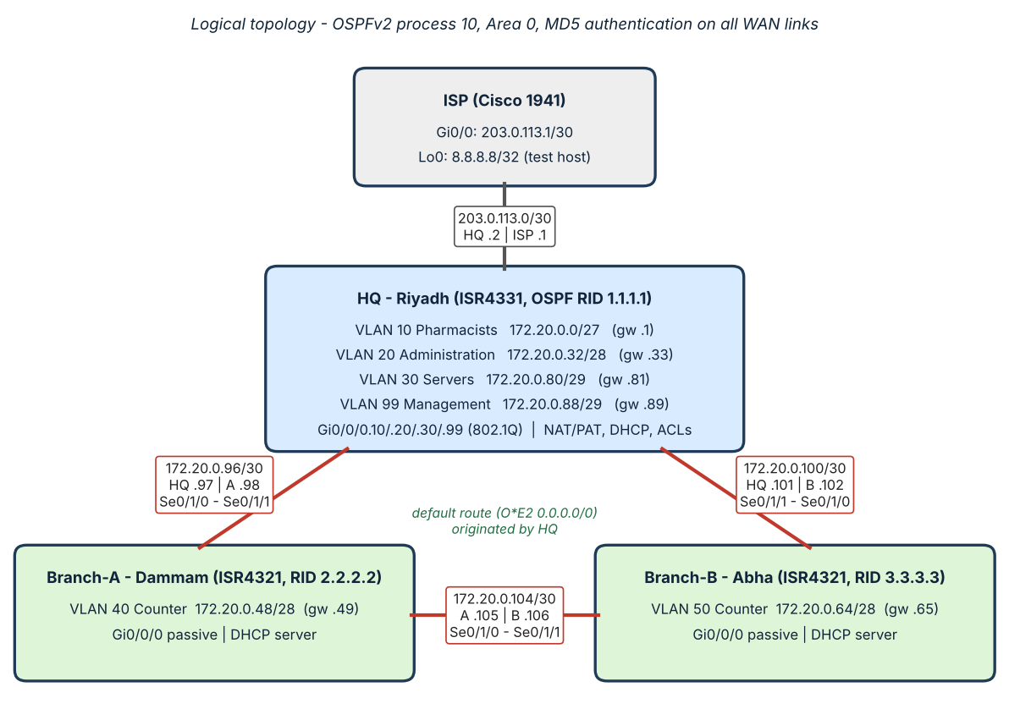
Figure 2: Logical topology: VLANs, subnets and routing paths

2.2 VLSM Addressing Plan
The requirements were sorted from largest to smallest, and each was given the smallest prefix that holds the required hosts plus one address for the default gateway (a WAN link needs only two usable addresses). VLAN 50 needs six hosts plus a gateway, and a /29 offers only six usable addresses, so a /28 was chosen. The nine subnets use 108 of the 128 addresses, leaving 172.20.0.108 – 172.20.0.127 free for growth. Table 1 lists the plan.
Table 1: VLSM addressing plan for 172.20.0.0/25
VLAN / Link | Hosts | Subnet | Mask | Usable range | Broadcast | Gateway
VLAN 10 Pharmacists (HQ) | 25 | 172.20.0.0/27 | 255.255.255.224 | .1 – .30 | .31 | .1
VLAN 20 Administration (HQ) | 12 | 172.20.0.32/28 | 255.255.255.240 | .33 – .46 | .47 | .33
VLAN 40 Branch-A Counter | 10 | 172.20.0.48/28 | 255.255.255.240 | .49 – .62 | .63 | .49
VLAN 50 Branch-B Counter | 6 | 172.20.0.64/28 | 255.255.255.240 | .65 – .78 | .79 | .65
VLAN 30 Servers (HQ) | 5 | 172.20.0.80/29 | 255.255.255.248 | .81 – .86 | .87 | .81
VLAN 99 Management (HQ) | 4 | 172.20.0.88/29 | 255.255.255.248 | .89 – .94 | .95 | .89
WAN HQ – Branch-A | 2 | 172.20.0.96/30 | 255.255.255.252 | .97 – .98 | .99 | n/a
WAN HQ – Branch-B | 2 | 172.20.0.100/30 | 255.255.255.252 | .101 – .102 | .103 | n/a
WAN Branch-A – Branch-B | 2 | 172.20.0.104/30 | 255.255.255.252 | .105 – .106 | .107 | n/a

Usable range, broadcast and gateway show the last octet of 172.20.0.x.

2.3 Address Documentation
Table 2 completes the documentation with VLAN IDs, names, DHCP ranges and device assignments, and Table 3 lists the interface addresses of every router. The first five usable addresses of each DHCP pool are excluded, and the HQ servers and the management host use static addresses. Because of these exclusions, the VLAN 20 and VLAN 40 pools lease at most nine addresses, which is sufficient for this lab but small for production.
Table 2: VLAN and device assignment table
VLAN | Name | Subnet | DHCP range | Device assignments
10 | Pharmacists | 172.20.0.0/27 | 172.20.0.6 – .30 (HQ) | Laptop4, Laptop3 (DHCP); Printer0 (static, excluded range)
20 | Administration | 172.20.0.32/28 | 172.20.0.38 – .46 (HQ) | Laptop0, Laptop6 (DHCP)
30 | Servers | 172.20.0.80/29 | Static | Server0 172.20.0.82; Server1 172.20.0.83
99 | Management | 172.20.0.88/29 | Static | PC1 172.20.0.91
40 | Branch-A-Counter | 172.20.0.48/28 | 172.20.0.54 – .62 (Branch-A) | Laptop5, Laptop1 (DHCP)
50 | Branch-B-Counter | 172.20.0.64/28 | 172.20.0.70 – .78 (Branch-B) | PC0, Laptop2 (DHCP)

Table 3: Router interface addressing
Device | Interface | Address | Role
HQ | Gi0/0/0.10 | 172.20.0.1/27 | VLAN 10 gateway (802.1Q)
HQ | Gi0/0/0.20 | 172.20.0.33/28 | VLAN 20 gateway
HQ | Gi0/0/0.30 | 172.20.0.81/29 | VLAN 30 gateway; extended ACL applied outbound
HQ | Gi0/0/0.99 | 172.20.0.89/29 | VLAN 99 gateway
HQ | Se0/1/0 | 172.20.0.97/30 | WAN to Branch-A
HQ | Se0/1/1 | 172.20.0.101/30 | WAN to Branch-B
HQ | Gi0/0/1 | 203.0.113.2/30 | ISP link (NAT outside)
Branch-A | Gi0/0/0 | 172.20.0.49/28 | VLAN 40 gateway
Branch-A | Se0/1/1 | 172.20.0.98/30 | WAN to HQ
Branch-A | Se0/1/0 | 172.20.0.105/30 | WAN to Branch-B
Branch-B | Gi0/0/0 | 172.20.0.65/28 | VLAN 50 gateway
Branch-B | Se0/1/0 | 172.20.0.102/30 | WAN to HQ
Branch-B | Se0/1/1 | 172.20.0.106/30 | WAN to Branch-A
ISP | Gi0/0 | 203.0.113.1/30 | Link to HQ
ISP | Loopback0 | 8.8.8.8/32 | Simulated internet destination

3. Implementation

3.1 VLANs and Trunking
On SW-HQ, VLANs 10 (Pharmacists), 20 (Administration), 30 (Servers) and 99 (Management) were created (Figure 3). Ports Fa0/1–3 serve VLAN 10, Fa0/4–5 serve VLAN 20, Fa0/6–7 serve VLAN 30 and Fa0/8 serves VLAN 99, while Fa0/9 is an 802.1Q trunk to the HQ router that allows only VLANs 10, 20, 30 and 99 (Figure 4, Figure 5). Each branch switch carries a single VLAN: VLAN 40 on SW-A and VLAN 50 on SW-B (Figure 6, Figure 7).
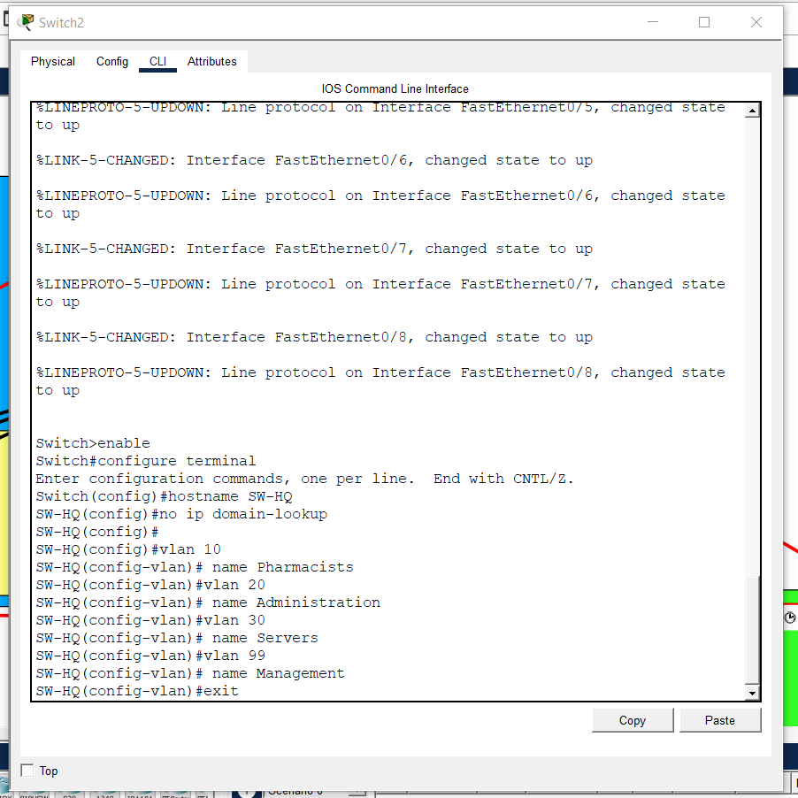
Figure 3: SW-HQ: VLAN creation
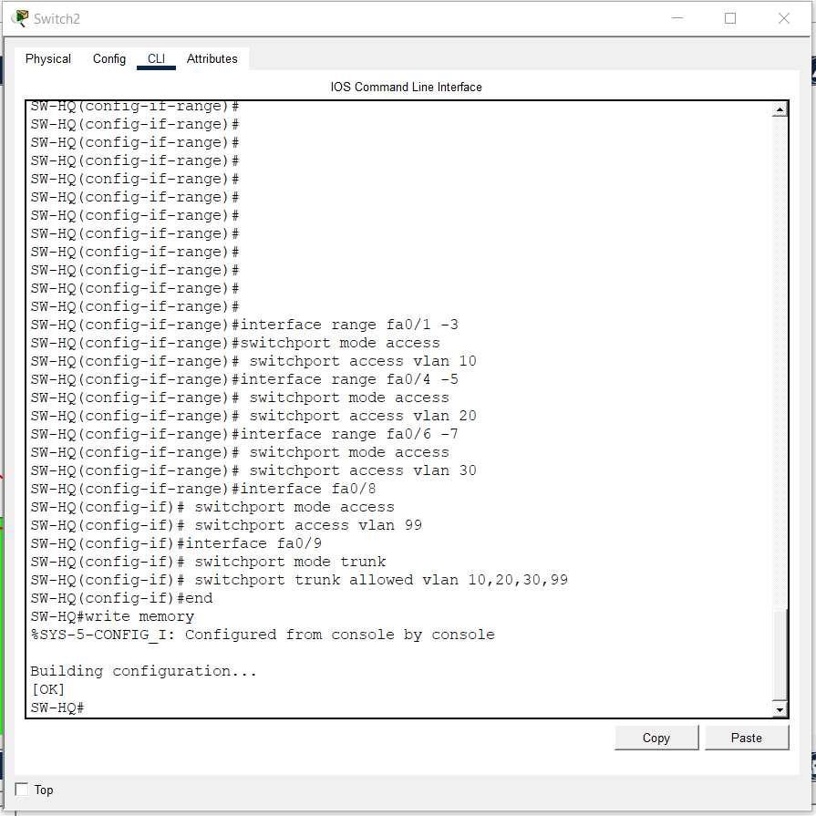
Figure 4: SW-HQ: access ports and trunk on Fa0/9
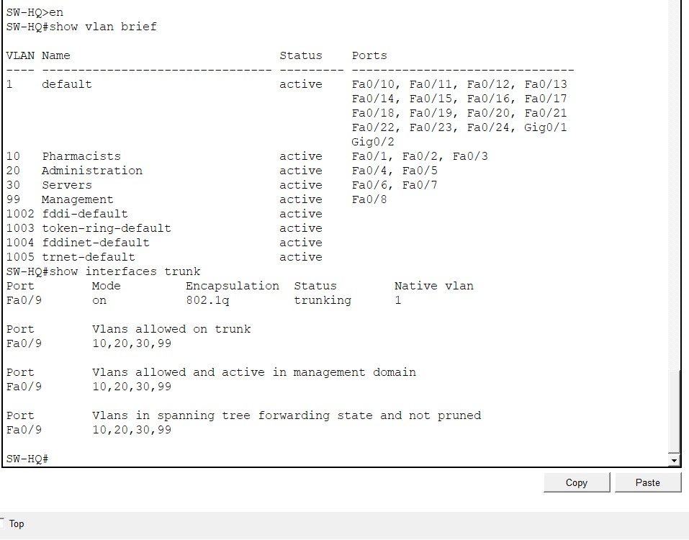
Figure 5: SW-HQ: show vlan brief and show interfaces trunk
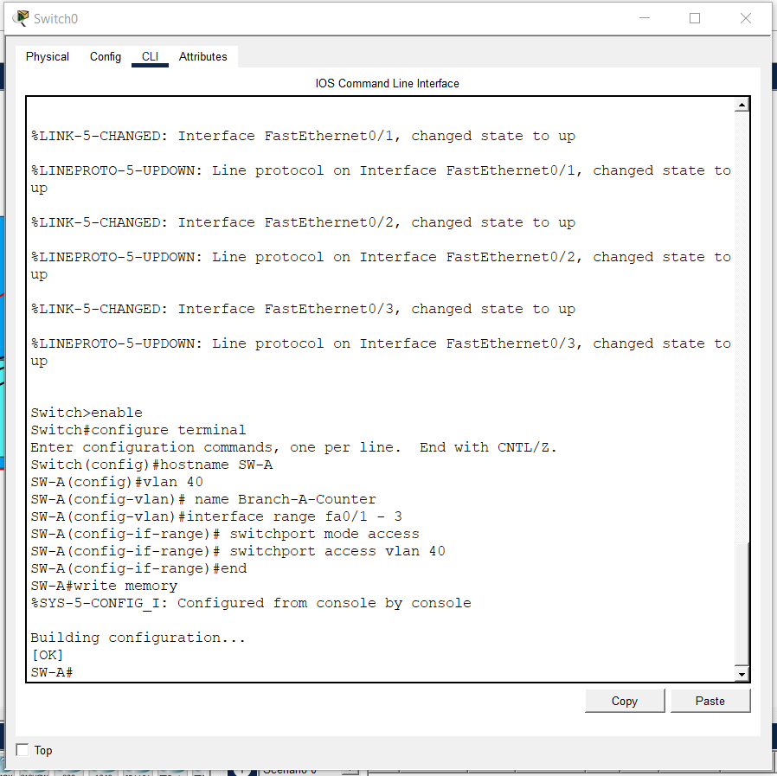
Figure 6: SW-A: VLAN 40 and access ports
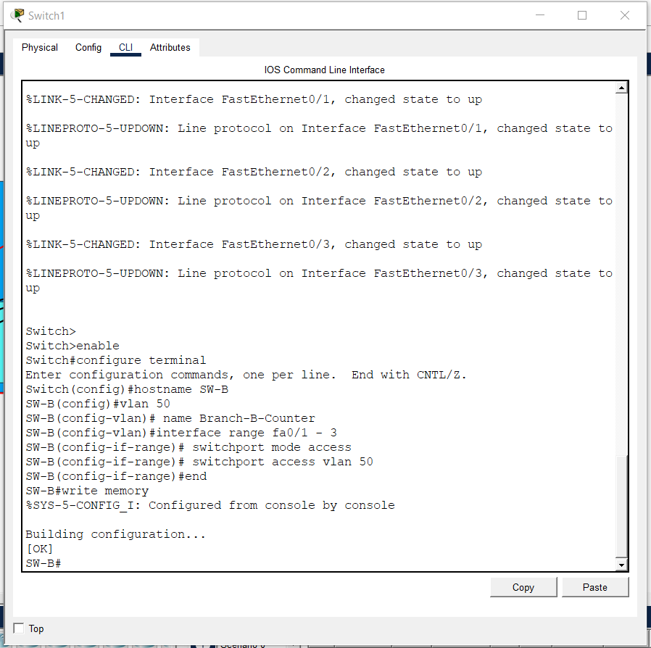
Figure 7: SW-B: VLAN 50 and access ports

3.2 Inter-VLAN Routing
The HQ router connects to the trunk through Gi0/0/0, which is divided into four sub-interfaces. Each uses dot1Q encapsulation with its VLAN ID and carries the gateway address of that VLAN (Figure 8). All four sub-interfaces are up/up (Figure 36).
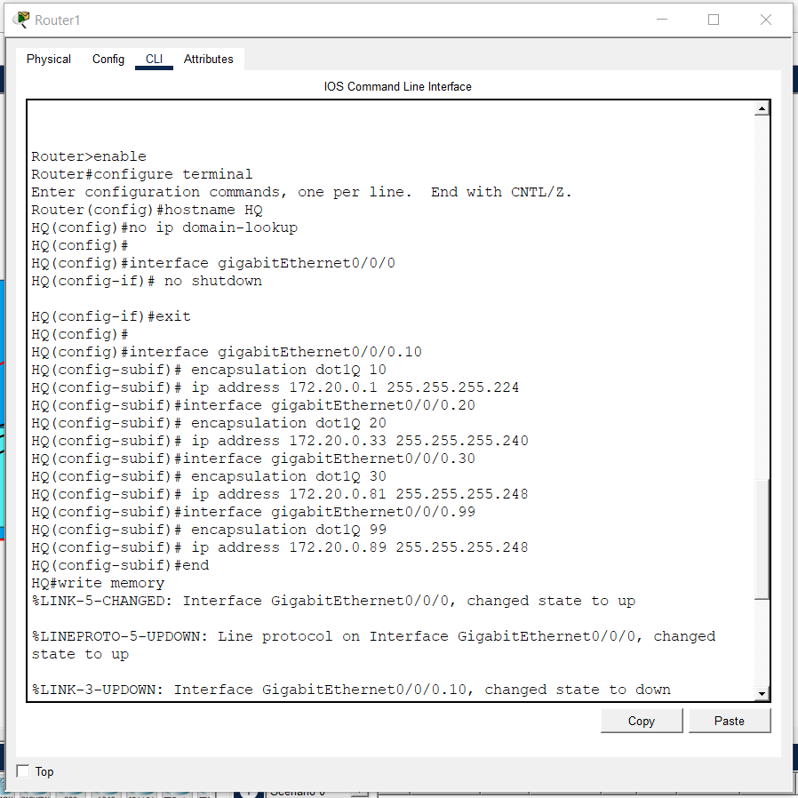
Figure 8: HQ: router-on-a-stick sub-interfaces

3.3 WAN Links and Internet Connection
The serial interfaces take their addresses from the three /30 subnets, with HQ always using the lower host address. The clock rate (64000) was set on the DCE ends; the DTE ends correctly reject the command. HQ Gi0/0/1 uses 203.0.113.2/30 towards the ISP gateway 203.0.113.1, and a default static route points to that gateway (Figure 9, Figure 10, Figure 11, Figure 12). Pings across the WAN links succeeded; only the first echo to the ISP was lost while ARP resolved (Figure 13, Figure 14).
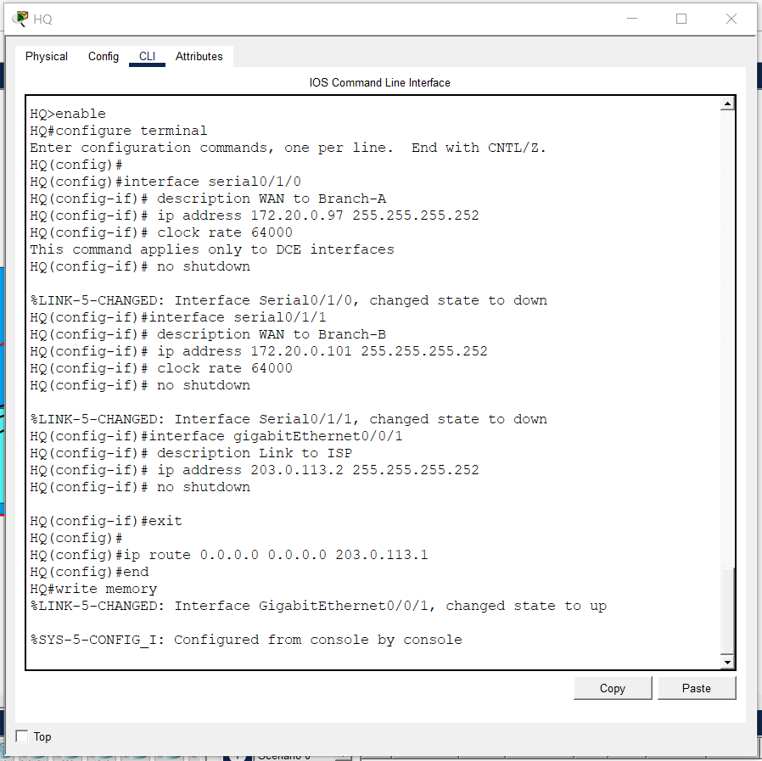
Figure 9: HQ: WAN interfaces, ISP link and default route
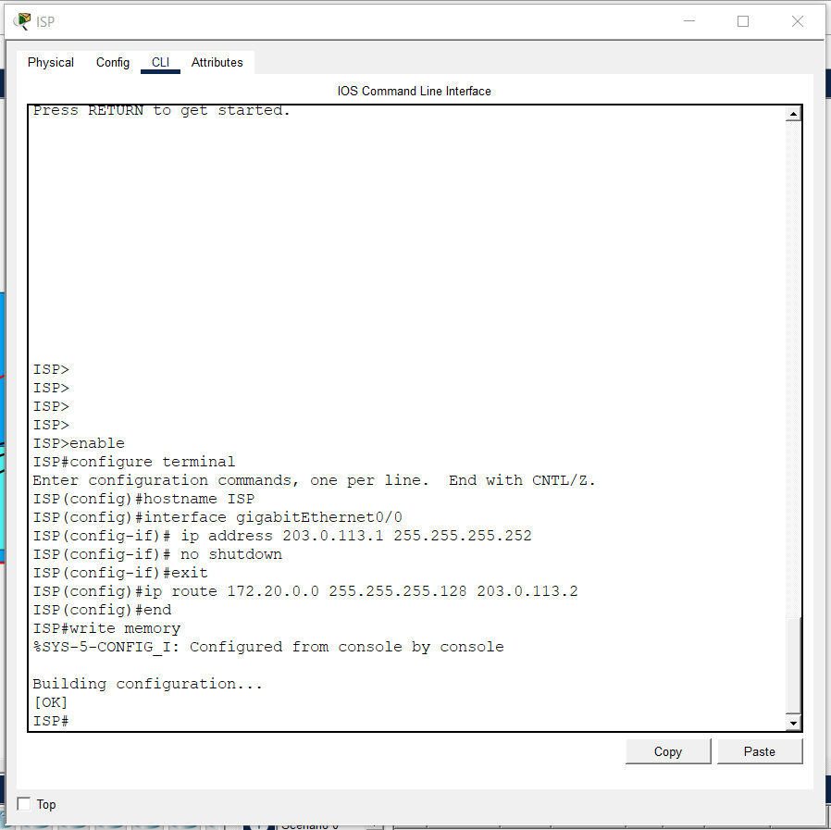
Figure 10: ISP router configuration
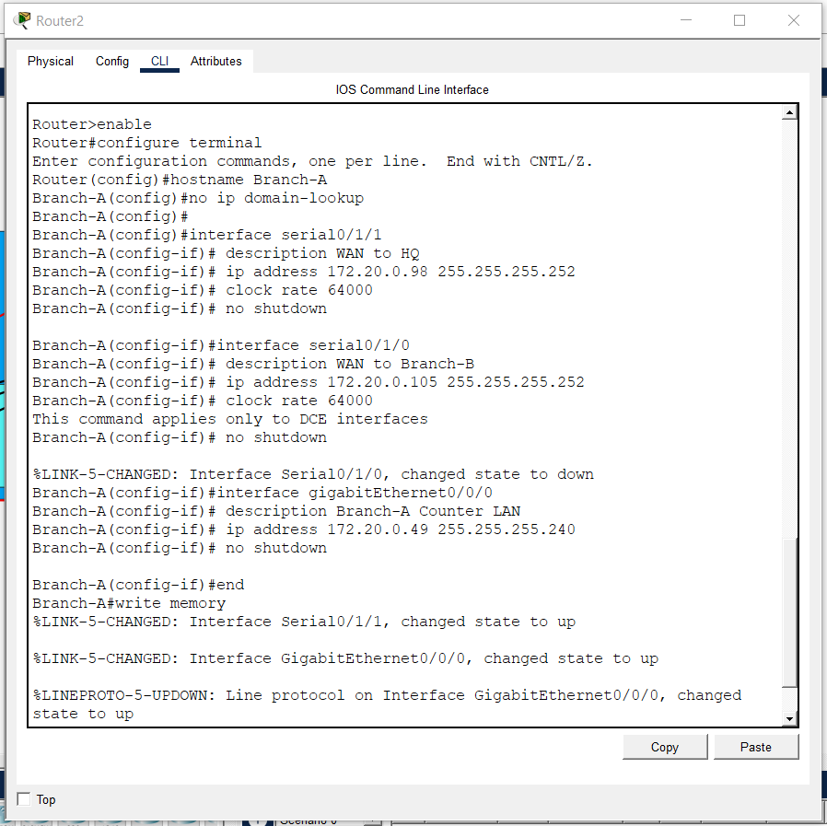
Figure 11: Branch-A: WAN and LAN interfaces
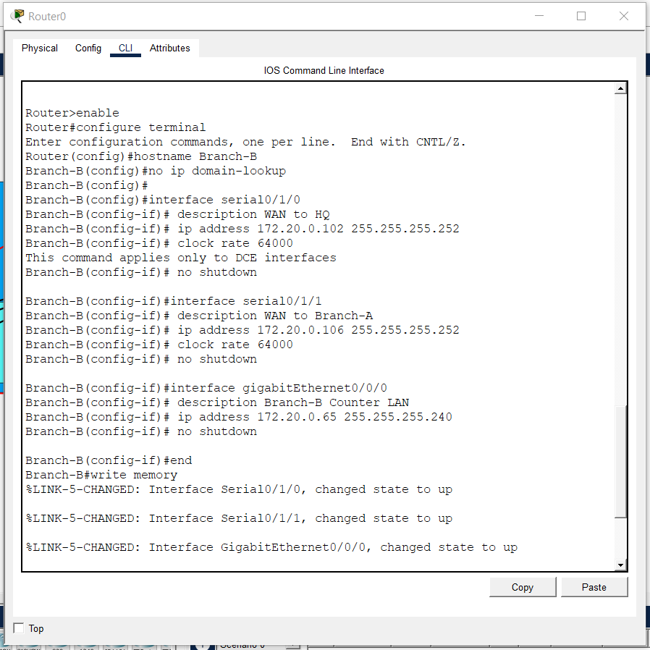
Figure 12: Branch-B: WAN and LAN interfaces
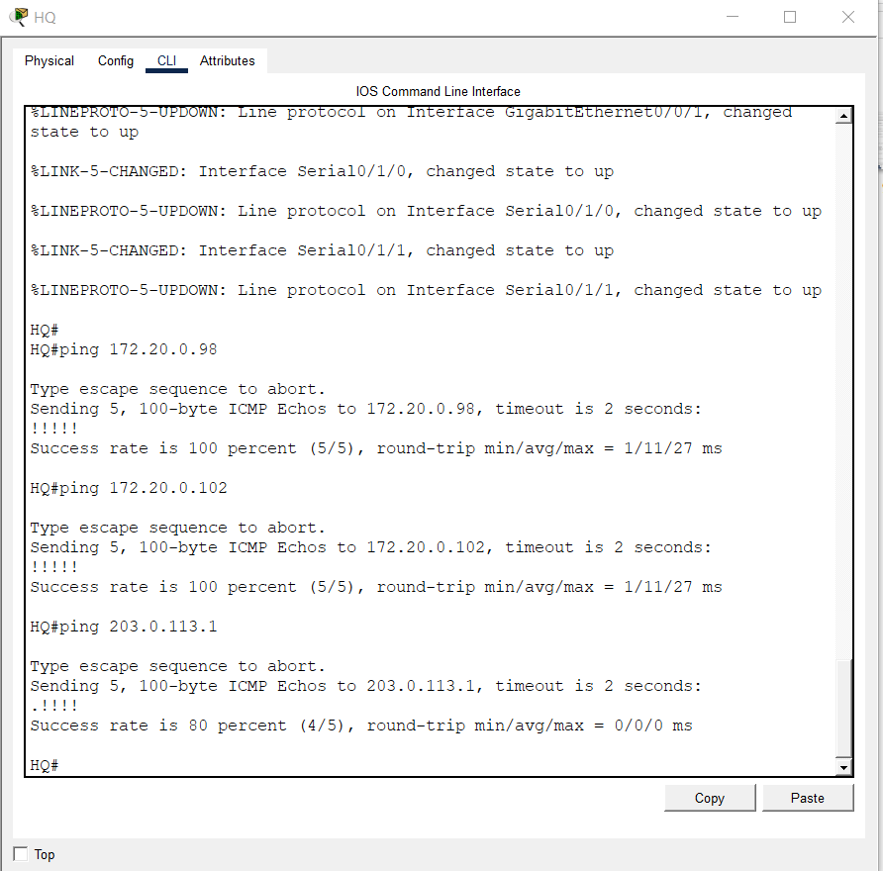
Figure 13: HQ: ping tests to both branches and the ISP
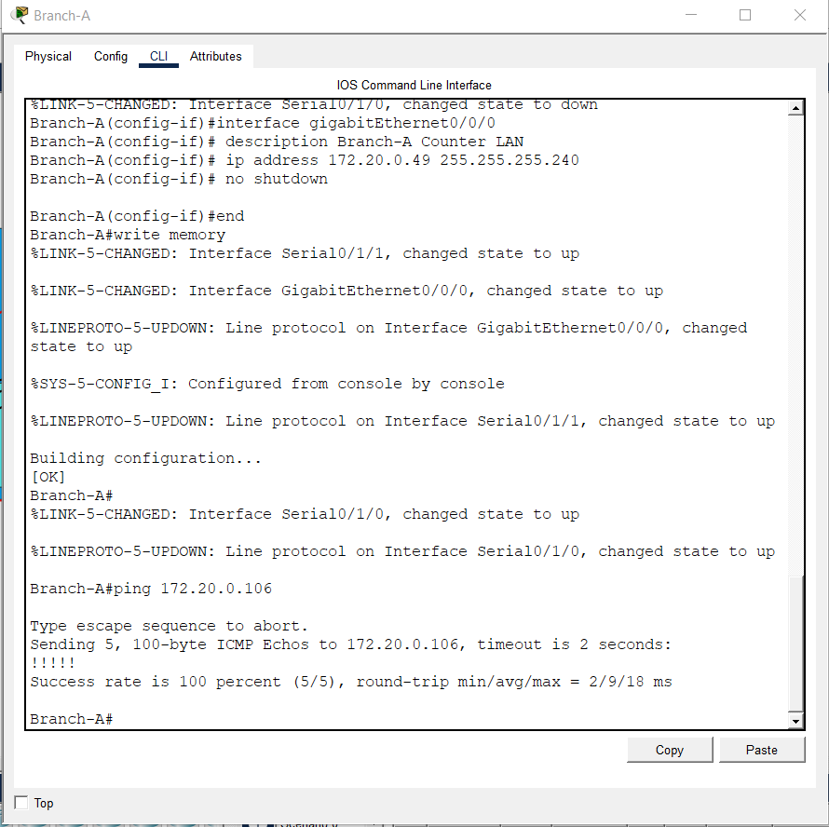
Figure 14: Branch-A: ping test to Branch-B

3.4 OSPF Routing
OSPFv2 [6] runs as process 10 in the single Area 0 on all three routers. The router IDs were set manually to 1.1.1.1 (HQ), 2.2.2.2 (Branch-A) and 3.3.3.3 (Branch-B). Instead of a catch-all statement, every subnet is advertised with its exact network address and wildcard mask, for example network 172.20.0.32 0.0.0.15 area 0 for VLAN 20. All LAN-facing interfaces are passive, which stops hello packets reaching user networks while still advertising the connected subnets. HQ also runs default-information originate so that its static default route reaches the branches (Figure 15, Figure 16, Figure 17).
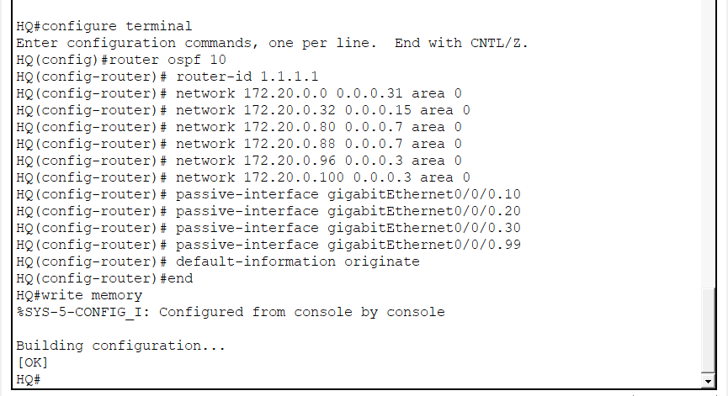
Figure 15: HQ: OSPF configuration
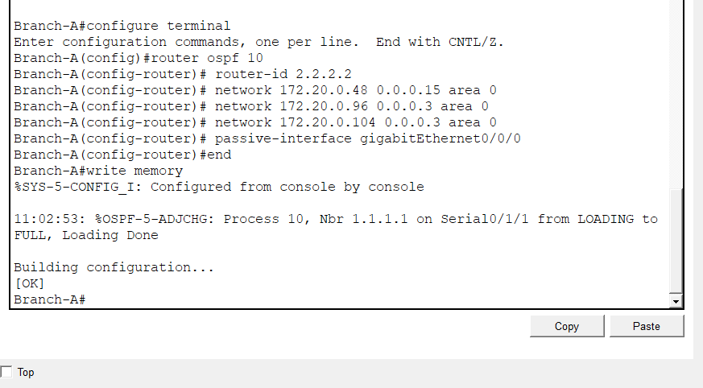
Figure 16: Branch-A: OSPF configuration
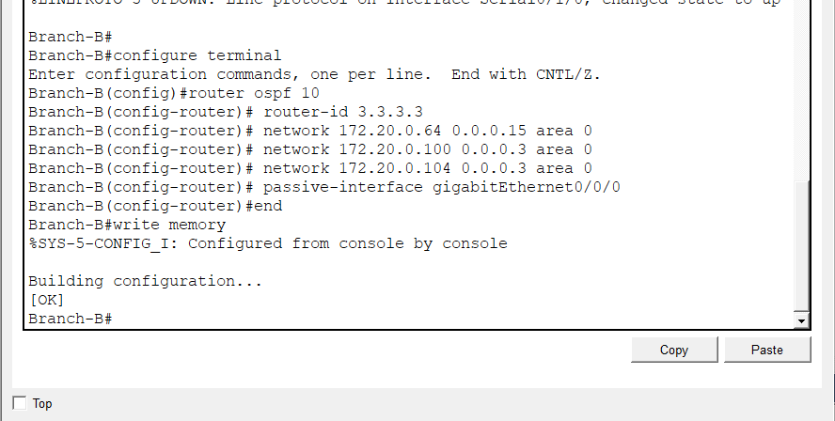
Figure 17: Branch-B: OSPF configuration

3.5 Security Measures
OSPF authentication. MD5 authentication with key ID 1 was enabled on both ends of every WAN link (Figure 18, Figure 19, Figure 20), so an unauthorised router cannot form an adjacency or inject routes.
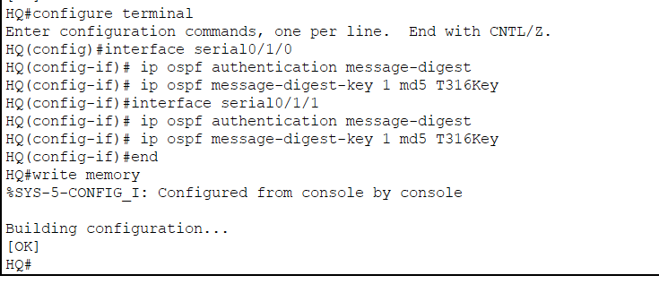
Figure 18: HQ: OSPF MD5 authentication
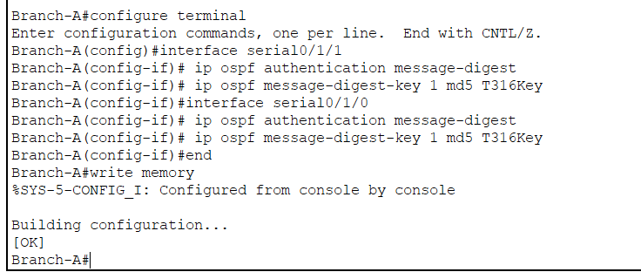
Figure 19: Branch-A: OSPF MD5 authentication
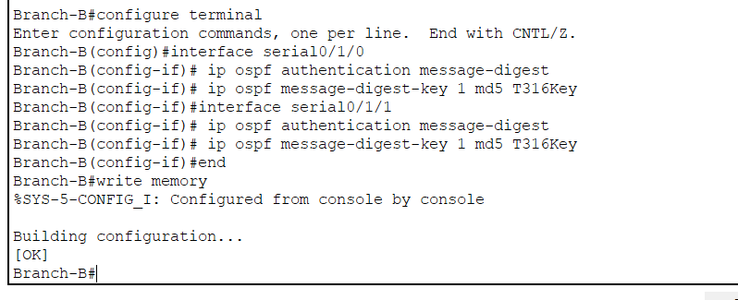
Figure 20: Branch-B: OSPF MD5 authentication
Secure management. On the HQ router the domain name pharmacy.local was set, a local user with a secret password was created, 1024-bit RSA keys were generated and SSH version 2 was enabled. The VTY lines accept SSH only with local login, which disables Telnet (Figure 21). A standard ACL (number 99) permits only the management subnet 172.20.0.88/29 and is applied to the VTY lines with access-class (Figure 22).
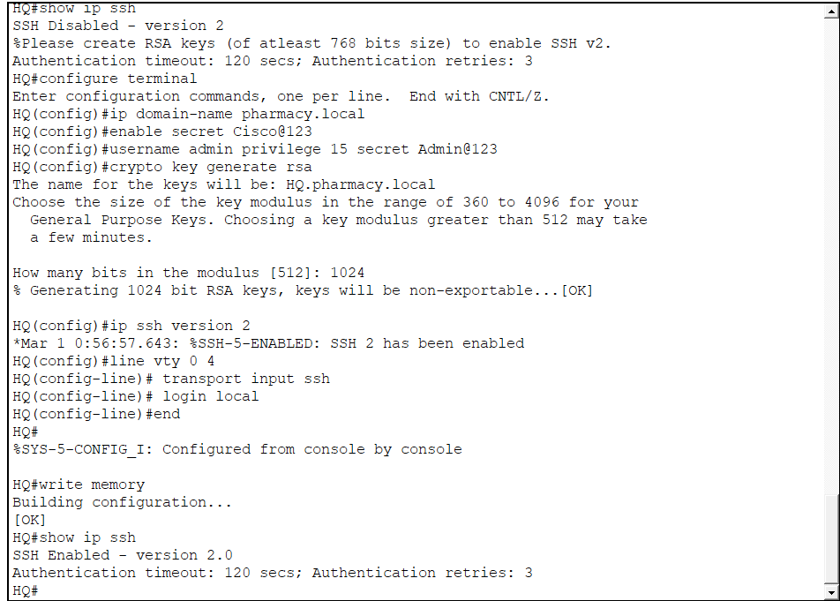
Figure 21: HQ: SSH version 2 configuration and verification
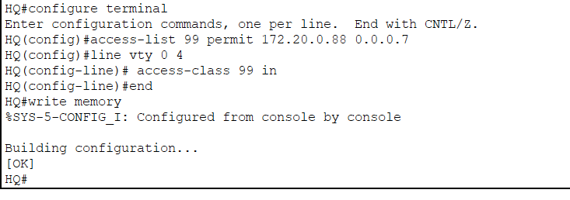
Figure 22: HQ: standard ACL 99 on the VTY lines
Server protection. The extended ACL BRANCH_TO_SERVERS permits TCP port 443 from the two branch counter subnets to the server subnet 172.20.0.80/29, denies every other IP traffic between them, and permits all remaining traffic so that HQ VLANs and internet access are unaffected. It is applied outbound on Gi0/0/0.30, next to the protected servers (Figure 23).
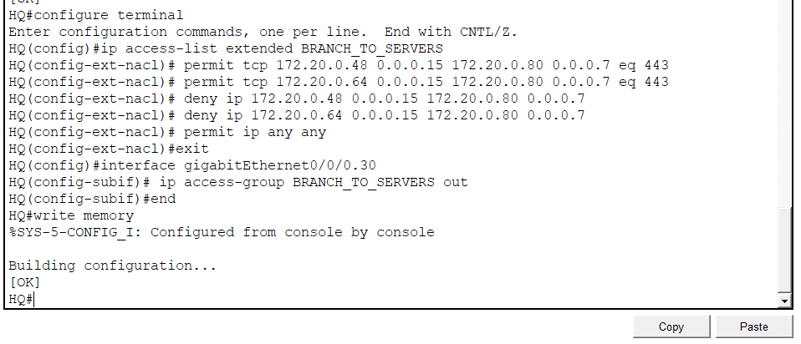
Figure 23: HQ: extended ACL applied to VLAN 30

3.6 DHCP, Static Addressing and NAT
HQ is the DHCP server for VLANs 10 and 20, and each branch router serves its own counter VLAN. The first five usable addresses of every pool (172.20.0.1–5, .33–37, .49–53 and .65–69) are excluded before the pools are defined, so gateways, the printer and reserved devices are never leased (Figure 24, Figure 25, Figure 26). The clients received the first free address of their pools (Figure 27, Figure 28, Figure 29). The servers in VLAN 30 and the management host in VLAN 99 use static addresses.
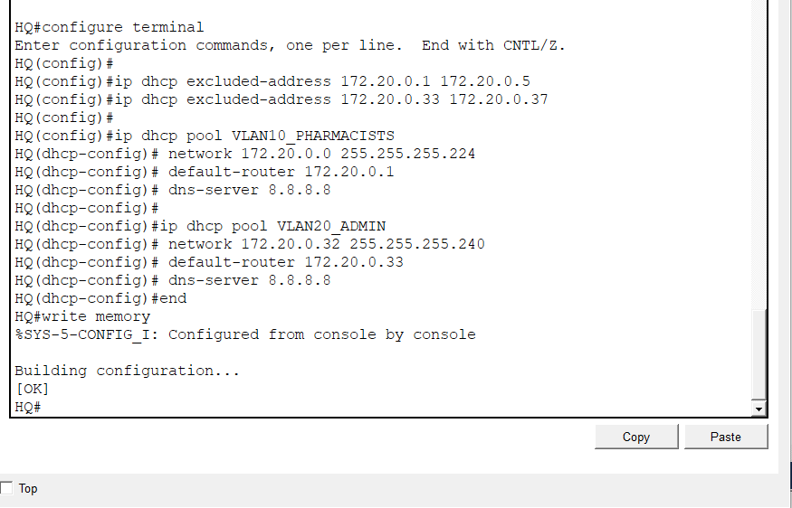
Figure 24: HQ: DHCP exclusions and pools for VLANs 10 and 20
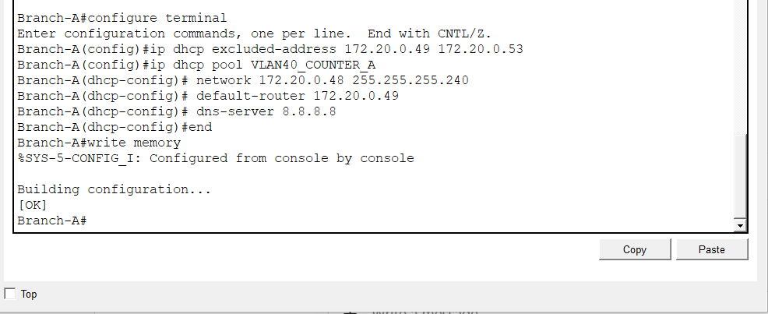
Figure 25: Branch-A: DHCP pool for VLAN 40
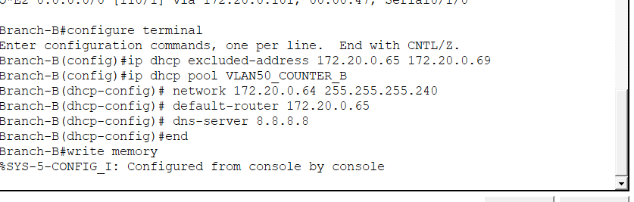
Figure 26: Branch-B: DHCP pool for VLAN 50
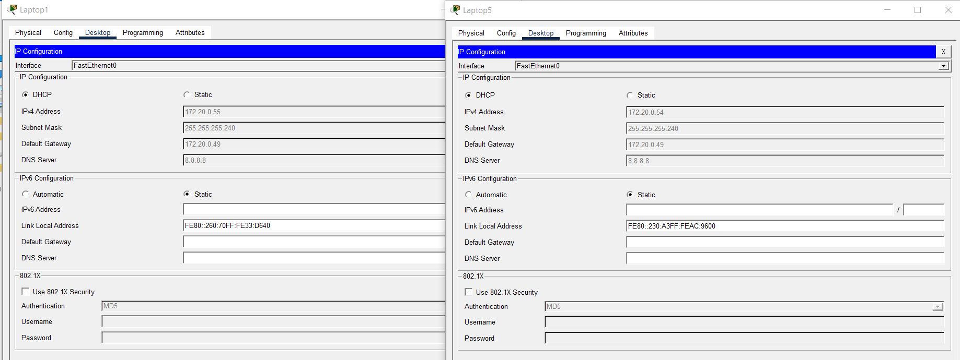
Figure 27: DHCP clients Laptop1 and Laptop5 (Branch-A)
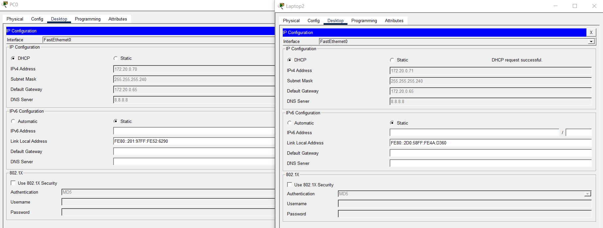
Figure 28: DHCP clients PC0 and Laptop2 (Branch-B)
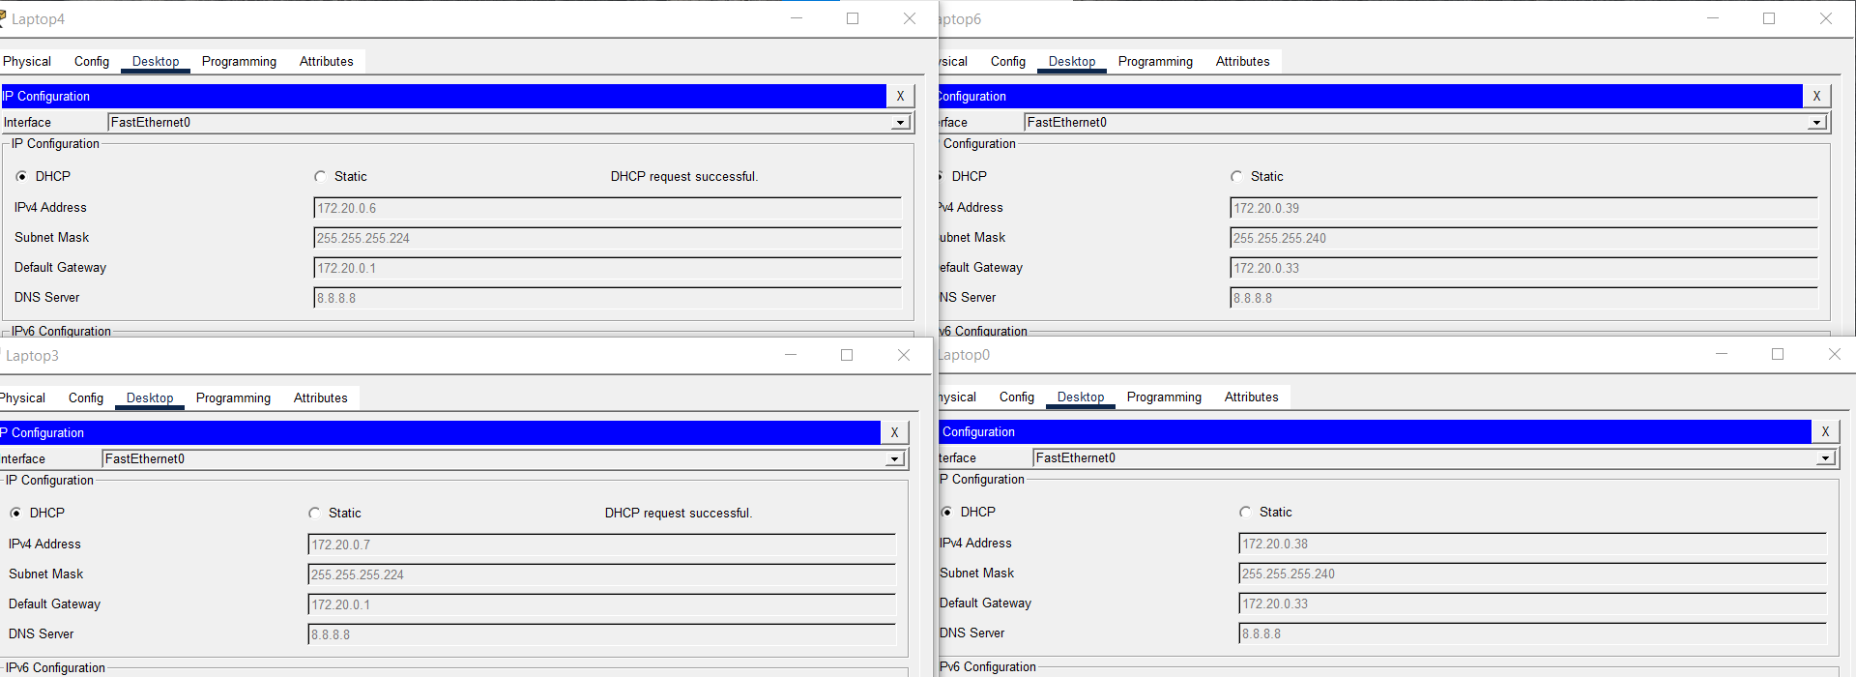
Figure 29: DHCP clients Laptop4, Laptop6, Laptop3 and Laptop0 (HQ)
PAT [4] was configured on HQ. Access list 1 matches 172.20.0.0/25, Gi0/0/1 is the outside interface, and the four sub-interfaces and both serial links are inside interfaces because branch traffic reaches HQ over the serial links. The command ip nat inside source list 1 interface gigabitEthernet0/0/1 overload translates every internal host to 203.0.113.2 (Figure 30). To prove that NAT, and not a return route, provides internet access, the ISP was given the loopback 8.8.8.8 and its static route to the company block was removed (Figure 31).
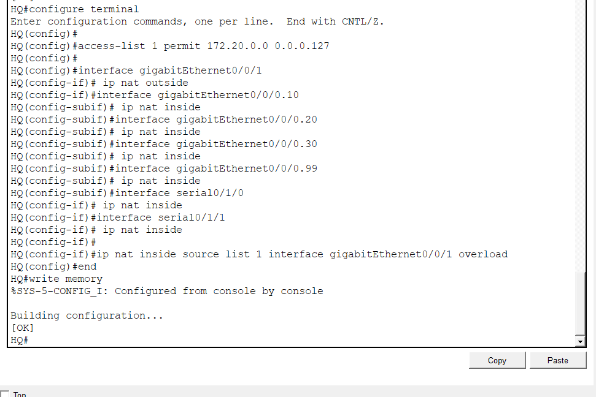
Figure 30: HQ: NAT/PAT configuration
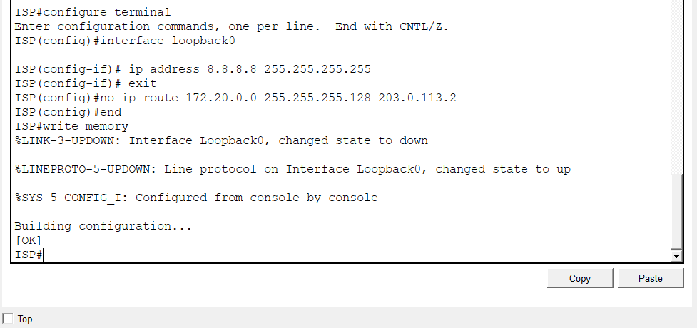
Figure 31: ISP: loopback 8.8.8.8 and removal of the static route

4. Validation and Test Results
Routing. Each router shows two neighbours in the FULL state (Figure 32, Figure 33). The branch routers learned the HQ LANs and the other branch LAN as O routes, plus the default route as O*E2 0.0.0.0/0 via HQ. The WAN subnets 172.20.0.100 and 172.20.0.104 appear with two equal-cost next hops where applicable, which shows that the triangle provides a second path. The running configuration confirms the exact network statements, the passive interfaces and default-information originate (Figure 34). Figure 35 confirms that message-digest authentication is enabled with a Hello of 10 and a Dead interval of 40 seconds.
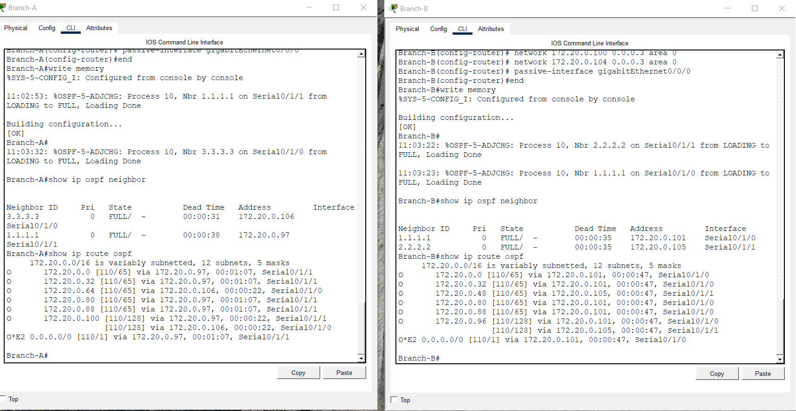
Figure 32: Branch-A and Branch-B: OSPF neighbours and routes
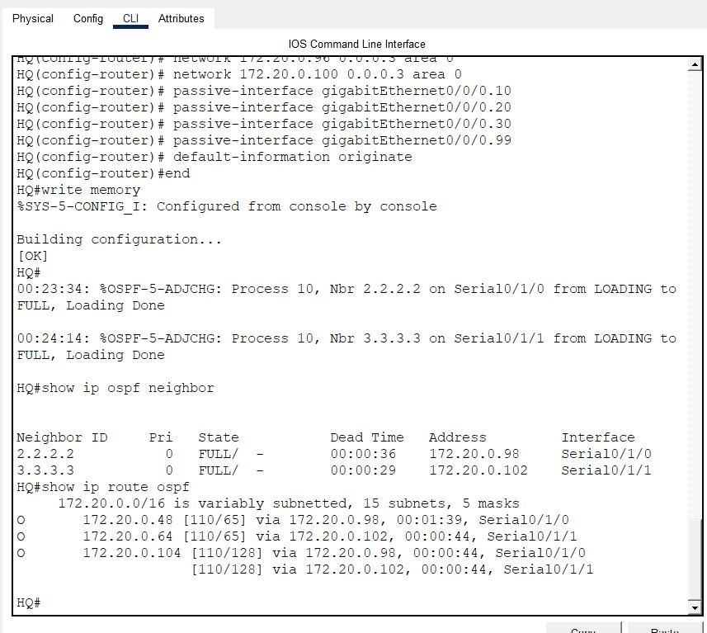
Figure 33: HQ: OSPF neighbours and learned routes
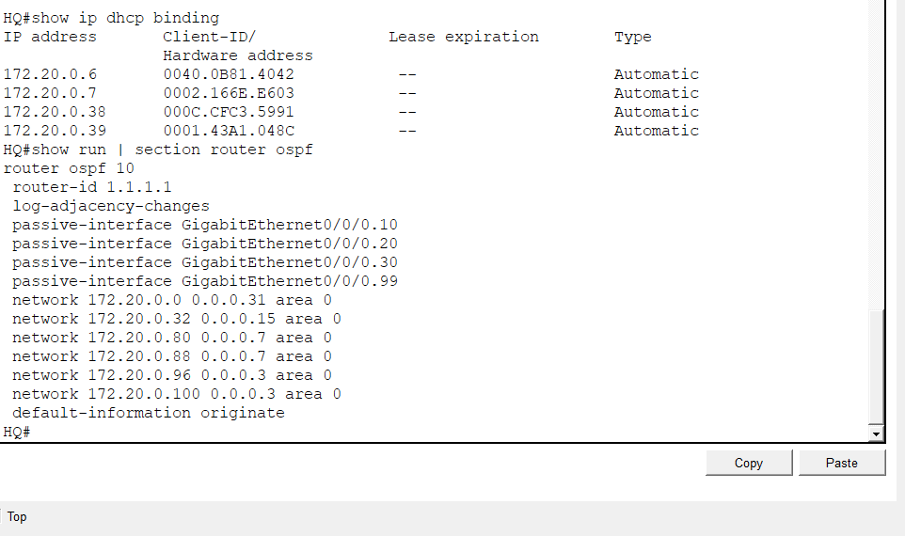
Figure 34: HQ: DHCP bindings and OSPF section of the running configuration
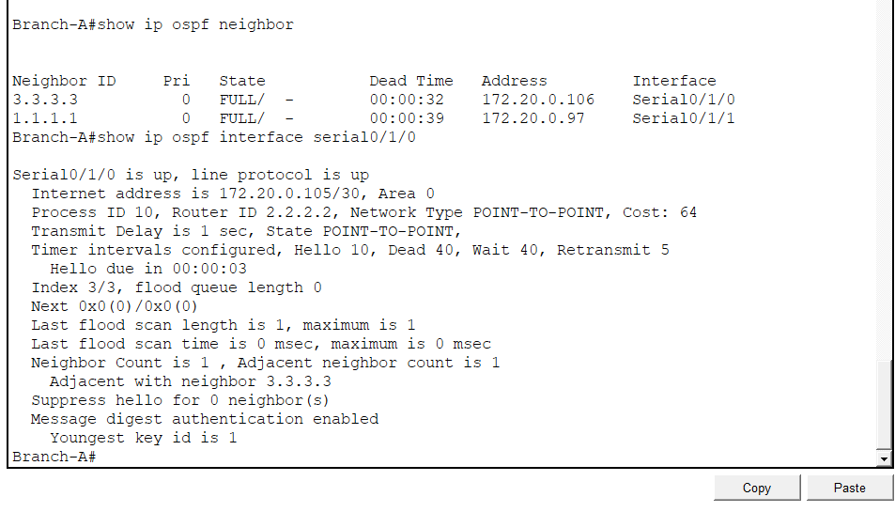
Figure 35: Branch-A: OSPF neighbours and MD5 authentication enabled
Interfaces, ACLs and DHCP. Figure 36 shows the four sub-interfaces and both serial links up/up, the three access lists, and the HQ DHCP bindings, which start at 172.20.0.6 and 172.20.0.38 as intended.
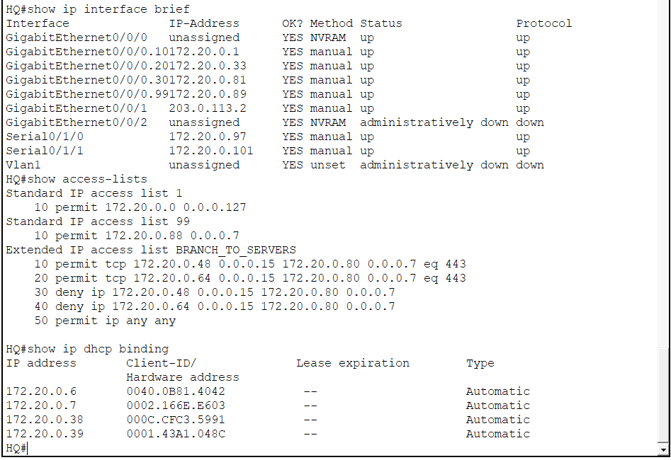
Figure 36: HQ: interface status, access lists and DHCP bindings
Internet and NAT. PC0 (Branch-B), Laptop5 (Branch-A) and Laptop4 (HQ) all reached 8.8.8.8 with no packet loss (Figure 37). The NAT table lists Branch-A host 172.20.0.54 and Branch-B host 172.20.0.70 translated to 203.0.113.2 with unique port numbers (Figure 38).
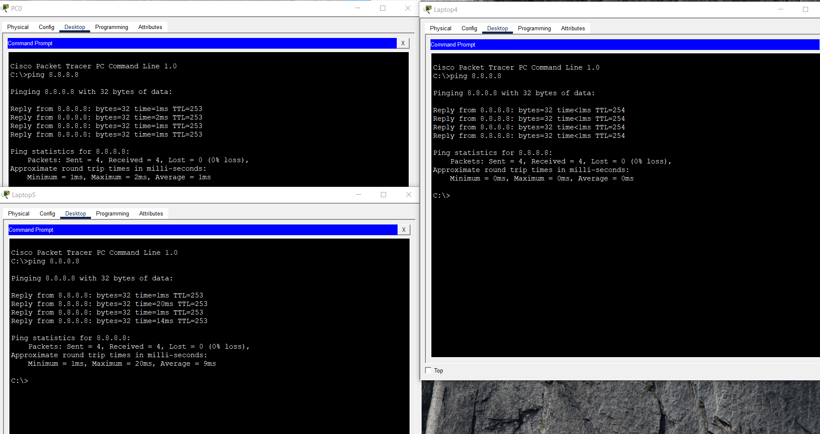
Figure 37: Ping to 8.8.8.8 from Branch-B, Branch-A and HQ hosts
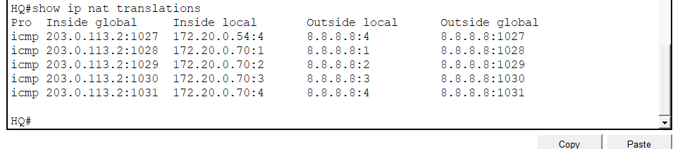
Figure 38: HQ: show ip nat translations
Management access. From PC1 in VLAN 99, SSH to the HQ router opened the router prompt after authentication; the first attempt timed out while waiting for the password and the second succeeded (Figure 39). From Laptop4 in VLAN 10 the same request was refused (Figure 40).
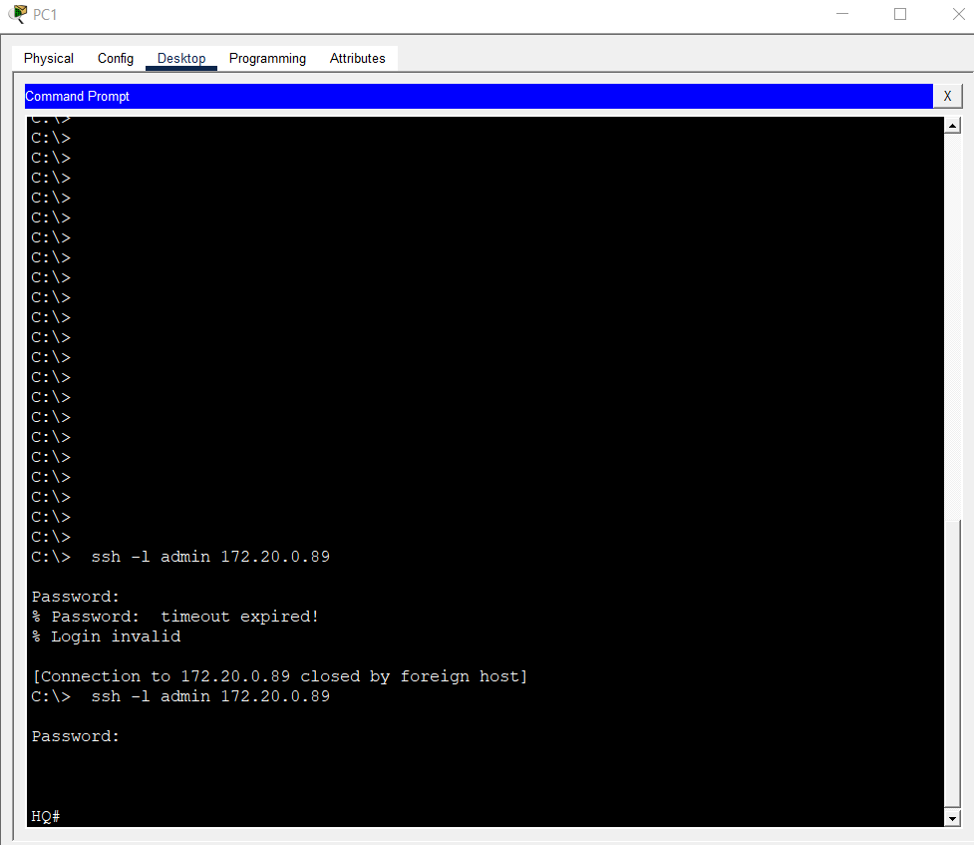
Figure 39: SSH from PC1 (VLAN 99) to HQ
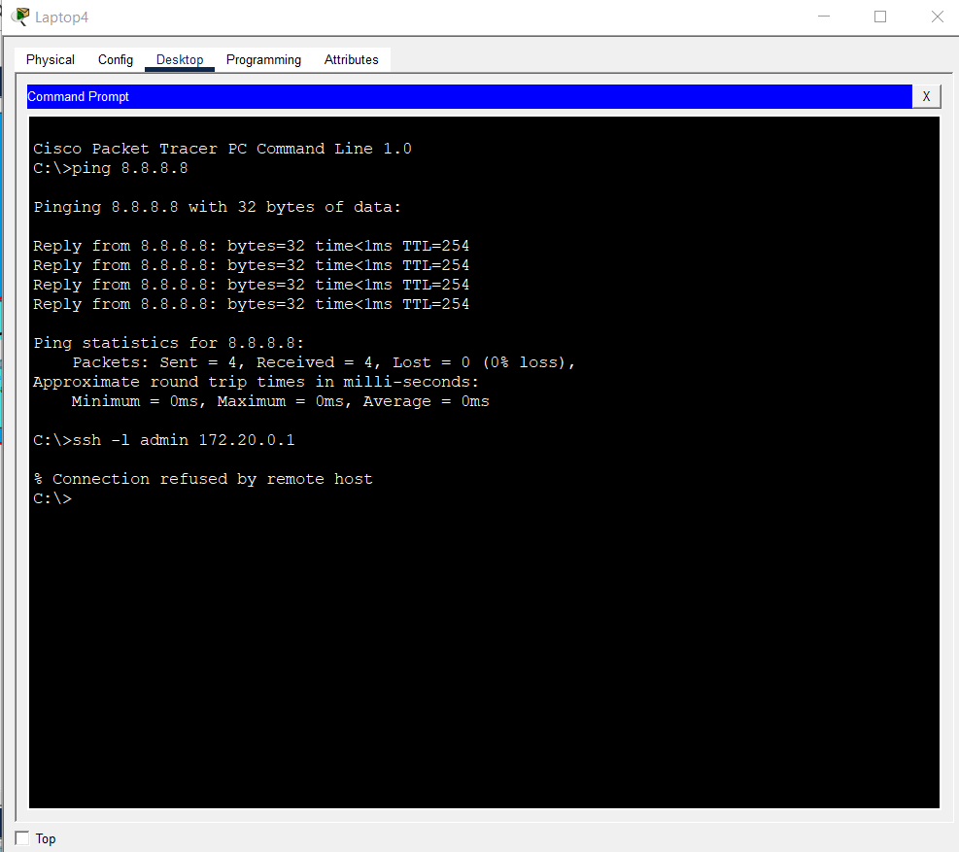
Figure 40: SSH from Laptop4 (VLAN 10) refused
Server access control. A VLAN 30 server reached its gateway, the second server and the management gateway (Figure 41). Laptop5 in Branch-A opened https://172.20.0.83 successfully (Figure 42), but a ping to the same server returned "Destination host unreachable" from 172.20.0.97 with 100% loss (Figure 43). HTTPS is therefore the only permitted service from the branches to VLAN 30.
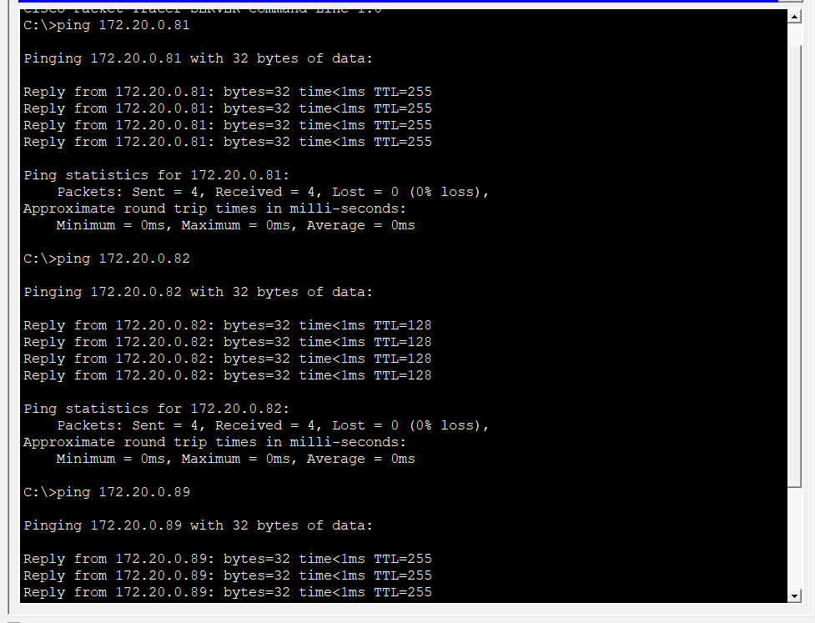
Figure 41: VLAN 30 server: connectivity tests
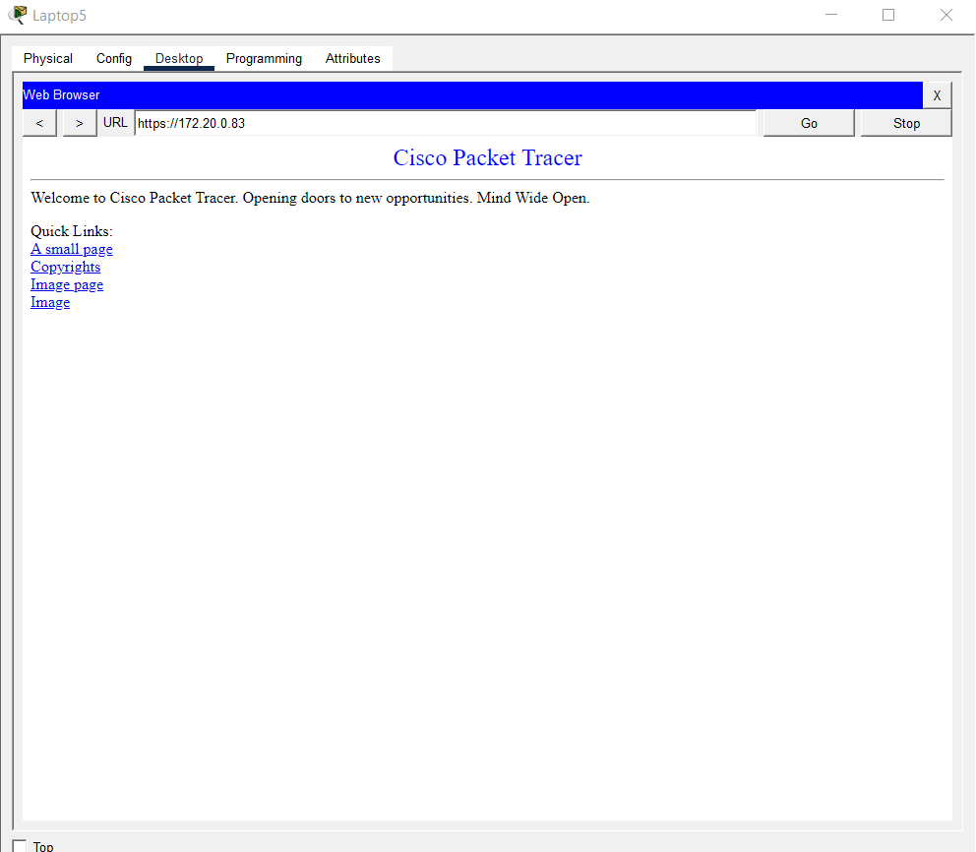
Figure 42: Laptop5 (Branch-A): HTTPS to the server is allowed
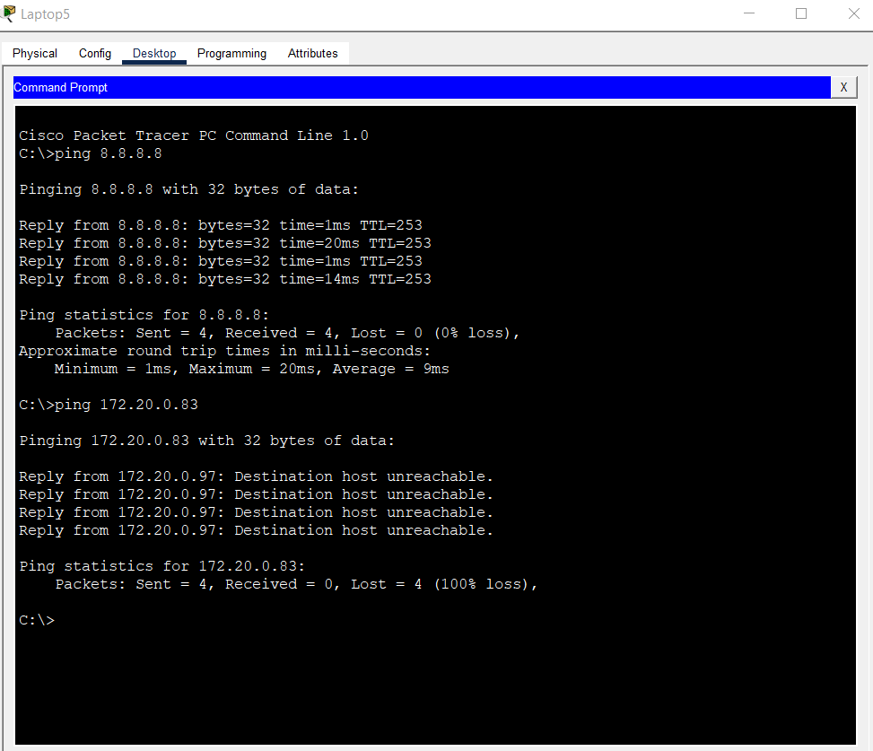
Figure 43: Laptop5 (Branch-A): ICMP to the server is denied

5. Network Analysis Report

(a) Why OSPF suits a multi-site chain better than static routing
With static routing every route must be typed on every router, so adding one subnet or moving a link means editing several devices, and one typing mistake silently black-holes traffic. OSPF is a link-state protocol [1], [5]: each router floods advertisements about its own links, all routers in Area 0 build an identical topology database, and each runs the SPF algorithm to choose the lowest-cost path. On these serial links the interface cost is 64 (Figure 35), so a branch reaches HQ directly at cost 64, while the alternative path through the other branch costs 128. If one link of the triangle fails, for example HQ–Branch-A, the routers on that link lose their neighbour, flood updated advertisements and recalculate. Traffic from Branch-A then flows through Branch-B to HQ without any administrator action.

(b) How VLSM conserves address space compared with a fixed /27
The design needs 68 host addresses (25+12+10+6+5+4 for the LANs and 3×2 for the WAN links). With VLSM the nine subnets allocate 108 addresses, so 40 addresses (37%) are not used by hosts. A fixed /27 gives every subnet 32 addresses, so nine subnets allocate 288 addresses and 220 (76%) are unused. That total is larger than the entire /25 block, so the fixed-prefix design would not fit and would need at least a /23. The worst waste occurs on the WAN links: a /30 gives 4 addresses to a link that needs 2, whereas a /27 would leave 30 addresses idle on each link (90 in total).
Table 4: VLSM compared with a fixed /27 prefix
Metric | VLSM design | Fixed /27
Addresses allocated | 108 | 288
Host addresses required | 68 | 68
Addresses not used by hosts | 40 (37%) | 220 (76%)
Waste on the three WAN links | 6 | 90
Fits in 172.20.0.0/25 | Yes, 20 spare | No (needs a /23)

(c) VLAN segmentation, ACLs and the Saudi PDPL
Prescription and inventory records contain personal data, and prescriptions in particular relate to health. The Saudi Personal Data Protection Law (PDPL) [7], supervised by SDAIA, expects organisations to protect personal data with suitable security measures, to restrict access to those who need it, to keep it confidential and to remain accountable for its handling. VLAN 30 places the servers in a separate broadcast domain behind the HQ router, so pharmacists, administrative staff and branch users must pass a controlled Layer 3 point to reach them. The extended ACL then applies least privilege: branches may use only HTTPS, whose encryption protects data in transit, while ICMP and every other protocol are denied (Figure 42, Figure 43). A dedicated management VLAN, SSH and the VTY ACL limit who can change device configuration, MD5 authentication prevents routing updates from being forged to redirect traffic. Together these controls support the principles of confidentiality, data security, restricted access and accountability. Network controls alone do not guarantee compliance; access logging, encryption at rest and staff training are also required.

6. Conclusion
The network meets the Part A requirements: a nine-subnet VLSM plan fits inside 172.20.0.0/25 with 20 addresses spare, HQ routes four VLANs over one trunk, OSPF with MD5 authentication joins the three sites in a resilient triangle, and the servers accept only HTTPS from the branches. DHCP, PAT and SSH hardening complete the services.

7. References
[1] J. Moy, "OSPF Version 2," RFC 2328, IETF, Apr. 1998.
[2] Y. Rekhter et al., "Address Allocation for Private Internets," RFC 1918, IETF, Feb. 1996.
[3] V. Fuller and T. Li, "Classless Inter-domain Routing (CIDR): The Internet Address Assignment and Aggregation Plan," RFC 4632, IETF, Aug. 2006.
[4] P. Srisuresh and K. Egevang, "Traditional IP Network Address Translator (Traditional NAT)," RFC 3022, IETF, Jan. 2001.
[5] W. Odom, CCNA 200-301 Official Cert Guide, Volumes 1 and 2, Cisco Press.
[6] Cisco Systems, "IP Routing: OSPF Configuration Guide," Cisco IOS documentation, cisco.com.
[7] Kingdom of Saudi Arabia, Personal Data Protection Law, Royal Decree No. M/19 (2021), as amended in 2023; supervised by the Saudi Data and AI Authority (SDAIA).

