Data visualization

Worksheet:

Profit margin by product:

Total Sales by Store location:

Discount Vs. Total Sales:

Store Ranked Contribution:

Year over Year Growth:

Top Profitable Products:

Highest total sales store name.

Effects of discounts on Profit Margin:

Total Sales:

Units Sold:

Average Profit Marginal:

Total sales by product category:

Total sales by store location:

YOY Sales:

Top product performance:

Profitability Trend:

Dashboards:

Sales overview Dashboard:

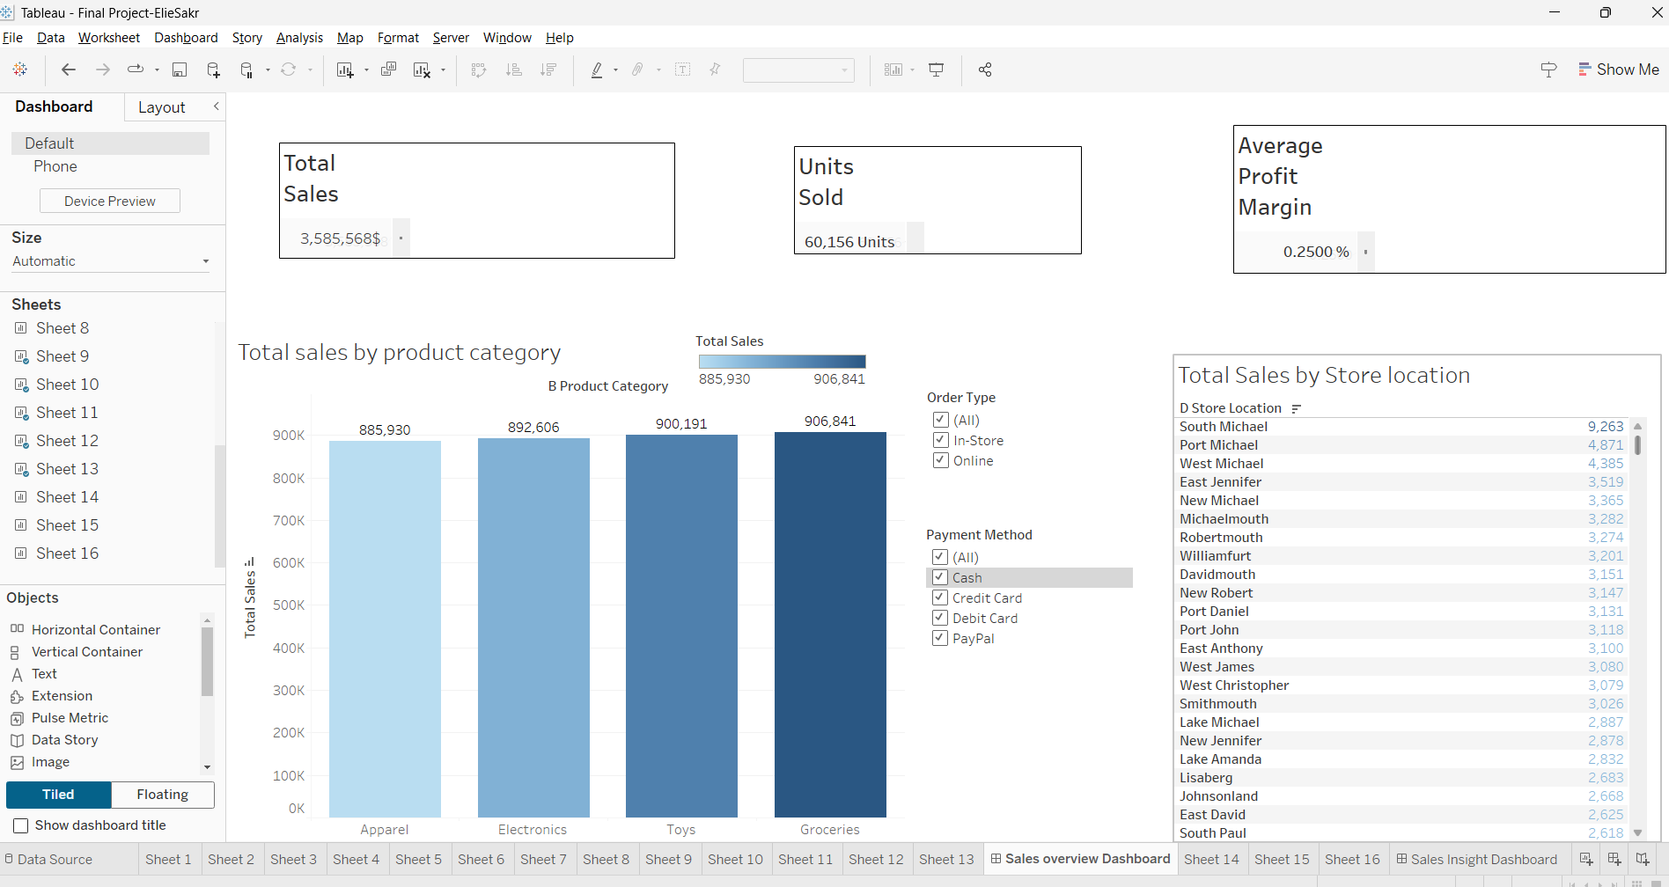

**Insights:**

1. **Total Sales:**
   * Total sales amount is **3,585,568**. This is a significant number, indicating high revenue performance overall.
   * Further analysis could segment this value by region or store location to understand which areas contribute the most.
2. **Units Sold:**
   * A total of **60,156 units** were sold, which highlights the volume of sales.
   * To improve this insight, showing the average sales per unit or units sold by category could provide more depth.
3. **Average Profit Margin:**
   * The profit margin is **0.2500%**, which seems very low. This indicates that either operational costs are too high or there is aggressive discounting.
   * Explore:
     + Which product categories or stores have the highest/lowest margins.
     + Analyze the relationship between discounts and profit.
4. **Total Sales by Product Category:**
   * **Groceries** had the highest total sales (**906,841**), followed by **Toys**, **Electronics**, and **Apparel**.
   * Groceries might be the primary revenue driver, but further insights are needed to confirm if it is also the most profitable.
5. **Total Sales by Store Location:**
   * The top store location, **South Michael**, contributed significantly to the sales (**9,263 units**).
   * However, the bottom-performing locations (e.g., **East Paul** with 2,638 units) highlight areas that may require attention to improve performance.

**Recommendations for Better Business Outcomes:**

**1. Improve Profitability (Key Concern: Low Average Profit Margin of 0.25%):**

* **Review Cost Structure:** Investigate operational costs, supplier contracts, and logistics to identify inefficiencies.
* **Adjust Pricing Strategies:** Evaluate product pricing to ensure it's competitive yet profitable. Focus on premium pricing for high-demand categories like **Groceries** or **Toys**.
* **Reduce Discount Overuse:** Analyze if excessive discounting is impacting profits and introduce smarter promotional strategies, like bundling products or loyalty rewards.

**2. Enhance Low-Performing Store Locations:**

* **South Michael** and other top stores contribute significantly, but locations like **East Paul** are lagging behind.
  + Launch **localized marketing campaigns** tailored to these regions.
  + Identify product preferences and adjust inventory or promotions accordingly.
  + Introduce incentives for staff in low-performing stores to boost sales.

**3. Capitalize on High-Performing Product Categories:**

* Focus marketing campaigns on top-performing categories like **Groceries** and **Toys** to further drive sales.
* Diversify inventory in **Apparel** and **Electronics** to increase their contributions to total revenue.
* Introduce **seasonal promotions** for underperforming categories to increase their appeal.

**4. Analyze Customer Purchase Behavior by Order Type:**

* If **Online** sales dominate, prioritize improving the e-commerce platform, user experience, and delivery times.
* For **In-Store** sales, consider offering exclusive in-store promotions or hosting events to attract foot traffic.
* Align payment options with customer preferences to streamline transactions (e.g., focus on widely used methods like credit cards or PayPal).

**5. Monitor and Reward Top-Performing Stores:**

* Encourage **best practices sharing** among top-performing locations like **South Michael** and mid-tier stores.
* Offer recognition or incentives for employees in high-performing locations to maintain motivation and outcomes.

**6. Increase Customer Retention Through Loyalty Programs:**

* Introduce loyalty programs to encourage repeat purchases.
* Offer personalized promotions based on customers' purchase history to enhance satisfaction and drive sales.

**7. Expand Product Availability in Growth Categories:**

* Since **Groceries** lead in sales, ensure consistent stock availability, especially for high-demand items.
* Introduce new, complementary product lines within the top categories to drive cross-selling opportunities.

**8. Track and Drive Year-over-Year Growth:**

* Add **YoY sales growth tracking** to understand how the business is scaling over time.
* Focus efforts on regions, product categories, or stores that are not meeting growth expectations.

**9. Optimize Resource Allocation:**

* Invest in expanding operations or marketing in top-performing areas while carefully managing costs in underperforming ones.
* Reassess inventory allocation to ensure products are available where demand is highest.

**10. Future Trends and Insights:**

* Perform a deeper analysis of **seasonal trends** to align marketing campaigns with peak demand periods.
* Explore introducing new product lines or services that align with customer preferences and market demands.

Sales insights dashboard:

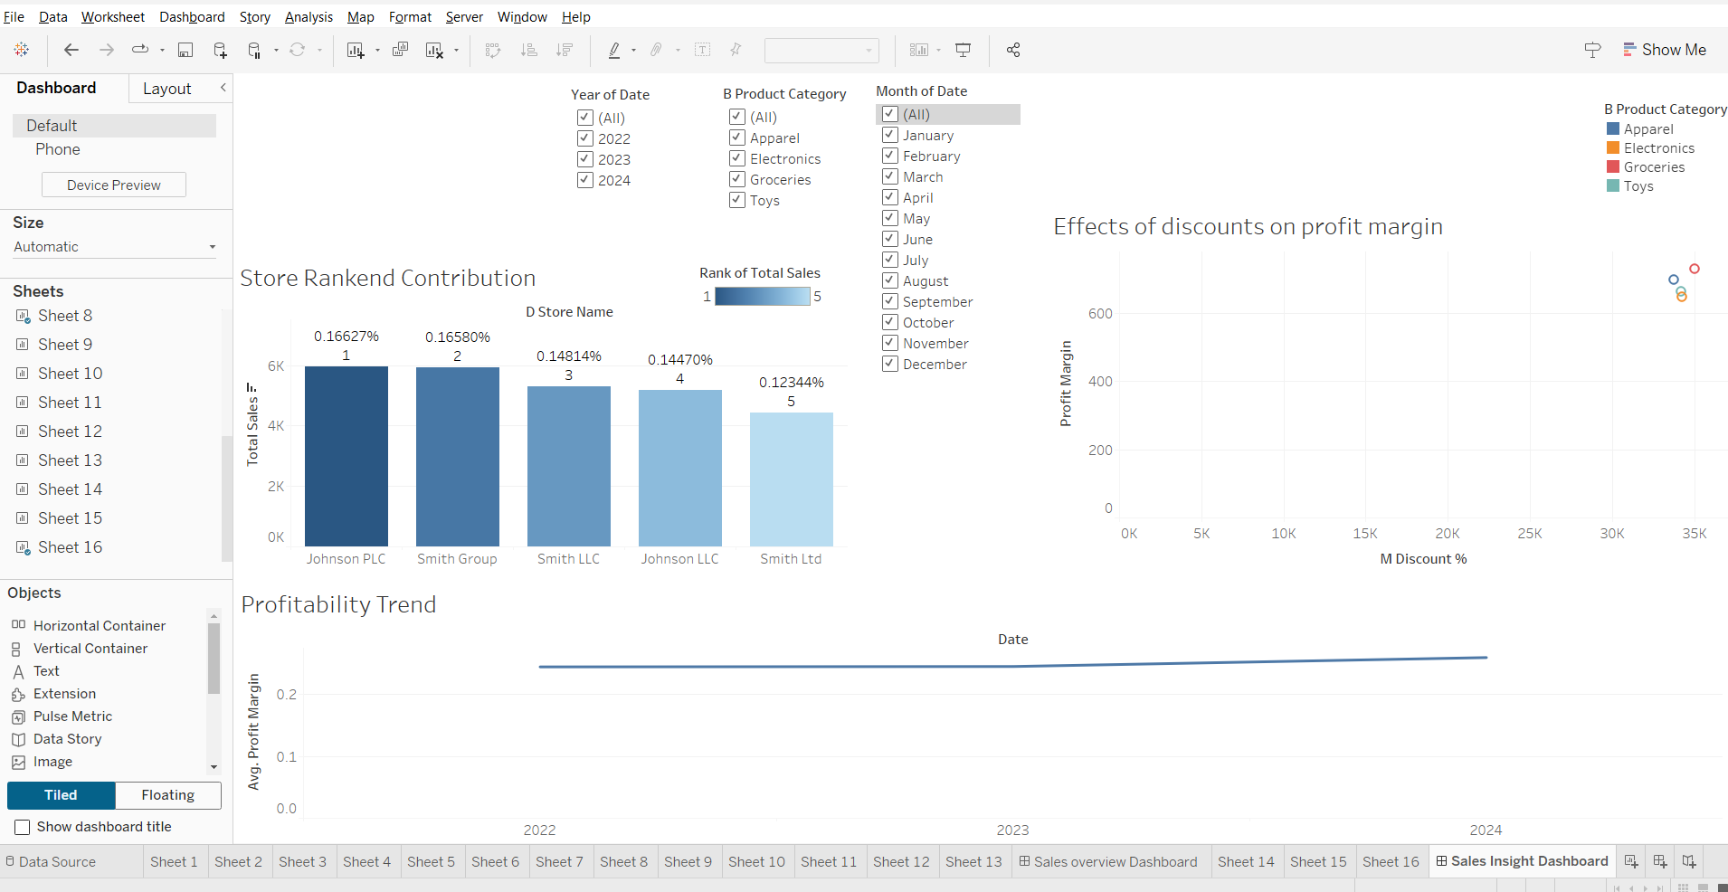

**Key Insights:**

1. **Profitability Trend:**
   * The Profitability Trend chart shows a slight upward trajectory over the years. This suggests that the overall profitability of the business is improving.
2. **Store Rank and Contribution:**
   * Johnson PLC has the highest contribution to total sales, followed by Smith Group.
   * Smith LLC and Johnson LLC have similar contributions, slightly lower than the top two stores.
   * Smith Ltd has the lowest contribution to total sales.
3. **Effects of Discounts on Profit Margin:**
   * The scatter plot reveals a general trend: as the discount percentage increases, the profit margin tends to decrease. This is expected, as higher discounts directly impact the revenue.
   * However, there are some outliers where even with higher discounts, the profit margin remains relatively high. These cases might be due to higher sales volume or other factors that offset the impact of discounts.
4. **Product Category and Month of Date:**
   * The bar chart highlights the sales distribution across product categories and months.
   * Apparel consistently has the highest sales throughout the year, followed by Electronics.
   * Toys and Groceries have lower sales compared to the other categories.

**Recommendations:**

1. **Discount Optimization:**
   * Analyze the outliers in the discount vs. profit margin scatter plot to identify strategies that allow for higher discounts without significantly impacting profit margins.
   * Consider implementing dynamic pricing strategies based on demand and inventory levels to optimize discounts and revenue.
2. **Product Category Focus:**
   * Continue to prioritize Apparel and Electronics, as they are the top-performing categories.
   * Explore ways to boost the sales of Toys and Groceries, potentially through targeted promotions or product bundling.
3. **Store Performance Analysis:**
   * Conduct a deeper analysis of the top-performing stores (Johnson PLC and Smith Group) to identify their success factors.
   * Implement best practices from these stores in other locations to improve overall performance.
   * Provide additional support to Smith Ltd to increase its contribution to total sales.
4. **Seasonal Trends:**
   * Analyze the seasonal patterns in sales data to optimize inventory management and marketing efforts.
   * Identify peak sales periods and plan accordingly to maximize revenue.

Extras:

Percent of total Sales

Total cost

Total sales:

Year of date

YOY Sales:

