Early Warning of Persistent Land Degradation from Sentinel-2 Time Series Using Climate-Conditioned Resilience Features and Calibrated Gradient Boosting
Ankur Bhattarai  Reg. No. 24BCE2954  Department of ____________  ____________ (Institution)  City, Country  email: ____________ | ________________  Reg. No. ____________  Department of ____________  ____________ (Institution)  City, Country  email: ____________ | ________________  Reg. No. ____________  Department of ____________  ____________ (Institution)  City, Country  email: ____________

Abstract—Satellite monitoring of land degradation is usually retrospective: it maps vegetation loss after it has happened. This paper addresses the forecasting problem instead. Given open Earth-observation data up to month t, the task is to estimate the probability that a 10 m pixel will enter a persistent, climate-unexplained vegetation decline within the next six months. The proposed system, CARE-EW, builds monthly Sentinel-2 composites and removes the climate-driven part of each pixel's vegetation anomaly with a land-cover-specific ridge model and a peer-relative correction. It derives resilience indicators such as lag-1 autocorrelation and variance of the residual, and feeds 64 causal features to a heavily regularised LightGBM classifier with isotonic calibration and Mondrian conformal abstention. One labelling rule is used in every country. On 4.29 million labelled pixel-months from 17 sites in nine countries, evaluated on a hold-out that is new in both space and time, the model reaches a ROC-AUC of 0.805 and a PR-AUC of 0.144, 5.7 times the 2.5 % base rate. At a 2.7 % false-alarm rate it gives precision 0.22 and recall 0.29, with an expected calibration error of 0.0025, and 41 % of degradation onsets are warned at least one month ahead. Without retraining, six further sites in Nepal and India give a ROC-AUC of 0.839. Ablation shows that the climate-conditioned residual and the resilience features, not spectral state or raw weather, carry the predictive signal.
Index Terms—land degradation, early warning, Sentinel-2, gradient boosting, conformal prediction, critical slowing down
I. Introduction
Land degradation affects a large share of the world's drylands, forests and croplands and is tracked by Sustainable Development Goal indicator 15.3.1 [1], [2]. Operational assessment relies on trends in productivity, land cover and soil carbon computed over multi-year windows [2], [3]. These products answer the question where has degradation already occurred? A forest department or district office needs a different answer: where is degradation likely to start in the next few months, with an honest statement of uncertainty, so that field teams can be sent before damage becomes persistent.
Two lines of research point toward such a warning system, but neither delivers it. Residual-trend methods separate rainfall-driven from human-driven vegetation change [4], [5], yet they are retrospective. Studies of resilience show that ecosystems approaching a transition recover more slowly from disturbance, visible as rising lag-1 autocorrelation and variance of their time series [6], [7]. Satellite records have been used to map these indicators at continental and global scale [8]–[10], but not to issue calibrated, pixel-level forecasts with a measured lead time and a controlled false-alarm rate. Machine-learning studies in remote sensing also tend to overstate accuracy because spatially and temporally autocorrelated samples leak between training and test sets [11], [12].
This paper makes the following contributions:
• A forecasting target. The label is the onset of a persistent (at least six months), climate-unexplained decline within the next six months, defined by one rule in all countries, so the task is prediction rather than mapping.
• Climate conditioning and resilience features tested by ablation rather than assumed: the residual after removing climate and landscape-wide effects, and its autocorrelation and variance.
• Calibrated probabilities with abstention. Isotonic calibration and Mondrian conformal prediction let the system say “uncertain — inspect” instead of forcing a decision.
• A leakage-resistant evaluation. Test pixels are new in space (1 km blocks) and time (an embargoed future period), with transfer tests to unseen countries and to six independent sites.
• An open, reproducible pipeline and web console that uses only free data and runs on a laptop.
Section II reviews related work. Section III describes the data, the system architecture, the model and the training setup. Section IV reports results against baselines and discusses limitations. Section V concludes and lists concrete future work.
II. Related Work
A. Retrospective trend and residual methods
RESTREND regresses vegetation index on rainfall and treats a declining residual as human-induced degradation [4]. Local Net Production Scaling compares each pixel with land-cover peers in the same region [5]. BFAST decomposes a time series into trend and season and detects breaks [13], and Trends.Earth packages trend, land-cover and carbon sub-indicators for SDG reporting [3]. All are designed to detect change that has already happened.
B. Machine-learning disturbance mapping
Large-scale forest products use decision trees on Landsat to map annual tree-cover loss [14], and radar alerts from Sentinel-1 flag disturbance in humid tropical forests within weeks [15]. These systems are accurate for abrupt clearing but react to disturbance under way and are mostly limited to forests.
C. Resilience and early-warning signals
Critical-slowing-down theory predicts rising autocorrelation and variance before a transition [6], [7]. Satellite studies found lower resilience in drought-sensitive tropical forests [8], widespread resilience loss since the early 2000s [9], [10], and spatial-pattern indicators of desertification [16]. These are descriptive; whether they improve held-out forecasts is rarely tested.
TABLE I
Comparison of Prior Work
Work | Method | Data / region | Outcome | Gap for early warning
[4] | Rainfall–NDVI residual trend | AVHRR, S. Africa | Separates human vs. rain effects | Retrospective, annual
[5] | Peer scaling (LNS) | MODIS, Zimbabwe | Relative productivity loss | Retrospective
[13] | Trend–season breaks | MODIS NDVI | Abrupt and gradual breaks | Detects after change
[14] | Decision trees | Landsat, global | Annual tree-cover loss | Forest only, after loss
[15] | Radar change detection | Sentinel-1, tropics | Near-real-time alerts | Disturbance under way
[8] | AC1 resilience | AVHRR, tropics | Low resilience before drought impact | No pixel forecast
[9] | AC1 trends | AVHRR/MODIS, global | Resilience loss mapped | Descriptive
Ours | LightGBM + residual + resilience + conformal | Sentinel-2, 23 sites, 9 countries | ROC 0.805, PR-AUC 0.144 (5.7×) on space–time hold-out | Precision 0.22; cropland weak

III. Proposed Methodology
A. System architecture
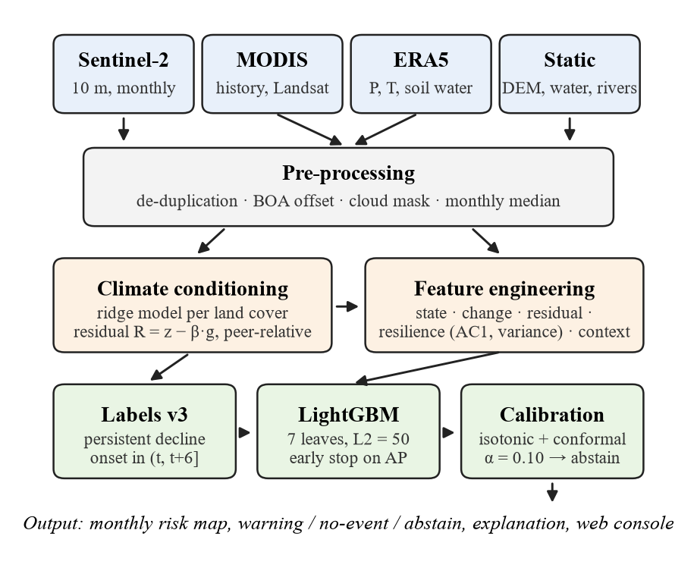
Fig. 1. CARE-EW architecture. Open data are composited monthly, the climate-driven part of the anomaly is removed, causal features feed a regularised LightGBM model, and calibrated probabilities are turned into warning, no-event or abstain decisions shown in a web console.
Fig. 1 shows the pipeline. Every step uses data at or before the prediction month t; unit tests perturb future values and confirm that no feature changes.
B. Dataset
Study areas. The model is trained on 17 areas of 5.12 × 5.12 km (512 × 512 pixels) in nine countries: Nepal (5), India (5), Ethiopia, Kenya, Senegal, Spain, Brazil, Mongolia and Australia. They cover Himalayan foothill forest, semi-arid cropland, rangeland, Mediterranean dryland and a mining landscape. Six further sites (Udayapur, Kailali and Sindhupalchok in Nepal; Marathwada, Singrauli and Shivalik in India) are used only as independent test sites.
Sources. All inputs are open: Sentinel-2 L2A [23] (10–20 m, 2017–2026), MODIS MOD13Q1 NDVI (250 m, 2000–), ERA5/ERA5-Land [24] climate (precipitation, temperature, soil moisture, reference evapotranspiration), ESA WorldCover 2021 [17], NASADEM terrain, JRC surface water and HydroRIVERS. Landsat 8/9 is used only to check labels.
Preprocessing. For each month the four least-cloudy Sentinel-2 scenes of one MGRS tile are used. Duplicate processings are removed, and the bottom-of-atmosphere offset of processing baseline 04.00 and later is corrected. Pixels outside the vegetation, soil and water scene classes are masked. NDVI, NDMI, NBR and BSI are computed per scene and composited by the monthly median:
NDVI = (ρ_{NIR} − ρ_{red}) / (ρ_{NIR} + ρ_{red}) (1)
A seasonal baseline μₘ (calendar-month median, 2017–2020) and a robust spread σ (1.4826 × MAD) give the standardised anomaly:
z_{t} = (Y_{t} − μ_{m(t)}) / σ (2)
Size. The labelled table holds 4,294,330 pixel-months, from 5000 sampled pixels per site (Table II).
TABLE II
Study Areas (5.12 × 5.12 km Each)
Region | Sites | Landscape | Role
Nepal | Chure, Dang, Sarlahi, Kavre, Surkhet | foothill forest, mid-hills | train / test
India | Bundelkhand, Chambal, Thar, Banni, Jharia | cropland, rangeland, mining | train / test
Africa | Tigray (ET), Baringo (KE), Ferlo (SN) | highland crop, rangeland | train / test
Other | Murcia (ES), Matopiba (BR), steppe (MN), Murray–Darling (AU) | dryland, cerrado, steppe, woodland | train / test
Nepal | Udayapur, Kailali, Sindhupalchok | foothills, landslide hills | independent test
India | Marathwada, Singrauli, Shivalik | rainfed crop, mining, forest | independent test

C. Climate conditioning and residual
For each site and land-cover class, a ridge regression g predicts the class-mean anomaly from 1/3/6/12-month standardised precipitation, temperature and soil-moisture anomalies, and climatic water balance. It is fitted only on the training period and cross-fitted by leaving one year out. Pixel sensitivity β is shrunk toward 1. The residual is taken relative to landscape peers, so that a drought or haze affecting every pixel of a class is not called degradation:
R_{t} = (z_{t} − βg_{t}) − med_{peer}(z − βg) (3)
Climate adjustment is applied only where its leave-one-year-out R² is at least 0.05; elsewhere R = z minus the peer median. Weather data are therefore used only where they demonstrably help.
D. Labels
Month s is below expectation when Rₛ ≤ −1 and the peer-relative NDVI deviation is ≤ −0.02. An onset occurs when such a run starts and lasts at least six months, with at least 75 % real observations and a mean loss of at least 0.05 NDVI. The prediction target at month t is:
y_{t} = 1 if an onset occurs in (t, t + 6] (4)
Labels are undefined when fewer than 60 % of the following 11 months are observed. The same rule and thresholds are used in every country. Fig. 2 traces one pixel through the steps.
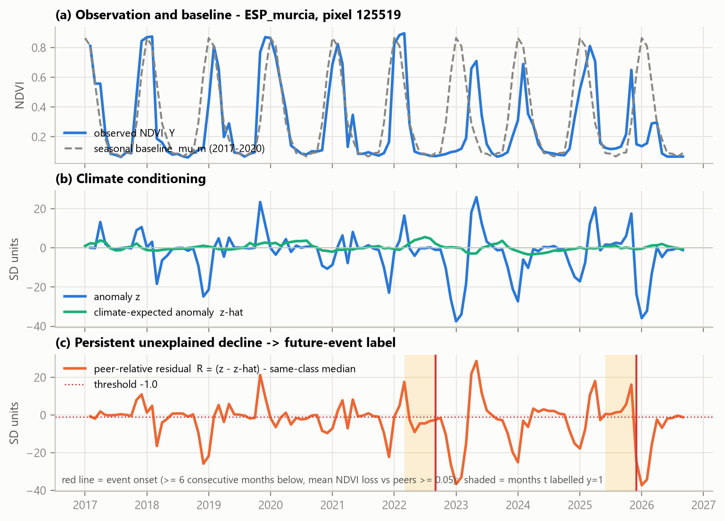
Fig. 2. One Murcia (Spain) pixel: (a) observed NDVI and its 2017–2020 seasonal baseline; (b) the anomaly z and the climate-expected anomaly; (c) the peer-relative residual R, two onsets (red lines) and the months labelled y = 1 (shaded).
E. Features
64 features in six groups, all causal: A1 spectral state; A2 change (1/3/12-month differences and slopes); A3 climate; A4 residual statistics; A5 resilience; A6 spatial and terrain context. The resilience features use the lag-1 autocorrelation and variance of the high-pass-filtered residual x over 12- and 24-month windows:
AC1 = Σ(x_{t} − x̄)(x_{t−1} − x̄) / Σ(x_{t} − x̄)² (5)
together with months since the last dip, recovery fraction and MODIS 60-month variance and autocorrelation.
F. Model, calibration and abstention
LightGBM [18] minimises the weighted logistic loss with an L2 penalty on leaf values v:
L = −Σ_{i} w_{i}[y_{i} ln p_{i} + (1−y_{i})ln(1−p_{i})] + ½λΣ_{j} v_{j}² (6)
Each pixel contributes about 40 strongly autocorrelated monthly rows, so deep trees memorise pixels. Trees are therefore kept small (Table III). Scores are calibrated by isotonic regression [19] on a disjoint calibration set. A Mondrian split-conformal predictor [20], [21] with α = 0.10 returns the prediction set:
Γ(x) = {y : s_{y}(x) ≤ q̂_{y}} (7)
A set {0, 1} is reported as abstain. The warning threshold maximises F1 on the calibration set.
G. Training setup
TABLE III
Training Setup and Hyperparameters
Item | Setting
Model | LightGBM, binary log-loss, early stopping on AP
Trees | 7 leaves, ≥ 4000 rows per leaf, learning rate 0.03
Regularisation | L2 λ = 50, feature fraction 0.4, bagging 0.7, extra-trees
Class balance | weight √(neg/pos), area-balanced sample weights
Train | months ≤ 2022-03, 60 % of 1 km blocks; 800,784 rows
Validation / calibration | 2023-03 … 2023-12; 169,049 / 378,057 rows
Test (locked) | months ≥ 2024-12 on test blocks; 132,230 rows
Embargo | ≥ 11-month gaps = label look-ahead (no leakage)
Hardware | Intel Core 5 210H, 16 GB RAM, CPU only; final fit 14 s
Decision rule | a change is adopted only if validation AP gains ≥ 0.005 (5 seeds)

Model choices were made on validation data only. The test set was evaluated once. 95 % confidence intervals use a cluster bootstrap over (site, block).
IV. Results and Discussion
A. Evaluation metrics
Degradation onsets are rare (2.5 % of test pixel-months). A model that never warns would therefore score 97.5 % accuracy, so PR-AUC and its lift over chance are the primary metrics. Table IV reports all metrics at the calibrated threshold (p = 0.129) on the locked test set.
TABLE IV
Test-Set Performance (132,230 Pixel-Months)
Metric | Value | Metric | Value
ROC-AUC | 0.805 (0.766–0.838) | Precision | 0.217
PR-AUC | 0.144 (0.112–0.184) | Recall | 0.289
Lift over chance | 5.7× | F1-score | 0.248
Accuracy | 95.6 % | False-alarm rate | 2.7 %
ECE / Brier | 0.0025 / 0.0228 | Specificity | 97.3 %
Onsets warned ≥ 1 mo | 41 % (median 3 mo) | NPV of “no event” | 99.6 %
Confusion: TP / FP | 963 / 3,468 | FN / TN | 2,364 / 125,435
Brackets: 95 % cluster-bootstrap CI. NPV refers to the conformal “no event” decisions; the system abstains on 52 % of pixels, and on the confident remainder ROC-AUC is 0.877.
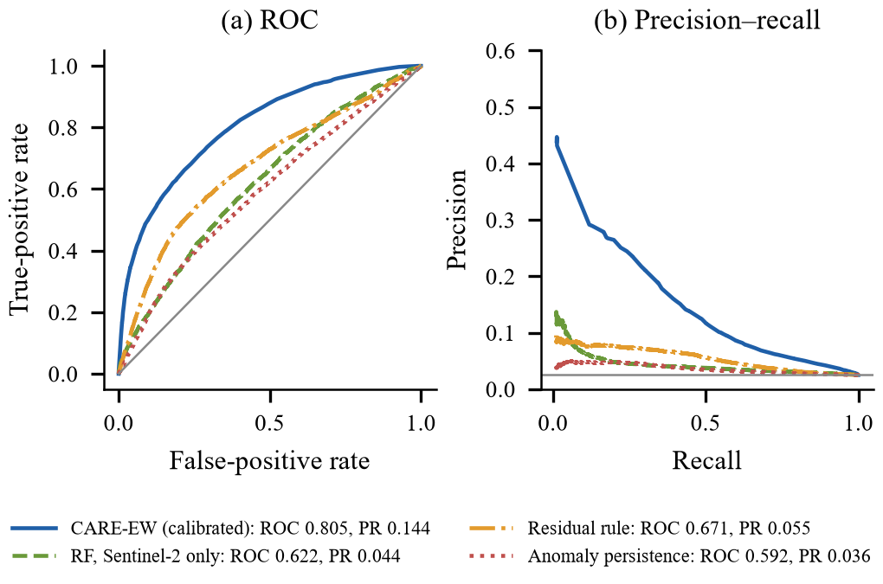
Fig. 3. ROC and precision–recall curves on the locked test set for CARE-EW and three baselines. The grey line in (b) is the 2.5 % base rate.
B. Comparison with baselines and ablation
Fig. 3 and Fig. 4 compare CARE-EW with three non-deep baselines on the same rows: anomaly persistence (PR-AUC 0.036), a residual threshold rule (0.055) and a random forest on Sentinel-2 state and change features (0.044). Adding feature groups one at a time shows where the signal lies. Spectral state, change and raw climate stay near chance (0.032–0.036). The climate-conditioned residual lifts PR-AUC to 0.131, and resilience and context features to 0.152. Weather data matter only through the residual, not as direct inputs.
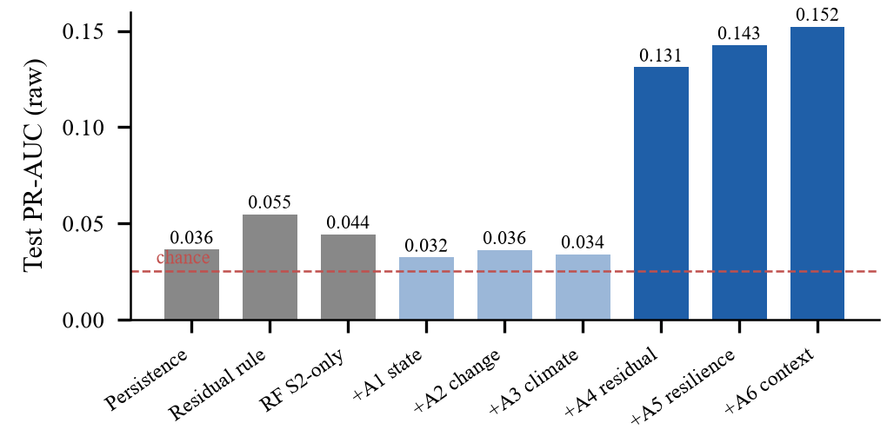
Fig. 4. Cumulative ablation on the locked test set (uncalibrated scores). Grey: baselines; light blue: groups that add no skill; dark blue: residual, resilience and context.
Further pre-registered experiments were rejected because they did not raise validation AP by at least 0.005: GLCM texture, red-edge chlorophyll indices, doubling the pixels per site, confident-learning label cleaning [22], a five-seed ensemble and training on all 23 sites.
C. Over- and under-fitting
Fig. 5(a) varies tree size from 3 to 255 leaves. Validation PR-AUC stays within 0.13–0.15 and training AP never runs far above it, so larger trees add no skill. In Fig. 5(b), validation and test PR-AUC rise with training size (test 0.068 at 5 % of pixels to 0.152 at 100 %). The model is limited by data, not capacity.
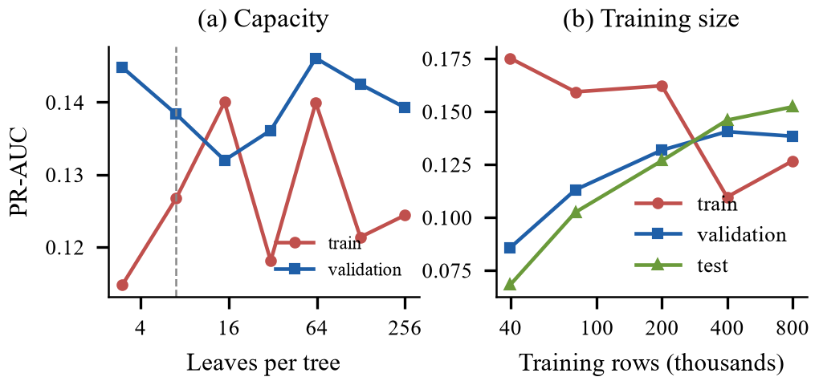
Fig. 5. (a) Validation curve over model capacity (dashed: chosen 7 leaves). (b) Learning curve over training size.
D. Generalisation across countries, sites and time
When each country is held out entirely, lift remains 2.3–13.8×: Australia 13.8, Ethiopia 10.2, Senegal 9.8, Kenya 7.0, Nepal 6.2, Spain 4.6, India 4.1, Brazil 2.3. Mongolia has no test events. The 17-site model, without retraining, was applied to six new sites (Table V); together they reach ROC-AUC 0.839, lift 8.6× and PR-AUC 0.217. In walk-forward retraining (Fig. 6), test-year PR-AUC rises from chance in 2021 to 0.179 in 2025 as the Sentinel-2 record grows.
TABLE V
Independent Test on Six New Sites
Site | Landscape | ROC-AUC | Lift
Sindhupalchok (NP) | mid-hill forest, landslides | 0.873 | 9.8×
Singrauli (IN) | coal mining | 0.876 | 6.8×
Udayapur (NP) | Chure foothills | 0.844 | 7.0×
Kailali (NP) | Chure foothills | 0.803 | 10.1×
Shivalik (IN) | foothill forest | 0.782 | 12.7×
Marathwada (IN) | rainfed cropland | 0.597 | 1.7×
All six |  | 0.839 | 8.6×

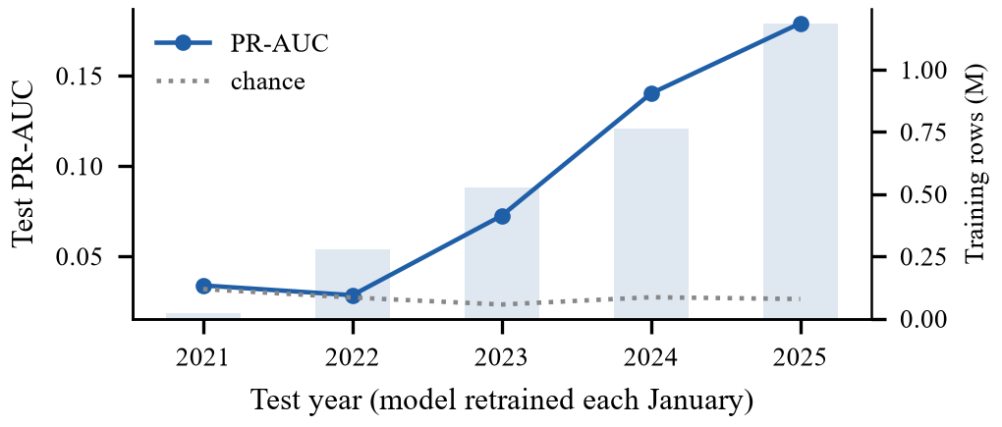
Fig. 6. Walk-forward retraining: test-year PR-AUC (line) and training rows (bars).
E. Operational output
For every site and month the system produces a risk map, hotspot boxes with hectares at risk, a process explanation and the upstream river network. A user can also draw a box anywhere to run the full pipeline on demand (Fig. 7). Fig. 8 shows the maps for nine sites. By land cover (Table VI), skill is highest in shrubland and grassland and lowest in cropland, where sowing and harvest changes resemble degradation.
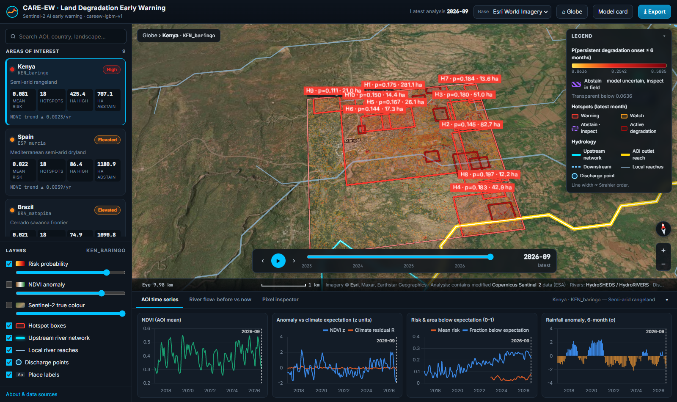
Fig. 7. Web console: September 2026 warning hotspots (red boxes, probability and area) over Baringo, Kenya, with the upstream river network and monthly NDVI, residual, risk and rainfall series.
TABLE VI
Test Performance by Land Cover
Land cover | PR-AUC | Lift | ROC-AUC | Recall | FAR
Shrubland | 0.275 | 6.8× | 0.858 | 0.42 | 3.6 %
Grassland | 0.218 | 6.6× | 0.870 | 0.38 | 3.8 %
Bare / sparse | 0.123 | 4.1× | 0.755 | 0.25 | 4.1 %
Tree cover | 0.110 | 8.8× | 0.812 | 0.36 | 2.3 %
Cropland | 0.096 | 3.5× | 0.743 | 0.17 | 2.1 %
FAR: false-alarm rate at the operating threshold.
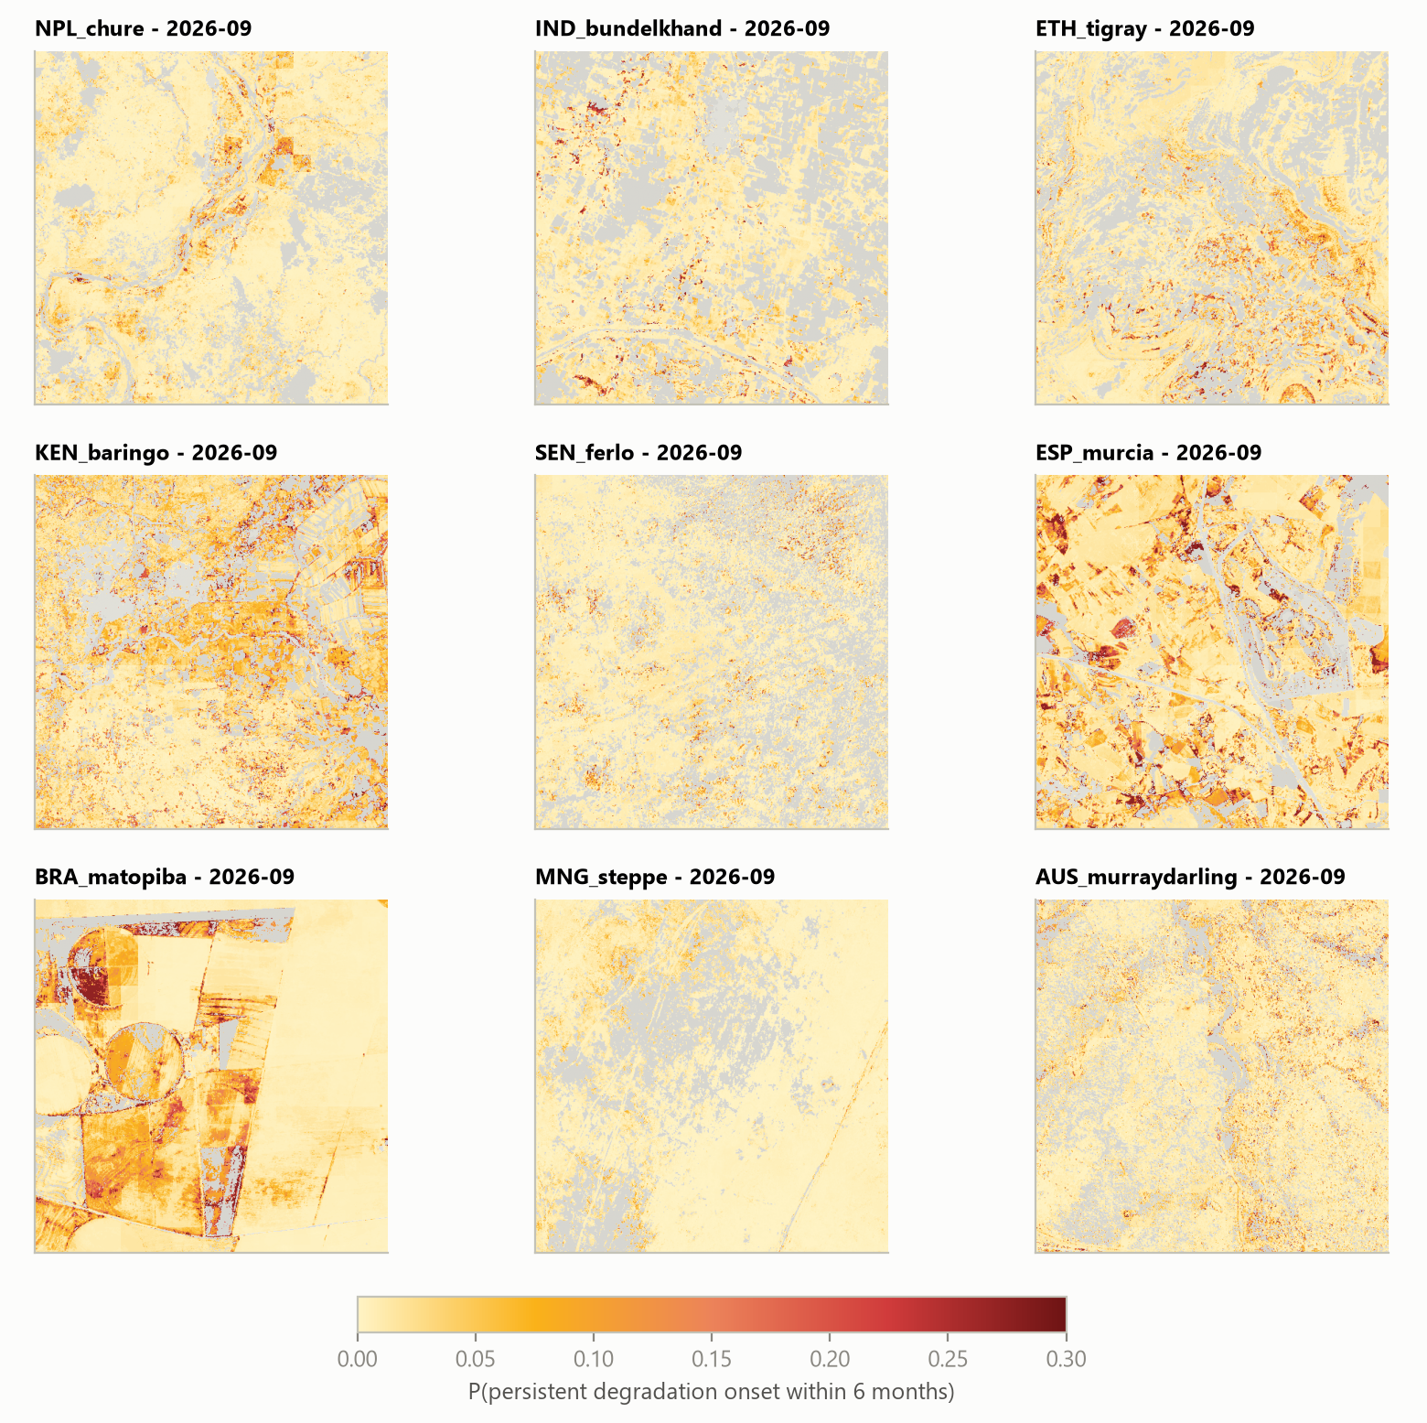
Fig. 8. Six-month risk maps for September 2026 at nine training sites (5.12 km each). Warm colours: probability of onset; grey: pixels already below their peers (not eligible for an early warning) or masked.
F. Discussion
The ablation supports the central hypothesis in a falsifiable way. If future degradation could be read from present greenness or from weather alone, groups A1–A3 would score well; they do not. Skill appears only once each pixel is compared with what climate and its landscape peers predict, and it grows when the autocorrelation and variance of that residual are added. This is the pattern critical-slowing-down theory predicts [6], [7], here tested on held-out data rather than assumed. We do not claim that rising autocorrelation marks a tipping point, only that it improves forecasts.
Calibration makes the scores usable. A stated 10 % risk corresponds to about 10 % observed onsets (ECE 0.0025), so a district officer can rank hotspots by expected hectares rather than by an arbitrary score. Abstention is the price of moderate discrimination at a 2.5 % base rate. The system clears about half of the landscape with 99.6 % reliability and sends the uncertain half to field teams. Label design mattered more than model choice: an earlier label that followed monsoon timing produced plausible but meaningless accuracy and was rejected on validation diagnostics.
G. Limitations
• Labels are satellite proxies, not field data. Persistent unexplained decline also captures land-use change, fire and harvest timing. Cropland remains the weak case (Marathwada ROC 0.60).
• Moderate precision. About one warning in five is followed by an onset, so the system suits triage of field inspections, not enforcement.
• No independent visual confirmation yet. In a blind pilot on 233 before/after pairs of sub-metre imagery, a visible change was seen at 19.6 % of warnings and 24.5 % of safe pixels (difference −4.9 points, 95 % CI −15 to +6). The pilot was underpowered and mostly showed abrupt events rather than gradual thinning.
• Short baseline and coarse climate. The Sentinel-2 baseline covers only 2017–2020, and climate is at 9–25 km.
• Single validation year. Model selection used one validation year, whose seed noise is close to the decision margin.
V. Conclusion and Future Work
CARE-EW turns free satellite and climate data into calibrated six-month warnings of persistent land degradation at 10 m. On a hold-out new in both space and time it ranks future onsets with ROC-AUC 0.805 (0.839 on six unseen sites), at a 2.7 % false-alarm rate. The predictive signal comes from the climate-conditioned residual and resilience indicators, not from spectral state or raw weather.
Future work is specific:
• crop-calendar-aware labels and more cropland sites, to lift cropland ROC-AUC above 0.60;
• an independent human review of the 233 image pairs, followed by a power-calculated campaign of at least 300 pairs per group with same-season imagery taken within six months before the warning;
• a prospective test on months after October 2025, comparing the 17-site model, a 23-site model and a seed ensemble;
• Sentinel-1 radar features to fill monsoon cloud gaps.
References
[1] M. Cherlet et al., Eds., World Atlas of Desertification, 3rd ed. Luxembourg: Publications Office of the EU, 2018.
[2] N. C. Sims et al., “Good practice guidance: SDG indicator 15.3.1, version 2.0,” UNCCD, Bonn, Germany, 2021.
[3] M. Gonzalez-Roglich et al., “Synergizing global tools to monitor progress towards land degradation neutrality: Trends.Earth and the World Overview of Conservation Approaches and Technologies sustainable land management database,” Environ. Sci. Policy, vol. 93, pp. 34–42, 2019.
[4] K. J. Wessels et al., “Can human-induced land degradation be distinguished from the effects of rainfall variability? A case study in South Africa,” J. Arid Environ., vol. 68, no. 2, pp. 271–297, 2007.
[5] S. D. Prince, I. Becker-Reshef, and K. Rishmawi, “Detection and mapping of long-term land degradation using local net production scaling: Application to Zimbabwe,” Remote Sens. Environ., vol. 113, no. 5, pp. 1046–1057, 2009.
[6] M. Scheffer et al., “Early-warning signals for critical transitions,” Nature, vol. 461, pp. 53–59, 2009.
[7] V. Dakos et al., “Methods for detecting early warnings of critical transitions in time series illustrated using simulated ecological data,” PLoS ONE, vol. 7, no. 7, e41010, 2012.
[8] J. Verbesselt et al., “Remotely sensed resilience of tropical forests,” Nature Clim. Change, vol. 6, pp. 1028–1031, 2016.
[9] T. Smith, D. Traxl, and N. Boers, “Empirical evidence for recent global shifts in vegetation resilience,” Nature Clim. Change, vol. 12, pp. 477–484, 2022.
[10] C. A. Boulton, T. M. Lenton, and N. Boers, “Pronounced loss of Amazon rainforest resilience since the early 2000s,” Nature Clim. Change, vol. 12, pp. 271–278, 2022.
[11] P. Ploton et al., “Spatial validation reveals poor predictive performance of large-scale ecological mapping models,” Nature Commun., vol. 11, 4540, 2020.
[12] H. Meyer and E. Pebesma, “Predicting into unknown space? Estimating the area of applicability of spatial prediction models,” Methods Ecol. Evol., vol. 12, no. 9, pp. 1620–1633, 2021.
[13] J. Verbesselt, R. Hyndman, G. Newnham, and D. Culvenor, “Detecting trend and seasonal changes in satellite image time series,” Remote Sens. Environ., vol. 114, no. 1, pp. 106–115, 2010.
[14] M. C. Hansen et al., “High-resolution global maps of 21st-century forest cover change,” Science, vol. 342, pp. 850–853, 2013.
[15] J. Reiche et al., “Forest disturbance alerts for the Congo Basin using Sentinel-1,” Environ. Res. Lett., vol. 16, no. 2, 024005, 2021.
[16] S. Kéfi et al., “Spatial vegetation patterns and imminent desertification in Mediterranean arid ecosystems,” Nature, vol. 449, pp. 213–217, 2007.
[17] D. Zanaga et al., “ESA WorldCover 10 m 2021 v200,” Zenodo, 2022, doi: 10.5281/zenodo.7254221.
[18] G. Ke et al., “LightGBM: A highly efficient gradient boosting decision tree,” in Proc. NeurIPS, 2017, pp. 3146–3154.
[19] B. Zadrozny and C. Elkan, “Transforming classifier scores into accurate multiclass probability estimates,” in Proc. ACM SIGKDD, 2002, pp. 694–699.
[20] V. Vovk, A. Gammerman, and G. Shafer, Algorithmic Learning in a Random World. New York, NY, USA: Springer, 2005.
[21] A. N. Angelopoulos and S. Bates, “Conformal prediction: A gentle introduction,” Found. Trends Mach. Learn., vol. 16, no. 4, pp. 494–591, 2023.
[22] C. Northcutt, L. Jiang, and I. Chuang, “Confident learning: Estimating uncertainty in dataset labels,” J. Artif. Intell. Res., vol. 70, pp. 1373–1411, 2021.
[23] M. Drusch et al., “Sentinel-2: ESA's optical high-resolution mission for GMES operational services,” Remote Sens. Environ., vol. 120, pp. 25–36, 2012.
[24] J. Muñoz-Sabater et al., “ERA5-Land: A state-of-the-art global reanalysis dataset for land applications,” Earth Syst. Sci. Data, vol. 13, pp. 4349–4383, 2021.

