Cu 29 · Ni 28
ReserveChain
Industrial-Metals Reserve Registry
and Tokenization Framework
INSTITUTIONAL WHITEPAPER · DISCUSSION DRAFT · IN DEVELOPMENT
Version: Draft v0.10 — subject to legal review and final approval
Date of this version: [To be inserted on approval by ReserveChain]
reservechain.io
Mandatory disclosure. ReserveChain is currently in development. No tokens are being offered or sold through this website. Registration of interest does not constitute an investment, token purchase, asset reservation, price reservation, token allocation or entitlement to participate in any future offering. Any future availability will be subject to the final Swiss corporate and legal structure, definitive offering documentation, asset verification, custody arrangements, jurisdictional eligibility, KYC/KYB, sanctions screening and final approval.
EU/EEA notice. ReserveChain does not currently intend to offer tokens to residents of, or persons located in, the EU/EEA.

Contents
Right-click and choose Update Field to build the table of contents.

Important Notice
Mandatory disclosure. ReserveChain is currently in development. No tokens are being offered or sold through this website. Registration of interest does not constitute an investment, token purchase, asset reservation, price reservation, token allocation or entitlement to participate in any future offering. Any future availability will be subject to the final Swiss corporate and legal structure, definitive offering documentation, asset verification, custody arrangements, jurisdictional eligibility, KYC/KYB, sanctions screening and final approval.
EU/EEA notice. ReserveChain does not currently intend to offer tokens to residents of, or persons located in, the EU/EEA.
This document is a discussion draft describing a proposed platform and proposed operating frameworks. It is published for information only. It is not a prospectus, offering memorandum, key information document, or any other form of offering document, and it has not been reviewed or approved by any supervisory authority in any jurisdiction.
Nothing in this document constitutes an offer to sell, a solicitation of an offer to buy, or a recommendation in respect of any token, security, commodity, derivative or other instrument. No token described in this document has been issued on any production blockchain. Any smart contracts referred to have been deployed, if at all, only to public test networks for demonstration and testing.
The legal entity that may operate the platform is a proposed Swiss structure. No representation is made that such an entity has been formed, licensed, registered or authorised. References to other jurisdictions are for context only.
Throughout this document, information that has not yet been provided or verified is shown as an explicit placeholder — for example [To be provided by ReserveChain] or Pending — subject to final approval. Placeholders must not be read as implying that the corresponding arrangement exists. In particular, no custody, insurance, Proof of Reserves, liquidity, redemption right, ownership right or economic return is confirmed by this document.
Forward-looking statements (including words such as "proposed", "planned", "intended", "may", "would") reflect current intentions only and are subject to change, to legal and regulatory constraints, and to risks described in the Risk Factors section.
Recipients should obtain independent legal, tax, regulatory and financial advice before making any decision in relation to the matters described.

1. Abstract
ReserveChain is an in-development platform designed to register, evidence and — only if and when legally authorised — represent on a blockchain specific physical lots of two industrial metals: ultra-high-purity copper powder (program identity Cu 29) and high-purity nickel wire (program identity Ni 28).
The platform's central proposition is that a token representing a physical asset is only as credible as the evidence behind it. ReserveChain therefore puts the evidence layer first: an asset registry of lots, batches, containers and coils; a library of certificates of analysis, custody records, insurance documents, valuations and reserve reports, each fingerprinted with SHA-256; a Digital Asset Passport (DAP) for every registered physical unit, with a lifecycle timeline, an evidence ledger and a Merkle root summarising all supporting documents; and a tamper-evident audit trail whose state can be anchored on a public blockchain.
On top of that evidence layer, ReserveChain has designed a token architecture based on audited open-source building blocks (OpenZeppelin Contracts v5) with compliance-gated transfers, a reserve-gated mint ceiling that is fail-closed by default, a proposed redemption workflow, a role-controlled treasury and an audit-anchoring contract. All economic parameters — supply, asset-to-token ratio, price, redemption thresholds, allocations — are unset and remain to be determined, subject to written approval. The token, wallet, purchase, Proof-of-Reserves and redemption features are implemented as inactive modules, switched off until authorised.
Every factual claim on the platform carries a visible Claim Status — proposed, in development, pending verification, verified or not applicable — so that readers can distinguish intention from evidence at a glance.
Since the previous draft, the platform in development has gained: a Proof-of-Reserves reconciliation engine with explicit exception rules and four-eyes-approved, fingerprinted snapshots (Section 14); an off-chain redemption workflow with compliance re-checks and unit-level status (Section 13); wallet linking and USDT payment verification modules that are implemented but inactive and restricted to test networks (Section 15); a participant portal with audience-restricted data rooms and an asset-owner intake pipeline (Section 16); and operations monitoring, backups and disaster-recovery procedures (Section 17). For each metal program, the asset owner has supplied a laboratory Certificate of Analysis; these are recorded as owner-supplied and remain subject to documentary verification (Section 4).

2. The Problem: Trust in Physical-Asset Representations
Digital representations of physical commodities promise operational benefits: fractional record-keeping, faster transfer of entitlements, programmable compliance and continuous transparency. In practice, many such representations have suffered from recurring weaknesses:
- Opaque backing. Statements that tokens are "backed" by physical assets are often supported by infrequent, high-level attestations that do not identify specific lots, specifications, locations or custodians.
- Claim inflation. Marketing materials frequently describe arrangements (insurance, audited reserves, redemption rights) as existing when they are only planned.
- Unverifiable documents. Certificates and reports are published as images or PDFs without any mechanism for a reader to confirm that the document they hold is the one the issuer relied on.
- Mutable records. Off-chain databases can be silently altered; on-chain tokens can be minted without reference to off-chain reality.
- Weak separation of duties. The same individual can often draft, approve and publish material claims.
Industrial metals add further complexity. Unlike investment-grade bullion, materials such as metal powders and fine wire are defined by technical specifications (chemistry, purity, particle size or diameter, packaging and handling conditions) that matter to their industrial value and must be evidenced by competent laboratories.
ReserveChain's design responds to each weakness with a specific control, summarised below and detailed in later sections.
Weakness | ReserveChain proposed control
Opaque backing | Unit-level registry and Digital Asset Passports
Claim inflation | Claim Status System; placeholders instead of assumptions; four-eyes approval
Unverifiable documents | SHA-256 fingerprints; client-side verification; Merkle roots
Mutable records | Append-only, hash-chained audit trail with database triggers and on-chain anchoring
Mint without reality | Reserve-gated mint ceiling, fail-closed by default
Weak separation of duties | Role-based access, four-eyes workflow, multisig administration (intended)

3. Project Model

3.1 Overview
ReserveChain is conceived as a turnkey registry and tokenization platform with three layers:
- Evidence layer (off-chain, system of record): registry, documents, passports, audit trail.
- Control layer: editorial workflow, roles, compliance controls, site modes and module flags.
- Representation layer (on-chain, testnet in this phase): token, compliance registry, reserve guard, redemption manager, treasury and audit anchor.
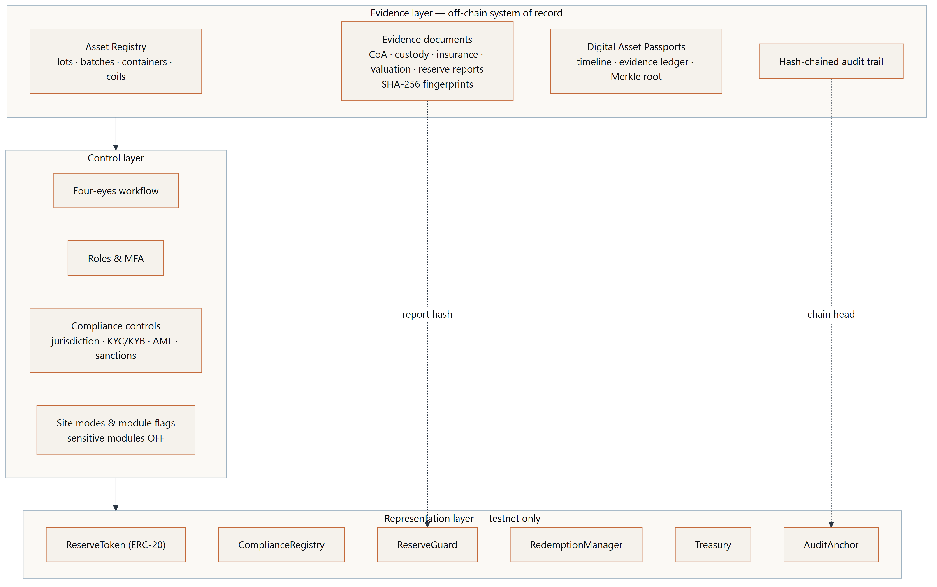
Figure 1 — Platform overview

3.2 Participants (proposed)
Participant | Role | Status
ReserveChain operating entity | Platform operator, registry owner | Proposed Swiss structure — Pending — subject to final approval
Producers / refiners | Supply of material | [To be provided by ReserveChain]
Independent laboratories | Certificates of analysis | [To be provided by ReserveChain]
Custodian(s) / warehouse operator(s) | Safekeeping, receipts | [To be provided by ReserveChain]
Insurer(s) | Coverage of stored material | [To be provided by ReserveChain]
Independent attestor / auditor | Reserve reporting | [To be appointed by ReserveChain]
KYC/KYB/AML/sanctions provider | Eligibility screening | [To be decided by ReserveChain]
Multisig signers | On-chain administration | [To be provided by ReserveChain]
Eligible participants | Prospective token holders | Not applicable — no offering exists

3.3 Proposed lifecycle
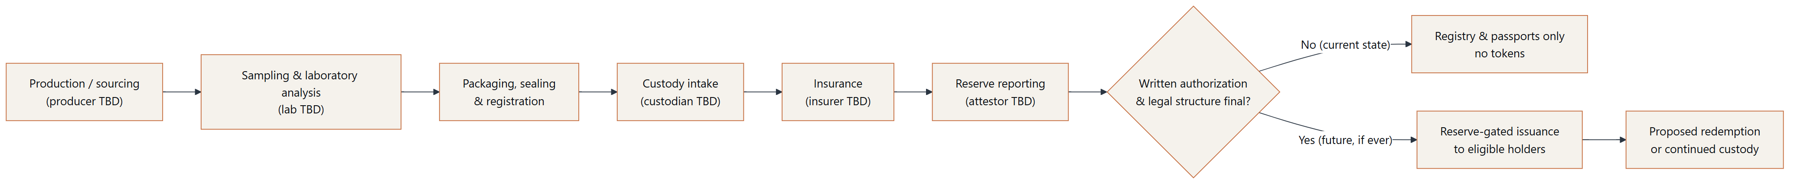
Figure 2 — Asset lifecycle
At present ReserveChain operates only in the state labelled "Registry & passports only — no tokens".

4. The Metal Programs
Provisional Asset Notice. Preliminary illustrative information only - subject to documentary verification, independent assessment and final approval. No asset or token is currently offered for sale through this website.
This section describes the two materials in general industrial terms and reproduces facts stated on owner-supplied Certificates of Analysis (CoA). Those facts are recorded as pending verification: ReserveChain has not yet independently confirmed the certificates with the issuing laboratory, and their reproduction here does not imply any verification, valuation, custody arrangement, reserve claim or token. No price, value, custody location or counterparty arrangement for ReserveChain's assets is stated or implied. Further asset-specific data will be published in the registry and Digital Asset Passports only when provided and evidenced.

4.1 Copper Powder — Cu 29
General industrial context. Copper is valued for its high electrical and thermal conductivity. In powder form, copper is used across a range of industrial processes, including powder metallurgy (pressed and sintered components), additive manufacturing, electrically and thermally conductive pastes and inks, brazing materials, friction materials, and electronics and thermal-management applications. Performance in these uses typically depends on chemical purity, oxygen content, particle size distribution, particle morphology, apparent density and flowability, and on handling conditions that limit oxidation.
ReserveChain program parameters.
Parameter | Value | Claim status
Material form | Ultrafine copper powder (as described on owner-supplied CoA 0004512) | Pending verification
Stated purity | 99.9999 % as stated on owner-supplied CoA 0004512 — subject to documentary verification | Pending verification
Purity basis | Chemical purity based on the impurities Al, Cd, Fe, Mg, Mo, Ni, Sb, Ti, Zn per TU 1793-011-50316079-2004 (as stated on the certificate) | Pending verification
Particle size distribution | Pending — laboratory analysis required | Pending verification
Packaging | Glass ampoules packed in cardboard boxes (per owner-supplied CoA) | Pending verification
Producer / origin | Pending — producer to be disclosed | Proposed
Declared quantity | Lot #03-K-07: 2000 kg declared (net weight according to data supplied by the customer to the laboratory) | Pending verification
Unit of account | Not yet determined | Proposed
Laboratory | IGAS research, Goslar — named on the owner-supplied certificate; not yet independently confirmed; no partnership, endorsement or accreditation implied | Pending verification
Custodian / location | Custodian to be appointed — subject to final approval | Proposed
Insurance | Insurance not yet arranged — subject to final approval | Proposed

4.2 Nickel Wire — Ni 28
General industrial context. Nickel is used for its corrosion resistance, its behaviour at elevated temperatures and its electrical and magnetic properties. High-purity nickel wire is used in applications such as electronic and electrical components, lead wires, battery connections, heating and resistance elements (often in alloy form), vacuum and lighting technology, chemical-processing equipment, and as feedstock for specialised alloys and thermal spray. Relevant characteristics typically include chemical purity, diameter and tolerance, temper/annealing condition, surface finish, tensile properties and spool or coil format.
ReserveChain program parameters.
Parameter | Value | Claim status
Material form | Nickel wire, 0.025 mm diameter (as described on owner-supplied CoA 0004368 — dimensional inspection pending) | Pending verification
Stated purity | 99.9807 % as stated on owner-supplied CoA 0004368 — subject to documentary verification | Pending verification
Purity basis | Impurities per GOST 2179-75 (As, Cu, Fe, Mn, Pb, Si) stated as 0,0193 % by weight | Pending verification
Wire diameter tolerance | Pending — laboratory analysis required | Pending verification
Temper / condition | [To be provided by ReserveChain] | Proposed
Coil / spool format | 30 bobbins in one box (per owner-supplied CoA) | Pending verification
Producer / origin | Pending — producer to be disclosed | Proposed
Declared quantity | Lot 120/NP1: 5000 g total net weight declared (according to information given by the customer to the laboratory) | Pending verification
Laboratory | IGAS research, Goslar — named on the owner-supplied certificate; not yet independently confirmed; no partnership, endorsement or accreditation implied | Pending verification
Custodian / location | Custodian to be appointed — subject to final approval | Proposed
Insurance | Insurance not yet arranged — subject to final approval | Proposed

4.3 Owner-supplied Certificates of Analysis
The asset owner has supplied one IGAS Certificate of Analysis for each program. ReserveChain has registered a scan of each certificate as an evidence document (SHA-256 fingerprinted; the customer address block is redacted on the supplied copy) and transcribed its stated values into a CoA record. Both records carry provenance owner-supplied and Claim Status pending verification. The figures below are reproduced as stated on the certificates; they are not ReserveChain findings.
Item | Copper — CoA 0004512 | Nickel — CoA 0004368
Provenance | Owner-supplied — subject to documentary verification | Owner-supplied — subject to documentary verification
Laboratory named on certificate | IGAS research, Goslar (DE) | IGAS research, Goslar (DE)
Date of certificate | 04.07.2022 | 19.10.2021
Goods described | Ultrafine Copper Powder, Lot #03-K-07 | Nickel wire 0,025 mm dia, DKRNT NP1, Lot 120/NP1
Declared quantity | 2000 kg (net weight according to data supplied by customer) | 5000 g total net weight, 30 bobbins in 1 box (according to information given by customer)
Sample (as stated) | 10 g, from Box no. 20, sampled 01.07.2022 | 0,8 g, from bobbins no. 8, 10, 19 and 27, sampled 14.10.2021
Method | ICP/OES | ICP/MS and ICP/OES
Stated purity | 99.9999 % | 99.9807 %
Purity basis | Impurities Al, Cd, Fe, Mg, Mo, Ni, Sb, Ti, Zn per TU 1793-011-50316079-2004 | Impurities per GOST 2179-75 (As, Cu, Fe, Mn, Pb, Si): 0,0193 % by weight
Verification status | Pending verification — not yet confirmed with the issuing laboratory | Pending verification — not yet confirmed with the issuing laboratory

Important limitations:
- The declared quantities are net weights declared by the customer to the laboratory; they have not been weighed or verified by ReserveChain, by a custodian or by an independent inspector.
- A certificate describes the sample analysed at the time stated. It does not establish the present existence, location, condition, ownership or quantity of the material.
- A purity figure computed on a stated impurity basis is not necessarily comparable with purity figures computed on other bases or standards.
- Physical-property and dimensional fields not covered by the certificates (for example particle size distribution, diameter tolerance and temper) remain pending.
- In the Proof-of-Reserves reconciliation (Section 14), a unit whose only certificate is owner-supplied raises an owner-supplied only exception until independent verification is recorded.

4.4 Why unit-level registration matters for industrial metals
Industrial materials are not fungible in the way that standardised bullion bars are. Two lots of nominally identical copper powder may differ in particle size distribution or oxygen content, and two coils of nickel wire may differ in temper or diameter tolerance. ReserveChain's proposed registry therefore tracks specific physical units — lots, batches, containers and coils — each with its own evidence and passport, rather than an undifferentiated pool. Any future token program would need to define, in its offering documentation, exactly which registered units it relates to and how differences between units are treated. That definition is [To be determined — subject to written approval].

5. Proposed Legal, Custody and Reserve Frameworks
All arrangements in this section are proposed. None is in place. Their final form depends on legal advice, regulatory analysis and commercial agreements that have not been concluded.

5.1 Corporate and legal structure
ReserveChain intends to operate through a proposed Swiss structure. The legal form, registered office, governing bodies, licensing analysis and any required registrations are Pending — subject to final approval. References elsewhere to other jurisdictions (including Estonia) are for context only; no entity is represented as formed in any jurisdiction.
Key legal questions to be resolved by ReserveChain's counsel before any token issuance include:
Question | Status
Legal characterisation of any token (e.g. ledger-based security, payment token, utility, other) under applicable law | Pending — subject to legal analysis
Holder rights (ownership, claim, entitlement to delivery, none) | Not yet determined — subject to final legal structure
Bankruptcy remoteness / segregation of physical assets | Pending — subject to legal analysis
Licensing or registration requirements (including AML self-regulatory organisation membership, if applicable) | Pending — subject to legal analysis
Offering documentation and investor categories | Pending — subject to final approval
Target jurisdictions and exclusions (EU/EEA currently excluded by intention) | Pending — subject to final approval
Tax treatment | Pending — subject to advice

5.2 Custody framework (proposed)
The proposed custody model aims to give each registered physical unit an evidenced chain of custody:
- Custody intake — receipt of sealed units by a custodian or warehouse operator, with a receipt identifying unit IDs and seal numbers.
- Segregation — physical and book-entry segregation of program material from other holdings (type of segregation [To be determined]).
- Periodic inspection — counts and seal checks by the custodian and, where agreed, by an independent inspector.
- Transfers and releases — every movement recorded as a custody record linked to the unit's passport.
- Environmental controls — storage conditions appropriate to the material (e.g. humidity and oxidation control for fine powders), to be specified with the custodian.
Element | Value
Custodian(s) | [To be provided by ReserveChain]
Facility location(s) | [To be provided by ReserveChain] — public disclosure level to be decided
Custody agreement | Pending — subject to final approval
Warehouse receipt form | [To be provided by ReserveChain]
Legal owner of the material | Pending — subject to final legal structure

5.3 Insurance framework (proposed)
ReserveChain intends to seek insurance appropriate to stored industrial materials (e.g. property/all-risk while in custody, and transit cover during movements). Insurer, coverage type, sum insured, exclusions and policy period are [To be provided by ReserveChain]. Until a certificate of insurance is registered and verified, the platform displays "Insurance not yet arranged — subject to final approval."

5.4 Reserve framework (proposed)
The proposed reserve framework links three items for each program:
- Registered units — the set of Published registry units (with passports) designated to the program;
- Reserve reports — periodic statements by an independent attestor of the units held, with the report document fingerprinted;
- Outstanding representation — tokens outstanding, if any (currently: none).
Any future issuance would be limited by the reserve-gated mint ceiling (Section 7.4). The attestor, reporting frequency, procedures (e.g. agreed-upon procedures vs. assurance engagement) and acceptance criteria are [To be determined — subject to written approval].

6. Digital Asset Passport and Evidence Model

6.1 Registry hierarchy
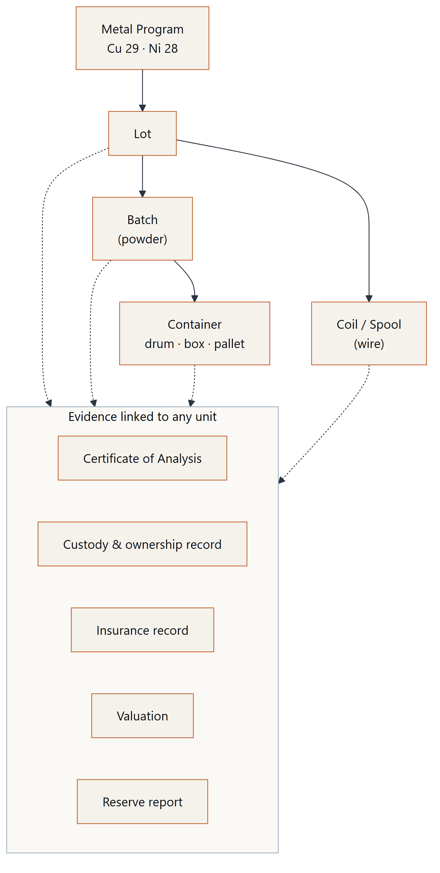
Figure 3 — Registry hierarchy
Every registry record carries a verification status (Claim Status) and a workflow state. Only records that have passed four-eyes review and are in the Published state are visible publicly.

6.2 The Digital Asset Passport
A Digital Asset Passport is generated for every Published lot, batch, container and coil. It contains:
Section | Content
Identity | Passport number, entity type, program, registry number, QR code
Fields | Every public attribute with its value or its explicit pending text, plus a Claim Status per field
Completeness | Share of public fields that have evidenced values — gaps are displayed, not hidden
Timeline | Lifecycle events derived from evidence (analysis, intake, transfers, reports)
Evidence ledger | Linked documents with type, issuer (or "Not yet provided"), status and SHA-256 fingerprint
Custody | Custody and ownership records
Merkle root | A single SHA-256 commitment over all evidence fingerprints
Anchoring | Reference to on-chain anchor, where enabled

6.3 Fingerprinting and Merkle commitment
Each evidence document is hashed with SHA-256 at ingest. The hash is stored with the document record and becomes immutable once the document is Published. For each passport, the sorted list of evidence fingerprints forms the leaves of a Merkle tree; its root is displayed on the passport.
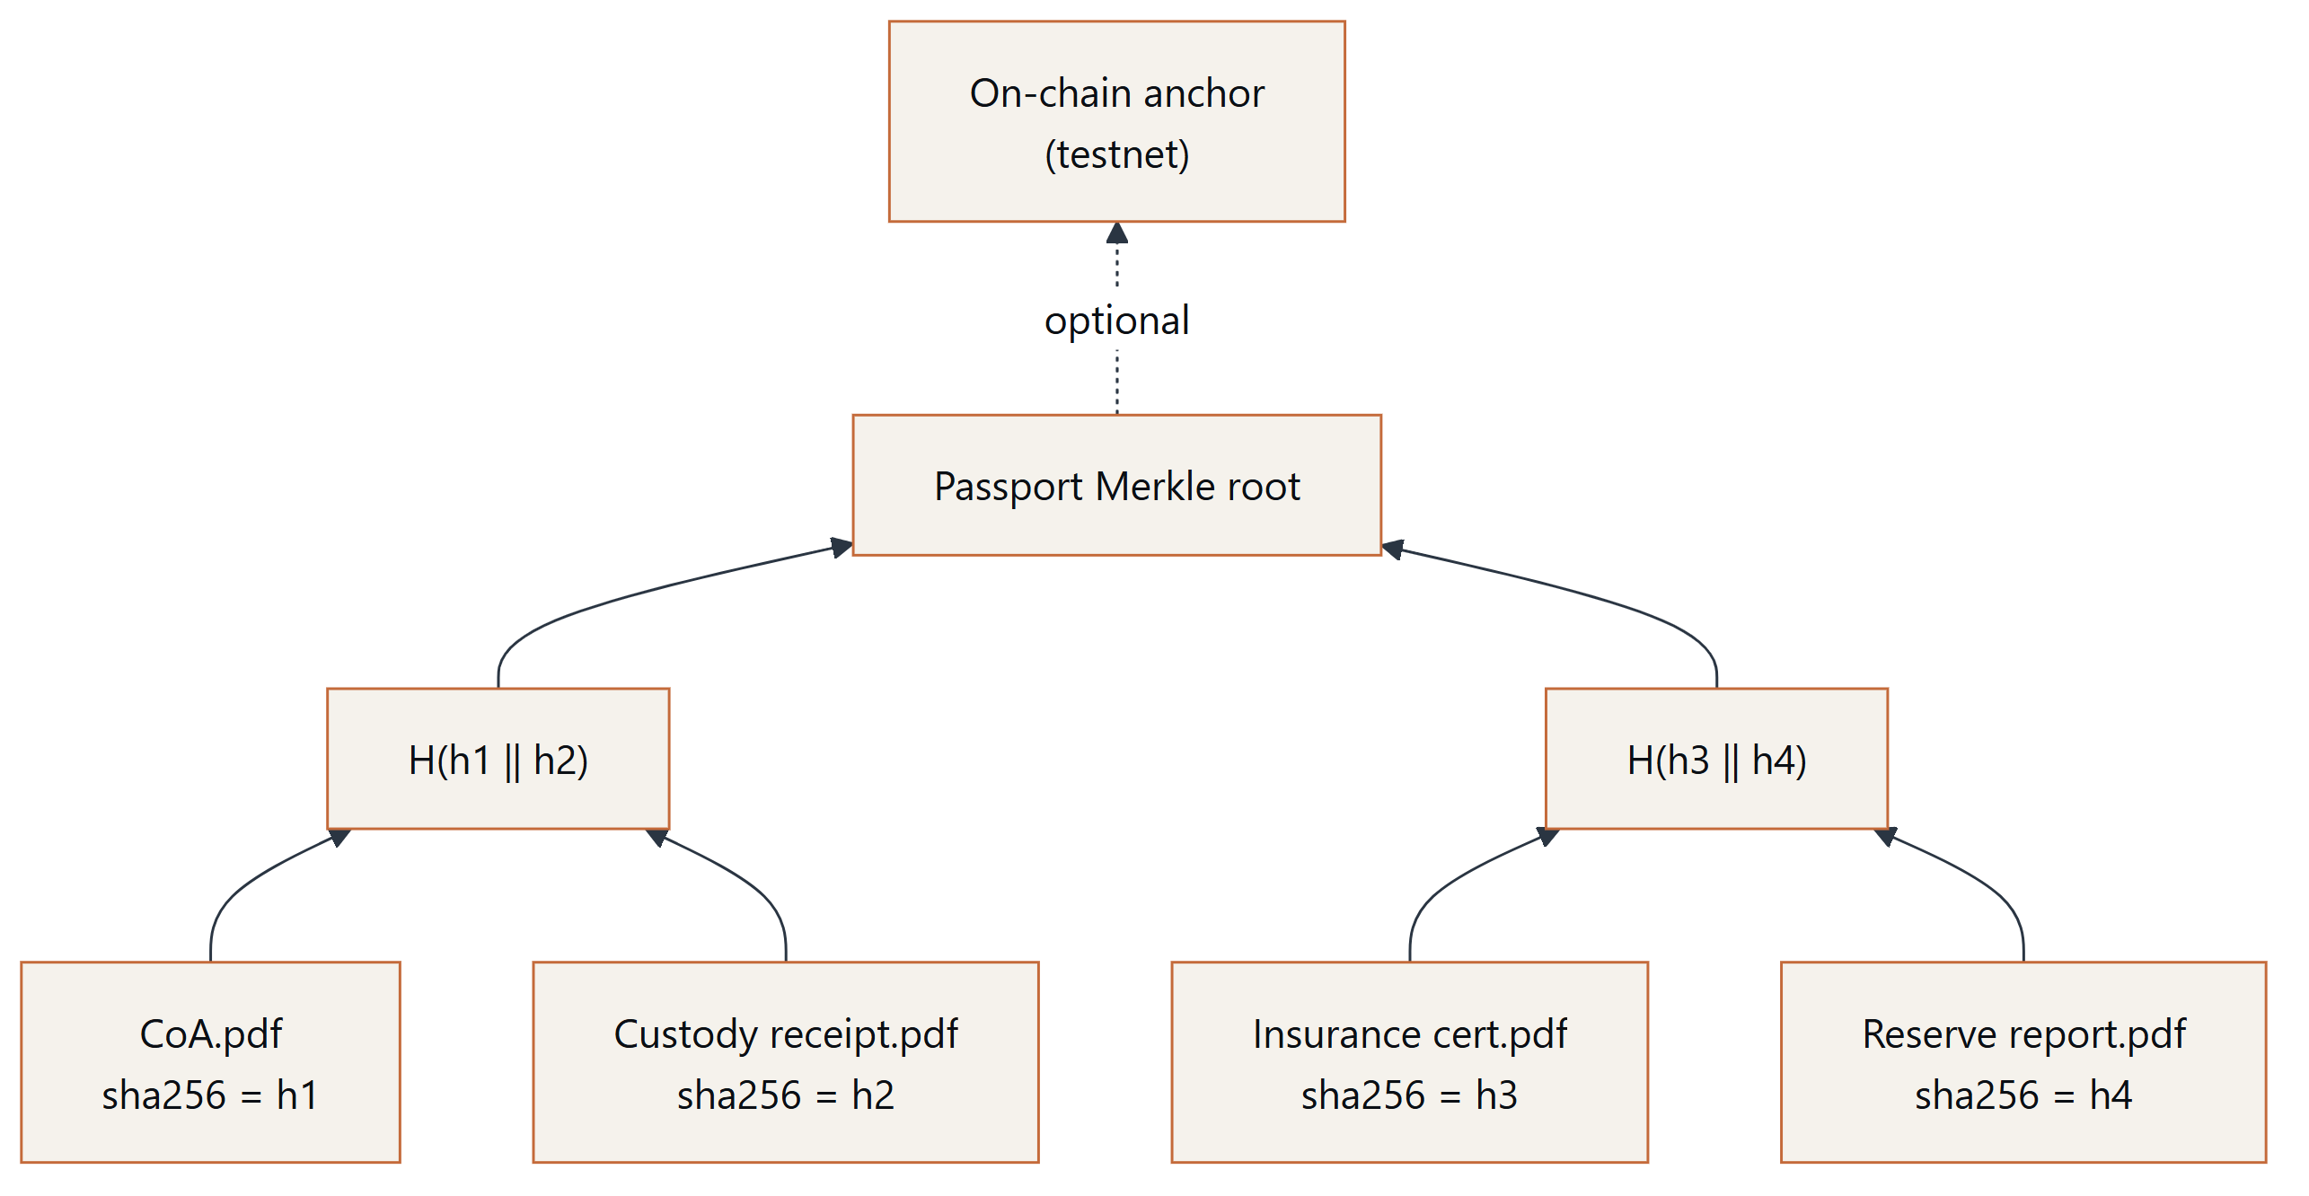
Figure 4 — Evidence merkle
Properties:
- Changing, adding or removing any evidence document changes the passport's Merkle root.
- A third party holding a document can prove its inclusion with a short Merkle proof without the issuer disclosing other documents.
- Anchoring a root (or the audit-trail head that records it) on a public chain fixes it in time.

6.4 Client-side verification
Any visitor can verify a document they hold: the file is hashed locally in the browser (or app) using the Web Crypto API; only the 64-character hash is sent to the registry's verification endpoint, which responds whether the fingerprint matches a registered document and, if so, which passport it belongs to. The file itself is never uploaded.
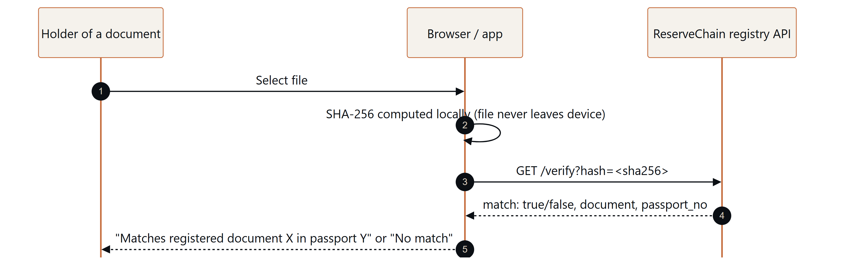
Figure 5 — Client verify

6.5 Claim Status System
Status | Meaning | Who may set
Proposed | Intended arrangement, not yet in progress | Editors / registry managers
In development | Work under way, not complete | Editors / registry managers
Pending verification | Evidence submitted, not yet verified | Registry managers
Verified | Evidence reviewed and accepted under four-eyes control | Compliance approval only
Not applicable | Does not apply in the current phase | Editors with review

7. Token Architecture
Contracts described here exist as source code with automated tests and are intended for test networks only (Ethereum Sepolia by default; Polygon Amoy optional). Mainnet deployment is not performed. No token has been issued to any person.

7.1 Contract suite
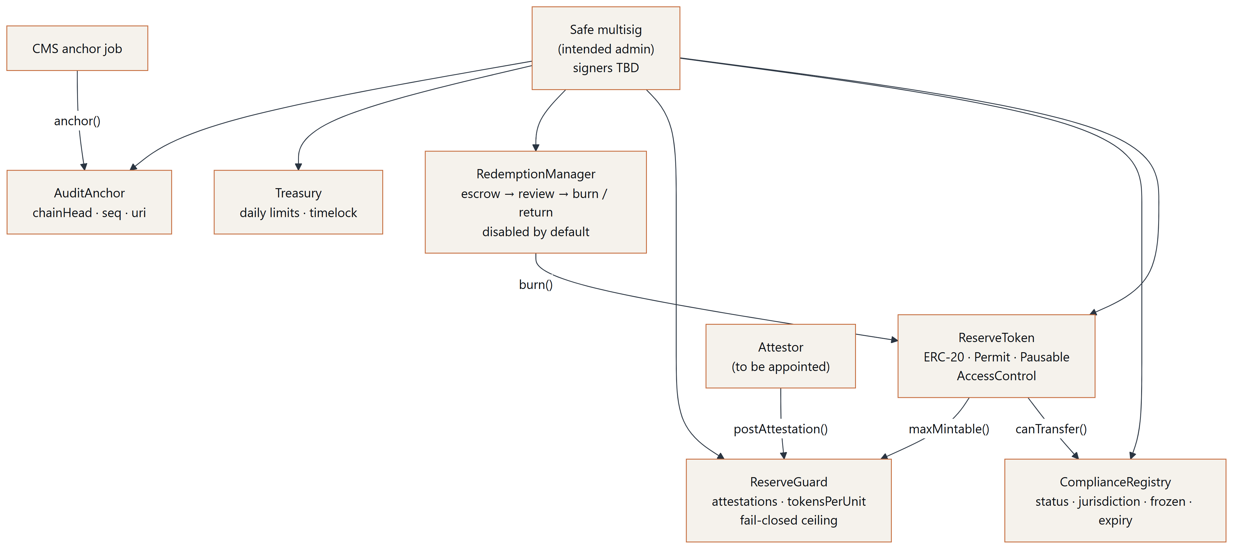
Figure 6 — Token architecture
Contract | Purpose | Key properties
ReserveToken | ERC-20 representation (if ever authorised) | OpenZeppelin v5; ERC20Permit; Pausable; roles MINTER, BURNER, PAUSER, COMPLIANCE_ADMIN, TREASURY, DEFAULT_ADMIN; name, symbol, decimals and supply cap from configuration; optional compliance hook and reserve guard; document URI + hash reference
ComplianceRegistry | On-chain eligibility flags | Per-address status, two-letter jurisdiction code, frozen flag, expiry; blocked-jurisdiction list; roles KYC_OPERATOR and JURISDICTION_ADMIN; no personal data on-chain
ReserveGuard | Reserve-gated mint ceiling | Attestor posts (programId, units, reportHash, uri, asOf); ceiling = units × tokensPerUnit; staleness window; returns zero unless fully configured
RedemptionManager | Proposed redemption workflow | Request escrows tokens; operator approves (burn) or rejects (return); min/max thresholds; disabled by default
Treasury | Role-controlled holdings | Per-token daily limits; optional timelocked withdrawals; pausable
AuditAnchor | Anchors the CMS audit-trail head | Monotonic sequence numbers; verify(seq, chainHead); ANCHOR_ROLE only

7.2 Roles and separation of duties
Role | Contract | Intended holder
DEFAULT_ADMIN (with delayed transfer rules) | All | Safe multisig — signers and threshold [To be provided by ReserveChain]
MINTER | ReserveToken | Multisig; minting additionally bounded by ReserveGuard
BURNER | ReserveToken | RedemptionManager / multisig
PAUSER | ReserveToken, RedemptionManager, Treasury | Multisig and optional emergency signer
COMPLIANCE_ADMIN | ReserveToken | Compliance multisig
KYC_OPERATOR, JURISDICTION_ADMIN | ComplianceRegistry | Compliance operations
ATTESTOR | ReserveGuard | Independent attestor [To be appointed]
GUARD_ADMIN | ReserveGuard | Multisig
REDEMPTION_OPERATOR, CONFIG_ADMIN | RedemptionManager | Operations / multisig
TREASURER, LIMIT_ADMIN | Treasury | Multisig
ANCHOR_ROLE | AuditAnchor | Platform anchor key (low privilege)

7.3 Compliance-gated transfers
When compliance is enabled on the token, every balance movement — transfers and the recipient side of minting — calls ComplianceRegistry.canTransfer(from, to, amount). A movement is permitted only if the parties are eligible: approved status, not frozen, record not expired, and jurisdiction not on the blocked list. EU/EEA jurisdiction codes are proposed to be blocked by default in line with the EU/EEA notice above. All movements are also blocked while the token is paused.

7.4 Reserve-gated minting (fail-closed)
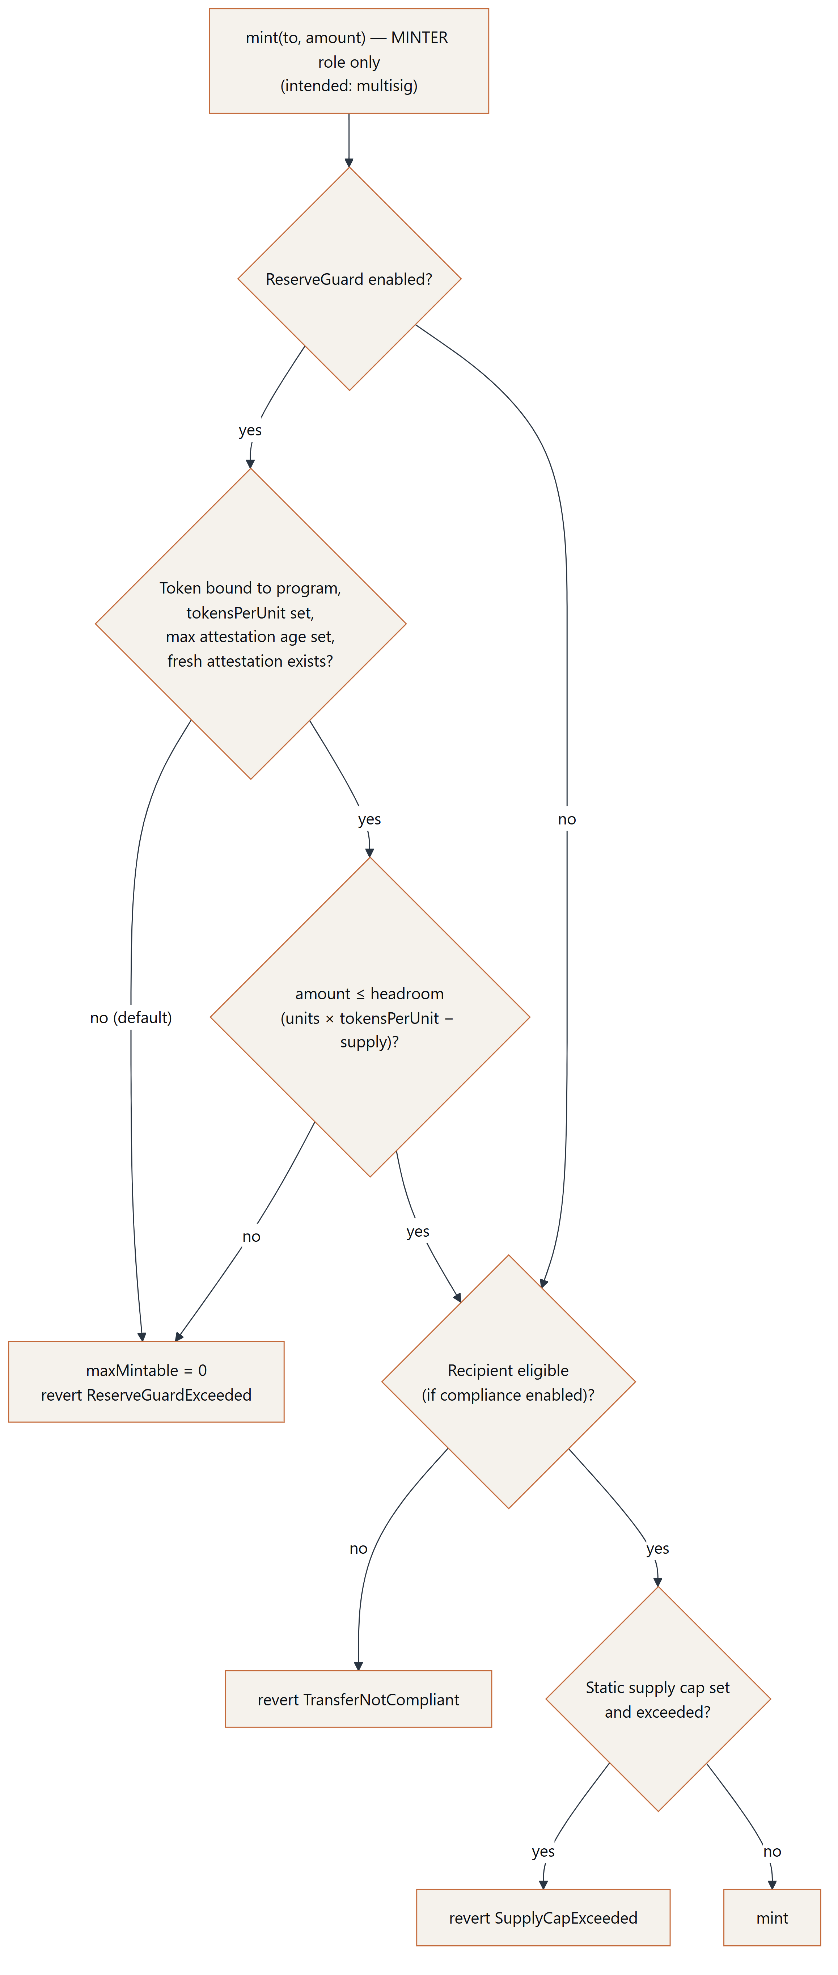
Figure 7 — Reserve gated mint
When the ReserveGuard is enabled, its ceiling is zero unless the token is bound to a program, the ratio (tokensPerUnit) is set, the staleness window is set and a fresh attestation exists — all of which are unset by default. Minting is therefore impossible until each element has been deliberately configured. The intended operating policy is that any token representing registered material is deployed with the ReserveGuard enabled, that the MINTER role is held only by the multisig, and that no minting takes place during the current phase. The reserve ceiling is a technical safeguard; it is not itself a Proof of Reserves, which depends on the independence and quality of the attestation behind each posted figure.

7.5 Configuration, not code
Token name, symbol, decimals, supply cap, ratio, thresholds and limits are supplied through per-network configuration files and administrative transactions. Nothing economic is hard-coded. Default configuration leaves every economic parameter unset.

8. Tokenomics Framework
No tokenomics have been decided. The table below is a framework listing the parameters that would need to be defined, approved in writing and disclosed in definitive offering documentation before any issuance. Every value is To be determined — subject to written approval.
Parameter | Description | Value
Token name and symbol | Identifier(s) per program | To be determined — subject to written approval
Decimals | Divisibility | To be determined — subject to written approval
Unit of account | Physical unit underlying the representation (e.g. mass unit) | To be determined — subject to written approval
Asset-to-token ratio | Tokens per unit of registered material | To be determined — subject to written approval
Supply cap | Maximum tokens per program | To be determined — subject to written approval
Issuance price / pricing methodology | How any issuance price would be set | To be determined — subject to written approval
Allocations | Any allocation categories | To be determined — subject to written approval
Holder rights | Legal nature of any entitlement | To be determined — subject to final legal structure
Redemption minimum / maximum | Thresholds per request | To be determined — subject to written approval
Redemption fees and delivery terms | Costs and logistics | To be determined — subject to written approval
Custody and insurance cost allocation | How ongoing costs are borne | To be determined — subject to written approval
Transfer restrictions | Eligibility rules, lock-ups | To be determined — subject to written approval
Secondary transfer venues / liquidity | Any trading arrangements | To be determined — no liquidity is represented
Reporting frequency | Reserve report cadence | To be determined — subject to written approval

ReserveChain makes no statement regarding price, value, appreciation, liquidity, yield or return of any future token.

9. Governance

9.1 Principles
- Separation of duties — no single person can author, approve and publish a material claim.
- Least privilege — role-based access in the CMS and on-chain.
- Traceability — every material action is recorded in a tamper-evident audit trail.
- Explicit authorization — sensitive modules require a written authorization reference and two distinct authorised users.
- External verifiability — fingerprints, Merkle roots and audit anchors allow outside parties to check integrity.

9.2 Editorial and registry workflow
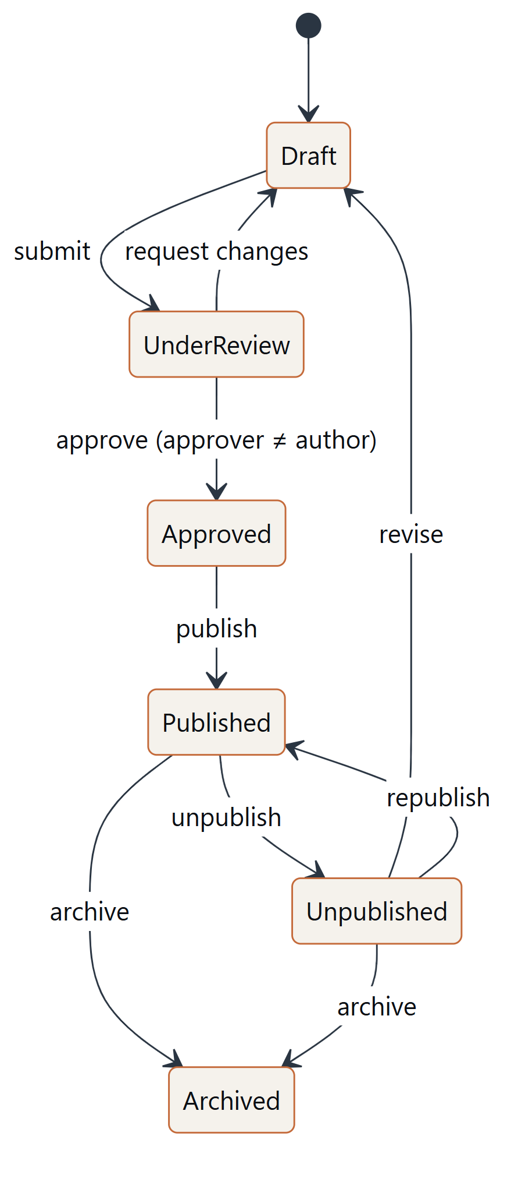
Figure 8 — Four eyes workflow

9.3 Platform roles
Role | Responsibility
Content editor | Drafts public content; submits for review
Registry manager | Creates and maintains registry and evidence records; submits for review
Reviewer | Reviews and approves others' submissions
Compliance officer | Publishes; approves compliance-sensitive changes; manages jurisdictions, eligibility statuses and waitlist data
Auditor | Read-only access; verifies audit-trail integrity; exports evidence
Administrator | Platform settings, module authorization (with written reference), audit anchoring

9.4 On-chain governance (intended)
Administrative rights over contracts are intended to be held by a Safe multisig whose signers and threshold are [To be provided by ReserveChain]. Admin transfers use delayed two-step rules. Emergency pause is available to designated pausers. All role changes are to be mirrored in the CMS audit trail with transaction references.

9.5 Corporate governance
Board composition, committees (e.g. risk, compliance), conflicts-of-interest policy and external audit arrangements of the proposed entity are Pending — subject to final approval.

10. Technology Platform
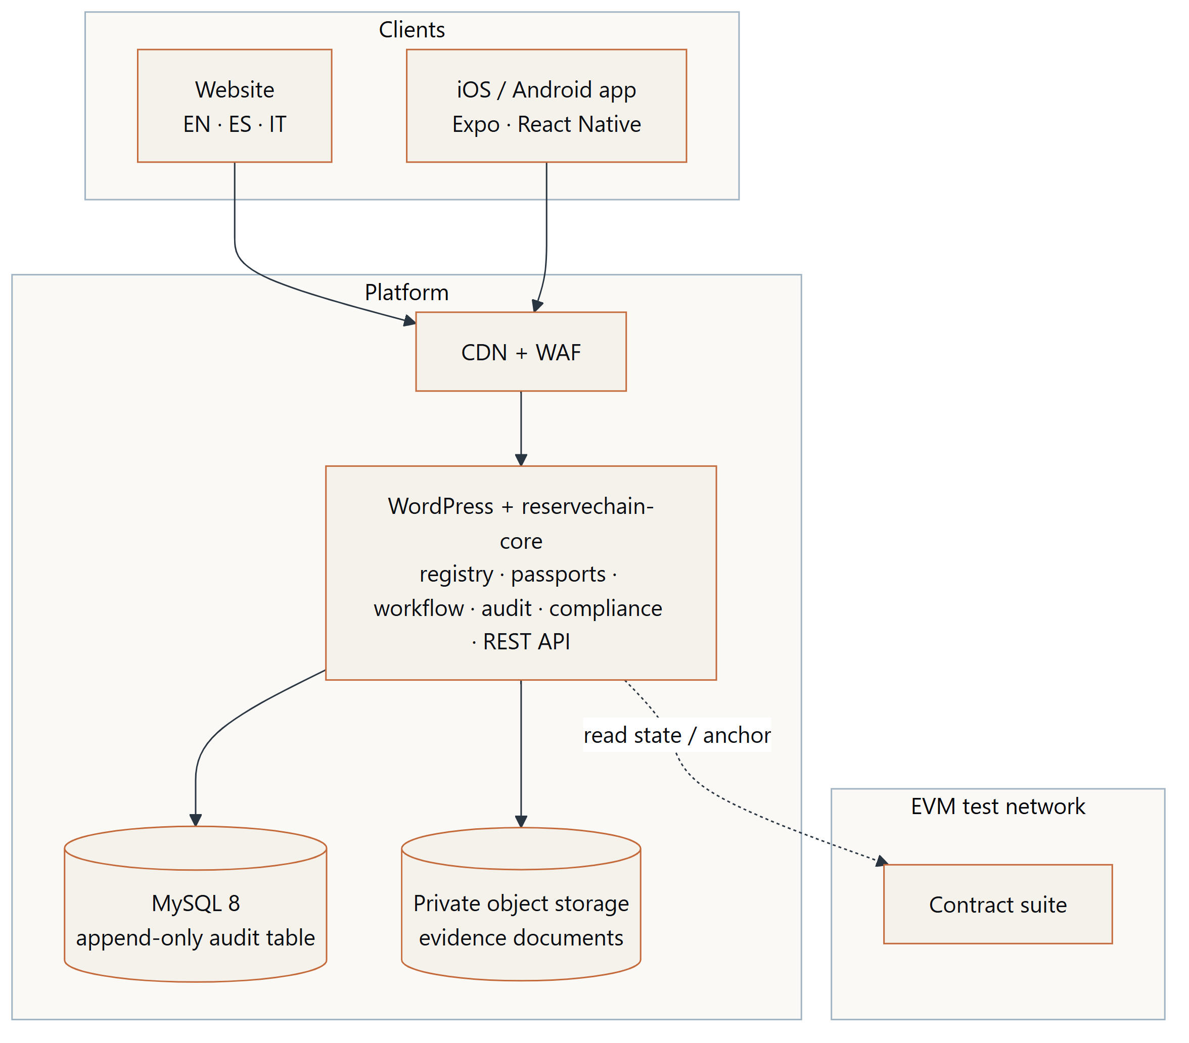
Figure 9 — Technology stack
Component | Technology | Notes
Website and CMS | WordPress, custom theme and plugin (PHP 8.1+), MySQL 8 | Declarative registry schema; extensible without rebuild
REST API | /wp-json/rc/v1 | Public read-only endpoints; authenticated member endpoints with MFA
Mobile apps | Expo / React Native (TypeScript), native builds for iOS and Android | Remote configuration; inactive modules hidden
Smart contracts | Solidity, Hardhat, OpenZeppelin Contracts v5 | Testnet only
Languages | English, Spanish, Italian | Legal texts subject to counsel-approved translation
Environments | Development, Staging, Production — strictly separated | Separate data, secrets and access

Audit trail. Each audit entry stores the hash of the previous entry and its own SHA-256 hash over a canonical field sequence. Database triggers reject any UPDATE or DELETE on the audit table. An integrity tool recomputes the entire chain on demand and daily. The latest chain head can be anchored to the AuditAnchor contract; any later rewrite of history becomes detectable against the anchor.
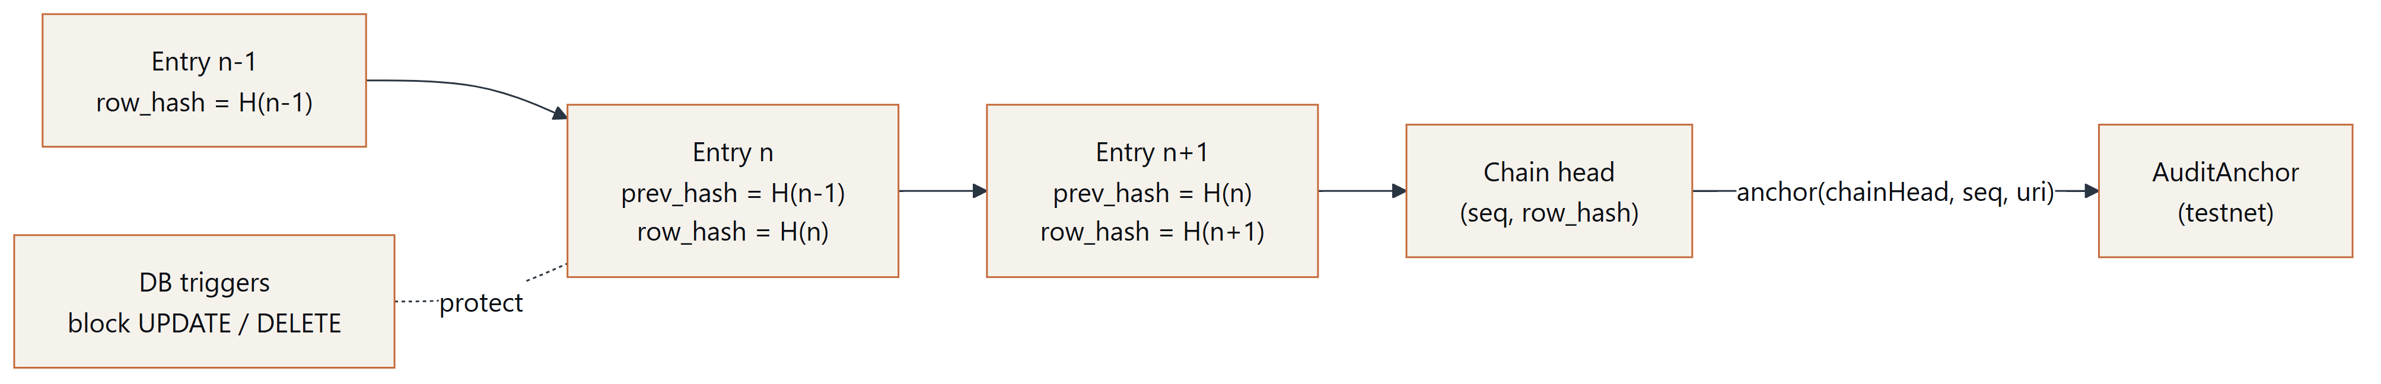
Figure 10 — Audit anchoring

11. Security
ReserveChain's proposed security programme comprises:
Domain | Proposed controls
Identity | Named accounts; role-based access; mandatory TOTP multi-factor authentication for staff
Sessions | Secure, HttpOnly cookies; idle and absolute timeouts; revocation on role change
Transport & browser | TLS 1.2+, HSTS, Content Security Policy, hardened headers
Application | Prepared statements, output escaping, nonces, capability checks; file editing disabled in production
Uploads | Type allow-list, magic-byte validation, malware scanning, private storage, signed URLs, SHA-256 at ingest
Abuse | Edge WAF, rate limiting, honeypots, optional challenge
Secrets | Secrets manager; no secrets in source; scheduled rotation
Data protection | Hashed IPs and emails for de-duplication; PII restricted to compliance roles; KYC documents held by provider, not by the platform
Backups | 3-2-1 strategy with immutable off-site copy; scheduled restore drills (see Section 17)
Monitoring | Health endpoints, audit-chain and trigger checks, failed sign-ins, backup age, disk and scheduler checks, with alerting (see Section 17)
Vulnerability management | Dependency and image scanning; static analysis (PHP and Solidity); external penetration test and smart-contract audit [firms to be appointed by ReserveChain]
Incident response | Severity model; maintenance mode; contract pause via multisig; evidence preservation against on-chain anchors
Keys | Hardware-backed multisig for contract administration; low-privilege anchor key; deployer admin renounced after deployment

No security control eliminates risk. External audits and penetration tests have not yet been performed.

12. Compliance

12.1 Eligibility controls
Any future participation would require, at minimum: identity verification (KYC) for individuals, business verification (KYB) for entities including beneficial owners, AML risk assessment, sanctions and politically-exposed-person screening, and jurisdictional eligibility. The provider is [To be decided by ReserveChain]. The platform currently stores only status values (not started, pending, approved, rejected) per member; documents remain with the provider.
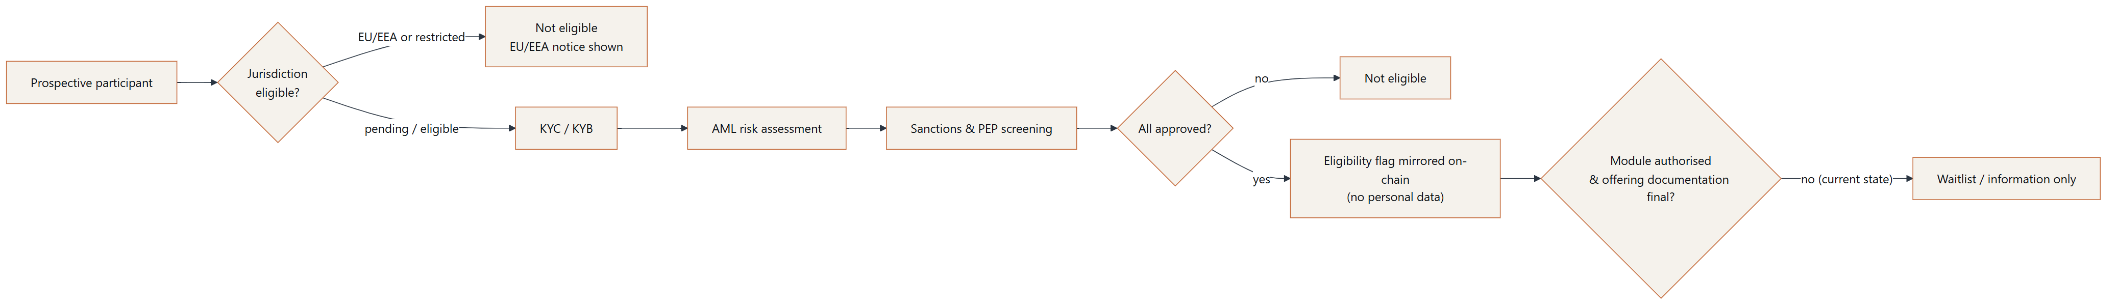
Figure 11 — Compliance gating

12.2 Jurisdictions
- EU/EEA: ReserveChain does not currently intend to offer tokens to residents of, or persons located in, the EU/EEA. EU/EEA registrations of interest are recorded as restricted and receive general updates only if they opt in.
- Other jurisdictions: eligibility is Pending — subject to legal analysis. Sanctioned jurisdictions would be blocked.

12.3 Registration of interest
The waitlist collects name, email, country, entity type, optional organisation, program interest and language, together with explicit consent to the disclosure and privacy notice. The version and SHA-256 hash of the consent text are recorded. Double opt-in confirmation is required. Registration of interest creates no entitlement of any kind (see Important Notice).

12.4 Data protection
The platform is designed for data minimisation: hashed identifiers in logs, restricted access to personal data, export and erasure procedures, and retention periods [To be defined by ReserveChain counsel] under applicable law (including the Swiss Federal Act on Data Protection and, where applicable, the GDPR).

12.5 Communication standards
Public materials use the terms proposed, planned, in development and subject to final approval. They do not describe any arrangement as confirmed unless it has been verified through the four-eyes process with evidence, and they do not use language of investment, profit or return.

13. Redemption (Proposed Process)
Redemption is a proposed feature. It is disabled in the platform and in the RedemptionManager contract. No redemption right exists. Thresholds, fees, delivery terms, eligible locations and timelines are To be determined — subject to written approval.

13.1 On-chain process (testnet contract)
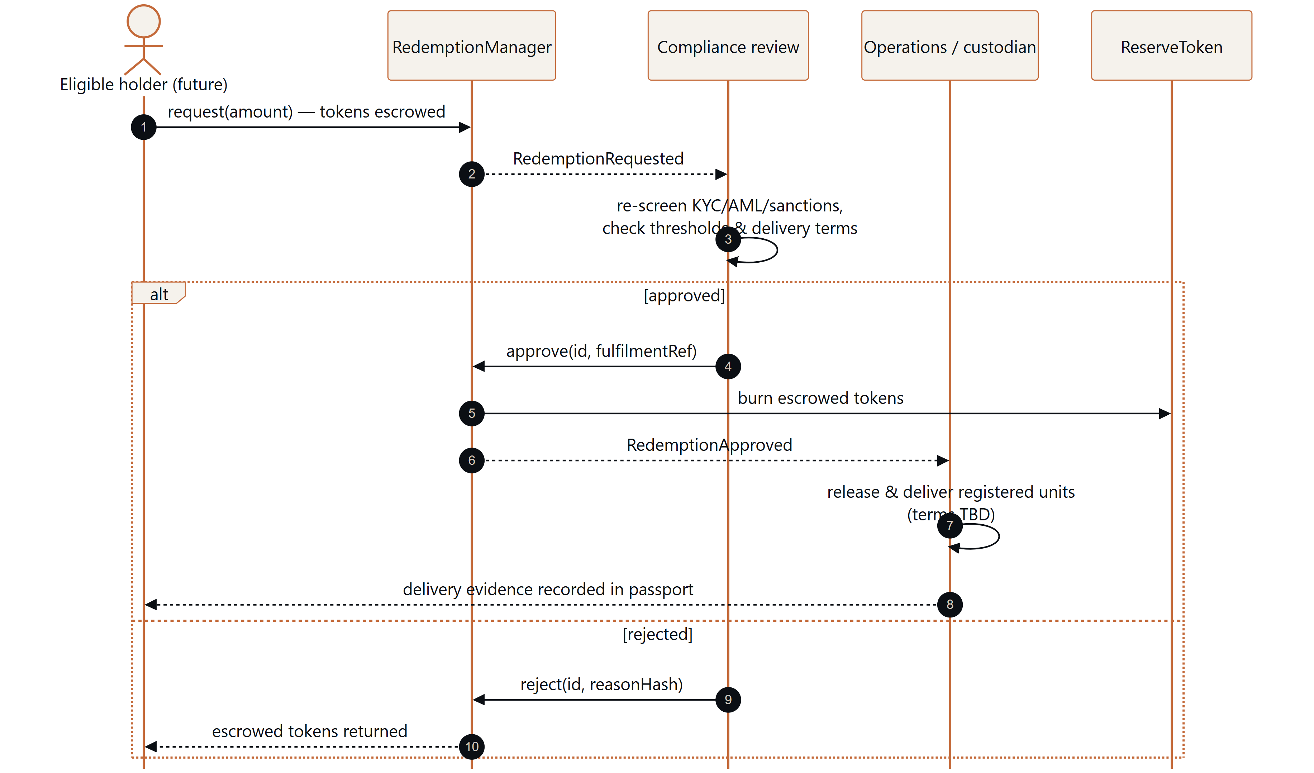
Figure 12 — Redemption flow
Design properties of the proposed process: tokens are escrowed (not burned) until approval, so a rejection is fully reversible; approvals and rejections are recorded on-chain with a fulfilment reference or reason hash; the corresponding CMS redemption record mirrors the state; physical release would be evidenced by custody records attached to the affected passports.

13.2 Off-chain redemption workflow (in development, module inactive)
The platform contains an off-chain workflow that mirrors the RedemptionManager contract. It is part of the gated redemption module, which is inactive until written authorization. While the module is off, staff can create only clearly labelled test redemptions in the development environment.
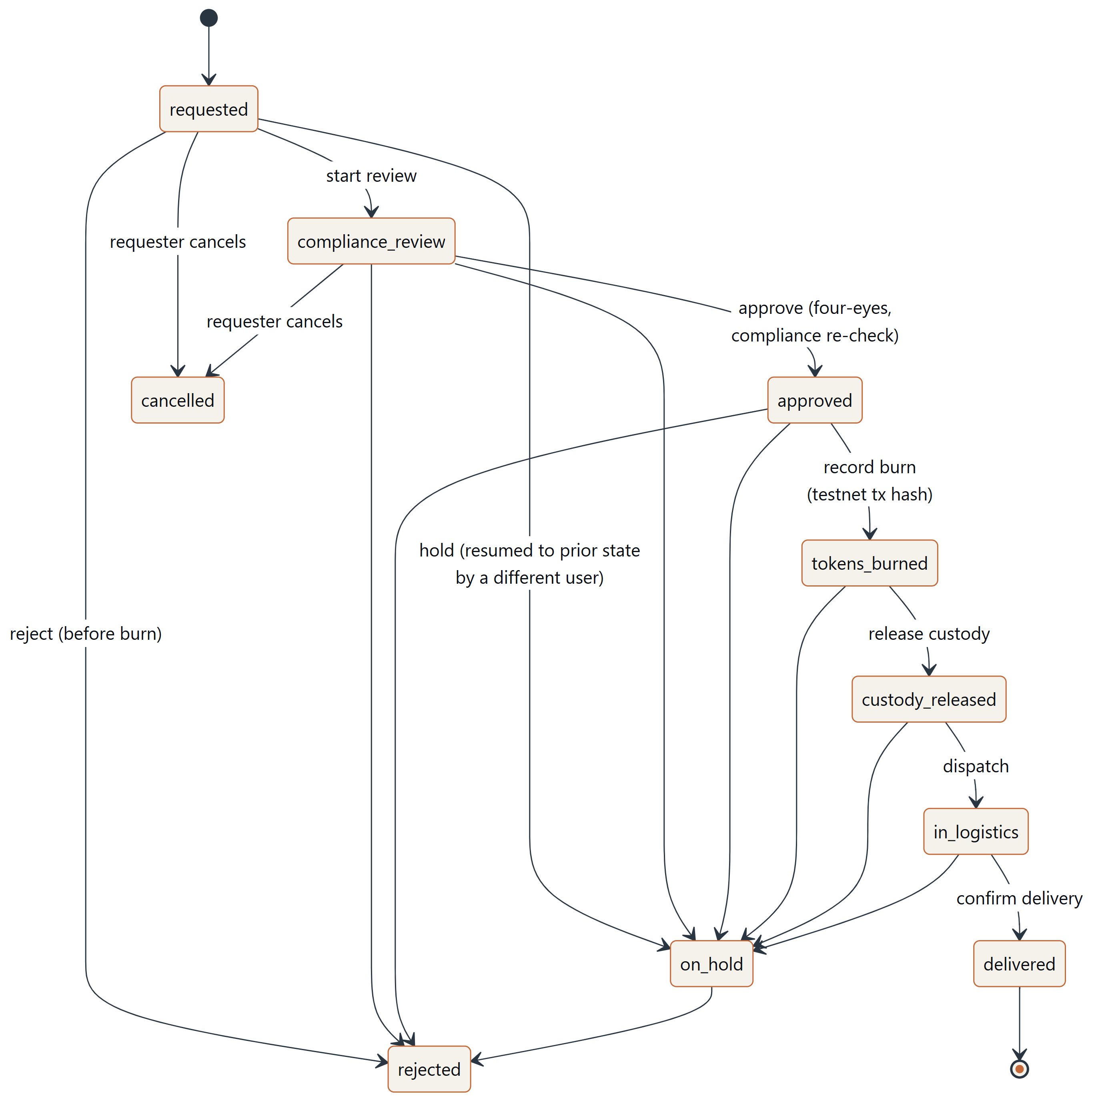
Figure 13 — Redemption states
Control | Implementation (in development)
States | requested → compliance review → approved → tokens burned → custody released → in logistics / customs → delivered; side exits: rejected (staff, before burn), cancelled (requester, before approval), on hold (staff, resumable to the prior state)
Reversibility | Rejection and cancellation are possible only before the burn is recorded, matching the on-chain escrow model; the burn step must carry the test-network burn transaction hash as evidence
Four-eyes | Every transition is capability-checked; the approver must differ from the requester and the preparing operator; the burn recorder must differ from the approver; the delivery confirmer must differ from the dispatcher; a hold must be released by a different user from the one who placed it
Approval binding | Approval is bound to a fingerprint of what was approved (units, lot, amount, program, delivery method, delivery-address hash); a later change invalidates the approval
Compliance re-checks | Eligibility (jurisdiction plus KYC/KYB, AML and sanctions status) is snapshotted at request and re-checked at approval; a restricted jurisdiction or any required check not approved blocks the step and is recorded in the audit trail
Unit-level status | Selected containers, coils or lot are locked against double selection; each unit's redemption status follows the workflow (requested → released → delivered) and is restored on rejection or cancellation, with audit diffs
Thresholds and fees | Never invented: read from the token program or platform settings; when missing they are displayed as to be determined and a live (non-test) request is refused
Personal data | The delivery address is encrypted at rest; only its SHA-256 hash enters the audit trail

The reconciliation engine (Section 14) flags any unit that is accepted into reserve while a redemption is open, to prevent double counting.

14. Proof of Reserves (Proposed)
Proof of Reserves is a proposed feature and is inactive. No reserve attestation has been published. No attestor has been appointed.
The proposed approach combines four elements:
- Unit-level registry — reserves are identified as specific registered units with passports, not as an aggregate figure alone.
- Independent attestation — an attestor [To be appointed by ReserveChain] issues periodic reports covering the registered units; each report is fingerprinted and registered.
- On-chain posting — the attestor posts the attested quantity, the report hash and its URI to ReserveGuard; the mint ceiling is derived from the most recent fresh attestation.
- Public reconciliation — a reserves page would display, per program, the attested units, report date, attestor, report fingerprint, on-chain transaction, and tokens outstanding (currently: Not applicable — no tokens issued).
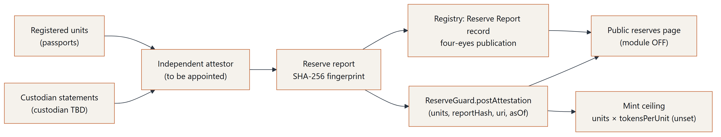
Figure 14 — Proof of reserves

14.1 Reconciliation engine (in development)
For each program, the platform computes a deterministic reconciliation from the registry: registered units by type; declared versus verified weight; custody evidence; reserve eligibility; token supply (read from a test-network contract only when one is configured — otherwise shown as not deployed or RPC not configured); the latest attestation; and coverage. Coverage is computed only from a verified attestation, an approved asset-to-token ratio and a known token supply; otherwise it is shown as not computed. No figure is estimated or filled in. Uploaded information is never described as "independently verified" unless the corresponding reserve report itself has been approved with status verified.

14.2 Exception rules
Exceptions surface problems instead of smoothing them away. Each carries a severity (critical, warning, information) and a reference to the affected unit, document or program.
Exception | Severity | Condition
Reserve without custody | Critical | Unit marked reserve-eligible but custody not evidenced
Unfingerprinted document | Critical | Linked document has no SHA-256 fingerprint
Insurance expired | Critical | Linked insurance record has expired
Supply without attestation | Critical | Tokens outstanding but no verified attestation exists
Supply exceeds reserve | Critical | Token supply exceeds the attested reserve allowance
No CoA | Warning | No Certificate of Analysis linked to the lot
Missing weight | Warning | Net weight not recorded
Redemption overlap | Warning | Unit accepted into reserve while a redemption is open (double-counting risk)
Insurance expiring | Warning | Linked insurance record approaching expiry
Stale valuation | Warning | Valuation missing or older than 180 days for a reserve unit
Stale attestation | Warning | Latest attestation older than 90 days or undated
Owner-supplied only | Information | Certificate is owner-supplied and not independently verified
No attestation | Information | No reserve attestation published for the program

A daily job records an audit entry and alerts compliance staff whenever the set of open exceptions changes.

14.3 Reserve snapshots
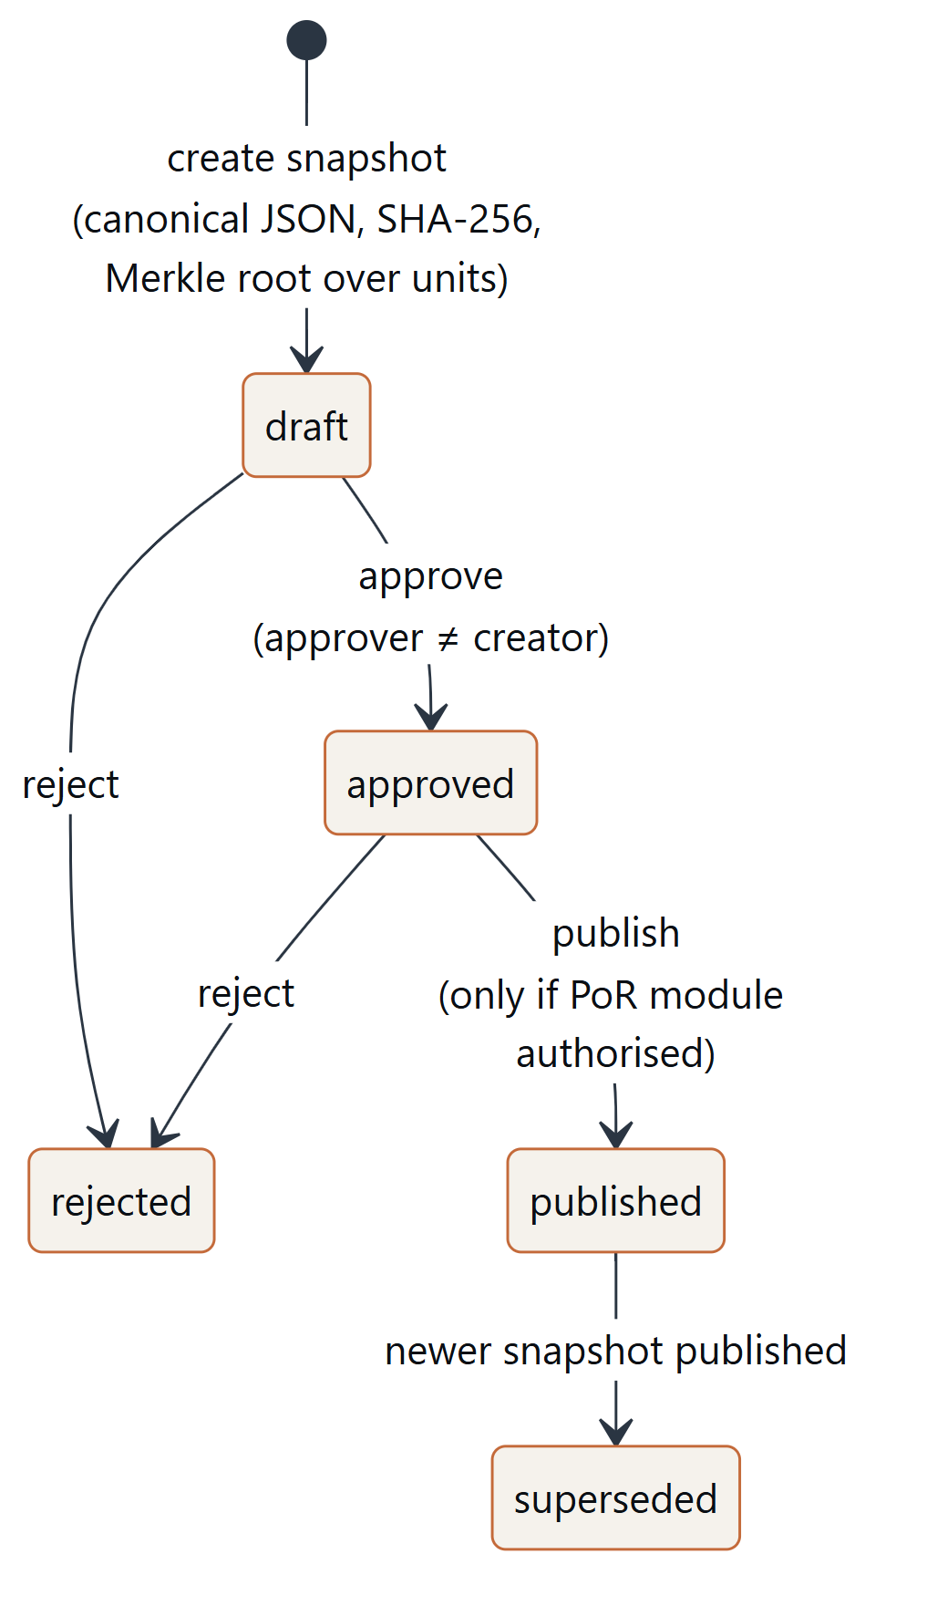
Figure 15 — Por snapshot lifecycle
A snapshot freezes a reconciliation as canonical JSON, records its SHA-256 hash and a Merkle root over the unit fingerprints, and counts its open exceptions. Snapshots are created manually or as a weekly automatic draft for review. Under the four-eyes rule the creator of a snapshot cannot approve it; only an approved snapshot can be published, and publication is locked until the Proof of Reserves module is authorised. Each published snapshot supersedes the previous one for its program, and its integrity can be re-checked against the stored hash. Every step is recorded in the audit trail together with the snapshot hash, so published reports are anchored whenever the audit chain is anchored on-chain. Attestation reports can be uploaded, fingerprinted and routed as draft reserve-report records to the review queue.
Limitations: an on-chain attestation records a statement by a key holder; its reliability depends entirely on the independence, competence and procedures of the attestor and the custodian. A reserve report at a point in time does not guarantee reserves at other times. A reconciliation is only as complete as the registry data behind it.

15. Wallet Linking and Payment Verification (Inactive Modules)
The modules in this section are implemented as source code but are inactive. They operate only against test networks, and they cannot be activated without written authorization. No purchase, payment or token acquisition is possible through the platform. Nothing in this section is an offer or an invitation to pay.

15.1 Wallet linking (module wallet)
A participant could link up to three wallets to an account by signing a Sign-In-with-Ethereum-style (EIP-4361) challenge with personal_sign (EIP-191). The signed statement reads "Link this wallet to your ReserveChain account. No transaction, no fees." Challenges expire after ten minutes. Signatures are verified server-side: the message is rebuilt from the stored challenge, hashed (Keccak-256) and the signer recovered with secp256k1 in pure PHP; where the required maths library is unavailable, the test-network ecrecover precompile is used instead. Linking a wallet creates no entitlement of any kind.

15.2 USDT payment verification (modules purchase and usdt_payments)
This module would verify ERC-20 USDT transfers. It is gated by both the purchase and usdt_payments modules and by a site mode that permits participation, none of which is enabled. There is no pricing logic anywhere in the platform: any amount would be entered and approved by staff under four-eyes control, bound to a fingerprint. Verification would require a successful transaction receipt containing a Transfer event from the configured USDT contract, from the participant's linked wallet, to the configured treasury, for exactly the approved amount, with the configured number of confirmations; a scheduled job re-checks pending payment intents (states: created, awaiting transaction, confirming, confirmed, failed, expired).

15.3 Test networks only
Every RPC call first checks the network chain ID against an allow-list of test networks (Ethereum Sepolia, Polygon Amoy, local development) and against the platform network setting. Mainnet calls are refused.

16. Participant Portal, Data Rooms and Asset-Owner Intake

16.1 Participant portal (in development)
The participant portal is a single-page interface on top of the platform API, offering sign-in with multi-factor authentication and a personal dashboard. It is the staged-access entry point; registration follows the platform's registration settings. Use of the portal creates no entitlement and is not a channel for any offering.

16.2 Restricted documents and data rooms
Each evidence document carries an audience: public, investor, enterprise, auditor, custodian or staff. Restricted files are moved to private storage that denies direct web access and uses unguessable file names; they are only ever streamed through the application via a signed link that expires after ten minutes and re-checks access on use. Read-only participant roles (investor data room, enterprise client, custodian) have no administrative access. The investor and enterprise data rooms are gated by the investor_portal and enterprise_portal modules, which are inactive; until they are authorised, non-staff members cannot see documents in those audiences.

16.3 Asset-owner / originator intake (module asset_owner_portal)
Producers, owners, originators and custodians of copper powder or nickel wire could submit material for consideration through an intake form gated by the asset_owner_portal module. Submissions become private records that move through the pipeline received → initial review → due diligence → accepted for onboarding | declined. Final decisions are four-eyes: one manager proposes and a different authorised user confirms, bound to a fingerprint of the submission as proposed. Supporting certificates (PDF or images, up to five files of 20 MB) are stored privately, SHA-256 fingerprinted and accessible to staff only. A submission is not an acceptance, a valuation or a commitment by either side.

17. Operations: Monitoring, Backups and Disaster Recovery
Operational targets in this section are proposed and subject to final approval by ReserveChain; they are not commitments of any hosting provider.

17.1 Monitoring and alerting (implemented for the single-server deployment)
Element | Description
Public health endpoint | GET /wp-json/rc/v1/health — rate-limited, no secrets; reports overall status (ok / degraded), audit chain head and last verification, trigger presence, cron age, disk headroom and backup status
Detailed health endpoint | Token-protected; returns every check with detail, versions, last backup record, recent failures and alert state
Scheduled checks | Database reachability; audit-chain verification; presence of the audit-immutability triggers; failed sign-ins (threshold 20 per hour); waitlist / contact / mail failures; age of last successful backup (26-hour limit); disk usage (85 % threshold); scheduler heartbeat
Alerting | E-mail and optional chat webhook, de-duplicated (repeat interval six hours); an operations widget on the staff dashboard

17.2 Backups (proposed targets)
The proposed backup strategy follows a 3-2-1 model with one off-site, immutable copy held under a separate account and provider whose credentials are not available to the production application. Proposed schedule: continuous point-in-time recovery logs, daily database snapshots, daily encrypted logical dumps off-site, versioned object storage and a daily export of the audit log to write-once storage. Retention periods are subject to counsel's retention policy.
Metric | Proposed target
RPO (data loss) | ≤ 15 minutes (point-in-time recovery)
RTO (service restore, same region) | ≤ 4 hours
RTO (region loss) | ≤ 24 hours

17.3 Restore and disaster-recovery drills
The restore procedure verifies the archive checksum before decryption, refuses to overwrite production without an explicit override, confirms that the audit-immutability triggers are present straight from the dump, never rewrites the audit tables, and succeeds only if the tamper test, a full audit-chain verification, the home page and the health endpoint all pass. A local restore drill was performed on 2026-10-06 against a throwaway environment: the triggers were present after import, tamper attempts were rejected and the audit chain verified intact. That drill used development data only; drills with production archives are proposed to be repeated quarterly, and a full rebuild in a disaster-recovery region annually and before launch. External assurance of these procedures has not yet been performed.

18. Roadmap
The roadmap is phase-based. No dates are given; timing depends on legal, regulatory, commercial and technical dependencies, many outside ReserveChain's control. Completion of any phase does not imply that later phases will occur.
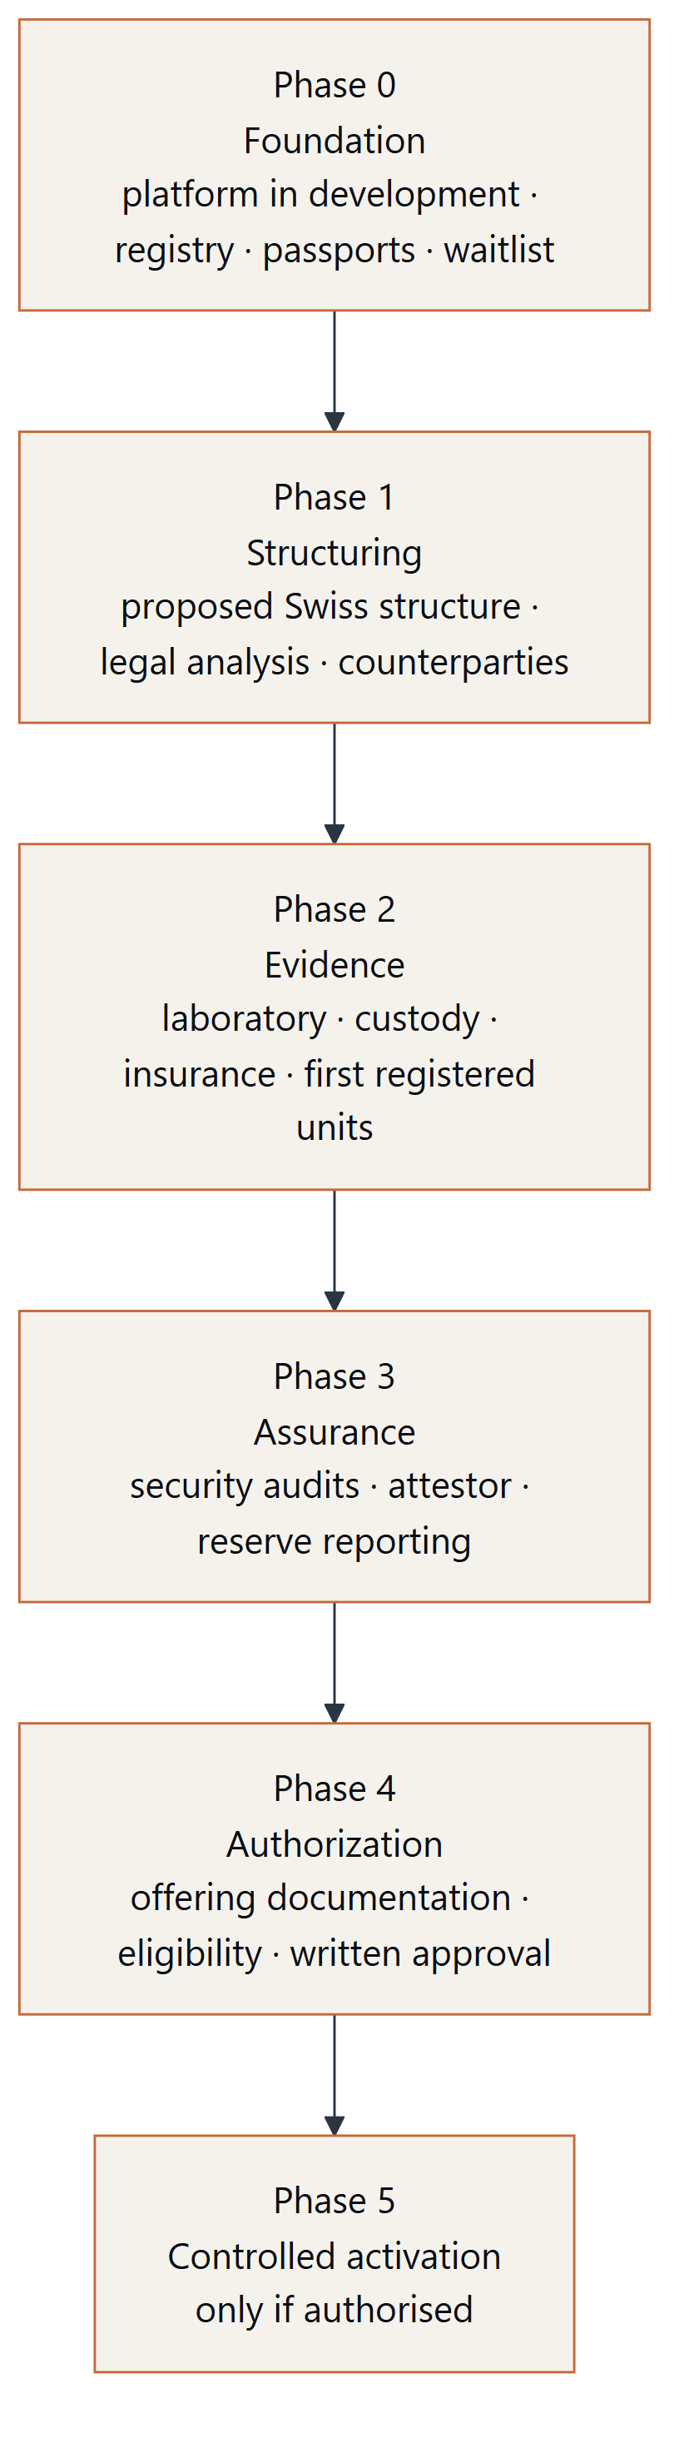
Figure 16 — Roadmap
Phase | Objectives | Status
0 — Foundation | Website, CMS, registry, Digital Asset Passports, audit trail, waitlist, testnet contracts, mobile app source, documentation; reserve reconciliation and snapshots, redemption workflow, wallet and payment-verification modules (inactive), participant portal and data rooms, asset-owner intake, operations monitoring and backups; registration of owner-supplied certificates (pending verification) | In development
1 — Structuring | Corporate and legal structure; regulatory analysis; selection of providers | Proposed
2 — Evidence | Laboratory, custody and insurance arrangements; first units registered with evidence | Proposed
3 — Assurance | Penetration test, smart-contract audit, attestor appointment, first reserve report | Proposed
4 — Authorization | Definitive offering documentation; eligibility framework; written approvals | Proposed
5 — Controlled activation | Activation of gated modules only if all prior conditions are met | Proposed — subject to final approval

19. Risk Factors
The following non-exhaustive risks apply to the project and to any future representation of physical metals. They should be read together with the Important Notice.

19.1 Project and structural risks
- Development risk. The platform is in development; features may change, be delayed or never be completed.
- Entity risk. The proposed Swiss structure has not been formed or authorised; it may not be formed, or may be formed in a different form or jurisdiction.
- Counterparty-selection risk. Laboratories, custodians, insurers, attestors and service providers have not been appointed; suitable counterparties may not be available on acceptable terms.
- Funding and continuity risk. The project may lack resources to complete development or operate the platform.
- Key-person risk. The project may depend on a small number of individuals.

19.2 Legal and regulatory risks
- Characterisation risk. Tokens may be characterised as securities, financial instruments, deposits, commodities derivatives or other regulated products, with licensing, prospectus and conduct consequences.
- Regulatory change. Laws on crypto-assets, tokenised securities, AML, sanctions and data protection are evolving and may restrict or prohibit the proposed activities.
- Jurisdictional restrictions. Persons in the EU/EEA and potentially other jurisdictions will not be eligible; eligibility rules may change.
- Enforceability. Holder rights (if any) may be uncertain or unenforceable in some jurisdictions or in insolvency.
- Sanctions and AML. Counterparties, sourcing or participants could become subject to sanctions, triggering freezes or exclusions.

19.3 Asset and custody risks
- Specification risk. Material may not meet target specifications; laboratory results may vary between methods and laboratories.
- Owner-supplied evidence risk. The certificates currently registered were supplied by the asset owner and have not been independently confirmed with the issuing laboratory; they may prove inaccurate, incomplete, outdated or not attributable to the material. Declared quantities are customer declarations, not verified weights.
- Degradation risk. Fine metal powders can oxidise or absorb moisture; wire can be damaged or corrode; storage conditions matter.
- Custody risk. Loss, theft, fraud, misallocation, commingling, or custodian insolvency.
- Insurance risk. Insurance may be unavailable, insufficient, subject to exclusions or not pay out.
- Valuation risk. Industrial metals are subject to price volatility; specialised forms may have thin markets and wide differences between valuation and realisable value. No valuation is published.
- Provenance and ESG risk. Sourcing may be subject to responsible-sourcing, environmental and human-rights scrutiny; documentation may be incomplete.
- Logistics risk. Transport, export controls, customs, hazardous-material handling and delivery may delay or prevent physical movements.

19.4 Reserve and redemption risks
- Attestation risk. Attestations are statements at a point in time and depend on the attestor's procedures and independence.
- Mismatch risk. Operational errors could cause registry, reserve reports and on-chain state to diverge. Reconciliation exceptions are designed to surface such divergences but cannot detect errors that are not reflected in the recorded data.
- Redemption risk. Redemption may never be available; if available, it may be subject to thresholds, fees, delays, suspension, jurisdiction limits and delivery constraints.

19.5 Technology risks
- Smart-contract risk. Contracts may contain vulnerabilities despite testing and use of established libraries; audits have not yet been performed.
- Key-management risk. Loss or compromise of administrative or signer keys.
- Blockchain risk. Network congestion, forks, reorganisations, fee spikes, client bugs, or changes to the underlying network.
- Oracle / attestor key risk. A compromised attestor key could post incorrect data (mitigated, not eliminated, by staleness windows, caps and multisig oversight).
- Wallet and payment risk. If ever activated, wallet linking and payment verification would depend on correct signature verification, RPC providers and stablecoin contracts; payments sent to wrong addresses, in wrong amounts or on wrong networks may be unrecoverable. These modules are currently inactive.
- Platform risk. Web, CMS, API or app vulnerabilities; third-party dependency compromise; outages.
- Data risk. Data loss or corruption despite backups; restoration may lose recent data.

19.6 Market and liquidity risks
- No liquidity. No secondary market or liquidity arrangement exists or is represented.
- Price risk. Any token, if issued, could trade (where permitted) at prices different from any reference value of the underlying material.
- Concentration risk. Two programs only; exposure to two metals and to specific forms.

19.7 Operational and reputational risks
- Human error in data entry or approvals, mitigated but not eliminated by four-eyes controls.
- Fraud by insiders or counterparties.
- Misinformation. Third parties may misrepresent the project or impersonate it; only official channels [To be provided by ReserveChain] should be relied upon.

20. Glossary
Term | Definition
AML | Anti-money laundering controls and procedures
Attestation | A statement by an independent party about the existence and quantity of reserves at a point in time
Audit trail | Append-only record of material platform actions, hash-chained for tamper evidence
Chain head | The hash of the most recent audit-trail entry together with its sequence number
Certificate of Analysis (CoA) | Laboratory document reporting the measured composition/properties of a sample
Claim Status | Visible status of a factual claim: proposed, in development, pending verification, verified, not applicable
Coil / spool | A wound unit of wire tracked individually in the registry
Custody record | Evidence of receipt, holding, transfer or release of a unit by a custodian
Data room | Audience-restricted document area served only through signed, expiring links; investor and enterprise data rooms are gated modules
DAP — Digital Asset Passport | Public, per-unit page showing identity, fields with status, timeline, evidence ledger and Merkle root
EEA | European Economic Area (EU member states plus Iceland, Liechtenstein, Norway)
ERC-20 | A standard interface for fungible tokens on Ethereum-compatible blockchains
Fail-closed | A design in which a control defaults to the most restrictive state when not fully configured
Four-eyes principle | Requirement that a second, different authorised person approves a change before it takes effect
KYB | Know Your Business — verification of a legal entity and its beneficial owners
KYC | Know Your Customer — verification of an individual's identity
Merkle root | A single hash committing to a set of hashes, enabling inclusion proofs
Multisig | A wallet requiring signatures from multiple keys to execute a transaction
Owner-supplied | Provenance label for evidence provided by the asset owner and not yet independently confirmed with its issuer
PEP | Politically exposed person
Proof of Reserves (PoR) | A process for demonstrating that represented assets exist, proposed here as a combination of registry, attestation and on-chain posting
Reconciliation exception | A rule-based flag raised when registry, custody, insurance, attestation or supply data are missing, stale or inconsistent
Reserve snapshot | A fingerprinted, four-eyes-approved record of a program's reconciliation at a point in time
ReserveGuard | Contract computing a mint ceiling from attested units and a configured ratio
SHA-256 | Cryptographic hash function producing a 256-bit fingerprint
SIWE | Sign-In with Ethereum (EIP-4361): a signed text challenge proving control of a wallet without a transaction
Testnet | A public blockchain network used for testing, whose tokens have no economic value
USDT | A US-dollar stablecoin issued by a third party as an ERC-20 token; referenced only by the inactive payment-verification module
Waitlist | Registration of interest; creates no entitlement

21. Document Control
Item | Value
Document | ReserveChain Institutional Whitepaper — Discussion Draft
Version | Draft v0.10
Status | In development — subject to legal review and final approval
Owner | ReserveChain [responsible person to be provided]
Approval | Pending — subject to final approval
Distribution | Information only; not an offering document
Diagram sources | docs/whitepaper/diagrams/*.mmd
Build | docs/whitepaper/build/ (Markdown → DOCX and PDF)
Changes in Draft v0.10 | Owner-supplied certificates (Section 4.3); off-chain redemption workflow (Section 13.2); reserve reconciliation, exceptions and snapshots (Sections 14.1–14.3); new Sections 15–17; risk factors and glossary updated

Mandatory disclosure. ReserveChain is currently in development. No tokens are being offered or sold through this website. Registration of interest does not constitute an investment, token purchase, asset reservation, price reservation, token allocation or entitlement to participate in any future offering. Any future availability will be subject to the final Swiss corporate and legal structure, definitive offering documentation, asset verification, custody arrangements, jurisdictional eligibility, KYC/KYB, sanctions screening and final approval.
EU/EEA notice. ReserveChain does not currently intend to offer tokens to residents of, or persons located in, the EU/EEA.

