1. Marcello Peterbu coordinates the farm share program for his family’s farm. Besides the traditional vegetable and fruit shares, the Peterbu farm share has also been expanded to include meat and dairy options for its members.

Marcello is reviewing the farm share sales data from the last few years to see how best to expand the program. He first wants to create a line chart of the total sales from the farm shares over a four year period.

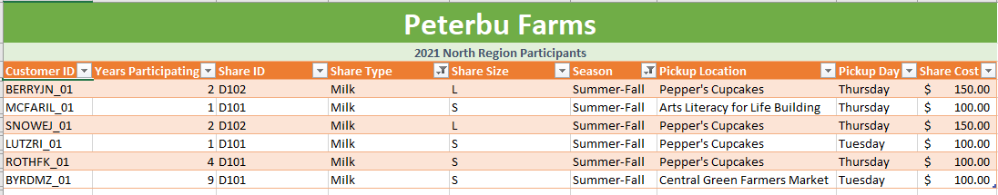

Objective: To determine seasonal differences in Milk sales.

Hypothesis:

Null Hypothesis: The share sale of milk remains same through different seasons

Alternative Hypothesis: The share sale of the milk is more in summer than winter.

I support Alternative Hypothesis with enough data to support and reject the null hypothesis.