Assignment 4: Deep-Dive into LLaVA Vision-Language Architectures
NJIT CS-685: Computer Vision | Spring 2026
Author: Saketh Varma Dantuluri | UCID: sd2399
____________________________________________________________

1. Architectural Analysis [Tasks 1.1 - 1.3]
The Large Language-and-Vision Assistant (LLaVA) represents an architectural milestone in multimodal AI. Rather than training a completely new modality-aware model from the ground up, LLaVA employs an 'agentic' approach, bridging a frozen vision encoder with a powerful large language model (LLM) using a learned projection interface.
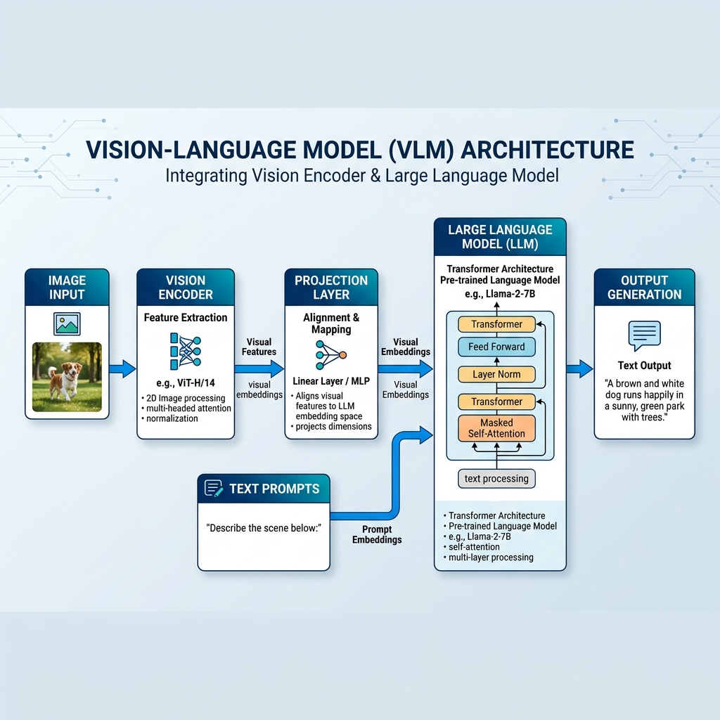
Figure 1: High-level architectural flow of the LLaVA framework.

1.1 The Multimodal Forward Pass Mechanics
The technical core of LLaVA lies in its ability to treat visual features as 'pseudo-text' tokens. The process begins with an input image processed through a CLIP ViT-L/14 transformer, which extracts grid-level visual features. These features are then mapped through a projection matrix (W) into the LLM's word embedding space, allowing the model to attend to visual concepts as a series of prefix tokens.

1.2 The Logic of Minimalist Projection
A simple projection layer is sufficient because both CLIP and LLaMA are already semantically rich. The architecture assumes a 'latent space continuity,' where a linear mapping can bridge the gap between visual and textual manifestations of the same concepts. However, if alignment is poor, the LLM may ignore visual cues entirely, favoring its own language priors.

1.3 Strategic Integration vs. Native Training
The decision to use a minimal projection layer preserves the LLM's pre-trained intelligence while dramatically reducing computational overhead. The primary drawback is the 'Frozen Vision Backbone,' which prevents the model from learning new visual primitives during multimodal fine-tuning.

2. Quantitative Training Pipeline [Tasks 2.1 - 2.2]
The pedagogical achievement of LLaVA is its two-stage training regime, which ensures stability while gaining capabilities.
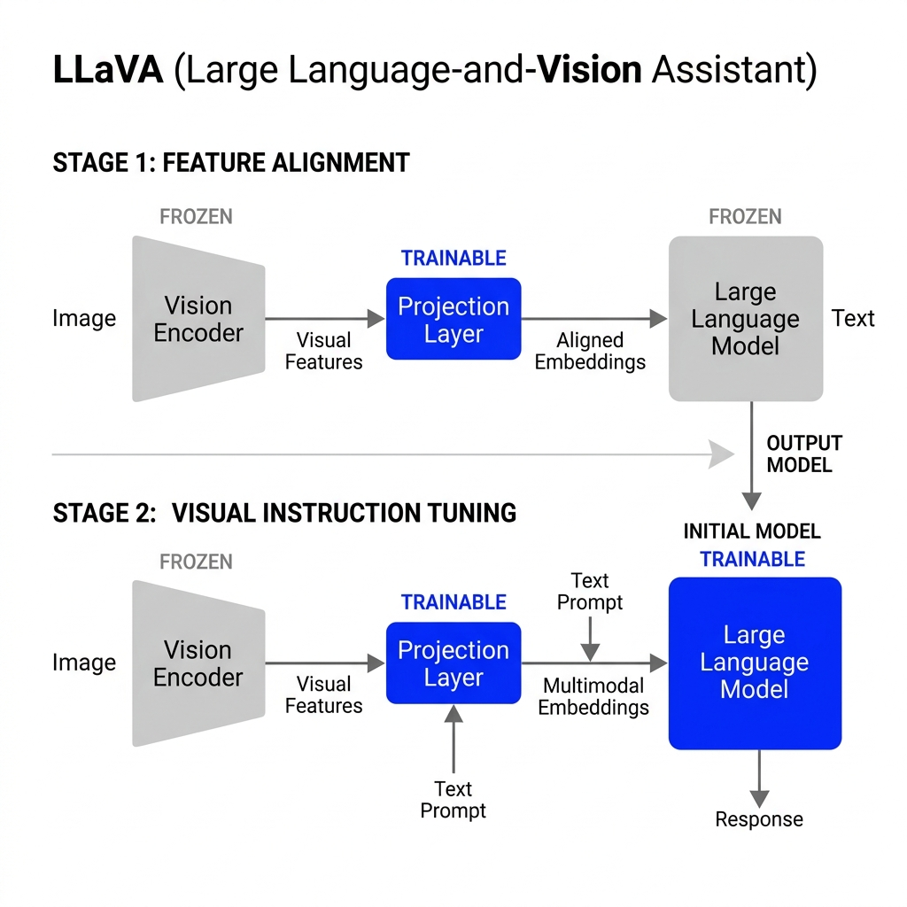
Figure 2: The progressive transition from freezing to fine-tuning across the pipeline stages.

2.1 The Two-Stage Training Paradigm
Stage | Technical Objective | Trained Components | Data Type
1: Alignment | Sync CLIP to LLM space | Projection Layer Only | 595K CC3M pairs
2: Tuning | Align to human intent | LLM + Projection | 158K GPT-4 Dialogs
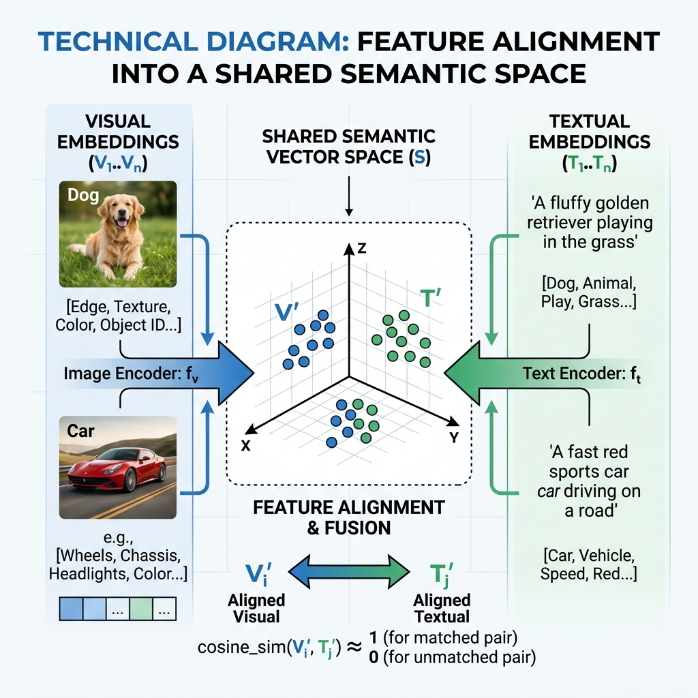
Figure 3: Conceptual alignment of visual and textual manifolds.

2.2 Synthetic Data & The GPT-4 Bridge
LLaVA's success is deeply tied to synthetic multi-turn dialogues generated by language-only GPT-4. While this allows for massive scaling, the model inherits GPT-4's linguistic biases and risks of 'poisoned' training data if the original textual descriptions used for generation were incorrect.

3. Comparative Reflection & Synthesis [Tasks 3.1 - 3.3]
The LLaVA project marks a pivotal moment in the transition from specialized vision models to unified multimodal agents. However, it also highlights the fundamental challenges of 'bolting' together disparate sensory modules that were never designed for joint operation.

3.1 Taxonomy of Multimodality: Late-Fusion vs. Native-Fusion
LLaVA is fundamentally a Language Model conditioned on visual embeddings (late-fusion). Compared to architectures like BLIP-2 with its Q-Former, LLaVA's simpler projection is more efficient but less selective. Native multimodal models like Gemini represent 'early-fusion,' where images are processed as fundamental sensory inputs rather than linguistic abstractions.

3.2 The Dual-Locus of Alignment
Alignment is a dual-process phenomenon. Structural alignment (Stage 1) creates the manifold bridge, while Behavioral alignment (Stage 2) teaches the model to synchronize its intense conversational reasoning with specific visual intents. Without both, the model suffers from cognitive dissonance between its vision and logic.

3.3 The "Frozen Vision" Resolution Ceiling
The primary bottleneck is the 'frozen vision backbone.' Because CLIP operates at a fixed resolution, fine-grained details are irretrievably lost before the LLM begins processing. This 'sampling bottleneck' creates a hard ceiling on visual precision that later models like LLaVA-1.5 attempt to bypass with larger resolution and deeper projection layers.

4. References & Bibliography
- Liu, H., Li, C., Wu, Q., & Lee, Y. J. (2023). Visual Instruction Tuning. NeurIPS.
- Radford, A., et al. (2021). CLIP. arXiv preprint arXiv:2103.00020.
- Touvron, H., et al. (2023). LLaMA. arXiv preprint arXiv:2302.13971.
- Zhu, D., et al. (2023). MiniGPT-4. arXiv preprint arXiv:2304.10592.
- Dai, W., et al. (2023). InstructBLIP. arXiv preprint arXiv:2305.06500.

