Reports
Jacoco :-
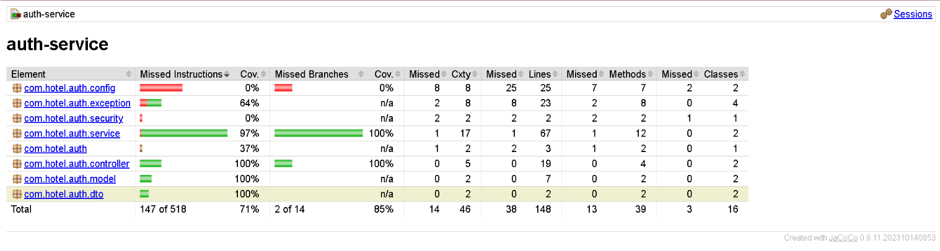

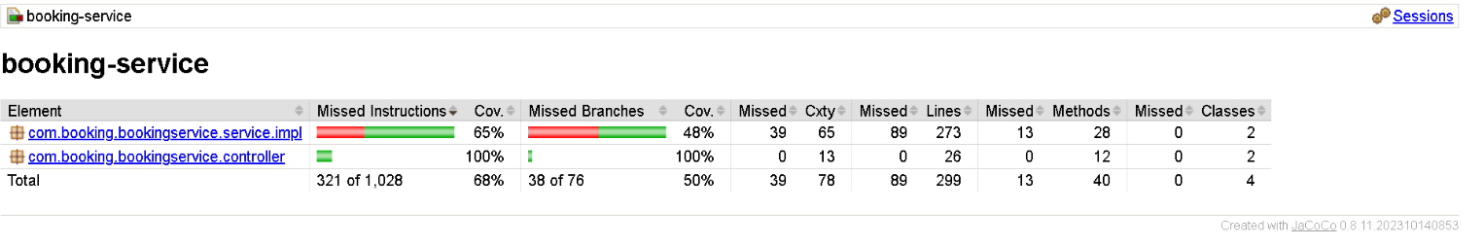

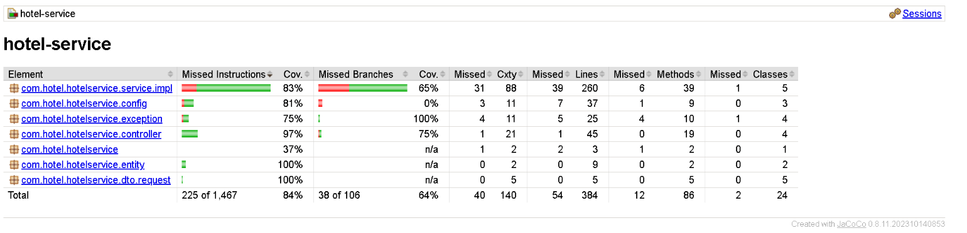

SonarQube:-
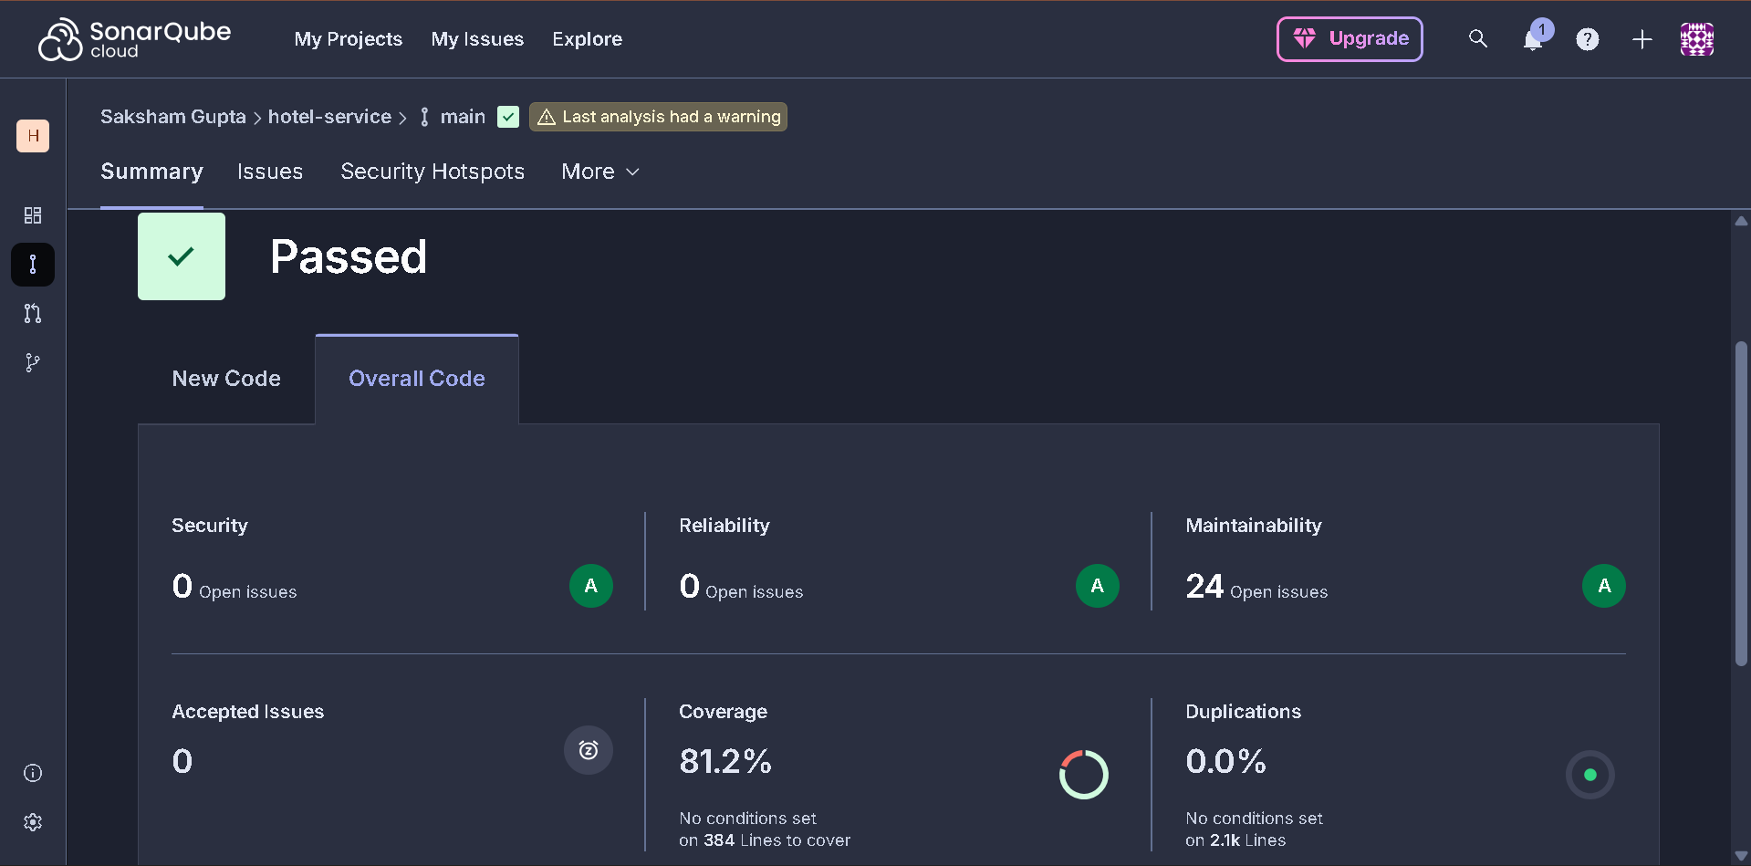

DOCKER AND JENKINS (together) :-
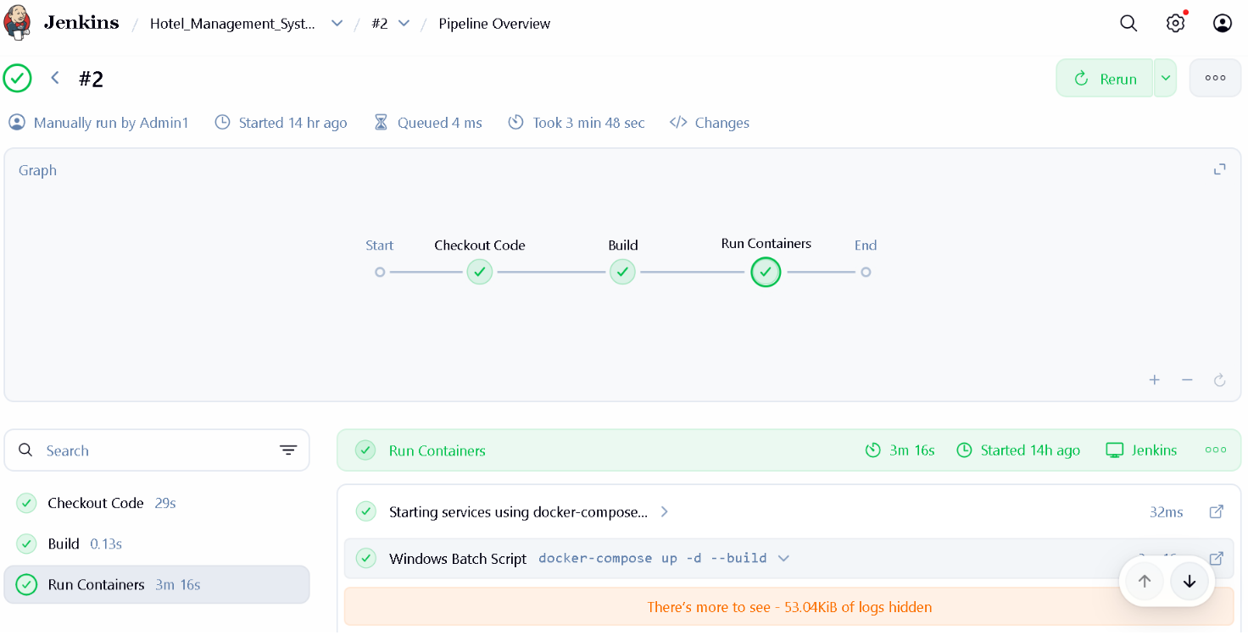
Config server for both the profiles- local and docker
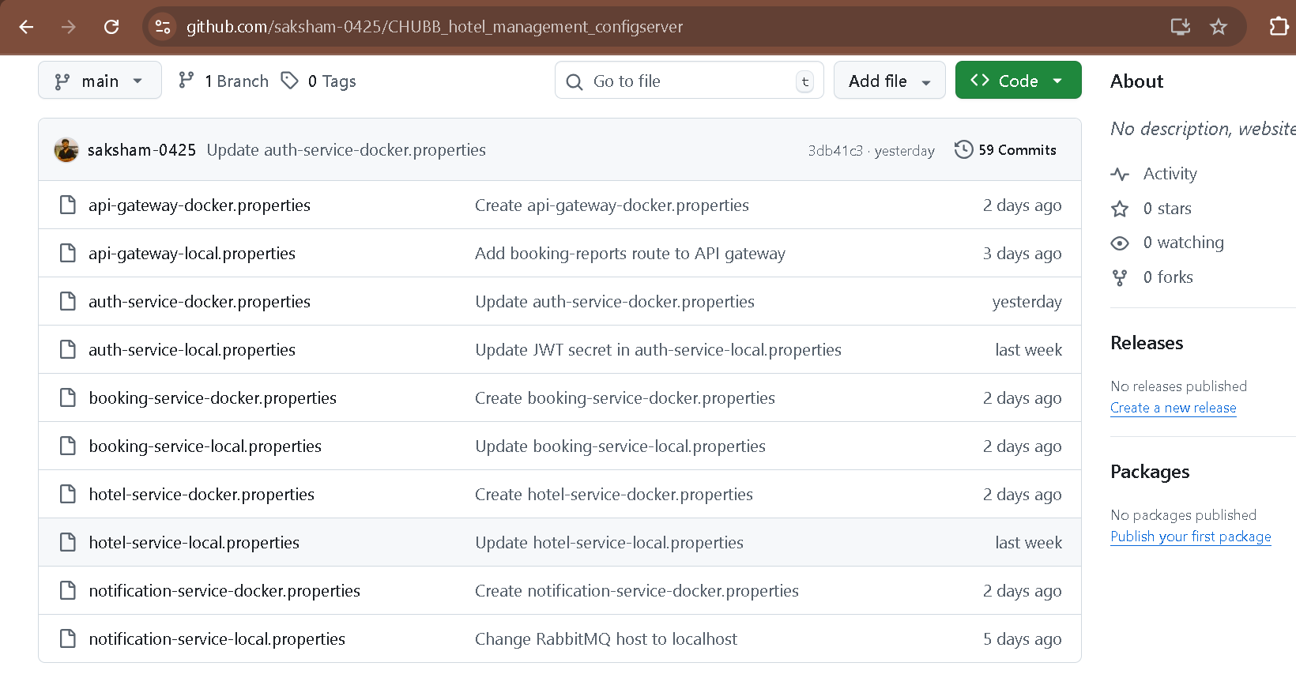

Service registry:-
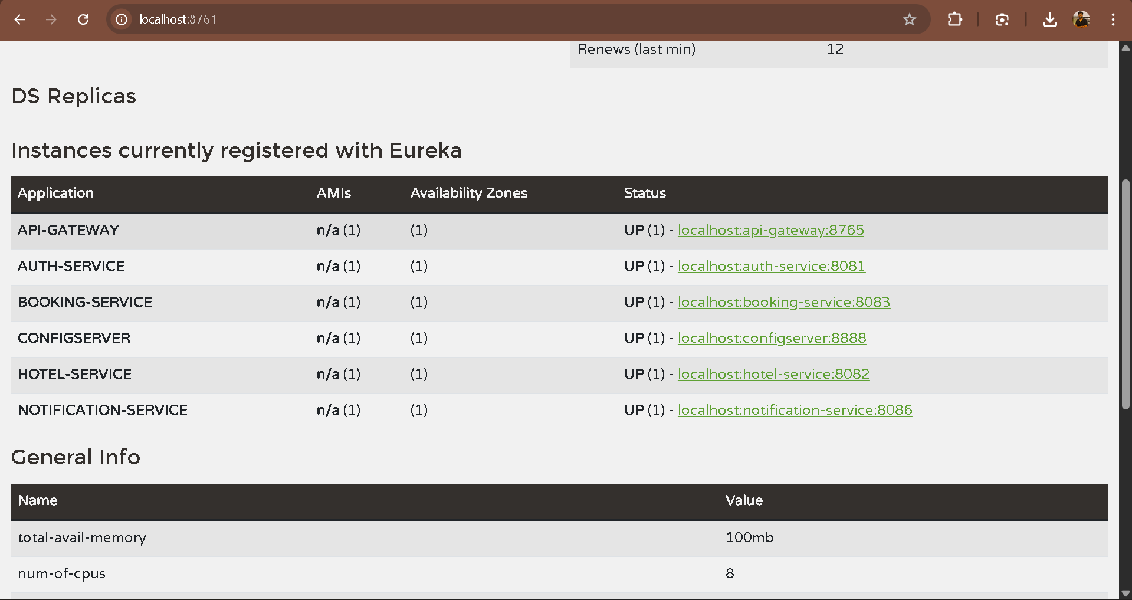

Negative testing on POSTMAN :-
