# Cryptocurrency Data Analysis Report

## Introduction

This report details the analysis of live data for the top 50 cryptocurrencies fetched using the **CoinMarketCap** API. The objective was to collect real-time market data, perform essential analysis, and update the findings in a live Excel sheet that refreshes every 5 minutes.

## Data Collection and Methodology

• Data Source: **CoinMarketCap API**

• Data Collected:

- Cryptocurrency Name  
 - Symbol  
 - Current Price (USD)  
 - Market Capitalization  
 - 24-hour Trading Volume  
 - 24-hour Price Change (percentage)

• Process Overview:

1. Fetching Data: A Python script requests live data from the API.

2. Data Processing: The raw JSON response is parsed to extract the required fields and organized into a Pandas DataFrame.

3. Analysis:

- The top 5 cryptocurrencies by market capitalization were identified.

- The average price of the top 50 cryptocurrencies was computed.

- The highest and lowest 24-hour percentage price changes were determined.

4. Excel Update: The script writes the full dataset and the analysis summary into a live-updating Excel file with multiple sheets.

## Analysis Summary

• Top 5 Cryptocurrencies by Market Capitalization:

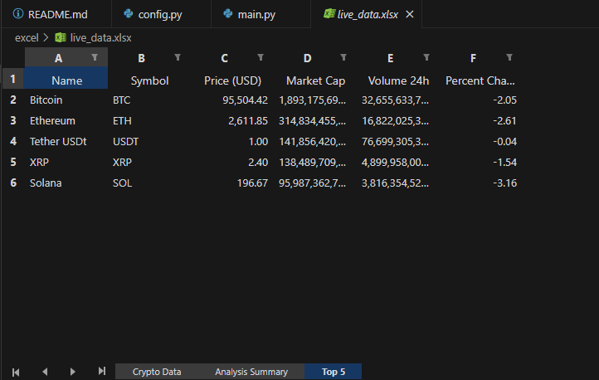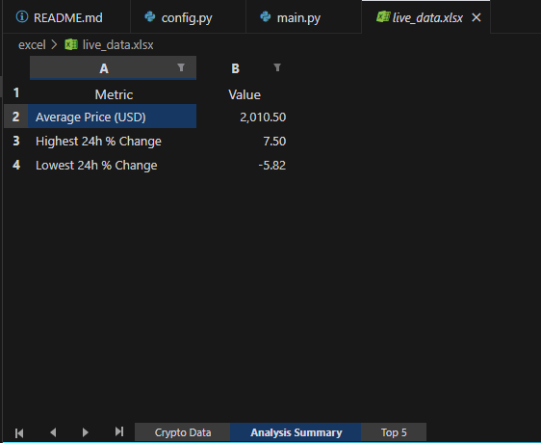

* Average Price of Top 50 Cryptocurrencies: $[2010.50]
* Highest 24-hour % Price Change: [7.50]%
* Lowest 24-hour % Price Change: [-5.82]%

## Key Insights

* The top 5 cryptocurrencies continue to dominate the market in terms of market capitalization.
* There is significant volatility as seen by the wide range in the 24-hour percentage price changes.
* The live data update mechanism ensures that the analysis reflects current market conditions in real time.

## Conclusion

The implemented system offers an effective method for monitoring and analyzing the cryptocurrency market in real time. The analysis provides valuable insights for investors and traders looking to understand market trends and volatility.

## Future Enhancements

* Data Visualization: Integration of real-time charts and dashboards.
* Extended Analysis: Incorporate historical data for trend analysis and predictive modeling.
* Alert System: Develop notification features for significant market changes.