Architecture
How the Voice Agent portal is put together, and why each piece is the way it is.
This document is rank 2 in the source-of-truth table in CLAUDE.md: the specs (Voice Agent Project.pdf, Admin dashboard Voice agent .pdf) outrank it, the ADRs in decisions/ are the binding record of each individual choice, and this file is the map that ties them together. Where a diagram and an ADR disagree, the ADR wins and this file is stale — fix it.
Spec citations are §13.9 (portal) and admin §5.2 (admin console).
Contents
- The shape of the product
- Deployment topology
- Repo layout and why it is split this way
- Request lifecycle: auth, workspace, RLS
- The two doors to Postgres
- Data model
- Agent lifecycle and prompt generation
- Publishing, and the Retell projection
- Inbound call authorisation — the hot path
- Metering and the money path
- Webhooks, exactly once
- Jobs, queues and schedulers
- Configuration as data
- Admin console and staff access
- Observability, secrets, environments
- Decision log — the why, in one table
- Services, access and what is provisioned

1. The shape of the product
A small service business signs up, answers a structured brief, gets a generated phone agent, tests it in the browser, buys a credit pack, attaches a phone number, and publishes. From then on every minute of talk time burns credits. There is no subscription and no invoice to chase.
Three properties fall out of that sentence and they drive nearly every decision below.
It is prepaid. Money moves before service, not after. That makes the credit ledger the most correctness-critical thing in the system — more than the voice quality, more than the UI. A double-charge is a refund and a support ticket; a double-credit is free money walking out the door. Hence: append-only ledger, idempotency keyed on the Retell call_id, one module that owns every write, and tests that are mandatory rather than best-effort.
It is multi-tenant with real money per tenant. A cross-workspace read is not a privacy embarrassment, it is a billing incident. Hence: RLS as a second guard underneath the application one, and a default failure mode of see nothing rather than see everything.
Retell is invisible. The customer is buying "an AI receptionist", not a Retell account. If Retell is ever named in the UI, the product becomes a reseller and the margin argument collapses. Hence: a single RetellGateway, no Retell vocabulary in customer-facing copy, and no Retell feature — however convenient — allowed to become load-bearing in a customer flow.
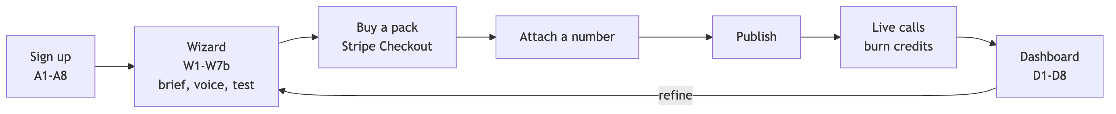
Under 15 minutes from A1 to E is the product promise. Everything slow — prompt generation, number provisioning, knowledge ingestion — is a background job with an SSE progress channel, never a blocking request.

2. Deployment topology
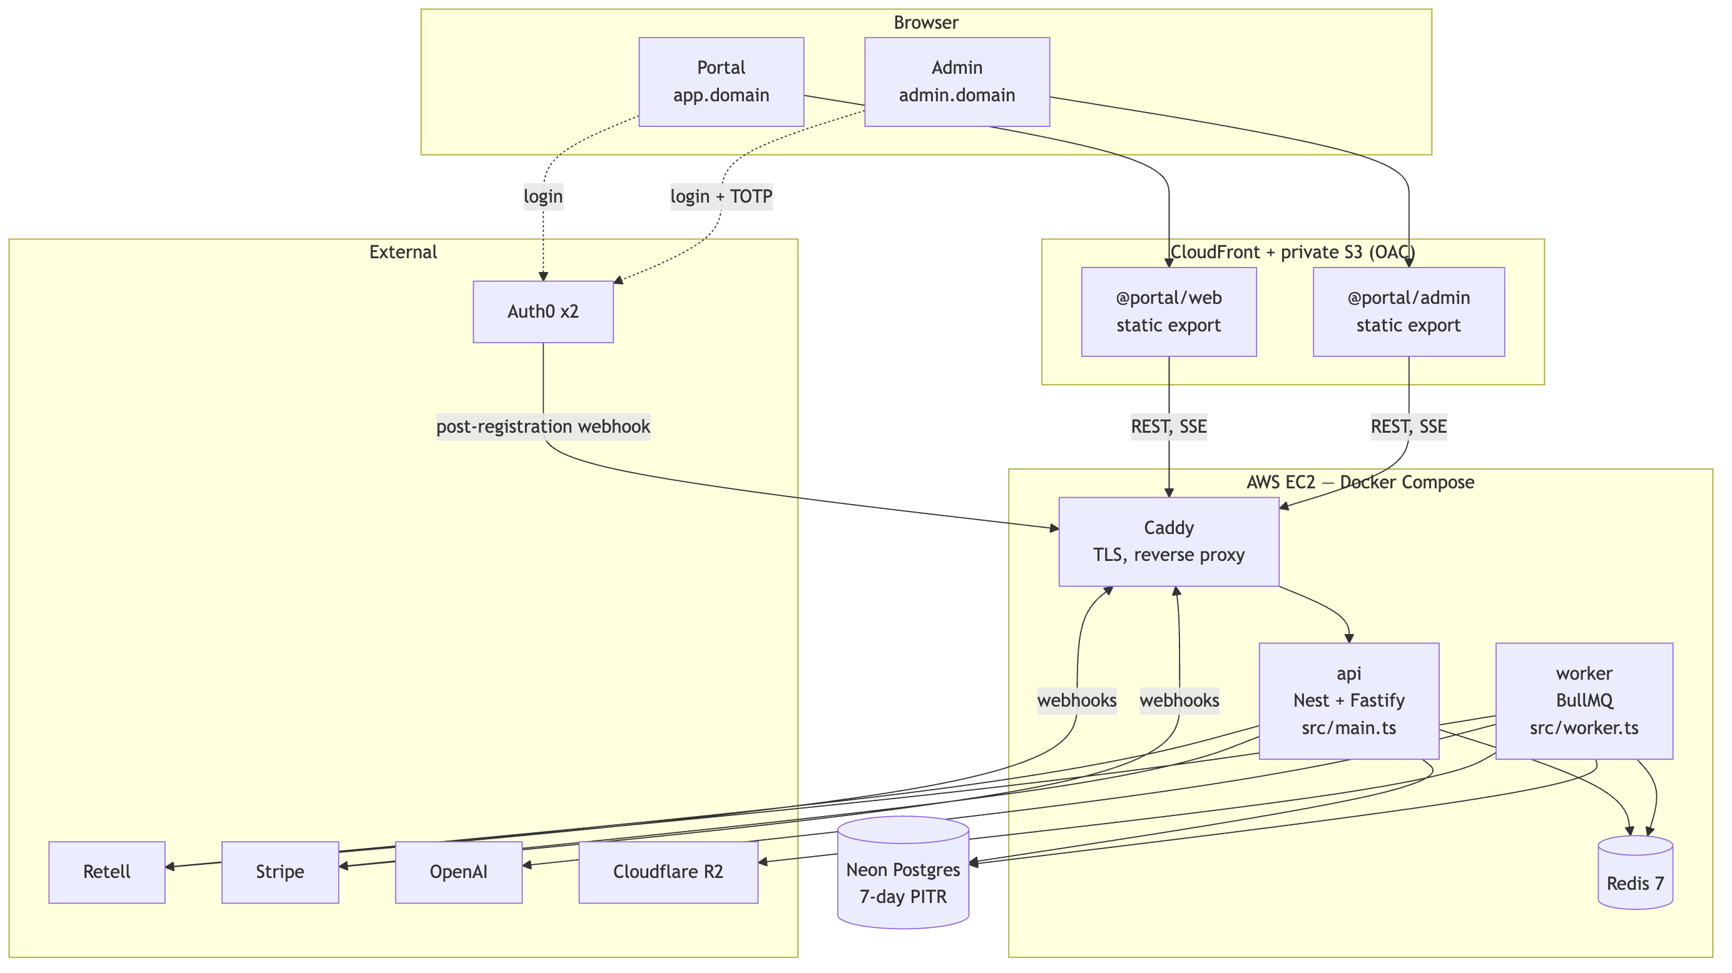
Why the frontend and backend are hosted differently. The two apps compile to static files — every screen is behind a login, so there is nothing for a server to render that the browser cannot fetch itself. The backend is the opposite: a long-lived process that holds a Redis connection, runs a BullMQ worker, and must accept webhooks on a stable hostname. A CDN over a private bucket gives the first, EC2 gives the second (ADR 0008, ADR 0004).
Why webhooks and SSE bypass the CDN. A signature must be verified on the raw body, and a CDN that re-encodes or buffers breaks both that and a long-lived SSE stream. Retell and Stripe point at api.<domain> directly; CloudFront never sees them.
Why Redis is a container on the same box, not Upstash. BullMQ needs blocking TCP commands (BRPOPLPUSH, BZPOPMIN). Upstash's HTTP interface cannot express them, so it cannot run the queue at all. A compose-internal Redis on the same instance also puts the inbound-authorisation path — the one with a p95 budget of 300 ms — on a loopback hop rather than a network round trip.
Why Neon and not RDS. Branch-per-environment and 7-day PITR out of the box (§17), with no instance to patch. The trade is that Postgres is off-box, so every request pays a network hop — which is exactly why the inbound hot path never touches Postgres synchronously (§9 below).

3. Repo layout and why it is split this way
The top-level split is by deploy target, not by language or by layer:
frontend/ → S3 + CloudFront web, admin, ui, api-client backend/ → EC2 api (+ worker), db shared/ → neither schemas, config templates/ → data agent templates as JSON infra/ → build and ops Dockerfile, compose, Auth0 actions, doctor
The rule this encodes: you can tell where a file runs by its path. A dependency that crosses from backend/ into frontend/ is a mistake you can see in a diff without reading the code. shared/ is the only thing both sides import, and it is deliberately tiny — zod schemas, enums, error codes, and tsconfig/eslint/tailwind bases. @portal/schemas depends on zod and nothing else, so pulling it into the browser costs nothing.
One image, two entrypoints.backend/api builds once and runs as two compose services: src/main.ts binds HTTP, src/worker.ts registers BullMQ processors and schedulers. They import the samemodules/*/service.ts files. A controller and a job processor calling different code paths to do the same thing is how metering bugs are born, so they don't.
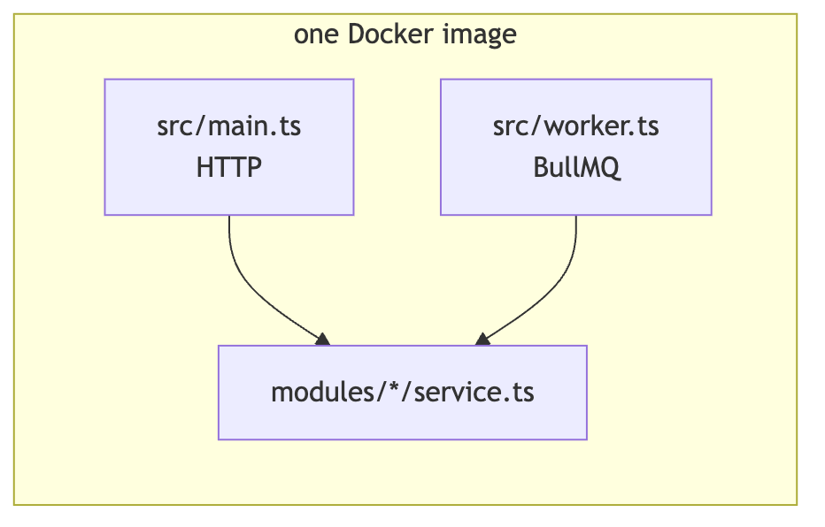
Why NestJS rather than plain Fastify. The spec names it, and the DI container earns its keep here specifically because of the two entrypoints: the same provider graph boots in both processes with no wiring duplicated. Plain Fastify was considered and rejected in ADR 0001 — less ceremony, but it would have meant hand-rolling the module graph twice.
Why Prisma rather than Drizzle. Also the spec. Drizzle's SQL-first migrations would honestly have suited the hand-written RLS policies, grants and triggers better; the compromise is that those live as hand-written SQL inside Prisma migrations (20260914044100_rls_roles_append_only), which works fine and keeps one migration runner.

4. Request lifecycle: auth, workspace, RLS
Every customer request carries two headers:
Authorization: Bearer <jwt> X-Workspace-Id: <uuid>
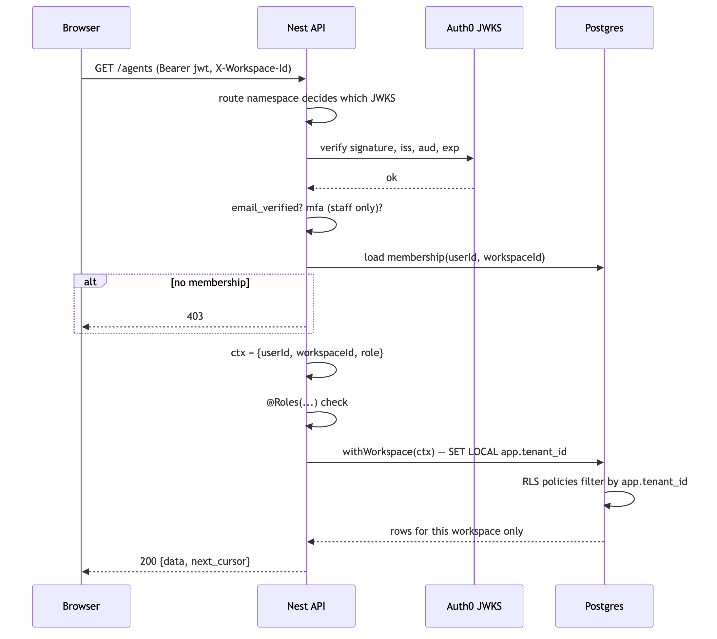
Why the namespace is chosen by the route path and never by the token. There are two Auth0 tenants (ADR 0002): customers, and staff (Google Workspace domain + mandatory TOTP). /admin/* is verified against the staff JWKS only. A customer token presented to a staff route fails on iss before any handler runs — there is no code path where a customer token can be "upgraded" by claims, because the claims are never consulted to pick the verifier. On boot the API asserts the two issuers differ, so a misconfiguration that collapses them into one tenant fails to start rather than silently granting staff access.
Why two Auth0 tenants instead of one with roles. A role is a row someone can edit. A separate tenant with a domain restriction and mandatory MFA is a boundary that survives a mistake in the role table. Staff access to customer data is the highest-blast-radius thing in the product.
Why workspace in HTTP and tenant_id in the database. The product word is workspace; the spec's schema (§15) says tenant_id and so does every foreign key. Renaming either one would mean fighting a source of truth. The translation happens in exactly one place, WorkspaceGuard, and nowhere else — ctx.workspaceId goes in, app.tenant_id comes out.
Routes are authenticated by default.@Public() opts out, @NoWorkspace() skips the workspace lookup, @Roles(...) / @StaffRoles(...) enforce the §6.1 and admin §2.2 matrices. Default-deny means a forgotten decorator produces a 401, not a leak.

5. The two doors to Postgres
This is the single most important invariant in the backend (ADR 0006).
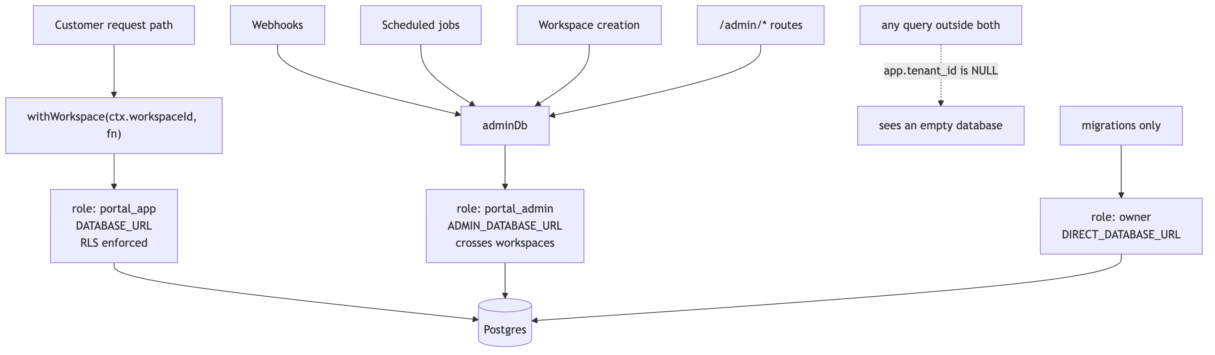
Why SET LOCAL and not a session variable.withWorkspace sets app.tenant_id as a transaction-local GUC (set_config(..., true)), inside $transaction. The setting dies with the transaction. With a connection pool, a session-scoped setting would let workspace A's context leak onto workspace B's next request through a recycled connection — a bug that would be intermittent, production-only, and catastrophic. Transaction scope makes it impossible by construction.
Why the failure mode is "empty" rather than "error". Every RLS policy compares against app.current_tenant_id(). With nothing set, the comparison is against NULL, which is never true, so the query returns zero rows. A developer who forgets withWorkspace gets an empty list in development — loud enough to notice immediately, and safe if it ever escapes. The alternative (no RLS, trust the where clause) fails the other way: silently correct in dev, silently cross-tenant in prod.
Why adminDb exists at all. Three cases genuinely cannot know the workspace in advance: a webhook (the workspace is only discoverable after the payload is parsed and verified), a scheduled job that sweeps every workspace, and workspace creation itself. Pretending otherwise would mean either disabling RLS or inventing a fake tenant context — both worse than one named, auditable second role.
Why assertRlsEnforced() blocks boot. RLS does not apply to superusers or to table owners. If DATABASE_URL were ever pointed at the owner role — an easy copy-paste in a hurry — every policy in the database would silently stop applying and nothing would look wrong. So before the API or worker binds anything, it checks that its connection is a portal_app member and is neither a superuser nor a table owner, and refuses to start otherwise. A refusal to boot is the cheapest possible failure for this class of mistake.
Why history is append-only, enforced twice.credit_ledger, audit_log and staff_audit_log carry both a REVOKE UPDATE, DELETE from the app role and a BEFORE UPDATE OR DELETE ... RAISE EXCEPTION trigger. The grant stops the application; the trigger stops everything, including a BYPASSRLS connection and including me at 2am with psql open. Reversals are new negative rows.
Two consequences, both deliberate:
- A workspace with ledger history cannot be hard-deleted — the cascade hits the trigger. The §17 delete request is therefore an anonymisation job, not a DELETE. This is the correct outcome: financial history must outlive the account.
- TRUNCATE is deliberately not covered by the trigger, so pnpm db:reset still works locally.

6. Data model
Sixty-odd tables. Two clusters matter for correctness; the rest is CRUD.
The backend is 47 Prisma models. They fall into six clusters, and almost every one of them hangs off tenants — that is what makes a single RLS predicate on tenant_id sufficient.
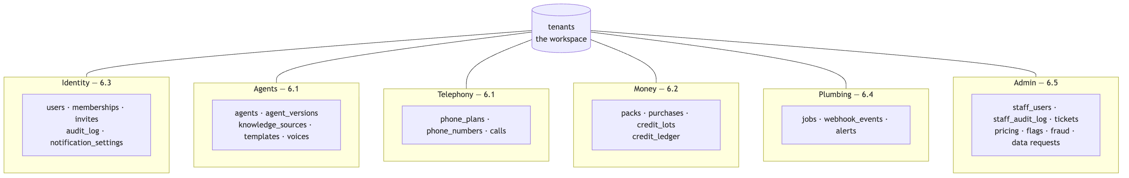
Three tables are append-only and appear in bold below wherever they occur: credit_ledger, audit_log, staff_audit_log. Seventeen more are config tables with no foreign keys at all (§6.6) — they are read through GET /pricing and GET /flags and versioned rather than mutated.

6.1 Agents, versions, numbers, calls
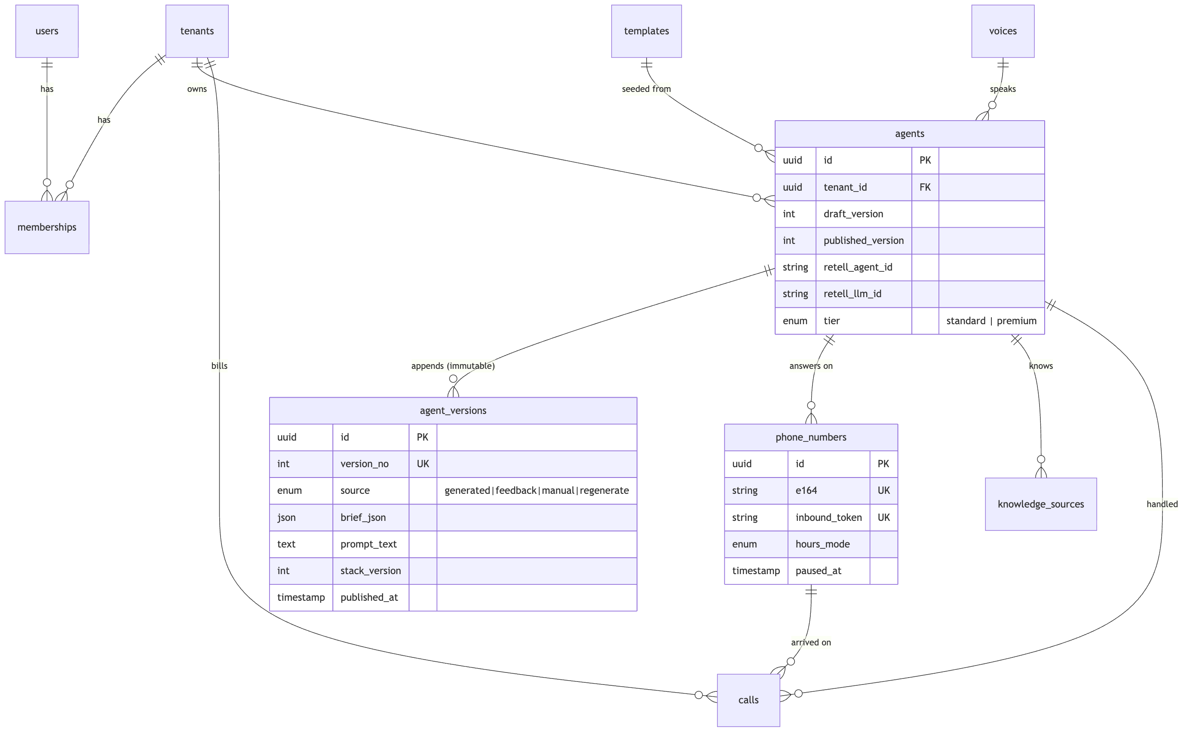
agents.published_version is the pointer a live number follows. draft_version is what the wizard is editing. Nothing is ever updated in place in agent_versions — every generation, feedback patch or manual edit appends a row with a new version_no, which is what makes "roll back to v3" a pointer move rather than a reconstruction.

6.2 The money cluster
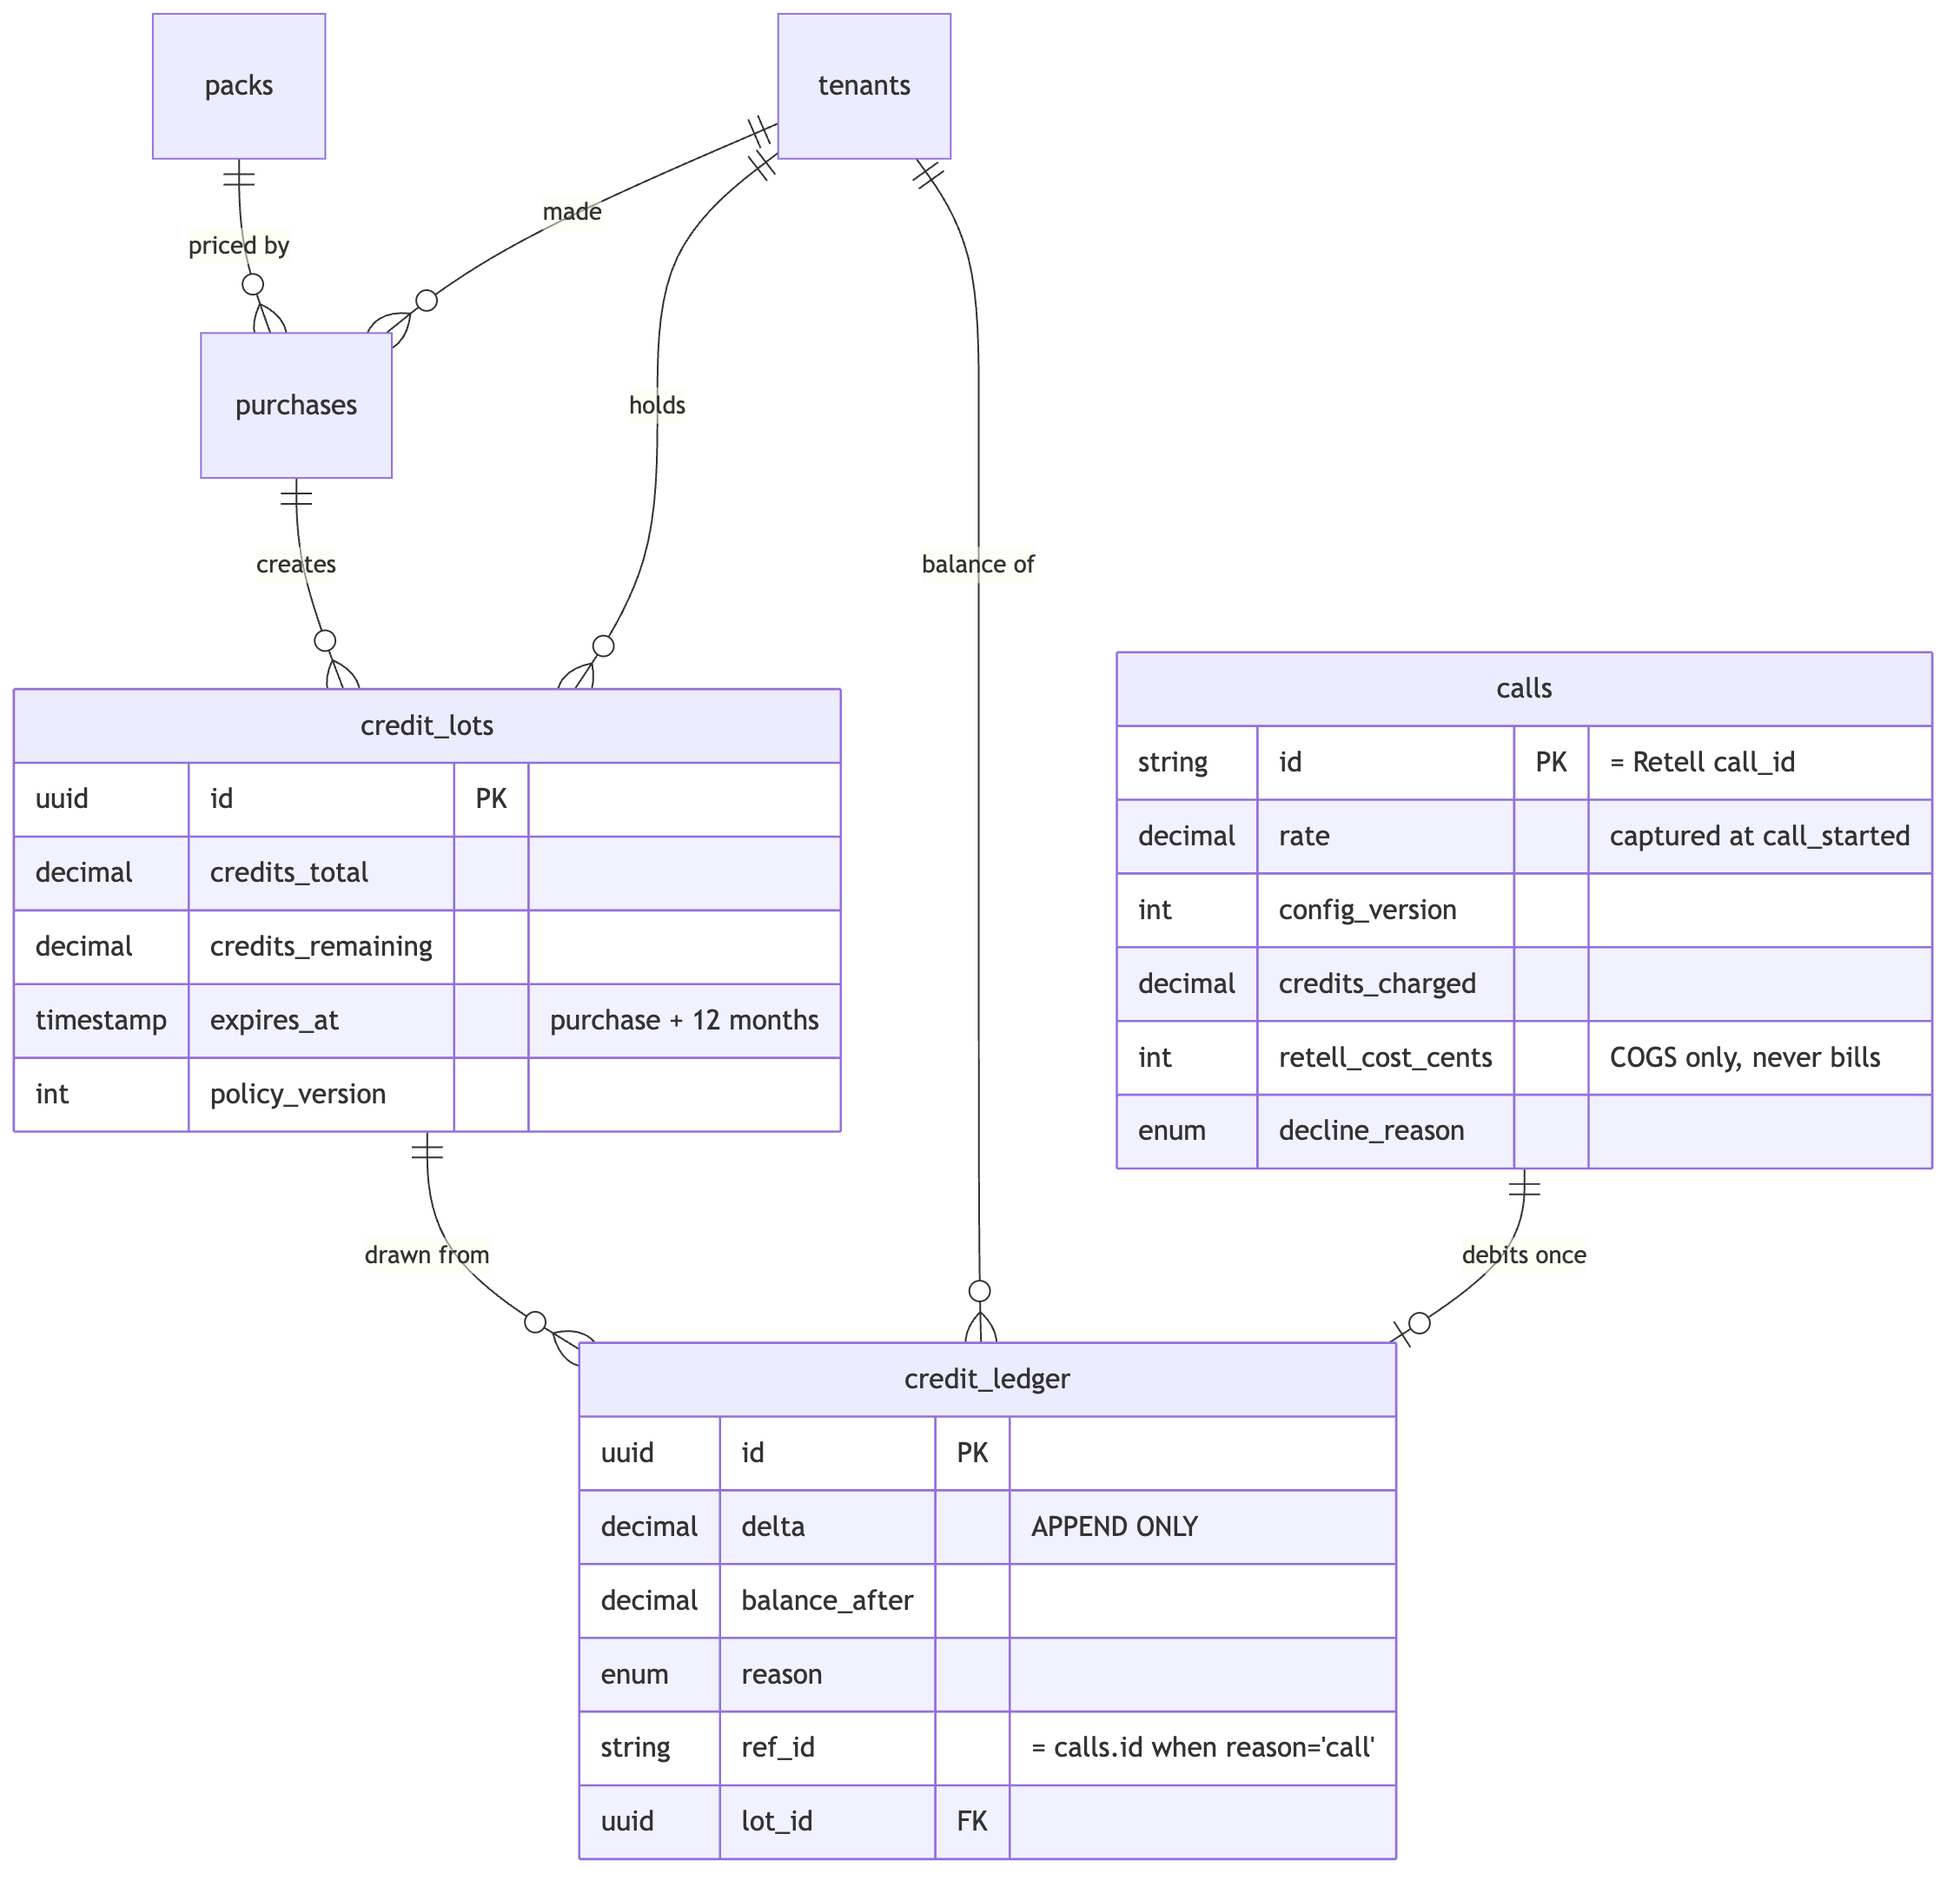
Three details in there are load-bearing:
calls.id is the Retell call_id. Not a surrogate key. That is what makes the ledger debit idempotent: a partial unique index on credit_ledger (ref_id) WHERE reason = 'call' means a replayed call_ended webhook collides at the database level instead of billing twice. The guard is in Postgres, not in application logic, because application logic runs twice under a race and a unique index does not. Declined calls never reach Retell, so they carry a synthetic dec_<uuid> id.
calls.rate and calls.config_version are captured at call_started. If pricing changed mid-call, the call bills at the rate that was current when it began. Reading the rate at call_ended would make an admin price change retroactively re-bill calls already in flight.
retell_cost_cents sits next to credits_charged and never touches it. One is our revenue side, one is our COGS side. Keeping them in the same row makes margin per call a single query; keeping them in different columns makes it impossible to accidentally bill the customer our cost.

6.3 Identity, membership and history
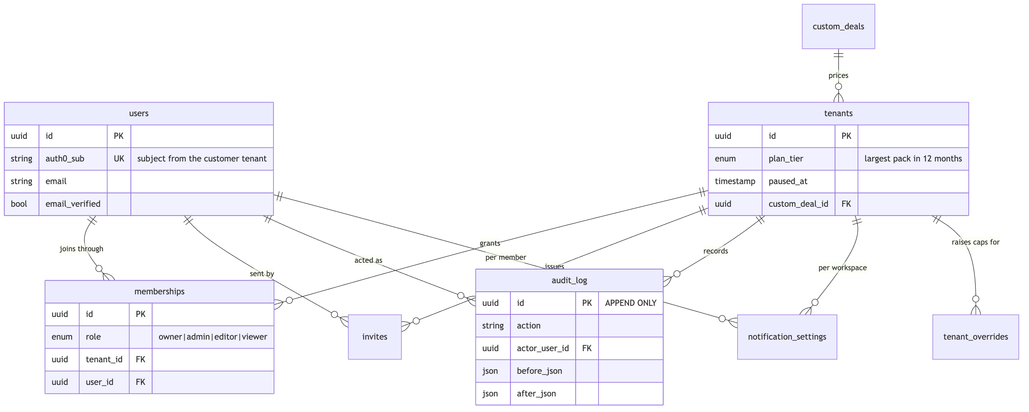
memberships is the many-to-many that makes a user's identity independent of any workspace, and it carries the §6.1 role. Exactly one owner per workspace is a rule the workspaces service enforces, not a constraint — a partial unique index would block the ownership transfer that the spec requires.
tenants.custom_deal_id pointing at custom_deals, which itself has a tenant_id, looks circular and is not: the deal is authored against a workspace by staff (admin §8), then attached once agreed.

6.4 Knowledge, plans and plumbing
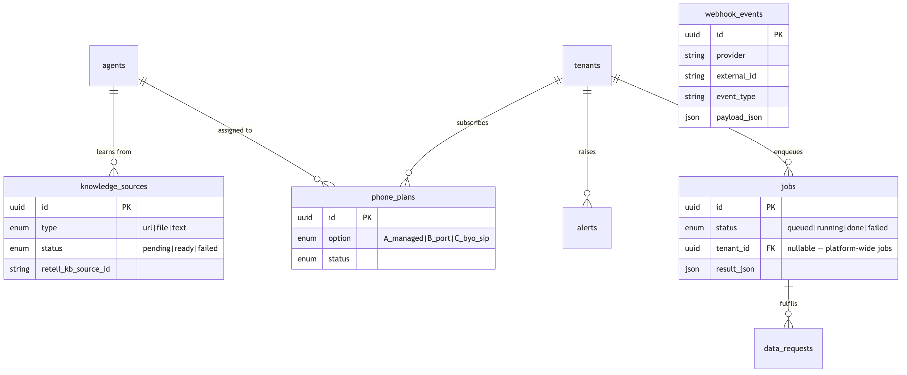
webhook_events deliberately has no foreign key to anything. It is written before the payload is parsed, which is the only moment at which the workspace is still unknown — the exactly-once guard in §11 works precisely because storage happens before interpretation. Its unique key is (provider, external_id, event_type).
jobs.tenant_id is nullable so that platform-wide work (voice-cache refresh, lot expiry sweep) is the same row shape as a customer's export.

6.5 The admin console
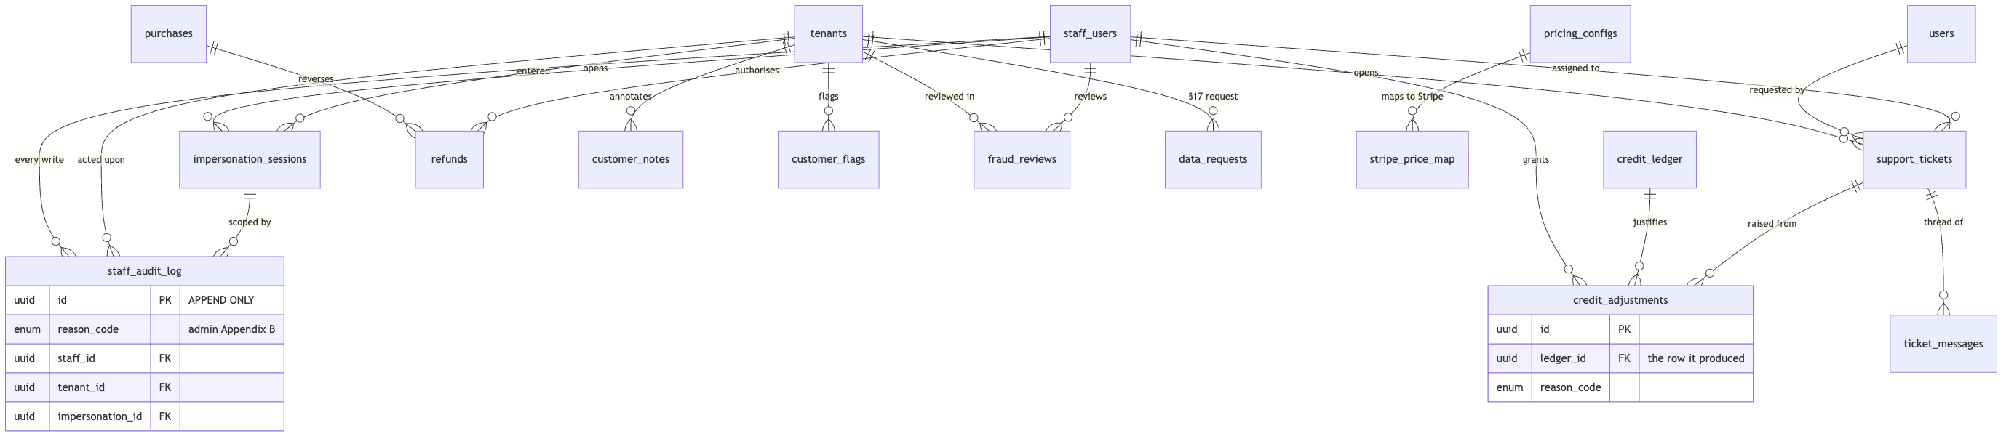
The shape worth noticing: credit_adjustments does not hold an amount. It points at the credit_ledger row it caused. Staff cannot move credits except by making a ledger entry, and the adjustment table exists only to attach a reason code and an author to it. The same applies to refunds → purchases. This is the §14 rule — every ledger write goes through the wallet module — expressed in the schema rather than trusted to reviewers.
impersonation_sessions links into staff_audit_log so that every write made while impersonating a customer is attributable both to the staff member and to the session, which is the question asked after an incident.

6.6 Config tables with no foreign keys
Seventeen tables carry no tenant_id and no relations. They are global, versioned, and read through the cached config endpoints — never joined to a customer row at query time.
Table | Read as | Why it has no FK
packs | GET /pricing | The catalogue (§5.2). A purchase copies the numbers it needs, so changing a pack never re-prices history
pricing_drafts  ,  pricing_configs | pricing:current | Versioned.  calls.config_version  and  credit_lots.policy_version  point  back  at a version, never forward
stripe_price_map | Checkout | The only one with a relation — to  pricing_configs  , by version
agent_stack_configs | RetellGateway | Tier → model/voice mapping.  agent_versions.stack_version  records which one generated a prompt
retell_cost_inputs | COGS reporting | What Retell charges us, by period
templates  ,  voices | Wizard W1, W3 | voices  is a read-only cache refreshed from  list-voices  by a job
promo_codes | Checkout | Applied at purchase; the discount lands in  purchases  , not in a join
feature_flags  ,  kill_switches | flags:* | Toggled without a deploy; the portal re-reads within 60 s
blocklists | Inbound path | Denormalised into  num:{e164}  in Redis — the 300 ms path never reads this table
staff_role_limits | Admin guards | Per-role limits as data (admin §2.2), seeded by  pnpm db:seed
canned_responses  ,  email_templates  ,  announcements | Support, email | Content, not customer data

The rule this encodes: anything that can change price, behaviour or capability is a versioned row, and anything that consumed it stores the version it saw. That is what makes "why was this call billed at that rate?" answerable a year later.

7. Agent lifecycle and prompt generation
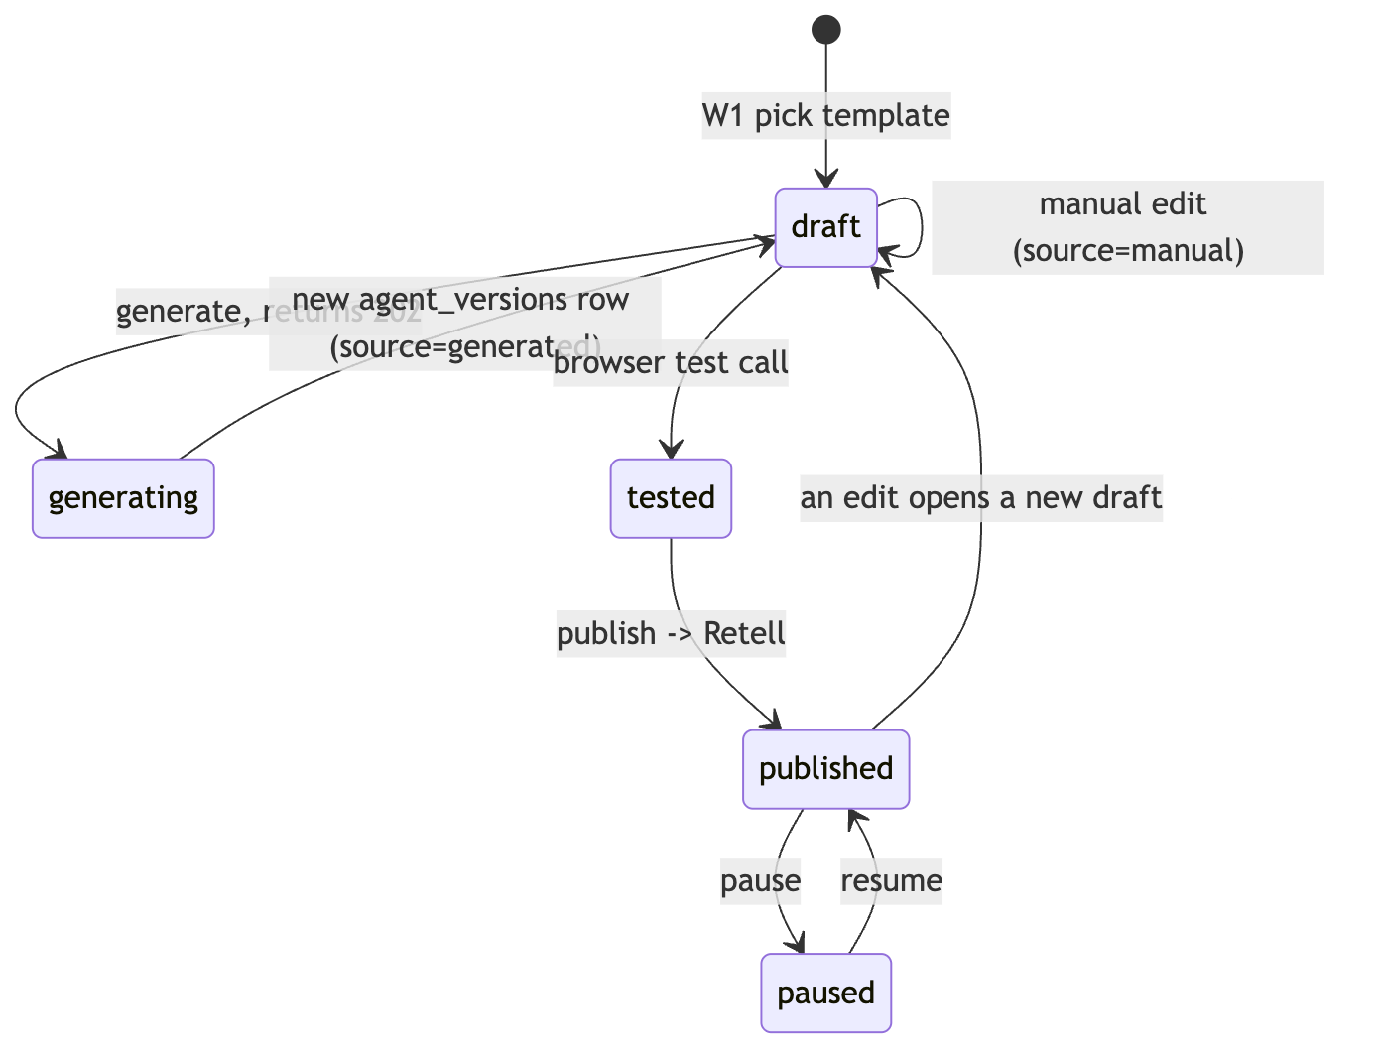
The generation call itself:
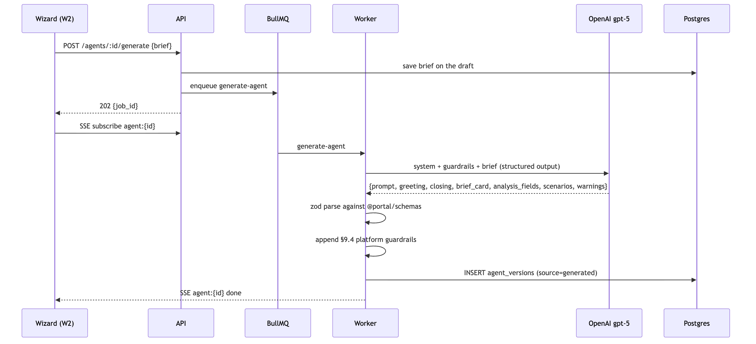
Why generation is a job and not a request. It takes several seconds and the wizard must stay responsive. 202 {job_id} plus SSE, with GET /jobs/:id every 3 s as a fallback, is the pattern for every long operation in the API (§16) — generation, number provisioning, knowledge ingestion, exports. One pattern, learned once.
Why the generation LLM is not the in-call LLM. They are different models solving different problems and it is easy to conflate them. The generation LLM runs two or three times in an agent's entire life, from a background job, and its output is text we store. The in-call LLM runs on every turn of every call, inside Retell, with a latency budget measured in hundreds of milliseconds. The first is OpenAI gpt-5 and is ours (ADR 0007); the second is Retell's to configure and is still open (§20 item 3).
Why OpenAI for generation. Owner preference plus family alignment with the in-call model — the prompt this LLM writes is executed by an OpenAI model inside Retell, so the writer and the executor share phrasing conventions. ADR 0007 is explicit that this was a judgement call made without a benchmark, that the benchmark is scheduled, and that the provider therefore lives behind modules/prompting/providers/ so reversing it is one file. Cost did not enter into it: a generation call is three or four cents against a $49 Starter pack.
Why not Retell Conductor. Conductor is Retell's dashboard copilot. It is not in the SDK, it is capped at 30 messages per person and 200 per organisation per day, and its stated golden rule is that it never changes an agent without a human approving a diff. Every one of those is disqualifying for an automated POST /agents/:id/generate serving every customer. Recorded in full in ADR 0007's alternatives. It is still worth using by hand during the D2 benchmark to learn from how it structures prompts.
Why guardrails are appended server-side and cannot be removed. §9.4 guardrails are what stop a customer's agent from making promises the business cannot keep. They are appended after the model returns, not requested from it, because a model can be talked out of including something and a string concatenation cannot. Feedback that conflicts with a guardrail returns changes: [] plus an explanation rather than silently declining to apply it.

8. Publishing, and the Retell projection
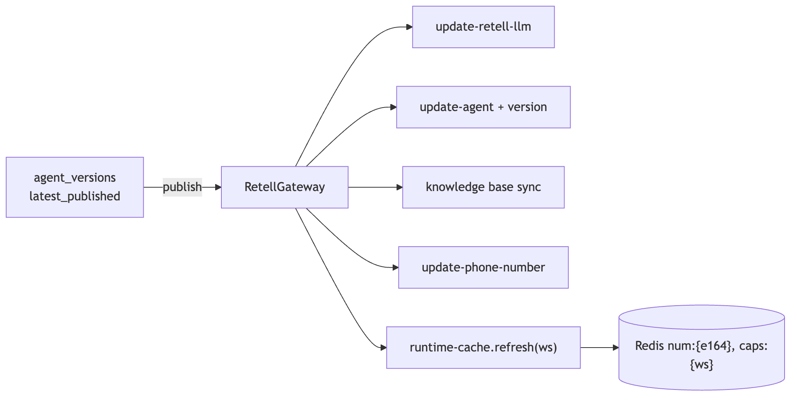
Postgres is the source of truth; the Retell objects are a projection of it. One retell_llm_id and one retell_agent_id per agent, plus numbers and knowledge bases. Numbers always run latest_published — drafts are reachable only by passing an explicit agent_version to create-web-call, which is how the wizard tests an unpublished draft without ever exposing it to a real caller.
Why every Retell call goes through one gateway.RetellGateway owns the tier → model/voice mapping, webhook URL construction, and retry/backoff. Concentrating it means the P0 findings about Retell's actual behaviour land in one file, tier changes are a mapping edit, and — if Retell is ever replaced — the blast radius is known in advance. It is the same isolation argument as modules/prompting/providers/, applied to the vendor we are most dependent on.
Why runtime-cache.refresh(workspaceId) is called from every mutating path. Pause/resume, plan change, number change, publish, ledger write. The inbound hot path reads Redis and only Redis (§9), so a stale cache is not a display bug — it is a call answered by a paused agent, or a call declined for a workspace that just topped up. A periodic full refresh backstops any path that forgets.

9. Inbound call authorisation — the hot path
POST /webhooks/retell/inbound/:number_token. Retell times out at 10 s and retries 3×. Our budget is p95 < 300 ms. This is the only endpoint in the system with a latency SLO, and it is the reason several other decisions look the way they do.
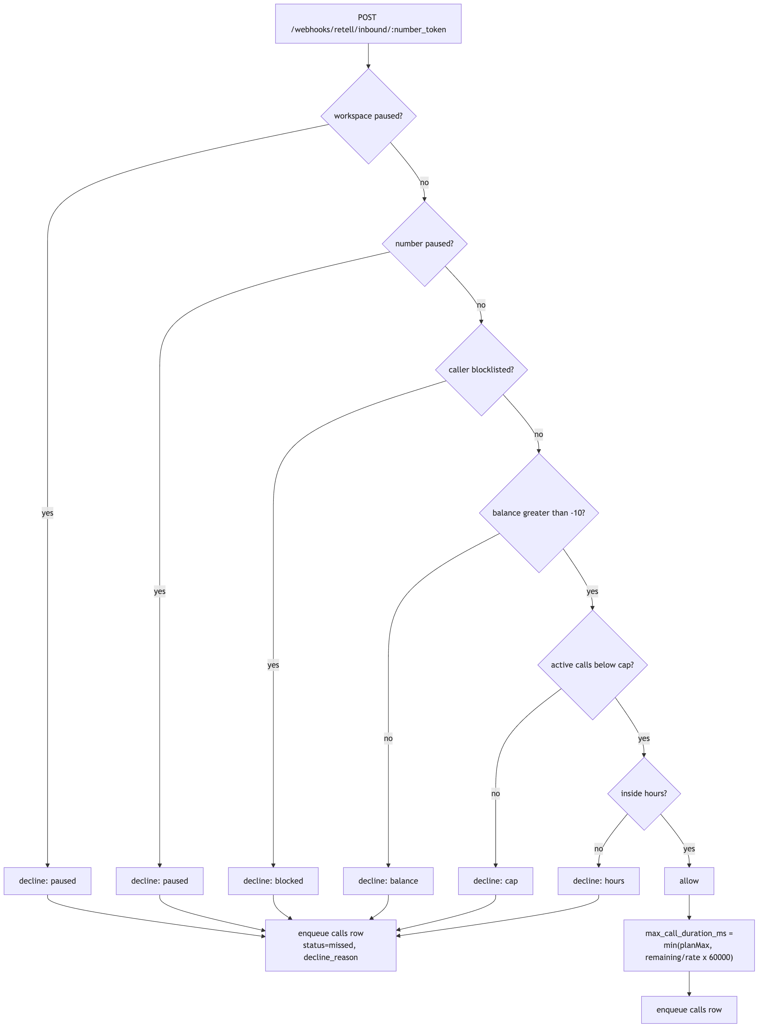
Why this path never touches Postgres. Neon is off-box. A single round trip plus a query is a meaningful fraction of a 300 ms budget, and six ordered checks would be several. Everything the six checks need is denormalised into Redis — num:{e164}, bal:{ws}, active:{ws}, caps:{ws} — on loopback. The cost of that choice is cache-freshness discipline, which is paid by runtime-cache.refresh() on every mutating path.
Why both outcomes write the calls row via an enqueued job, never inline. A synchronous insert would put Postgres back on the hot path and hand Retell a 500 whenever the database hiccuped. The decline path matters as much as the allow path: declined rows carry decline_reason ∈ {balance, cap, blocked, hours, paused} and surface in the dashboard as "Missed" — which is how a customer discovers they ran out of credits at 9am rather than at month-end.
Why the checks are ordered the way they are. Cheapest and most absolute first. A paused workspace is one field; a blocklist check is a set membership; an hours rule involves timezone arithmetic. Ordering also decides which decline_reason a caller gets when several apply, and the most actionable reason should win.
Why max_call_duration_ms is computed here.min(planMax, remainingCredits/rate × 60000). Retell enforces it, so a customer with 3 credits left gets a call that ends cleanly at three minutes instead of one that runs up an overdraft. Combined with the 10-credit grace overdraft, the result is that a call is never cut mid-sentence and never runs away.
The Redis-down policy is not invented here. It is decided by the P0 spike and recorded in docs/decisions/0003-retell-findings.md (pending, due 15 Sep 2026). Fail-open means free calls; fail-closed means a dead phone line. That trade needs the spike's data, not a guess.

10. Metering and the money path
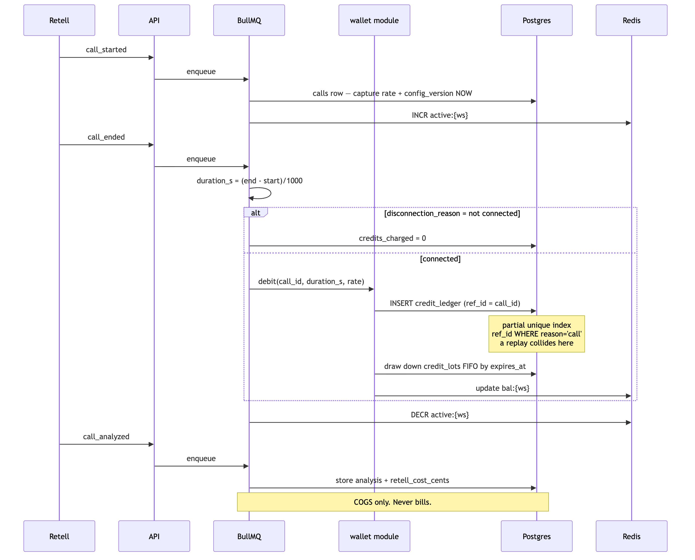
The rules, stated once so they can be checked against the code:
- call_ended is the only event that moves credits.call_analyzed stores analysis and retell_cost_cents and never bills. Two events that both touch money is how you get double-billing under retry.
- duration_s = (end_timestamp − start_timestamp)/1000. If disconnection_reason indicates the call never connected (dial failed, no answer, busy), the charge is 0 — the customer does not pay for a phone ringing.
- credits = duration_s/60 × rate(tier), rounded to 0.01. Standard is 1 credit/min, Premium 1.5.
- Every ledger write goes through the wallet module. No direct credit_ledger inserts anywhere else, ever. One module means one place to audit, one place to test, and one place where the FIFO lot drawdown lives.
- Balance = Σ credit_ledger.delta, cached at bal:{ws}, and rebuilt from the ledger on mismatch. The cache is an optimisation; the ledger is the truth. Lots are consumed FIFO by expires_at so the credits closest to expiring burn first — which is both what the customer would choose and what keeps unearned revenue falling off the books predictably.
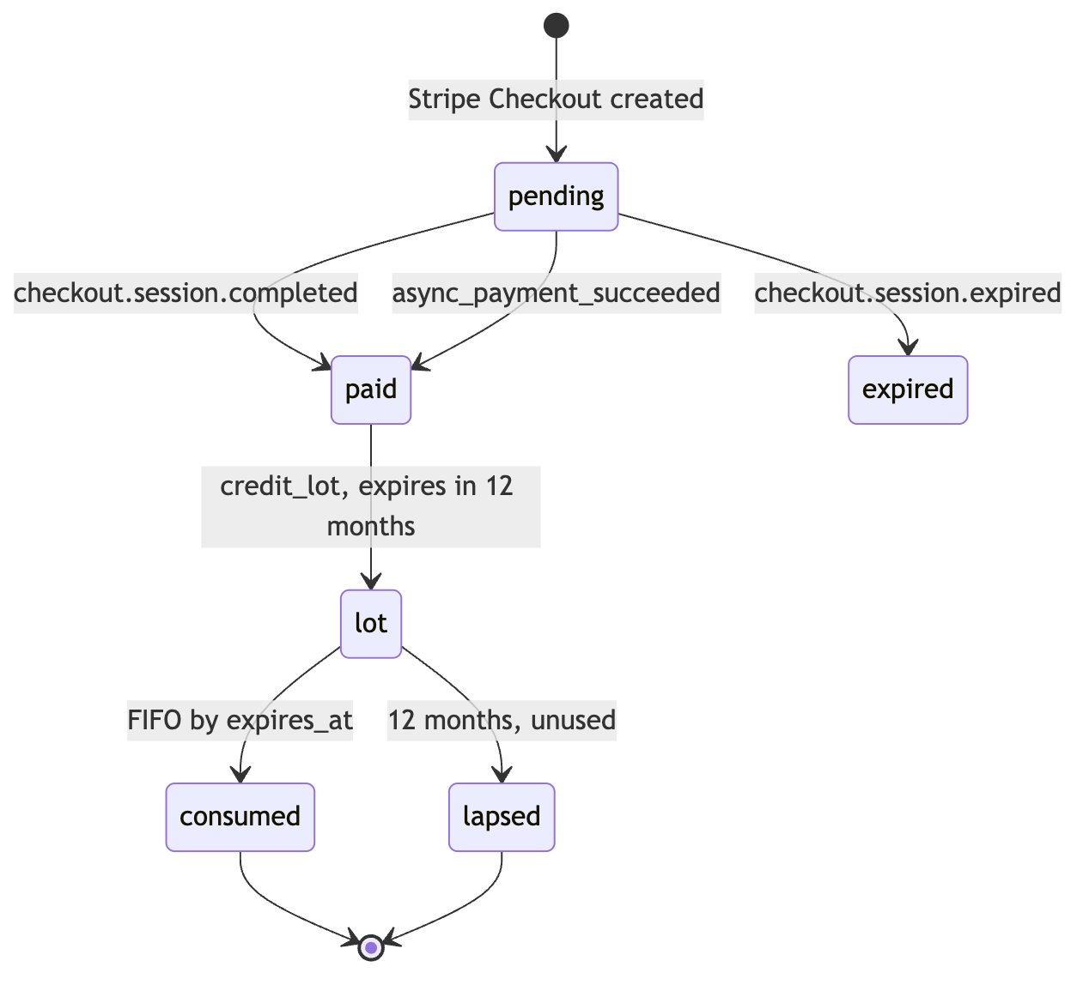

11. Webhooks, exactly once
Four inbound webhook routes, no JWT on any of them: /webhooks/retell, /webhooks/retell/inbound/:number_token, /webhooks/stripe, /webhooks/auth.
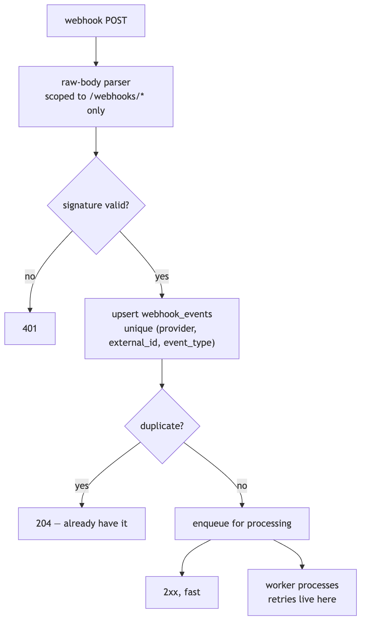
Why the raw-body parser is scoped to /webhooks/* only. Signature verification must run against the exact bytes sent. Disabling JSON parsing globally to achieve that would make every other route in the application worse; scoping it to the webhook prefix costs one line of Fastify configuration.
Why store first, then process. Once the event is durably in webhook_events, we owe Retell nothing further — so we return 2xx immediately and do the work in BullMQ where retries are ours to control, with backoff and a dead-letter queue. Never return 5xx to Retell after the event is stored: that would make Retell retry an event we already have, and a provider's retry policy is a worse queue than the one we run.
Why (provider, external_id, event_type) and not just external_id. One Retell call produces call_started, call_ended and call_analyzed all carrying the same call_id. The event type is part of the identity.
Why the duplicate returns 204. It is a successful outcome, not an error. A provider replaying an event is normal operation, and logging it as a failure trains you to ignore the alert.

12. Jobs, queues and schedulers
BullMQ on the same Redis. Processors and Job Schedulers are registered idempotently on boot, so a redeploy or a second worker does not double-register a schedule.
Kind | Examples | Why it is a job
Long, user-visible | generate-agent  , number provisioning, knowledge ingestion, export | Wizard must stay responsive —  202 {job_id}  + SSE
Webhook processing | Retell + Stripe event handlers | Retries under our control, not the provider's
Write-behind | the  calls  row from the inbound path | Keeps Postgres off a 300 ms hot path
Scheduled | number rental (15 cr/month on the purchase anniversary), extra-KB charges, lot expiry, low-balance alerts,  voice-cache  refresh, periodic runtime-cache refresh | Nobody is holding a request open

Jobs use adminDb — they sweep across workspaces by design — or withWorkspace(workspaceId, ...) when they are operating on exactly one, which is preferred wherever it applies because it keeps RLS in play.

13. Configuration as data
Pricing, feature flags, kill switches, templates and the agent stack live in versioned tables, read through GET /pricing and GET /flags.
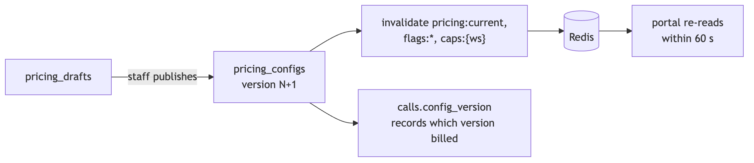
Never hard-code a price, rate, cap or model id. The reason is not flexibility for its own sake: it is that calls.config_version and credit_lots.policy_version let you answer "why was this call billed at that rate?" a year later, and that answer only exists if the rate came from a versioned row. A constant in the code makes every historical billing dispute unanswerable.
Publishing a config invalidates pricing:current, flags:* and caps:{ws}; the portal re-reads within 60 s. Kill switches exist so a staff member can disable a feature without a deploy — which, with one developer, is the difference between a two-minute mitigation and a twenty-minute one.

14. Admin console and staff access
A separate Next.js app on admin.<domain>, a separate Auth0 tenant, and /admin/* routes that accept staff JWTs only. A staff JWT without the https://portal/mfa claim is rejected outright.
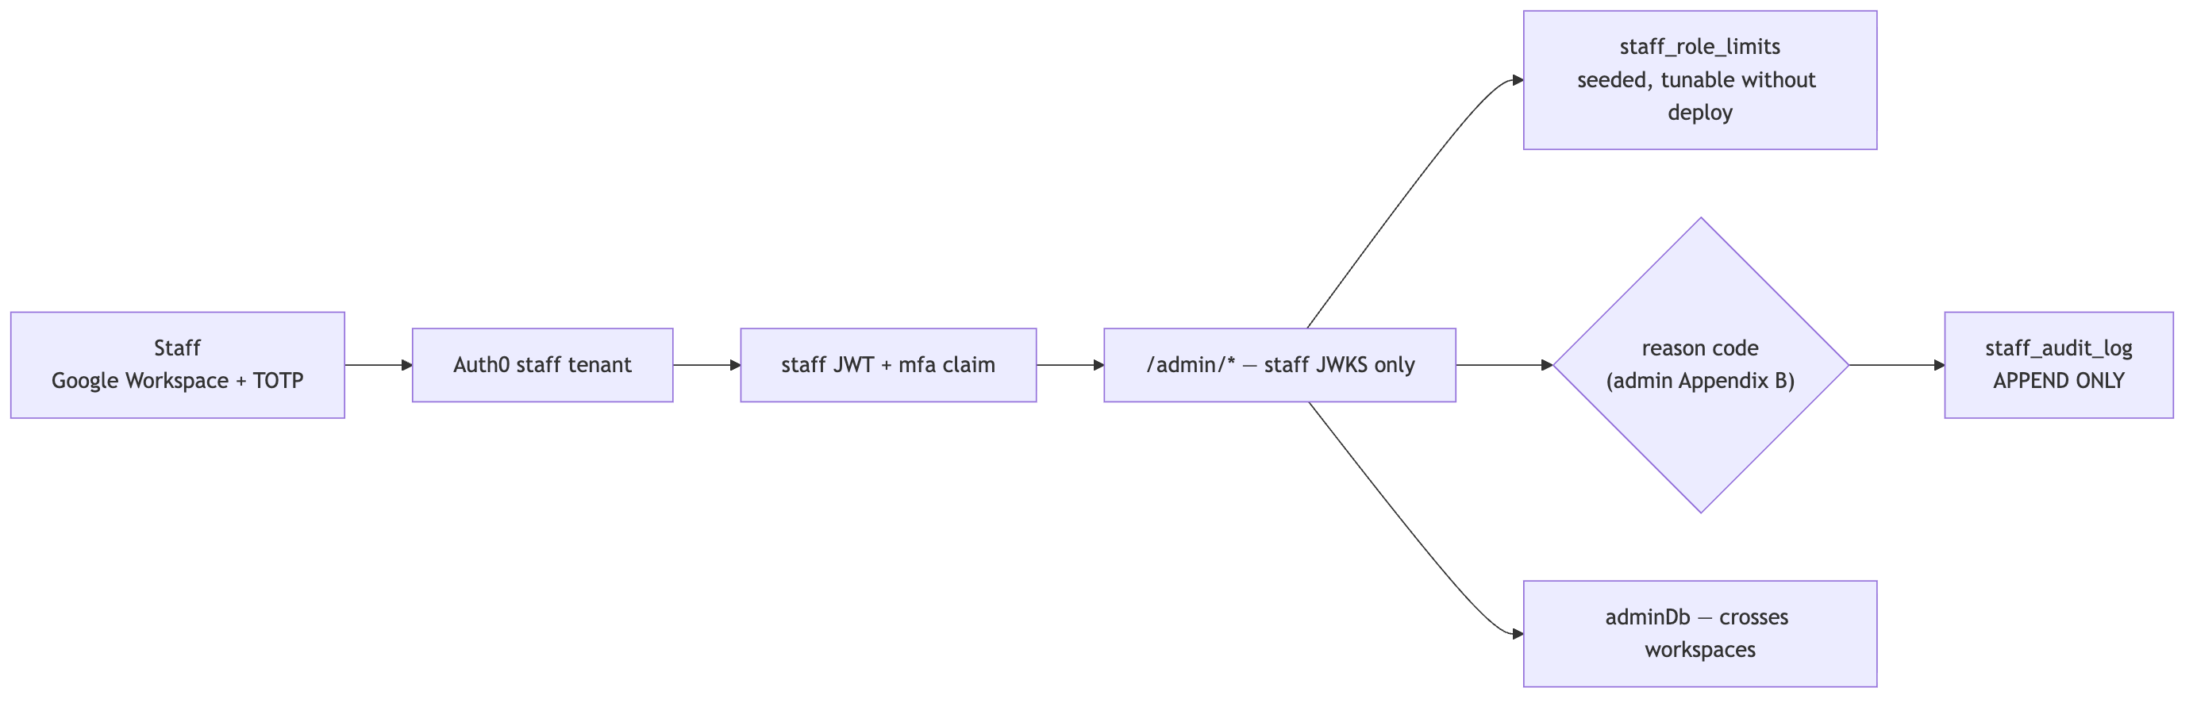
Why every customer-affecting staff write needs a reason code and an audit row. Staff can adjust credits, issue refunds, override caps and impersonate. Each of those is indistinguishable from fraud without a recorded reason, and staff_audit_log is append-only for the same reason credit_ledger is. Role limits live in staff_role_limits as data so they can be tuned without a deploy, and they are enforced server-side — a disabled button is a hint, not a control.

15. Observability, secrets, environments
OpenTelemetry → Grafana Cloud, Sentry for exceptions, Slack for alerts. Recordings stay on Retell URLs and are proxied with signed 1-hour URLs; only exports land in Cloudflare R2.
Why recordings are proxied rather than copied. Copying them would mean storing customer call audio ourselves, which is a materially larger privacy and retention obligation for no product benefit. A signed 1-hour URL gives the customer access without making us the custodian.
Secrets live in AWS SSM Parameter Store, nothing in the repo. SIP credentials get one extra layer — envelope encryption with an AWS KMS data key (AES-256-GCM) — because they are the one credential that lets someone else place calls billed to our customer.
Environments are dev, staging, prod, with one Retell API key and one webhook URL set per environment, and Retell test agents prefixed dev-. Stripe test and live keys never mix. pnpm doctor reports what is unset and what is unreachable, so a broken environment says so in one command rather than through a confusing runtime error.
Tests are required — not best-effort — for metering, ledger idempotency, webhook exactly-once, inbound decline paths, and RLS cross-tenant isolation. That list is exactly the set of failures that are silent, expensive, and discovered by customers rather than by us.

16. Decision log — the why, in one table
Decision | Chosen | Why | Rejected, and why | ADR
Backend framework | NestJS on Fastify | Spec names it; DI graph boots identically in both entrypoints | Plain Fastify (less ceremony, but module graph duplicated); FastAPI (would fork the shared zod layer) | 0001
ORM | Prisma | Spec names it; one migration runner for hand-written RLS SQL | Drizzle (better SQL-first migrations, but off-spec) | 0001
API surface | Nest, not Next route handlers | Route handlers break SSE and cannot host BullMQ | Next-only backend | 0001
Auth | Auth0, two tenants;  @auth0/auth0-spa-js  (PKCE) in the browser | Staff boundary survives a mistake in a role table; MFA and domain restriction are tenant-level. PKCE keeps every secret out of the frontend | One tenant with roles; Clerk (superseded);  @auth0/nextjs-auth0  server sessions (needs a server we no longer run) | 0002  ,  0008
Backend hosting | AWS EC2 + Docker Compose | Long-lived worker, TCP Redis, stable webhook hostname | Railway (superseded); serverless (no BullMQ, no SSE) | 0004
Frontend hosting | S3 (private) + CloudFront (OAC) + ACM, static export | Every screen is behind a login, so SSR buys nothing; no server means no client secret in the frontend and no AWS role for the build | Amplify (largest third-party grant, two extra IAM roles, adapter lag); Next on the EC2 box (contends with the 300 ms inbound path); OpenNext on Lambda; Vercel | 0008
Redis | Redis 7 container on the backend box | BullMQ needs blocking TCP; loopback keeps the 300 ms inbound budget | Upstash — HTTP Redis cannot run BullMQ at all | 0001
Database | Neon Postgres | Branch-per-environment, 7-day PITR, no instance to patch | RDS (more ops for no gain at this size) | 0001
Tenancy | Two roles + RLS + append-only triggers | Second guard under the app; failure mode is "see nothing"; history survives even a BYPASSRLS connection | App-level  where tenant_id  only (silently cross-tenant in prod); schema-per-tenant (migration cost) | 0006
Generation LLM | OpenAI  gpt-5  , structured output | Owner's quality judgement + family alignment with the in-call model; behind a provider interface so it is one file to reverse | Anthropic  claude-sonnet-5  (no evidence against, just not preferred); both per template (ambiguous  stack_version  );  Retell Conductor  (dashboard-only, 200 msg/org/day, requires human approval) | 0007
Voice platform | Retell behind  RetellGateway | Single import site bounds the blast radius and concentrates the P0 findings | Direct SDK use across modules | 0001
Ledger idempotency | Partial unique index on  (ref_id) WHERE reason='call' | A database constraint survives a race; application logic does not | Application-level "check then insert" | 0006
Inbound authorisation | Redis-only, six ordered checks | 300 ms p95 against a 10 s Retell timeout; Neon is off-box | Synchronous Postgres reads | §13.9
Long operations | 202 {job_id}  + SSE,  GET /jobs/:id  fallback | One pattern for generation, provisioning, ingestion, exports | Blocking requests; polling only | §16
SSE client | @microsoft/fetch-event-source | EventSource  cannot send  Authorization  or  X-Workspace-Id | Native  EventSource  ; WebSockets (more infrastructure than one-way progress needs) | 0001
Recordings | Proxied from Retell, signed 1-hour URLs | Avoids becoming custodian of customer call audio | Copying to R2 | §17

17. Services, access and what is provisioned
What the platform runs on, what each piece is for, and where it stands as of 14 Sep 2026 (D3). Status is read from pnpm doctor, the Auth0 tenants and the Retell dashboard — not from the plan. This is the one section expected to change weekly until MVP; fix it when something is provisioned.

What we need access to right now
Four things, in the order they unblock work. Everything else in this section either already exists or can wait.
Ask | Why we need it | Why now | Blocked without it
OpenAI API key  with billing, on the existing org | The only LLM we call ourselves: brief → prompt (§9.3) and feedback patches (§9.6). The in-call model is Retell's (  ADR 0007  ) | D5 is prompt generation | POST /agents/:id/generate  returns nothing; W2 is a dead end; the D2 quality benchmark cannot run
Neon project  — one I can create branches and roles in | The only Postgres we run. 7-day PITR is the §17 recovery requirement; branch-per-environment gives staging its own data with no second server (  ADR 0006  ) | Migrations, RLS, triggers and seed are done and green locally. Nothing on AWS is worth creating before the database it talks to exists | No staging environment at all
AWS — scoped access, not admin  (see below) | Runs the backend: the long-lived process BullMQ, SSE and a stable webhook hostname all require (  ADR 0004  ), plus S3 + CloudFront for the two apps (  ADR 0008  ) | D7–D8. Setting up IAM, SSM and the instance is a day of work that should not land on deploy day | Nothing deploys anywhere
Domain  — registrar login or a delegated zone | app.  ,  admin.  and  api.  all hang off it | It costs nothing to decide and unblocks four other things | Webhooks stay on a  trycloudflare  URL that changes on restart; no Auth0 production callbacks; no ACM certificate; Caddy cannot issue TLS

On AWS access.AdministratorAccess is not available to us, and it is not actually required — it was only ever the fastest path. Two workable alternatives, in order of preference:
- Scoped setup access. The PowerUserAccess managed policy (everything except IAM and Organizations) plus a narrow IAM slice — iam:CreateRole, iam:AttachRolePolicy, iam:PassRole restricted to the path /voice-agent/ and governed by a permissions boundary. That is enough to create the instance role and the ci user without being able to touch anything outside the project's own path. This is the standard answer to "we cannot grant admin" and is what I would ask for.
- Admin creates, we consume. Whoever holds admin creates the resources from the table below — it is a fixed list, not an open-ended one — and hands back an EC2 instance with the role attached, the ci access key, the four bucket names, the two distribution IDs and the KMS key id. We lose the ability to iterate on infrastructure, which matters on D7–D8, but nothing is blocked outright.
Either way, ask whoever sets the account up to add a budget alert at $50/month. Expected steady state is well under that, so the alert is a mistake detector, not a cost control.

AWS
Service | What it does for us | Access it needs | Why this, and not the alternative | Status
EC2  —  t3.small  staging,  t3.medium  prod | Runs  api  ,  worker  ,  redis  ,  caddy  via Docker Compose (  ADR 0004  ) | Instance role:  ssm:GetParameters  on  /voice-agent/<env>/*  ,  kms:Decrypt  on the SIP key,  ssmmessages:*  for Session Manager. Security group: inbound  443 only  , no SSH port | BullMQ needs a process that never sleeps, SSE a connection that stays open, webhooks a hostname that does not change. Serverless fails all three. One box beats ECS at this scale — one compose file, and the deploy is  docker compose up -d | Not started  —  docker-compose.prod.yml  lands D7
Elastic IP  ×2 | Stable address for  api.<domain> | Attached to the instance, nothing else | Retell and Stripe webhook URLs are configured once and must survive an instance replacement | Not started
S3  ×4 (web/admin × staging/prod) | Holds the compiled Next.js static export. Bucket  private  —  Block all public access  ON (  ADR 0008  ) | CI user:  s3:PutObject  ,  s3:DeleteObject  ,  s3:ListBucket  on these buckets only. CloudFront reads via OAC; no public principal, ever | A static export needs a file store, not a server. Private + OAC means the only way in is through the CDN — no second, uncached, unlogged path to the app | Not started  — D8
CloudFront  ×2 | CDN and HTTPS for  app.<domain>  and  admin.<domain>  ; reads S3 through  OAC | CI user:  cloudfront:CreateInvalidation  on these two distributions. OAC grants the distribution  s3:GetObject  on its own bucket, conditioned on the distribution ARN | Hitting the S3 URL directly gives  Access Denied  — that is OAC working. Custom error responses map  403 and 404  →  /index.html  200; a private bucket returns 403, not 404, which is the classic thing to get wrong | Not started  — D8
ACM  — 1 certificate | TLS for both distributions | DNS validation on the domain's zone | Must be requested in us-east-1  even though the rest of the account is  ca-central-1  — CloudFront reads certificates only from N. Virginia. Caddy on EC2 is unaffected; it keeps issuing its own Let's Encrypt certificate for  api.<domain> | Blocked  on the domain
SSM Parameter Store | The only home for secrets:  SecureString  under  /voice-agent/<env>/*  (§17) | CI user:  ssm:PutParameter  on that prefix. Instance role:  ssm:GetParameters  . The frontend build needs none — a static export has no server-side secrets. Nobody gets  /voice-agent/*  unscoped | Free at our volume, IAM-scoped per environment prefix, KMS-encrypted at rest. Secrets Manager adds rotation and cost we do not need yet | Not started  — local  .env  only
SSM Session Manager | Deploys and shell access with no SSH key and no open port 22 | Instance role  ssmmessages:*  ; CI user  ssm:SendCommand  scoped by instance tag | A leaked SSH key is a permanent credential; a Session Manager session is IAM-authenticated, logged and revocable | Not started
KMS  — one customer-managed key | Wraps the data key for SIP credentials (AES-256-GCM envelope) →  SIP_CREDENTIALS_KMS_KEY_ID | kms:GenerateDataKey  +  kms:Decrypt  for the  api  role  only  ; the worker never decrypts SIP secrets | SIP credentials let someone place calls billed to our customer. Envelope encryption means the database holds nothing usable even under a full dump. Everything else in SSM is already KMS-encrypted with the AWS-managed key | Placeholder  —  .env  holds a dummy id;  pnpm doctor  marks it optional until D8
IAM  — 1 user, 1 role | ci  user (GitHub Actions):  ssm:PutParameter  ,  ssm:SendCommand  , S3 write on the four buckets,  cloudfront:CreateInvalidation  .  ec2-api  instance role. That is the whole account | Least privilege, scoped by  /voice-agent/<env>/  prefix and by instance tag; no  *  resources | The CI credential is the one that lives in a third party. It must be able to deploy and nothing else | Not started
Route 53  (optional) | DNS for  <domain> | Hosted zone; CloudFront needs an alias record and Caddy an A record | Only if the domain is registered with AWS. If DNS stays at Cloudflare — where the tunnel and R2 already are — skip it | Blocked  on the domain
CloudWatch  (minimal) | EC2 status-check alarm → Slack | Default instance metrics; one alarm | Application telemetry goes to Grafana Cloud over OTel. CloudWatch is only for "the box is gone" | Not started

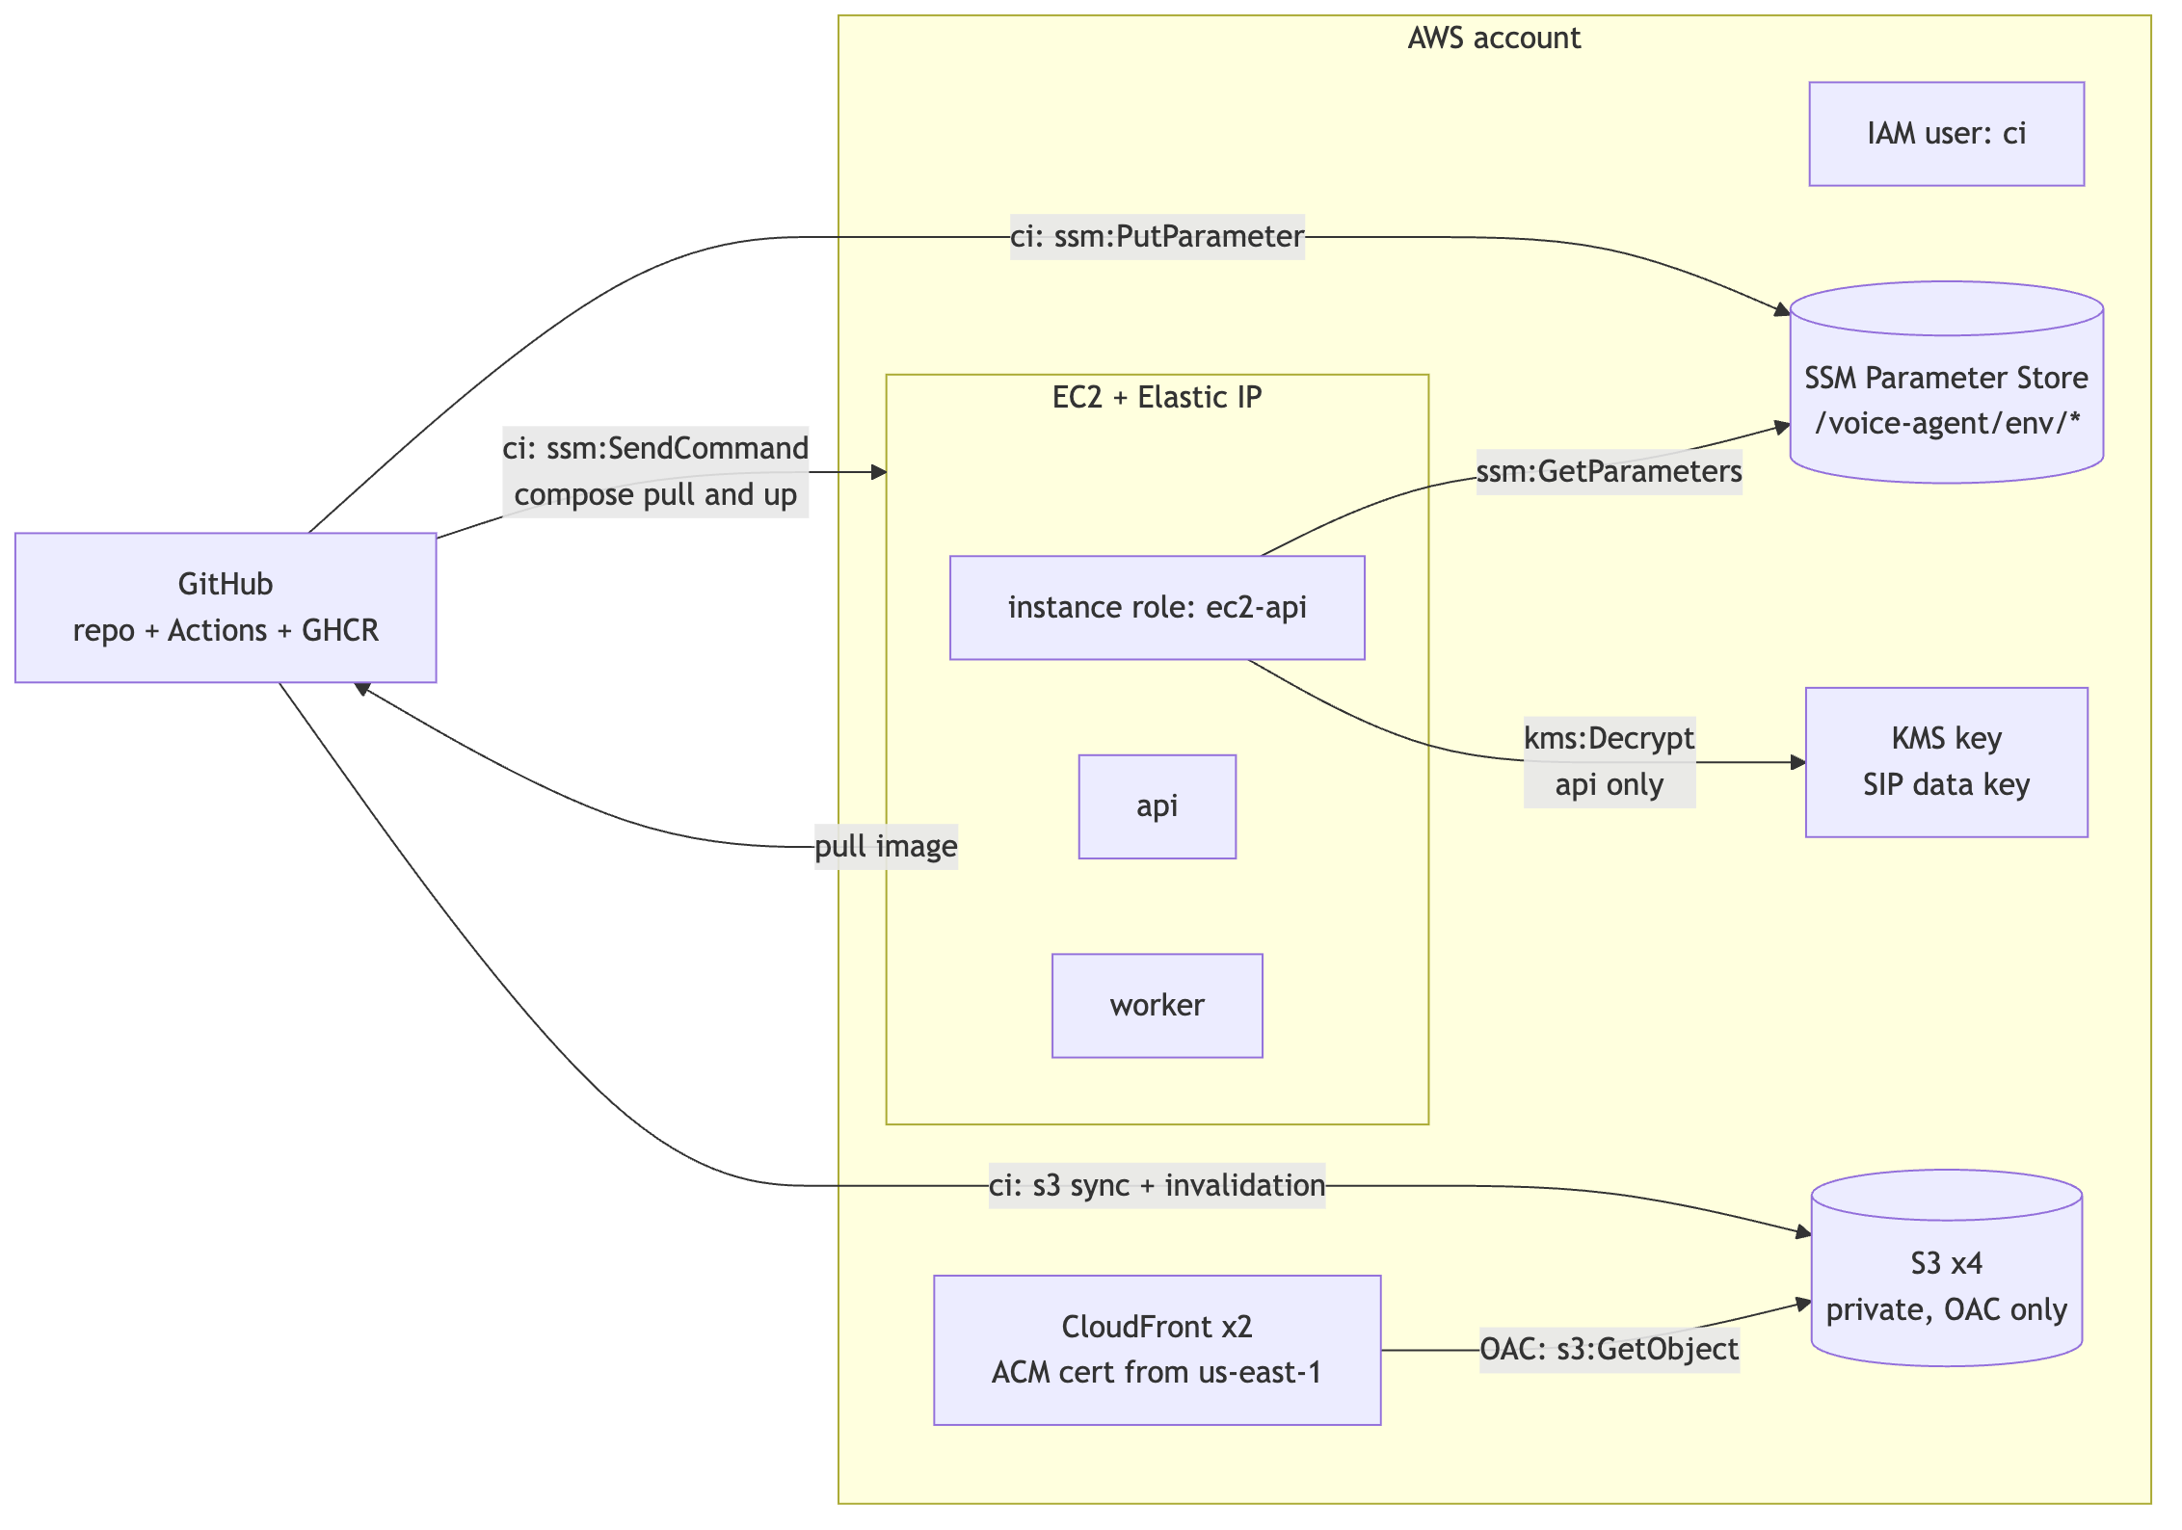
Every arrow is one IAM statement. There is no path from the frontend to KMS, none from the worker to SIP secrets, and none from CI to the running database — CI can put a secret, sync files and trigger a deploy, and that is all. The whole account is one IAM user and one instance role; the frontend build needs no AWS role at all, because a static export has no server-side secrets to fetch.
What we deliberately do not use from AWS
Not used | We use instead | Reason
RDS | Neon Postgres | Branch-per-environment and 7-day PITR out of the box; no instance to patch (§17)
S3  for exports | Cloudflare R2 | Zero egress, and exports are pure egress. S3  is  used for the frontend — a CDN-fronted static site is cached at the edge, so egress never hits the bucket
ECR | GitHub Container Registry | The image is built by GitHub Actions; pushing to GHCR needs no AWS credential in the build
ElastiCache | Redis 7 container on the EC2 box | The inbound path has a 300 ms p95 budget; loopback beats a network hop, and ElastiCache costs more than the instance
Cognito | Auth0 ×2 | Two-tenant staff/customer split, Google Workspace connection, mandatory TOTP — Cognito makes each harder (  ADR 0002  )
Lambda / API Gateway | NestJS on EC2 | No BullMQ, no SSE, cold starts on the webhook path
Amplify Hosting | S3 + CloudFront | Superseded on 14 Sep — the SSR premise was circular. Full reasoning in  ADR 0008
ACM  for the API | Caddy on EC2 | Caddy issues and renews its own Let's Encrypt certificate for  api.<domain>  . ACM serves CloudFront only, and only from us-east-1

Everything that is not AWS
Vendor | What it does for us | Access it needs | Status
Neon | Postgres, 7-day PITR, one branch per environment | Owner string →  DIRECT_DATABASE_URL  ; two login roles →  DATABASE_URL  ,  ADMIN_DATABASE_URL  (  ADR 0006  ) | Not started.  All three URLs point at local Docker Postgres. Migrations, RLS, triggers and seed are done and pass  pnpm test:e2e  locally
Retell AI | Voice platform behind  RetellGateway  : agents, LLM objects, numbers, knowledge bases, web and phone calls, webhooks | One API key per environment; webhook secret; webhook URL →  api.<domain>/webhooks/retell | Live (dev).  Workspace on pay-as-you-go, key and webhook secret set, a test agent and a number exist. Webhooks currently reach a  trycloudflare  tunnel
Stripe | Checkout, Customer Portal,  checkout.session.*  webhooks, off-session PaymentIntent for auto top-up, disputes | Test-mode account, restricted key, webhook endpoint →  /webhooks/stripe  . Live keys live in a separate SSM path and never in  .env | Live (test mode).  Secret, publishable and webhook secret all set. The live account waits on the merchant-of-record decision and is not needed before the first real purchase
Auth0  — two tenants (  ADR 0002  ) | Customer login (database, Google, Microsoft); staff login (Google Workspace + mandatory TOTP); Post-Registration and Post-Login Actions | Per tenant: a  Single Page Application  (  ADR 0008  ), an API audience, an M2M app for the Management API | Live (dev).  pnpm doctor  confirms two distinct issuers, both audiences and the action secret. Still to do: switch both apps from Regular Web App to SPA, and verify the Actions are deployed from  infra/auth0/actions/
OpenAI | Brief → prompt generation only (  ADR 0007  ) | API key; org id | Partial.  OPENAI_ORG_ID  and  GENERATION_MODEL=gpt-5  set,  OPENAI_API_KEY  empty. Blocks D5
GitHub | Repo, Actions CI, GHCR image registry | Actions secrets: the AWS  ci  user keys only. GHCR uses  GITHUB_TOKEN | Live.  saksham-metacognixion/Voice-Agent  , CI workflow present
Cloudflare | Tunnel for local webhook delivery today;  R2  bucket for CSV and audio exports later | Tunnel: none. R2: bucket + scoped API token, worker only | Tunnel in use  (  API_PUBLIC_URL  ). R2 not started — exports are D14
Resend | Verification email, low-balance alerts, invites | Verified sending domain, API key | Not started.  Needed by D5, blocked on the domain
PostHog · Sentry · Grafana Cloud · Slack | Product analytics, exceptions, traces, alerts | Project key · DSN · OTLP endpoint · incoming webhook | Not started.  Free tiers cover MVP volume; wanted before staging exists so the first deploy is observed rather than guessed at
Domain | Everything under  app.  ,  admin.  ,  api. | Registrar or delegated zone | Blocked.  Nothing above that says  <domain>  can be finished without it

Where we stand
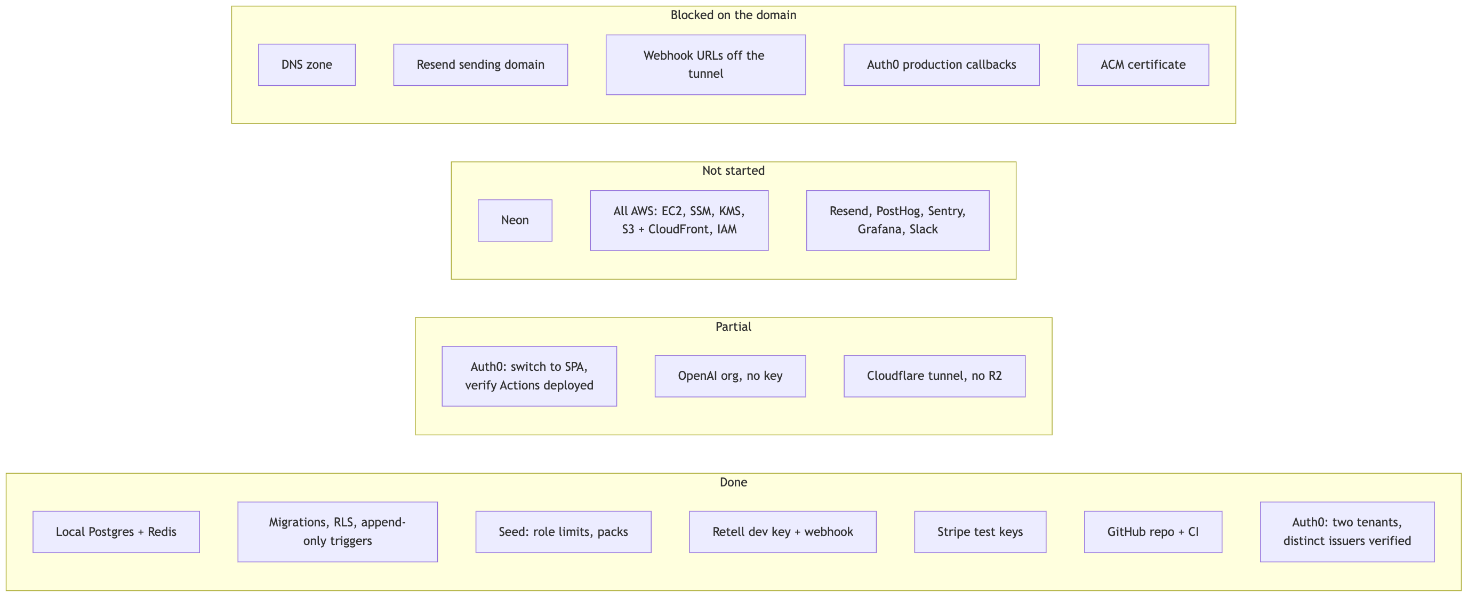
The critical path to the 15 Sep P0 exit is OpenAI key → Neon. AWS is a D7–D8 job and is not on this week's critical path, which is fortunate given the access question above. The domain blocks five things and costs nothing to decide.

