**“****Microsoft HoloLens”**

*A Seminar Report*

*submitted* *by*

SAKSHAM GUPTA (1614110140)

*For the degree of*

**BACHELOR OF TECHNOLOGY**

*In*

**COMPUTER ENGINEERING**

*Under the guidance of*

**Prof. S.U. Rasal**



**DEPARTMENT OF COMPUTER ENGINEERING**

**BHARATI VIDYAPEETH (DEEMED TO BE UNIVERSITY)**

**COLLEGE OF ENGINEERING, PUNE- 43**

2019-20

**BHARATI VIDYAPEETH (DEEMED TO BE UNIVERSITY)**

**COLLEGE OF ENGINEERING, PUNE- 43**



**CERTIFICATE**

This is to certify that the seminar report titled **Microsoft HoloLens**, submitted by

1. SAKSHAM GUPTA (1614110140)

to the Bharati Vidyapeeth (Deemed to be University), College of Engineering, Pune - 43 for the award of the degree of **BACHELOR OF TECHNOLOGY** in Computer Engineering is a bonafide record of the project work done by them under my supervision. The contents of this report, in full or in parts, have not been submitted to any other Institute or University for the award of any degree or diploma.



Place: Pune

Date:

ACKNOWLEDGEMENT

*It gives me great pleasure in presenting the seminar report for my seminar on “***Microsoft HoloLens***”.*

*I would like to take this opportunity to thank my guide* ***Prof. S.U. Rasal*** *for giving me all the help and guidance I needed. I am really grateful to him for his support throughput the learning phase. His valuable criticism and suggestions were very helpful.*

*I am grateful to* ***Dr. Anand Bhalerao, BHARATI VIDYAPEETH (Deemed to be University) COLLEGE OF ENGINEERING, Pune for*** *his indispensable support, priceless suggestions and for most valuable time lent as and when required.*

*In the end my special thanks to* ***Prof. D.M. Thakore*** *for providing various resources such as well-equipped laboratory with all needed software platform, continuous Internet connection for my seminar work.*

Students Names

1.SAKSHAM GUPTA (PRN - 1614110140)

ABSTRACT

This seminar examines the new technology of Holographic Projections (Microsoft HoloLens). It highlights the importance and need of this technology and how it represents the new wave in the future of technology and communication, the different application of the technology the fields of life it will dramatically affect including business, education, telecommunication and healthcare.

With the ability to interact with three-dimensional holograms in our real world, we will have a new medium to express our creativity, a more efficient way to teach and learn, and a more effective way to visualize our work and share our ideas with others. There isn’t a screen to touch or a mouse to click, use gestures to create, shape, and size holograms. Use our eyes to navigate and explore. Use our voice to communicate with your apps. Microsoft HoloLens understands user’s movements, vision, and voice, enabling you to interact with content and information in the most natural way possible. Microsoft HoloLens understands user’s movements, vision, and voice, enabling you to interact with content and information in the most natural way possible. Microsoft HoloLens brings forth a powerful new holographic platform. As holograms, your digital content will be as real as physical objects in the room.

HoloLens is essentially a holographic computer built into a headset that lets you see, hear and interact with holograms within an environment such as a living room or an office space. It is based on Augmented reality, Augmented reality (AR) is a live direct or indirect view of a physical, real-world environment whose elements are augmented (or supplemented) by computer-generated sensory input such as sound, video, graphics or GPS data.

Microsoft HoloLens features see-through, holographic, high-definition lenses and spatial sound so you can see and hear holograms in the world around you. Complete with advanced sensors and a new Holographic Processing Unit (HPU) that understands the world around you, Microsoft HoloLens is able to run without any wires while processing terabytes of data from the sensors in real-time. Microsoft HoloLens can be used to shape holograms to fine-tune a design, interact with them to learn something new. When you share your ideas, show and tell from multiple perspectives. Microsoft HoloLens allows you to pin holograms in your physical environment and provides a new way to see your world

TABLE OF CONTENTS

INTRODUCTION……………………………………………………………………….Error! Bookmark not defined.

MICROSOFT HOLOLENS Error! Bookmark not defined.

PARTS OF HOLOLENS Error! Bookmark not defined.

SPECIFICATONS OF HOLOLOENS Error! Bookmark not defined.

WORKING OF HOLOLENS Error! Bookmark not defined.

APPLICATIONS Error! Bookmark not defined.

PRO’S AND CON’S OF HOLO LOENS Error! Bookmark not defined.

CONCLUSION Error! Bookmark not defined.

REFERENCES Error! Bookmark not defined.

LIST OF FIGURES

|  |  |  |
| --- | --- | --- |
| Figure No. | Figure Caption | Page Number |
| 1 | HoloLens Application | 8 |
| 2 | Microsoft HoloLens | 9 |
| 3 | Optical view of HoloLens | 13 |
| 4 | Sensor view of HoloLens | 14 |
| 5 | Game Simulator Flowchart | 16 |
| 6 | Person using HoloLens to build a model | 18 |
| 7 | Person skypes with hologram | 19  19 |
| 8 | Exploring mars surface using HoloLens | 19 |
| 9 | Playing games with HoloLens | 20 |
|  |  |  |

CHAPTER 1

INTRODUCTION

Virtual Reality or Virtual Environments is a computer simulated environment that gives the user the experience of being present in that environment. It is a 3-Dimensional computer-generated environment. VR provides the effects of a concrete existence without actually having a concrete existence. VR not only provides immersions of vision but also of sound and tactile feedback. Basically, VR is a theory based on the human desire to escape the real-world boundaries and this is done by embracing the cyber world. It is a new form of human machine interaction that is beyond keyboard, mouse or even touch screen for that matter. It is a means by which one can interact with full visual immersion. Immersion is based two main components: depth of information and breadth of information. Depth of information includes resolution, quality and effectiveness of audio visuals etc. Breadth of information is the number of sensory present at a time. VR is implemented by using interactive devices like gloves headsets or helmets.

Augmented Reality is a variation of Virtual Reality or Virtual Environments. Virtual Reality technologies completely immerse a user inside a synthetic environment. While immersed, the user cannot see the real world around him. In contrast, AR allows the user to see the real world, with virtual objects superimposed upon or composited with the real world. Therefore, AR supplements reality, rather than completely replacing it. Ideally, it would appear to the user that the virtual and real objects coexisted in the same space. AR can be thought of as the "middle ground" between VR and telepresence. Both virtual reality and augmented reality are similar in the goal of immersing the user, though both systems to this in different ways. With AR, users continue to be in touch with the real world while interacting with virtual objects around them. With VR, the user is isolated from the real world while immersed in a world that is completely fabricated.

**3D Holographic Technology**

Holography is a diffraction-based coherent imaging technique in which a complex three-dimensional object can be reproduced from a flat, two-dimensional screen with a complex transparency representing amplitude and phase values. It is commonly agreed that real-time holography is the ne plus ultra art and science of visualizing fast temporally changing 3-D scenes. The integration of the real-time or electro-holographic principle into display technology is one of the most promising but also challenging developments for the future consumer display and TV market. Only holography allows the reconstruction of natural-looking 3-D scenes, and 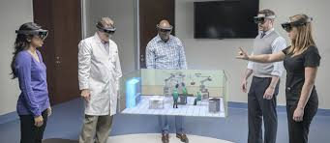therefore provides observers with a completely comfortable viewing experience.

Fig-1 HoloLens application

A HoloLens will use holographic technology to project large-scale, high-resolution images onto a variety of different surfaces, at different focal distances, from a relatively small-scale projection device. To understand the technology used in HoloLens, we must understand the term ‘Hologram’, and the process of making and projecting holograms. Holography is a technique that allows the light scattered from an object to be recorded and later reconstructed. The technique to optically store, retrieve, and process information. The holograms preserve the 3-D information of a holographed subject, which helps to project 3D images.

**Microsoft HoloLens**

HoloLens is essentially a holographic computer built into a headset that lets you see, hear, and interact with holograms within an environment such as a living room or an office space. Microsoft has built the headset without the need to be wirelessly connected to a PC, and has used high-definition lenses and spatial sound technology to create that immersive, interactive holographic experience. The HoloLens comes with semi-transparent holographic lenses which 'generate multi-dimensional full-colour holograms'. That means it's not going to be projecting images into a room that everyone can see. It's cutting edge stuff, but it's not quite that advanced yet. Basically, HoloLens is a high-tech computer system that can be wearable and works according to your gestures with hands, eyes, etc.

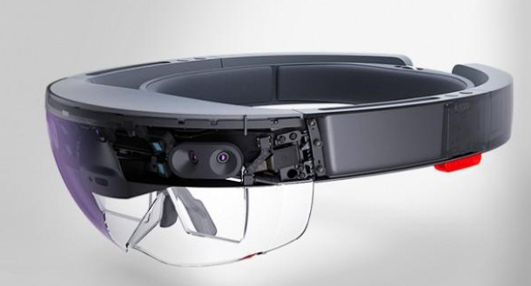Fig 2-Microsoft HoloLens

As seen in above fig. 3.1, That is actual picture of wearable augmented reality from Microsoft named by HoloLens. This is the first holographic computer which is running on Windows 10. It is completely unattached as no wires, phones or computers needed; it is a computer itself. The premier device for Windows Holographic, Microsoft HoloLens is a smart-glasses headset that is a cordless, self-contained Windows 10 computer. It uses various sensors, a high-definition stereoscopic 3D optical head-mounted display, and spatial sound to allow for augmented reality applications, with a natural user interface that the user interacts with through gaze, voice, and hand gestures.

Microsoft HoloLens, known under development as Project Baraboo, is a pair of mixed reality head-mounted smartglasses developed and manufactured by Microsoft. HoloLens is essentially a holographic computer built into a headset that lets you see, hear and interact with holograms within an environment such as a living room or an office space. It is based on Augmented reality, Augmented reality (AR) is a live direct or indirect view of a physical, real-world environment whose elements are augmented (or supplemented) by computer-generated sensory input such as sound, video, graphics or GPS data. The history of augmented reality can be traced back to 1990 and work undertaken by Professor Tom Caudell as part of a neural systems project at Boeing.

This project was focused upon finding new ways to help the company's engineering process and involved the use of virtual reality. Augmented reality is the blending of virtual reality and real life, as developers can create images within applications that blend in with contents in the real world. With AR, users are able to interact with virtual contents in the real world, and are able to distinguish between the two.

Microsoft HoloLens intelligently maps the room you’re in, blending holograms with the environment around you. Pin holograms to physical locations you choose so that your room becomes the canvas for your holographic projects and games. With Microsoft HoloLens, you can interact with holograms and everyday objects together. It puts you at the center of a world that blends holograms with reality. With the ability to design and shape holograms, you’ll have a new medium to express your creativity, a more efficient way to teach and learn, and a more effective way to visualize your work and share ideas.

CHAPTER 2

PARTS OF HOLOLENS

It has a major six parts those are bone of this product Camera, Computer, Lenses, Vent, Sensor, Buttons. Let us study them one by one:

**Camera:**

The project HoloLens depth camera has a field of vision that spans 120 by 120 degree, so it can sense what your hands are doing even when they are nearly outstretched.

**Computer:**

HoloLens is not just a visor connected to a computer; it is a computer on its own. HoloLens contain CPU, battery, GPU and first of its kind HPU (holographic processing unit). 18 sensors flood the brain of the device with terabyte of data every second.

**Lenses:**

Microsoft HoloLens has two display. They are transparent so that wearer can see the real world behind virtual object. To create project HoloLens image, light particles bounce around millions of times in the so-called light engine of the device. Then the photons enter the two lenses (one for each eye), where they ricochet between layers of glasses before finally hitting of wearer eye.

**Vent:**

The device is more powerful than a laptop but won’t overheat- warm air flows to the sides, where it vents up and out.

**Sensor:**

Sensor track where the wearer is looking and adjust the display. Motion sensor detect wearers movement. The sensor can also see wearers hands, the hands are an input system: user can interact with whatever he sees by just touching it. Wearer also give gesture as input sensor enables the tracking of user movement.

**Buttons:**

On the right-side buttons allow user to adjust the volume and to control the contrast of the hologram.

CHAPTER 3

SPECIFICATION OF HOLOLENS

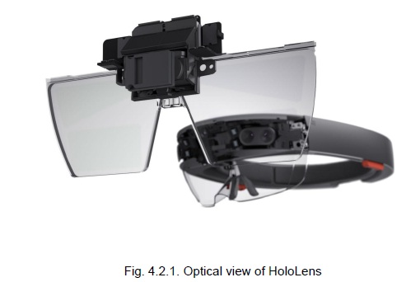**Optics**

Fig-3 optical view of HoloLens

* See through holographic lenses (Waveguides)
* 2 HD 16:9 light engines.
* Automatic pupillary distance calibration.
* Holographic Resolution: 2.3 total light points.
* Holographic Density: > 2.5 radiant (lights point per radian).

**Sensor**

* 4 environment understanding cameras
* 1 depth camera
* 1 2MP photo / HD video camera
* Mixed reality capture
* 4 microphones
* 1 ambient light sensor
* 1 IMU

**Weight**

* 579g

**Memory**

* 64GB Flash  
  2GB RAM

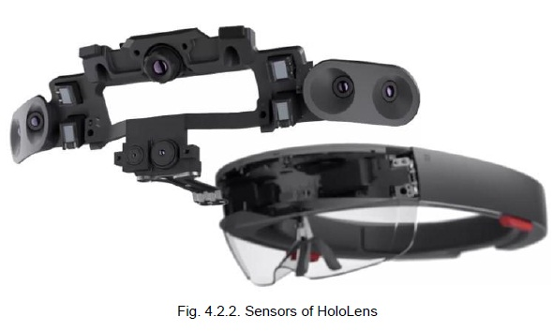Fig-3 sensor view of HoloLens

**Human Understanding**

* Spatial sound
* Gaze tracking
* Gesture input
* Voice support

**Input / Output / Connectivity**

* Built-in speakers
* Audio 3.5mm jack
* Volume up/down
* Brightness up/down
* Power button
* Battery status LEDs
* Wi-Fi 802.11ac
* Micro USB 2.0
* Bluetooth 4.1 LE

**Power**

* Battery Life
* 2-3 hours of active use
* Up to 2 weeks of standby time
* Fully functional when charging
* Passively cooled (no fans)

CHAPTER 4

**Working of HoloLens**

The idea behind augmented reality is nothing new and early prototypes date back to the late 60s. Early achievements include heads up displays (HUDs) in jet fighters and helicopters, help with targeting and provide night vision. Such advancements were then passed on to civil aviation and later cars. The technology behind augmented reality systems involves numerous fields of research including signal processing and tracking systems, graphics, user interfaces, human factors, wearable and mobile computing, networking or information visualization. The requirements for an AR system depend greatly on its intended application. A visual AR system revolves around a display, a precise tracking system which provides accurate environmental information to keep virtual elements synchronized with the real ones and extensive computational power to handle the real-time requirements of augmented reality. AR systems must satisfy at least three conditions in order to function properly.

1. Trackers must be accurate to a small fraction of a degree in orientation and a few millimetres in position.

2. The combined latency of the tracker and the graphics engine must be very low.

3. The tracker must work at long ranges.

Microsoft holo-lens has user interface so it takes voice, gaze and gestures as input command. Then internal computer works on input command. Now projection of hologram, for projection HoloLens use the HUE (head up display) method two nano- projector located at each side of head and semi-transparent visor which reflect the image as light on users’ eye. Microsoft explains the holographic element in this way: “The key to a great holographic experience is hologram that are light point rich, i.e. have a high holographic density, and are pinned or anchored to the world around you. To achieve this, HoloLens has been designed for optimal holographic density of 2.5K radiant. The more radiant and light points there are, the brighter and richer the holograms become.” We here divide it in three parts to make easy to understand, in one of them we study the major hardware parts of it, and specification than we will move to the real-world example of augmented reality-based HoloLens.

As mentioned in the previous sections Microsoft HoloLens is equipped with a Holographic processing unit. Which is a specialized electronic circuit designed as a Coprocessor chip (along with CPU and GPU) dedicated to process and seamlessly merge real environments with virtually generated data and graphics. Essentially, HPU's try to understand the world around itself. The HPU was exclusively developed for Microsoft's HoloLens. According to Microsoft the HPU is capable of, "processing terabytes of information from all its sensors in real time. The HPU is integrated into the Microsoft HoloLens, which facilitates the merging of virtual objects with the user's environment in real time. The device has transparent lenses, which is said to be of three layers. These helps the user to view the holographic object in its depth and reality. The device auto adjusts to the user’s eye pitch and then creates the objects accordingly. Microsoft's HoloLens is not actually producing 3D images that everyone can see. Instead of everyone walking into a room made to reproduce 3D images, HoloLens show images only the wearer can see. HoloLens is not trying to transport you to a different world, but rather bring the wonders of a computer directly to the one you're living in it’s just overlaying images and 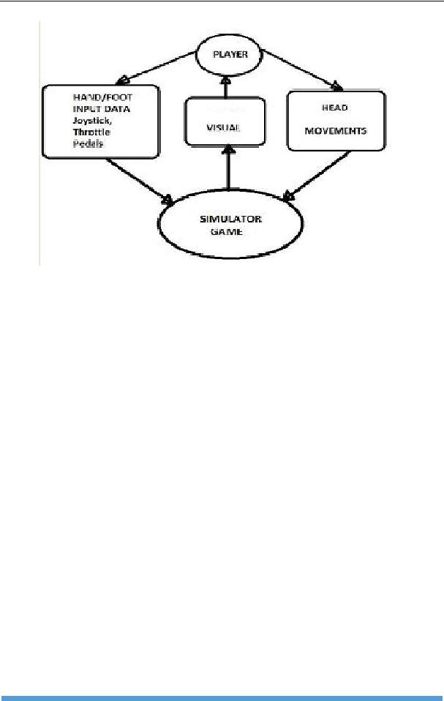objects onto our living rooms.

Fig 5- Game Simulator Flowchart

The device has camera that looks at the room, so the HoloLens knows where tables, chairs and other objects are. It then uses that information to project 3D images on top of and even inside them. The HPU processes the data from these cameras to identify the objects in the room, their shapes, and positions. The device has a plethora of sensors to sense your movements in a room and it uses this information along with layers of coloured glass to create images you can interact with or investigate from different angles. The devices use different kinds of sensors to take inputs from the user and to understand the surrounding. Its uses motion tracker that use a gyroscope, accelerometer, and magnetometer to sense user’s head motion. Sensors are used to read the light intensity, Motion sensors to detect the user’s actions, IR sensors to detect the obstacles, a depth camera, GPS to locate the user, orientation trackers and so on. Microsoft HoloLens captures even slight movement of the user and acts accordingly to it.

HoloLens has a spatial sound system which gives the user a reality experience to the things happening around, we can hear holograms even if they're behind the user. The user can interact with the HoloLens either by using hand gestures like a mid-air click by raising and lowering your finger to interact with the 3D images. The goggles will track your movements, watch your gaze and transform what you see by blasting light at the screen.

Microsoft explains the holographic element in this way: "The key to a great holographic experience is holograms that are light point rich, i.e. have a high holographic density, and are pinned or anchored to the world around you. To achieve this, HoloLens has been designed for optimal holographic density of 2.5K radiant. The more radiant and light points there are, the brighter and richer the holograms become.

" Unlike Google Glass then, Microsoft's AR headset will create virtual 3D models that, thanks to the HoloLens' various cameras and sensors, interact with the environment you're in. The in-built speakers that sit above your ears create sound based upon where each hologram is in relation to your position, making for an even more immersive experience.

CHAPTER 5

APPLICATIONS

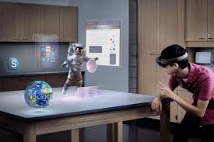The possibilities enabled by the Microsoft HoloLens see a wide array of use-cases developers, commercial organizations, designers, creators, and those seeking a whole new way to be entertained will find unique value in Microsoft HoloLens. For developers, Windows 10 and Microsoft HoloLens are the premier holographic platform that enables him to unleash the creativity and be among the first to shape holographic computing. Microsoft HoloLens will be a revolutionary tool for businesses. It will transform how companies, designers, and creators work with three-dimensional data to bring products and information to life. Microsoft had given demo on four application using the prototype. They are Building a 3D Model, installing a Light Switch with a help from a technician over a Skype call, exploring the surface of Mars, Minecraft-Like Gaming

Fig 6- Person using HoloLens to build a model

Microsoft HoloLens can be used to design 3D Models in real-time using HoloStudio, a 3D modelling tool. You can walk around the hologram, grab tools from a holographic control

panel, and then used a combination of voice and gestures to build and shape model. These models can then be sent to a 3D printer for manufacturing

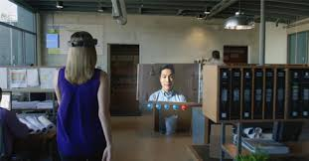A HoloLens-enabled version of Skype can be used to interact between two personals and can remotely assist the other to do some tasks. A small window appears in virtual field so the user could video chat. But using the HoloLens, the person at the other end could see what user is watching. The person can assist the user by drawing an arrow or annotations that shows exactly what actions to perform.

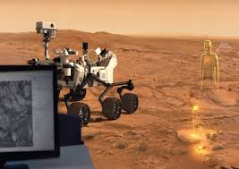Fig 7- Person skypes with hologram

Fig 8-Exploring mars surface using HoloLens

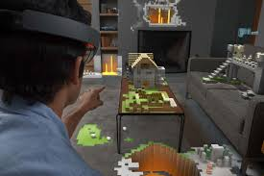Microsoft has been working with NASA's Jet Propulsion Laboratory (JPL) to create a holographic version of Mars for research and maintenance purposes. Using the HoloLens, the user can feel the experience of standing near the Mars rover, surrounded by the Red Planet's vistas. Looking down he can see the rocks of the Martian land just inches away. This entire environment had to be constructed from photos taken from the Mars rover.

Fig 9-Playing games with HoloLens

Playing games using the HoloLens will be a different level of experience. Microsoft had given demos using their own block building game. Which can turn the small living room to be filled with blocky castles, on the coffee table and along the wall. user could walk around the structures, gaze upon individual blocks, and then make changes to them using the air click. Voice command lets us change the tools quickly. We can drill holes in the castle and look down through the virtual floor into the levels below. It was definitely immersive, but probably a little slower than it might be with a mouse and keyboard.

CHAPTER 6

**Advantages of HoloLens**

## Easy to wear and use.

## Sensitive and responsive to the presence of people.

* HoloLens can be used in army battlefield, where detailed instruction can be given to the untrained person in the mildest of combat.
* A spectacle, based computer to reside directly

## On your eyes rather than your pocket.

**Disadvantages of HoloLens**

* Can be easily damaged or broken user will have a tough time taking care of it.

## It may lead to accident while driving.

## Privacy of people may break due to new glasses.

## It also needs complicated positioning and calibrations.

## No word about the data bandwidth needed for this quality.

## Requires good and even lighting

CHAPTER 7

CONCLUSION

The premier device for Windows Holographic, Microsoft HoloLens is a smart-glasses headset that is cordless, self-contained Windows 10 computer. It uses advance sensors, a high-definition stereoscopic 3D optical head-mounted display, and spatial sound to allow to augmented reality applications, with a nature user interface that the user interact with trough gaze, voice and hand gestures that gives you ways to go beyond the screen, so see your world as a canvas, and gives you more natural way to interact. HoloLens is a thing where you can connect, create and explore like never before, create what you imagine, visualize your work, collaborate and explore.

Considering the present technology’s and their performance Microsoft HoloLens is far ahead than all the existing technology’s. Since apple had acquired two patents on similar technology earlier there is a chance that apple and other companies can come up with improved ideas, if the market is welcoming the new face of the augmented reality.

Virtual reality is being used by pilots in the training process to help them overcome the fear of heights. With the help of AR, it is also possible for scientists to comprehend the chemical reactions in a much better way and help them gather the minute details of any reaction. Architects can make an optimum use of VR and AR by visualizing a building that is yet not into existence and to experience a virtual tour of the structure. Augmented reality also offers great deal of amusement with the museums and galleries. These could also be used by surgeons while in a surgery who can be assisted by other surgeons in other part of the world.

HoloLens with Holographic processing unit, sensor fusion, power and grace, advanced optics, build in speakers, spatial sound gives you the new augmented or virtual world over real world. Without bumping to walls you can watch Netflix, play Minecraft, use AutoCAD, talk to Dad on Skype, design a brand-new car, and so on…

REFERENCES

[1] Pandher, Gurmeet Singh (2 March 2016). "Microsoft HoloLens Preorder: Price, Specs of The Augmented Reality Headset.". The Bitbag. (thebitbag.com).

[2]"Microsoft HoloLens hardware". Microsoft. Retrieved 1 May 2015. (microsoft.com).

[3] Microsoft HoloLens - Here are the full processor, storage and RAM specs, Windows Central, May 2, 2016 (windowscentral.com).

[4] Terry Myerson, Alex Kipman, Jeff Norris, Satya Nadella (21 January 2015). Windows 10: The Next Chapter. Microsoft. Event occurs at 01:36:53. Retrieved (vimeo.com).

[5] Microsoft HoloLens: Partner Spotlight with Case Western Reserve University. Microsoft. 8 July 2015. Retrieved 9 July 2015.

[6] Microsoft HoloLens. Official Wikipedia articles. (wikipedia.org).

[7] Documents on HoloLens. Individual documentations on Scribd. (scribd.com).

[8] Augmented Reality Through Wearable Computing (Thad Starner, Steve Mann, Bradley Rhodes, Jerey Levine Jennifer Healey, Dana Kirsch, Roz Picard, and Alex Pentland) Augmented Reality (Benjamin Obst – 507497 Ludwig Tröller – 507084).

[9] "Announcing the Microsoft HoloLens 'Share Your Idea' campaign". Building Apps  
for Windows. Microsoft. 1 December 2015. Retrieved 17 February 2016.  
(blog.microsoft.com).

[10] Images source: Microsoft.com, google images.

[11] www.tomshardware.com - “What’s Inside Microsoft's HoloLens And How It Works”.

[12] http://spectrum.ieee.org/tech-talk/consumer-electronics/audiovideo/cautious-optimism- about-Microsoft-HoloLens.

[13] http://www.microsoft.com/microsoft-hololens/en-us/home.

