PROJECT REPORT
CareerAI - AI-Powered Career Guidance and Resume-Based Interview System
Submitted in partial fulfillment of the requirements for the Diploma in Computer Engineering
Institute:
[INSTITUTE NAME]
Department:
Department of Computer Engineering
Academic Year:
2026-27
Submitted By:
1. [STUDENT NAME]
2. [STUDENT NAME]
3. [STUDENT NAME]
4. [STUDENT NAME]
5. [STUDENT NAME]
Guided By:
[GUIDE NAME]

Certificate
This is to certify that the project report entitled CareerAI - AI-Powered Career Guidance and Resume-Based Interview System is a bonafide work carried out by the students listed on the cover page in partial fulfillment of the requirements for the Diploma in Computer Engineering during the academic year 2026-27. The work has been prepared for academic submission and viva evaluation.
Place: [PLACE]
Date: [DATE]
Guide: [GUIDE NAME]
Head of Department: [HOD NAME]
External Examiner: [EXAMINER NAME]

Declaration
We hereby declare that the project report entitled CareerAI - AI-Powered Career Guidance and Resume-Based Interview System has been prepared by us under the guidance of [GUIDE NAME]. The report is based on the actual Django project implementation submitted with this work. All sources of technical reference have been acknowledged in the References section. The personal academic details not available in the source archive have been kept as editable placeholders.

Acknowledgement
We express our sincere gratitude to our project guide [GUIDE NAME] for valuable guidance, encouragement, and technical support throughout the development of this project. We also thank the Department of Computer Engineering and [INSTITUTE NAME] for providing the academic environment required to complete this work. We are thankful to our classmates, friends, and family members for their cooperation during analysis, implementation, and testing.

Abstract
CareerAI is a Django-based web application developed to support students and job seekers in career planning, resume analysis, and interview preparation. The system allows a registered user to upload a PDF resume, extracts readable text using pypdf, builds a local profile of skills, education, experience, projects, and certifications, and then uses that evidence to generate career suggestions and resume-grounded interview questions. The implementation includes user registration, login, settings, PDF-only resume upload validation, password recovery through a short-lived OTP, performance analytics, interview scoring, feedback generation, bilingual professional answer generation, and PDF interview report download. The default implementation is rule-based and local, while optional provider hooks for Gemini, OpenAI-compatible, or OpenRouter APIs are present only when explicitly enabled through environment variables. The project uses Django 6, SQLite, HTML, CSS, JavaScript, pypdf, ReportLab, and Django authentication features. This report documents the actual modules, models, workflows, security mechanisms, testing evidence, limitations, and future scope of the submitted source code.

Table of Contents
- Chapter 1 Introduction
- Chapter 2 Literature and Existing System Study
- Chapter 3 Requirement Analysis
- Chapter 4 System Analysis and Design
- Chapter 5 Technology Stack
- Chapter 6 System Modules
- Chapter 7 Database Design
- Chapter 8 Implementation
- Chapter 9 Algorithms and Logic
- Chapter 10 User Interface and Screenshots
- Chapter 11 Testing
- Chapter 12 Security
- Chapter 13 Results and Discussion
- Chapter 14 Advantages Limitations and Future Scope
- Chapter 15 Conclusion
- References
- Appendix

List of Figures
- Figure 4.1 System Architecture
- Figure 4.2 Overall Workflow
- Figure 4.3 Context Diagram
- Figure 4.4 DFD Level 0
- Figure 4.5 DFD Level 1
- Figure 4.6 Use Case Diagram
- Figure 4.7 Activity Diagram
- Figure 4.8 Sequence Diagram
- Figure 4.9 Component Diagram
- Figure 4.10 ER Diagram
- Figure 9.1 Resume Processing Flowchart
- Figure 9.2 Interview Evaluation Flowchart
- Figure 10.1 to 10.12 Screenshot Placeholders

List of Tables
- Table 2.1 Existing System vs Proposed System
- Table 3.1 Functional Requirements
- Table 3.2 Non Functional Requirements
- Table 5.1 Technology Stack
- Table 7.1 to 7.7 Data Dictionary
- Table 8.1 URL Routing
- Table 11.1 Automated Test Result Summary
- Table 11.2 Proposed Manual Test Cases

List of Abbreviations
Abbreviation | Meaning
AI | Artificial Intelligence, used in the project name and optional provider terminology
API | Application Programming Interface
CSRF | Cross Site Request Forgery
DFD | Data Flow Diagram
DRF | Django REST Framework
ER | Entity Relationship
HTML | HyperText Markup Language
JSON | JavaScript Object Notation
OTP | One Time Password
PDF | Portable Document Format
UI | User Interface

CHAPTER 1
INTRODUCTION

1.1 Introduction
CareerAI is a student project that addresses a practical academic and career-readiness problem. Diploma students often need guidance about suitable job roles, portfolio gaps, and interview preparation, but their preparation is frequently generic and not connected to the content of their own resume. The submitted system provides a web-based workflow where the user's PDF resume becomes the evidence source for career suggestions and practice interview questions.

1.2 Background
Career guidance and interview preparation are normally handled through teachers, placement officers, mentors, online articles, and mock interviews. These methods are useful, but students may still find it difficult to convert their own skills and project work into clear interview answers. The project therefore combines a resume upload feature, deterministic text analysis, question generation, answer scoring, feedback, and a downloadable interview report.

1.3 Problem Statement
Students require a simple platform that can read a resume, identify visible skills and project evidence, suggest career improvement areas, and provide interview practice linked to that evidence. The system should not replace a professional counsellor; it should help a learner practise and organize preparation in a structured way.

1.4 Motivation
The motivation behind CareerAI is to make interview practice more personal than a static question bank. A resume-based interview is useful because it asks the candidate to defend real claims already written in the resume.

1.5 Need for the System
The need for the system comes from gaps in ordinary preparation: resumes are often not reviewed technically, interview questions are often generic, and students may not know how to explain projects using situation, action, result, and learning.

1.6 Objectives
The implemented objectives are user registration and authentication, resume upload, local PDF text extraction, profile construction from resume text, career guidance, resume-grounded interview generation, answer evaluation, feedback, performance history, password reset with OTP, and PDF report generation.

1.7 Scope of the Project
The scope is a Django web application for local or college-level deployment. It supports individual authenticated users and stores their resumes, interview sessions, answers, feedback, and settings in SQLite. It is suitable for academic demonstration and controlled use.

1.8 Proposed Solution
The proposed solution is a modular Django application named CareerAI. The users app handles registration, login, settings, resume upload, career guidance, interview APIs, report pages, and PDF report download. Local logic in resume_services.py performs the core resume analysis and interview processing.

1.9 Advantages
The system is simple to deploy, works in local fallback mode without paid APIs, grounds interview questions in resume evidence, provides bilingual model answers, and stores performance history per user.

1.10 Limitations
The default logic is rule-based and depends on selectable PDF text. It does not perform OCR, does not guarantee professional counselling quality, does not include a production-grade rate limiter, and sends resume text to an external provider only if optional AI mode is enabled by configuration.

1.11 Future Scope
Future work may include OCR, stronger resume parsing, rate limiting, malware scanning for uploads, richer analytics, mobile application support, cloud deployment, and job recommendation integration.

1.12 Organization of the Report
The remaining chapters discuss existing systems, requirements, analysis and design, technologies, modules, database design, implementation details, algorithms, interface screens, testing, security, results, future scope, conclusion, references, and appendices.

CHAPTER 2
LITERATURE AND EXISTING SYSTEM STUDY

2.1 Existing Career Guidance Methods
Existing career guidance usually includes faculty counselling, placement-cell sessions, aptitude tests, online articles, and peer advice. These methods can guide broad choices, but they may not directly analyze the student's own resume evidence.

2.2 Existing Resume Screening and Analysis Approaches
Resume analysis systems usually parse documents, detect skills, and compare them with role requirements. In this project, the implemented parser is conservative and local: it extracts PDF text using pypdf and detects known skills and sections through string and regular-expression logic.

2.3 Existing Interview Preparation Platforms
Common interview platforms provide question banks, mock interviews, answer samples, and sometimes voice-based practice. CareerAI implements a resume-grounded interview flow rather than only static questions.

2.4 Problems in Existing Approaches
Existing approaches may give the same questions to all students, require paid services, or fail to connect answers with resume evidence. Some tools also overclaim AI capability without explaining the logic used.

2.5 Existing System vs Proposed System
The comparison below presents the actual proposed implementation without inventing market statistics.
Aspect | Traditional / Existing Approach | CareerAI Implementation
Resume basis | Often manual or generic | Reads uploaded PDF and stores raw_text and parsed_profile
Question source | Static question bank | Local resume-grounded generation with optional provider fallback
Scoring | Manual judgement | Rule-based technical, relevance, communication and filler scoring
Report | May be verbal only | HTML report and downloadable ReportLab PDF
Cost | May depend on paid services | Default local mode works without API keys

2.6 Research and Technology Gap
The main gap addressed by this project is the connection between resume evidence and interview preparation. The implementation avoids unsupported claims and uses deterministic processing as the baseline.

2.7 Summary
CareerAI is positioned as a practical student support system rather than a replacement for counsellors, recruiters, or professional interviewers.

CHAPTER 3
REQUIREMENT ANALYSIS

3.1 Functional Requirements
Requirement | Implemented | Evidence
User registration with email and password | Yes | RegisterForm and register view
User login and logout | Yes | user_login and user_logout views
Password reset using OTP | Yes | forgot_password, verify_password_otp, resend_password_otp, password_reset_new
User settings | Yes | UserSettings model and settings_page view
PDF resume upload | Yes | upload_resume view with extension, size, and PDF header checks
PDF text extraction | Yes | extract_resume_text using pypdf
Resume profile analysis | Yes | build_local_profile
Career guidance | Yes | career_guidance_page and generate_career_guidance
Resume-based interview | Yes | interview_start_api, interview_answer_api, interview_finish_api
Interview PDF report | Yes | build_interview_report_pdf with ReportLab
OCR for scanned resumes | No | Not present in source code
Job portal integration | No | Future enhancement only

3.2 Non Functional Requirements
Requirement | Implementation Status
Security | Django auth, CSRF middleware, password hashing, OTP hashing, upload validation, secure cookie settings
Usability | HTML templates, CSS pages, dashboard navigation, settings, performance page
Maintainability | Separate files for models, forms, views, resume services, PDF reports
Portability | SQLite and environment-variable settings support local deployment
Availability | No explicit production availability mechanism implemented

3.3 Hardware Requirements
Minimum recommended hardware for local demonstration is a standard computer with a modern browser, 4 GB RAM, and enough disk space for Python packages, SQLite database, static files, and uploaded resumes.

3.4 Software Requirements
The source uses Python, Django 6, Django REST Framework, pypdf, ReportLab, python-dotenv, SQLite, HTML, CSS, and JavaScript. A virtual environment is recommended.

3.5 User Requirements
A user should be able to create an account, sign in, upload a readable PDF resume, start an interview, answer questions, view scores and feedback, download a report, update settings, and reset a forgotten password.

3.6 System Constraints
The resume must be a valid PDF with selectable text. The default mode is rule-based. External AI providers are optional and require explicit environment configuration.

3.7 Feasibility Study
Technical feasibility is high for academic deployment because Django and SQLite are sufficient. Economic feasibility is high because the local mode avoids paid API services. Operational feasibility is acceptable because the workflow is browser based. Schedule feasibility is reasonable because the project is organized as a single Django app with focused modules.

CHAPTER 4
SYSTEM ANALYSIS AND DESIGN

4.1 System Architecture
Figure 4.1 System Architecture
Browser UI
|
| HTTP / JSON / CSRF
v
Django URL Router
|
+-- Template Views: home, dashboard, settings, upload, guidance, reports
+-- Interview APIs: start, answer, finish, history
|
v
users app services
+-- resume_services.py: extraction, profile, questions, scoring, feedback
+-- pdf_reports.py: ReportLab interview PDF
|
v
SQLite database + media/resumes

4.2 Overall System Workflow
Figure 4.2 Overall System Workflow
Register/Login -> Update settings/profile -> Upload PDF resume -> Validate file -> Extract text -> Build parsed profile -> Generate guidance or start interview -> Save questions -> Submit answers -> Calculate scores -> Finish session -> Save feedback and model answers -> View HTML report or PDF report

4.3 Context Diagram
Figure 4.3 Context Diagram
Student/User <-> CareerAI Web Application <-> SQLite Database
CareerAI Web Application -> Email Backend for OTP
CareerAI Web Application -> Optional AI Provider only when ENABLE_AI=true and provider settings are configured

4.4 Data Flow Diagram Level 0
Figure 4.4 Data Flow Diagram Level 0
User Input -> Authentication Process -> User Account Data
Resume File -> Resume Processing -> Resume and Parsed Profile Data
Interview Request -> Question Generation -> Interview Session Data
Answer Text -> Answer Evaluation -> Scores and Feedback
Completed Session -> Report Generation -> HTML/PDF Output

4.5 Data Flow Diagram Level 1
Figure 4.5 Data Flow Diagram Level 1
Upload Resume: Request.FILES -> extension check -> size check -> PDF signature check -> Resume row -> pypdf extraction -> raw_text -> build_local_profile -> parsed_profile
Interview: JSON start request -> latest resume -> generate_questions -> InterviewSession + InterviewQuestion rows -> answer JSON -> evaluate_answer -> InterviewAnswer -> finish -> InterviewFeedback

4.6 Use Case Diagram
Figure 4.6 Use Case Diagram
Actor: Registered User
Use cases: Register, Login, Reset Password, Update Settings, Upload Resume, Generate Career Guidance, Start Interview, Submit Answer, Finish Interview, View Performance, View Report, Download PDF, Logout
Actor: Admin
Use cases: Access Django admin for model administration

4.7 Activity Diagram
Figure 4.7 Activity Diagram
Start -> User logs in -> Upload resume? -> If no, request PDF upload -> Validate PDF -> Extract text -> Build profile -> User selects career guidance or interview -> If interview, generate questions -> submit answers -> score answers -> finish -> show report -> End

4.8 Sequence Diagram
Figure 4.8 Sequence Diagram
User -> Browser: click Start Interview
Browser -> Django API: POST /api/interview/start/
Django -> Resume model: fetch latest resume
Django -> resume_services: generate_questions
Django -> Database: create session and questions
Django -> Browser: return questions JSON
User -> Browser: submits answer
Browser -> Django API: POST /api/interview/answer/
Django -> resume_services: evaluate_answer
Django -> Database: save InterviewAnswer

4.9 Component Diagram
Figure 4.9 Component Diagram
career_guidance project
manage.py
career_guidance/settings.py and urls.py
users/models.py
users/forms.py
users/views.py
users/resume_services.py
users/pdf_reports.py
users/templates/users/*.html
users/static/users/*.css and landing.js
users/migrations/*.py

4.10 ER Diagram
Figure 4.10 ER Diagram
auth.User 1--1 Student
auth.User 1--1 UserSettings
auth.User 1--many Resume
auth.User 1--many InterviewSession
Resume 1--many InterviewSession
InterviewSession 1--many InterviewQuestion
InterviewQuestion 1--1 InterviewAnswer
InterviewSession 1--1 InterviewFeedback

4.11 Database Design
The project uses Django ORM models backed by SQLite. Authentication uses Django's built-in auth_user table. The application-specific models are Student, UserSettings, Resume, InterviewSession, InterviewQuestion, InterviewAnswer, and InterviewFeedback.

4.12 Data Dictionary
A detailed data dictionary is provided in Chapter 7.

CHAPTER 5
TECHNOLOGY STACK

Technology | What it is | Use in CareerAI
Python | General purpose programming language | Back-end application logic and services
Django 6 | Python web framework | Routing, views, ORM, templates, authentication, sessions, security middleware
Django REST Framework | API support package | Installed as a third-party app; interview APIs are implemented with Django JsonResponse
SQLite | File-based relational database | Default database configured as BASE_DIR / db.sqlite3
HTML | Markup language | Templates for landing, login, dashboard, upload, guidance, interview, reports
CSS | Style sheet language | Separate static CSS files for major pages
JavaScript | Browser scripting language | Landing animation and interview UI API calls, speech synthesis/recognition support in template
pypdf | PDF reading library | Extracts selectable text from uploaded PDF resumes
ReportLab | PDF generation library | Creates downloadable interview reports
python-dotenv | Environment variable helper | Loads .env files when available
Email backend | Django email system | Sends password reset OTP through SMTP or prints to console backend

Optional provider settings exist for Gemini, OpenAI-compatible APIs, and OpenRouter, but the default project configuration keeps AI disabled and provider set to local. Therefore, the report treats external AI as optional configuration, not as a guaranteed implemented runtime feature.

CHAPTER 6
SYSTEM MODULES

6.1 Landing and Home Module
Public landing page served by landing_page and index.html. It introduces resume intelligence, adaptive questions, voice interview room, bilingual coaching, scoring, and report download as product concepts shown in the UI.

6.2 User Registration
RegisterForm collects username, email, and password. Email is required and must be unique. The view validates password strength using Django validators and stores the password through set_password.

6.3 User Login and Logout
user_login authenticates username and password and redirects valid users to dashboard. Invalid or malformed requests return the login page with an error message. user_logout signs out and redirects to login.

6.4 Password Recovery and OTP
forgot_password sends a six-digit OTP, stores only a hashed OTP in session, applies expiry, limits attempts, supports resend cooldown, and invalidates existing sessions after successful reset.

6.5 User Profile and Settings
settings_page creates or updates Student and UserSettings records. It stores full name, college, course, email, notification options, theme, and profile visibility.

6.6 Resume Upload
upload_resume accepts a file named resume, requires .pdf extension, checks size using RESUME_MAX_SIZE, verifies the PDF signature starts with %PDF-, saves Resume, extracts text, and stores parsed profile.

6.7 Resume Text Extraction
extract_resume_text uses pypdf.PdfReader to extract selectable text from every page. Empty extracted text raises ResumeProcessingError.

6.8 Resume Profile Analysis
build_local_profile detects skills from SKILL_CATALOG and extracts education, experience, projects, and certifications from recognized resume sections.

6.9 Career Guidance
career_guidance_page uses the latest resume and optional latest interview feedback to produce target roles, strengths, gaps, project ideas, a thirty-day plan, and next steps.

6.10 Resume-Based Interview
interview_start_api creates a session and stores generated questions. Easy and medium interviews are clamped to 15 to 30 questions; hard interviews use 40 questions.

6.11 Answer Evaluation
interview_answer_api evaluates answer text using expected topics, word count, communication estimate, and filler words. It saves technical, relevance, communication, and overall scores.

6.12 Interview Feedback
interview_finish_api averages submitted answer scores, generates strengths, weaknesses, recommendations, and professional bilingual answers, then marks the session completed.

6.13 Interview Report
interview_report renders a protected HTML report for completed sessions owned by the signed-in user.

6.14 PDF Report Generation
interview_report_pdf calls build_interview_report_pdf, which uses ReportLab to generate a styled report with score summary, feedback, questions, model answers, and candidate answers.

6.15 Performance Module
performance_page calculates completed interview count, average score, best score, latest score, improvement delta, category scores, trend data, and recent session links for the current user only.

CHAPTER 7
DATABASE DESIGN

The database is SQLite as configured in settings.py. Django also creates standard authentication and session tables. The application models are documented below.

7.x Student Model
Field | Type | Purpose
id | BigAutoField | Primary key
user | OneToOneField User | Student belongs to one user
full_name | CharField(100) | Student name
college | CharField(100) | College name
course | CharField(100, blank) | Course name
cgpa | FloatField | Academic score
skills | TextField(blank) | Manually entered skills

7.x UserSettings Model
Field | Type | Purpose
id | BigAutoField | Primary key
user | OneToOneField User | Settings owner
career_notifications | BooleanField | Career notification preference
resume_notifications | BooleanField | Resume notification preference
job_notifications | BooleanField | Job notification preference
theme | CharField choices | light, dark, or system
profile_visibility | BooleanField | Profile visibility preference

7.x Resume Model
Field | Type | Purpose
id | BigAutoField | Primary key
user | ForeignKey User | Owner
resume_file | FileField | Uploaded under resumes/
raw_text | TextField | Extracted PDF text
parsed_profile | JSONField | Detected skills, education, projects, experience
parse_status | CharField choices | pending, complete, failed
parse_error | CharField(255) | Extraction error
uploaded_at | DateTimeField | Upload timestamp

7.x InterviewSession Model
Field | Type | Purpose
id | BigAutoField | Primary key
user | ForeignKey User | Owner
resume | ForeignKey Resume nullable | Resume evidence
role | CharField(100) | Target role
difficulty | CharField(20) | easy, medium, hard
interview_type | CharField(30) | general, technical, behavioral
status | CharField(20) | in_progress or completed
question_count | PositiveSmallIntegerField | Number of questions
overall_score | FloatField nullable | Final score
started_at | DateTimeField | Start time
completed_at | DateTimeField nullable | Finish time

7.x InterviewQuestion Model
Field | Type | Purpose
id | BigAutoField | Primary key
session | ForeignKey InterviewSession | Parent session
order | PositiveSmallIntegerField | Question order
question_text | TextField | Question
category | CharField(50) | Question category
source | CharField(30) | local, ai, project, skill, fallback
source_evidence | CharField(255) | Resume evidence phrase
expected_topics | JSONField | Expected answer topics

7.x InterviewAnswer Model
Field | Type | Purpose
id | BigAutoField | Primary key
question | OneToOneField InterviewQuestion | One answer per question
answer_text | TextField | Candidate answer
duration_seconds | PositiveIntegerField nullable | Optional duration
technical_score | FloatField | Technical score
relevance_score | FloatField | Relevance score
communication_score | FloatField | Communication score
overall_score | FloatField | Overall score
filler_count | PositiveIntegerField | Detected filler words
feedback | JSONField | Feedback items
submitted_at | DateTimeField | Last submission time

7.x InterviewFeedback Model
Field | Type | Purpose
id | BigAutoField | Primary key
session | OneToOneField InterviewSession | Completed session
strengths | JSONField | Strength list
weaknesses | JSONField | Weakness list
recommendations | JSONField | Recommendations
professional_answers | JSONField | Bilingual model answers
generated_by | CharField(20) | local or provider indicator
created_at | DateTimeField | Generation time

7.10 ER Diagram
Figure 7.1 ER Diagram
auth.User 1--1 Student
auth.User 1--1 UserSettings
auth.User 1--many Resume
auth.User 1--many InterviewSession
Resume 1--many InterviewSession
InterviewSession 1--many InterviewQuestion
InterviewQuestion 1--1 InterviewAnswer
InterviewSession 1--1 InterviewFeedback

CHAPTER 8
IMPLEMENTATION

Route | View | Purpose
/ | landing_page | Public landing page
/register/ | register | Create account
/login/ | user_login | Authenticate user
/dashboard/ | dashboard | Main user dashboard
/upload/ | upload_resume | Upload and parse PDF resume
/career-guidance/ | career_guidance_page | Generate career suggestions
/ai-interview/ | ai_interview_page | Interview interface
/api/interview/start/ | interview_start_api | Create questions
/api/interview/answer/ | interview_answer_api | Score answer
/api/interview/finish/ | interview_finish_api | Complete session
/interview/<id>/report/ | interview_report | HTML report
/interview/<id>/report.pdf | interview_report_pdf | PDF download

Resume Upload Validation
extension = os.path.splitext(resume.name or '')[1].lower()
if extension != '.pdf':
return render(..., {'error': 'Only PDF resumes are supported.'})
header = resume.read(5)
resume.seek(0)
if header != b'%PDF-':
return render(..., {'error': 'The uploaded file is not a valid PDF.'})

PDF Text Extraction
from pypdf import PdfReader
with file_field.open('rb') as handle:
reader = PdfReader(handle)
pages = [(page.extract_text() or '').strip() for page in reader.pages]
text = '\n'.join(page for page in pages if page).strip()

Answer Scoring Formula
technical = round((topic_score * 0.7) + (length_score * 0.3), 2)
relevance = round(topic_score, 2)
overall = round((technical * 0.5) + (relevance * 0.25) + (communication * 0.25), 2)

PDF Report Response
pdf_bytes = build_interview_report_pdf(session)
response = HttpResponse(pdf_bytes, content_type='application/pdf')
response['Content-Disposition'] = f'attachment; filename="careerai_interview_report_{session.id}.pdf"'
Templates are stored under users/templates/users and static styling is stored under users/static/users. The interview template includes JavaScript fetch calls to the JSON endpoints and browser speech features. Error handling is implemented through form validation, JSON status codes, Django messages, and ResumeProcessingError.

CHAPTER 9
ALGORITHMS AND LOGIC

9.1 Resume Text Extraction Algorithm
Input: uploaded PDF FileField. Processing: open file, read all pages using pypdf, extract selectable text, join non-empty page strings, reject empty text, limit stored text to 100000 characters. Output: raw resume text or ResumeProcessingError.

9.2 Skill Detection Algorithm
Input: raw resume text and optional Student.skills. Processing: compare text against SKILL_CATALOG using token-aware regular expression matching, merge manually entered skills, remove duplicates case-insensitively. Output: list of detected skills.

9.3 Section Detection Algorithm
Input: raw text lines. Processing: normalize each line, detect headings matching skills, education, experience, projects, or certifications aliases, collect following lines under the active section. Output: dictionary of section lines.

9.4 Interview Question Generation Algorithm
Input: parsed profile, role, difficulty, interview type, count, language. Processing: build project, skill, education, experience, motivation, and generic profile questions from evidence; fill sparse resumes with variant templates; optionally call configured provider and validate evidence before accepting. Output: ordered question list.

9.5 Answer Evaluation Algorithm
Input: question expected topics and answer text. Processing: tokenize answer, count filler words, match expected topics, compute topic score, length score, communication score, technical score, relevance score, and weighted overall score. Output: numeric scores and feedback list.

9.6 Feedback Generation Algorithm
Input: saved answer rows. Processing: mark strengths for high scores, weaknesses for low score or filler count, and recommendations based on detected weaknesses. Output: strengths, weaknesses, and recommendations.

9.7 OTP Reset Algorithm
Input: registered email. Processing: lookup active unique user without disclosing existence, generate six-digit OTP, store password hash of OTP in session, email OTP, verify attempts and expiry, validate new password, save new hash, invalidate old sessions. Output: reset success or safe error message.
Figure 9.1 Resume Processing Flowchart
Start
-> Receive PDF
-> Validate extension, size, signature
-> Extract text using pypdf
-> Detect sections and skills
-> Store raw_text and parsed_profile
End
Figure 9.2 Interview Evaluation Flowchart
Start
-> Receive answer JSON
-> Load owned question
-> Count words and filler terms
-> Match expected topics
-> Calculate technical, relevance, communication, overall
-> Save InterviewAnswer
End

CHAPTER 10
USER INTERFACE AND SCREENSHOTS

This chapter presents screenshots captured from the actual CareerAI Django application running locally on the development server. A demo account and demo resume were used so that no personal password, private resume, or API key is exposed.
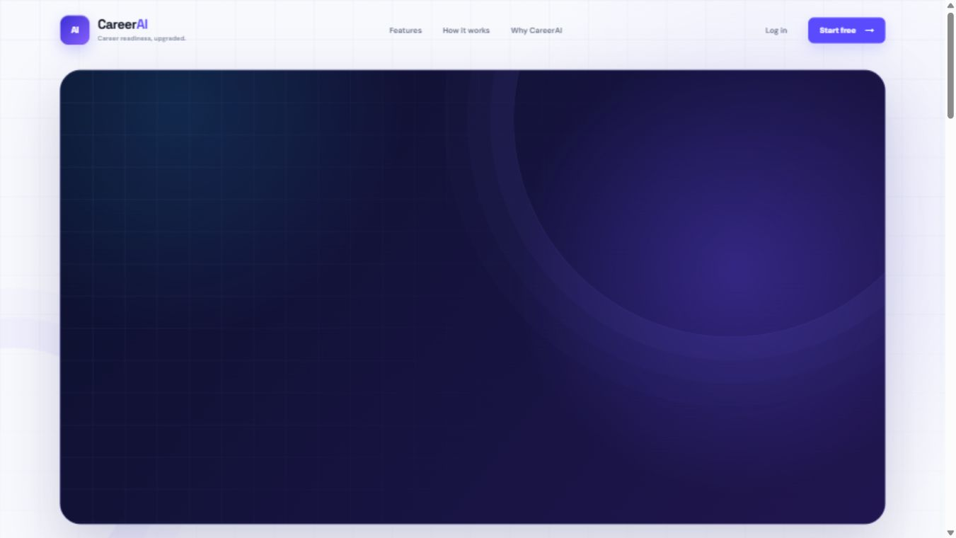
Figure 10.1: CareerAI Home Page
The home page is the public entry point served by the landing_page view and index.html template. It introduces the main workflow and provides navigation links to registration and login.

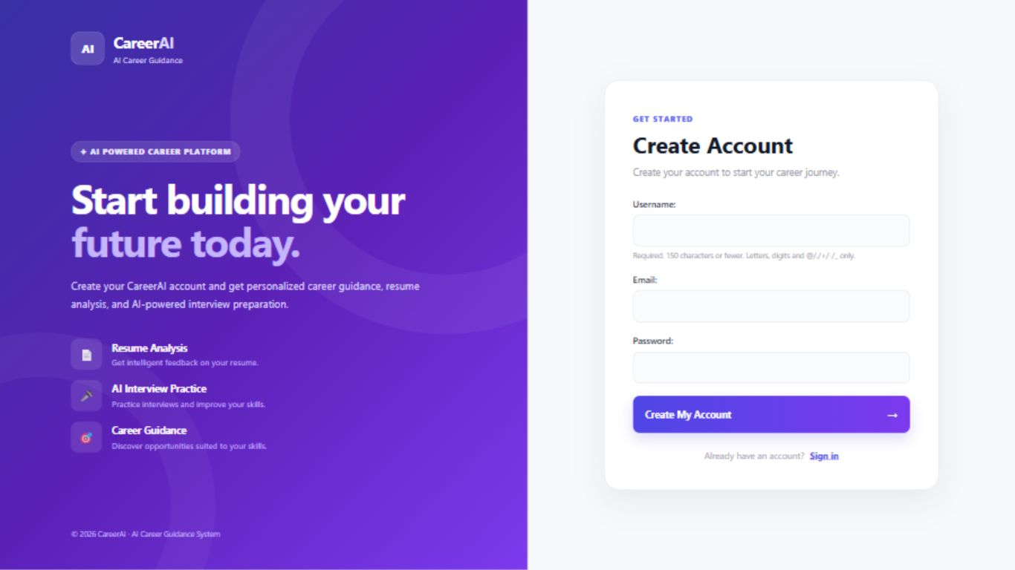
Figure 10.2: User Registration Interface
The registration screen belongs to the RegisterForm module. The user provides username, email address, and password before the system validates and creates a Django auth user.

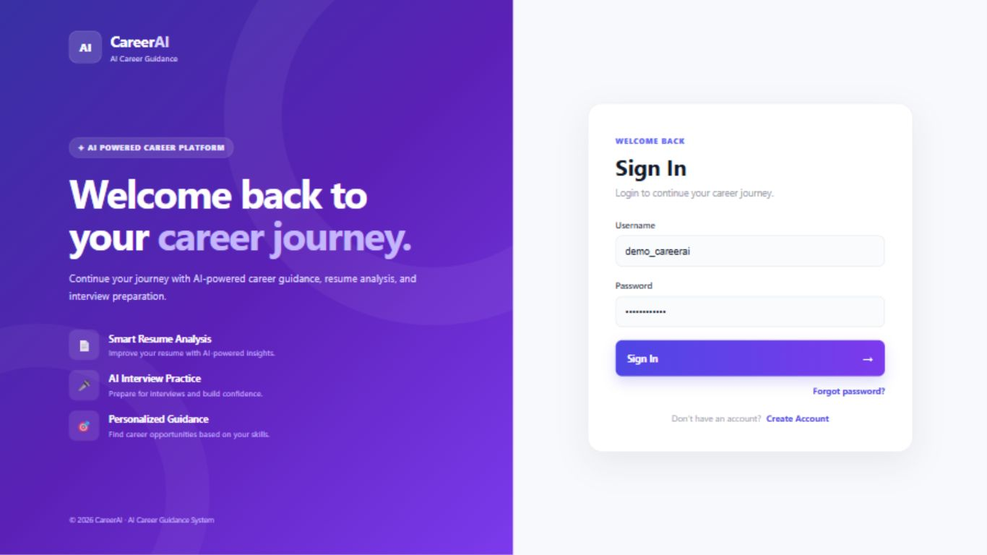
Figure 10.3: User Login Interface
The login page uses the user_login view. It accepts username and password and creates an authenticated Django session for valid credentials.

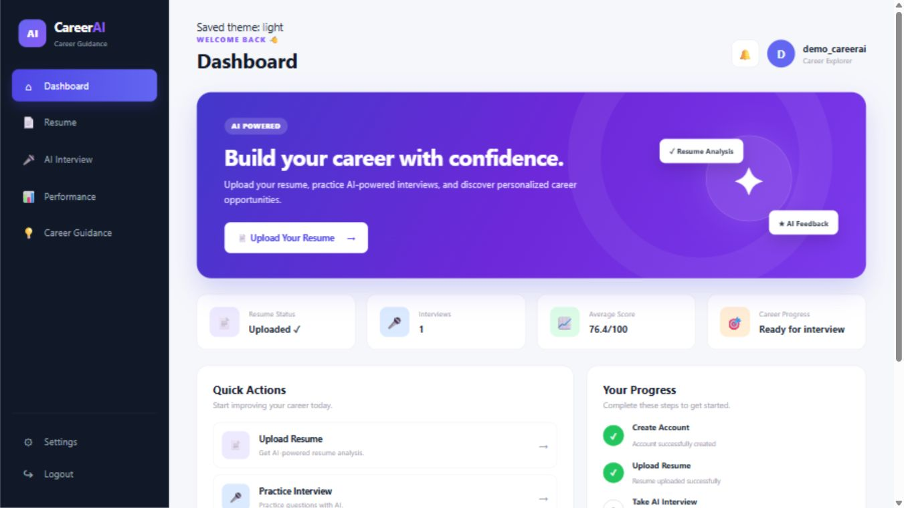
Figure 10.4: Authenticated Dashboard
The dashboard is the main user workspace. It shows resume status, interview count, average score information, and links to upload, interview, performance, career guidance, and settings modules.

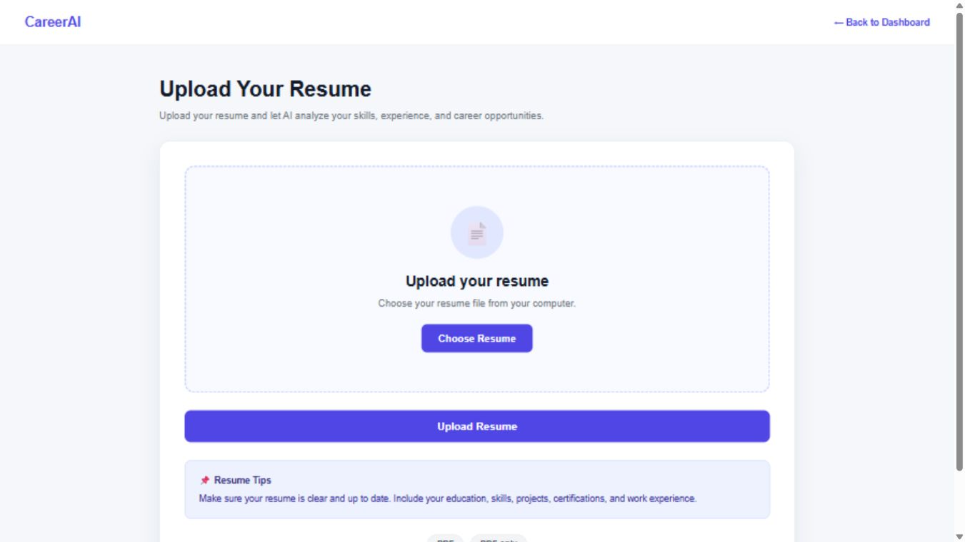
Figure 10.5: Resume Upload Interface
The resume upload screen accepts a PDF file and is connected with server-side validation for extension, file size, and PDF signature. After upload, the system extracts text and builds a parsed profile.

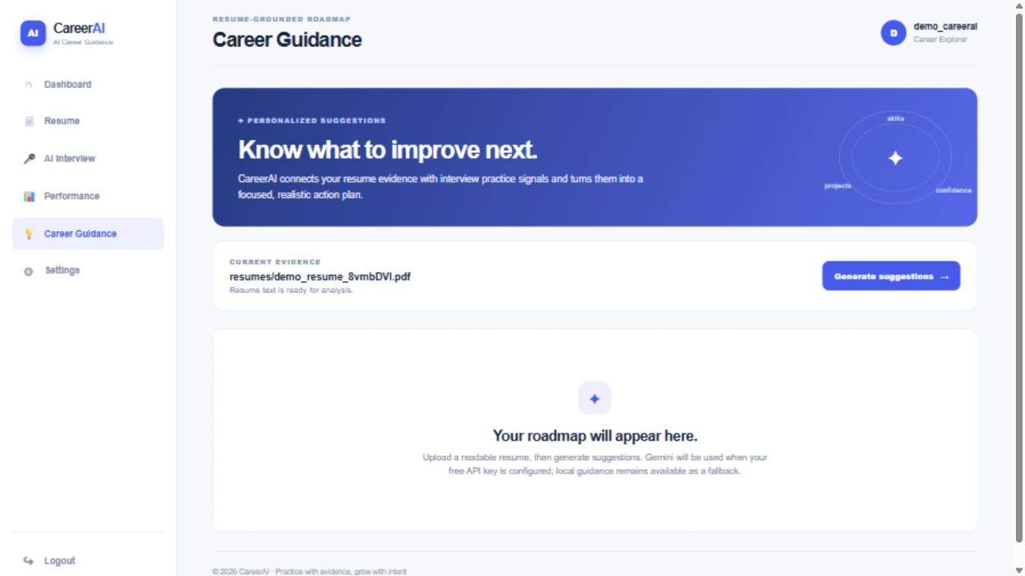
Figure 10.6: Career Guidance Request Screen
This screen shows the career guidance page before generating suggestions. It displays the current resume evidence and offers the action to generate guidance.

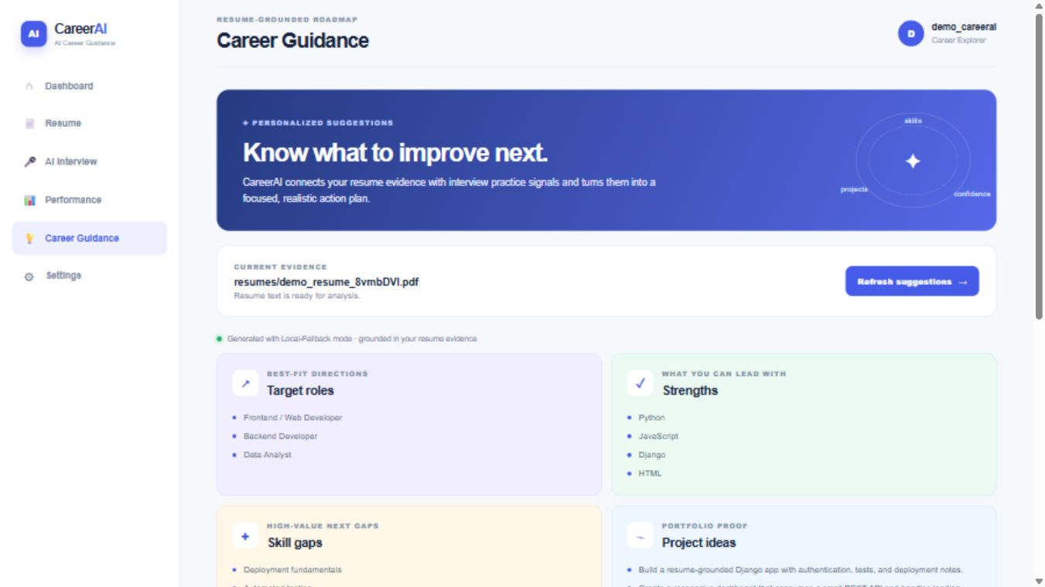
Figure 10.7: Career Recommendations Screen
The recommendations view shows generated target roles, strengths, gaps, project ideas, and a thirty-day plan based on the latest parsed resume and optional interview feedback.

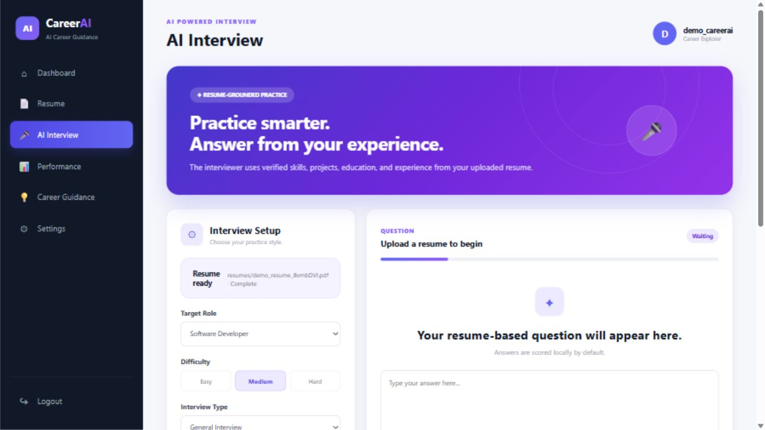
Figure 10.8: AI Interview Setup Screen
The interview page allows the user to select role, difficulty, interview type, language, and question count. It calls the interview JSON APIs through JavaScript.

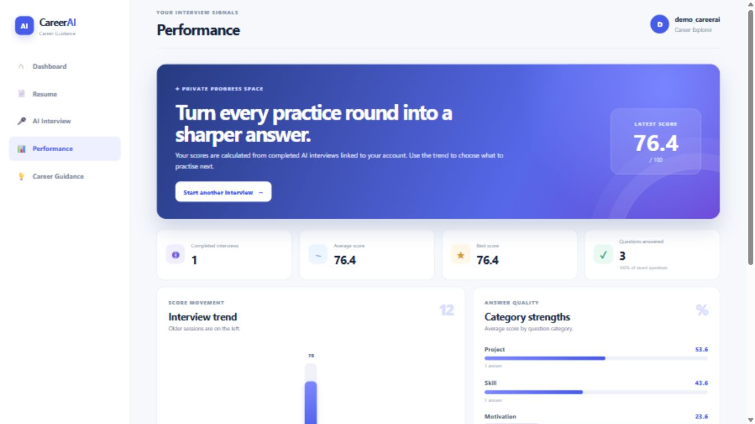
Figure 10.9: Performance Analytics Screen
The performance screen summarizes completed interview sessions for the signed-in user only. It displays latest score, average score, best score, category analysis, and recent interview links.

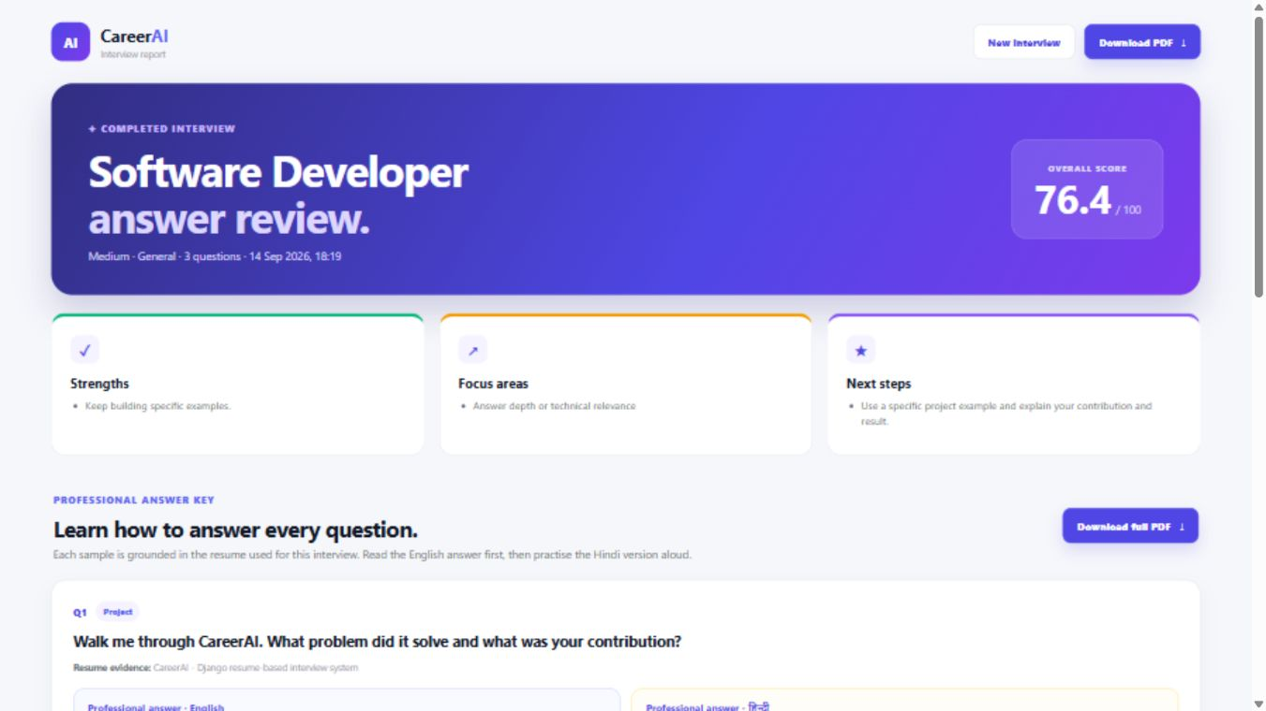
Figure 10.10: Interview Report Screen
The report page displays a completed interview score, coaching feedback, questions, candidate answers, and professional model answers. It also links to PDF report download.

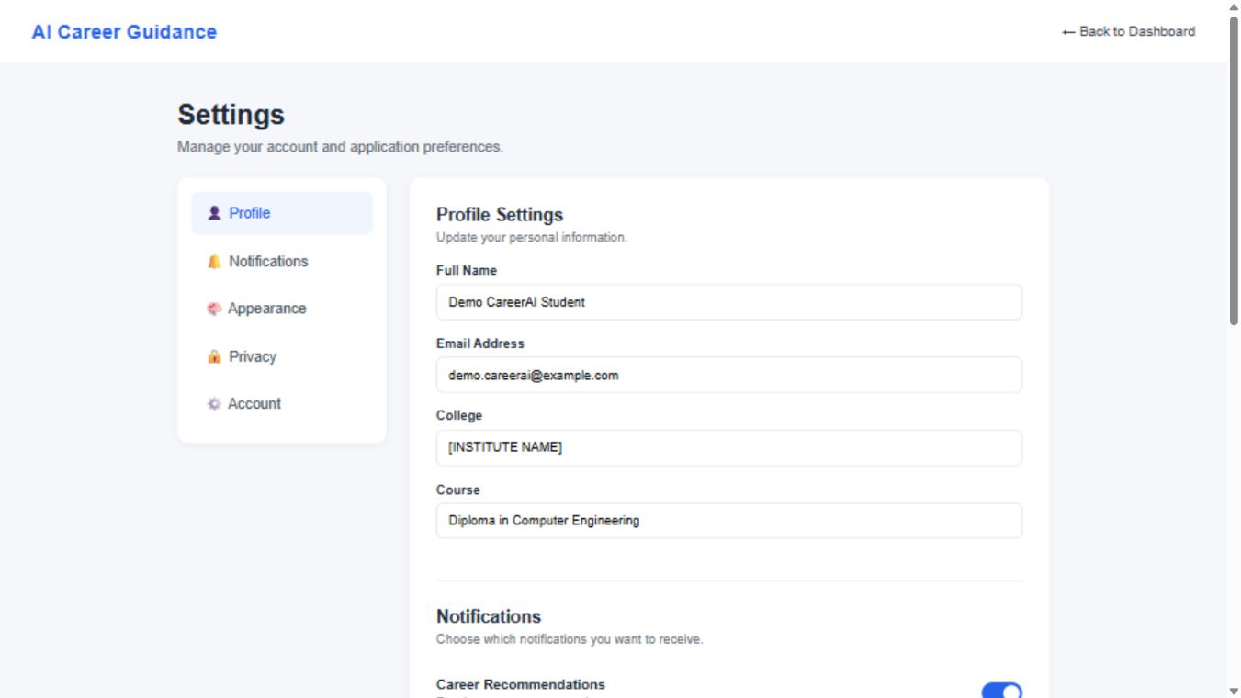
Figure 10.11: User Settings Screen
The settings screen lets the user edit profile information, email, notification settings, theme preference, and profile visibility values stored in Student and UserSettings models.

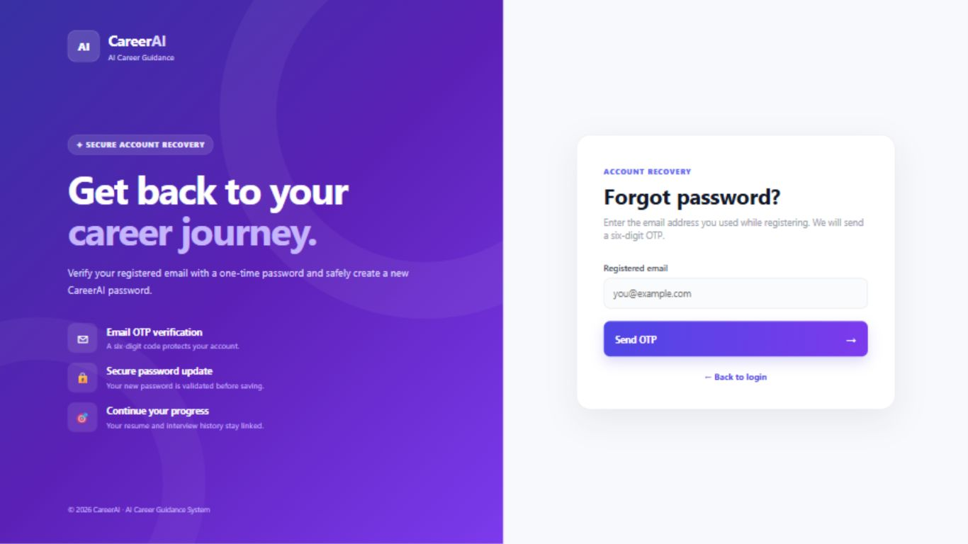
Figure 10.12: Password Recovery Screen
The password recovery page starts the OTP reset workflow. The submitted email is handled with neutral messaging so the system does not reveal whether an account exists.

CHAPTER 11
TESTING

The project includes a Django test file users/tests.py. A fresh test run was performed from the manage.py directory using the project virtual environment. The test suite discovered 9 tests. Eight tests passed and one failed because the test expected generated_by to equal local, while the current implementation returned local-fallback for the offline interview start response.
Metric | Observed Result
Command | ..\.venv\Scripts\python.exe manage.py test users
Tests discovered | 9
Passed | 8
Failed | 1
System check | No issues reported
Failure | test_offline_interview_saves_answer_and_report expected local but received local-fallback

Test Case ID | Module | Scenario | Expected Result | Actual Result | Status
AT-01 | Authentication | Anonymous dashboard access | Redirect to login | Covered by test and passed | Pass
AT-02 | Resume Upload | Upload non-PDF file | Reject file | Covered by test and passed | Pass
AT-03 | Resume Processing | Upload PDF and build profile | Resume parse_status complete | Covered by test but contains response-text mismatch risk | Pass in related assertions
AT-04 | Interview | Start offline interview | generated_by local | Returned local-fallback | Fail
AT-05 | Password Reset | Valid OTP and new password | New password works, old password fails | Covered by test and passed | Pass
AT-06 | Performance Privacy | Other user's interview hidden | Private data not shown | Covered by test and passed | Pass

11.9 Proposed Manual Test Cases
ID | Module | Input | Expected Result | Execution Status
MT-01 | Registration UI | New username, unique email, strong password | Account created and redirected to login | Proposed manual
MT-02 | Resume Upload UI | Scanned image PDF | Readable-text error shown | Proposed manual
MT-03 | Career Guidance | POST after resume upload | Target roles and plan displayed | Proposed manual
MT-04 | Voice Interview | Browser with speech support | Question audio and transcript controls work | Proposed manual
MT-05 | PDF Report | Completed interview | Downloadable PDF opens correctly | Proposed manual
MT-06 | Settings | Updated full name, college, course, email | Profile and settings values persist | Proposed manual
MT-07 | OTP Resend | Resend before cooldown | Cooldown message appears | Proposed manual
MT-08 | OTP Attempts | More than maximum wrong OTP attempts | Reset flow clears and asks user to restart | Proposed manual
MT-09 | Interview Count | Hard difficulty | Question count fixed at 40 | Proposed manual
MT-10 | Interview History API | Authenticated GET request | Recent sessions returned for same user | Proposed manual
MT-11 | Report Access Control | Try another user's report URL | Report not shown | Proposed manual
MT-12 | Upload Size Limit | PDF larger than RESUME_MAX_SIZE | Upload rejected | Proposed manual
MT-13 | Career Guidance Without Resume | POST before upload | Upload resume message shown | Proposed manual
MT-14 | Malformed JSON | Invalid body to interview API | 400 JSON error | Proposed manual
MT-15 | Theme Selection | light, dark, system | Dashboard follows saved theme behavior | Proposed manual

CHAPTER 12
SECURITY

- Django authentication and password hashing are used for account login and password storage.
- CSRF middleware is enabled and templates include csrf_token for forms and interview AJAX requests.
- Protected pages use login_required decorators.
- Password reset stores a hashed OTP, not the plain OTP, and applies expiry, attempt limit, and resend cooldown.
- Successful password reset invalidates existing sessions for the recovered account.
- Forgot-password response text avoids revealing whether an email exists.
- Resume upload checks extension, server-side size limit, and PDF signature before processing.
- Production settings enable secure cookies, HSTS, clickjacking denial, referrer policy, content sniffing protection, and HTTPS redirect when DEBUG is false.
- The project does not implement shared IP/account rate limiting, malware scanning, or OCR sandboxing; these are future hardening items.

CHAPTER 13
RESULTS AND DISCUSSION

The final working system is a Django web application capable of supporting the main CareerAI workflow: authenticated user access, resume upload, profile extraction, career guidance, resume-grounded interview practice, scoring, feedback, performance history, and PDF report generation. The implementation is especially suitable for academic demonstration because the default mode works without an external AI key.
Feature | Verified From Source | Discussion
Authentication | Yes | Registration, login, logout, protected views
Resume Processing | Yes | PDF extraction and local profile generation
Career Guidance | Yes | Rule-based target roles, gaps, project ideas, and 30-day plan
Interview | Yes | Session, questions, answers, scoring, feedback
Performance | Yes | Private analytics from completed interviews
PDF Report | Yes | ReportLab generated PDF
External AI | Optional only | Disabled by default; provider hooks require configuration

CHAPTER 14
ADVANTAGES LIMITATIONS AND FUTURE SCOPE

14.1 Advantages
- Resume-grounded preparation
- No paid API required in default mode
- Django security foundation
- Clear database models
- PDF reports for revision
- Bilingual professional answer key

14.2 Limitations
- No OCR for scanned resumes
- Rule-based analysis has limited semantic understanding
- No production rate limiter
- No malware scanning for uploaded PDFs
- No real job board integration
- No mobile app is included

14.3 Future Enhancements
- Add OCR and stronger resume parsing
- Add cache-backed throttling
- Add cloud deployment configuration
- Add mobile responsive testing and mobile application
- Add advanced AI/ML ranking as a clearly separate feature
- Add job recommendation integration
- Add richer admin dashboard and analytics

CHAPTER 15
CONCLUSION

CareerAI - AI-Powered Career Guidance and Resume-Based Interview System was developed as a Diploma Computer Engineering project using Django, SQLite, Python, HTML, CSS, JavaScript, pypdf, and ReportLab. The system addresses the practical problem of helping students prepare for careers and interviews using their own resume evidence. It includes registration, login, password recovery, settings, resume upload, local profile analysis, career guidance, resume-grounded interviews, answer scoring, feedback, performance tracking, HTML reports, and PDF reports. The project demonstrates useful learning outcomes in web development, authentication, ORM-based database design, file upload validation, JSON-based browser APIs, local text processing, and report generation. Its limitations are clearly identified, and future work can extend it with stronger parsing, rate limiting, OCR, cloud deployment, and job recommendation features.

References
- Python Software Foundation. Python Documentation. https://docs.python.org/
- Django Software Foundation. Django Documentation. https://docs.djangoproject.com/
- SQLite Consortium. SQLite Documentation. https://www.sqlite.org/docs.html
- Django REST Framework. Official Documentation. https://www.django-rest-framework.org/
- pypdf Contributors. pypdf Documentation. https://pypdf.readthedocs.io/
- ReportLab. ReportLab User Guide and Documentation. https://www.reportlab.com/docs/
- Mozilla Developer Network. HTML, CSS, and JavaScript Web Documentation. https://developer.mozilla.org/

Appendix A - Project Directory Structure
C:\Users\SAKSHAM\OneDrive\Documents\Project
|-- Project
| |-- manage.py
| |-- db.sqlite3
| |-- requirements.txt
| |-- career_guidance
| | |-- settings.py
| | |-- urls.py
| | |-- asgi.py
| | |-- wsgi.py
| |-- users
| |-- models.py
| |-- forms.py
| |-- views.py
| |-- serializers.py
| |-- resume_services.py
| |-- pdf_reports.py
| |-- tests.py
| |-- migrations
| |-- templates/users
| |-- static/users
|-- .env.example
|-- SECURITY_AUDIT_20260829.md
|-- README.md
|-- LICENSE

Appendix B - User Manual
- Open the application in a browser after running the Django server.
- Register with username, valid unique email address, and strong password.
- Log in from the CareerAI login page.
- Open Settings to update full name, college, course, email, notifications, theme, and profile visibility.
- Open Upload Resume and select a valid text-based PDF resume.
- Review the upload result and confirm that resume text was processed successfully.
- Open Career Guidance and generate suggestions based on the latest resume.
- Open AI Interview, choose role, difficulty, interview type, language, and question count where applicable.
- Start the interview, listen to or read questions, and submit answers.
- Finish the interview to calculate overall score and feedback.
- Open Performance to view score trends and recent completed interviews.
- Open the interview report to review professional English and Hindi answer models.
- Download the PDF report for offline revision.
- Use Forgot Password if account recovery is required.

Appendix C - Installation Instructions
cd C:\Users\SAKSHAM\OneDrive\Documents\Project\Project
python -m venv .venv
.\.venv\Scripts\activate
pip install -r requirements.txt
python manage.py migrate
python manage.py createsuperuser
python manage.py runserver
Optional .env values:
DJANGO_SECRET_KEY=<secure secret>
DJANGO_DEBUG=1
EMAIL_HOST_USER=<email address>
EMAIL_HOST_PASSWORD=<app password>
ENABLE_AI=false
AI_PROVIDER=local
GEMINI_API_KEY=<only if AI_PROVIDER=gemini and ENABLE_AI=true>

Appendix D - Important Notes for Submission
- Do not submit real .env secrets, personal API keys, or production passwords.
- Do not publish uploaded resumes from the media folder.
- Replace all cover-page placeholders with institute, guide, student, enrollment, and date details before printing.
- Capture real screenshots from the running application and replace the placeholders in Chapter 10.
- Fix the current automated test expectation or implementation label mismatch before claiming all tests pass.

Appendix E - Detailed Module Inventory
Module | Source Files | Responsibility | Database Interaction
Landing/Home | index.html, index.css, landing.js | Public page with feature descriptions and links to login/register | No database write
Registration | RegisterForm, register view, register.html | Creates Django User after email and password validation | auth_user
Login | user_login, login.html | Authenticates username and password | Django auth session
Password Reset | forgot_password, verify_password_otp, reset_password templates | Sends and verifies OTP, changes password, invalidates sessions | auth_user, django_session
Settings | settings_page, settings.html | Updates profile, email, notification settings, theme, privacy | Student, UserSettings, auth_user
Resume Upload | upload_resume, upload_resume.html | Receives PDF, validates extension, size, header, extracts text | Resume
Resume Processing | resume_services.py | Builds local profile from resume text | Resume.raw_text, Resume.parsed_profile
Career Guidance | career_guidance_page, career_guidance.html | Generates role suggestions, strengths, gaps, projects, plan | Reads Resume and latest InterviewFeedback
Interview UI | ai_interview.html, ai_interview.css | Browser interface with role, difficulty, type, language, question count | Calls JSON APIs
Question API | interview_start_api | Creates interview session and question rows | InterviewSession, InterviewQuestion
Answer API | interview_answer_api | Scores and stores each answer | InterviewAnswer
Finish API | interview_finish_api | Calculates overall score and feedback | InterviewSession, InterviewFeedback
Report Page | interview_report, interview_report.html | Shows question-wise report and answer key | Reads session, questions, answers, feedback
PDF Report | interview_report_pdf, pdf_reports.py | Generates downloadable ReportLab PDF | Reads completed interview data
Performance | performance_page, performance.html | Shows score trend, category scores, recent completed interviews | InterviewSession, InterviewAnswer

Appendix F - Module Input Processing Output Details
Module | Input | Processing | Output
Registration | username, email, password | Validate unique email and password strength; hash password | User account
Login | username and password | Authenticate through Django | Authenticated session or error
Settings | profile, email, checkboxes, theme | Validate email and save related settings | Updated Student, User, UserSettings
Resume Upload | PDF file | Check extension, size and signature; save file; extract text | Resume row with parse status
Profile Builder | raw resume text | Detect skills and sections with regular expressions | parsed_profile JSON
Career Guidance | latest resume profile and optional feedback | Select target roles, gaps, projects, next steps | Guidance displayed in template
Interview Start | role, difficulty, type, language, count | Clamp values; generate questions; bulk create rows | questions JSON
Answer Submit | question_id, answer, duration | Check ownership; calculate scores and feedback | answer score JSON
Interview Finish | session_id | Average answer scores; generate feedback and model answers | report and PDF URLs
Performance | current user | Aggregate completed sessions and category score data | analytics page
PDF Report | completed session id | Build ReportLab document | application/pdf response
OTP Request | email address | Neutral lookup; generate hashed OTP; send email | redirect or notice
OTP Verify | six digit OTP | Check expiry, attempts, hash | verified session state
New Password | password and confirmation | Validate and set password; invalidate sessions | login redirect

Appendix G - Expanded Data Dictionary Notes

Student
The field id is stored as BigAutoField. Primary key. In the submitted implementation, this field is part of the Student model and is accessed through Django ORM queries rather than direct SQL in application code.
The field user is stored as OneToOneField User. Student belongs to one user. In the submitted implementation, this field is part of the Student model and is accessed through Django ORM queries rather than direct SQL in application code.
The field full_name is stored as CharField(100). Student name. In the submitted implementation, this field is part of the Student model and is accessed through Django ORM queries rather than direct SQL in application code.
The field college is stored as CharField(100). College name. In the submitted implementation, this field is part of the Student model and is accessed through Django ORM queries rather than direct SQL in application code.
The field course is stored as CharField(100, blank). Course name. In the submitted implementation, this field is part of the Student model and is accessed through Django ORM queries rather than direct SQL in application code.
The field cgpa is stored as FloatField. Academic score. In the submitted implementation, this field is part of the Student model and is accessed through Django ORM queries rather than direct SQL in application code.
The field skills is stored as TextField(blank). Manually entered skills. In the submitted implementation, this field is part of the Student model and is accessed through Django ORM queries rather than direct SQL in application code.

UserSettings
The field id is stored as BigAutoField. Primary key. In the submitted implementation, this field is part of the UserSettings model and is accessed through Django ORM queries rather than direct SQL in application code.
The field user is stored as OneToOneField User. Settings owner. In the submitted implementation, this field is part of the UserSettings model and is accessed through Django ORM queries rather than direct SQL in application code.
The field career_notifications is stored as BooleanField. Career notification preference. In the submitted implementation, this field is part of the UserSettings model and is accessed through Django ORM queries rather than direct SQL in application code.
The field resume_notifications is stored as BooleanField. Resume notification preference. In the submitted implementation, this field is part of the UserSettings model and is accessed through Django ORM queries rather than direct SQL in application code.
The field job_notifications is stored as BooleanField. Job notification preference. In the submitted implementation, this field is part of the UserSettings model and is accessed through Django ORM queries rather than direct SQL in application code.
The field theme is stored as CharField choices. light, dark, or system. In the submitted implementation, this field is part of the UserSettings model and is accessed through Django ORM queries rather than direct SQL in application code.
The field profile_visibility is stored as BooleanField. Profile visibility preference. In the submitted implementation, this field is part of the UserSettings model and is accessed through Django ORM queries rather than direct SQL in application code.

Resume
The field id is stored as BigAutoField. Primary key. In the submitted implementation, this field is part of the Resume model and is accessed through Django ORM queries rather than direct SQL in application code.
The field user is stored as ForeignKey User. Owner. In the submitted implementation, this field is part of the Resume model and is accessed through Django ORM queries rather than direct SQL in application code.
The field resume_file is stored as FileField. Uploaded under resumes/. In the submitted implementation, this field is part of the Resume model and is accessed through Django ORM queries rather than direct SQL in application code.
The field raw_text is stored as TextField. Extracted PDF text. In the submitted implementation, this field is part of the Resume model and is accessed through Django ORM queries rather than direct SQL in application code.
The field parsed_profile is stored as JSONField. Detected skills, education, projects, experience. In the submitted implementation, this field is part of the Resume model and is accessed through Django ORM queries rather than direct SQL in application code.
The field parse_status is stored as CharField choices. pending, complete, failed. In the submitted implementation, this field is part of the Resume model and is accessed through Django ORM queries rather than direct SQL in application code.
The field parse_error is stored as CharField(255). Extraction error. In the submitted implementation, this field is part of the Resume model and is accessed through Django ORM queries rather than direct SQL in application code.
The field uploaded_at is stored as DateTimeField. Upload timestamp. In the submitted implementation, this field is part of the Resume model and is accessed through Django ORM queries rather than direct SQL in application code.

InterviewSession
The field id is stored as BigAutoField. Primary key. In the submitted implementation, this field is part of the InterviewSession model and is accessed through Django ORM queries rather than direct SQL in application code.
The field user is stored as ForeignKey User. Owner. In the submitted implementation, this field is part of the InterviewSession model and is accessed through Django ORM queries rather than direct SQL in application code.
The field resume is stored as ForeignKey Resume nullable. Resume evidence. In the submitted implementation, this field is part of the InterviewSession model and is accessed through Django ORM queries rather than direct SQL in application code.
The field role is stored as CharField(100). Target role. In the submitted implementation, this field is part of the InterviewSession model and is accessed through Django ORM queries rather than direct SQL in application code.
The field difficulty is stored as CharField(20). easy, medium, hard. In the submitted implementation, this field is part of the InterviewSession model and is accessed through Django ORM queries rather than direct SQL in application code.
The field interview_type is stored as CharField(30). general, technical, behavioral. In the submitted implementation, this field is part of the InterviewSession model and is accessed through Django ORM queries rather than direct SQL in application code.
The field status is stored as CharField(20). in_progress or completed. In the submitted implementation, this field is part of the InterviewSession model and is accessed through Django ORM queries rather than direct SQL in application code.
The field question_count is stored as PositiveSmallIntegerField. Number of questions. In the submitted implementation, this field is part of the InterviewSession model and is accessed through Django ORM queries rather than direct SQL in application code.
The field overall_score is stored as FloatField nullable. Final score. In the submitted implementation, this field is part of the InterviewSession model and is accessed through Django ORM queries rather than direct SQL in application code.
The field started_at is stored as DateTimeField. Start time. In the submitted implementation, this field is part of the InterviewSession model and is accessed through Django ORM queries rather than direct SQL in application code.
The field completed_at is stored as DateTimeField nullable. Finish time. In the submitted implementation, this field is part of the InterviewSession model and is accessed through Django ORM queries rather than direct SQL in application code.

InterviewQuestion
The field id is stored as BigAutoField. Primary key. In the submitted implementation, this field is part of the InterviewQuestion model and is accessed through Django ORM queries rather than direct SQL in application code.
The field session is stored as ForeignKey InterviewSession. Parent session. In the submitted implementation, this field is part of the InterviewQuestion model and is accessed through Django ORM queries rather than direct SQL in application code.
The field order is stored as PositiveSmallIntegerField. Question order. In the submitted implementation, this field is part of the InterviewQuestion model and is accessed through Django ORM queries rather than direct SQL in application code.
The field question_text is stored as TextField. Question. In the submitted implementation, this field is part of the InterviewQuestion model and is accessed through Django ORM queries rather than direct SQL in application code.
The field category is stored as CharField(50). Question category. In the submitted implementation, this field is part of the InterviewQuestion model and is accessed through Django ORM queries rather than direct SQL in application code.
The field source is stored as CharField(30). local, ai, project, skill, fallback. In the submitted implementation, this field is part of the InterviewQuestion model and is accessed through Django ORM queries rather than direct SQL in application code.
The field source_evidence is stored as CharField(255). Resume evidence phrase. In the submitted implementation, this field is part of the InterviewQuestion model and is accessed through Django ORM queries rather than direct SQL in application code.
The field expected_topics is stored as JSONField. Expected answer topics. In the submitted implementation, this field is part of the InterviewQuestion model and is accessed through Django ORM queries rather than direct SQL in application code.

InterviewAnswer
The field id is stored as BigAutoField. Primary key. In the submitted implementation, this field is part of the InterviewAnswer model and is accessed through Django ORM queries rather than direct SQL in application code.
The field question is stored as OneToOneField InterviewQuestion. One answer per question. In the submitted implementation, this field is part of the InterviewAnswer model and is accessed through Django ORM queries rather than direct SQL in application code.
The field answer_text is stored as TextField. Candidate answer. In the submitted implementation, this field is part of the InterviewAnswer model and is accessed through Django ORM queries rather than direct SQL in application code.
The field duration_seconds is stored as PositiveIntegerField nullable. Optional duration. In the submitted implementation, this field is part of the InterviewAnswer model and is accessed through Django ORM queries rather than direct SQL in application code.
The field technical_score is stored as FloatField. Technical score. In the submitted implementation, this field is part of the InterviewAnswer model and is accessed through Django ORM queries rather than direct SQL in application code.
The field relevance_score is stored as FloatField. Relevance score. In the submitted implementation, this field is part of the InterviewAnswer model and is accessed through Django ORM queries rather than direct SQL in application code.
The field communication_score is stored as FloatField. Communication score. In the submitted implementation, this field is part of the InterviewAnswer model and is accessed through Django ORM queries rather than direct SQL in application code.
The field overall_score is stored as FloatField. Overall score. In the submitted implementation, this field is part of the InterviewAnswer model and is accessed through Django ORM queries rather than direct SQL in application code.
The field filler_count is stored as PositiveIntegerField. Detected filler words. In the submitted implementation, this field is part of the InterviewAnswer model and is accessed through Django ORM queries rather than direct SQL in application code.
The field feedback is stored as JSONField. Feedback items. In the submitted implementation, this field is part of the InterviewAnswer model and is accessed through Django ORM queries rather than direct SQL in application code.
The field submitted_at is stored as DateTimeField. Last submission time. In the submitted implementation, this field is part of the InterviewAnswer model and is accessed through Django ORM queries rather than direct SQL in application code.

InterviewFeedback
The field id is stored as BigAutoField. Primary key. In the submitted implementation, this field is part of the InterviewFeedback model and is accessed through Django ORM queries rather than direct SQL in application code.
The field session is stored as OneToOneField InterviewSession. Completed session. In the submitted implementation, this field is part of the InterviewFeedback model and is accessed through Django ORM queries rather than direct SQL in application code.
The field strengths is stored as JSONField. Strength list. In the submitted implementation, this field is part of the InterviewFeedback model and is accessed through Django ORM queries rather than direct SQL in application code.
The field weaknesses is stored as JSONField. Weakness list. In the submitted implementation, this field is part of the InterviewFeedback model and is accessed through Django ORM queries rather than direct SQL in application code.
The field recommendations is stored as JSONField. Recommendations. In the submitted implementation, this field is part of the InterviewFeedback model and is accessed through Django ORM queries rather than direct SQL in application code.
The field professional_answers is stored as JSONField. Bilingual model answers. In the submitted implementation, this field is part of the InterviewFeedback model and is accessed through Django ORM queries rather than direct SQL in application code.
The field generated_by is stored as CharField(20). local or provider indicator. In the submitted implementation, this field is part of the InterviewFeedback model and is accessed through Django ORM queries rather than direct SQL in application code.
The field created_at is stored as DateTimeField. Generation time. In the submitted implementation, this field is part of the InterviewFeedback model and is accessed through Django ORM queries rather than direct SQL in application code.

Appendix H - Source Code Reference Extracts

H.1 settings.py database and media configuration
DATABASES = {
'default': {
'ENGINE': 'django.db.backends.sqlite3',
'NAME': BASE_DIR / 'db.sqlite3',
}
}
MEDIA_URL = '/media/'
MEDIA_ROOT = BASE_DIR / 'media'
This extract is included to help the examiner connect the report explanation with the actual submitted Django source code.

H.2 settings.py optional AI configuration
AI_PROVIDER = os.getenv('AI_PROVIDER', 'local').lower()
AI_ENABLED = os.getenv('ENABLE_AI', 'false').lower() in {'1', 'true', 'yes', 'on'}
GEMINI_API_KEY = os.getenv('GEMINI_API_KEY', '')
OPENAI_API_KEY = os.getenv('OPENAI_API_KEY', '')
This extract is included to help the examiner connect the report explanation with the actual submitted Django source code.

H.3 RegisterForm email validation
email = forms.EmailField(required=True)
def clean_email(self):
email = self.cleaned_data['email'].strip().lower()
if User.objects.filter(email__iexact=email).exists():
raise forms.ValidationError('An account with this email already exists.')
return email
This extract is included to help the examiner connect the report explanation with the actual submitted Django source code.

H.4 InterviewSession model summary
class InterviewSession(models.Model):
user = models.ForeignKey(User, on_delete=models.CASCADE, related_name='interviews')
resume = models.ForeignKey(Resume, on_delete=models.SET_NULL, null=True, blank=True, related_name='interviews')
role = models.CharField(max_length=100)
difficulty = models.CharField(max_length=20, default='medium')
interview_type = models.CharField(max_length=30, default='general')
status = models.CharField(max_length=20, default='in_progress')
question_count = models.PositiveSmallIntegerField(default=5)
overall_score = models.FloatField(null=True, blank=True)
This extract is included to help the examiner connect the report explanation with the actual submitted Django source code.

H.5 Resume profile builder return format
return {
'skills': skills,
'education': education,
'experience': experience,
'projects': projects,
'certifications': certifications,
'source': 'local',
}
This extract is included to help the examiner connect the report explanation with the actual submitted Django source code.

H.6 Interview start ownership and resume requirement
resume = Resume.objects.filter(user=request.user).order_by('-uploaded_at').first()
if resume is None:
return JsonResponse({'error': 'Upload a PDF resume before starting an interview.'}, status=400)
This extract is included to help the examiner connect the report explanation with the actual submitted Django source code.

H.7 OTP expiry setting usage
expiry = max(60, int(getattr(settings, 'PASSWORD_RESET_OTP_EXPIRY_SECONDS', 600)))
return not started_at or (time.time() - started_at) > expiry
This extract is included to help the examiner connect the report explanation with the actual submitted Django source code.

H.8 Performance privacy query
completed_sessions = list(
InterviewSession.objects.filter(user=request.user, status='completed')
.exclude(overall_score__isnull=True)
.order_by('-completed_at', '-started_at')
.prefetch_related('questions__answer')
)
This extract is included to help the examiner connect the report explanation with the actual submitted Django source code.

Appendix I - Extended Manual Test Case Catalogue
ID | Module | Scenario | Expected Result | Status
MTC-01 | Registration | Submit blank registration form | Required field errors should be shown | Proposed manual
MTC-02 | Registration | Register with duplicate email | Duplicate email validation error should be shown | Proposed manual
MTC-03 | Registration | Register with weak numeric password | Django password validator should reject it | Proposed manual
MTC-04 | Login | Submit valid credentials | User should be redirected to dashboard | Proposed manual
MTC-05 | Login | Submit invalid credentials | Invalid username or password message should appear | Proposed manual
MTC-06 | Settings | Change notification checkboxes | Preferences should be saved | Proposed manual
MTC-07 | Settings | Use invalid email | Validation message should appear | Proposed manual
MTC-08 | Upload | Upload no file | Please select a resume file first should appear | Proposed manual
MTC-09 | Upload | Upload .docx file | Only PDF resumes are supported should appear | Proposed manual
MTC-10 | Upload | Upload fake PDF extension without PDF header | Invalid PDF message should appear | Proposed manual
MTC-11 | Upload | Upload valid text PDF | Resume should be saved and analysed | Proposed manual
MTC-12 | Career Guidance | Generate without resume | Upload resume prompt should appear | Proposed manual
MTC-13 | Career Guidance | Generate after parsed resume | Target roles and plan should appear | Proposed manual
MTC-14 | Interview Start | Start without resume | 400 error requiring PDF resume | Proposed manual
MTC-15 | Interview Start | Invalid difficulty | Difficulty should default to medium | Proposed manual
MTC-16 | Interview Start | Hard difficulty | 40 questions should be requested | Proposed manual
MTC-17 | Interview Answer | Invalid question id | 400 or 404 response should be returned | Proposed manual
MTC-18 | Interview Answer | Valid answer | Scores should be returned and saved | Proposed manual
MTC-19 | Interview Finish | Invalid session id | 404 response should be returned | Proposed manual
MTC-20 | Interview Finish | Completed session | Overall score, feedback, report URL and PDF URL should be returned | Proposed manual
MTC-21 | Interview Report | Open incomplete session report | User should be redirected to interview page | Proposed manual
MTC-22 | Interview Report | Open completed own report | Report should display questions, answer key, and score | Proposed manual
MTC-23 | PDF Report | Download before completion | 400 message should be returned | Proposed manual
MTC-24 | PDF Report | Download after completion | PDF file should be downloaded | Proposed manual
MTC-25 | Performance | No completed interviews | Empty state should be displayed | Proposed manual
MTC-26 | Performance | Completed interviews exist | Trend and recent sessions should be displayed | Proposed manual
MTC-27 | Password Reset | Unknown email | Neutral notice should be displayed | Proposed manual
MTC-28 | Password Reset | Correct OTP | User should continue to new password page | Proposed manual
MTC-29 | Password Reset | Wrong OTP repeatedly | Attempts should reduce and flow should reset after limit | Proposed manual
MTC-30 | Password Reset | Resend too quickly | Cooldown message should be displayed | Proposed manual

Appendix J - Academic Formatting Checklist
- Use A4 paper size before final printing.
- Use Times New Roman or another approved academic font.
- Replace placeholders for institute, guide, student names, enrollment numbers, and date.
- Insert real application screenshots in Chapter 10 after running the server.
- Update the table of contents page numbers in Microsoft Word before printing.
- Keep implemented features and future enhancements separate during viva explanation.
- Explain clearly that default processing is local and rule-based, with optional provider integration only when configured.

Appendix K - Requirements Traceability Matrix
ID | Requirement | Implementation Evidence | Verification | Status
FR-01 | Account registration | RegisterForm, register view | users/tests.py registration email test | Implemented
FR-02 | Login and logout | user_login, user_logout | Malformed login test | Implemented
FR-03 | Protected dashboard | login_required dashboard | Anonymous dashboard redirect test | Implemented
FR-04 | Settings management | settings_page, UserSettings, Student | Manual testing proposed | Implemented
FR-05 | PDF resume upload | upload_resume | Non-PDF upload test | Implemented
FR-06 | PDF text extraction | extract_resume_text | Mock extraction upload test | Implemented
FR-07 | Profile analysis | build_local_profile | Local profile assertion | Implemented
FR-08 | Career guidance | career_guidance_page | Manual testing proposed | Implemented
FR-09 | Interview question generation | generate_questions, interview_start_api | Offline interview test with one label mismatch | Implemented with failing assertion
FR-10 | Answer evaluation | evaluate_answer, interview_answer_api | Offline interview answer test | Implemented
FR-11 | Interview completion | interview_finish_api | Offline interview finish test | Implemented
FR-12 | Performance dashboard | performance_page | Performance privacy test | Implemented
FR-13 | HTML report | interview_report | Manual testing proposed | Implemented
FR-14 | PDF report | interview_report_pdf, pdf_reports.py | Manual testing proposed | Implemented
FR-15 | OTP password reset | forgot_password and related views | Valid OTP reset test | Implemented
NFR-01 | Security | settings.py middleware and decorators | Django check and security-oriented tests | Partially implemented
NFR-02 | Maintainability | Separate models, views, services, reports | Source inspection | Implemented
NFR-03 | Deployability | requirements.txt, .env.example, migrations | Django check | Implemented for local deployment
NFR-04 | Privacy | User-filtered queries and media ignored by Git | Performance privacy test | Partially implemented
NFR-05 | Reliability | Local fallback around provider calls | Source inspection | Implemented

Appendix L - File by File Source Structure
Path | Purpose
manage.py | Django command entry point used for runserver, migrations, tests, and checks
career_guidance/settings.py | Project settings, installed apps, middleware, SQLite database, static/media paths, email, security and optional provider configuration
career_guidance/urls.py | Root URL router connecting admin and users.urls
career_guidance/asgi.py | ASGI application entry point
career_guidance/wsgi.py | WSGI application entry point
users/models.py | Application data models for settings, student profile, resume, interview sessions, questions, answers, and feedback
users/forms.py | Registration and profile model forms
users/views.py | Main page views, password reset flow, resume upload, career guidance, interview APIs, report views and performance page
users/resume_services.py | Resume text extraction, local profile analysis, optional provider adapter, question generation, scoring and guidance logic
users/pdf_reports.py | ReportLab PDF generation for completed interviews
users/serializers.py | Present but not functionally used for API serialization in current source
users/tests.py | Django TestCase classes for authentication, upload, interview, reset, and privacy behavior
users/templates/users/index.html | Landing page
users/templates/users/register.html | Registration page
users/templates/users/login.html | Login page
users/templates/users/dashboard.html | Authenticated dashboard
users/templates/users/upload_resume.html | Resume upload page
users/templates/users/career_guidance.html | Career suggestion page
users/templates/users/ai_interview.html | Interactive interview page and JavaScript API calls
users/templates/users/interview_report.html | HTML interview report and answer key
users/templates/users/performance.html | Performance analytics page
users/templates/users/settings.html | Profile, notification, theme and privacy settings
users/templates/users/forgot_password.html | Password reset request page
users/templates/users/verify_otp.html | OTP verification page
users/templates/users/reset_password.html | New password page
users/templates/users/emails/password_reset_otp.html | HTML email body for OTP
users/static/users/*.css | Page-specific styling files
users/static/users/landing.js | Landing page animation script
users/static/users/favicon.svg | Site icon
users/migrations/*.py | Database migration history for all application models and fields

Appendix M - Actual Source Code Listings
The following listings are copied from the submitted project source in order to support viva discussion. They are included as reference excerpts and should not be treated as separate invented code.

M.1 users models.py
from django.db import models
from django.contrib.auth.models import User
class UserSettings(models.Model):
user = models.OneToOneField(
User,
on_delete=models.CASCADE,
related_name="settings"
)
career_notifications = models.BooleanField(default=True)
resume_notifications = models.BooleanField(default=True)
job_notifications = models.BooleanField(default=False)
theme = models.CharField(
max_length=10,
choices=[
("light", "Light"),
("dark", "Dark"),
("system", "System Default"),
],
default="light"
)
profile_visibility = models.BooleanField(default=True)
def __str__(self):
return f"{self.user.username} Settings"
class Student(models.Model):
user = models.OneToOneField(
User,
on_delete=models.CASCADE
)
full_name = models.CharField(
max_length=100
)
college = models.CharField(
max_length=100
)
course = models.CharField(
max_length=100,
blank=True
)
cgpa = models.FloatField(
default=0
)
skills = models.TextField(
blank=True
)
def __str__(self):
return self.full_name
class Resume(models.Model):
user = models.ForeignKey(
User,
on_delete=models.CASCADE
)
resume_file = models.FileField(
upload_to="resumes/"
)
# Extracted locally with pypdf and optionally enriched by the configured
# AI provider. Keeping this data avoids sending the PDF on every request.
raw_text = models.TextField(blank=True)
parsed_profile = models.JSONField(default=dict, blank=True)
parse_status = models.CharField(
max_length=20,
choices=[
("pending", "Pending"),
("complete", "Complete"),
("failed", "Failed"),
],
default="pending",
)
parse_error = models.CharField(max_length=255, blank=True)
uploaded_at = models.DateTimeField(
auto_now_add=True
)
def __str__(self):
return self.user.username
class InterviewSession(models.Model):
"""One practice interview linked to the resume used as evidence."""
user = models.ForeignKey(User, on_delete=models.CASCADE, related_name="interviews")
resume = models.ForeignKey(
Resume,
on_delete=models.SET_NULL,
null=True,
blank=True,
related_name="interviews",
)
role = models.CharField(max_length=100)
difficulty = models.CharField(max_length=20, default="medium")
interview_type = models.CharField(max_length=30, default="general")
status = models.CharField(max_length=20, default="in_progress")
question_count = models.PositiveSmallIntegerField(default=5)
overall_score = models.FloatField(null=True, blank=True)
started_at = models.DateTimeField(auto_now_add=True)
completed_at = models.DateTimeField(null=True, blank=True)
class Meta:
ordering = ["-started_at"]
def __str__(self):
return f"{self.user.username} - {self.role} ({self.started_at:%Y-%m-%d})"
class InterviewQuestion(models.Model):
session = models.ForeignKey(
InterviewSession,
on_delete=models.CASCADE,
related_name="questions",
)
order = models.PositiveSmallIntegerField()
question_text = models.TextField()
category = models.CharField(max_length=50, default="General")
source = models.CharField(max_length=30, default="fallback")
source_evidence = models.CharField(max_length=255, blank=True)
expected_topics = models.JSONField(default=list, blank=True)
class Meta:
ordering = ["order"]
constraints = [
models.UniqueConstraint(
fields=["session", "order"],
name="unique_question_order_per_session",
)
]
def __str__(self):
return f"Q{self.order}: {self.question_text[:60]}"
class InterviewAnswer(models.Model):
question = models.OneToOneField(
InterviewQuestion,
on_delete=models.CASCADE,
related_name="answer",
)
answer_text = models.TextField(blank=True)
duration_seconds = models.PositiveIntegerField(null=True, blank=True)
technical_score = models.FloatField(default=0)
relevance_score = models.FloatField(default=0)
communication_score = models.FloatField(default=0)
overall_score = models.FloatField(default=0)
filler_count = models.PositiveIntegerField(default=0)
feedback = models.JSONField(default=dict, blank=True)
submitted_at = models.DateTimeField(auto_now=True)
def __str__(self):
return f"Answer for {self.question_id} ({self.overall_score:.1f})"
class InterviewFeedback(models.Model):
session = models.OneToOneField(
InterviewSession,
on_delete=models.CASCADE,
related_name="feedback",
)
strengths = models.JSONField(default=list, blank=True)
weaknesses = models.JSONField(default=list, blank=True)
recommendations = models.JSONField(default=list, blank=True)
# Stored once when an interview is completed so the report page and PDF
# always show the same professional bilingual answer key.
professional_answers = models.JSONField(default=list, blank=True)
generated_by = models.CharField(max_length=20, default="local")
created_at = models.DateTimeField(auto_now=True)
def __str__(self):
return f"Feedback for interview {self.session_id}"

M.2 users forms.py
from django import forms
from django.contrib.auth.models import User
from .models import Student
class RegisterForm(forms.ModelForm):
# Password recovery is email-based, so every newly-created account must
# provide a usable and unambiguous address.
email = forms.EmailField(required=True)
password = forms.CharField(
widget=forms.PasswordInput
)
class Meta:
model = User
fields = [
"username",
"email",
"password"
]
def clean_email(self):
email = self.cleaned_data["email"].strip().lower()
if User.objects.filter(email__iexact=email).exists():
raise forms.ValidationError("An account with this email already exists.")
return email
class ProfileForm(forms.ModelForm):
class Meta:
model = Student
fields = [
"full_name",
"college",
"cgpa",
"skills"
]

M.3 users urls.py
from django.urls import path
from django.views.generic import RedirectView
from . import views
urlpatterns = [
path("favicon.ico", RedirectView.as_view(url="/static/users/favicon.svg", permanent=False), name="favicon"),
path("", views.landing_page, name="home"),
path("settings/", views.settings_page, name="settings"),
path("register/", views.register, name="register"),
path("login/", views.user_login, name="login"),
path("forgot-password/", views.forgot_password, name="forgot_password"),
path("forgot-password/verify/", views.verify_password_otp, name="verify_password_otp"),
path("forgot-password/resend/", views.resend_password_otp, name="resend_password_otp"),
path("forgot-password/new/", views.password_reset_new, name="password_reset_new"),
path("logout/", views.user_logout, name="logout"),
path("dashboard/", views.dashboard, name="dashboard"),
path("performance/", views.performance_page, name="performance"),
path("career-guidance/", views.career_guidance_page, name="career_guidance"),
path("upload/", views.upload_resume, name="upload_resume"),
path("ai-interview/", views.ai_interview_page, name="ai_interview"),
path("interview/<int:session_id>/report/", views.interview_report, name="interview_report"),
path("interview/<int:session_id>/report.pdf", views.interview_report_pdf, name="interview_report_pdf"),
path("api/interview/start/", views.interview_start_api, name="interview_start_api"),
path("api/interview/answer/", views.interview_answer_api, name="interview_answer_api"),
path("api/interview/finish/", views.interview_finish_api, name="interview_finish_api"),
path("api/interview/history/", views.interview_history_api, name="interview_history_api"),
]

M.4 career_guidance settings.py
"""
Django settings for career_guidance project.
Generated by 'django-admin startproject' using Django 6.0.8.
For more information on this file, see
https://docs.djangoproject.com/en/6.0/topics/settings/
For the full list of settings and their values, see
https://docs.djangoproject.com/en/6.0/ref/settings/
"""
import os
from pathlib import Path
from django.core.exceptions import ImproperlyConfigured
try:
from dotenv import load_dotenv
except ImportError: # .env loading is optional for the offline mode
load_dotenv = None
# Build paths inside the project like this: BASE_DIR / 'subdir'.
BASE_DIR = Path(__file__).resolve().parent.parent
if load_dotenv:
load_dotenv(BASE_DIR.parent / ".env")
# Also support a .env placed beside manage.py, which is the usual layout
# when this project is copied out of the repository.
load_dotenv(BASE_DIR / ".env")
# Quick-start development settings - unsuitable for production
# See https://docs.djangoproject.com/en/6.0/howto/deployment/checklist/
# SECURITY WARNING: keep the secret key used in production secret!
SECRET_KEY = os.getenv(
"DJANGO_SECRET_KEY",
"careerai-local-development-secret-change-before-deployment",
)
# SECURITY WARNING: don't run with debug turned on in production!
DEBUG = os.getenv("DJANGO_DEBUG", "1").lower() in {"1", "true", "yes", "on"}
if not DEBUG and SECRET_KEY == "careerai-local-development-secret-change-before-deployment":
raise ImproperlyConfigured("Set DJANGO_SECRET_KEY before running CareerAI with DJANGO_DEBUG=0.")
ALLOWED_HOSTS = [
host.strip()
for host in os.getenv("DJANGO_ALLOWED_HOSTS", "localhost,127.0.0.1").split(",")
if host.strip()
]
# Application definition
INSTALLED_APPS = [
'django.contrib.admin',
'django.contrib.auth',
'django.contrib.contenttypes',
'django.contrib.sessions',
'django.contrib.messages',
'django.contrib.staticfiles',
# Third-party apps
'rest_framework',
# Local apps
'users',
]
MIDDLEWARE = [
'django.middleware.security.SecurityMiddleware',
'django.contrib.sessions.middleware.SessionMiddleware',
'django.middleware.common.CommonMiddleware',
'django.middleware.csrf.CsrfViewMiddleware',
'django.contrib.auth.middleware.AuthenticationMiddleware',
'django.contrib.messages.middleware.MessageMiddleware',
'django.middleware.clickjacking.XFrameOptionsMiddleware',
]
# Safe defaults for both local and hosted deployments. Secure-only cookie
# flags are enabled automatically when DEBUG is disabled; localhost remains
# usable over plain HTTP during development.
SESSION_COOKIE_HTTPONLY = True
SESSION_COOKIE_SAMESITE = "Lax"
CSRF_COOKIE_SAMESITE = "Lax"
SECURE_CONTENT_TYPE_NOSNIFF = True
X_FRAME_OPTIONS = "DENY"
SECURE_REFERRER_POLICY = "same-origin"
SECURE_SSL_REDIRECT = os.getenv(
"SECURE_SSL_REDIRECT",
"true" if not DEBUG else "false",
).lower() in {"1", "true", "yes", "on"}
if not DEBUG:
SESSION_COOKIE_SECURE = True
CSRF_COOKIE_SECURE = True
SECURE_HSTS_SECONDS = int(os.getenv("SECURE_HSTS_SECONDS", "31536000"))
SECURE_HSTS_INCLUDE_SUBDOMAINS = True
SECURE_HSTS_PRELOAD = True
ROOT_URLCONF = 'career_guidance.urls'
TEMPLATES = [
{
'BACKEND': 'django.template.backends.django.DjangoTemplates',
'DIRS': [],
'APP_DIRS': True,
'OPTIONS': {
'context_processors': [
'django.template.context_processors.request',
'django.contrib.auth.context_processors.auth',
'django.contrib.messages.context_processors.messages',
],
},
},
]
WSGI_APPLICATION = 'career_guidance.wsgi.application'
# Database
# https://docs.djangoproject.com/en/6.0/ref/settings/#databases
DATABASES = {
'default': {
'ENGINE': 'django.db.backends.sqlite3',
'NAME': BASE_DIR / 'db.sqlite3',
}
}
# Password validation
# https://docs.djangoproject.com/en/6.0/ref/settings/#auth-password-validators
AUTH_PASSWORD_VALIDATORS = [
{
'NAME': 'django.contrib.auth.password_validation.UserAttributeSimilarityValidator',
},
{
'NAME': 'django.contrib.auth.password_validation.MinimumLengthValidator',
},
{
'NAME': 'django.contrib.auth.password_validation.CommonPasswordValidator',
},
{
'NAME': 'django.contrib.auth.password_validation.NumericPasswordValidator',
},
]
# Internationalization
# https://docs.djangoproject.com/en/6.0/topics/i18n/
LANGUAGE_CODE = 'en-us'
TIME_ZONE = 'UTC'
USE_I18N = True
USE_TZ = True
# Static files (CSS, JavaScript, Images)
# https://docs.djangoproject.com/en/6.0/howto/static-files/
STATIC_URL = 'static/'
MEDIA_URL = "/media/"
MEDIA_ROOT = BASE_DIR / "media"
# Authentication defaults. Without this, Django redirects protected pages to
# /accounts/login/, which is not a route in this project.
LOGIN_URL = "/login/"
LOGIN_REDIRECT_URL = "/dashboard/"
LOGOUT_REDIRECT_URL = "/login/"
# Password-reset email. With no SMTP credentials the console backend keeps
# local development free: the OTP is printed in the server terminal. For a
# real inbox, set the Gmail SMTP values in .env (use a Gmail App Password).
EMAIL_HOST_USER = os.getenv("EMAIL_HOST_USER", "")
EMAIL_HOST_PASSWORD = os.getenv("EMAIL_HOST_PASSWORD", "")
EMAIL_BACKEND = os.getenv(
"EMAIL_BACKEND",
"django.core.mail.backends.smtp.EmailBackend"
if EMAIL_HOST_USER and EMAIL_HOST_PASSWORD
else "django.core.mail.backends.console.EmailBackend",
)
EMAIL_HOST = os.getenv("EMAIL_HOST", "smtp.gmail.com")
EMAIL_PORT = int(os.getenv("EMAIL_PORT", "587"))
EMAIL_USE_TLS = os.getenv("EMAIL_USE_TLS", "true").lower() in {"1", "true", "yes", "on"}
DEFAULT_FROM_EMAIL = os.getenv("DEFAULT_FROM_EMAIL", "").strip() or EMAIL_HOST_USER or "no-reply@careerai.local"
PASSWORD_RESET_OTP_EXPIRY_SECONDS = int(os.getenv("PASSWORD_RESET_OTP_EXPIRY_SECONDS", "600"))
PASSWORD_RESET_MAX_ATTEMPTS = int(os.getenv("PASSWORD_RESET_MAX_ATTEMPTS", "5"))
PASSWORD_RESET_RESEND_COOLDOWN_SECONDS = int(os.getenv("PASSWORD_RESET_RESEND_COOLDOWN_SECONDS", "30"))
REPORT_PDF_FONT_PATH = os.getenv("REPORT_PDF_FONT_PATH", "").strip()
# The interview remains usable without any external service. These values only
# enable the optional provider adapter when the user explicitly configures it.
AI_PROVIDER = os.getenv("AI_PROVIDER", "local").lower()
AI_ENABLED = os.getenv("ENABLE_AI", "false").lower() in {"1", "true", "yes", "on"}
AI_TIMEOUT_SECONDS = int(os.getenv("AI_TIMEOUT_SECONDS", "20"))
GEMINI_API_KEY = os.getenv("GEMINI_API_KEY", "")
GEMINI_MODEL = os.getenv("GEMINI_MODEL", "gemini-2.5-flash")
OPENAI_API_KEY = os.getenv("OPENAI_API_KEY", "")
OPENAI_BASE_URL = os.getenv("OPENAI_BASE_URL", "https://api.openai.com/v1")
OPENAI_MODEL = os.getenv("OPENAI_MODEL", "gpt-4o-mini")
OPENROUTER_HTTP_REFERER = os.getenv("OPENROUTER_HTTP_REFERER", "")
OPENROUTER_TITLE = os.getenv("OPENROUTER_TITLE", "CareerAI Resume Interview")
# Resume uploads are deliberately constrained on the server, independent of
# the browser's accept attribute.
RESUME_MAX_SIZE = int(os.getenv("RESUME_MAX_SIZE", str(10 * 1024 * 1024)))

M.5 users resume_services.py excerpt
"""Resume processing, offline question generation, and optional AI helpers.
The local path is the product baseline. External providers are deliberately
optional: a missing key, timeout, invalid JSON, or quota error never prevents a
user from practising an interview.
"""
from __future__ import annotations
import json
import secrets
import re
from collections import OrderedDict
from typing import Any
from django.conf import settings
class ResumeProcessingError(Exception):
"""Raised when a resume cannot be safely converted to text."""
SKILL_CATALOG = (
"Python", "Java", "JavaScript", "TypeScript", "C", "C++", "C#",
"Django", "Flask", "FastAPI", "React", "Angular", "Node.js",
"HTML", "CSS", "Bootstrap", "REST API", "GraphQL", "SQL", "MySQL",
"SQLite", "PostgreSQL", "MongoDB", "Git", "GitHub", "Docker",
"AWS", "Azure", "Linux", "Machine Learning", "Deep Learning",
"TensorFlow", "PyTorch", "Pandas", "NumPy", "Power BI", "Excel",
"Figma", "Firebase", "Web Speech API", "OpenAI", "Gemini",
)
SECTION_ALIASES = OrderedDict(
[
("skills", ("skills", "technical skills", "skill set", "technologies")),
("education", ("education", "academic", "qualification")),
("experience", ("experience", "employment", "work history", "internship")),
("projects", ("projects", "project work", "personal projects")),
("certifications", ("certifications", "certificates", "courses")),
]
)
def extract_resume_text(file_field) -> str:
"""Extract text from a PDF FileField using the local pypdf package."""
try:
from pypdf import PdfReader
except ImportError as exc: # pragma: no cover - dependency is in requirements
raise ResumeProcessingError("pypdf is not installed") from exc
try:
with file_field.open("rb") as handle:
reader = PdfReader(handle)
pages = [(page.extract_text() or "").strip() for page in reader.pages]
except Exception as exc:
raise ResumeProcessingError(f"Could not read the PDF: {exc}") from exc
text = "\n".join(page for page in pages if page).strip()
if not text:
raise ResumeProcessingError(
"No selectable text was found. Upload a text-based PDF or type your profile manually."
)
return text[:100_000]
def _clean_line(value: str) -> str:
value = re.sub(r"^[\s•●▪‣*-]+", "", value)
return re.sub(r"\s+", " ", value).strip(" -–—:")
def _section_lines(text: str) -> dict[str, list[str]]:
lines = [_clean_line(line) for line in text.splitlines()]
sections: dict[str, list[str]] = {name: [] for name in SECTION_ALIASES}
current: str | None = None
for line in lines:
if not line:
continue
lower = re.sub(r"[^a-z ]", "", line.lower()).strip()
found = next(
(name for name, aliases in SECTION_ALIASES.items()
if lower in aliases or any(lower.startswith(alias + " ") for alias in aliases)),
None,
)
if found:
current = found
continue
if current:
sections[current].append(line)
return sections
def _unique(values: list[str]) -> list[str]:
seen: set[str] = set()
result: list[str] = []
for value in values:
value = value.strip()
key = value.casefold()
if value and key not in seen:
seen.add(key)
result.append(value)
return result
def _contains_skill(text: str, skill: str) -> bool:
"""Match a skill as a token, avoiding C matching Computer or JavaScript."""
return bool(re.search(rf"(?<![A-Za-z0-9]){re.escape(skill)}(?![A-Za-z0-9])", text, re.IGNORECASE))
def build_local_profile(text: str, student=None) -> dict[str, Any]:
"""Create a conservative, deterministic profile without any API call."""
text = text or ""
lower = text.casefold()
skills = [skill for skill in SKILL_CATALOG if _contains_skill(text, skill)]
if student is not None and getattr(student, "skills", ""):
skills.extend(re.split(r"[,;/|\n]", student.skills))
skills = _unique(skills)
sections = _section_lines(text)
education = _unique(sections["education"][:8])
experience = _unique(sections["experience"][:8])
raw_projects = _unique(sections["projects"][:8])
certifications = _unique(sections["certifications"][:8])
# Resumes often omit headings. Keep only lines that explicitly provide
# project evidence rather than inventing a project name.
if not raw_projects:
raw_projects = _unique(
[
_clean_line(line)
for line in text.splitlines()
if "project" in line.casefold()
][:8]
)
projects = []
for line in raw_projects:
technologies = [skill for skill in skills if _contains_skill(line, skill)]
projects.append(
{
"name": line[:100],
"description": line[:300],
"technologies": technologies,
}
)
return {
"skills": skills,
"education": education,
"experience": experience,
"projects": projects,
"certifications": certifications,
"source": "local",
}
def _profile_evidence(profile: dict[str, Any]) -> list[str]:
evidence: list[str] = list(profile.get("skills", []) or [])
for key in ("education", "experience", "certifications"):
evidence.extend(profile.get(key, []) or [])
for project in profile.get("projects", []) or []:
if isinstance(project, dict):
evidence.append(str(project.get("name", "")))
evidence.append(str(project.get("description", "")))
return [item.strip() for item in evidence if str(item).strip()]
def local_questions(
profile: dict[str, Any],
role: str,
difficulty: str = "medium",
interview_type: str = "general",
count: int = 5,
language: str = "en",
) -> list[dict[str, Any]]:
"""Generate grounded questions from resume evidence, entirely offline."""
difficulty = difficulty if difficulty in {"easy", "medium", "hard"} else "medium"
interview_type = interview_type if interview_type in {"general", "technical", "behavioral"} else "general"
language = language if language in {"en", "hi", "bilingual"} else "en"
try:
target_count = max(1, min(int(count), 40))
except (TypeError, ValueError):
target_count = 15
questions: list[dict[str, Any]] = []
def localized(english: str, hindi: str) -> str:
if language == "hi":
return hindi
if language == "bilingual":
return f"{english}\n{hindi}"
return english
def add(text: str, category: str, source: str, evidence: str, topics: list[str]):
questions.append(
{
"question": text,
"type": category,
"category": category,
"source": source,
"source_evidence": evidence[:255],
"expected_topics": _unique(topics),
}
)
projects = profile.get("projects", []) or []
skills = profile.get("skills", []) or []
education = profile.get("education", []) or []
experience = profile.get("experience", []) or []
if interview_type in {"general", "technical"}:
for project in projects[:2]:
if isinstance(project, dict):
name = project.get("name") or "the project listed on your resume"
description = project.get("description") or name
technologies = project.get("technologies", []) or []
else:
name, description, technologies = str(project), str(project), []
add(
localized(
f"Walk me through {name}. What problem did it solve and what was your contribution?",
f"{name} प्रोजेक्ट के बारे में बताइए। इसने कौन-सी समस्या हल की और आपका योगदान क्या था?",
),
"Project",
"project",
description,
["problem", "contribution", "implementation", *technologies],
)
if difficulty != "easy":
add(
localized(
f"What technical decision did you make in {name}, and what would you improve now?",
f"{name} में आपने कौन-सा तकनीकी निर्णय लिया था और आज आप इसमें क्या सुधार करेंगे?",
),
"Project Technical",
"project",
description,
["decision", "trade-off", "improvement", *technologies],
)
for skill in skills[:3]:
add(
localized(
f"You listed {skill} on your resume. Explain how you have used it and give one concrete example.",
f"आपने रिज्यूमे में {skill} लिखा है। आपने इसका उपयोग कैसे किया? एक वास्तविक उदाहरण दीजिए।",
),
"Skill",
"skill",
skill,
[skill, "example", "implementation"],
)
if interview_type in {"general", "behavioral"}:
for item in experience[:1]:
add(
localized(
f"Tell me about the experience described here: {item[:160]}. What did you learn?",
f"यहाँ दिए गए अनुभव के बारे में बताइए: {item[:160]} आपने इससे क्या सीखा?",
),
"Experience",
"experience",
item,
["responsibility", "result", "learning"],
)
for item in education[:1]:
add(
localized(
f"How has your education or coursework prepared you for a {role} position?",
f"आपकी शिक्षा या coursework ने आपको {role} भूमिका के लिए कैसे तैयार किया?",
),
"Education",
"education",
item,
["coursework", "foundation", role],
)
add(
localized(
f"Why are you interested in working as a {role}, and which resume experience supports that choice?",
f"आप {role} के रूप में काम करने में रुचि क्यों रखते हैं और रिज्यूमे का कौन-सा अनुभव इसका समर्थन करता है?",
),
"Motivation",
"profile",
", ".join(_profile_evidence(profile)[:3]) or role,
[role, "motivation", "experience"],
)
if not questions:
add(
localized(
f"What makes you a good candidate for a {role} role? Use only the skills and experience in your profile.",
f"आप {role} भूमिका के लिए अच्छे उम्मीदवार क्यों हैं? अपने प्रोफाइल की skills और experience का उपयोग करें।",
),
"General",
"fallback",
role,
[role, "skills", "experience"],
)
# Small or sparse resumes still get a complete practice set. These prompts
# refer to the user's profile without inventing a technology or employer.
profile_evidence = ", ".join(_profile_evidence(profile)[:3]) or role
generic = [
(
localized(
f"Which part of your profile ({profile_evidence[:120]}) best prepares you for this role?",
f"आपके प्रोफाइल का कौन-सा भाग ({profile_evidence[:120]}) आपको इस भूमिका के लिए सबसे अच्छी तरह तैयार करता है?",
),
"Profile",
["profile", role, "preparation"],
),
(
localized(
"Describe a challenge you faced while learning or building something listed in your profile.",
"अपने प्रोफाइल में दी गई किसी skill या project को सीखते या बनाते समय आई चुनौती बताइए।",
),
"Behavioral",
["challenge", "action", "result"],
),
(
localized(
"What would you improve next in the work or project experience shown on your resume?",
"रिज्यूमे में दिखाए गए work या project experience में आप अगला सुधार क्या करेंगे?",
),
"Improvement",
["improvement", "reason", "plan"],
),
(
localized(
"Choose one item from your profile and explain how you would measure a successful outcome.",
"अपने प्रोफाइल की एक item चुनिए और बताइए कि successful outcome को कैसे measure करेंगे।",
),
"Results",
["measurement", "outcome", "result"],
),
(
localized(
"How would you explain one project or skill from your resume to a non-technical teammate?",
"अपने रिज्यूमे के किसी project या skill को non-technical teammate को कैसे समझाएंगे?",
),
"Communication",
["explanation", "audience", "clarity"],
),
]
for text, category, topics in generic:
if len(questions) >= target_count:
break
add(text, category, "profile", profile_evidence, topics)
# Expand sparse resumes into a realistic long-form interview. Every item
# still points to an exact resume/profile evidence phrase; only the angle
# of the question changes.
evidence_items = _unique(_profile_evidence(profile)) or [role]
variant_templates = [
(
"Explain the most important idea behind {evidence} and how you would teach it to a teammate.",
"{evidence} के पीछे का सबसे महत्वपूर्ण idea समझाइए और इसे teammate को कैसे सिखाएंगे?",
"Concept clarity",
["explain", "concept", "teammate"],
... excerpt limited to first 360 lines for report readability ...

M.6 users views.py excerpt
import json
import os
import secrets
import time
from django.shortcuts import render, redirect
from django.contrib.auth.models import User
from django.contrib.auth import authenticate, login, logout
from django.contrib import messages
from django.contrib.auth.hashers import check_password, make_password
from django.contrib.sessions.models import Session
from .forms import RegisterForm
from django.contrib.auth.decorators import login_required
from django.contrib.auth.password_validation import validate_password
from django.core.exceptions import ValidationError
from django.core.mail import EmailMultiAlternatives
from django.core.validators import validate_email
from django.http import HttpResponse, JsonResponse
from django.template.loader import render_to_string
from django.urls import reverse
from django.utils import timezone
from django.views.decorators.http import require_GET, require_POST
from django.shortcuts import render, redirect
from django.conf import settings
from .models import (
InterviewAnswer,
InterviewFeedback,
InterviewQuestion,
InterviewSession,
Resume,
Student,
UserSettings,
)
from .pdf_reports import build_interview_report_pdf
from .resume_services import (
ResumeProcessingError,
build_local_profile,
evaluate_answer,
feedback_from_answers,
generate_career_guidance,
generate_interview_feedback,
generate_professional_answers,
generate_questions,
extract_resume_text,
)
def landing_page(request):
"""Public first page explaining CareerAI before authentication."""
return render(request, "users/index.html")
@login_required
def settings_page(request):
# Get or create settings for this user
user_settings, created = UserSettings.objects.get_or_create(
user=request.user
)
# Get or create student profile
student, created = Student.objects.get_or_create(
user=request.user,
defaults={
"full_name": request.user.get_full_name() or request.user.username,
"college": "",
"course": "",
"cgpa": 0,
"skills": "",
}
)
# =========================
# SAVE SETTINGS
# =========================
if request.method == "POST":
# -------------------------
# Profile
# -------------------------
full_name = request.POST.get(
"full_name",
""
).strip()
college = request.POST.get(
"college",
""
).strip()
course = request.POST.get(
"course",
""
).strip()
email = request.POST.get(
"email",
""
).strip().lower()
if email:
try:
validate_email(email)
except ValidationError:
messages.error(request, "Enter a valid email address.")
return redirect("settings")
if User.objects.filter(email__iexact=email).exclude(pk=request.user.pk).exists():
messages.error(request, "That email address is already linked to another account.")
return redirect("settings")
# Save profile information
student.full_name = full_name
student.college = college
student.course = course
student.save()
# Save email
request.user.email = email
request.user.save()
# -------------------------
# Notifications
# -------------------------
user_settings.career_notifications = (
"career_notifications" in request.POST
)
user_settings.resume_notifications = (
"resume_notifications" in request.POST
)
user_settings.job_notifications = (
"job_notifications" in request.POST
)
# -------------------------
# Theme
# -------------------------
user_settings.theme = request.POST.get(
"theme",
"light"
)
# -------------------------
# Privacy
# -------------------------
user_settings.profile_visibility = (
"profile_visibility" in request.POST
)
# Save UserSettings
user_settings.save()
# Return to settings page
return redirect("settings")
# =========================
# DISPLAY SETTINGS PAGE
# =========================
return render(
request,
"users/settings.html",
{
"user_settings": user_settings,
"student": student,
}
)
@login_required
def upload_resume(request):
user_settings, created = UserSettings.objects.get_or_create(
user=request.user
)
if request.method == "POST":
resume = request.FILES.get("resume")
if not resume:
return render(
request,
"users/upload_resume.html",
{
"user_settings": user_settings,
"error": "Please select a resume file first."
}
)
extension = os.path.splitext(resume.name or "")[1].lower()
if extension != ".pdf":
return render(
request,
"users/upload_resume.html",
{"user_settings": user_settings, "error": "Only PDF resumes are supported."},
)
max_size = getattr(settings, "RESUME_MAX_SIZE", 10 * 1024 * 1024)
if resume.size > max_size:
return render(
request,
"users/upload_resume.html",
{
"user_settings": user_settings,
"error": f"Resume must be smaller than {max_size // (1024 * 1024)} MB.",
},
)
# Extension checks alone are trivial to bypass, so also verify the PDF
# signature before saving user-controlled content.
header = resume.read(5)
resume.seek(0)
if header != b"%PDF-":
return render(
request,
"users/upload_resume.html",
{"user_settings": user_settings, "error": "The uploaded file is not a valid PDF."},
)
saved_resume = Resume.objects.create(
user=request.user,
resume_file=resume,
parse_status="pending",
)
try:
raw_text = extract_resume_text(saved_resume.resume_file)
student = Student.objects.filter(user=request.user).first()
saved_resume.raw_text = raw_text
saved_resume.parsed_profile = build_local_profile(raw_text, student)
saved_resume.parse_status = "complete"
saved_resume.parse_error = ""
saved_resume.save(update_fields=["raw_text", "parsed_profile", "parse_status", "parse_error"])
message = "Resume uploaded and locally analysed. You can now start a resume-based interview."
except ResumeProcessingError as exc:
saved_resume.parse_status = "failed"
saved_resume.parse_error = str(exc)[:255]
saved_resume.save(update_fields=["parse_status", "parse_error"])
message = f"Resume uploaded, but text extraction failed: {exc}"
return render(
request,
"users/upload_resume.html",
{
"user_settings": user_settings,
"message": message,
"resume": saved_resume,
},
)
return render(
request,
"users/upload_resume.html",
{
"user_settings": user_settings
}
)
PASSWORD_RESET_SESSION_KEYS = (
"password_reset_email",
"password_reset_otp_hash",
"password_reset_sent_at",
"password_reset_attempts",
"password_reset_verified",
"password_reset_verified_at",
)
def _clear_password_reset_session(request):
for key in PASSWORD_RESET_SESSION_KEYS:
request.session.pop(key, None)
request.session.modified = True
def _password_reset_user(request):
email = str(request.session.get("password_reset_email", "")).strip().lower()
if not email:
return None
matches = list(User.objects.filter(email__iexact=email, is_active=True).order_by("id")[:2])
# An address must map to exactly one active account before it can reset a
# password. This prevents an old duplicate-email record from resetting
# the wrong user.
return matches[0] if len(matches) == 1 else None
def _invalidate_user_sessions(user):
"""Sign out every existing browser session for a user after a reset.
Django password hashes stop the old password from authenticating, but a
browser that was already signed in can otherwise keep using its existing
session. Removing those sessions makes the reset behaviour unambiguous
and is the safer recovery policy.
"""
user_id = str(user.pk)
sessions = Session.objects.filter(expire_date__gt=timezone.now())
for session in sessions.iterator():
try:
session_data = session.get_decoded()
except (KeyError, TypeError, ValueError):
# Ignore malformed/stale rows rather than breaking a password
# reset for the account being recovered.
continue
if str(session_data.get("_auth_user_id", "")) == user_id:
session.delete()
def _password_reset_expired(request, timestamp_key="password_reset_sent_at"):
try:
started_at = float(request.session.get(timestamp_key, 0))
except (TypeError, ValueError):
return True
expiry = max(60, int(getattr(settings, "PASSWORD_RESET_OTP_EXPIRY_SECONDS", 600)))
return not started_at or (time.time() - started_at) > expiry
def _mask_email(email):
local, separator, domain = email.partition("@")
if not separator:
return email
if len(local) <= 2:
masked_local = local[:1] + "*"
else:
masked_local = f"{local[0]}{'*' * max(1, len(local) - 2)}{local[-1]}"
return f"{masked_local}@{domain}"
def _send_password_reset_otp(request, user):
"""Create a short-lived hashed OTP and send it through configured email."""
otp = f"{secrets.randbelow(1_000_000):06d}"
email = user.email.strip().lower()
request.session["password_reset_email"] = email
request.session["password_reset_otp_hash"] = make_password(otp)
request.session["password_reset_sent_at"] = int(time.time())
request.session["password_reset_attempts"] = 0
... excerpt limited to first 360 lines for report readability ...

M.7 users pdf_reports.py
"""Polished, resume-grounded interview report PDFs."""
from __future__ import annotations
import html
import os
from io import BytesIO
from pathlib import Path
from typing import Any
from django.conf import settings
def _font_paths() -> list[Path]:
base_dir = Path(getattr(settings, "BASE_DIR", Path.cwd()))
windows_dir = Path(str(Path.home()))
windir = Path(str(os.environ.get("WINDIR", "C:/Windows")))
paths = [
base_dir / "users" / "static" / "users" / "fonts" / "Nirmala.ttf",
base_dir / "users" / "static" / "users" / "fonts" / "NirmalaUI.ttf",
base_dir / "users" / "static" / "users" / "fonts" / "Mangal.ttf",
base_dir / "static" / "fonts" / "NotoSansDevanagari-Regular.ttf",
windir / "Fonts" / "Nirmala.ttf",
windir / "Fonts" / "NirmalaUI.ttf",
windir / "Fonts" / "Mangal.ttf",
windows_dir / "AppData" / "Local" / "Microsoft" / "Windows" / "Fonts" / "Nirmala.ttf",
Path("/usr/share/fonts/truetype/noto/NotoSansDevanagari-Regular.ttf"),
Path("/usr/share/fonts/truetype/lohit-devanagari/Lohit-Devanagari.ttf"),
]
configured_path = str(getattr(settings, "REPORT_PDF_FONT_PATH", "")).strip()
if configured_path:
paths.insert(0, Path(configured_path))
return paths
def _register_fonts():
from reportlab.pdfbase import pdfmetrics
from reportlab.pdfbase.ttfonts import TTFont
regular = "Helvetica"
bold = "Helvetica-Bold"
for font_path in _font_paths():
if not font_path.is_file():
continue
try:
pdfmetrics.registerFont(TTFont("CareerAIUnicode", str(font_path)))
regular = "CareerAIUnicode"
bold = "CareerAIUnicode"
break
except Exception:
continue
return regular, bold
def _paragraph_text(value: Any) -> str:
text = html.escape(str(value or "").strip())
return text.replace("\r\n", "\n").replace("\n", "<br/>") or "-"
def _list_items(items: Any, limit: int = 6) -> list[str]:
if not isinstance(items, list):
return []
result = []
for item in items[:limit]:
text = str(item or "").strip()
if text:
result.append(text)
return result
def _answer_map(feedback) -> dict[int, dict[str, Any]]:
values = getattr(feedback, "professional_answers", []) or []
if not isinstance(values, list):
return {}
result = {}
for item in values:
if not isinstance(item, dict):
continue
try:
result[int(item.get("order"))] = item
except (TypeError, ValueError):
continue
return result
def build_interview_report_pdf(session) -> bytes:
"""Return a complete PDF report for one completed InterviewSession."""
try:
from reportlab.lib import colors
from reportlab.lib.enums import TA_CENTER, TA_LEFT
from reportlab.lib.pagesizes import A4
from reportlab.lib.styles import ParagraphStyle, getSampleStyleSheet
from reportlab.lib.units import mm
from reportlab.platypus import (
KeepTogether,
PageBreak,
Paragraph,
SimpleDocTemplate,
Spacer,
Table,
TableStyle,
)
except ImportError as exc: # pragma: no cover - dependency is declared in requirements
raise RuntimeError("reportlab is not installed. Run pip install -r requirements.txt") from exc
regular_font, bold_font = _register_fonts()
purple = colors.HexColor("#4f46e5")
dark_purple = colors.HexColor("#312e81")
ink = colors.HexColor("#111827")
muted = colors.HexColor("#6b7280")
light_purple = colors.HexColor("#f5f3ff")
line = colors.HexColor("#e5e7eb")
styles = getSampleStyleSheet()
title_style = ParagraphStyle(
"CareerAITitle",
parent=styles["Title"],
fontName=bold_font,
fontSize=25,
leading=30,
textColor=ink,
alignment=TA_LEFT,
spaceAfter=6,
)
subtitle_style = ParagraphStyle(
"CareerAISubtitle",
parent=styles["Normal"],
fontName=regular_font,
fontSize=10,
leading=15,
textColor=muted,
spaceAfter=16,
)
section_style = ParagraphStyle(
"CareerAISection",
parent=styles["Heading2"],
fontName=bold_font,
fontSize=15,
leading=20,
textColor=dark_purple,
spaceBefore=14,
spaceAfter=8,
)
body_style = ParagraphStyle(
"CareerAIBody",
parent=styles["BodyText"],
fontName=regular_font,
fontSize=9.5,
leading=14,
textColor=ink,
spaceAfter=5,
)
small_style = ParagraphStyle(
"CareerAISmall",
parent=body_style,
fontSize=8,
leading=11,
textColor=muted,
)
question_style = ParagraphStyle(
"CareerAIQuestion",
parent=body_style,
fontName=bold_font,
fontSize=11,
leading=15,
textColor=ink,
spaceAfter=6,
)
answer_label_style = ParagraphStyle(
"CareerAIAnswerLabel",
parent=body_style,
fontName=bold_font,
fontSize=8.5,
leading=11,
textColor=purple,
spaceAfter=4,
)
center_small_style = ParagraphStyle(
"CareerAICenterSmall",
parent=small_style,
alignment=TA_CENTER,
)
buffer = BytesIO()
doc = SimpleDocTemplate(
buffer,
pagesize=A4,
rightMargin=17 * mm,
leftMargin=17 * mm,
topMargin=18 * mm,
bottomMargin=17 * mm,
title="CareerAI Interview Report",
author="CareerAI",
)
def draw_header_footer(canvas, document):
canvas.saveState()
width, height = A4
canvas.setFillColor(purple)
canvas.rect(0, height - 8 * mm, width, 8 * mm, fill=1, stroke=0)
canvas.setFont("Helvetica-Bold", 8)
canvas.setFillColor(colors.white)
canvas.drawString(17 * mm, height - 5.2 * mm, "CareerAI")
canvas.setFont("Helvetica", 7.5)
canvas.setFillColor(muted)
canvas.drawString(17 * mm, 9 * mm, "CareerAI · Resume-grounded interview practice")
canvas.drawRightString(width - 17 * mm, 9 * mm, f"Page {document.page}")
canvas.restoreState()
feedback = getattr(session, "feedback", None)
feedback = feedback if feedback is not None else type("EmptyFeedback", (), {})()
questions = list(session.questions.all().prefetch_related("answer"))
answer_map = _answer_map(feedback)
story = []
story.append(Spacer(1, 5 * mm))
story.append(Paragraph("CareerAI Interview Report", title_style))
started = getattr(session, "started_at", None)
date_text = started.strftime("%d %b %Y") if started else ""
story.append(
Paragraph(
_paragraph_text(f"{session.role} · {str(session.difficulty).title()} · {date_text}"),
subtitle_style,
)
)
score = float(session.overall_score or 0)
score_table = Table(
[
[
Paragraph("<b>OVERALL SCORE</b><br/><font size=24 color='#312e81'>" + f"{score:.1f}" + "</font><font size=10 color='#6b7280'> / 100</font>", center_small_style),
Paragraph(_paragraph_text(f"{len(questions)} questions completed"), center_small_style),
Paragraph(_paragraph_text(str(getattr(feedback, "generated_by", "local")).upper() + " FEEDBACK"), center_small_style),
]
],
colWidths=[55 * mm, 55 * mm, 55 * mm],
)
score_table.setStyle(
TableStyle(
[
("BACKGROUND", (0, 0), (-1, -1), light_purple),
("BOX", (0, 0), (-1, -1), 0.7, colors.HexColor("#ddd6fe")),
("INNERGRID", (0, 0), (-1, -1), 0.5, colors.HexColor("#e9e5ff")),
("VALIGN", (0, 0), (-1, -1), "MIDDLE"),
("TOPPADDING", (0, 0), (-1, -1), 12),
("BOTTOMPADDING", (0, 0), (-1, -1), 12),
]
)
)
story.append(score_table)
story.append(Spacer(1, 4 * mm))
story.append(Paragraph("Coach summary", section_style))
summary_data = []
for label, values in (
("Strengths", _list_items(getattr(feedback, "strengths", []))),
("Focus areas", _list_items(getattr(feedback, "weaknesses", []))),
("Next steps", _list_items(getattr(feedback, "recommendations", []))),
):
rendered = "<br/>".join(f"• {_paragraph_text(value)}" for value in values) or "-"
summary_data.append([Paragraph(f"<b>{html.escape(label)}</b>", body_style), Paragraph(rendered, body_style)])
summary_table = Table(summary_data, colWidths=[32 * mm, 133 * mm], hAlign="LEFT")
summary_table.setStyle(
TableStyle(
[
("BACKGROUND", (0, 0), (0, -1), light_purple),
("BOX", (0, 0), (-1, -1), 0.5, line),
("INNERGRID", (0, 0), (-1, -1), 0.35, line),
("VALIGN", (0, 0), (-1, -1), "TOP"),
("LEFTPADDING", (0, 0), (-1, -1), 8),
("RIGHTPADDING", (0, 0), (-1, -1), 8),
("TOPPADDING", (0, 0), (-1, -1), 7),
("BOTTOMPADDING", (0, 0), (-1, -1), 7),
]
)
)
story.append(summary_table)
story.append(Paragraph("Professional answers are practice models. Replace any generic wording with your exact contribution and verified results before using it in a real interview.", small_style))
story.append(PageBreak())
story.append(Paragraph("Question-by-question answer key", section_style))
story.append(Paragraph("Every answer is grounded in the resume evidence used to create this interview and is provided in English and Hindi.", subtitle_style))
for index, question in enumerate(questions, start=1):
item = answer_map.get(int(question.order), {})
professional_en = item.get("answer_en", "Professional answer was not stored for this question.")
professional_hi = item.get("answer_hi", "इस प्रश्न के लिए professional answer उपलब्ध नहीं है।")
evidence = item.get("source_evidence", question.source_evidence)
candidate_answer = getattr(getattr(question, "answer", None), "answer_text", "")
candidate_score = getattr(getattr(question, "answer", None), "overall_score", None)
heading = Paragraph(f"<font color='#4f46e5'><b>Q{index:02d}</b></font> {_paragraph_text(question.question_text)}", question_style)
evidence_text = Paragraph(f"<b>Resume evidence:</b> {_paragraph_text(evidence)}", small_style)
english_box = Table([[Paragraph("PROFESSIONAL ANSWER · ENGLISH", answer_label_style), Paragraph(_paragraph_text(professional_en), body_style)]], colWidths=[45 * mm, 120 * mm])
english_box.setStyle(TableStyle([
("BACKGROUND", (0, 0), (-1, -1), colors.HexColor("#f8faff")),
("BOX", (0, 0), (-1, -1), 0.5, colors.HexColor("#c7d2fe")),
("LEFTPADDING", (0, 0), (-1, -1), 9), ("RIGHTPADDING", (0, 0), (-1, -1), 9),
("TOPPADDING", (0, 0), (-1, -1), 7), ("BOTTOMPADDING", (0, 0), (-1, -1), 7),
]))
hindi_box = Table([[Paragraph("PROFESSIONAL ANSWER · हिन्दी", answer_label_style), Paragraph(_paragraph_text(professional_hi), body_style)]], colWidths=[45 * mm, 120 * mm])
hindi_box.setStyle(TableStyle([
("BACKGROUND", (0, 0), (-1, -1), colors.HexColor("#fffdf7")),
("BOX", (0, 0), (-1, -1), 0.5, colors.HexColor("#fde68a")),
("LEFTPADDING", (0, 0), (-1, -1), 9), ("RIGHTPADDING", (0, 0), (-1, -1), 9),
("TOPPADDING", (0, 0), (-1, -1), 7), ("BOTTOMPADDING", (0, 0), (-1, -1), 7),
]))
parts = [heading, evidence_text, Spacer(1, 1.5 * mm), english_box, Spacer(1, 2 * mm), hindi_box]
if candidate_answer:
score_text = f" · Score: {float(candidate_score):.1f}/100" if candidate_score is not None else ""
candidate_box = Table([[Paragraph(f"<b>YOUR ANSWER{html.escape(score_text)}</b><br/>{_paragraph_text(candidate_answer)}", small_style)]], colWidths=[165 * mm])
candidate_box.setStyle(TableStyle([
("BACKGROUND", (0, 0), (-1, -1), colors.HexColor("#f9fafb")),
("BOX", (0, 0), (-1, -1), 0.5, line),
("LEFTPADDING", (0, 0), (-1, -1), 9), ("RIGHTPADDING", (0, 0), (-1, -1), 9),
("TOPPADDING", (0, 0), (-1, -1), 7), ("BOTTOMPADDING", (0, 0), (-1, -1), 7),
]))
parts.extend([Spacer(1, 2 * mm), candidate_box])
parts.append(Spacer(1, 6 * mm))
story.append(KeepTogether(parts))
story.append(Spacer(1, 5 * mm))
story.append(Paragraph("End of report · Keep practising with a new resume-grounded interview to get a different question set.", small_style))
doc.build(story, onFirstPage=draw_header_footer, onLaterPages=draw_header_footer)
return buffer.getvalue()

M.8 users tests.py
import json
from unittest.mock import patch
from django.contrib.auth.models import User
from django.core.files.uploadedfile import SimpleUploadedFile
from django.test import TestCase, override_settings
from .models import InterviewAnswer, InterviewSession, Resume
from .resume_services import build_local_profile
class ResumeInterviewTests(TestCase):
def setUp(self):
self.user = User.objects.create_user(
username="candidate",
password="StrongPass123!",
)
self.client.force_login(self.user)
def test_anonymous_dashboard_redirects_to_login(self):
self.client.logout()
response = self.client.get("/dashboard/")
self.assertRedirects(response, "/login/?next=/dashboard/")
def test_upload_rejects_non_pdf(self):
response = self.client.post(
"/upload/",
{"resume": SimpleUploadedFile("resume.docx", b"not a pdf")},
)
self.assertEqual(response.status_code, 200)
self.assertContains(response, "Only PDF resumes are supported")
self.assertEqual(Resume.objects.count(), 0)
@patch("users.views.extract_resume_text")
def test_upload_builds_local_profile(self, extract):
extract.return_value = (
"Education\nDiploma Computer Engineering\n"
"Skills\nPython, Django, MySQL\n"
"Projects\nAI Interview Simulator - Django project"
)
response = self.client.post(
"/upload/",
{
"resume": SimpleUploadedFile(
"resume.pdf",
b"%PDF-1.4 fake test payload",
content_type="application/pdf",
)
},
)
self.assertEqual(response.status_code, 200)
resume = Resume.objects.get(user=self.user)
self.assertEqual(resume.parse_status, "complete")
self.assertIn("Django", resume.parsed_profile["skills"])
self.assertContains(response, "Local resume analysis ready")
def test_offline_interview_saves_answer_and_report(self):
raw_text = (
"Education\nDiploma Computer Engineering\n"
"Skills\nPython, Django, MySQL\n"
"Projects\nAI Interview Simulator - Django project"
)
resume = Resume.objects.create(
user=self.user,
resume_file=SimpleUploadedFile("resume.pdf", b"%PDF-1.4"),
raw_text=raw_text,
parsed_profile=build_local_profile(raw_text),
parse_status="complete",
)
response = self.client.post(
"/api/interview/start/",
data=json.dumps(
{
"role": "Software Developer",
"difficulty": "medium",
"interview_type": "general",
"count": 5,
}
),
content_type="application/json",
)
self.assertEqual(response.status_code, 200)
payload = response.json()
self.assertEqual(payload["generated_by"], "local")
self.assertGreaterEqual(len(payload["questions"]), 1)
question_id = payload["questions"][0]["id"]
answer_response = self.client.post(
"/api/interview/answer/",
data=json.dumps(
{
"question_id": question_id,
"answer": "I used Django and Python to build the project and implemented authentication.",
}
),
content_type="application/json",
)
self.assertEqual(answer_response.status_code, 200)
self.assertEqual(InterviewAnswer.objects.count(), 1)
finish_response = self.client.post(
"/api/interview/finish/",
data=json.dumps({"session_id": payload["session_id"]}),
content_type="application/json",
)
self.assertEqual(finish_response.status_code, 200)
session = InterviewSession.objects.get(pk=payload["session_id"])
self.assertEqual(session.status, "completed")
self.assertIsNotNone(session.overall_score)
class PasswordResetTests(TestCase):
@override_settings(EMAIL_BACKEND="django.core.mail.backends.locmem.EmailBackend")
@patch("users.views.secrets.randbelow", return_value=123456)
def test_valid_otp_persists_new_password_and_rejects_old_password(self, _randbelow):
user = User.objects.create_user(
username="reset-candidate",
email="reset-candidate@example.com",
password="OldStrongPass123!",
)
already_logged_in = self.client.__class__()
already_logged_in.force_login(user)
response = self.client.post("/forgot-password/", {"email": user.email})
self.assertRedirects(response, "/forgot-password/verify/")
response = self.client.post("/forgot-password/verify/", {"otp": "123456"})
self.assertRedirects(response, "/forgot-password/new/")
response = self.client.post(
"/forgot-password/new/",
{
"password": "NewStrongPass123!X",
"confirm_password": "NewStrongPass123!X",
},
)
self.assertRedirects(response, "/login/")
user.refresh_from_db()
self.assertTrue(user.check_password("NewStrongPass123!X"))
self.assertFalse(user.check_password("OldStrongPass123!"))
old_password_response = self.client.post(
"/login/",
{"username": user.username, "password": "OldStrongPass123!"},
)
self.assertEqual(old_password_response.status_code, 200)
self.assertContains(old_password_response, "Invalid username or password.")
new_password_response = self.client.post(
"/login/",
{"username": user.username, "password": "NewStrongPass123!X"},
)
self.assertRedirects(new_password_response, "/dashboard/")
# A session that was open before recovery is also invalidated.
stale_session_response = already_logged_in.get("/dashboard/")
self.assertRedirects(stale_session_response, "/login/?next=/dashboard/")
def test_performance_is_private_and_dashboard_links_to_it(self):
other_user = User.objects.create_user(
username="other-candidate",
password="OtherStrongPass123!",
)
InterviewSession.objects.create(
user=other_user,
role="Private role",
status="completed",
question_count=15,
overall_score=99,
)
self.client.force_login(
User.objects.create_user(
username="performance-candidate",
password="PerformanceStrongPass123!",
)
)
dashboard = self.client.get("/dashboard/")
self.assertEqual(dashboard.status_code, 200)
self.assertContains(dashboard, 'href="/performance/"')
performance = self.client.get("/performance/")
self.assertEqual(performance.status_code, 200)
self.assertContains(performance, "No completed interviews yet")
self.assertNotContains(performance, "Private role")
def test_unknown_reset_email_uses_neutral_response(self):
response = self.client.post(
"/forgot-password/",
{"email": "does-not-exist@example.com"},
)
self.assertEqual(response.status_code, 200)
self.assertContains(response, "If an active CareerAI account matches this email")
self.assertNotContains(response, "No active account was found")
self.assertNotIn("password_reset_otp_hash", self.client.session)
def test_registration_requires_an_unambiguous_email(self):
response = self.client.post(
"/register/",
{"username": "missing-email", "password": "StrongPass123!"},
)
self.assertEqual(response.status_code, 200)
self.assertContains(response, "This field is required")
def test_malformed_login_post_does_not_raise_server_error(self):
response = self.client.post("/login/", {})
self.assertEqual(response.status_code, 200)
self.assertContains(response, "Invalid username or password.")

