ARCHITECTURE REFERENCE — NAMASYS LEAD-GEN PIPELINE

Who does what, and how it's wired together
Fourteen Python scripts, one Claude Managed Agent, and three external systems (Apollo, HubSpot, Gmail) — this maps every hop: which parts are the agent reasoning, which are plain deterministic code, and which protocol connects each pair (MCP, the Anthropic Sessions API, REST, or SMTP).

Legend
■ Agent (LLM) step — amber outline
■ Deterministic script — teal outline
■ External system / human — dashed grey outline
Arrow colors follow the same scheme: amber = MCP tool call, teal = Anthropic API / REST call, grey dashed = SMTP email or a manual human handoff.

Figure 1 — From main.py to the SDR's inbox
The automatic part. Two independent Agent sessions do all the searching, enrichment, and scoring against Apollo — but the agent only ever talks to Apollo through MCP tool calls. Everything below the agent's final answer is plain Python.
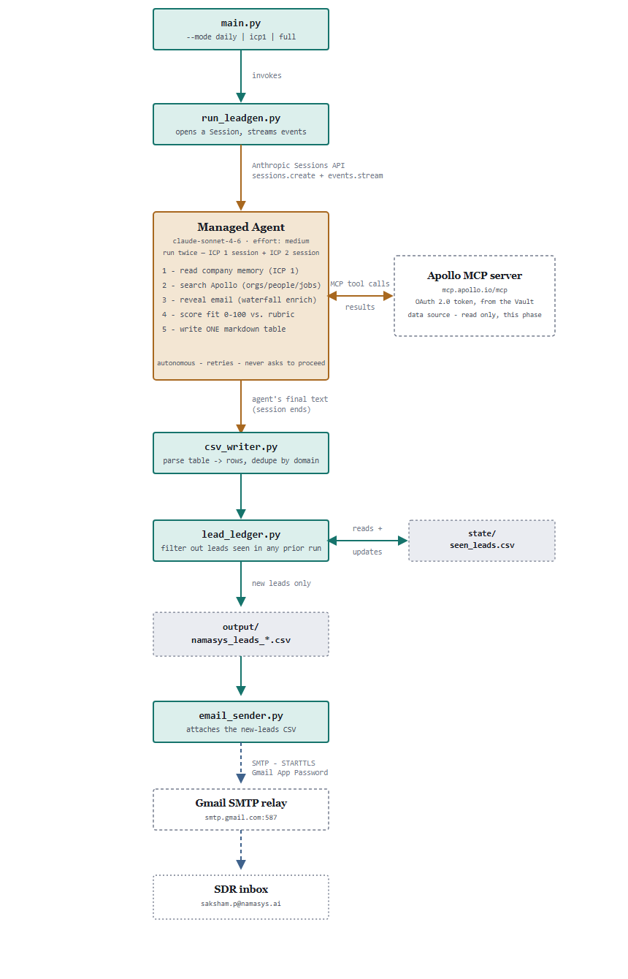
Figure 1. One run = two independent Agent sessions (ICP 1, ICP 2), merged back together in Python. Apollo is reached only inside the amber region, only via MCP.

Figure 2 — Two gated paths out of the reviewed CSV
Nothing past the SDR's inbox happens automatically. Both destinations below require a typed “y” — and they're independent: run one, both, or neither.
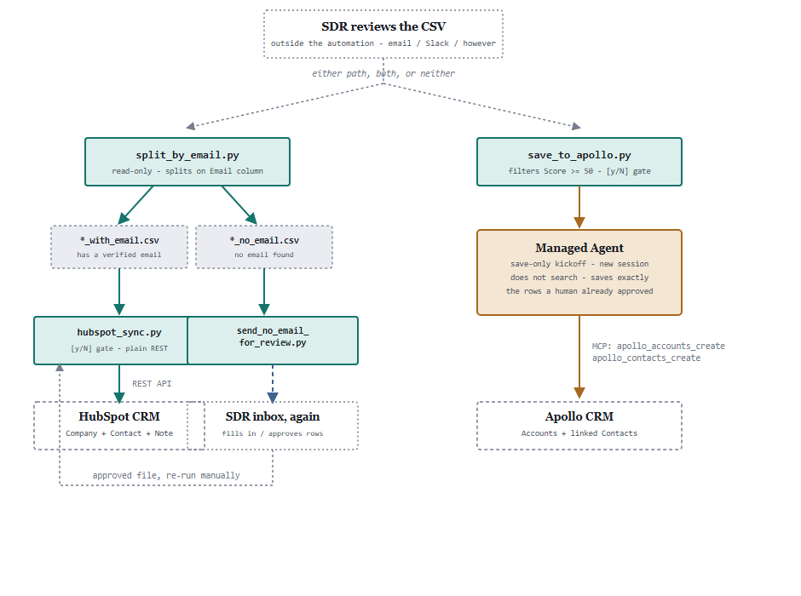
Figure 2. Apollo shows up a second time here — as a write destination, through a second, save-only Agent session. HubSpot never touches the agent at all; it's a direct REST integration.

Table A — every component, one line each
All 14 scripts plus the agent itself, in three categories: things the agent reasons through, deterministic Python, and one-time provisioning that isn't part of a normal run.
Component | Category | What it does | Run how often
Managed Agent | agent (LLM) | Searches / scores / enriches leads via Apollo MCP; also saves pre-approved leads when given a save-only kickoff. | Inside every session
main.py | script | Entry point — picks mode, runs session(s), dedupes, writes CSV, emails the SDR. | Daily / weekly
run_leadgen.py | script | Opens & streams Agent sessions; holds the ICP1/ICP2 kickoff prompts; auto-approves stray tool confirmations. | Imported by main.py, save_to_apollo.py
csv_writer.py | script | The 17-column schema; parses the agent's markdown table into rows; dedupes by domain. | Imported everywhere
lead_ledger.py | script | Permanent seen-leads ledger; filters out anything surfaced in a previous run. | Imported by main.py
email_sender.py | script | SMTP sending — the main leads email and the no-email review-request email. | Imported by main.py, send_no_email_for_review.py
split_by_email.py | script | Read-only split of a CSV into with-email / no-email files, purely on the Email column. | Manual, after main.py
send_no_email_for_review.py | script | Emails the no-email CSV to the SDR to fill in / approve rows before HubSpot. | Manual, when needed
hubspot_sync.py | script | Plain REST push into HubSpot — Company always, Contact + Note when an email exists. | Manual, human-confirmed
save_to_apollo.py | script | Filters Score ≥ 50, previews, then opens a save-only Agent session to write Apollo CRM. | Manual, human-confirmed
config.py | script | Loads .env; exposes constants and require_*_config() validators. | Imported everywhere
setup_agent.py | one-time setup | Creates the Environment + Vault + Agent from the YAML files. | Once, or full reset
update_agent.py | one-time setup | Pushes a new Agent version after the YAML system prompt changes. | After each YAML edit
setup_namasys_memory.py | one-time setup | Seeds the Memory Store from namasys_company_profile.md. | Once, or on profile refresh
apollo_oauth_connect.py | one-time setup | OAuth 2.0 + PKCE dance; stores the Apollo token in the Vault. | Once, or to reconnect

Table B — exactly what the agent does
The agent runs under two different kickoffs, and does different work under each.
Kickoff | Step | Detail
Search (ICP1/ICP2) | Ground itself | Reads the read-only company-profile Memory Store before judging ICP 1 fit.
Search | Find candidates | Apollo org/people search; job-postings search for ICP 2's hiring signal.
Search | Reveal email | Runs the waterfall email-enrichment tool, then polls for the async result — mandatory, never optional.
Search | Score | 0–100 against the ICP rubric; writes a transparent Score Breakdown, flags anything under 50.
Search | Report | Returns exactly one markdown table, "-" for any blank cell, no narration before or after.
Save (save_to_apollo.py) | Accept the list | Receives the exact human-approved rows in the kickoff message — does not search or re-verify anything.
Save | Write Apollo | Calls the Accounts and Contacts create tools for each row, linking Contacts to their Account.
Both | Stay unattended | Runs autonomously (never pauses to ask permission), retries transient tool errors, auto-continues past any stray "ask" permission event.

Table C — what Apollo is actually used for
Apollo plays two roles in this pipeline, and Python code never talks to it directly for lead data — only the agent does, and only over MCP.
Role | Triggered by | Mechanism | What happens
Data source (read) | main.py → search sessions | Apollo MCP tool calls | Agent searches, enriches, and scores — our code only ever reads the agent's finished markdown text.
CRM destination (write) | save_to_apollo.py → save session | Apollo MCP tool calls | Pre-approved (Score ≥ 50, human-confirmed) leads become Accounts + Contacts in Apollo's own CRM.
Auth setup (one-time) | apollo_oauth_connect.py | Direct HTTPS to Apollo's OAuth endpoints | Registers a client, exchanges a code for tokens, stores them in the Vault — the one place raw Python touches Apollo, and only for auth, never lead data.

Table D — every connection, by protocol
The full answer to “how is everything wired together” — five distinct mechanisms, no two components talking to each other more than one way.
From → To | Mechanism | Auth | What flows
run_leadgen.py → Managed Agent | Anthropic Sessions API (SSE) | ANTHROPIC_API_KEY | Kickoff message in, streamed agent events + final text out.
Managed Agent ⇄ Apollo | MCP (Model Context Protocol) | OAuth 2.0 token, from the Vault | Search / enrich / create tool calls and their results — the only path lead data takes to or from Apollo.
apollo_oauth_connect.py → Apollo | Direct HTTPS (urllib) | PKCE + Dynamic Client Registration | One-time: registers a client, gets an access + refresh token.
hubspot_sync.py → HubSpot | Plain REST (urllib) | Bearer token, Private App | Upserts Companies/Contacts, creates Notes — no agent involved at all.
email_sender.py → Gmail | SMTP (smtplib, STARTTLS) | Gmail App Password | Lead CSV or review-request CSV, as an attachment, to the SDR.
run_leadgen.py → Memory Store | Session resource mount (read-only) | Vault-scoped, per session | namasys_company_profile.md, grounding ICP 1 judgment.
Generated from a live read of every script in lead agent/ and cross-checked against HANDOFF.md — reflects the pipeline as of 2026-08-13, after the HubSpot company-upsert fix (search-then-create/update, in place of the batch-upsert-by-domain call HubSpot's portal wouldn't allow).

