HOSPITAL MANAGEMENT SYSTEM
Comprehensive Project Report

Java Capstone Project
B.Tech Computer Science Engineering
University of Petroleum & Energy Studies (UPES)
Batch 27 | Semester IV | 2025

Team Members | Tech Stack
Member 1 — Patient + Records  Member 2 — Doctor + Appointments  Member 3 — Pharmacy + Billing  Member 4 — Admin + Reports | Java 17+ | Java Swing  MySQL 8.x | JDBC  Railway Cloud DB  IntelliJ IDEA | Git + GitHub

1. Introduction

1.1 Project Overview
The Hospital Management System (HMS) is a comprehensive Java desktop application that automates core hospital operations. Built using Java Swing for the GUI and MySQL for persistent storage hosted on Railway cloud, it follows a clean 4-layer architecture: Presentation, Service, DAO, and Database layers with strict separation of concerns.

1.2 Problem Statement
Manual, paper-based hospital operations suffer from:
- Double booking of doctor appointment slots with no conflict detection
- Inability to track patient medical history across multiple visits
- Expired or low-stock medicines going unnoticed in the pharmacy
- Manual billing errors and no real-time revenue tracking
- No centralized administrative dashboard for hospital statistics

1.3 Objectives
- Build a fully-featured HMS covering Patient, Doctor, Appointment, Pharmacy, Billing, and Admin modules
- Implement core OOP principles: abstraction, inheritance, encapsulation, and polymorphism
- Use JDBC with PreparedStatements for all database operations
- Prevent double-booking at both Java service layer and MySQL UNIQUE KEY constraint level
- Deploy MySQL on Railway cloud for shared access across all team machines
- Package the application as a runnable JAR requiring no IDE or MySQL setup

1.4 Scope
The system covers six modules: Patient Management, Doctor Management, Appointment Booking with conflict detection, Pharmacy Inventory with expiry alerts, Billing with revenue tracking, and Admin Reports dashboard.

2. Use Case Diagram
The use case diagram shows all actors interacting with the system and the operations each actor can perform. The Admin has the highest privilege with access to all modules. Doctors can view appointments. Patients interact with booking and billing.
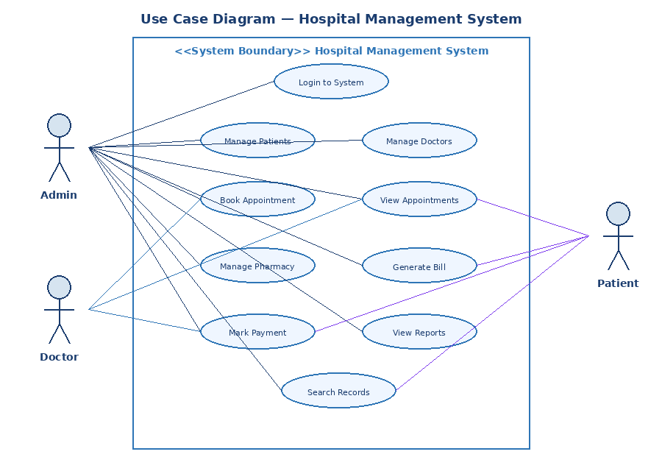
Actor | Role | Use Cases
Admin | System administrator | Login, manage patients/doctors/pharmacy/billing, view reports
Doctor | Medical professional | View appointments, view patient records
Patient | Hospital patient | Book appointments, view bills, search records

3. System Architecture
The HMS follows a strict 4-layer architecture. No layer communicates with a non-adjacent layer — UI only calls Services, Services only call DAOs, DAOs only talk to MySQL. This is the Separation of Concerns principle.
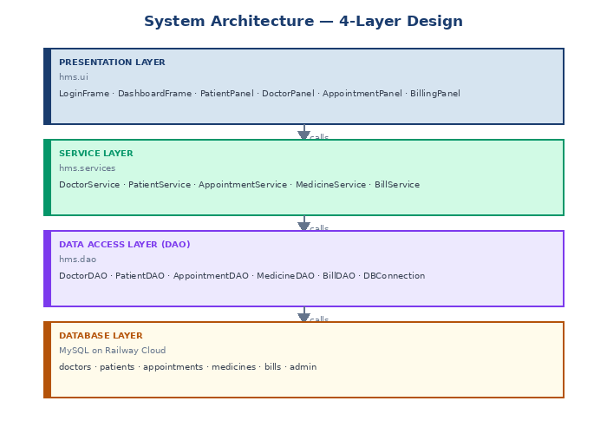
Layer | Package | Responsibility
Presentation | hms.ui | All Swing frames and panels — user interaction and display
Service | hms.services | Business logic, validation, exception throwing
Data Access | hms.dao | All SQL via JDBC PreparedStatements — no business logic here
Database | MySQL / Railway | Persistent storage — 6 tables with foreign key constraints

4. Data Flow Diagram (Level 0)
The Level 0 DFD shows the highest-level view of the system — how data flows between external entities (Admin, Doctor, Patient), the central HMS process, and the MySQL data store. Arrows represent data flows in both directions.
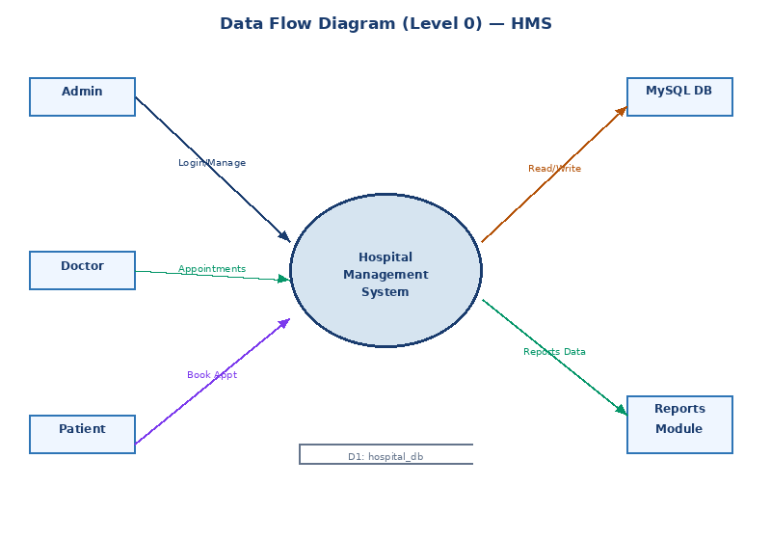
Level 0 DFD treats the entire system as a single process bubble. It shows what data enters, what exits, and where it is stored — without showing internal processing details.

5. Entity Relationship (ER) Diagram
The ER diagram shows all six database entities and their relationships. Primary keys (PK) identify each record uniquely. Foreign keys (FK) create relationships between tables. The appointments table is the central entity linking patients and doctors.
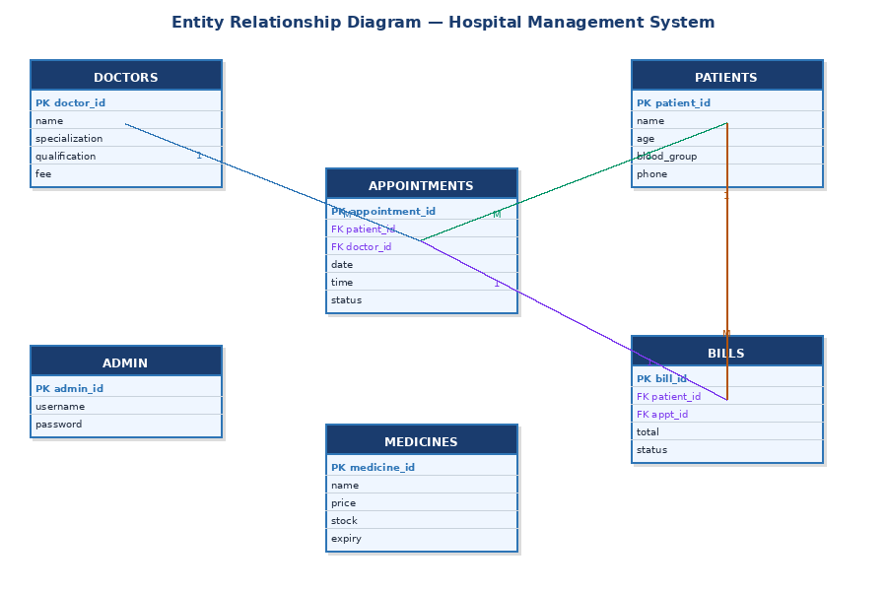

5.1 Relationships
Entity 1 | Entity 2 | Cardinality & Description
doctors | appointments | 1 to Many — one doctor can have many appointments
patients | appointments | 1 to Many — one patient can book many appointments
appointments | bills | 1 to 1 — each appointment generates one bill
patients | bills | 1 to Many — patient can have multiple bills over time

5.2 Key Database Constraints
- PRIMARY KEY on every table ensures each record is uniquely identifiable
- FOREIGN KEY (patient_id) and (doctor_id) on appointments enforce referential integrity — no orphan records
- UNIQUE KEY (doctor_id, appointment_date, appointment_time) prevents double booking at the database level
- ON DELETE CASCADE ensures when a patient/doctor is deleted, linked records are also removed
The UNIQUE KEY double-booking constraint is the second line of defense — even if the Java service check fails, the database will reject the INSERT with SQLIntegrityConstraintViolationException.

6. Class Diagram
The class diagram shows the complete OOP hierarchy. Person is abstract and cannot be instantiated directly. Doctor extends Person and implements the Schedulable interface. Patient extends Person. All custom exceptions extend RuntimeException.
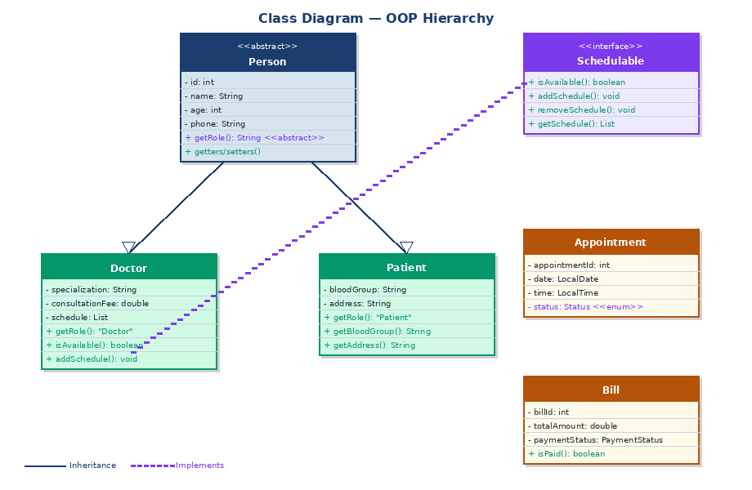

6.1 Key Design Decisions
- Person is abstract — forces every subclass to implement getRole(), ensuring type identity across the system
- Schedulable is an interface — any future entity (e.g. Nurse, Staff) can implement it without changing the class hierarchy
- Custom exceptions extend RuntimeException — unchecked, so service methods stay clean without throws declarations
- Status and PaymentStatus are nested enums — scoped inside their owning class, no risk of invalid string values
- schedule List in Doctor returns a defensive copy — prevents external mutation of internal state

7. Process Flowcharts

7.1 Login Process Flowchart
The login process validates at two levels: empty field check in Java before any database call, then credential verification via JDBC query. On failure at either point the user sees a specific error message and can retry.
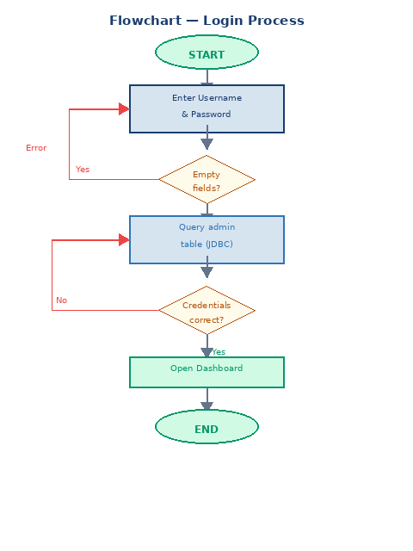

7.2 Book Appointment Flowchart
Appointment booking passes through three sequential validation gates before any database write. Each gate throws a specific custom exception on failure, caught by the UI and displayed as a user-friendly dialog.
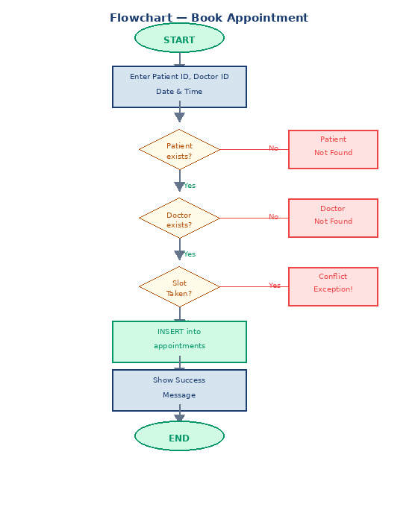
Validation Gate | Exception Thrown
Patient ID not found in DB | PatientNotFoundException
Doctor ID not found in DB | DoctorNotFoundException
Slot already booked | AppointmentConflictException

8. Sequence Diagram — Book Appointment
The sequence diagram shows the exact method call chain when a user books an appointment. It demonstrates the 4-layer architecture in action — each layer communicates only with the adjacent layer, and return values propagate back up the chain.
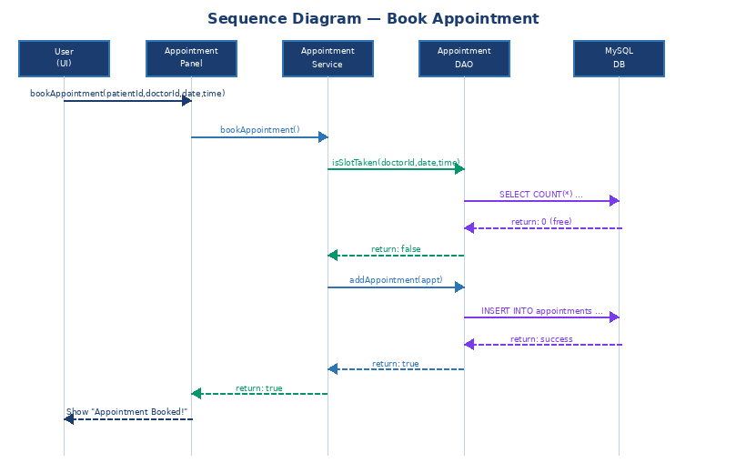
# | Layer | Action
1 | UI (AppointmentPanel) | User clicks Book — panel calls AppointmentService.bookAppointment()
2 | Service Layer | Validates patient exists via PatientService, doctor exists via DoctorService
3 | DAO Layer | AppointmentDAO.isSlotTaken() queries DB with SELECT COUNT(*)
4 | MySQL DB | Returns 0 — slot is free
5 | DAO Layer | Returns false to service layer
6 | Service Layer | Calls AppointmentDAO.addAppointment() to INSERT record
7 | MySQL DB | Executes INSERT, returns success
8 | UI (AppointmentPanel) | Shows JOptionPane "Appointment Booked!" message

9. Java Concepts Demonstrated

9.1 OOP Principles

Abstraction
Person is declared abstract — it enforces a contract (getRole()) without providing an implementation. Neither Doctor nor Patient could exist without extending it.
public abstract class Person {
public abstract String getRole(); // subclass MUST implement this
}

Inheritance
Doctor and Patient both extend Person, inheriting id, name, age, gender, phone, email and all getters/setters without code duplication.
public class Doctor extends Person implements Schedulable {
@Override
public String getRole() { return "Doctor"; }
}

Interface Implementation
The Schedulable interface defines a scheduling contract. Doctor implements all four methods, providing concrete scheduling behavior.
public interface Schedulable {
boolean isAvailable(LocalDateTime dateTime);
void addSchedule(LocalDateTime dateTime); // throws if slot taken
}

Encapsulation
All model fields are private. The getSchedule() method returns a defensive copy of the list to prevent external mutation of the Doctor's internal schedule state.
public List<LocalDateTime> getSchedule() {
return new ArrayList<>(schedule); // copy, not reference
}

9.2 JDBC & PreparedStatements
All database operations use PreparedStatements throughout the DAO layer. This prevents SQL injection and provides type-safe parameter binding.
String sql = "INSERT INTO doctors (name, age, phone, specialization) VALUES (?,?,?,?)";
try (PreparedStatement ps = conn.prepareStatement(sql)) {
ps.setString(1, d.getName());
ps.setInt(2, d.getAge());
return ps.executeUpdate() > 0;
}

9.3 Java Streams
MedicineService and BillService use Java Streams for in-memory filtering and aggregation, avoiding extra SQL round trips.
// Filter expired medicines in-memory
return medicineDAO.getAllMedicines().stream()
.filter(Medicine::isExpired) // method reference
.collect(Collectors.toList());

// Sum revenue of paid bills
return billDAO.getAllBills().stream()
.filter(Bill::isPaid)
.mapToDouble(Bill::getTotalAmount)
.sum();

9.4 Custom Exceptions
Four domain-specific exceptions extend RuntimeException. They carry meaningful messages and are thrown by Services, caught by the UI layer.
public class AppointmentConflictException extends RuntimeException {
public AppointmentConflictException(String msg) { super(msg); }
}

// UI layer catches it and shows a friendly dialog:
catch (AppointmentConflictException ex) {
JOptionPane.showMessageDialog(this, ex.getMessage(), "Slot Taken", WARNING_MESSAGE);
}

Concept | Location | Implementation
Abstraction | Person.java | abstract getRole() method
Inheritance | Doctor, Patient | extends Person
Interface | Schedulable | implements on Doctor
Encapsulation | All models | private fields + defensive copy
Custom Exceptions | hms.exceptions | 4 RuntimeException subclasses
JDBC | hms.dao | PreparedStatements in all DAOs
Collections | All DAOs, Doctor | ArrayList, List interface
Streams | MedicineService, BillService | filter, mapToDouble, sum
Enum | Appointment, Bill | Status, PaymentStatus nested enums
Singleton | DBConnection | Single shared JDBC connection
DAO Pattern | hms.dao | Separate class per entity, SQL isolated

10. Test Cases
# | Module | Test Case | Expected | Result
1 | Login | Correct admin credentials | Dashboard opens | PASS
2 | Login | Wrong password | Error dialog shown | PASS
3 | Login | Empty username/password | IllegalArgumentException | PASS
4 | Patient | Add new patient with all fields | Appears in table | PASS
5 | Patient | Search by partial name | Filtered results shown | PASS
6 | Patient | Edit patient phone number | Updated in DB and table | PASS
7 | Patient | Delete patient | Removed with cascade | PASS
8 | Doctor | Add doctor with specialization | Appears in table | PASS
9 | Doctor | Search by specialization | Filtered results shown | PASS
10 | Appointment | Book valid patient + doctor + slot | Appointment created | PASS
11 | Appointment | Book same doctor same slot twice | ConflictException shown | PASS
12 | Appointment | Mark appointment Completed | Status updated in table | PASS
13 | Appointment | Cancel an appointment | Status Cancelled in table | PASS
14 | Pharmacy | Add new medicine with expiry | Appears in table | PASS
15 | Pharmacy | Filter expired medicines | Only expired shown | PASS
16 | Pharmacy | Expired row color | Row highlighted red | PASS
17 | Pharmacy | Update stock quantity | Quantity updated in DB | PASS
18 | Billing | Generate bill from appt | Total calculated correctly | PASS
19 | Billing | Mark bill as Paid | Revenue counter updates | PASS
20 | Reports | Click Refresh | All 6 stat cards update | PASS

11. Limitations & Future Scope

11.1 Current Limitations
- Admin password stored as plain text — production systems should use BCrypt hashing
- Single admin role — no separate Doctor or Patient login portal
- Desktop-only — Swing UI cannot be accessed from a browser or mobile device
- No PDF bill generation — invoices are viewed only within the application
- No email or SMS notifications for appointment reminders
- Basic reporting — no charts or graphs in the Reports module

11.2 Future Scope
- Migrate to Spring Boot + React web application for browser access from any device
- Add BCrypt password hashing and JWT session management for secure authentication
- Implement multi-role login — separate portals for Admin, Doctor, and Patient
- PDF bill generation using Apache PDFBox or iText library
- Email appointment reminders using JavaMail API
- SMS notifications via Twilio API integration
- Interactive charts in Reports module using JFreeChart
- Multi-hospital/branch support with location-based management

12. Conclusion
The Hospital Management System successfully demonstrates a production-grade Java desktop application using industry-standard software engineering practices. All six modules are fully functional, connected to a live Railway cloud database, and packaged as a runnable JAR for easy distribution to evaluators and teammates.
The project showcases mastery of all core Java concepts required for the B.Tech CSE curriculum — abstract classes, interfaces, inheritance, JDBC, Collections Framework, Java Streams, custom exceptions, and Java Swing GUI development. The clean 4-layer architecture ensures the codebase remains maintainable and extensible as new features are added.
The double-booking prevention system, enforced at both the Java service layer and the MySQL UNIQUE KEY database constraint, exemplifies defensive programming and a thorough understanding of data integrity across multiple system layers.

Total deliverables: 33 Java files across 6 packages, 6-table MySQL schema on Railway cloud, runnable JAR, GitHub repository with README, and this comprehensive project report.

