**NATIONAL INSTITUTE OF TECHNOLOGY DELHI**

**ASSIGNMENT**

**NUMERICAL METHODS LAB, MAP281**



**NAME** : SAKSHAM MITTAL

**ROLL NO**  : 181210045

**BRANCH**  : CSE 2ND YEAR, G2

**SUBMITTED TO**  : DR. PRASHANT KUMAR

**PROGRAMMING LANGUAGE USED** : MATLAB R2018b

**Example 3.4 (Page 115)**

**Code:**

clc;

clear all; close all;

n = input("Number of elements: ");

x=[];

fx=[];

for i = 1:n

xi = input("x"+i+": ");

x = [x xi];

fxi = input("fx"+i+": ");

fx = [fx fxi];

end

fd=fx;

i=n-1;

dif=0;

while(i>0) j=1;

dif=dif+1;

for j = 1:i

fd(n+1-i, j) = (fd(n-i, j+1)-fd(n-i, j));

end

i=i-1;

end

h = x(2)-x(1);

x0 = input("Enter value of x: "); s = (x0-x(1))/h;

k = s+1;

f11 = (fx(k+1)-fx(k))/h;

f12 = (-3*fx(k)+4*fx(k+1)-fx(k+2))/(2*h);

f2 = (fx(k+2)-2*fx(k+1)+fx(k))/(h^2);

fprintf("First differentiation using First Order: %f\n" ,f11); fprintf("First differentiation using Second Order: %f\n" ,f12);

fprintf("Second differentiation using First Order: %f\n" ,f2);

**Output:**

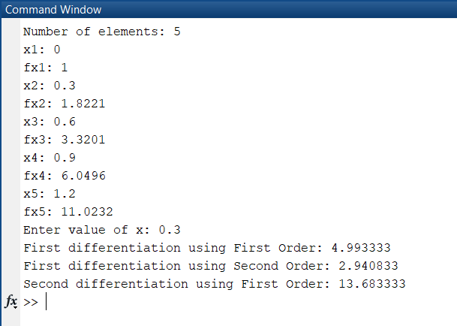

**Example 3.12 (Page 132)**

**Code:**

function[y] = trapezium(a,b,n)

y = 0;

k = (b-a)/n;

for i = 1:n

temp = (func(a+(i-1)*k)+func(a + i*k))*k/2;

y = y + temp;

end

end

**For function func:**

function[y]=func(x)

y=1/(1+x);

end

**Output:**

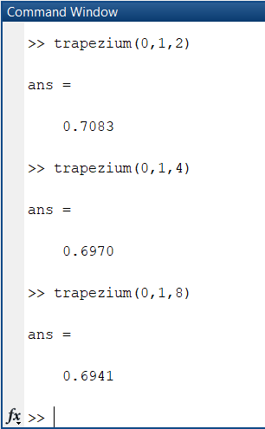

**Example 3.18 (Page 143)**

**Code:**

function[y] = simpson(a,b,n)

y = 0;

k = (b-a)/n;

for i = 0:n

if i==0 || i==n

y = y + func(a+i*k);

elseif mod(i,2)~=0

y = y + 4*func(a+i*k);

else

y = y + 2*func(a+i*k);

end

end

y = y*k/3;

end

**For function func:**

function[y]=func(x)

y=1/(x^2 + 6*x + 10);

end

**Output:**

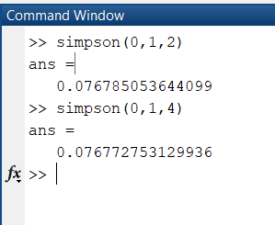

**Example 3.18 (Page 143)**

**Code:**

function[y] = simpson38(a,b,n)

y = 0;

k = (b-a)/n;

for i = 0:n

if i==0 || i==n

y = y + func(a + i*k);

elseif mod(i,3)==0

y = y + 2*func(a+i*k);

else

y = y + 3*func(a+i*k);

end

end

y = 3*y*k/8;

end

**For function func:**

function[y]=func(x)

y=1/(5 + 3*x);

end

**Output:**

