Name – Saksham Bairathi

Roll no – 2018btechcse114

Lab Assignment

About Project

This react app is a clone to Tinder (a social media platform) it contains users and their details in the form of a card which will be visible to all users using the react- app. You can swipe through and watch all cards added in it.

It is connected to mongodb database and the get and post request has been included to add and retrieve the data. Although for now I didn’t create a form instead I used postman to post data and used axios to fetch the data.

It is a single page application containing only a fragment of features of Tinder.

I have deployed the front-end of the application on firebase and backend on Heroku

Here is the link for

Front-end

<https://tinder-clone-ffda5.web.app/>

Back-end

<https://tinder-database.herokuapp.com/tinder/cards>

Here are some of the snippets of the working project

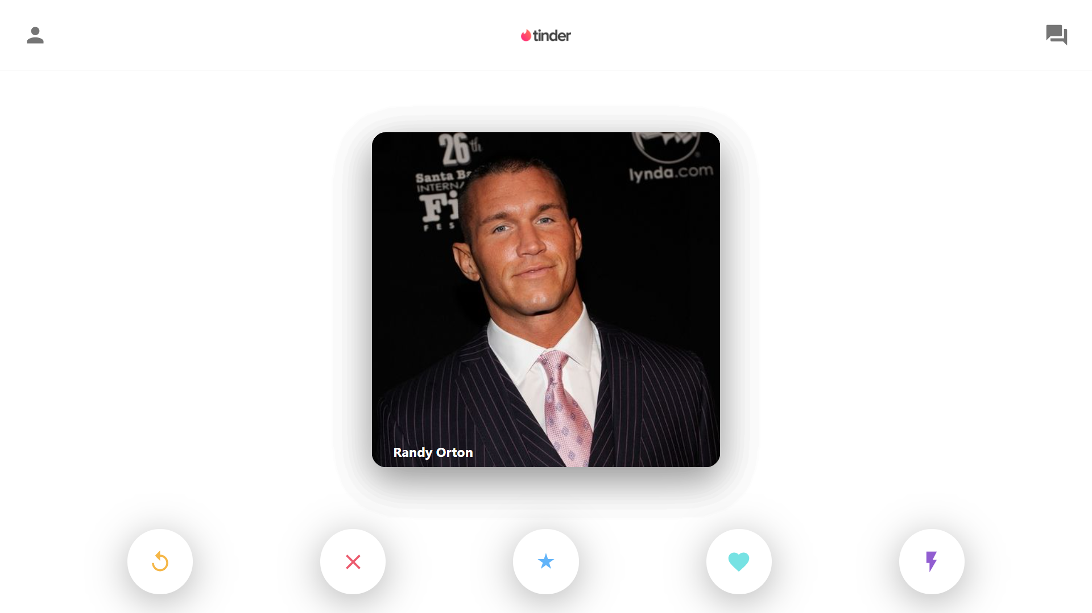

This is the starting page of the application

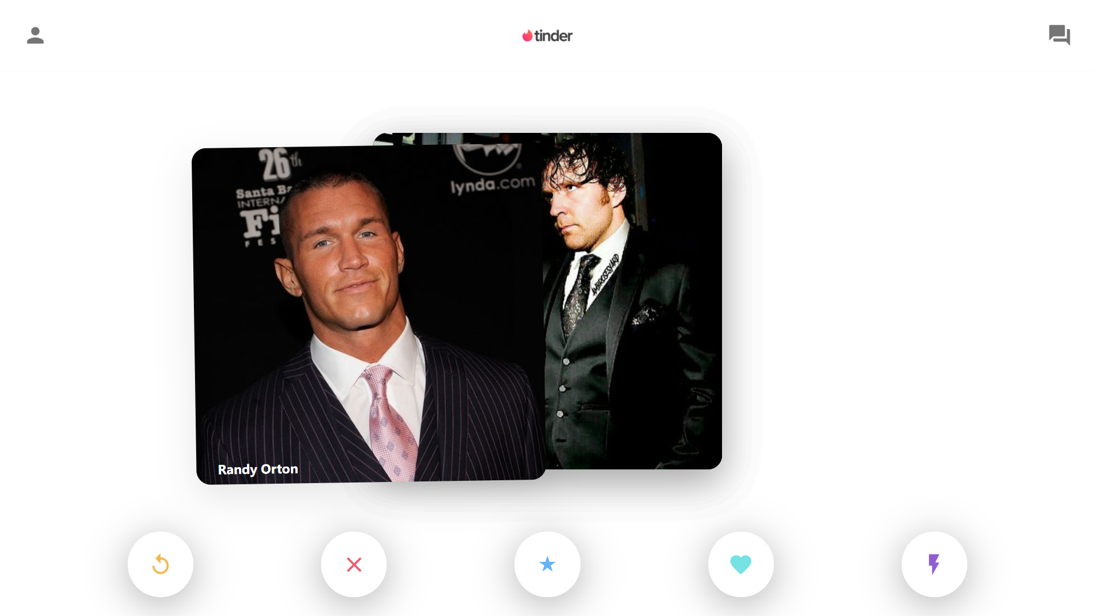

As you can see you can swipe and see the next card

The buttons down contain the reload but and a window close button etc.

The backend screen shots

