Submitted by
Shreya Patel (B16CS025)
Saksham Gupta (B16CS030)
Revision History
Date | Version | Description | People
17 Feb 2018 | 1.0 | Created Use-case and Sequence diagrams | Shreya Patel
17 Feb 2018 | 1.0 | Created Class and Activity diagrams | Saksham Gupta
5 March 2018 | 2.0 | Corrected Use-case diagram and changes in formatting | Shreya Patel  Saksham Gupta

Table of Contents
1. Introduction 4
1.1 Purpose 4
1.2 Scope 4
1.3 Constraints 4
1.4 Assumptions and Dependencies 4
1.5 Definitions, Acronyms and Abbreviations 5
1.6 References 5
1.7 Organization of the Document 5
2. Overall Description 6
2.1 Product Functions 6
2.2 User Characteristics 12
3. Specific Requirements 12
3.1 Use case description 12
3.2 Supportability 15

Software Requirements Specification

Introduction

Purpose
The purpose of this document is to illustrate the requirements and describe the development and operations of the software- Objective Exam. This project aims at creating an objective exam portal for students to attempt an exam (quiz) and view the result as well as adding or editing the questions in the database by the faculty members. This would be useful for educational institutes for evaluating students by reducing time consumed and paperwork for manual examination.

Scope
The software aims at providing an objective exam portal for the students to attempt the exam as well as a convenient way for the faculties to generate and manage database of questions.
Scope of Faculty
- The faculty will be able to login using Login Id and Password.
- The faculty will be able to add questions, their options and correct answers alongwith the positive and negative marks associated with that particular question in the database.
- Only the faculty will have the access to the database of questions.
Scope of Student
- He will be able to register and login using login Id and Password.
- He will be able to take the test of different courses and get Score Sheet.
This software will thus help to reduce the hassle involved in taking exam on paper and the delay in displaying the results. Moreover the database for the questions can be managed easily for different courses.

Constraints
- The number of questions in a test will be limited and the test will be time-bounded.
- Student can attempt only one course test at a time. He cannot view others’ profile or results.

Assumptions and Dependencies
- Users should provide legitimate details while logging in or signing up.
- Students will attempt the tests of his registered courses only.
- The faculties are fixed, that is, no new faculty can be registered.
- The database of questions should contain atleast 10 questions of each course.
- The server where database is stored should be well secured.
- The end user has proper understanding about functionality of the software.
- All the hardware and software requirements are provided to the system so as to run this software.

Definitions, Acronyms and Abbreviations

Term | Definition
User | Includes both student and faculty
Student | User mostly a student who will attempt the test
Faculty | User mostly professors who will manage the database of questions

References
- Sommerville, Software Engineering
- Roger S. Pressman, Software Engineering: A Practitioner’s Approach
- UML@Classroom: An Introduction to Object-Oriented Modeling
- Wikipedia – en.wikipedia.org/wiki

Organization of the Document
- Section 2.1.1 talks about the functional requirements or the capabilities of the software and the functions that different users can perform through the software.
- Section 2.1.2 describes the other system hardware requirements or other requirements that must be met for the software to run efficiently and effectively.
- Section 2.2 gives brief description of the different users interacting with the software.

Overall Description

Product Functions

Functional Requirements
- All the users, both students and faculty, can login into the system.
- The faculty can add, edit or delete the questions of his course from the database.
- Students can select a course from the list of courses and can attempt the MCQs test.
- The student can view the Score sheet after conducting the test.

Use Case Diagram

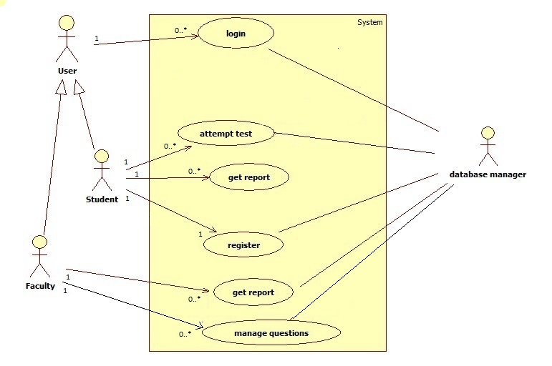

Class Diagram
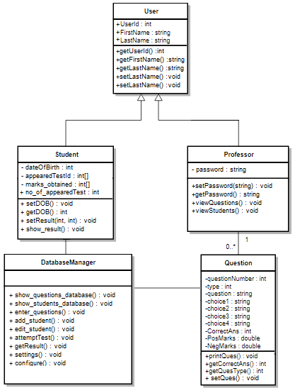

Sequence Diagram

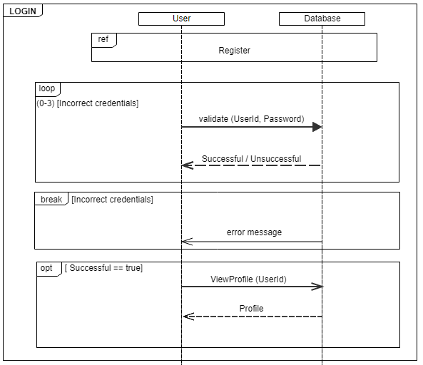

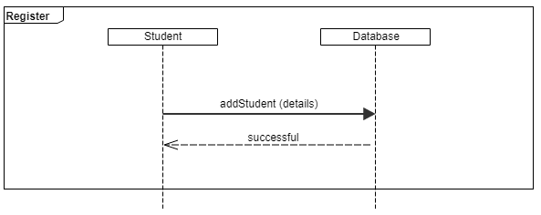
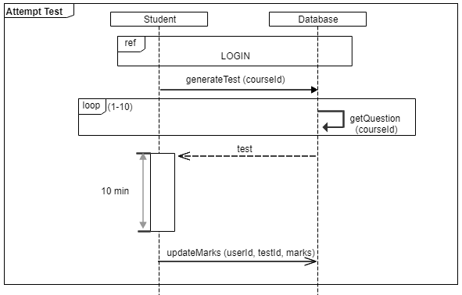

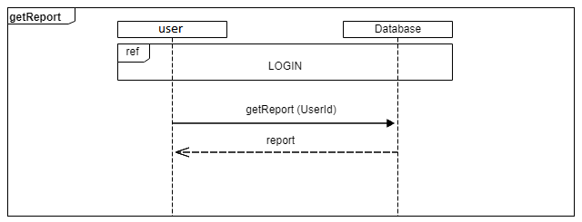

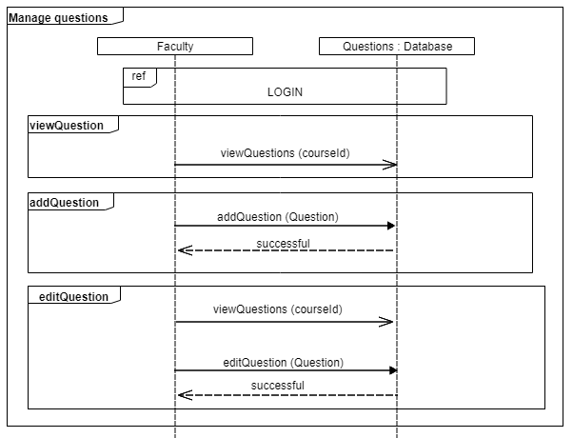

Activity Diagram
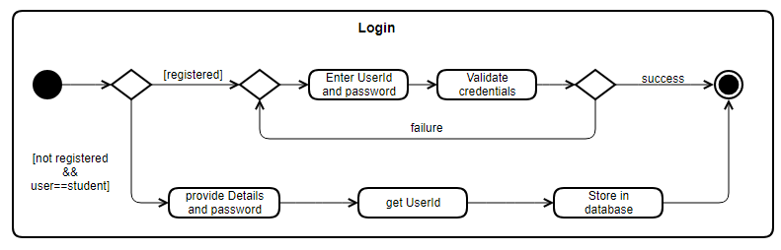

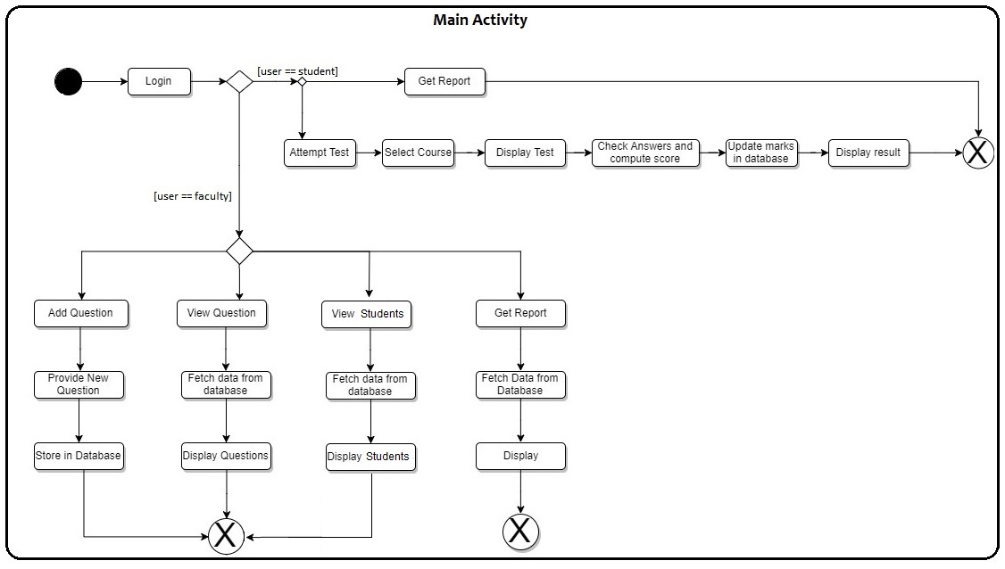

Non-Functional Requirements
- The computer system must be provided with the proper software/platform so as to run the software.

User Characteristics
There are two types of users – Student and Faculty who will interact with the software.
- All the users have unique login credentials.
- Student will select the course and attempt the MCQs test for that course. He will be then able to view the Score Sheet after the test is conducted
- Faculty will add, edit or delete the questions.
- All users have proper basic knowledge about operating the system and functionalities of the software.

Specific Requirements

Use case description

Name | Login
Short description | The user will provide valid username and password to login in the software
Actors | Professor, Student
Precondition | User has the username and password
Postcondition | The system accepts the username and password and user is logged in
Trigger | Launching of the software
System state in the event of an error | Display error message
Standard process | - The user enters username and password  - The credentials are verified from the database  - If valid, user is logged in and if not valid, error message is shown
Alternative process | 1. If the users have no username and password  2. User (only student) creates his own new account  3. Go to standard process

3.1.2

Name | Register
Short description | The user will be registered in the database
Actors | Student
Precondition | Users have all the required information
Postcondition | Users are registered
Trigger | Clicking on Register button
System state in the event of an error | Display error message
Standard process | - The user enters all the required information  - The credentials are stored in the database  - User is registered
Alternative process | 1. If the users did not enter all the required information  2. Prompt users to enter all the required information  3. Go to standard process

3.1.3

Name | Attempt test
Short description | The user (student) can attempt for the test
Actors | Student
Precondition | Users must be logged in
Postcondition | Students submit their answer
Trigger | Logging in the software and Clicking on attempt test
System state in the event of an error | Display error message
Standard process | - The user logs in the software  - The user wants to take the exam  - User search the course of which he/she wants to take a test of.  - User attempts the test  - Finish in the given time  - Submit the answer
Alternative process | 1. If the user did not finish all the given questions in given time  2. User have to submit what they answered  3. Go to standard process

3.1.4

Name | Get Report
Short description | The test report is generated by calculating the score of submitted answers by the student
Actors | Professor, Student
Precondition | All authorised must be logged in
Postcondition | The test reports are displayed
Trigger | Logging in the software
System state in the event of an error | Display error message
Standard process | - The user logs in the software  - The user wants to get the test reports  - The test reports are fetched from the database  - All the tests taken by a particular user are displayed
Alternative process | 1. If the student has not taken any test  2. Prompt the student to take a test

3.1.5

Name | Manage Questions
Short description | Displaying, adding, editing questions according to the courses
Actors | Professor
Precondition | All authorized must be logged in
Postcondition | The questions are displayed or added or edited
Trigger | Logging in the software by professors
System state in the event of an error | Display error message
Standard process | - Professor wants to manage questions  - Professor manages the question by their course ID.  - The questions are managed
Alternative process | 1. If professor fails to manage questions, he/she should contact database manager

Supportability

Naming Convention
All code will be written as specified by the Hungarian Naming Convention.

