- Injecting dependencies into a Spring application

Complete this assignment with XML Configuration.

Problem statement-1.1: Injecting dependencies

Write an Employee bean. Inject values into bean using DI and display all values. Refer the class diagram below

The output would look as shown below:
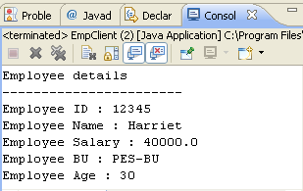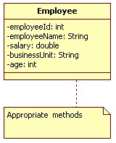
Class Diagram 1: Employee

 Keep each of the lab solutions separate, preferably in different packages/source folders

Problem statement-1.2: Injecting dependencies

Code SBU bean. Revisit the Employee bean and provide a method to retrieve SBU details (getSBUDetails()) for the employee. You will need to inject the SBU bean to the Employee bean as shown in the Class diagram below:

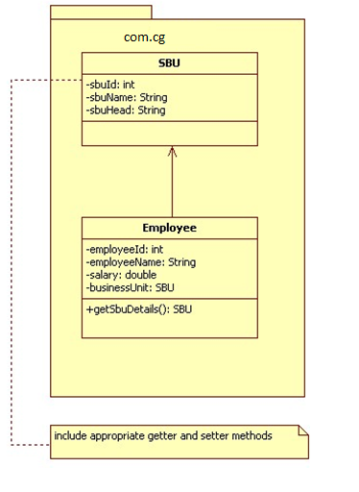
Class Diagram 2: SBU and Employee

The output would look as shown below:

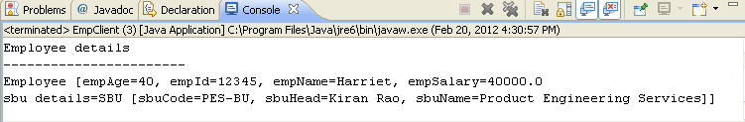

Problem statement-1.3: Injecting dependencies

Revisit the SBU bean. Create a new property called empList which will contain a list of all employees in the PES BU. Display the SBU details, followed by a list of all employees in that BU. To inject employee objects into the SBU bean, use “List” collection. Allocate two employees to PES. Refer Class diagram below

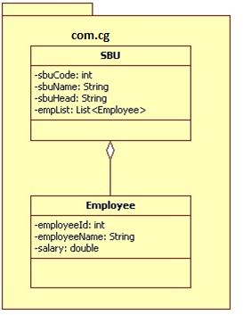

Class Diagram 3: SBU and Employee (Ver -2)

The output would look as shown below:

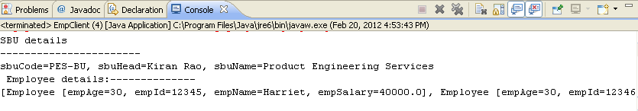

Problem statement-1.4: Injecting dependencies
Develop a console based spring application where main method of client class will retrieve employee information from Employee collection and displays info in the console as shown:

Input:
Employee ID : 100

Output:
Employee Info:
Employee ID :100
Emplpoyee NAME :Rama
Employee SALARY :12345.67

Refer diagram below for implementation details:

beans.xml
Collection

main()
EmployeeService
EmployeeDao

Employee

Flow Diagram - 1

Note: implement above application using

- Setter Injection
- Constructor Injection (use index and type attribute with constructor arg tag)
- Use different bean wiring mechanism like..
- By Name
- By Type
- Auto Wiring

Change Request: Now Change the application so that all components are autowired and components are automatically scanned.Use Spring boot API.

