**A REPORT**

**ON**

**Brain Tumor Extraction from MRI Images**

**Submitted in partial fulfillment of the course**

**EEE F435 Digital Image Processing**

**Submitted by**

**Saksham Consul 2016A8PS0424P**



**BIRLA INSTITUTE OF TECHNOLOGY & SCIENCE**

**PILANI, RAJASTHAN-333031**

**10 NOVEMBER 2018**

**Project Motivation**

Magnetic Resonance Imaging (MRI) is a tool which has the capacity to produce high quality images of the human body. MRI is often used as a diagnostics for treatment of brain, spinal cord, bones, joints, heart and other internal organs. MRI allows for various imaging profiles by changing the contrast, highlighting different tissue types. This property is taken advantage of to design multi-modal systems for automatic detection. One such important application is the detection of brain tumors. Tumors are defined as abnormal growth of tissue. Brain tumors are especially dangerous due to the delicate nature of the brain. As such, early detection of tumors is necessary for improved prognosis. Preprocessing of MRI images such as de-noising, morphological operations are required for feature extraction. In this study, axial slices of MRI scans are used to detect and extract the brain tumor. The brain tumor is seen as a brighter spot in the MRI scan.

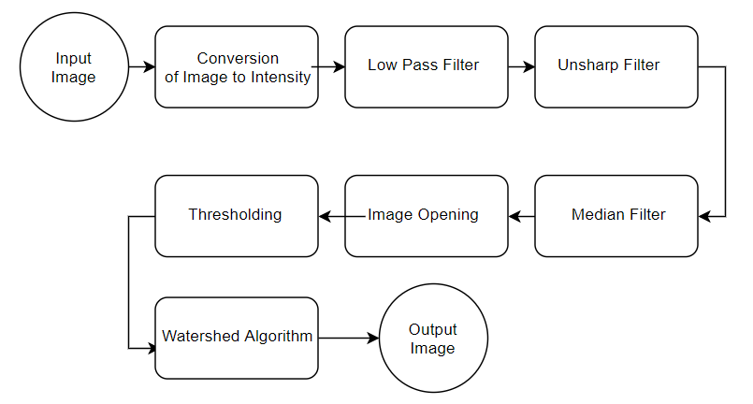

**Block Diagram**

**Objectives**

The objective of this project is to extract the brain tumor sections from the MRI scans. The extracted features were enclosed in a region to highlight the region of tumor. The MRI scans were obtained from an online repository.

**Validation Procedure**

**Low Pass Filter**

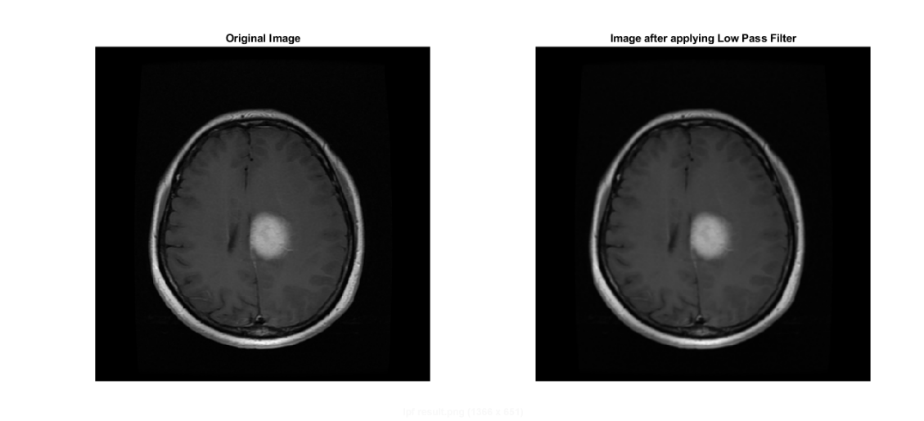The MRI image contains high frequency noise. To reduce the effect of noise, a 3x3 uniform averaging filter was applied. The drawback of this method is that the edges of the image get blurred.

**Unsharp Filter**

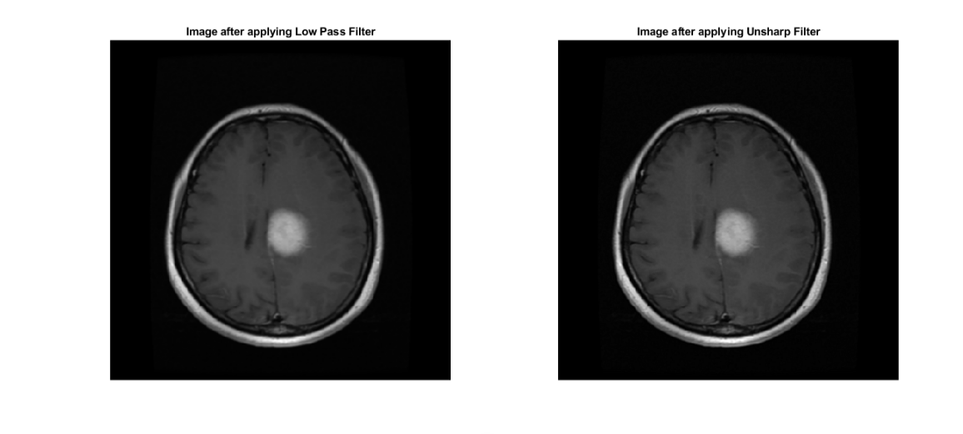To improve the edge quality, an unsharp filter was applied. An unsharp filter mask is the difference between the original image and blurred image. As such the mask contains the high frequency components such as the edge information. The original image is added with the mask to enhance the quality of the edges.

**Median Filter**

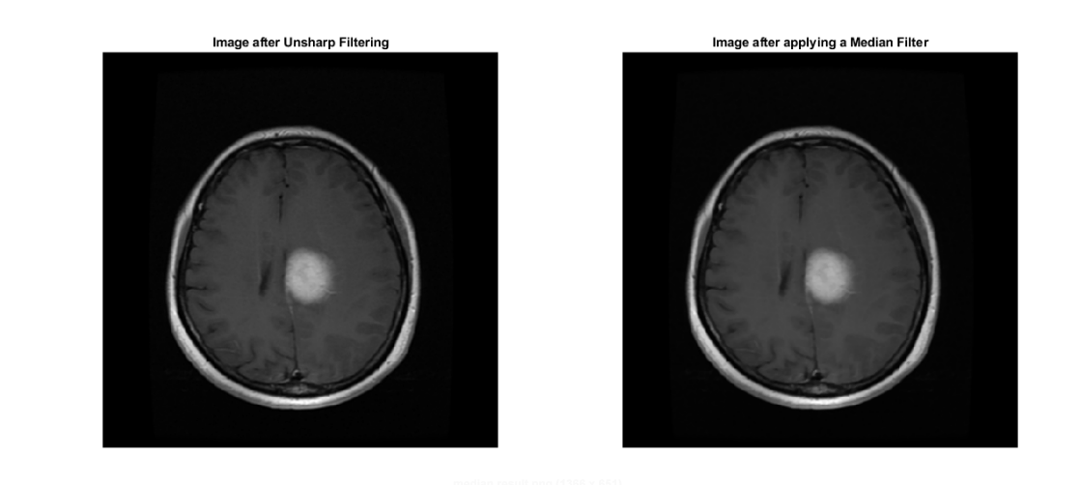Median filter is a non-linear filter and has the ability to remove salt and pepper noise. The median filter also does not degrade the edges, hence doing a better job than a simple averaging filter. A 3x3 median filter is applied with the padding taken as symmetric to ensure no image degradation due to boundaries

**Image Opening**

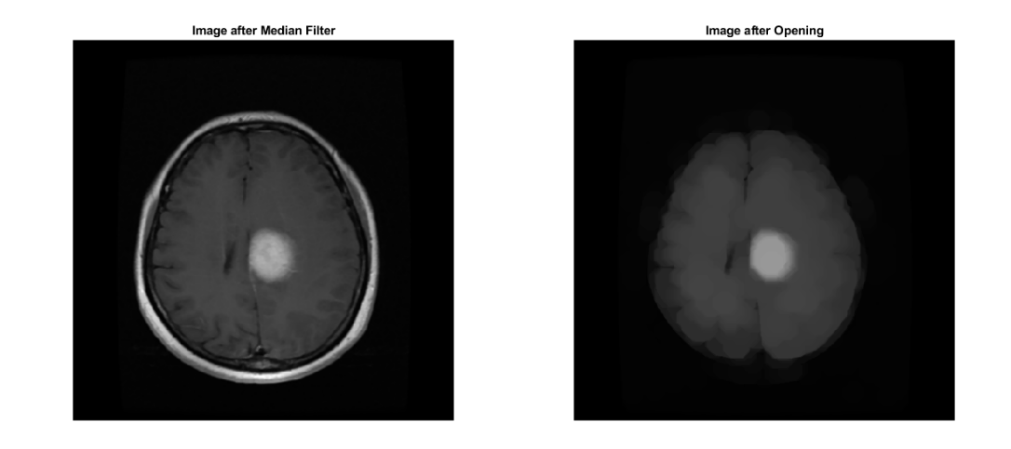Image opening is a morphological operation useful for removal of noise and certain elements as defined by the structuring element. Image opening can be defined as the dilation of the erosion of an image by a structuring element. The structuring element in this case was a disk of radius 15. Image opening was used to remove the skull artifact. In an axial MRI scan, the cranium image results in a bright white circumference which interferes with the thresholding process.

**Thresholding**

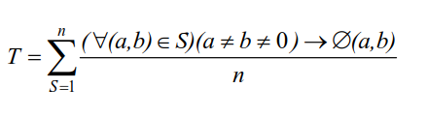The threshold value (T) was computed by taking the sum of unique values excluding zero (black) and dividing it by the count of unique values. This thresholding method was especially effective in segmenting the tumor section.

Where T is the threshold value, a and b are pixel values and n is the count of unique pixel values.

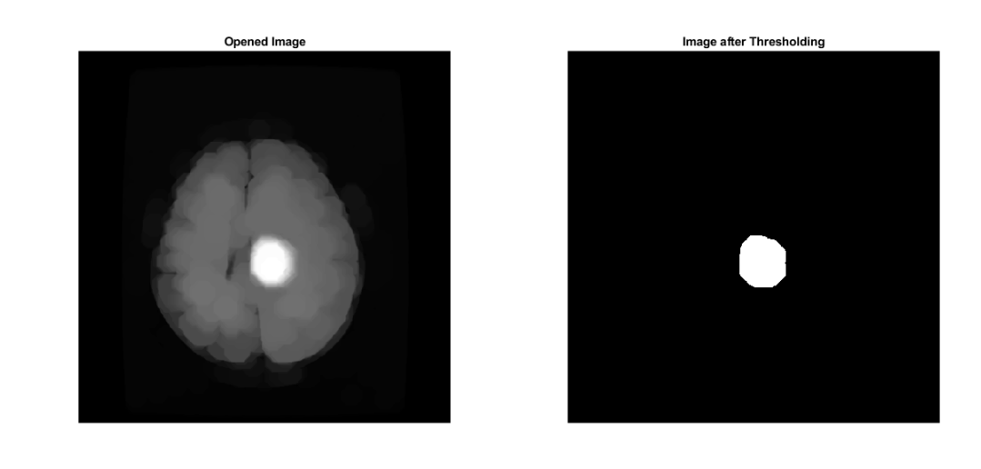

**Watershed Algorithm**

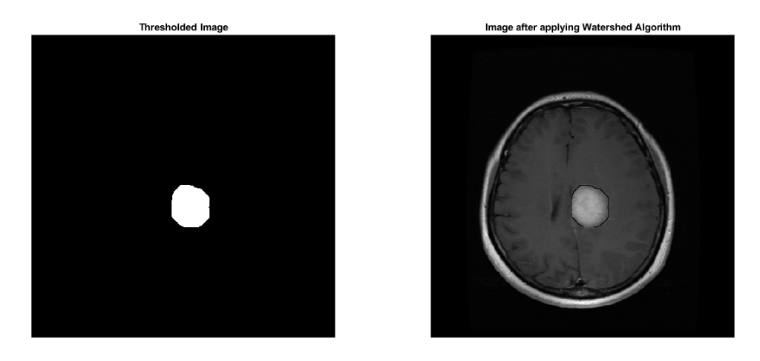The watershed algorithm was used to obtain the edges of the tumor. The principle of watershed algorithm is to treat the image as a 3-D structure with the height corresponding to the pixel intensity. As such the pixels of low intensity will be considered as drips. The algorithm then identifies regions of equal probability and marks them as watershed lines. The watershed lines encompass a particular catchment. Since the object in this case is bright, the complement is taken to ensure the object of interest lies in a catchment. Also, the background distance is taken as $-∞$ to ensure the object of interest lies in the catchment area. Finally the computed catchment ridges are used to mark the tumor region in the original image.

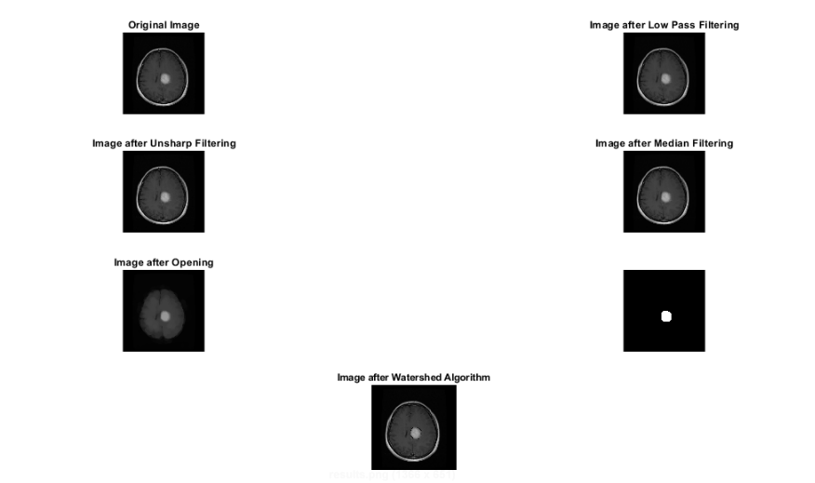**Results**

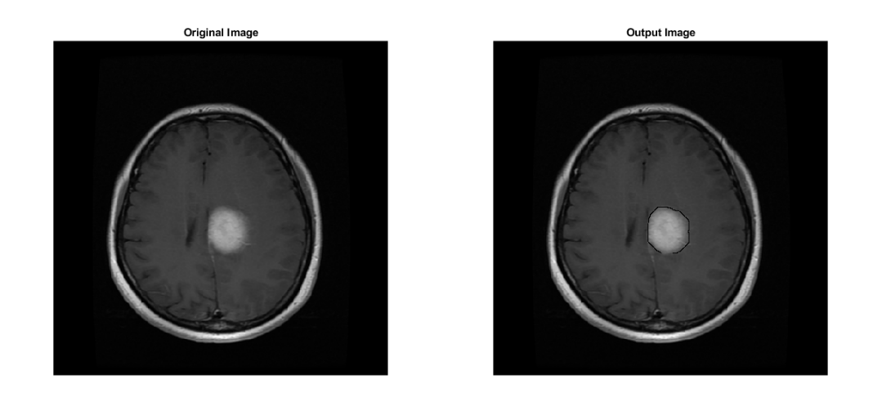

**Observations**

* The following algorithm is successful in identifying the brain tumors for axial MRI scans of the brain.
* The following algorithm is not adaptive and is not successful to extract brain tumor when different types of MRI scans were used.
* The algorithm will also face a problem when MRI scans of younger patients are used since the size of the cranium artifact will be smaller for young children.
* The brain tumor and surrounding tissues were of similar contrast and traditional thresholding algorithms such as Otsu’s method were incapable of selecting the region of interest.
* For cleaner and adaptive feature extraction, an intelligent algorithm needs to be used.

**Test Image Sources**

To test the credibility of the algorithm, a select few images were chosen from <https://figshare.com/articles/brain_tumor_dataset/1512427>

**References**

[1] Cheng, Jun (2017): brain tumor dataset. figshare. Dataset.

[2] U. Ilhan, et.al, “Brain Tumor Segmentation Based on a new Threshold Approach,” presented at 9th International Conference on Theory and Application of Soft Computing, Budapest, Hungary, 2017

[3] R.Patil, et.al, “Brain Tumor Extraction from MRI Images Using MATLAB,”*International Journal of Electronics, Communication & Soft Computing Science and Engineering,* vol. 2, no. 1, ISSN: 2277-9477, 2012

[4] SivaSankari.S, et.al, “Feature Extraction of Brain Tumor Using MRI,” *International Journal of Innovative Research in Science, Engineering and Technology*, vol. 3, no. 3, Mar., pp. 10281-10286, 2014

[5] W. Gonzalez, “Digital Image Processing”, 3rd ed. Person Education Inc, 2014