Code Art Web Technologies
Project Documentation
SkillConnect — Online Job Portal
Prepared for
Elevate Workforce Solutions
A digital recruitment platform connecting Job Seekers with Companies —
secure authentication, paginated job listings, company-managed postings, and application tracking.
Prepared by: Web Development Team, Code Art Web Technologies
Document Version 1.0
August 2026

Table of Contents
1. Introduction 3
2. Problem Statement 4
3. Proposed Solution & Objectives 5
4. System Features 6
5. Technology Stack 7
6. System Architecture 8
7. Database Design 9
8. UML Class Diagram 10
9. Use Case Diagram 11
10. Sequence Diagram — Apply to a Job 12
11. MVC Design Mapping 13
12. Object-Oriented Design Principles Applied 14
13. API Endpoint Reference 15
14. Security Considerations 17
15. Testing & Validation 18
16. Future Enhancements 19
17. Conclusion 20

1. Introduction
Code Art Web Technologies has been engaged by Elevate Workforce Solutions, an established employment agency based in Nepal, to design and build a digital job portal. Elevate Workforce Solutions currently relies on manual and semi-manual processes to connect job seekers with employers, which limits its reach, transparency, and scalability. This document describes the problem, the proposed solution, the system design, and the implementation delivered for this engagement — SkillConnect.
SkillConnect is a full-stack web application consisting of a RESTful ASP.NET Core Web API backend and a React (TypeScript) single-page application frontend. The system allows two categories of registered users — Job Seekers and Companies — to interact with a shared pool of job postings: Companies publish, edit, and remove job vacancies and review applicants, while Job Seekers browse, search, and apply to jobs and track their application history.

1.1 Purpose of this Document
This document serves as the technical and functional reference for the SkillConnect project. It covers the business problem, proposed solution and objectives, functional features, system architecture, database design, UML diagrams (class, use case, and sequence diagrams), the mapping of the implementation to the Model-View-Controller (MVC) pattern, the object-oriented design principles applied, and a reference of the exposed API endpoints.

1.2 Intended Audience
- Elevate Workforce Solutions — as the client reviewing the proposed and delivered solution.
- Developers and maintainers who will extend or support the system going forward.
- Academic/assignment evaluators assessing adherence to object-oriented and MVC design principles.

2. Problem Statement
Elevate Workforce Solutions wants to grow beyond its existing manual, in-person, and phone/email-based placement process. The agency has identified the following pain points in its current way of working:
- Job openings are not centrally listed, making it difficult for candidates to discover new opportunities in one place.
- There is no self-service way for partner companies to publish, update, or close their own vacancies — every change currently requires manual intervention by agency staff.
- Candidates have no visibility into the status of applications they have submitted.
- The lack of a digital record makes it hard to guarantee transparency and equal opportunity for all applicants, which is a core value of the agency.
- Reaching a broader demographic (across different regions of Nepal) is difficult without an accessible, always-on online presence.
These constraints motivate a web-based job portal that digitizes the core recruitment workflow: account registration and secure login, browsing and searching job listings, posting and managing jobs, and applying to jobs with visible application tracking.

3. Proposed Solution & Objectives
Code Art Web Technologies proposes SkillConnect, a two-sided job portal web application with distinct experiences for Job Seekers and Companies, built on a secure, maintainable, and extensible architecture. The solution directly addresses each pain point identified above:
Problem | Proposed Solution
No centralized listing | A public, searchable, paginated job board visible to any visitor.
No self-service job management | Authenticated Companies can create, update, and delete their own job postings from a dedicated dashboard.
No application visibility | Job Seekers get a personal 'My Applications' view; Companies get a dashboard of every applicant across their postings, with Accept/Reject actions.
Transparency & equal opportunity | All active jobs are visible to everyone without bias; every application is timestamped and status-tracked in the database.
Limited reach | A responsive web application accessible from any device with a browser, reachable across Nepal and beyond.

3.1 Objectives
- Provide a secure authentication system (registration, login, logout) that distinguishes between Job Seeker and Company accounts.
- Display all active job listings to the public with proper pagination and keyword search.
- Allow a logged-in Company to add, update, and delete only the jobs it has posted.
- Allow a logged-in Job Seeker to apply to jobs and track their application history.
- Give each Company a dashboard listing applicants across all of its job postings, with the ability to accept or reject applications.
- Strictly follow object-oriented design and the Model-View-Controller (MVC) architectural pattern throughout the implementation.

4. System Features

4.1 Authentication & Accounts
- Registration as either a Job Seeker or a Company, with server-side validation of name, email, and password strength.
- Secure password storage using BCrypt one-way hashing (passwords are never stored or transmitted in plain text after hashing).
- Stateless authentication using signed JSON Web Tokens (JWT), carrying the user's identity and role as claims.
- Role-based authorization: endpoints are decorated to accept only 'Company' or 'JobSeeker' tokens where appropriate.
- Explicit logout endpoint and client-side session clearing.
- Job Seeker profile management: skills, experience, education, bio, contact details, and resume upload.

4.2 Public Job Listings
- Paginated public job listing endpoint (default 9 jobs per page) that only surfaces active postings.
- Keyword search across job title, company name, and location.
- Detailed job view with salary range, job type, location, description, and application deadline.

4.3 Company Job Management (CRUD)
- Create a job posting — the posting company name is automatically taken from the logged-in account, preventing impersonation.
- Update a job posting — restricted to the company that originally posted it (ownership check at the repository layer).
- Delete a job posting — same ownership restriction.
- Paginated 'My Jobs' dashboard view scoped to the logged-in company.

4.4 Job Applications
- A Job Seeker can apply to any active job with an optional cover letter and an optional freshly-uploaded resume (falling back to the resume already on file in their profile).
- Duplicate applications to the same job by the same applicant are rejected.
- A Job Seeker can view their own paginated application history.
- A Company can view every applicant for a specific job, or a combined, paginated list of applicants across all of its postings.
- A Company can update an application's status to Accepted or Rejected.

5. Technology Stack
Layer | Technology | Purpose
Backend Framework | ASP.NET Core 10 Web API (C#) | REST API, routing, dependency injection, MVC controllers
ORM / Data Access | Entity Framework Core 10 + SQL Server | Object-relational mapping, migrations, LINQ queries
Authentication | JWT Bearer tokens, BCrypt.Net-Next | Stateless auth and secure password hashing
API Documentation | Scalar / OpenAPI | Interactive API reference during development
Frontend Framework | React 19 + TypeScript, Vite | Single-page application, type safety, fast dev builds
Routing | React Router DOM 7 | Client-side routing and protected routes
HTTP Client | Axios | Typed REST calls to the backend API
UI Components | Tailwind CSS, shadcn/ui, Radix UI, lucide-react | Accessible, consistent, themeable UI primitives

6. System Architecture
SkillConnect follows a classic three-tier architecture. The Client Tier is a React single-page application that never talks to the database directly — it exclusively calls the versioned REST API. The Application Tier is an ASP.NET Core Web API implemented with the Model-View-Controller pattern (Section 11 maps this in detail). The Data Tier is a SQL Server database accessed exclusively through Entity Framework Core's SkillConnectDbContext, plus local file storage for uploaded resumes.
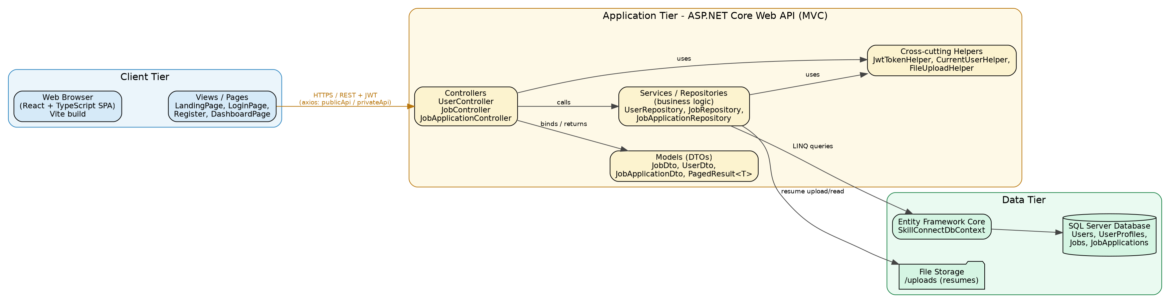
Figure 1 — SkillConnect three-tier system architecture.
Cross-cutting helper classes (JwtTokenHelper, CurrentUserHelper, FileUploadHelper) are injected via .NET's built-in dependency injection container and are shared across controllers and repositories, keeping authentication, current-user resolution, and file handling logic in one place rather than duplicated.

7. Database Design
The relational schema consists of four tables. A single Users table holds both Job Seeker and Company accounts, distinguished by a Type discriminator column; this keeps authentication logic uniform while still allowing role-specific behavior in the application layer.
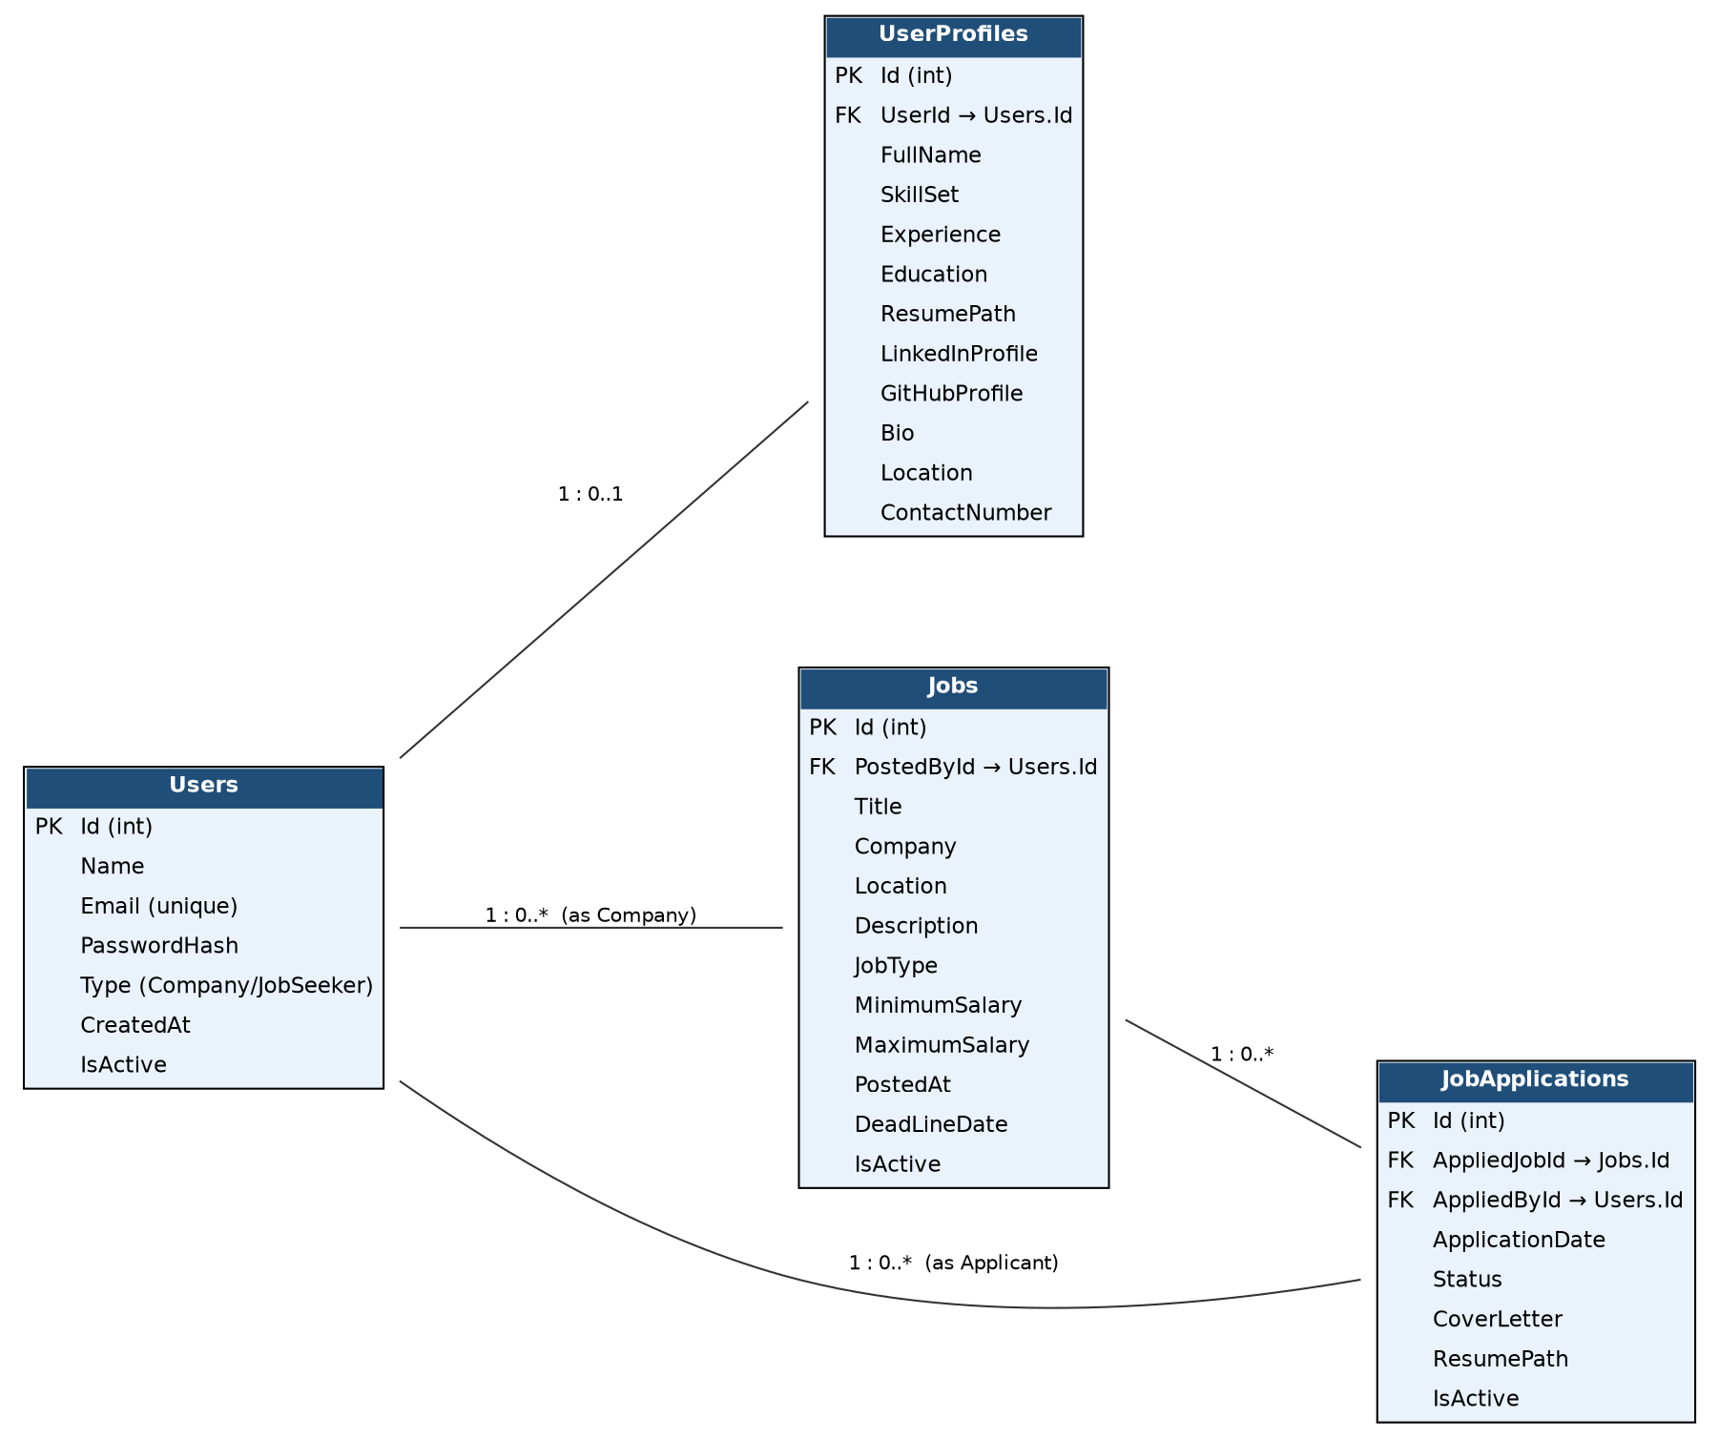
Figure 2 — Entity-Relationship diagram of the SkillConnect database.

7.1 Relationship Summary
- Users (1) — UserProfiles (0..1): a Job Seeker may optionally complete an extended profile.
- Users (1) — Jobs (0..*): a Company can post many jobs; each job has exactly one posting company.
- Users (1) — JobApplications (0..*): a Job Seeker can submit many applications.
- Jobs (1) — JobApplications (0..*): a job can receive many applications.

8. UML Class Diagram
The class diagram below shows the domain entities (User, UserProfile, Job, JobApplication), the repository interfaces that abstract data access (IUserRepository, IJobRepository, IJobApplicationRepository), their concrete implementations, the MVC controllers that depend on those interfaces, and the supporting helper classes. Interfaces are shown with the «interface» stereotype; dashed arrows with hollow triangle heads denote realization (a class implementing an interface); dashed arrows with open arrowheads denote a usage/dependency relationship; hollow-diamond-ended lines denote aggregation between domain entities.
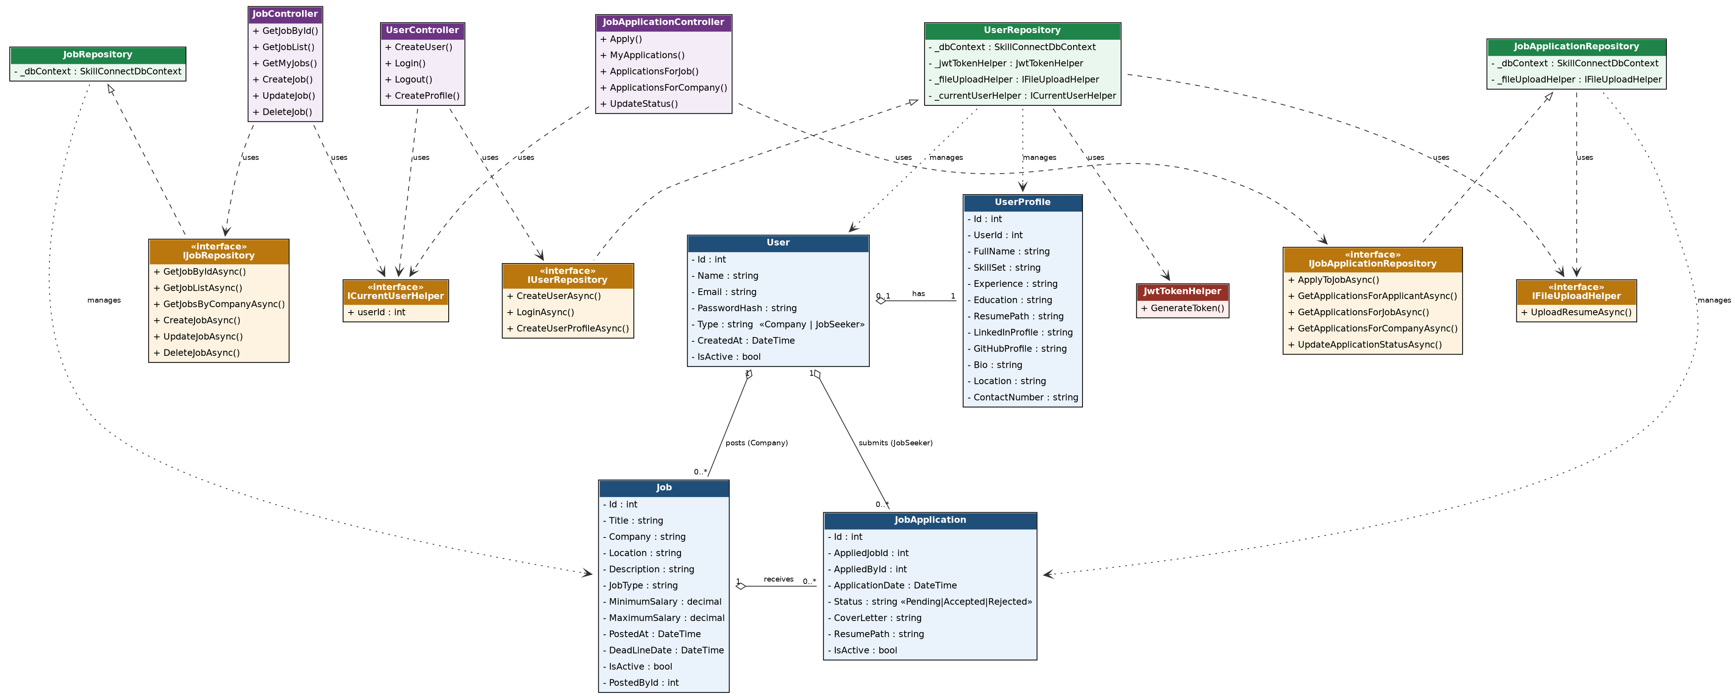
Figure 3 — UML class diagram of the SkillConnect domain and service layers.

9. Use Case Diagram
Three actors interact with the system: an anonymous Visitor, an authenticated Job Seeker, and an authenticated Company. A Job Seeker inherits every capability of a Visitor plus job seeker-specific actions; a Company has its own distinct set of management use cases. 'Apply to a Job' and 'Post a New Job' both require the actor to be logged in (modeled with a «requires» dependency to the Login use case).
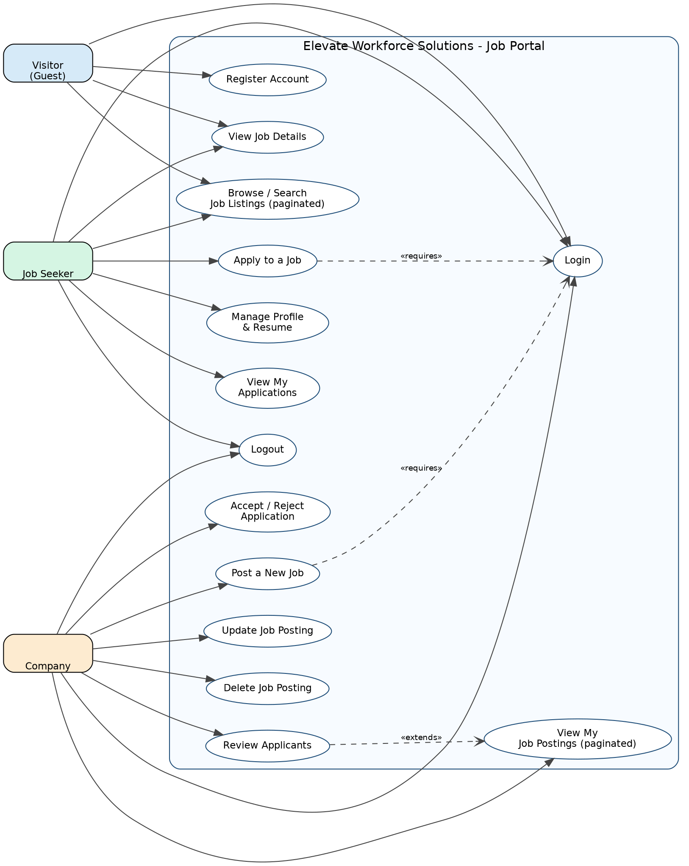
Figure 4 — Use case diagram for SkillConnect.

10. Sequence Diagram — Apply to a Job
The sequence diagram below traces a single representative use case end-to-end through every architectural layer: the React view collects the application data and calls the API; the JobApplicationController authorizes the request and delegates to the repository; the repository applies business rules (job must be active, no duplicate applications) before persisting through Entity Framework Core.
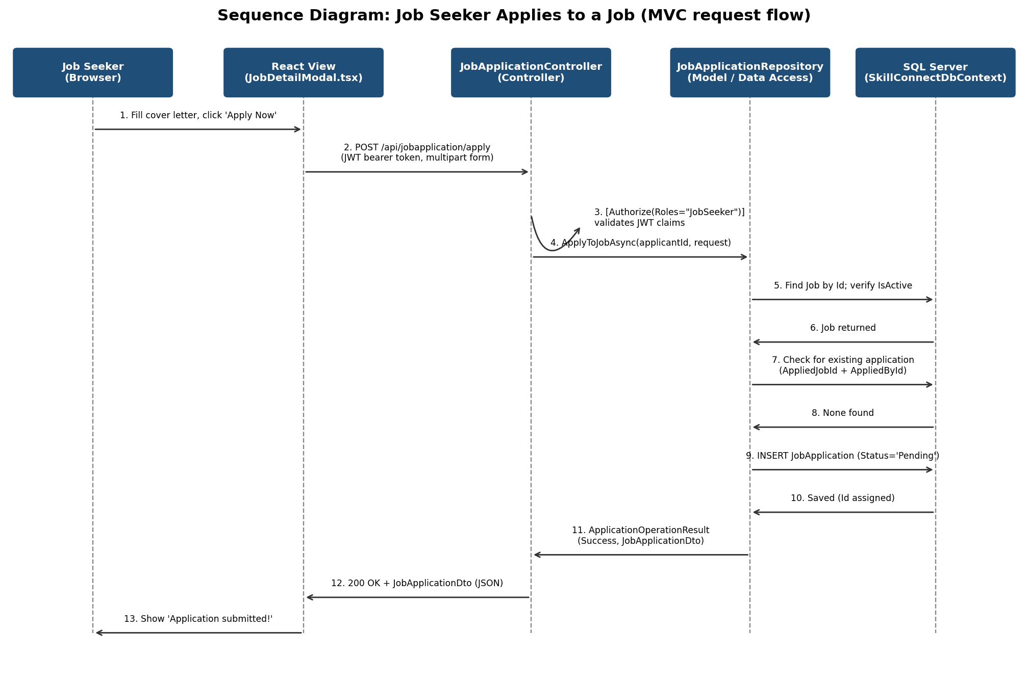
Figure 5 — Sequence diagram: a Job Seeker applies to a job.

11. MVC Design Mapping
The backend strictly follows the Model-View-Controller pattern as implemented in ASP.NET Core Web API projects (where the 'View' is the JSON representation returned to a separate frontend client, rather than a server-rendered page):
MVC Role | Implementation | Responsibility
Model | Entities (User, Job, JobApplication, UserProfile) + DTOs (JobDto, UserDto, JobApplicationDto, PagedResult<T>) + SkillConnectDbContext | Represents and persists application data; DTOs shape the data actually exposed over the wire, decoupling the public contract from the internal EF Core entities.
View | JSON responses serialized by ASP.NET Core, consumed by the React SPA's Pages/Components (LandingPage, DashboardPage, JobDetailModal, etc.) | Presents data to the end user; because this is an API-first architecture, the 'view' is rendered client-side from the JSON payload rather than server-side Razor views.
Controller | UserController, JobController, JobApplicationController | Receives HTTP requests, applies authentication/authorization, invokes the appropriate repository (service) method, and returns an HTTP response with the correct status code.

Between the Controller and the Model sits a Service/Repository layer (UserRepository, JobRepository, JobApplicationRepository) that encapsulates business logic and data-access rules — for example, verifying that only the Company that posted a job may update or delete it, or that a Job Seeker cannot apply twice to the same job. Controllers depend only on repository interfaces (IJobRepository, etc.), never on concrete implementations, which keeps the Controller layer thin and testable and is itself an application of the Dependency Inversion Principle.

12. Object-Oriented Design Principles Applied

12.1 Encapsulation
Every entity (User, Job, JobApplication, UserProfile) exposes its state only through public C# properties with validation attributes (e.g. [Required], [EmailAddress], [StringLength]). Sensitive fields such as PasswordHash are never returned directly to clients — DTOs (CreateUserRequestDto, LoginResponseDto, JobDto, etc.) act as controlled, purpose-built views into the underlying entities.

12.2 Abstraction
Data access is hidden behind interfaces — IUserRepository, IJobRepository, IJobApplicationRepository, ICurrentUserHelper, and IFileUploadHelper. Controllers and other consumers depend on these abstractions, not on Entity Framework Core or SQL directly, so the underlying storage technology could be replaced without changing controller code.

12.3 Inheritance & Polymorphism
All ASP.NET Core controllers derive from the framework's ControllerBase, inheriting standard HTTP-result helpers (Ok(), NotFound(), Forbid(), CreatedAtAction()) which are used polymorphically to return the correct response type for each outcome. The result-wrapper types (JobOperationResult / JobOperationStatus and ApplicationOperationResult / ApplicationOperationStatus) let a single repository method communicate multiple possible outcomes (Success, NotFound, Forbidden) that the controller then maps polymorphically to different HTTP status codes.

12.4 Single Responsibility
Each class has one reason to change: JwtTokenHelper only issues tokens, FileUploadHelper only persists uploaded files, CurrentUserHelper only resolves the current authenticated user's id from the HTTP context, and each repository is scoped to a single aggregate (Job, User, or JobApplication).

12.5 Dependency Injection & Inversion of Control
All services (repositories, helpers, the DbContext) are registered in Program.cs and injected into controllers and other services via constructor injection, rather than being instantiated with 'new' inside consuming classes. This is configured through .NET's built-in IoC container (builder.Services.AddScoped<...>()).

13. API Endpoint Reference

13.1 Authentication (UserController) — /api/user
Method & Route | Auth | Description
POST /create | Public | Register a new account as 'Company' or 'JobSeeker'.
POST /login | Public | Authenticate and receive a JWT.
POST /logout | JWT required | Explicit, auditable logout call (session is cleared client-side).
POST /profile/create | JWT required | Create/attach a Job Seeker profile, including resume upload (multipart/form-data).

13.2 Jobs (JobController) — /api/job
Method & Route | Auth | Description
GET /{id} | Public | Fetch a single job's details.
GET /list?page&pageSize&search | Public | Paginated, searchable list of active job postings.
GET /my-jobs?page&pageSize | Company | Paginated list of jobs posted by the logged-in company.
POST /create | Company | Create a new job posting (company name auto-derived from the account).
PUT /update/{id} | Company (owner only) | Update a job posting; 403 if not the owning company.
DELETE /delete/{id} | Company (owner only) | Delete a job posting; 403 if not the owning company.

13.3 Job Applications (JobApplicationController) — /api/jobapplication
Method & Route | Auth | Description
POST /apply | JobSeeker | Apply to a job (multipart/form-data: JobId, CoverLetter, optional ResumeFile).
GET /my-applications?page&pageSize | JobSeeker | Paginated list of the caller's own applications.
GET /job/{jobId} | Company (owner only) | All applicants for one specific job posting.
GET /company?page&pageSize | Company | Paginated list of applicants across all of the company's postings.
PUT /{id}/status | Company (owner only) | Update an application's status to Accepted or Rejected.

14. Security Considerations
- Passwords are hashed with BCrypt (a slow, salted hashing algorithm designed to resist brute-force attacks) — never stored or logged in plain text.
- Authentication uses signed JWTs validated on every request (issuer, audience, lifetime, and signing key are all checked).
- Authorization is enforced with role claims ([Authorize(Roles = "Company")] / [Authorize(Roles = "JobSeeker")]), and further narrowed at the repository layer by ownership checks (a company can only edit its own jobs; only the applicant or the owning company can see an application).
- Cross-Origin Resource Sharing (CORS) is explicitly restricted to the known frontend origin rather than left open to any domain.
- Server-side model validation (data annotations) rejects malformed registration and job data before it reaches the database.
- Uploaded resumes are renamed with a generated GUID on disk to avoid path traversal and filename collisions.

15. Testing & Validation
The following verification was performed on the delivered codebase during development:
- Frontend: full TypeScript strict type-check (tsc -b) across the entire React application completed with zero errors, including all new pages and components.
- Backend: manual code review of every controller/repository pairing to confirm request DTOs, response DTOs, and Entity Framework Core query shapes are consistent end-to-end.
- Ownership rules (a company editing another company's job, or viewing another company's applicants) are checked in the repository layer and return HTTP 403 Forbidden rather than silently succeeding or leaking data.
- Duplicate job applications by the same Job Seeker to the same job are explicitly rejected with HTTP 409 Conflict.
Recommended next steps before production launch: automated unit tests for each repository (using an in-memory EF Core provider), integration tests for the controllers using ASP.NET Core's WebApplicationFactory, and end-to-end UI tests (e.g. Playwright) covering the registration, job posting, and application workflows.

16. Future Enhancements
- Refresh-token rotation and server-side token revocation for a stronger logout guarantee than relying purely on token expiry.
- Email notifications to applicants when their application status changes.
- Admin/moderation role for Elevate Workforce Solutions staff to oversee postings agency-wide.
- Advanced filters on the public job board (salary range, job type, posted-date range).
- Analytics dashboard for companies (views per posting, application funnel).

17. Conclusion
SkillConnect delivers on Elevate Workforce Solutions' brief: a secure, transparent, and accessible job portal that lets companies self-manage their own postings and lets job seekers discover and apply to opportunities with visibility into their application status. The implementation strictly follows the Model-View-Controller architecture and established object-oriented design principles — encapsulation, abstraction, single responsibility, and dependency inversion — which keeps the codebase maintainable and ready for the enhancements outlined above as the agency's needs grow.

