CS-307

System Practicum

Lab report for Q3
-Saksham Barara(B18190)

Introduction and Procedure
There are two files merge_sort.cpp and merge_sort_prll.cpp which implement merge sort algorithm sequentially and parallelly(using threads). These files can take a size of array and number of threads as input in the form of command line arguments. Both the programs have been run on same inputs and time taken by them is noted. Also the parallel program has been run on varying number of threads and the corresponding running time is noted. There are 5 readings taken for each input and their average is taken for analysis.

Observations
Comparison of Sequential vs Parallel running times for 4 threads
S.No | Input size(n) | Sequential running time(in ms) | Parallel running time(in ms)
1. | 100 | 10 | 84
 |  | 9 | 132
 |  | 10 | 231
 |  | 10 | 91
 |  | 43 | 113
 |  | Avg: 16.4 | Avg: 130.2
2. | 5000 | 577 | 315
 |  | 548 | 306
 |  | 548 | 305
 |  | 580 | 316
 |  | 553 | 323
 |  | Avg: 561.2 | Avg: 313
3. | 100000 | 12796 | 6185
 |  | 14561 | 5685
 |  | 13973 | 7837
 |  | 13049 | 5329
 |  | 14188 | 6168
 |  | Avg: 13713.4 | Avg: 6240.8
4. | 500000 | 82479 | 30174
 |  | 74229 | 36105
 |  | 72739 | 28701
 |  | 73887 | 31360
 |  | 75610 | 30348
 |  | Avg: 75788.8 | Avg: 31337.6
5. | 1000000 | 152293 | 63879
 |  | 151542 | 67397
 |  | 148052 | 63125
 |  | 157184 | 63642
 |  | 156538 | 64722
 |  | Avg: 153121.8 | Avg: 64556.6
6. | 1500000 | 477182 | 194724
 |  | 497138 | 167284
 |  | 455076 | 244820
 |  | 475283 | 205172
 |  | 488054 | 206986
 |  | Avg: 478546.6 | Avg: 203797.2
7. | 2000000 | 634324 | 229476
 |  | 630419 | 217219
 |  | 622974 | 225470
 |  | 687286 | 224015
 |  | 672076 | 277301
 |  | Avg: 648715.8 | Avg: 234696.2

Comparison of running times as number of threads is increased for n=500000-
S.no | Number of threads | Average running time(in ms)
1. | 2 | 38474.8
2. | 3 | 33509.0
3. | 4 | 31337.6
4. | 5 | 28243.0
5. | 6 | 30177.6
6. | 7 | 28679.0
7. | 8 | 31743.8
8. | 9 | 30346.4
9. | 10 | 29058.0
10. | 20 | 29811.2
11. | 30 | 30838.0
12. | 35 | 32232.6
13. | 40 | 33861.8
14. | 45 | 32801.0
15. | 50 | 33585.6
16. | 55 | 33237.0

GRAPHS-
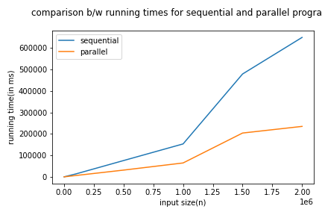
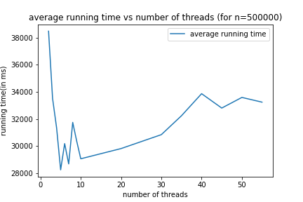

INFERENCES AND CONCLUSION-
1. Running times decrease as we increase thread size from here till nthreads=8. After that running times increase again.
2. Times of sequential and parallel programs increase with input size. Time of parallel program is less than sequential programs after a certain point.
3. Change in running times is more for sequential programs than parallel programs.

